Student name: Catalina Trasc Cert HE Construction, Digital, Computing & Engineering
Student ID number: 2018162 Module: Digital Technologies

Technology in Practice

- Actual stage – the age of technology
- The Evoluation of tehnology in the field of construction
  - Short computer software history for building design
  - The 10 most promising technologies to improve productivity in E&C
  - New skills in the digital technologies area
  - Evolution of contruction programs
- Conclusions

- Actual stage – the age of technology

It is the stage of technologicalization and technological evolution from all the points of view. In terms of medicine, studies, laboratories, automobile production, art, electronics and home appliances, computers, everything is evolving rapidly. (Anon., 1990)
Peoples expectations about constructions is growing and they want to be in line with tehnology. They want green houses, smart houses with less energy cost and more friendly with the environment. They want to control the house from work, from holiday or any other place, to change temperature, to see in their house and even to lock and unlock doors and gates. (Meinshausen, et al., 2009)

- The Evoluation of tehnology in the field of construction

  - Short computer software history for building design:
- In 1960, Ivan Sutherland produced a project named SKETCHPAD, which is considered the first step o CAD industry.
- In 1983 appear The first German and French versions of AutoCAD
- AutoSketch 1.0 entry level CAD program from Autodesk is available from 1986
- The first AutoCAD (Release 12) for Windows platforms was in 1993
- In 1997 Autodesk ships 3D Studio MAX release 2 and a cut-down version called 3D Studio Viz.
- After 2000 a lot of softwares appears and they are in continue growing and development, softwares for design, for management, for building etc. (Anon., n.d.)
- New construction project management softwares are: Procore, BIM360, BuildTools, CoConstruct, SiteMax PlanGrid and a lot of others (Anon., n.d.)
2.2. The 10 most promising technologies to improve productivity in E&C

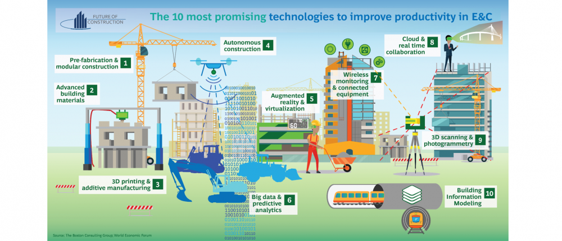

Fig.1 The 10 most promising technologies in Engineering & Construction (Zupanciuc, 2017)

  - New skills in the digital technologies area:

Participating in this course, I learned new things and I acquired new habits that will be useful both in my personal projects and at work.
Before starting this course I had an easy to remember password for all my accounts. Now I changed all my passwords learning the newdiscovered tricks and I also cleaned and rearrange my documents in my personal laptop. I put all my personal data that I consider important and I don’t want to lose on an exterior hard disk, where is save and secured.
I learned how to use google drive better and I started to share documents, pictures and videos with my friends.
Before I had some elementary knolegde about new construction softwares, I used to work in Autocad 2D, in Microsoft Project and some other estimate programs like Doclib.

  - Evolution of contruction programs:

Having the opportunity to discover new design and management softwares for construction industry, it piqued my curiosity to search for more new programs, to read more and I was pleasantly surprised to discover the multitude of new technologies that help construction engineers.
I have selected a few and I made a short presentation of them:

- Autodesk Construction Cloud combines new generation technology, a network of professionals and firms, and powerful analytics with the purpose to make your business thrive across all phases of construction with best results. (Anon., 2021)
- Archdesk is designed for construction and production industries, representing an innovative workflow management solution. This software resolves the challenges of the company and has been developed by industry experts. Can plan each stage of the project in specific details, track progress and budget. (Anon., n.d.)
- Zutec Cloud is a total management platform for entire construction team, Zutec Field can run online and offline and get integrated with the other Zutec services. Allow stakeholders acces to all the information requested on each project and can manage in real time all the data. Zutec BIM can store and manage all 3D projects, offering acces to all member to see and edit in one file. (Anon., n.d.)
- Synchro is an integrated software for digital construction management. (Anon., n.d.)
- Matterport is a new standard for online virtual tours for real estate and architecture, engineering and construction. It is the software which impressed me the most as it is very useful and can save you for travelling to the site, you can actualy be there in a few seconds from your desk and you can see the stage of the project. It can be used for any field, but in my opinion for the construction industry is a big plus. As I used to work in cost management and project management in Romania, I used to make a lot of trips to different sites and loosing a lot of time, staing in cold, wind, rain just to check some works that now with Matterport can be solved really fast and easy.

- Conclusions:

At the beginning of the course, I had a basic knowledge of the digital world and certainly evolved after attending this course. The knowledge gained is from the usual one, such as ensuring a secure password for e-mail and other personal accounts and harder to be discover by hackers, sharing files with others, schedule meeting with colleagues, new excel functions that could help us to manage better our projects, until discovering new construction softwares that allows engineers to use now a days technology. I was surprised to learn how fast technology is evolving and was delighted to discover new programs in the field of construction, softwares that hopes to be able to learn and put into practice in future jobs.
I would like to learn how to use programs as Revit (Zolotova, et al., 2014), 3D Studio Max, Skech Up (Qiang & Yongshou, 2014) and Soliworks. (Anon., n.d.)

References
Anon., 1990. https://apps.dtic.mil. [Online]
Available at: https://apps.dtic.mil/dtic/tr/fulltext/u2/a227328.pdf
[Accessed 11 January 2021].
Anon., 2021. https://construction.autodesk.com. [Online]
Available at: https://construction.autodesk.com/vision
[Accessed 5 January 2021].
Anon., n.d. https://archdesk.com/. [Online]
Available at: https://archdesk.com/
[Accessed 6 January 2021].
Anon., n.d. https://www.aboutcivil.org/. [Online]
Available at: https://www.aboutcivil.org/
[Accessed 12 January 2021].
Anon., n.d. https://www.bentley.com. [Online]
Available at: https://www.bentley.com/en/products/brands/synchro
[Accessed 11 January 2021].
Anon., n.d. https://www.predictiveanalyticstoday.com. [Online]
Available at: https://www.predictiveanalyticstoday.com/top-construction-project-management-software/
[Accessed 14 January 2021].
Anon., n.d. https://www.sculpteo.com/. [Online]
Available at: https://www.sculpteo.com/en/3d-learning-hub/3d-printing-software/best-architecture-design-software/
[Accessed 11 January 2021].
Anon., n.d. https://www.zutec.com/. [Online]
Available at: https://www.zutec.com/
[Accessed 11 January 2021].
Meinshausen, M. et al., 2009. Greenhouse-gas emission targets for limiting global warming to 2°C. Nature Publishing Group, Volume 458 (7242), pp. 1158-1162.
Qiang , D. & Yongshou, Y., 2014. Research on SketchUp Application in Graphing of Civil Engineering, s.l.: Trans Tech Publications, Switzerland.
Zolotova, J., Vatin, N., Tuchkevich, E. & Rechinsky, A., 2014. Autodesk Revit - Key To Successful Training Of Highly Qualified Civil, s.l.: Trans Tech Publications, Switzerland.
Zupanciuc, T., 2017. https://futureofconstruction.org. [Online]
Available at: https://futureofconstruction.org/blog/infographic-the-10-most-promising-technologies-in-engineering-construction/
[Accessed 5 January 2021].

