LCBB4003 - Introducing the Modern Workplace
Assessment – 1

Student ID: 2019148
Student name : Raluca Marilena Botanoiu

Table of Contents
Introduction 3
Organisational Overview of Procter & Gamble 4
The Relationship of Organisational Structure with the Organisational Culture in Procter & Gamble 4
Leadership and Management Approaches of Procter & Gamble 6
The Factors That Influence the Group and Team Behaviours in Procter & Gamble 7
The Linkage of Motivation and Perception to Organisational Performances of Procter & Gamble 8
Conclusion 8
References 9
Appendix 10

Introduction
The report will discuss various issues o organisational structure, organisational culture, people and behaviour and performance. An organisation has been selected for carrying out the task that is Procter & Gamble. A simple overview of the organisation shall be provided in the first phase of the report. Then the relationship between organisational structure and organisational culture of Procter & Gamble will be discussed. P&G is such an organisation where innovation was always emphasised and all innovation efforts were made by focusing on the needs and demands of the customers. Then, in the following phase, the report will provide a brief discussion on the leadership and management approaches of the company. There are many factors that influence team and group behaviours of an organisation which will also be discussed in this report. At last, the linkage of motivation and perception with organisational performance will be discussed.

Organisational Overview of Procter & Gamble
The Procter & Gamble Company is a famous American transnational company that sells consumer goods to the customer. The headquarter of the company is located in Cincinnati, Ohio, US, in the year 1837. Procter & Gamble was instituted more than 180 years back as a soap and candle company by William Procter and James Gamble. Procter & Gamble operates worldwide except in two countries including North Korea and Cuba. P&G specialises in a variety of consumer health goods, personal care and hygiene goods. All products of Procter & Gamble are segmented into the following categories such as Grooming, Health Care, Beauty, Feminine, Family Care. The most trusted and famous brands of Procter & Gamble are Always, Gillette, Head & Shoulders, Oral B, Pampers, Fairy, Febreze, Charmin, Vicks, Tide, Pantene and so on. With the innovative and insightful minds of the employees of P&G, the company has been able to design, develop and make a success from these products (Lucà, 2016). The company has successfully spanned three centuries and millions of thanks to leadership, innovation and citizenship. David S. Taylor is presently working as Chairman, President and CEO of P&G. In 2020, P&G had more than $70 billion in revenue and net income was $13.03 billion. The company has assets of $120 billion across the world and more than 138000 employees work for P&G.

The Relationship of Organisational Structure with the Organisational Culture in Procter & Gamble
Organisational structure means a system that is used for defining the hierarchy within an administration that classifies each job, its purpose and where it reports to, how decisions are made across the business (Maduenyi, et al., 2015). Organisational culture means the underlying assumptions, beliefs, values and ways of interacting with each other. Organisational culture defines the core values that guide the behaviour of the members of the business and is expressed in member self-image, inner working, and future expectations.On the basis of the product portfolio of P&G, the structure of the company is made. Organisational and corporate culture of P&G also addresses the needs of the business on the basis of organisational function and consumer goods market geography (Okatan and Alankuş, 2017). The lines of authority and command in making and implementing decisions and solutions for solving problems are established and defined in the organisational structure of Procter & Gamble. P&G’s organisational structure has the following major characterizes in accordance with the significance of the company’s operations
Product-type Divisions: On the basis of product mic, the characteristics of organisational structure of this type is formed. Each division of products addresses a specific group of product lines. This also tells how different issues should be handled. However, it needs the involvement of the upper management body in large-scale issues (Cervantes, et al., 2015). This helps the business to minimise the cost of doing business. The product-type divisions of P&G are:
- H
- ealth Care
- Beauty
- Grooming
- Home Care & fabric
Geographical Divisions: Operation areas of Procter & Gamble are the centres for the characteristics of organisational structure. In this division of the company, the main concern is to maintain the corporate structure and to provide proper and adequate support for managing regional operations. P&G has operations in many international markets in many consumer goods industries. For instance, the company has a management team in North America, Europe (Han, et al., 2019). The following divisions are properly followed in the geographical divisions of the company.
- Asia Pacific
- Greater China
- India, the Middle East and Africa,
- North America
- Latin America.
Functional Division: P&G also ensure that the corporate structure of the company properly satisfied the fundamental business functions. This feature provides and creates sustenance for the Chief Executive Officer and his staff. This division of Procter & Gamble helps the company to run operations of different categories of products in a proper manner (Okatan and Alankuş, 2017). Functional visions of P&G are CEO, CFO, Legal & Secretariat, Human Resources, Global Grooming, Technology, Market Operations, Branding, Global Product Supply, Comptroller & Treasurer.
Proctor & gamble follows a purpose-driven organisational culture and this is viewed as one of the fundamental factors of individual and group activity of the company. The main characteristics of P&G’s organisational culture are honesty, leadership, possession, trust and passion for winning. The company provides quality brands that play a unique role in the world. P&G emphasises deeply on its moral outline and wants to safeguard transparency with its distinguished customers (Pinho, et al., 2014).

Leadership and Management Approaches of Procter & Gamble
P&G instils leadership in various aspects of business performance in this industry. In the organisational culture of the company, leadership in fulfilling job responsibilities is covered and these cultural traits in business help the employees and management body to achieve leadership in business direction and individual, group, and organisational output.
There are different types of leadership approaches such as autocratic, democratic, laissez-faire, motivational and so on. However, according to McLaurin (2013), the situational leadership approach is best for Procter & Gamble because it points out that leader should change their leadership approach to be less or more directive, and more or less supportive, on the basis of situation. The best leaders are those who can learn to discern what is needed in each situation rather than always following the same set of predefined roles and leadership attributes.
According to Agafitei and Avasilcai, (2015), in this new normal of the coronavirus and ever-changing environment, the scarcest resource in this world is leadership. Those leaders who make the best decisions based on the situations are widely needed in an increasingly more competitive world. In P&G, 5E of leadership is followed including envision, engage, energize, enable and execute. The company has been awarded the best company for developing leader talent.
Different types of management approaches are followed in Procter & Gamble. Operations managers of P&G are worried with the design of products and amenities. Novelty is the main factor in the intensive development tactic of the company. The management body of the corporation emphasises on cost minimisation strategy for applying this. In addition, based on the expectations of the target customers of P&G, the quality management body implements quality standards. P&G’s goal is to apply high-quality standards to operations management and products of higher quality are likely to be more successful in the consumer goods market (Cervantes et al., 2015). The management body of the company also focuses on optimal distances from resources to target markets. The strategy taken by the company focuses on proximity to target markets ensuring conveniences are situated where it is easier to conveyance products to the retailer.

The Factors That Influence the Group and Team Behaviours in Procter & Gamble
The behaviour of a group and team largely depends on many types of factors that remain within the organisational boundary. Roles of the members, size of the groups, level of independence of workers, glueyness, perception of employees towards the organisation, social interactions, are the major factors (Schjoedt, et al., 2013). The factors that will have an influence on the team and behaviours vary from organisation to organisation. In the aspect of Procter & Gamble, the practice is quite traditional, conservative, and bureaucratic management style. The management team has changed the conservative goal-setting plan to an individual appraisal system for extending the stretch goal-setting plan.
Besides, in P&G, product expansion exertions were absorbed on information technology rather than thoughtful the employees and customer necessities. Some members of the teams and groups were also forced to integrate IT tools into the new corporate structure (Agafitei and Avasilcai, 2015). In P&G, the independence of the employees matters the most and as the company follows a situational leadership style, the employees have a place to say anything in the decision-making process. Each member of the teams and groups is asked if they have any opinion regarding the issue of the matter. If they want to say something regarding any issue of the organisation, their immediate leaders listen to them properly and convey the message to superiors.
The perception of employees regarding the enterprise also plays a great role in influencing the team and group behaviours. The perception of employees can provide better behaviour within the business of Procter & Gamble and Vice-versa. Sometimes, the team managers specify some roles that can influence the behaviour of the team. Besides, if members of the team are not satisfied with the provided roles to them, their behaviour can be highly affected (Buchanan, and Huczynski, 2019). Cohesiveness among the members of the team is also a vital factor in this aspect because this helps to build a long-term relationship among the members of the team. In addition, the size of teams and groups can also influence the behaviour of team or group members of Procter & Gamble. In small groups or teams, usually, relationship or bonding is easily and quickly created, and in large groups, it might take some time to build a favourable relationship.

The Linkage of Motivation and Perception to Organisational Performances of Procter & Gamble
Organisational performance defines the outcome of a business where the business manager checks whether it has achieved the predefined goals and objectives. In organisational performance of most business organisations, motivation and perception play a significant role. When employees of Procter & Gamble are motivated properly, they are likely to work faster and more efficiently. Organisational productivity increases tremendously when its employees are motivated. In addition, when employees are highly motivated, they are more likely to offer even better, motivated employees remain focused on work and look for areas of improvement. When employees of P&G are highly motivated, they will remain happier with their working life and would not miss work without proper reason, thus leading to lower absenteeism. Motivation also ensures a lower level of staff turnover in P&G. Motivated employees work on their own and they feel appreciated working in the company.
Perception is closely linked with the higher organisational performance of business. If the employees of an organisation do not have a good perception of the organisation, then organisational performance will not be good or satisfactory. Procter & Gamble arranges different types of sessions; training and development programs for motivating the employees and fir changing their bad perception of the company. When employees of P&G will have a better perception, organisational performance will be automatically improved.

Conclusion
An organisation is structured and modified by how it wants to serve the people. Organisational culture defines the company’s vision, mission, values, that guides its workers and employees. Business with defined structure and proper culture tend to be more successful than less structured organisations. Proper organisational culture increase employee engagement, decrease turnover, elevate productivity and so on. Throughout this report, different aspects of organisational structure, culture, behaviour etc. have been discussed. Linkage between motivation, perception with organisational performance will also be discussed.

References
Agafitei, I.G. and Avasilcai, S., 2015, October. A case study on open innovation on Procter & Gamble. Part II: Co-creation and digital involvement. In IOP Conference Series: Materials Science and Engineering (Vol. 95, No. 1, p. 012150). IOP Publishing.
Buchanan, D.A. and Huczynski, A.A., 2019. Organizational behaviour. Pearson UK.
Cervantes, M., Crimson, K., Figueroa, C., Hess, A. and Martinez, E., 2015. GM 105–12: PROCTER & GAMBLE COMPANY’S 2015 STRATEGIC AUDIT.
Han, C., Thomas, S., Yang, M. and Cui, Y., 2019. The ups and downs of open innovation efficiency: the case of Procter & Gamble. European Journal of Innovation Management.
Lucà, F., 2016. Successful sustainability strategy. Procter & Gamble Case.
Maduenyi, S., Oke, A.O., Fadeyi, O. and Ajagbe, A.M., 2015. Impact of organisational structure on organisational performance.
McLaurin, J.R., 2013. The role of situation in the leadership process: A review and application. Electronic Business, 12(2).
Okatan, K. and Alankuş, O.B., 2017. Effect of organizational culture on internal innovation capacity. J. Organ. Stud. Innov, 4(3), p.18.
Payaud, M.A., 2014. Marketing strategies at the bottom of the pyramid: Examples from Nestle, Danone, and Procter & Gamble. Global Business and Organizational Excellence, 33(2), pp.51-63.
Pinho, J.C., Rodrigues, A.P. and Dibb, S., 2014. The role of corporate culture, market orientation and organisational commitment in organisational performance: the case of non-profit organisations. Journal of management development.
Schjoedt, L., Monsen, E., Pearson, A., Barnett, T. and Chrisman, J.J., 2013. New venture and family business teams: Understanding team formation, composition, behaviors, and performance. Entrepreneurship Theory and Practice, 37(1), pp.1-15.
Thompson, G. and Glasø, L., 2015. Situational leadership theory: A test from three perspectives. Leadership & Organization Development Journal.

Appendix
Organisational Structure of P&G

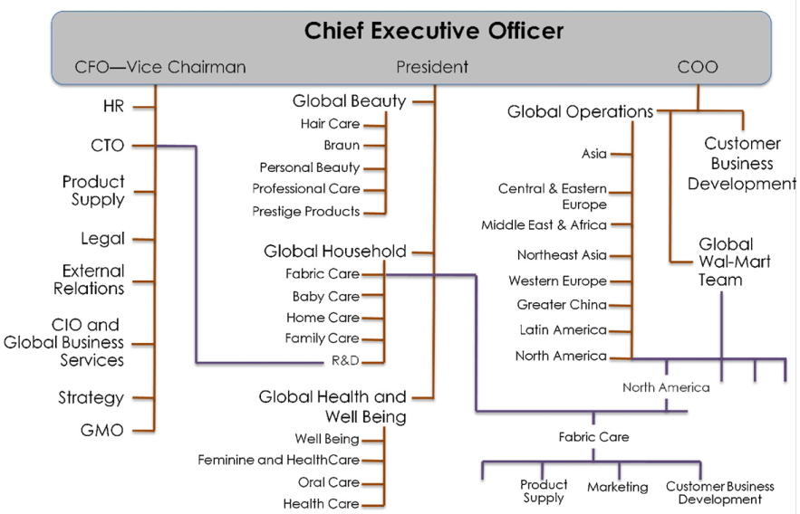
Figure: Organisational Structure of P&G (Lucà, F., 2016)

