Hospitality and Guest Services Management
Student Name: Razvan Joita
Student Code: 1905612
Module Code: M4X01915
Lecturer: ABDI RAHMAN

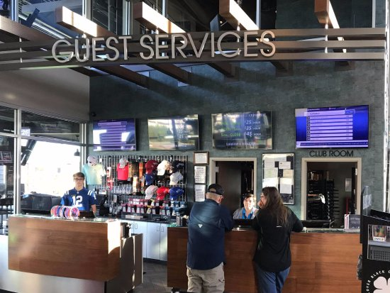

Table of contents
Introduction…………………………………………………………………Page 3
Discussion and critical analysis…………………………………Page 3-4
Conclusion…………………………………………………………………Page 4



Introduction.
For today, I will use the JW Marriott Bucharest Grand Hotel as a model while speaking about the way they are managing the guest services to be able to initiate constant changes and improvements considering what the customers are expecting from a luxury and popular hotel located in the capital of the country (Romania). Guest services is very important in hotels, especially in hotels that are having good reputation and even more important for the international ones such as the one that is used today, Marriott. Hospitality and tourism industry became one of the largest industries that are continuously developing following the newest technology and techniques to attract guests.
Thinking about guest services, this term is defined as being a barrier against the competition, ensure customer loyalty, help to differentiate product and decrease marketing costs and increase company profit” (Bovee and Thill 1992). Looking at the quote, is easily to notice that, again, the way the staff of the hotel is treating the customers is very important and the way the managers are structuring what the customers are saying is necessary to be done well because otherwise, the hotel would not be able to touch the customer’s expectations and this would be one of the factors that would affect the hotel very much negatively. Next to that factor, there are some other factors such the location and the surroundings, the prices of the products/ services, how quick the customer are getting what they order, the communication and empathy showed to them and many others.

Discussion and critical analysis
The management of the hotel plays an important role over the entire hotel not only on its economy and guests. The quality of management of the hotel, considering the Gronroos’s research is described through the following aspects:
¬Professionalism and skills ¬Behaviour and attitudes ¬Accessibility and flexibility ¬Reliability and trustworthiness ¬Recovery and refunds ¬Reputation and credibility
The mentioned aspects are key aspects in providing a service at a good quality to be able to keep the hotel at the top list and to make sure that there are enough people coming to the hotel. Guests are people that are controlling what is and is not good in any hospitality and tourism environment and therefore, everything should be kept under control mostly by the people in charge of the hotel. The people in charge of the hotel, with the data and information collected, are taking continuous decisions about the services, products, aspect, everything in the hotel. All the changes that are made in the hotel are considered as being improvements that were made from what people thought in the hotel’s advantage because everything is new and modern and it is a big temptation for lots of people to come and spend a time.
Thinking about Marriott hotel (Bucharest) improvement is shown firstly through the fact that it is an International Hotel which is spread in more countries next to Romania and secondly most important through the fact that is a luxury rated hotel. The management of the hotel is very complex when it comes to the chosen hotel, Marriott (Bucharest) and this because there constant improvement showed especially through the fact that there are 101 employees that are sharing different responsibilities to be able to maintain the hotel at its standards especially because again, it is an international hotel. Also, the employers are working together using their skills and knowledge constantly to be able to provide constant services, facilities and new brand products after taking into consideration the guests opinion about what they wish to find in the hotel.
The hotel services are very important as well as the way it is structured in terms of everything, rooms, facilities, prices, location, everything is important to build strong guest services boundaries and rates. As O’Neill and Palmer said, the service quality and the degree of satisfaction derived from service quality are becoming the most important differentiating factors in almost every hospitality environment (2004). This quote clearly explains that everything that is introduced in the hotel is either a key to success or it will bring a sign that there is something else that should be introduced instead. The staff are most important in a hotel because they are delivering to guests’ empathy, communication, friendliness, patience, and they do also show their skills and abilities to make sure that everything is perfect for the customer. Everything perfect from the aspect and cleanliness of the room to the services and facilities the person has included in the deal. There are techniques that are increasing the quality of the services in a hotel. Those techniques could be based on the internal aspects such as the hygiene, the atmosphere, the health and safety, timing, etc… But now, thinking about the guests one of the used techniques has been discovered by LEWIS RC and this is the quantitative technique. The quantitative technique as Clark said, coasts on taking surveys to guests fairly in big amounts to make sure that there is a representative sample of the target market. The meaning of the quote drives the student’s mind to the variety types of people coming to the hotel from different sides of the world (target market). The quantitative technique is very important because in those questionnaires the guest’s opinions are getting known and in this way the hotel management can use those opinions to improve the services considering what the customers aspirations are.
Thinking about Marriott hotel it is a 5-star hotel and it is located in a way that links it with so many touristic points that people are mostly looking for in Bucharest. There are some other factors that are very important in this hotel and those are based on the building itself. The hotel contains 402 deluxe rooms, 6 restaurants, one creation centre, spa and health centre, bar, free internet accessibility, free parking and many other facilities that will be mentioned within the next paragraphs. The rooms are shared in more than one type. They have got 12 types of rooms and this important for the customers before in this way they have more options and their aspirations are obviously not limited. Most of the Marriott’s guests are saying that the rooms are very clean, and that the location is one of the best locations you can aspire to because there are theatres around, parks, select restaurant and fabulous views. Focusing on the hotel management now, there are managers and assistances for each department, and this is the only way they manage to do everything. For each department they have system which are working together to initiate of extract services or products depending on what the customers wants and since now, the staff done such a great job and this because they are using lots of strategies to make sure that first the quality of the services and of the hotel itself is good enough for the ones coming from anywhere. Also, they are using techniques that are helping them to collect information easily from the customers by using the internet and the quantitative technique as well because, for example, every time when you end a call with them they ask you to rate them in terms of services.
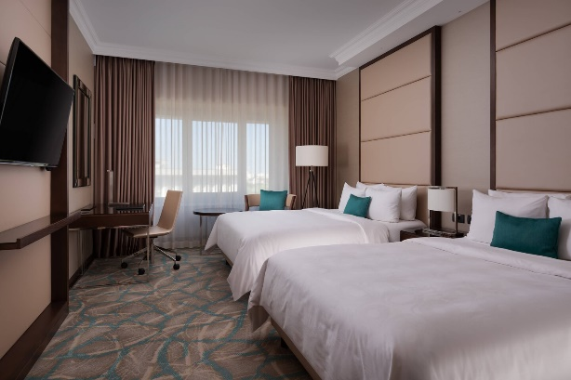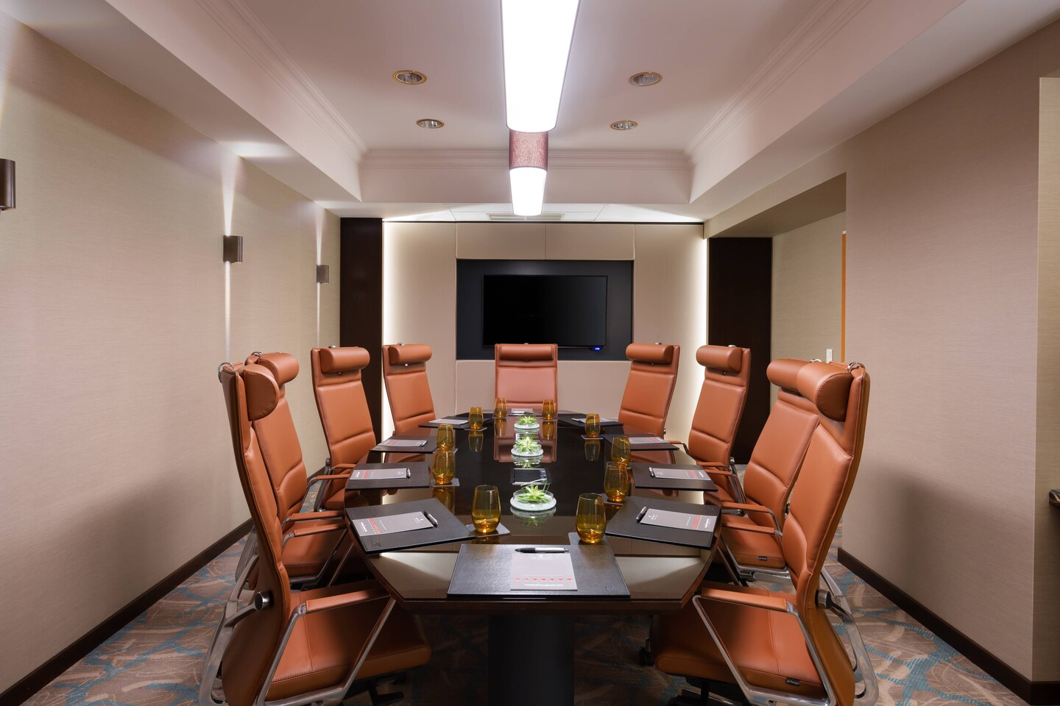
Anyway, considering the stage of the hotel, is easy to notice that its management is going very well, and they are all doing their jobs and they are all using specific skills that are very necessary in the hospitality and tourism environment. Skills such as team working, honestly, communication skills, punctuality, computing and technical skills, customer service skills, dedication, and a lot of others that are driving an employer to success. Skills and abilities are very important as well because, as Scott Adams said, every skill you acquire doubles your odds of success”. The most important skills when working in the hospitality and tourism settings, are the life skills:
- Decision Making- which proves that you have knowledge in analysing opinions, thing that at the Marriott hotel is very developed because each and every member of staff is trying their best to rise the hotel’s economy, profit and reputation as much as possible and they are doing it all by themselves, thing that is impressive considering the improvements they are making everyday to make sure that the level of satisfaction of a guest is high enough for the hotel’s standards which are again, high.
- Problem Solving- which demonstrates the fact that the employee has leadership skills to find a positive solution. This skills are very important because if most of the members of staff have it, then most of the conflicts are kept away and the atmosphere is always calm and moderate so then issues in the hotel may be solved easier than they would be if the members of staff would be vulnerable at some points.
- Goal Setting- Are showing that you are capable to set up a plan of successful achievement of specific purposes. A skills like this one in the Marriott hotel is very common because everything they planned they now have, they have good feedbacks, they have good economy, loads of people working for the hotel, lots of facilities such as pool, bar, restaurant in which people are saying such amazing things about the taste of the food and the coffee.
- Critical Thinking- Proves that you, as a worker are able to watch things from a negative extent as well, a negative way that is bringing logical arguments about the situation. This skill is necessary in the hotel, especially in the chosen hotel for today, Marriot Bucharest and this because they cannot agree with each decision taken and they might have some arguments against it, which are proving that that idea is better.
- Communicating Effectively- Is such an important skill and this because it demonstrates that you are able to speak and cooperate with others. Linking the skill with the hotel, the staff is using this skill mostly and they are using it as it is the most important because this is the skill that is helping them communicate one to another about what to do and how to do thinks in the guest’s advantage
.


Conclusion
In the conclusion the main thing to mention is that the Marriott’s hotel staff is working so hard in collecting and testing information from the customers and the second most important thing is that the management of the hotel is working very hard in using the information and data to continuously make improvements at the hotel to be able to raise the level of satisfaction at its best.
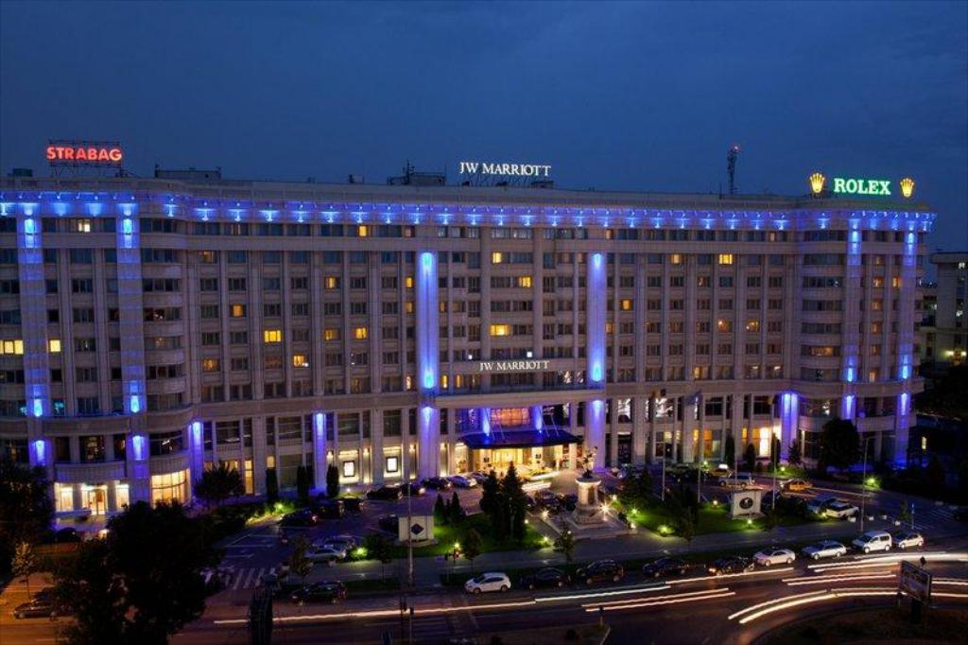
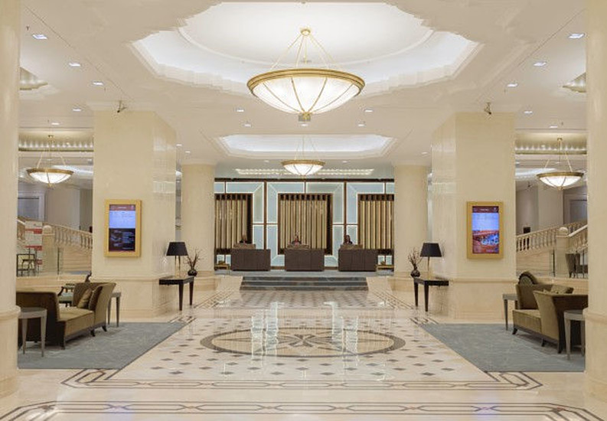

References
Bovée, C. L., & Thill, J. V. (1992). Study guide to accompany Marketing, McGraw-Hill
Clark, M. (1998), Researching and writing dissertations in hospitality and tourism. London: International Thomson Business Press
Gronroos, C., “Service Quality, the Six Criteria of Good Perceived Service Quality”, Review of Business, Vol. 9, 1988, pp. 1-9.
https://www.marriott.com/hotels/travel/buhro-jw-marriott-bucharest-grand-hotel/
https://www.booking.com/hotel/ro/jw-marriott-bucharest-grand.ro.html
Lewis, R.C., “The Basis of Hotel Selection”, Cornell Hotel and Restaurant Administration Quarterly, May 1984, pp. 54-9
Walker, J. (2013) Introduction to Hospitality, Pearson, London

