
University of Wales
Trinity Saint David
BA (Hons) Leadership & Management Skills for the Workplace
Module: Understanding & Engaging Stakeholders (LCLM5001)
Lecturer: Lakshani Nissanga Mendis
Student: Monday Eromosele
Student ID: 1916732
Date: 05/08/2026

Table of Contents
Executive Summary 2
Introduction 3
Smart Objectives 4
Identification of Key Internal and External Stakeholders 5
Internal and External Key Stakeholders 5
Stakeholders Matrix 6
Swot Analysis 8
The Roles and Responsibilities of Key Stakeholders 10
Key Internal Stakeholders 10
Key External Stakeholders 10
Stakeholder Engagement & Conflict Management Methods 11
Stakeholder Mapping 11
Communication Plans 12
Participation Models 13
Typology of stakeholder engagement strategies 14
Conflict Resolution Techniques 14
Conclusions and Recommendations 16
References 17

Executive Summary
Technological innovations and advancements in the past decade have ushered in interesting developments, such as the Internet of Things (IoT), which have positively impacted the e-commerce industry, including Amazon.com. Amazon.com has become the foremost technology disruptor within the online marketing industry. With the emergence of a plethora of e-commerce industry players from China, the UK, and Europe, Amazon.com has been driving further improvements in customer relationships to increase its market share. This development has resulted in Amazon.com commissioning the launch ConnectPlus both locally and internationally. ConnectPlus is a digital platform for improved customer interaction and loyalty. This system combines real-time customer insights, mobile-based rewards, and AI-driven personalized suggestions.
Accordingly, this report first and foremost addressed internal and external stakeholders and the SMART objectives of the company; identified and analysed internal and external stakeholders; developed plans; and executed and reviewed the project after execution. Secondly, a SWOT analysis was conducted to elicit the company’s strength, weaknesses, opportunities, and threats. Thirdly, through stakeholder engagement, a conflict management method Fourthly, the impact of sustainable stakeholder engagement on day-to-day business activities was evaluated. Finally, an effective communication, collaboration, and consultation framework was put in place.
It was gathered that the unique and dynamic relationship of stakeholders in the 21st Century requires project managers to examine more innovative ways of stakeholder engagement. In this regard, it is recommended that a comprehensive evaluation framework be developed. The comprehensive evaluation framework should be useful in assessing stakeholder engagement in a quantitative and qualitative manner. Additionally, flexibility in communication with all stakeholders is critical to project success, and the use of digital platforms and social media provides stakeholders with valuable tools that promote communication, enhance participation, and encourage feedback from diverse stakeholders.
Furthermore, incorporating these perspectives and recommendations into stakeholder engagement practices for the Amazon ConnectPlus project will improve conflict resolution, strengthen relationships, and foster a conducive environment where open dialogue and mutual understanding are respected and accommodated.

Introduction
Amazon.com, Inc., also known as Amazon, is among the top technology companies and, in 2026, was identified as the largest online retailer globally (Amazon.com, 2024). Amazon's business operations encompass e-commerce, cloud computing, online advertising, digital streaming, entertainment, and artificial intelligence. Jezz Bezos founded the company in 1994, and its headquarters is in Seattle, United States of America (Ukeni, 2022). In 2023, Amazon became the foremost player in the online retail industry, surpassing Walmart, and as of 2024, Amazon was recorded as the twelfth most visited website in the world, with 84% of its online traffic coming from the United States (Nassauer & McLain, 2026). It was reported in 2025 that Amazon has a total of 1,576,000 employees globally, with revenue, operating revenue, and net revenue of US$716.9 billion, US$$79.98 billion, and US$77.67 billion, respectively (Amazon.com, 2025).
Given the increased global competitiveness among key players in the e-commerce market, it has become imperative for Amazon to engage effectively with its customers (Tolossa et al., 2025). This will help Amazon retain its customers, maintain its market share, and protect its brand image and equity globally (Odoom et al., 2025). In this regard, Amazon will launch ConnectPlus both locally and internationally. ConnectPlus is a digital platform for improved customer interaction and loyalty.
This system combines real-time customer insights, mobile-based rewards, and AI-driven personalized suggestions
Accordingly, this report will first address internal and external stakeholders and the SMART objectives of the company; identify and analyse internal and external stakeholders; make plans; act; and review after execution. Secondly, a SWOT analysis will be conducted to elicit the company’s strength, weaknesses, opportunities, and threats. Thirdly, through stakeholder engagement, formulate a conflict management method. Fourthly, evaluate the impact of sustainable stakeholder engagement on day-to-day business activities. Finally, put in place an effective communication, collaboration, and consultation framework.

Smart Objectives
Specific | Identify and effectively engage with the salient stakeholders through a structured process that encompasses consultation, communication, and participation to ensure that they understand the project requirements and elicit community buy-in for the requirement prioritisation. Whilst ensuring that the project outcome will yield a minimum of 10% profit margin.
Measurable | Stakeholder analysis will be carried out to achieve a minimum of 90% stakeholder participation, whilst ensuring that stakeholder satisfaction is maintained at 85% and above. Ensure that the project milestones are completed within scope, thus ensuring a project benefit realisation of at least 10% net project upon the completion of the project.
Achievable | Ensure the appropriate allocation of resources and implementation of the stakeholder engagement plan, as well as the assignment of clear objectives. This objective will also entail cost monitoring and the implementation of an effective risk management framework to ensure that the 10% profit target is both realistic and achievable.
Relevant | Ensure that the objectives are consistent and support organisational goals. This involves strengthening stakeholders' relationships, enhancing project success, whilst improving customer satisfaction. In so doing, a sustainable financial performance of a 10% profit margin will be delivered.
Time-bound | Ensure that all relevant stakeholder engagement activities are completed within the project life cycle. This includes achieving the project deliverables within 12 months, as stated in the agreed project schedule and attaining the 10% profit margin at the end of the project.
Adapted from: Singh, H. and Williams, P.S. (2021).
This integrated SMART objective will underscore the successful completion of the project and project deliverables within 12 months through the comprehensive implementation of a robust stakeholder engagement strategy that achieves stakeholder participation and stakeholder engagement satisfaction of 90% and 85%, respectively (Mohammadi-Ghayeghchi et al., 2025).

Identification of Key Internal and External Stakeholders

Internal and External Key Stakeholders
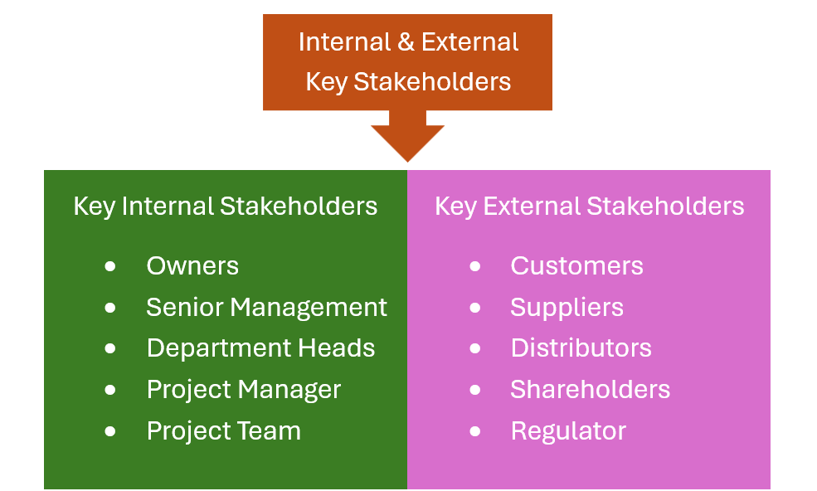
Figure 1: Internal & External Stakeholders (Adapted from Freeman, 2010).
Stakeholders are individuals, groups, or organisations that have an interest, concern, or stake in a project (Freeman, 2010). They can affect the project, be affected by the project, or a combination of both (Takagi & Varajão, 2020). As shown in Fig. 1, there are two groups of stakeholders: internal stakeholders and external stakeholders. Internal stakeholders are owner(s) and employees, teams within the organisation, such as Owner, Senior Management, Department Heads, Project Manager, Sales and Marketing, while external stakeholders are parties outside the organisation, such as customers, suppliers, distributors, shareholders, and regulators (Freeman, 2010)

Competing interests between organisations and stakeholders can lead to conflict, and organisations compete in markets that typically move towards stakeholder theory, which relies on several presumptions that explain how an organisation interacts with its surroundings. These presumptions include the following: organisations have relationships with a variety of stakeholders; top managers oversee businesses and achieve strategic equilibrium (Hillebrand et al., 2015).
It is a core responsibility of the Project Manager to identify key internal and external stakeholders and engage them, as their role is paramount for the successful launch of this new project (Fallah et al., 2024). The key internal stakeholders are those who have a direct impact on the company (Freeman, 2010).

Stakeholders Matrix
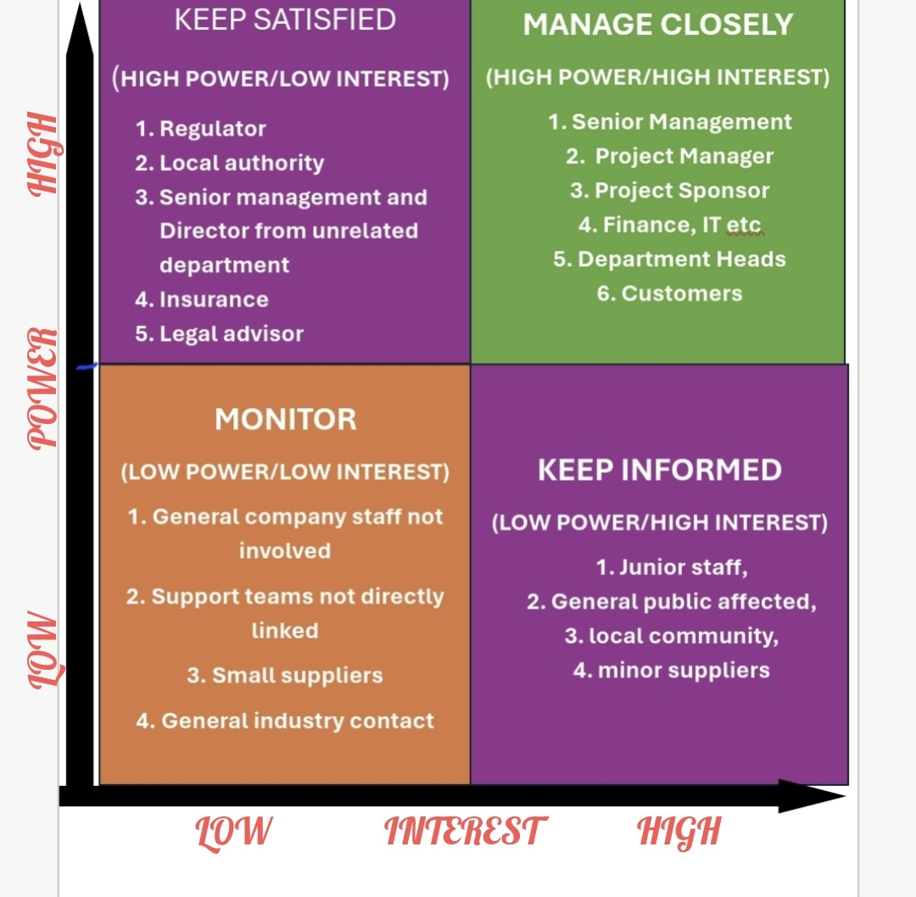

Fig (2) Adapted from: (Mendelow, 1981& PMI, 2017).
The stakeholders that have high power and low interest are the stakeholders that have significant authority over a project but are not actively involved in day-to-day activities, but need to be kept satisfied, such as internal stakeholders: Senior managers/Directors from unrelated departments, executive board not assigned as sponsor and external regulators, investors and Local authorities (PMI, 2017).
These groups of stakeholders are responsible for policy alignment, which involves collaborating closely with the UK Commission on both national digital infrastructure and economic goals; regulatory dialogue, which encompasses maintaining a well-structured engagement with the UK Competition and Markets Authority (CMA), which ensures that consumers are protected under the digital markets, competition and consumer Acts; the Information Commissioner Office (ICO) which regulates Data Protection Laws and electronic marketing rules; and the Advertising Standards Authority (ASA) that oversees honesty, transparency and rules pertaining to advertising in both online and digital space. In addition to the Department for Science, Innovation and Technology (DSIT), board oversight involves appointing non-executive directors responsible for overseeing regulatory relationships (International Trade Administration, 2026).
High-power, high-interest stakeholders should be consulted regularly, kept fully informed, and closely involved in key decisions to support the successful execution and management of the project (PMI, 2017). Internal stakeholders in this group include senior management, the project manager, the project sponsor, department heads, finance, and IT (Amazon.com, 2026). External stakeholders include major clients, customers, investors, and primary funders (Amazon.com, 2026). These stakeholders contribute to financial reporting by communicating financial performance, environmental compliance progress, and corporate social responsibility outcomes (Amazon.com, 2026). Amazon maintains ongoing dialogue with major stakeholders, such as its third-party sellers, affiliate programs, and regional e-commerce domains in Africa, Asia and Europe (Amazon.com, 2026).
There are stakeholders that have low power and high interest. They have no power to change major decisions alone, but they can help build support, keep them informed, and listen to concerns (PMI, 2017). Internal stakeholders include junior staff and staff who are indirectly involved, while external stakeholders include end users, the local community, the public, and minor suppliers (PMI, 2017). These stakeholders require internal workforce engagement; for example, a colleague feedback program, workshops, and focus groups will be rolled out across Amazon.com to elicit contributions from over 30,000 staff with the aim of shaping core corporate behaviours (Amazon.com, 2026).
Finally, stakeholders that have low power and low interest are updated occasionally and monitored only (PMI, 2017). Such internal stakeholders are general company staff that are not involved in the project and not direct support teams, and such external stakeholders are general industry contacts and small suppliers (Riahi, 2017). With these stakeholders, the focus is on customer and community relations building and engagement (Riahi, 2017). This will involve making billing structures very clear to reduce consumers' confusion with their bills (Amazon.com, 2026). It also involves empowering social media and community teams to seek amicable resolution of issues directly, whilst maintaining effective communication in cases where there is a local network outage (Amazon.com, 2026).
"Those who influence or affect, or are influenced or affected by, the corporation, but they are not engaged in transactions with the corporation and are not essential for its survival" is how Clarkson (1995: 107) characterises secondary stakeholders. Competition, the media, trade associations, and support groups (special interest) are examples of secondary stakeholder groups. These organisations can seriously disrupt the company even if they have no agreement or power with it, and the company does not depend on them to survive (Randel, 2009).
According to Winn (2001: 137), stakeholder groups are theoretically united by shared interests. However, stakeholder groups have subgroups and individuals who support multiple roles and have different interests, where "individuals wear different hats at different times." Additionally, Winn (2001) argues that it is useful to evaluate interactions between managers and stakeholders empirically to define stakeholder categories. Tullberg (2013) revises the debate over which groups should be included in the stakeholder concept. He acknowledges that having a stake in an organisation is a reasonable requirement for being a stakeholder and further suggests that those who have a stake within should be aware of what stakeholder’s need and desire to know. Stakeholders will lose credibility if they demand disclosure yet refuse to do so themselves. According to Mitchell et al. (1997), urgency, which is defined as the degree to which stakeholder claims need to be addressed right away, only arises when two circumstances are met: first, the claim must be time-sensitive, and second, the claim must be important to the stakeholder.

Swot Analysis
Identifying and evaluating internal strengths and weaknesses against external opportunities and threats is very crucial in this project (Kniazeva & Baskin, 2023). It is also important to identify the strengths and opportunities Amazon.com can leverage to achieve its objectives while mitigating or addressing internal weaknesses and external threats (Kniazeva & Baskin, 2023). SWOT analysis, as it is widely understood, is a method for considering the performance-enhancing and performance-inhibiting factors that Amazon.com faces in both its internal and external surroundings (Kniazeva & Baskin, 2023). Amazon.com has influence over both strengths and weaknesses, which are factors that either improve or hinder desired performance. Although these are thought to be outside of an organization's control, opportunities are enhancers, and threats are impediments to intended performance (Amazon.com).
Diagram of Swot Analysis
Fig. 3. Adapted from: (Kniazeva &amp; Baskin, 2023).
Strength
Amazon's strong financial position is attributed to significant growth and a broad product selection, providing a strong brand image despite not having the lowest prices. Key advantages include ongoing product and service expansion, such as Amazon Prime, offering features like free two-day delivery and unlimited streaming. The company is recognized for excellent customer service, bolstered by a robust network of sellers and a focus on consumer convenience. (Amiri, S. and Vida, V., 2023)
Weakness
Amazon's profit margin is relatively weak compared to competitors, influenced by rising shipping costs and counterfeit goods from third-party sellers, which have tarnished its reputation. Additionally, the company has not enhanced its mobile shopping experience, leading to a disparity in benefits for mobile users compared to competitors. (Amiri, S. and Vida, V., 2023)
Opportunity
Amazon is exploring expansion into Asian markets to drive growth, focusing on local customer needs and culturally adapted marketing strategies. Acquisitions like Twitch and Whole Foods may enhance market presence. Currently with three distribution centers, Amazon plans to leverage its physical stores for improved reach and same-day delivery, especially in grocery. Technological innovations, including drone delivery systems, are essential for maintaining competitiveness and fulfilling fast-paced consumer demands. (Amiri, S. and Vida, V., 2023)
Threat
The rapid growth of e-commerce has intensified competition for Amazon, especially from Walmart, which has enhanced its online services. Other competitors include eBay, Alibaba, and Flipkart, along with traditional retailers transitioning to e-commerce. Rising transportation costs and changing consumer preferences pose additional challenges; while younger shoppers increasingly favour online shopping, some consumers remain hesitant due to concerns about fraud and privacy. (Amiri, S. and Vida, V., 2023)
Internal attributes of the organization represent strengths and weaknesses, while external environmental attributes indicate opportunities and threats. Strengths and opportunities aid in achieving objectives, whereas weaknesses and threats hinder progress. (Teoli et al. 2024).

The Roles and Responsibilities of Key Stakeholders
The internal key stakeholders involved in this project are the Owner, Senior Management, Department heads, Project Manager, Project team and external key stakeholders are Customers, Suppliers, Distributors, Shareholders, and Regulator (Amazon.com, 2026). The collective roles and responsibilities of key stakeholders are the pivot on which the wheels of success rotate. Their dedication and commitment will enhance the expected success and objective achieved (Singh & Williams, 2021).

Key Internal Stakeholders
The roles of owners and shareholders are to provide capital to run the project and undertake the risk that comes with it. Their responsibilities include voting on key decisions, monitoring, holding leadership accountable, and receiving returns. Senior Management/Executives' roles include providing operational leadership and implementation, and their responsibilities include planning and executing tasks, leading teams, motivating teams, managing capital, and reporting to board members (Singh & Williams, 2021). Employees’ roles include using their skills and talent to complete tasks, being core operators, and delivering project results; their responsibilities include following company policies, delivering positive results, and supporting teamwork and sharing ideas that help achieve the project’s objectives (Singh & Williams, 2021).

Key External Stakeholders
The roles of Customers include being the primary source of revenue and market feedback about their perceptions and satisfaction, and their responsibilities include buying products and services, using them, generating feedback, and seeking improvement when and where necessary (Emmanuel & Priscilla, 2022). The roles of Government and Regulators include setting out the rules and overseeing compliance; their responsibilities include making sure laws are enforced, taxes are paid accurately, and public interests are protected (Pauna et al 2023). The roles of Suppliers include supplying materials used in the project and all that needs to be supplied to enhance the project, and their responsibilities include fair pricing, delivery, and complying with the signed contract (Ferreira et al 2024).
According to Bhatti & Durrani (2024), stakeholder duties must be addressed specifically under certain conditions. Otherwise, it would be impossible to respond to the crucial question: for example, do stakeholders have obligations to the focus enterprise that go beyond those set forth by law or contract, or to other stakeholders that go beyond those set forth by general moral and civic responsibilities? There are four broad kinds of situations where stakeholders have mutual and joint responsibilities: between the company and its stakeholders; among stakeholders themselves; and concerning common-pool resources (Shaukat et al., 2022). These obligations belong to morally upright individuals, interdependent actors, and citizens. A stakeholder must consider distributive equality and appropriate behaviour toward other stakeholders. Managers, owners, and other stakeholders are all subject to clear personal conduct guidelines. For instance, it serves no purpose for a consumer to mistreat a waitress. Nobody should act in an abusive manner. However, this regulation does not apply to a specific stakeholder position; rather, it is universal in nature. (Miller, 2022).

Stakeholder Engagement & Conflict Management Methods

Stakeholder Mapping
There are many stakeholders involved in the Amazon project; this makes it pertinent to recognise their respective motivations and understand their diversity, with a view to enhancing both collaboration and decision-making (Asana, 2025). The effective mapping of stakeholders, which begins by identifying the internal and external stakeholders, such as the government bodies, the community organisations, the industry representatives, coupled with the end users, is crucial to the success of the project because the interests of the various stakeholders need to be aligned and, most importantly, prioritised. The Power-Interest-Grid is an effective tool because of its characteristics such as visual illustrations of stakeholders' potential impact and involvement (Corazza et al., 2024).
Project managers use this tool to tailor communication frameworks and strategies, ensuring that salient stakeholders receive frequent updates and other stakeholders receive updates less frequently (Singh & William, 2021). The iterative component of this stakeholder identification offers the benefit of enhancing the mapping process because, by engaging with current stakeholders, the project manager can identify groups (essential to project success) that were previously overlooked (Singh & William, 2021). This stakeholder engagement approach is also adaptive and can respond to changes in the project and new developments. In addition, surveys and interviews can be used to elicit vital information regarding the requirements and expectations of the stakeholders. To better understand stakeholder relationships and improve stakeholder mapping, fostering successful engagement strategies in large-scale projects, it is important to incorporate visual aids, iterative identification, and focused assessment due to the relational dynamics within stakeholders (Ioanna et al., 2022).

Communication Plans
Throughout the project life-cycle, it is important to have an effective communication plan in place that allows information to be shared promptly and accurately amongst stakeholders, as well as addressing their requirements and expectations. Several tools and techniques can enhance stakeholder communication frameworks in projects, such as digital collaboration platforms that are secure, offer real-time updates, and promote transparency and active collaboration among stakeholders (Zwikael et al., 2023; Singh & William, 2021).
The project manager should ensure that communication timing aligns with stakeholders' interests, alongside regular updates on project milestones. This process, when performed weekly or monthly, can benefit the project by effectively communicating progress or changes to stakeholders (Freeman et al., 2025).
By contrast, adopting an informal communication approach, namely informal check-ins, may be more relevant for cases such as ongoing relationships or where new developments or issues emerge. In this regard, it becomes important for the project manager to choose communication channels, including emails, newsletters, virtual meetings or physical meetings. However, regardless of the communication channel adopted by the project manager, it is crucial that consideration is given to factors such as accessibility, preference, and the nature of the information being communicated (Freeman et al., 2025).
Recognising the importance of effective communication, the project manager needs to take into consideration the distinct nature of the respective stakeholders during the process of formulating, developing and implementing the communication framework. This is particularly important because whereas internal stakeholders may prefer detailed, comprehensive reports, this may not be the case with external stakeholders, who may prefer summaries with key development highlights. In this way, the project manager can understand the existing dynamics among stakeholders and prioritise the most effective communication channels, thereby building strong stakeholder relationships and improving project outcomes (Freeman et al., 2025).

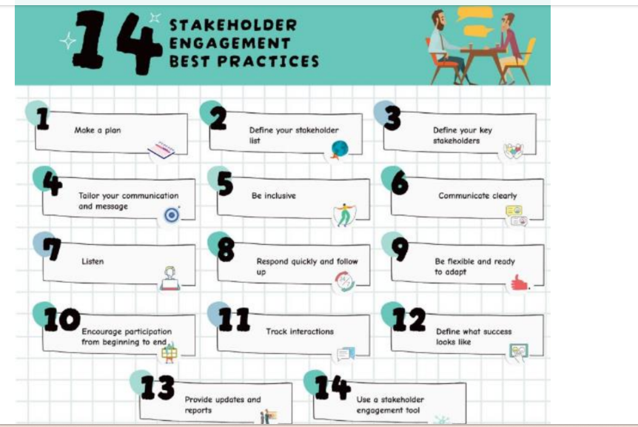Adapted from: Hassan et al. (2025).

Participation Models
Participation models, as the name suggests, include a range of strategies such as consultation, collaboration, empowerment, and co-creation that the project manager can adopt to effectively involve stakeholders in the project life cycle (Pellegrini & Lovati, 2025).
With the consultation method, the project manager invites stakeholders to share their insights regarding project plans, ensuring that structured meetings, surveys, or workshops enable stakeholders' viewpoints to contribute to informed decision-making. The consultation method is beneficial because it gathers important perspectives and fosters ownership among stakeholders (Freeman et al., 2025).
The consultation attribute is enhanced by collaboration because it positions the stakeholders not only as essential partners but also as shared decision-makers and resource contributors. By engaging stakeholders at this level, the project manager can leverage collective ideas and knowledge, coupled with co-developed solutions that address diverse interests, requirements, and expectations (Singh & Williams, 2021).
Empowerment strategies are important because they allow the project manager to focus on providing stakeholders with the tools and know-how needed for effective involvement, including training sessions that improve their understanding of critical issues (Bondinuba et al., 2025). Implementing empowerment strategies by the project manager has a multi-faceted benefit to the project because when stakeholders are empowered, they can contribute meaningfully to the project, amicably advocate for their requirements, and engage in collaborative efforts. To prioritise developing solutions with stakeholders instead of simply providing feedback requires implementing co-creation strategies. This encompasses ongoing dialogue that not only enables real-time adaptations based on stakeholder input but also fosters innovation through diverse perspectives whilst building and solidifying trust amongst the stakeholders. The project manager can strategically implement these participatory models to enhance stakeholder engagement, with a view to achieving the most preferred outcome for the project (Bondinuba et al., 2025).

Typology of stakeholder engagement strategies
 | Low complementary stakeholder engagement | High complementary stakeholder engagement
Low substitutionary stakeholder engagement | Minimalist stakeholder engagement strategy | Complementary stakeholder engagement strategy
High substitutionary stakeholder engagement | Substitutionary stakeholder engagement | Encompassing stakeholder engagement
Adapted From: Gupta et al. (2020).

Conflict Resolution Techniques
The resolution of conflicts in a project is imperative to successfully managing the relationships amongst stakeholders. This is due to the inevitability of conflicts in projects, which is regardless of size. In this regard, project managers should be proactive in adopting methods and strategies that are consistent with the dynamic uniqueness of the stakeholders involved in the project. To achieve this, project managers should adopt an approach that fosters open and transparent communication and creates accessible channels that recognise and give voice to stakeholders' concerns. By providing stakeholders with regular updates on project progress, the project manager can mitigate the risk of misunderstandings that could lead to conflicts, as emergent issues are quickly addressed through respectful interactions (Adham, 2023).
Disputes in projects can emerge from a plethora of avenues due to the complex diversity of the stakeholders, their interests and their priorities. Common examples of conflicts in projects include resource competition, communication breakdowns, and health and safety concerns (Hassan et al., 2025).
Another approach to conflict resolution is collaborative problem-solving, as its characteristics allow conflicting stakeholders to work together towards finding a solution. Additionally, placing emphasis on shared objectives can promote co-operation instead of rivalry. In many cases, the project manager can adopt negotiation and compromise techniques when a direct form of resolution, such as discussion, proves ineffective (Hassan et al. 2025).
To mitigate the risks of conflict, the project manager can articulate the requirements of the stakeholders whilst producing balanced resolutions that accommodate diverse viewpoints and acknowledge the flexibility of all stakeholder (Singh & William, 2021). In most cases, negotiations can fail, and this is where it becomes important for the project manager to involve a neutral third party as a mediator for conflict resolution. For this to be effective, a structured environment is imperative for the discussion to help the stakeholders voice their concerns whilst being in a position to pursue a mutual outcome that is beneficial to all stakeholders. However, when conflicts transcend the normal project resolution capacity, it is important that the project manager implements clearly defined escalation processes that allow issues to be escalated to either higher management or specialised teams, aimed at facilitating both swift and effective handling (IIIankoon et al., 2022).

Conclusions and Recommendations
The successful completion of projects is underscored by effective stakeholder engagement; as a result, it is imperative that a suitable communication and stakeholder engagement framework is formulated, designed and implemented in such a way that accommodates the unique dynamic relationships between the stakeholders whilst giving them a voice, listening to and addressing their concerns. Achieving desirable project outcomes requires the project manager to lead and manage the project stakeholders without overlooking the needs or expectations of the respective stakeholders. It thus becomes paramount that communication and stakeholder frameworks are designed transparently and tailored to the respective stakeholders, strengthening trust. In this regard, it is recommended that the stakeholder engagement framework include various dimensions such as strategic, ethical and practical. The stakeholder engagement framework should focus not only on the objectives but also on the activities and impact.
The proliferation of technological tools has provided project managers with improved and enhanced tools to manage stakeholder engagement in a way that accords flexibility in communication to all stakeholders. Digital platforms and social media provide stakeholders with a plethora of valuable tools that promote communication, enhance participation, and encourage feedback from diverse stakeholders. Accordingly, it is recommended that project managers integrate emerging technologies such as Artificial Intelligence (AI) and other innovative technologies into stakeholder engagement, since this will create an environment of seamless communication and stakeholder engagement.
The unique and dynamic relationship of stakeholders in the 21st Century requires project managers to examine more innovative ways of stakeholder engagement. In this regard, it is recommended that a comprehensive evaluation framework be developed. The comprehensive evaluation framework should be useful in assessing stakeholder engagement in a quantitative and qualitative manner.
Conclusively, it is suggested that the incorporation of these perspectives and recommendations into stakeholder engagement practices for the Amazon ConnectPlus project will serve to improve the resolution of conflicts, strengthen relationships and foster a conducive environment where open dialogue and mutual understanding are respected and accommodated.

References
Adham, T.K.I., 2023. Conflict resolution in team: Analyzing the of conflicts and best skills for resolution. Scholars Journal of Engineering and Technology, 11(08), pp.152-162.
Amazon.com, 2024. Investor Relations: Annual reports, proxies and shareholder letters [ONLINE] Available at: https://ir.aboutamazon.com/annual-reports-proxies-and-shareholder-letters/default.aspx [Accessed 05/08/2026]
Amazon.com, 2025. Annual Report 2025 [ONLINE] Available at: https://s2.q4cdn.com/299287126/files/doc_financials/2026/ar/Amazon-2025-Annual-Report.pdf [Accessed 05/08/2026].
Amazon.com, 2026. Amazon: About us [ONLINE] Available at: https://www.aboutamazon.co.uk/who-we-are [Accessed 05/08/2026].
Bhatti, M.B.A. and Durrani, M.K., 2024. The effect of project managers’ competencies on project success with mediating role of project stakeholders’ engagement: A case of IT sector. Journal of Management Info, 11(1), pp.51-73.
Bondinuba, F.K., Bondinuba, N., Mewomo, C.M., Camynta-Baezie, G. and Abudu, H.D., 2025. Building collaborative advantage: exploring innovative stakeholder engagement models for construction project success. International Journal of Construction Management, 25(16), pp.1879-1891.
Clarkson, M.E., 1995. A stakeholder framework for analyzing and evaluating corporate social performance. Academy of management review, 20(1), pp.92-117.
Corazza, L., Cottafava, D., Torchia, D. and Dhir, A., 2024. Interpreting stakeholder ecosystems through relational stakeholder theory: The case of a highly contested megaproject. Business strategy and the environment, 33(3), pp.2384-2412.
Emmanuel, B. and Priscilla, O.A., 2022. A review of corporate social responsibility and its relationship with customer satisfaction and corporate image. Open Journal of Business and Management, 10(2), pp.715-728.
Fallah, M.A., Agha Mohammad Ali Kermani, M., Moini, A. and Mashayekh, J., 2024. Identification and evaluation of collaborative relationships of internal project stakeholders: a social network analysis approach. Kybernetes, 53(10), pp.3621-3658.
Ferreira, M.D.A.V., Morgado, C.D.R.V. and Lins, M.P.E., 2024. Organizations and stakeholders’ roles and influence on implementing sustainability requirements in construction projects. Heliyon, 10(1).
Fiet, J.O., 2025. SWOT analysis. In The theoretical logic of strategy (pp. 157-158). Cham: Springer Nature Switzerland.
Amiri, S. and Vida, V., 2023. Analysis of marketing strategic issues at Amazon. SEA: Practical Application of Science, 11(31), p.3.
Freeman, R.E., 2010. Strategic management: A stakeholder approach. Cambridge University Press.
Freeman, R.E., Menghwar, P.S. and Grushka-Cockayne, Y., 2025. A stakeholder theory perspective for project management. International Journal of Project Management, p.102764.
Hassan, A., Mahomed, A. and Ebrahim, M., 2025. Stakeholder engagement and conflict management in mega projects: A systematic review and best practice framework [online]
Hillebrand, B., Driessen, P.H. and Koll, O., 2015. Stakeholder marketing: theoretical foundations and required capabilities. Journal of the Academy of Marketing Science, 43(4), pp.411-428.
Illankoon, I.M.C.S., Tam, V.W., Le, K.N. and Ranadewa, K.A.T.O., 2022. Causes of disputes, factors affecting dispute resolution and effective alternative dispute resolution for Sri Lankan construction industry. International Journal of Construction Management, 22(2), pp.218-228.
International Trade Administration, 2026. United Kingdom Country Commercial Guide [ONLINE] Available at: https://www.trade.gov/country-commercial-guides/united-kingdom-ecommerce [Accessed 05/08/2026].
Ioanna, N., Pipina, K., Despina, C., Ioannis, S. and Dionysis, A., 2022. Stakeholder mapping and analysis for climate change adaptation in Greece. Euro-Mediterranean Journal for Environmental Integration, 7(3), pp.339-346.
Jameson, L., 2025. Jacob Ward, Visions of a Digital Nation: Market and Monopoly in British Telecommunications Cambridge, MA: MIT Press, 2024. Pp. 344. ISBN 978-0-262-54629-4. The British Journal for the History of Science, 58(4), pp.748-750.
Kniazeva, M. and Baskin, E., 2023. Swot analysis. SAGE Publications, Inc.
Mendelow, A.L., 1981. Environmental scanning--the impact of the stakeholder concept.
Miller, G.J., 2022. Stakeholder roles in artificial intelligence projects. Project Leadership and Society, 3, p.100068.
Mitchell, R.K., Agle, B.R. and Wood, D.J., 1997. Toward a theory of stakeholder identification and salience: Defining the principle of who and what really counts. Academy of management review, 22(4), pp.853-886.
Mohammadi-Ghayeghchi, H., Bhagat, N., Campbell, M., Mayhew, M., Dufresne, R., Ewald, L., Devasahayam, A.J. and Mansfield, A., 2026. Are specific, measurable, action-oriented, realistic, and time-bound (SMART) goals associated with improved walking outcomes for stroke survivors undergoing outpatient stroke rehabilitation? An observational cross-sectional retrospective cohort study. Physiotherapy Canada, (aop), p.e20240098.
Nassauer, S., & McLain, S. 2026. Wall Street Journal: Amazon is now America’s biggest company. Its 17-year journey to surpass Walmart [ONLINE] Available at: https://www.wsj.com/business/retail/amazon-biggest-us-company-walmart-cfd0cac4 [Accessed 05/08/2026].
Odoom, R., Odoom, P.T., Amu, P.Y. and Adams, M., 2025. Sustainable digital marketing practices and consumer brand engagement–a brand reputation mediation investigation. Journal of Strategic Marketing, 33(2), pp.254-270.
Pauna, T., Lehtinen, J., Kujala, J. and Aaltonen, K., 2023. The role of governmental stakeholder engagement in the sustainability of industrial engineering projects. International Journal of Managing Projects in Business, 16(8), pp.77-99.
Pellegrini, G. and Lovati, C., 2025. Stakeholders’ engagement for improved health outcomes: a research brief to design a tool for better communication and participation. Frontiers in public health, 13, p.1536753.
Project Management Institute (PMI). (2017). A Guide to the Project Management Body of Knowledge (PMBOK Guide) (6th ed.).
Randel, A.E., Jaussi, K.S. and Standifird, S.S., 2009. Organizational responses to negative evaluation by external stakeholders: The role of organizational identity characteristics in organizational response formulation. Business & Society, 48(4), pp.438-466.
Riahi, Y., 2017. Project stakeholders: Analysis and management processes. International Journal of Economics and Management Studies, 4(3), pp.39-45.
Shaukat, M.B., Latif, K.F., Sajjad, A. and Eweje, G., 2022. Revisiting the relationship between sustainable project management and project success: The moderating role of stakeholder engagement and team building. Sustainable Development, 30(1), pp.58-75.
Singh, H. and Williams, P.S., 2021. A guide to the project management body of knowledge: Pmbok (®) guide. In Project management institute (pp. 1-8).
Takagi, N. and Varajão, J., 2020. Success management and the project management body of knowledge (PMBOK): An integrated perspective.
Teoli, D., Sanvictores, T. and An, J., 2024. SWOT Analysis. 2023 Sep 4. StatPearls [Internet]. Treasure Island (FL): StatPearls Publishing.
Tolossa, A.T., Singh, M. and Gautam, R.K., 2025. Bridging competitive advantage and sustainable development: the moderating role of value creation for stakeholders in Ethiopian SMEs. Business Strategy & Development, 8(1), p.e70066.
Tullberg, J., 2013. Stakeholder theory: Some revisionist suggestions. The Journal of Socio-Economics, 42, pp.127-135.
Winn, M.I., 2001. Building stakeholder theory with a decision modeling methodology. Business & Society, 40(2), pp.133-166.
Zwikael, O., Salmona, M., Meredith, J. and Zarghami, S.A., 2023. Enhancing project stakeholder communication under insufficient knowledge of project management concepts. Engineering, Construction and Architectural Management, 30(10), pp.5007-5029.

