Business Plan for

Gelato Fun
Ice cream truck and Carnival games


Produced By:

GROUP MEMBERS:
Student Name | Student No.
Madalina Duta | 2218871
Krystal Gardner | 2027750
Zomir Hussain Khan | 2209207
Roxana Mihaela Panainte | 2219073

Dated: 10/06/2024

Module Name: Entrepreneurship
Module Code: BMIH5001
Lecturer Name: Neil Dyer

CONTENTS

 |  |  |  | PAGE
1. | Executive Summary |  |  | ………2………
2. | The Business Idea |  |  | ………3……….
3. | The Team |  |  | ………3……….
4. | Market Research |  |  | ………7……….
5. | Marketing Plan |  |  | ………9…….
6. | Key Resources |  |  | ………10…….
7. | Finances & Start-Up Support |  |  | ………12…….
APPENDICES:
Appendix A |  |  |  | SWOT Analysis
Appendix B |  |  |  | PEST Analysis
Appendix C |  |  |  | Copy of Pitch Supporting Material
1. EXECUTIVE SUMMARY
Gelato Fun, situated in Bournemouth, England, offers a unique business strategy that blends the pleasure of gourmet gelato with the amusement of carnival-style games. This dual strategy not only distinguishes the company in a competitive market, but also appeals to a wide range of customers, from young families to health-conscious millennials. The executive summary describes the company's key offerings and strategic positioning, highlighting its novel blending of food and entertainment, which is consistent with consumer trends favouring experiential purchases. The company operates a mobile service that capitalises on Bournemouth's status as a tourist hotspot, increasing visibility and consumer reach by attending prominent local events and tourist-heavy sites. This mobility enables Gelato Fun to capitalise on peak traffic, increasing revenue prospects. The product line offers both traditional and unique gelato flavours that cater to a wide range of tastes and nutritional preferences, including vegan and gluten-free alternatives. This not only addresses the growing desire for healthier, artisanal food options, but it also benefits the local supply chain by promoting sustainability and providing fresh ingredients that improve product quality. Gelato Fun expects a robust first year, with significant revenue from direct sales and expanding services such as catering. Initial funds and capital expenditures are directed towards acquiring high-quality equipment and materials required for gelato manufacture and mobile service setup. Strategic connections with local suppliers, as well as digital marketing initiatives, are critical components of the company's growth and customer interaction strategy. In conclusion, Gelato Fun's business plan illustrates a well-thought-out approach for providing a unique blend of products and experiences that are in line with current market trends and consumer preferences. The company's agility and emphasis on quality and client experience are expected to propel it forward in Bournemouth's lively market.

2. THE BUSINESS IDEA

2.1 The Product/Service
Gelato Fun is conveniently placed in Bournemouth, England's south coast resort known for its beautiful beaches and sunny weather (BCP, 2023). Gelato Fun, a mobile food service and entertainment company that delivers gourmet gelato and funfair games, would work well here. An outdoor ice cream company would thrive in Bournemouth, one of the UK's sunniest cities with comfortable temperatures and more sunny hours than most of the country. Gelato Fun operates best around the town's busy seashore, gardens, and summer events (Burns, 2022). Gelato Fun offers vegan and gluten-free gelato in a selection of high-quality, homemade flavours.

Value proposition
Gelato Fun provides a distinct combination of artisan gelato and family-friendly funfair games. Our mobile service, designed to thrill both tourists and locals, elevates the coastal experience by mixing excellent, locally sourced gelato with engaging, prize-winning activities, making each visit memorable (Osterwalder et al., 2015).

2.2 SWOT Analysis Summary
Gelato Fun offers high-quality gelato and funfair games using locally sourced ingredients, catering to health-conscious and eco-friendly clients. Operating in Bournemouth, the business's mobile nature allows it to target high-traffic regions and events (BCP, 2023). However, the industry relies on favourable weather and managing both food and entertainment services can strain resources (Mintel, 2024). Opportunities include expanding gaming options, cooperating with local businesses, and catering to private events. Threats include competition, economic uncertainty, regulatory changes, and market saturation if competitors imitate the business model (Nelson, 2013).

3. THE TEAM

3.1 Key Personnel
Name and Company Position: Roxana Mihaela Panainte, Co-founder and Operations management

Skills and Experience:
- pursuing International Hotel Management
- problem-solving
- adaptability
- attention to detail through simulated operations.

Role and Responsibilities:
- Handles daily operations and serves clients.
- Ensures service delivery meets hospitality standards.
- Her leadership, critical thinking, and organisational abilities guarantee efficiency and excellent customer service.

Name and Company Position: Madalina Duta, Marketing and Public Relationships manager
Skills and Experience:
- communication skills
- creativity
- critical thinking

Role and Responsibilities:

- marketing initiatives
- effectively promote Gelato Fun across several channels
- maintains consistent brand messaging.

Name and Company Position: Krystal Gardner, Financial Coordinator

Skills and Experience:
- manage budgets
- financial analysis
- financial operations
- analytical abilities
- ethical judgement.
Role and Responsibilities:
- Manages budgeting, financial forecasting, spending and revenues.
- Ensures business profitability and financial health.
- Utilizes numerical expertise and ethical considerations.
- Utilizes real-world financial expertise for efficient, accurate financial tasks.

Name and Company Position: Zomir Hussain Khan, Entertainment and Customer Experience Manager

Skills and Experience:
- event management training
- experience working as a supervisor at several hotels.
- team leadership
- operational management
- customer service
Role and Responsibilities:
- Manages entertainment section, including selection, setup, and management of carnival-themed games.
- Ensures events are enjoyable, safe, and engaging.
- Manages customer engagement, from greeting to game explanation.

3.2 Skills Gaps & Key Partners

3.2.1 Additional Staff Requirements (Roles and Responsibilities):
Ice cream Selling Associate full time:
- Responsible for customer service, transaction processing, and maintaining cleanliness.
- Supports main business by providing fast, friendly service.
- Allows co-founders to focus on operational and strategic tasks.
- Receives product knowledge training to answer client queries.

3.2.2 Training and Development:

Food Safety and Hygiene Certificate Training
- All staff involved in food handling must complete Level 2 Food Safety & Hygiene Certificate course (CIEH, n.d.).
- Training delivered by certified providers accredited by CIEH.
- Course can be completed online for convenience.
- Covers foundations of food safety: proper handling, preparation, and storage.
- Essential for maintaining high hygiene standards.

Allergen Awareness Training
- Delivered via specialized programs by Allergy Training Consultancy or approved platforms by FSA (FSA, n.d.).
- Online training, lasting 2 to 3 hours, equips food-handling employees to manage allergen information.
- Aims to ensure client safety and health compliance.

3.2.3 Outsourced Support / Key Partners:

- Harvest Fine Foods is well-known for providing a wide range of high-quality products designed specifically for restaurant service. Based in the neighbourhood, their accessibility and extensive product line make them a perfect partner for procuring fresh, high-quality ingredients required for premium gelato production. They have a large assortment of dairy ingredients and fresh fruits, which are both essential for gelato manufacture. Their dependable delivery service ensures that ingredients are always fresh and ready (Harvest Fine Foods, n.d.). Prices will vary depending on the individual ingredients and amounts needed, however working with a local source like Harvest Fine Foods usually results in competitive pricing due to lower transportation costs (Richman and Roddick, 2013).
- Fun & Games Ltd. is a regional supplier renowned for its extensive selection of funfair and arcade games. Their proximity to Bournemouth, as well as their extensive inventory, make them an ideal partner for obtaining and maintaining Gelato Fun's gaming aspect. (Fun and Games, n.d.). They can provide, install and manage a wide range of funfair games, from traditional ring tosses to more modern digital games appropriate for all ages. Their service includes ongoing maintenance and updates to ensure safety and functionality. The costs vary according on the difficulty of the games. However, leasing solutions may be available to reduce initial expenses, with maintenance built into the lease agreements.

4. MARKET RESEARCH

4.1 Market Information, Trends and External Factors
Gelato Fun in Bournemouth has significant potential due to strong tourism, evolving consumer behaviours, and market demands. The local economy contributes to the region's economy, with 6.88 million visitors each year and a total spending of £501 million (National Coast Tourism Academy, n.d.). Gelato Fun can capitalize on this by offering a unique nightlife experience that combines gelato with interactive activities. Consumers are increasingly seeking experiences over basic goods consumption, and Gelato Fun can capitalize on this by offering immersive experiences. The local government's incentives and regulatory focus on food safety boost consumer trust (Bournemouth Tourism Strategy, 2023). The economic growth of 6.88 million tourists and the growing demand for healthier, artisanal food complement Gelato Fun's vegan and low-sugar options. Technologically, leveraging digital marketing, mobile POS systems, and new gelato-making equipment provides operational efficiency and a distinct customer experience (Mintel, 2024).

4.2 Customer Profiles

Young families and parents(25-34 years old)
This category consists of active ice cream users, with a high frequency of consumption associated with having children in the home. This population values quality and is more likely to enjoy ice cream as a family pleasure (Mintel, 2024). Gelato Fun's blend of high-quality, artisan gelato and fun, family-friendly activities appeals to young families seeking delightful experiences to share with their children.

Tourists and locals (broad range)
Bournemouth attracts a large number of tourists, especially during the summer. Tourists often seek out unique, local experiences and indulgences during their stay. Gelato Fun, which incorporates interactive games into classic ice cream trucks, has the potential to capitalise on tourists' need for unusual and memorable dining experiences (Bournemouth, n.d.).

Health Conscious Millennials (16-34 years old)
This demographic is particularly interested in novel and healthier dietary options. They are more inclined to seek out products that support a healthy lifestyle, such as low-sugar or vegan ice cream (Mintel, 2024). Gelato Fun can appeal to health-conscious millennials by providing a variety of gelato options, including those made with plant-based milk and lower sugar content. This demographic, which values sustainability, and ethical consumerism is likely to appreciate the company's commitment to quality and use of fresh, local foods.

4.3 Competitor Profiles
- Competing with established ice cream suppliers like Sprinkles Gelato, Giggi Gelateria and The Ice Cream Kiosk in Bournemouth.
- Sprinkles Gelato offers diverse flavors and high-quality Italian gelato, but lacks low-sugar or vegan options (Sprinkles Gelato, n.d..
- Gelato Fun can differentiate itself by offering unique vegan and low-sugar alternatives and leveraging its mobility (Barringer and Ireland, 2018).
- Giggi Gelateria, known for its authentic Italian gelato experience, lacks flexibility in menu innovation (Trip Advisor, n.d.).
- Gelato Fun can enhance customer experience by introducing novel local and seasonal flavors and interactive games.
- The Ice Cream Kiosk on Bournemouth Beach targets beachgoers but lacks quality, handcrafted items(Bournemouth Pier, n.d.).

USP
Gelato Fun offers a unique blend of gelato and interactive funfair games, enhancing consumer engagement and making it a popular destination for families and young adults (Henthorne, George and Miller, 2016). The company uses fresh, locally sourced ingredients, promoting health-conscious consumers and supporting local agriculture. Gelato Fun's movable nature allows for geographical flexibility, maximizing visibility and customer reach during peak tourist seasons. This approach capitalizes on the growing trend of experiential consumerism, ensuring customers appreciate memorable experiences alongside high-quality products (Blakeman, 2023).

5. MARKETING PLAN

5.1 Price
Gelato Fun uses a premium pricing strategy to reflect its high-quality offerings and the unique experiential value it provides to clients in Bournemouth. This pricing strategy elevates Gelato Fun somewhat above other ice cream providers, indicating a quality product that warrants a premium price (Ali and Anwar, 2021). Gelato costs begin at £3.00 for classic flavours and £4.50 for specialised variants, indicating the use of fresh, locally sourced ingredients and artisanal preparation methods.

5.2 Product
Gelato Fun offers a unique gelato experience with an interactive atmosphere. The handcrafted gelato is presented in visually appealing servings, matching the brand's playful character and vibrant color palette (Williams, 2021). Each meal is served in cones or paper cups with colorful graphics, reflecting the brand's emphasis on pleasure and excellence. Gelato Fun offers classic and inventive flavors, catering to both conventional tastes and those seeking new gastronomic experiences. Carnival-style games stimulate family and community participation, adding a new dimension to the gelato-eating experience. The truck's vivid appearance, uniforms, and marketing materials reflect the brand's enthusiastic and welcoming spirit.

5.3 Placement
Gelato Fun uses both physical and online strategies to reach a diverse customer base. The mobile truck is the main sales location, visiting popular public spaces for high foot traffic (Nelson, 2013). The company also expands its market reach through a website and social media platforms, enabling direct consumer engagement and serving as marketing assets (Kuester, Konya-Baumbach and Schuhmacher, 2018).

5.4 Promotion
Gelato Fun will use a comprehensive marketing strategy that combines digital and traditional advertising methods. Social media platforms will be used to engage the target audience with high-quality content, videos, and interactive customer experiences (Chaffey and Ellis-Chadwick, 2019). Branded hashtags and user-generated content will increase organic reach and consumer engagement. Collaborations with local influencers will increase visibility. Online advertising will be targeted using Google Ads and Facebook Ads, driving traffic to the website and social media (Bala and Verma, 2018). The website will serve as the heart, offering a comprehensive menu, truck location updates, and online ordering. Email marketing will keep customers engaged with exclusive deals and feedback questionnaires. Traditional advertising strategies, such as fliers, radio commercials and posters, will increase foot traffic and provide information about Gelato Fun's offers. A loyalty program will encourage repeat business and foster strong customer relationships (Kotler et al., 2018)..

6. KEY RESOURCES
- Utilizes a well-equipped gelato truck for quality and safety.
- Features branding and graphics to attract customers.
- Uses high-quality equipment like pasteurizers and display cabinets (Duong, 2021).
- Supports local businesses and freshens ingredients.
- Combines gelato with carnival-style games.
- Access Self Storage provides safe local storage solutions (Carpigiani, n.d.).
- Custom Concessions designed an arcade trailer for an inviting atmosphere and multiple games (Custom Concessions, n.d.).

6.1 Premises
- Gelato truck serves as the main physical venue, serving as both sales and production point (Nelson, 2013).
- The truck must have refrigeration units, serving counters, and storage compartments for quality and safety.
- An arcade trailer will be added for interactive space and improved client experience.
- Renting a business property is recommended for administrative and inventory storage.
- A viable choice is a 545 sq ft retail unit at 715 Christchurch Road, Boscombe, Bournemouth, costing £6,500 per year (Nettleship Sawyer, 2023).

6.2 Equipment
- Vevor commercial gelato machine (£1,500) for quick production and consistency (Vevor, n.d.).
- High-quality pasteurizer (£1,500) for health and safety (Taylor UK, 2023).
- Well-lit display case (£1,000-£3,000) (Modalita, n.d.).
- Proper storage containers, scoops, and spatulas.
- Stainless steel containers and utensils (£100-£500) recommended (Modalita, n.d.).

6.3 Key Suppliers
Gelato Fun relies on three key suppliers: Baboo Gelato, Joe Delucci's Gelato, and Lollipop Gelato Lab. Baboo Gelato specializes in handmade gelato made with seasonal fruit and local organic milk, offering natural, intense flavors (Baboo Gelato, n.d.). Joe Delucci's Gelato offers a diverse range of wholesale gelato flavors, including vegan and dietary options (Joe Delucci's Gelato, 2023). Lollipop Gelato Lab, with 30 years of experience, offers unique, authentic gelato flavors combining classic Italian processes with new inventions. Their local presence ensures prompt deliveries and fresh products (TripAdvisor, 2024).

7. FINANCES AND START-UP SUPPORT

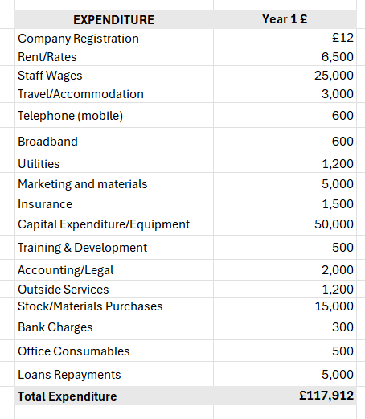
INCOME | Year 1  £
Sales A | 94,000
Sales B | 31,500
Sales C | 5,000
Capital Introduced | 20,000
Funding | 0
Loans/Borrowing | 30,000
Total Income | £ 180,500

YEAR ONE PROFIT/LOSS | £
Total Income | 180,500
Total Expenditure | 117,912
Profit/Loss | £
 | 62,588

7.1 Financial Summary
Gelato Fun's financial estimates for the first year are £190,500 in income and £117,912 in expenditure, resulting in a net profit of £72,588. Major expenses include rent and staff wages (Nettleship Sawyer, 2023). Capital expenditures include £50,000 for the gelato truck and apparatus, while marketing costs are £5,000. Income sources include daily gelato sales, catering services, and goods sales. Also, additional funding sources include £20,000 in cash provided by the founders and £30,000 in loans obtained through government backed Start Up Loans and the Recovery Loan Scheme, both of which offer favourable conditions to fledgling firms (GOV.UK, 2021).

APPENDICES

Appendix A – SWOT Analysis

Strengths | Weaknesses
- Gelato Fun's unique combination of high-quality gelato and funfair games sets it apart from traditional ice cream sellers or food trucks (Williams, 2021).  - Making handcrafted gelato from locally sourced ingredients assures a premium product that will appeal to health-conscious and environmentally sensitive customers.  - Operating in Bournemouth, which has one of the warmest climates in the UK, allows for an extended season of ice cream sales compared to other parts of the country (BCP, 2023).  - The ability to relocate places allows the company to target high-traffic areas, events, and festivals, hence increasing sales prospects. | - Relying heavily on good weather, rainy or abnormally chilly days can have a substantial influence on sales.  - Managing both a food and entertainment service adds to operational complexity and may put a strain on available resources (Zimmerer and Scarborough, 2011)..  - Despite the location's seasonal benefits, the business is likely to endure off-peak seasons throughout the colder months (Burns, 2022).  - The movable nature of the business limits the quantity of merchandise and equipment that can be carried, which may limit sales volume at peak times.
Opportunities | Threats
- Introducing new gaming options and expanding the range of gelato flavours can help to maintain interest and attract repeat customers (Rae, 2008).  - Working with local businesses, schools, and event organisers can provide new avenues for sales and promotion (Blackwell, 2011).  - Offering services for private parties, business events, and weddings will help diversify the revenue streams.  - Creating themed promos for holidays and local festivals can increase sales and brand visibility. | - Threats include competition from other ice cream vendors and entertainment businesses in Bournemouth (BCP, 2023).  - Economic uncertainty may limit discretionary spending on leisure activities such as dining out and entertainment (Jochem et al., 2017).  - Any changes to street vending rules, health regulations, or food safety standards may have an impact on operational procedures.  - As the concept gains popularity, there is a risk that additional entrants may duplicate the business model, leading to market saturation.

Appendix B – PEST Analysis

Political | Bournemouth's local government provides small businesses with numerous incentives, making it an appealing site for new entrepreneurs. The UK government's stable political environment and policies that promote small enterprises, such as lower corporation tax rates and incentives, benefit start-ups. Furthermore, the regulatory focus on food safety and cleanliness assures high standards, which will help Gelato Fun by increasing consumer trust and safety (BCP, n.d)..
Economic | Bournemouth's tourism business brings in around 6.88 million people each year, spending around £501 million (BCP, 2023). This flood of tourists, particularly during the summer, provides a steady consumer base for Gelato Fun. Furthermore, despite economic uncertainty, the trend towards experiential spending remains strong, with consumers willing to spend on unique, high-quality leisure experiences, which bodes well for Gelato Fun's business model, which combines gelato and entertainment (Mintel, 2024).
Social | Consumers, especially millennials and young families, are increasingly seeking healthier and more artisanal food options. Gelato Fun's offerings, which include vegan and low-sugar gelato, appeal to this group. The emphasis on local, fresh ingredients attracts not just to health-conscious consumers, but also to local farmers and producers, in line with the growing social trend towards sustainability and ethical consumption (Mintel, 2024).
Technological | Gelato Fun can use digital marketing and social media platforms to engage customers, promote services, and obtain feedback at a lower cost. Technologies like mobile point-of-sale (POS) systems improve operational efficiency and customer service (Chaffey and Elis-Chadwick, 2019). Furthermore, adopting sophisticated gelato-making equipment provides continuous product quality and food safety compliance. The incorporation of LED lighting and digital game equipment in the arcade trailer provides customers with a modern, engaging experience, distinguishing Gelato Fun from typical ice cream vendors.

Appendix C – Copy of Pitch Supporting Material

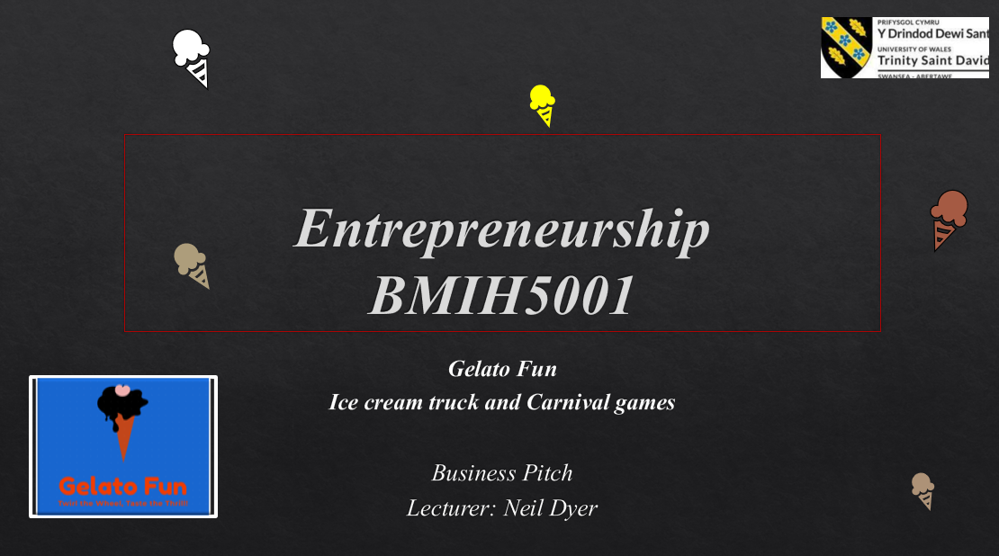

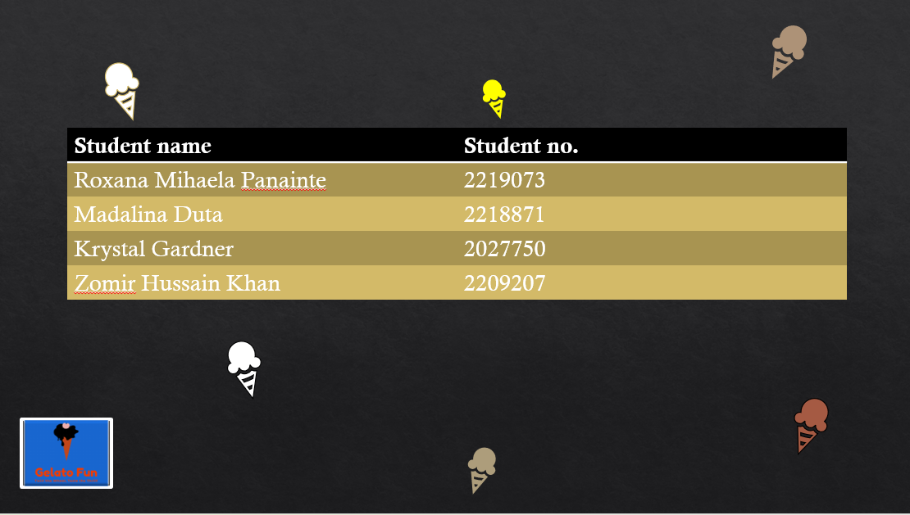
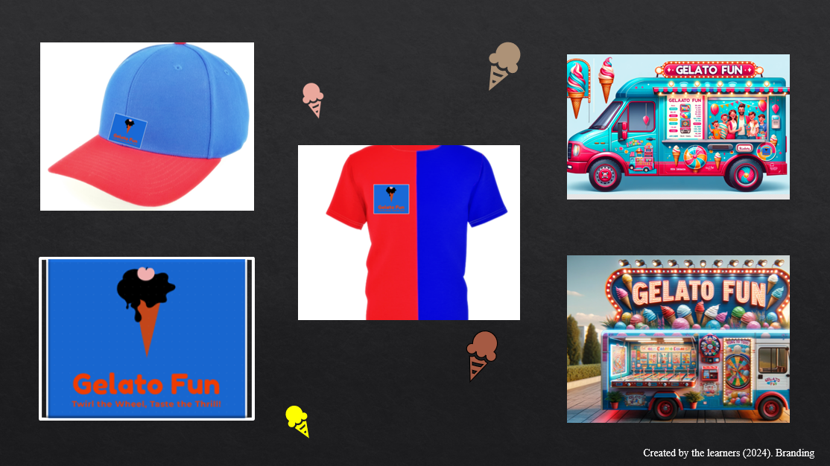
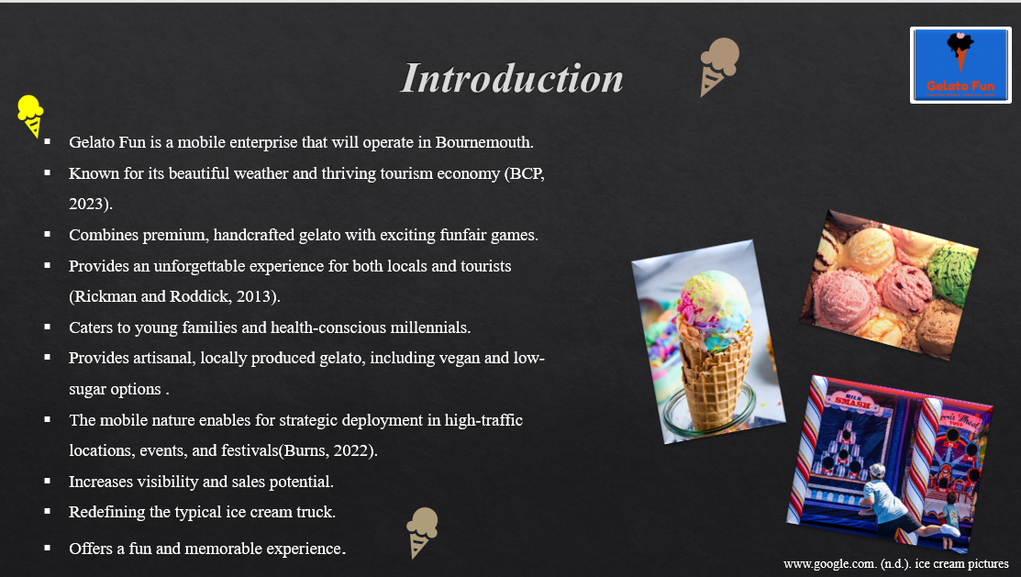
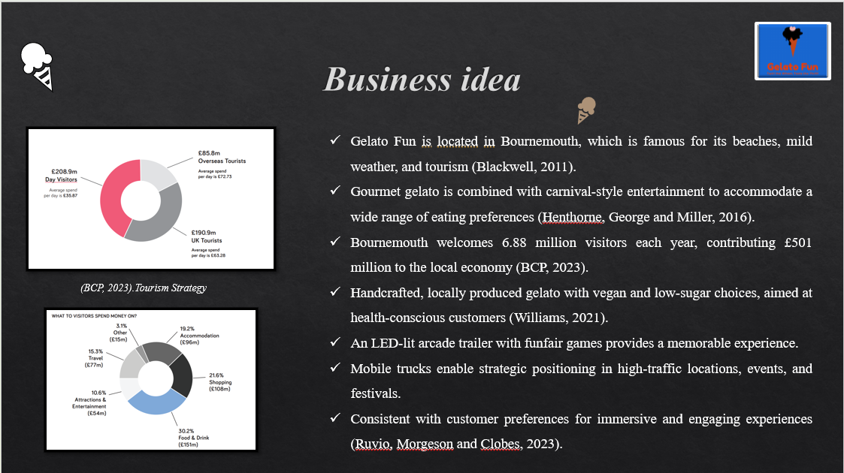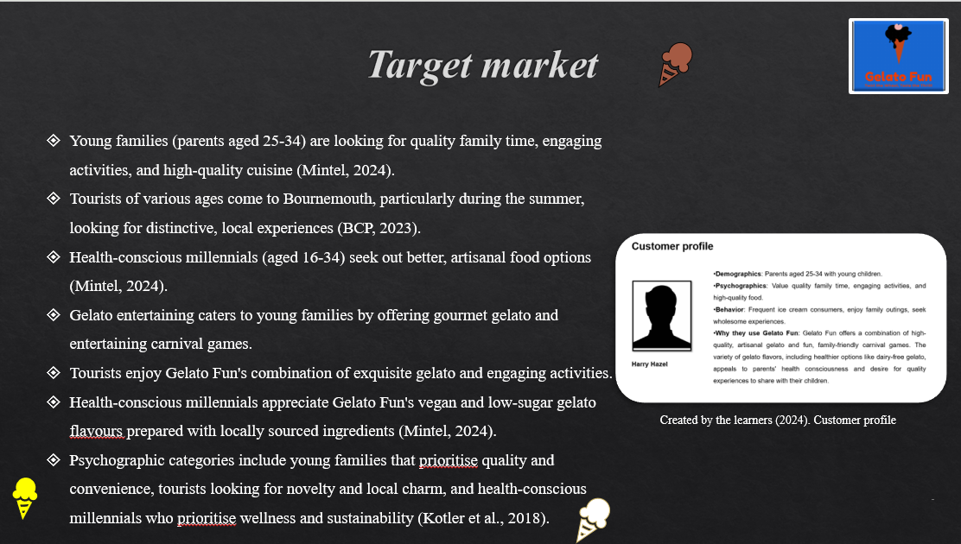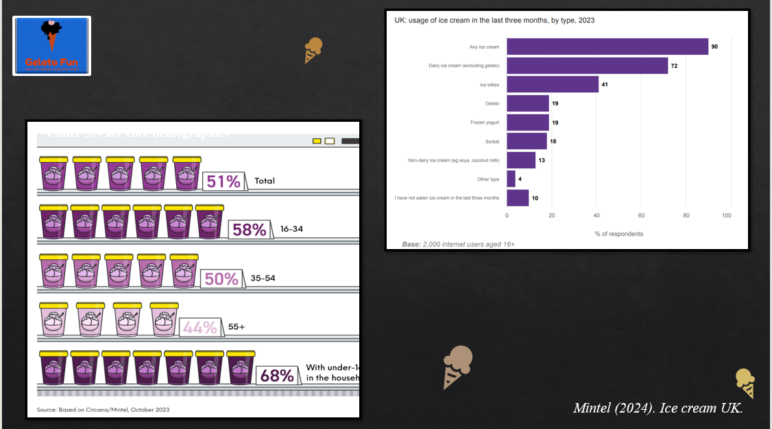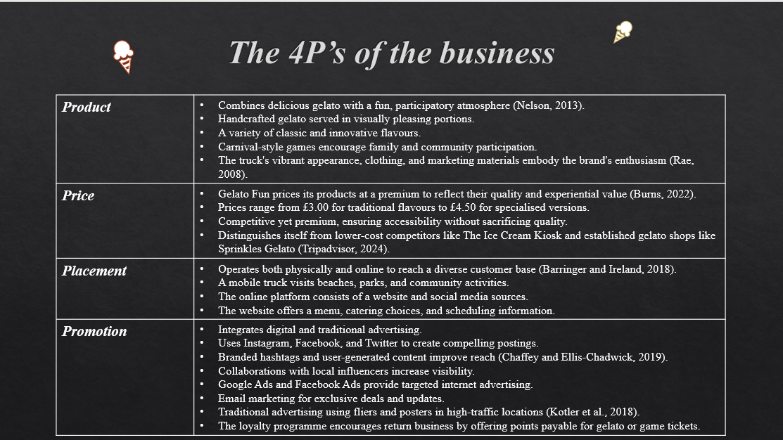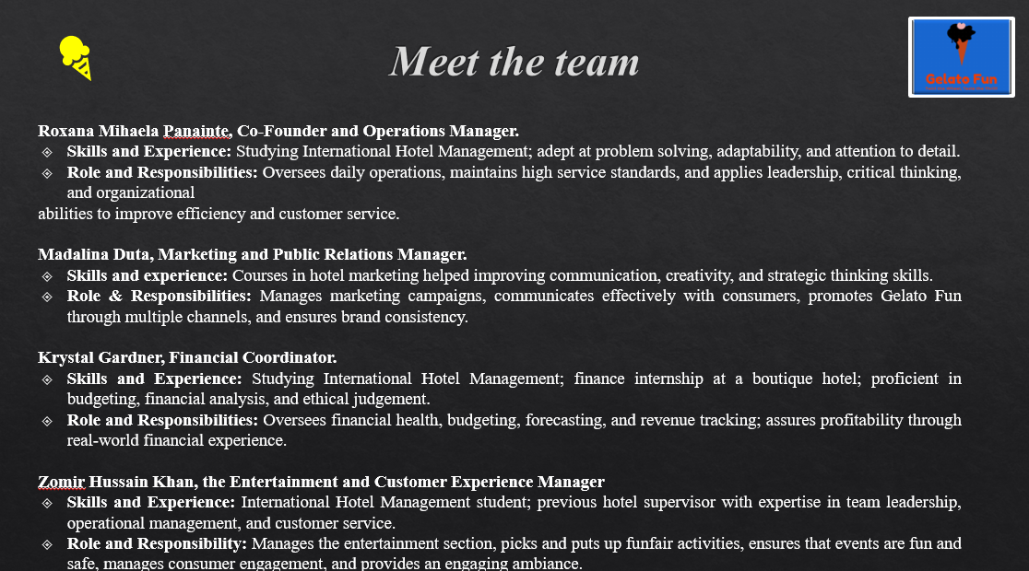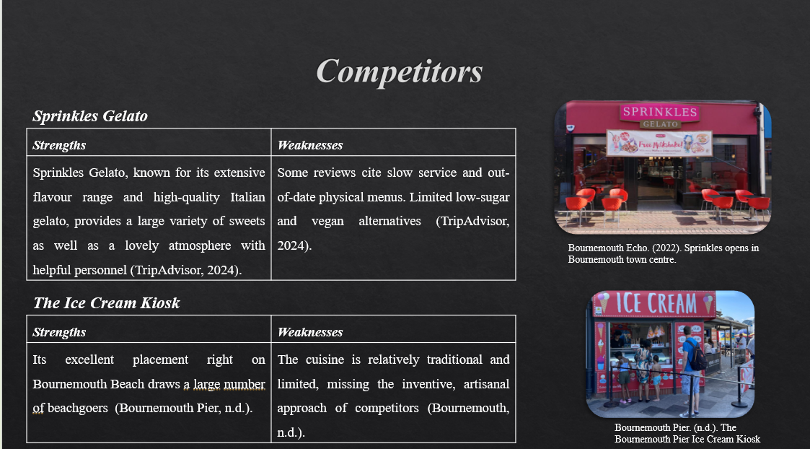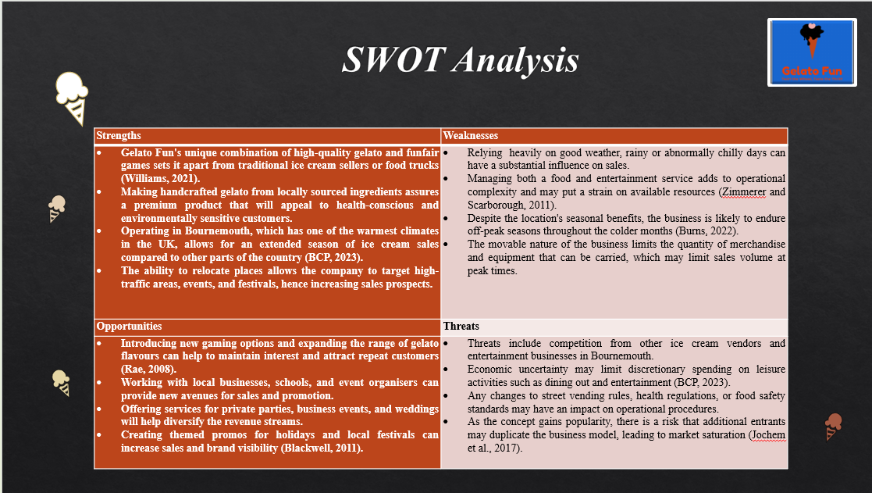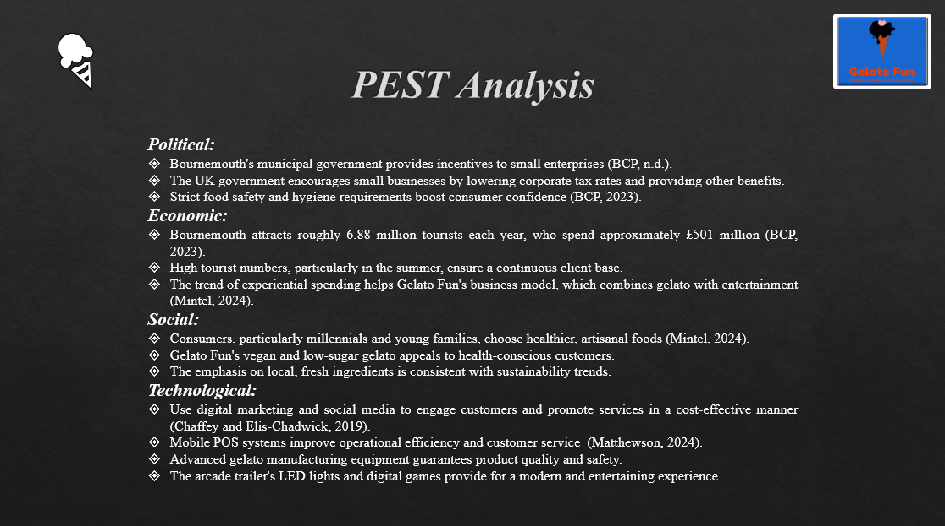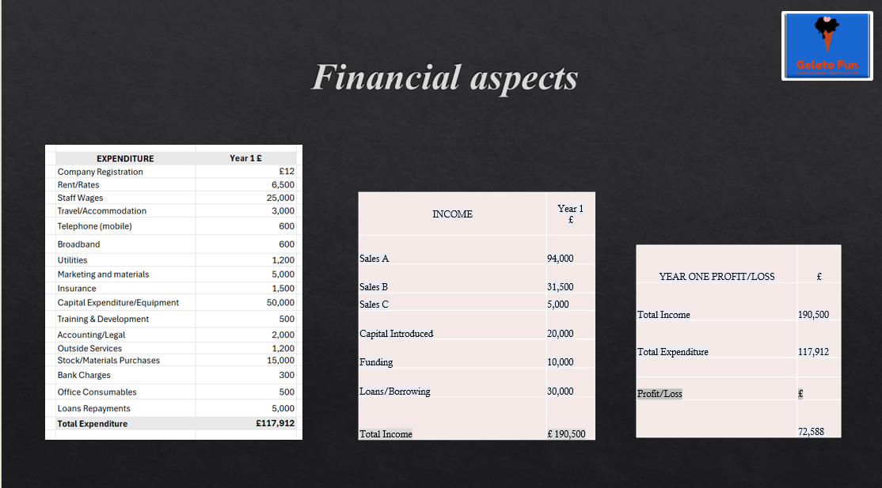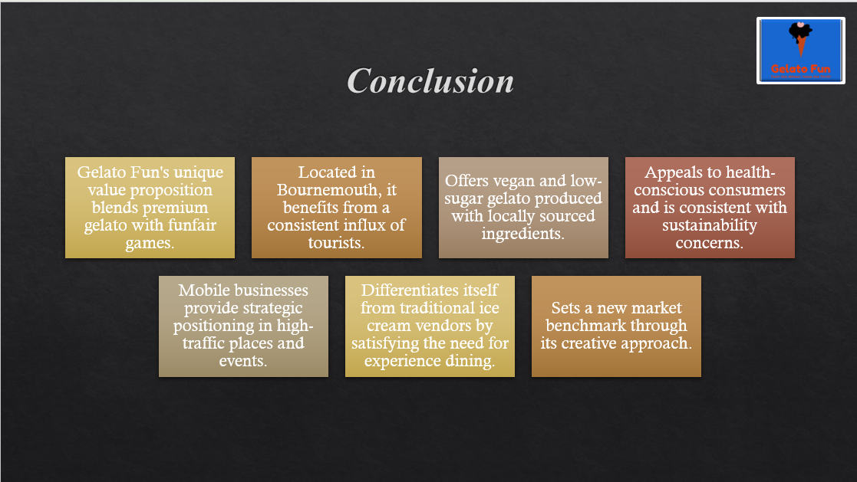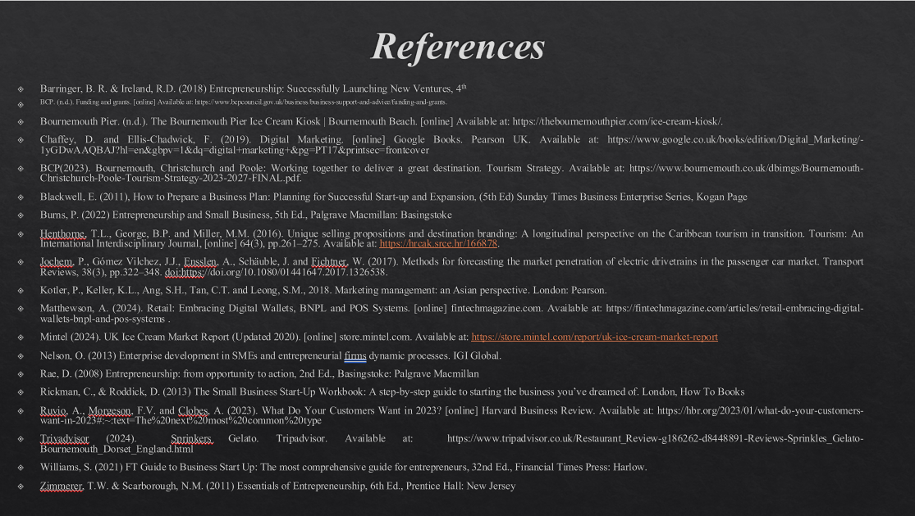
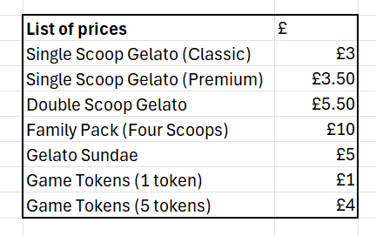

Employees Branded T-shirts and cap


Created by the learner (2024).

The Ice cream truck and trailer





REFERENCE LIST:

Ali, B.J. and Anwar, G. (2021). Marketing Strategy: Pricing Strategies and Its Influence on Consumer Purchasing Decision. [online] papers.ssrn.com. Available at: https://papers.ssrn.com/sol3/papers.cfm?abstract_id=3837579.

Bala, M. and Verma, D. (2018). A Critical Review of Digital Marketing. [online] SSRN. Available at: https://papers.ssrn.com/sol3/papers.cfm?abstract_id=3545505.

Baboo Gelato. (n.d.). Baboo Gelato | Award Winning Artisanal Ice Cream – West Dorset. [online] Available at: https://baboogelato.com/
‌Barringer, B. R. & Ireland, R.D. (2018) Entrepreneurship: Successfully Launching New Ventures, 4th Ed., Prentice Hall: New Jersey
BCP(2023). Bournemouth, Christchurch and Poole: Working together to deliver a great destination. Tourism Strategy. Available at: https://www.bournemouth.co.uk/dbimgs/Bournemouth-Christchurch-Poole-Tourism-Strategy-2023-2027-FINAL.pdf.

Blakeman, R. (2023). Integrated Marketing Communication: Creative Strategy from Idea to Implementation. [online] Google Books. Rowman & Littlefield. Available at: https://www.google.co.uk/books/edition/Integrated_Marketing_Communication/tPDIEAAAQBAJ?hl=en&gbpv=1&dq=unique+selling+proposition+brand+communication&pg=PP1&printsec=frontcover

Blackwell, E. (2011), How to Prepare a Business Plan: Planning for Successful Start-up and Expansion, (5th Ed) Sunday Times Business Enterprise Series, Kogan Page

Bournemouth. (n.d.). Shaping the Future: The new Bournemouth, Christchurch, and Poole Accommodation Business Improvement District (BCP ABID). [online] Available at: https://www.bournemouth.co.uk/ideas-and-inspiration/news/2024/5/14/bcpabidyesvote-a2650

Bournemouth Pier. (n.d.). The Bournemouth Pier Ice Cream Kiosk | Bournemouth Beach. [online] Available at: https://thebournemouthpier.com/ice-cream-kiosk/.

Bornemouth Tourism Strategy (2023). Bournemouth, Christchurch and Poole: Working together to deliver a great destination. Available at: https://www.bournemouth.co.uk/dbimgs/Bournemouth-Christchurch-Poole-Tourism-Strategy-2023-2027-FINAL.pdf.

Burns, P. (2022) Entrepreneurship and Small Business, 5th Ed., Palgrave Macmillan: Basingstoke

Carpigiani (n.d.). Commercial Gelato and Soft Ice Cream Machines. [online] Available at: https://www.carpigiani.co.uk/news/commercial-gelato-soft-ice-cream-machines

CIEH. (n.d.). Food safety | CIEH training programmes. [online] Available at: https://www.cieh.org/training-and-courses/work-based-training/food-safety/.

Chaffey, D. and Ellis-Chadwick, F. (2019). Digital Marketing. [online] Google Books. Pearson UK. Available at: https://www.google.co.uk/books/edition/Digital_Marketing/-1yGDwAAQBAJ?hl=en&gbpv=1&dq=digital+marketing&pg=PT17&printsec=frontcover.

Custom Concessions. (n.d.). Why Choose Custom Concessions? [online] Available at: https://www.customconcessions.com/why-choose-custom-concessions-food-truck-builder-concession-vending-trailers-for-sale/

Duong, L., 2021. Food truck company business plan in Vaasa.

FSA (n.d.). Food Standards Agency food allergy online training. [online] Available at: https://allergytraining.food.gov.uk/.

Fun & Games. (n.d.). Shop. [online] Available at: https://www.fun-and-games.co.uk/

Gov.uk (2021). Recovery Loan Scheme. [online] GOV.UK. Available at: https://www.gov.uk/guidance/recovery-loan-scheme.

Harvest Fine Foods (n.d.). Home | Harvest Fine Foods. [online] Available at: https://www.harvestfinefoods.co.uk/.

Henthorne, T.L., George, B.P. and Miller, M.M. (2016). Unique selling propositions and destination branding: A longitudinal perspective on the Caribbean tourism in transition. Tourism: An International Interdisciplinary Journal, [online] 64(3), pp.261–275. Available at: https://hrcak.srce.hr/166878.

Jochem, P., Gómez Vilchez, J.J., Ensslen, A., Schäuble, J. and Fichtner, W. (2017). Methods for forecasting the market penetration of electric drivetrains in the passenger car market. Transport Reviews, 38(3), pp.322–348. doi:https://doi.org/10.1080/01441647.2017.1326538

Joe Deluccis Gelatto (2023). Joe Delucci’s Gelato | Remarkable Italian Ice Cream. [online] Available at: https://joedeluccis.com/

Kotler, P., Keller, K.L., Ang, S.H., Tan, C.T. and Leong, S.M., 2018. Marketing management: an Asian perspective. London: Pearson.

Kuester, S., Konya-Baumbach, E. and Schuhmacher, M.C. (2018). Get the show on the road: Go-to-market strategies for e-innovations of start-ups. Journal of Business Research, 83, pp.65–81. doi:https://doi.org/10.1016/j.jbusres.2017.09.037.

Mintel (2024). UK Ice Cream Market Report (Updated 2020). [online] store.mintel.com. Available at: https://store.mintel.com/report/uk-ice-cream-market-report

MODALITA. (n.d.). Gelato Machines, Foodservice Equipment, Restaurant Design. [online] Available at: https://www.modalita.com/

National Coast Tourism Academy (n.d.). Facts and Figures about Bournemouth’s Visitors Business Development. Available at: https://coastaltourismacademy.co.uk/uploads/Bournemouth_Facts_and_Figures_pages1.pdf.

Nelson, O. (2013) Enterprise development in SMEs and entrepreneurial firms dynamic processes. IGI Global.

Nettleship Sawyer (n.d.). 715 Christchurch Road, Boscombe, Bournemouth, BH7 6AF | Nettleship Sawyer. [online] Available at: https://www.nettleshipsawyer.co.uk/properties-715-christchurch-rd

Osterwalder, A., Pigneur, Y., Bernarda, G. and Smith, A. (2015). Value Proposition Design: How to Create Products and Services Customers Want. [online] Google Books. John Wiley & Sons. Available at: https://www.google.co.uk/books/edition/Value_Proposition_Design/jgu5BAAAQBAJ?hl=en&gbpv=1&dq=value+proposition&pg=PA22&printsec=frontcover

Panwar, T. and Khan, K. (2020). Ingredient Branding: A Differentiation Strategy for the Commoditized World. Paradigm, 24(2), p.097189072095953. doi:https://doi.org/10.1177/0971890720959539.

Prospects (n.d.). Sales jobs | Prospects.ac.uk. [online] Available at: https://www.prospects.ac.uk/jobs-and-work-experience/job-sectors/sales/sales-jobs.

Rae, D. (2008) Entrepreneurship: from opportunity to action, 2nd Ed., Basingstoke: Palgrave Macmillan

Rickman, C., & Roddick, D. (2013) The Small Business Start-Up Workbook: A step-by-step guide to starting the business you’ve dreamed of. London, How To Books

Sprinkles Gelato(n.d.). Welcome to Sprinkles. [online] Available at: https://sprinklesgelato.co.uk/.

Taylor UK. (2023). Ice Cream Pasteuriser Machine | Gelato Pasteuriser. [online] Available at: https://www.taylor-company.co.uk/product-details/gelato/pasteurisers-heaters/.

Tripadvisor (2024). Giggi Gelateria Italian ice cream. Available at: https://www.tripadvisor.co.uk/Restaurant_Review-g190727-d4481375-Reviews-Giggi_Gelateria_Italian_ice_cream-Poole_Dorset_England.html

TripAdvisor (2024). Lollipop Gelato Lab. Available at: https://www.tripadvisor.co.uk/Restaurant_Review-g186262-d10469838-Reviews-Lollipop_Gelato_Lab-Bournemouth_Dorset_England.html

Vevor. (n.d.). VEVOR VEVOR Commercial Soft Ice Cream Machine 2200W Countertop Soft Ice Cream Machine 5.3 to 7.4 Gallons per Hour Ice Cream Machine for Restaurants Bars Cafes Bakeries | VEVOR UK. [online] Available at: https://uk.vevor.com/soft-serve-ice-cream-machines-c_10720/2200w-commercial-soft-ice-cream-machine-3-flavors-2-6l-ice-cream-maker-220v-p_010631467812
‌Williams, S. (2021) FT Guide to Business Start Up: The most comprehensive guide for entrepreneurs, 32nd Ed., Financial Times Press: Harlow.
Zimmerer, T.W. & Scarborough, N.M. (2011) Essentials of Entrepreneurship, 6th Ed., Prentice Hall: New Jersey
‌

