ASSESSMENT 1
HUMAN RESOURCE MANAGEMENT
SUBMITTED TO THE
UNIVERSITY OF WALES TRINITY SAINT
DAVID
IN PARTIAL FULFILLMENT OF THE REQUIREMENT
FOR THE AWARD OF THE
MASTER OF BUSINESS ADMINISTRATION
PROGRAM
BY
ALVIN SHAJU
(Student id:2214849)
UNDER THE GUIDANCE OF
Mr. Mushfiqur Rahman
(Associate professor)

UNIVERSITY OF WALES TRINITY SAINT
DAVID LONDON
ENGLAND, UNITED KINGDOM
2022-2023

Executive Summary
This report contains the labour market in the UK. This study says current situation and the reason behind situation and the condition of the HRM in the UK. The analysis of the situation contains in the report also. It involves the changing condition of the labour market in the UK. This report also includes a deep analysis of the effects of Covid-19 pandemic and Brexit on the large organizations and international businesses in the UK market and their responses to strategic changes within organizational boundaries. The core pandemic effects and Brexit impacts such as lower productivity, poor employee engagement, supply chain disruption and massive restriction on the business have been discussed as the key background of this report. Similarly, the major strategic changes by the HR departments including responding to logistic demands, business model change and increasing technological investments have been described as the major findings of this report.
Table of Contents
1.0 Introduction 5
1.1 scope and significance of the study…………………………………………………………………………………………………5
1.2 Research methodology…………………………………………………………………………………………………………………..5
1.3 Nature of the study ……………………………………………………………………………………………………………………….5
1.4 Area of the study ……………………………………………………………………………………………………………………..……5
1.5 period of study ……………………………………………………………………………………………………………………………..5
1.6 statistical tool………………………………………………………………………………………………………………………………..6
2.0 The current state of the labor market in the UK 7
2.1 Statistics ongoing 7
2.2 Factors affecting 7
2.3 Reason for the current state 9
3.0 The emerging changes in Human Resourcing Strategies 10
3.1 The changes in Post-Covid 10
3.2 The changes in the post-Brexit external environment 13
4.0 Conclusion 15
Aligning Personal experience for illustrating final thought 15
References 17

Table of figures

Figure 1: Employment rate in the united kingdom from march 1971 to October 2022………….9
Figure 2: Changing in the business model of Tesla Inc……………………………....................12

1.0 Introduction
Every organization has human resource management for managing employees. Generally, this management is creating, ensures, and supports a healthy and positive workplace for the employees (Adp.com, 2022). This report study includes the Current state of the labour market in the UK and the statics of the market, those factors affecting the market, and an analysis of the reason. This report also contains the emerging chances in human resourcing strategies after post covid, post-Brexit, and the external environment. This report says the current situation of human resource management in the UK.
1.1 Objectives
- To analyse the current state of the labor market in the UK
- To know about the emerging changes in human resourcing strategies in the post covid, post-Brexit and external environment.
1.2 Scope and significance of the study.
- To find out the current labor market in UK.
- To know about the human resourcing strategies after post covid.
- To know about the changes taking place after post Brexit.
- A detailed understanding about external environment in post Brexit
1.3 Research Methodology.
Research methodology is the specific procedure or technique used to identify, select, process
and analyse the topic. In a research paper, the methodology section allows the reader
critically evaluate a study’s overall validity and reliability.

1.4 Nature of the Study.
The type of study takes place through different areas like research papers, referencing etc.

1.5 Area of the Study.
The area of study was taken place at the online library of the university of wales trinity saint David

1.6 Period of study
The period of study was 10 weeks.

1.7 Statistical tool
Graph diagram :- A visual representation of the relationship between two quantities, particularly one that uses proportional areas, bars, or lines to indicate how one quantity affects or changes in relation to another. An equation or mathematical function represented as a curve or line, usually in a Cartesian coordinate system.

2.0 The current state of the labor market in the UK.
The UK labour market has seen numerous important changes since the end of World War II. Particularly, we have observed a drop in manufacturing occupations requiring full-time manual labour and an increase in labour market flexibility. There are more people working in self-employment, part-time work, and zero hour contracts than ever before, increasing the diversity of the labour market.

2.1 Statistics ongoing
The current labour market of any country is defined by the statics of the employment and unemployment rate of the country. This recent year the current rate of employment from June to August 2022 is 75.5%, which is lower than the previous quarter (Ons.gov.uk, 2022). This percentage is likely unchanged from the previous quarter. However, this is a good percentage after the pandemic has gone from the chest of the globe. The status of the "job opening" has been steady in recent times and increased (Uschamber.com, 2022). Moreover, in 2021 employers in the UK ended with 3.8 million jobs to the unemployed. However, at the same time, millions of employees are resigned all over the USA (Uschamber.com, 2022). Multiple companies like Rio Tinto, Unilever, and the pharma companies are giving a reasonable contribution to the employment rate in the UK. Most of the people suggest that it is a tight labour market in the reputation of the UK. Many knowledgeable people assumed that this situation would soften till the year 2023 (Oxfordeconomics.com, 2022). As compared to peak job opening is slowing down however the person says that it is higher than before the pandemic (Nerdwallet.com, 2022). Therefore, lastly, the situation in the UK labour market is in a tight situation and the UK is overcoming it.

2.2 Factors affecting
The factor that affects the UK labour market is discussed in the following. There are many factors affect the situation however these are the major ones.
- Labour supply and the demand
The UK govt. cannot supply the demand for labour as compared to before the pandemic however, the job rate is slightly high before this situation. This affects the jobs that are in the higher position in the UK government. The UK govt. are not getting sufficient labor for these positions (Tmc.ac.uk,2022).
- Regenerating economic
There is a place where the government has invested money for creating jobs for the employees. The construction in Manchester has helped to create and gain a percentage of the job (Tmc. ac. UK, 2022).
- Initiative in the education and training program
Moreover, in the UK organizations are investing in the training program and in the development of dedication also that helps to have 3 million apprentices in recent years (Tmc.ac.uk, 2022).
- Minimum wage legislation
This means the money that the workers should get from the works organizations. The govt. of the UK has passed the "Nation Living Wage (NLW)" for workers aged 25 and over that also leave a great impact on the labor market of the UK.
Population in the work
This refers to the number of people that work in the UK that is around 33.6 million. This not only affects the labor market but also school leaving, retirement, and many others (Tmc.ac.uk, 2022).
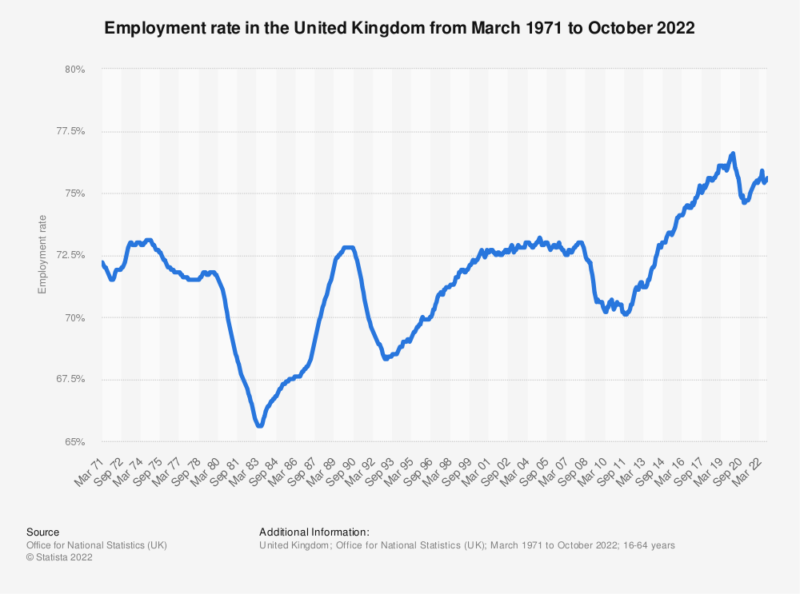
Figure 1: Employment rate
(Source: Statista.com, 2022)

2.3 Reason for the current state
There are various reasons for the factor affecting the labour market in the UK. The main reason for the recent situation in the UK is covid 19 pandemic. The Covid has made the restriction on the increase of jobs in the UK. As can be seen in Figure 1 the employment rate is in the same situation from the year 2020 (Statista.com, 2022). However, the person is saying that employment will increase from the next year that is a good thing for the unemployed in the UK (Statista.com, 2022). They should also increase the wages that are necessary for the employee. The employment rate is in stable condition the main reason for this is construction going on in Manchester (Economist.com, 2022).

3.0 The emerging changes in Human Resourcing Strategies
Human resource strategies drive entire organizational performance and business activities to achieve higher production, increased profitability and long-term sustainability within business boundaries. As criticized by Flynn et al. (2020), assessing business capacity, forecasting requirements, developing talent procedures and evaluating organizational performance are the major HR strategies in large businesses in the global market. However, some key drivers such as the Covid-19 pandemic and Brexit have influenced the decision-making, strategies processes and business processes of HR managers in the UK market. For instance, strategic changes enabled Tesco Plc, Unilever Inc, Morrisons and Tesla Inc to address the core strategic issues such as identifying customer characteristics, target market locations, lower traffic and emerging pedestrian and raw material shortage during Covid-19 pandemic (Roper and Turner, 2020). Apart from this, these giant retail sectors also encountered some effective issues such as business vulnerability, economic instability, talent reduction and poor employee engagement during Brexit in the UK market. Therefore, the HR departments of this large organization and giant business implemented some basic strategic changes and implementation after these significant events in the UK market catering to business opportunities and business advantages smoothly.

3.1 The changes in Post-Covid
Covid-19 pandemic has influenced every sector including education, business and administration harmfully from diverse angles and resulted in a decreased economy continuously in the UK market. As per the IBI (Integrated Benefits Institute) report, this pandemic could cost employees about 23 billion pounds due to getting infected (De Lyon and Dhingra, 2020). Therefore, the HR departments of large business organizations and multinational companies implemented some key strategic changes after this pandemic as mentioned in this section.
- Investing in innovation
The government of the UK enforced strict restrictions and lockdowns along with other countries' governments in terms of making the wider spread of Covid-19 within the country's premises creating both beneficial and harmful effects for businesses and organizations. In this emerging situation, human resource managers focused on innovation in internal organizational performance and workplace techniques in terms of reducing employee engagement issues, lack of resources and poor business culture in the Post-Covid situation. For example, the managers of Tesla Inc increased its investment by 70 million pounds in lowering its burn rate in 2022 in the UK market (Brown and Cowling, 2021). This innovation enabled the employees and managers to develop workplace conditions and management activities smoothly.
- Taking businesses online
Large organizations and businesses transformed thyroid business activities such as product and service offerings, customer engagement with brands, marketing campaigns and brand awareness programs online in the Post-Covid situation. In this way, organizational businesses promote their businesses aligning with regulatory bodies and government guidelines in terms of increasing customer boundaries and organizational productivity smoothly. As mentioned by Colak et al. (2022), the HR managers of Unilever Plc drive revenue growth, consumer traffic, conversion and employee engagement after the pandemic situation to make their retail businesses more effective and profitable.
- Responding to logistic demands
This strategic change addresses the marketing demands and consumer needs as per changing situations and marketing conditions due to the massive effects of the Covid-19 pandemic on the UK's economy and business environment. By changing this strategy, human resource managers make the business process and marketing responsibilities easier and quicker by making products and services available online and easily accessible remotely (Amankwah-Amoah et al. 2021). In this context, Amazon Inc changed its shipment and delivery strategy to a faster customer reaches approach. This strategic change enabled this company to achieve a higher sales rate in the Post-Covid situation in the UK market.

- Business model change
Covid-19 enabled businesses to experience new practices and strategic applications through diverse angles in the global market. Organizations adopted creative, easily adaptive and resilient business models in terms of gaining momentum within the business uncertainty and challenging situations of Covid-19 (Buil-Gil et al. 2019).
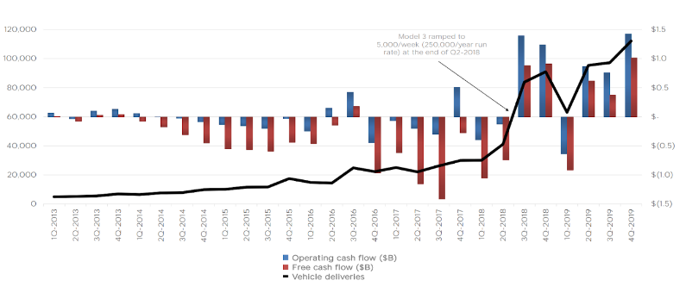
Figure 2: Changing in the business model of Tesla Inc
(Source: Forbes.com, 2022)
Human resource managers focused on transforming their current business models into more realistic and advanced approaches ensuring better employee safety of health and workplace development within organizational chains. For instance, Tesco Plc adopted a new business model based on focusing on monetary values, loyalty programs, fast delivery of products and services, utilizing retail media and promoting tech-enabled stores within the UK market. These strategic changes helped the managers and leaders of this retail sector to re-engage its skilled employees, increase customer retention and develop profitability in the Post-Covid situation.

3.2 The changes in the post-Brexit external environment
The exit of Britain for Brexit is also a significant driver of HR strategic changes in the highly competitive business environment internationally. As stated by Du and Shepotylo (2022), this political event created some significant issues and challenges enforcing human resource managers to accept and implement changes within their operations procedures and business performance activities. Economic uncertainty, depressed investment, lower productivity and talent division are some major effects of this political event on the businesses and large organizations in the UK market, which led the HR managers to implement strategic changes in the Post-Brexit situation.
- Supply chain management of Brexit delays
Brexit or the separation of the UK from the European Union led to lower employee engagement and poor productivity and disrupted the supply chain of businesses in the UK market catering to organizational barriers and growth issues. In this context, the human resource managers of large companies adopted supply chain promotion and reduced the factors resulting in supply chain delays (Bloom et al. 2019). The HR department of Tesla Inc utilized artificial intelligence, machine learning and advanced technologies to ensure better supply chain management and employee performance within the supply chain boundary. The HR managers focused on tracking the lead times of suppliers, increasing safety stocks, identifying project risks and optimizing inventory to develop the supply chain disruption and production issues.
- Increasing technological investment
Technologically advanced and modern techniques have achieved significant marketing success in every business field and department in this modern technological era. EazyStock is an effective optimization tool that supports making product and service stock available even in critical situations and marketing conditions (De Lyon and Dhingra, 2021). For example, Unilever Plc increased its in\venstent in developing its technological infrastructure and strategic approaches in managing larger employee and consumer circles smoothly in the Post-Brexit condition in the UK market. However, this strategic change also enabled businesses to bridge the employee lack gap that occurred due to Brexit. By using this strategy, human resource managers ensured better productivity and service quality through the ultimate efforts and practices of fewer employee and staff circles.
- Forecasting the volatility and uncertainty demand of businesses
The situational demands and marketing status determine the business uncertainty and effectiveness within the highly competitive business environment after Brexit in the UK market. In this condition, Crowley et al. (2019) argued that the human resource managers and leaders of large businesses focus on indicating a regular monthly forecast of business transactions and marketing performance in terms of identifying the business volatility and uncertainty engineering larger consumer circles and customer efforts eighth brands. The UK's government is also part scripted in making the business environment change through investing in technological development and boosting the country's economy in the Post-Brexit condition in the UK market. In this way, managers and leaders of large organizations and businesses accept changes within their strategic activities and decision-making performances in the UK market.
- Changing the ways of countering workforce risks
Risks and workplace issues are the major barriers to organizational growth and business suitability that affect the entire supply chain and working infrastructure deeply from diverse angles. Cultural conflicts, poor business environment, reduced employee efforts, economic uncertainty and market volatility are some major issues and challenges that influenced the business and organizational performance in the UK market. Therefore, human resource managers and leaders applied the Scientific Management theory to make their management way change in the Post-Brexit condition in the UK market. As mentioned by Sindakis and Aggarwal (2022), these strategic changes and response ways of HR managers enabled larger businesses to ensure increased productivity and sustainability within the organizational supply chain and business boundary. This management theory works on some specific calculations and scientific formulas to address critical management issues and challenges reducing their effects on workplace performance and effectiveness.

4.0 Conclusion
The overall report study concludes that labour maker in the UK is in a tight situation. However, this situation will overcome in the next year. The reason behind this situation is very genuine and sustainable. According to the knowledgeable, the human resourcing strategies will have to change and the external condition of the UK will help in the labour market change. Brexit also helps UK's local employees to get a reasonable job within the UK. This study also concludes the increasing employment in the chest of the UK. The overall study states that the UK will be in the peak position in its history.

Aligning Personal experience for illustrating final thought
Covid-19 pandemic and Brexit are two significant drivers influencing the entire labour market, business environments and marketing practices within the UK market. I have observed the current situation and emerging trends in the UK labour market through deep analysis and discussion based on evidence. I have also experienced the trends and emerging factors such as technological integration, Gig worker's opportunities, healthcare options and pivot workers, Gig economy within this market enables the worker's smooth performance. Apart from this, labour supply and demand, regenerative economy, education initiatives, training programs, and working population are the major factors affecting the current labour market of the UK. As per my personal experience, I have identified the needs and requirements for strategic changes of the HR managers and leaders after Covid-19 pandemic. Lower productivity, poor employee engagement, supply chain disruption and massive restriction are the key factors, which enabled human resource managers of large businesses to implement strategic change smoothly. Investing in innovation, changing business models and responding to logic demands are the major changes that the HR department implemented in the Post-Covid situation in the UK market. These strategic changes not only enabled the businesses to develop their organizational infrastructure but assisted to improve employee engagement and business effectiveness entire the business chain.
Similarly, some significant factors such as talent division, lower employee engagement, reduced production, business volatility and emerging economy influenced the HR managers to make strategic changes in the Post-Brexit situation in the highly competitive business environment. In this condition, supply chain management, increasing technological investment, forecasting business uncertainty and marketing volatility and the ways of encountering workplace issues are the major strategic changes that large organizations focused on after the UK's exit from the European Union. As per my personal experience, I can say that both Brexit and Covid-19 have influenced the business environment and marketing chain from diverse angles by disrupting their working infrastructure entirely in the UK market.

References

Adp.com, 2022. Human resource management (HRM) [Online] Available at: https://www.adp.com/resources/articles-and-insights/articles/h/human-resource-management.aspx [Accessed on: 30th December 2022]
Amankwah-Amoah, J., Khan, Z. and Wood, G., 2021. COVID-19 and business failures: The paradoxes of experience, scale, and scope for theory and practice. European Management Journal, 39(2), pp.179-184. DOI: https://doi.org/10.1016%25656568
Bloom, N., Bunn, P., Chen, S., Mizen, P., Smietanka, P. and Thwaites, G., 2019. The impact of Brexit on UK firms (No. w26218). National Bureau of Economic Research. DOI: https://doi.org/10.10168984948
Brown, R. and Cowling, M., 2021. The geographical impact of the Covid-19 crisis on precautionary savings, firm survival and jobs: Evidence from the United Kingdom’s 100 largest towns and cities. International small business journal, 39(4), pp.319-329. DOI: https://doi.org/10.1016%28889
Buil-Gil, D., Miró-Llinares, F., Moneva, A., Kemp, S. and Díaz-Castaño, N., 2021. Cybercrime and shifts in opportunities during COVID-19: a preliminary analysis in the UK. European Societies, 23(sup1), pp.S47-S59. DOI: https://doi.org/DEDFF
Colak, O., Enoch, M. and Morton, C., 2022. Airport business models and the COVID-19 pandemic: An exploration of the UK case study. Journal of Air Transport Management, p.102337. DOI: https://doi.org/10.1016%2Fjhfdf
Crowley, M., Exton, O. and Han, L., 2019. The impact of Brexit uncertainty on UK exports. London: VOX. DOI: https://doi.org/10.GGDSGDY855
De Lyon, J. and Dhingra, S., 2021. The impacts of Covid-19 and Brexit on the UK economy: early evidence in 2021. London: Centre for Economic Performance, London School of Economics and Political Science.
De Lyon, J. and Dhingra, S., 2021. The impacts of Covid-19 and Brexit on the UK economy: early evidence in 2021. London: Centre for Economic Performance, London School of Economics and Political Science.
Du, J. and Shepotylo, O., 2022. Brexit and UK services trade. The Economics of Brexit: What Have We Learned?. DOI: https://doi.org/10.1016%954
Economist.com, 2022 Home page of the economist [Online] Available at: https://www.economist.com/ [Accessed on: 30th December 2022]
Flynn, D., Moloney, E., Bhattarai, N., Scott, J., Breckons, M., Avery, L. and Moy, N., 2020. COVID-19 pandemic in the United Kingdom. Health Policy and Technology, 9(4), pp.673-691. DOI: https://doi.org/10.1016%2Fj.hlpt.2020.08.003
Forbes.com, 2022. Tesla: A History Of Innovation (and Headaches). Available at: https://www.forbes.com/sites/qai/2022/09/29/tesla-a-history-of-innovation-and-headaches/?sh=674758a21873. Accessed on 31/12/2022.
Hamouche, S., 2021. Human resource management and the COVID-19 crisis: Implications, challenges, opportunities, and future organizational directions. Journal of Management & Organization, 1, pp.1-16. DOI:https://doi.org/10.1017/jmo.2021.15
Nerdwallet.com, 2022. Labor Market Kept It Tight in 2022 [Online] Available at: https://www.nerdwallet.com/article/finance/labor-market-kept-it-tight-in-2022 [Accessed on: 30th December 2022]
Ons.gov.uk, 2022. Labour market overview, UK: October 2022 [Online] Available at: https://www.ons.gov.uk/employmentandlabourmarket/peopleinwork/employmentandemployeetypes/bulletins/uklabourmarket/october2022 [Accessed on: 30th December 2022]
Oxfordeconomics.com, 2022. UK labour market remains tight, but pressures begin to ease [Online] Available at: https://www.oxfordeconomics.com/resource/uk-labour-market-remains-tight-but-pressures-begin-to-ease/ [Accessed on: 30th December 2022]
Roper, S. and Turner, J., 2020. R&D and innovation after COVID-19: What can we expect? A review of prior research and data trends after the great financial crisis. International Small Business Journal, 38(6), pp.504-514. DOI: https://doi.org/10.18/987
Sindakis, S. and Aggarwal, S., 2022. The Implications of Brexit for Small Businesses in the UK. In Small Business Management and Control of the Uncertain External Environment. Emerald Publishing Limited. DOI: https://doi.org/10.198989898
statista.com, 2022. Employment rate [Online]https://www.statista.com/statistics/281992/employment-rate-in-the-united-kingdom/ [Accessed on: 30th December 2022]
Tmc.ac.uk, 2022. What affects the labour market? [Online] Available at: https://www.tmc.ac.uk/employers/blog/what-affects-labour-market/ [Accessed on: 30th December 2022]
Tomashevski, K.L., 2020. Digitalization and Its Impact on the Labour Market and Employment Relations (Theoretical and Comparative Legal Aspects). Vestnik Saint Petersburg UL, p.398. DOI: https://doi.org/10.10155
Uschamber.com, 2022. Understanding America’s Labor Shortage [Online] Available at: https://www.uschamber.com/workforce/understanding-americas-labor-shortage [Accessed on: 30th December 2022]

