RESEARCH PROPOSAL
THE IMPACT OF SOCIAL MEDIA MARKETING ON CONSUMER BUYING BEHAVIOUR CASE STUDY ANALYSIS OF UNILEVER

Table of Contents
Introduction 3
The rationale of the study 4
Research Aim 5
Research Objection 5
Research Question 5
Literature Review 6
Evaluating the importance of social media marketing in this present day of the business success 6
Critically analyzing the impact on the customer on the use of social media marketing by the Unilever Plc 6
The advantage and the disadvantage of social media marketing faced by the company 7
Researchers 7
Research Methodology 7
Research Design 8
Research philosophy 9
Data collection methods 9
Analysis of data 10
Sampling methods and types 10
Research ethics and privacy 10
Resources and planning 11
References 12
Appendix 15

Introduction
In the era of digitalization, the use of social media is increasing gradually. Therefore social media has been a huge contribution to maintaining individual business success. After a pandemic, the customer is habituated to managing shopping to study on conducting through online mode. Social media plays a major role in the decision-making process to get huge benefits to enhance the better business scope for effective business opportunities of the individual company (Voramontri, and Klieb, 2019).
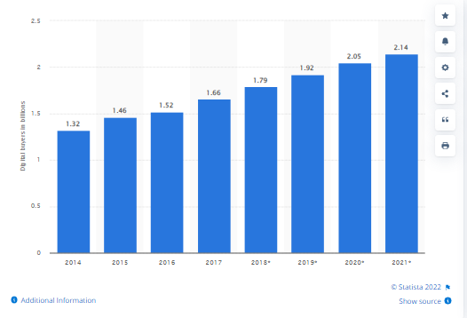
Figure 1: Digital buying capability worldwide
(Sources: Daniela Coppola, 2022)
Hence social media marketing has huge benefits to get a success of the individual company's success purpose. On the other hand, all companies have to move their marketing process in online mode through social media success such as Face book, Twitter, Instagram and YouTube. Therefore in this era and the present day all businesses have to change their marketing process online to grab the attention of the new-age customer.

The rationale of the study
In the era of digitization, a huge impact has been created on changing the marketing and customer behaviors towards some purchasing processes. On the other hand, the chosen company has huge benefits from using social media for their better business process. Here the company will invest almost 6.84 billion Euros in 2021 for maintaining its better marketing and branding process to grab the attention of the new age buyer (www.statista.com, 2022).
In the changing nature of the buyer view of the marketing and the business exposure is related due to the enhanced use of internet access (Miśkiewicz, and Wolniak, 2020). Therefore this specific reason Unilever Plc will be managing their better business marketing through advertising and social media marketing to grab the attention of the buyer (www.unilever.com, 2022).
In this global pandemic the exchange of the buyer nature in the traditional buying process to the digital buying process. Therefore all companies have to improve their marketing system as per the requirement of the buyer and the relevance of the business market.
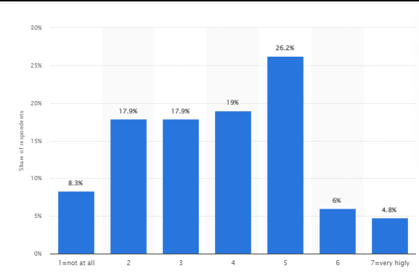
Figure 2: Contribution of social media marketing to the performance of companies in the United Kingdom (UK) in 2021
(Sources: www.statista.com, 2022)
In the present year, almost 26.2 % increased the better business development through adopting this social media as the new trend of the marketing process (www.statista.com, 2022).
The specific research has shed light on the effective business growth by adopting social media to better improve the business growth of Unilever Plc. The company will manage their global business with 3.4bn people who use this company's products and the almost 58% turnover done by the company in the last financial year (Annual report, 2021).

Research Aim
The aim of this research study will be to analyze the importance of social media marketing for the customer behaviors of the successful business operation of Unilever Plc. Through this research study, the impact of the social media marketing process is on the behaviors of the customer for maintaining an effective success of the Unilever plc business success.

Research Objection
The objective will be given in below:
- To examine the various social media marketing strategies adopted by Unilever Plc.
- To analyze the impact of the social media communication strategies implemented by the company for grabbing the attention of the buyer
- To evaluate the impact of the power of the social media marketing of the company to change the mode of the marketing process.
- To analyze the challenges faced by the company by applying the social media marketing process

Research Question
The research question will be delivered below:
Question 1
What are the social media marketing strategies adopted by Unilever for managing their business success?
Question 2
How does Unilever use the current integrated social media marketing strategy to enhance their performances?
Question 3
What is the impact on the buyer of Unilever after applying the social media marketing strategy by the company?

Literature Review

Evaluating the importance of social media marketing in this present day of the business success
In the era of digitalization, all companies have adopted new technology and innovative ideas for managing individual business success. The internationalization theory is highly related to this change and new things adopted. As per the theory, to grab the attention of the international market the individual company has to manage the mode of operation by adopting technology and innovation strategy to hold a suitable position in the globally competitive business era (Vadana et al. 2019). According to the authors Dutta et al. (2021), it can be stated that the manufacturing industry has a huge contribution to the individual country's economic success. Hence adopting technology in this digitalization era has huge benefits to making more manufacturing. On the other hand, digitalization in the marketing process also improves the base of the customer. This specific process helps to get success in individual business finance as well as the contribution to the country's economy.

Critically analyzing the impact on the customer on the use of social media marketing by the Unilever Plc
In the present day changing the mode of the business and the customer buying tendency has a huge impact on running individual business success. The context of the customer behaviour theory is mainly indicating the process of the buying tendency of the customer. According to the authors Floren, et al. (2019), it can be stated that modern customer behaviours have a huge impact on the changing process of the marketing of the individual business operation. In the may research it can be noticed that in this era of digitalization the customer has to change their purchasing mode online and has a pretty much comfortable shopping experience with the digital platform (Daniela Coppola, 2022). Therefore the individual company has to take steps into the online platform for managing their marketing system to get a comfort zone of their customer.

The advantage and the disadvantage of social media marketing faced by the company
Adopting the social media making process individual companies have faced some advantages and disadvantages for running their effective business operation. In this research study, Unilever Plc has a huge impact on adopting the specific social media marketing system. The company is mainly focusing on the contacts of the advertisement as per the cultural background of the individual country.
Advantage
The context of the video and the advertisement is mainly based on promoting equality such as the "Dove Real Beauty Pledge" and the "Daag Acche Hai" Holi camping has huge benefits to get a huge number of viewers as well as buyers which has huge benefits to manage their financial stability. Therefore the company will manage 6.61 per cent of global media content in 2020 to manage their better business progress (www.statista.com, 2022).
Disadvantage
The negative impact is also faced by the company by the advertisement contents of the ASX body spray. In the context of this specific advertisement, the company has faced huge criticism and faces a barrier to running this advertisement (www.racked.com, 2017).

Researchers
After analyzing the above-mentioned literature review, it can be identified that there is an impactful relationship between customer behaviours by using the social media marketing process. It can also evaluate that Unilever Plc has generated better financial stability by using the social media marketing process to manage the present-day market and customer needs.

Research Methodology
The research methodology will be indicating the process of conducting individual research in terms of managing all data. On the other hand, it helps to manage the effective tools and techniques to get a better process of the data management for conducting individual research studies (Pandey et al. 2021).
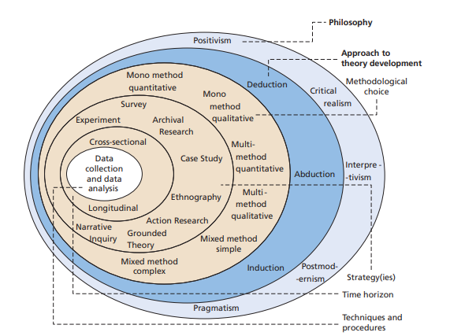
Figure 3: Research Onion
(Sources:Saundersb et al. 2007)
Through this research onion, the data collection methods, analyzing process, research design, research approach and philosophy will be indicating the effective progress of the research paper consumption. On the other hand, the need of the research paper, the process of the data collection, design and analysis process will be identified for better success of the specific research paper's progress purpose.

Research Design
The research design is mainly indicating the implementation strategy for managing a better and more logical way to effectively manage the data collection, measurements and analysis process of the research paper's success. According to the authors Asenahabi, (2019), it can be stated that the e systematic and methodical process is highly required for managing the effective research design managing system. The research design is mainly Descriptive Research Design. Correlational Research Design. Experimental Research Design and the Exploratory research design.
In this research study progression purpose, the descriptive design will be appropriate for better maintaining the quality and the in-depth analysis process to get a better research paper conduction process. Here it helps to enhance the progress and the quality of the details analysis process. The descriptive design helps to manage the better success of the research conduction.

Research philosophy
The research philosophy is mainly defined as an effective way to manage, and gather the data for further analyzing and using purpose. According to the authors Ahlskog (2020), it can be analyzed that the research philosophical process has huge benefits to get an effective approach to the individual research paper conduction process. There are four types of research philosophy present to manage the indicating research paper's success. The four types of philosophy are positivist research philosophy, interpretivism research philosophy, pragmatism research philosophy, and realistic research philosophy.
In this research paper's progress, due to the use of secondary data, the interpretive research philosophy is more suitable for the progress of the effective and in-depth research paper conduction paper. On the other hand, the specific research philosophy helps to enhance the quality of the performances in observing the social world. Hence, indicating the specific topic this philosophy helps to get success of the business operation by an individual company by adopting a social media marketing system.

Data collection methods
The data collection method is mainly indicating the process of gathering data to further conduct individual research study progress. Here the two ways of data collection methods such as primary and secondary are present for conducting individual research paper conduction. The primary data is indicating first-hand information such as surveys, interviews and the questionnaire. On the other hand, the secondary data is mainly the secondary sources of the referee to the research work of the other researcher. Due to maintaining the in-depth and descriptive analyzing process, the secondary data will be more appropriate for the progress of this research paper. The secondary data is collected through the help of relevant journals, news, articles, books, websites and government data (Siddiqui, 2019).

Analysis of data
Data analysis is focusing on the process of the data examination to conduct individual research paper progress (Rajšp, and Fister, 2020). Here the two types of data analyzing methods such as quantitative and qualitative processes to manage the individual research paper progression purpose.
Due to the secondary data collection and the descriptive nature of this particular research paper, the qualitative data analyzing system will be helpful for enhancing the progress of the research paper. Here the deductive research approach will also enhance the quality of the research by using relevant existing theory for this project paper progress.

Sampling methods and types
The sampling method is mainly defined as a process of the data analyzed with the help of the various segments. There are two types of sampling techniques used in the individual research paper conduction process such as non-probability and probability. The probability sampling is indicating the data analyzing with the specific segment such as age, community, education and the various zones. Hence the primary data collection and the analyzing process will be indicating the use of the probability sampling techniques to enhance the progress of the individual research paper conduction.
Due to the use of the secondary data for this research conduction process the more suitable sampling method will be non-probability sampling techniques. According to the non-probability sampling techniques, the research paper quality will be enhanced and the described design will be maintained (Bae et al. 2022).

Research ethics and privacy
Research ethics and privacy is mainly indicating the way of managing data protection and the privacy management of the individual authors and company details (d'Aquin et al. 2018). Therefore this research paper conducted there will be no harm to the data and the maintaining confidentiality to get a continuation of this research paper's progress.

Resources and planning
[Refer to the Appendix]

References
Ahlskog, J., 2020. The Primacy of Method in Historical Research: Philosophy of History and the Perspective of Meaning (Vol. 40). Routledge.
Annual report (2021) Available From:https://www.unilever.com/files/92ui5egz/production/e582e46a7f7170fd10be32cf65113b738f19f0c2.pdf[Accessed: 9 July, 2022]
Asenahabi, B.M., 2019. Basics of research design: A guide to selecting appropriate research design. International Journal of Contemporary Applied Researches, 6(5), pp.76-89.
Bae, I., Park, J.H. and Jeon, H.G., 2022. Non-Probability Sampling Network for Stochastic Human Trajectory Prediction. In Proceedings of the IEEE/CVF Conference on Computer Vision and Pattern Recognition (pp. 6477-6487).
Daniela Coppola, (2022) digital buyer capability Available at:https://www.statista.com/statistics/251666/number-of-digital-buyers-worldwide/[Accessed: 9 July, 2022]
d'Aquin, M., Troullinou, P., O'Connor, N.E., Cullen, A., Faller, G. and Holden, L., 2018, December. Towards an" ethics by design" methodology for AI research projects. In Proceedings of the 2018 AAAI/ACM Conference on AI, Ethics, and Society (pp. 54-59).
Dutta, G., Kumar, R., Sindhwani, R. and Singh, R.K., 2021. Digitalization priorities of quality control processes for SMEs: A conceptual study in perspective of Industry 4.0 adoption. Journal of Intelligent Manufacturing, 32(6), pp.1679-1698.
Floren, J., Rasul, T. and Gani, A., 2019. Islamic marketing and consumer behaviour: a systematic literature review. Journal of Islamic Marketing.
Miśkiewicz, R. and Wolniak, R., 2020. Practical application of the Industry 4.0 concept in a steel company. Sustainability, 12(14), p.5776.
Pandey, P. and Pandey, M.M., 2021. Research methodology tools and techniques. Bridge Center.
Rajšp, A. and Fister, I., 2020. A systematic literature review of intelligent data analysis methods for smart sport training. Applied Sciences, 10(9), p.3013.
Saunders, M., Lewis, P.H.I.L.I.P. and Thornhill, A.D.R.I.A.N., 2007. Research methods. Business Students 4th edition Pearson Education Limited, England.
Siddiqui, N., 2019. Using secondary data in education research. Social Research Update, 68, pp.1-4.
Vadana, I.I., Torkkeli, L., Kuivalainen, O. and Saarenketo, S., 2019. Digitalization of companies in international entrepreneurship and marketing. International Marketing Review.
Voramontri, D. and Klieb, L., 2019. Impact of social media on consumer behaviour. Int. J. Inf. Decis. Sci., 11(3), pp.209-233.
www.racked.com, (2017) ASX Available at:https://www.racked.com/2017/6/28/15874802/axe-rebranding-toxic-masculinity[Accessed: 9 July, 2022]
www.statista.com, (2022) digital and branding investment of the Unilever Plc Available at:https://www.statista.com/statistics/600133/univelever-marketing-spend//[Accessed: 9 July, 2022]
www.statista.com, (2022) market share by using the social media business success Available at:https://www.statista.com/statistics/476158/social-media-marketing-performance-uk/[Accessed: 9 July, 2022]
www.statista.com, (2022) social media context by univer Available at:https://www.statista.com/statistics/973398/worldwide-media-perception-of-unilever/
www.unilever.com, (2022) Advertising and marketing Available at:https://www.unilever.com/planet-and-society/responsible-business/advertising-and-marketing/[Accessed: 9 July, 2022]

Activities/Weeks | 1 | 2 | 3 | 4 | 5 | 6 | 7 | 8 | 9 | 10 | 11 | 12 | 13 | 14 | 15 | 16
Topic selection
Literature reviews
Establishing aim of the research, identifying research objectives and determining the research questions
Research proposal imitative
Secondary data collection
Analyzing collected data
Identifying themes in the data
Interpretation of the collected data
Recommendation of strategies
Proposed research report
Gaining tutor’s Feedback
Final preparation of the report and final submission

Appendix

