BSC in Automotive Engineering

Stephen Hutchings
P148299
Emissions
Emissions Control and Diagnostics
Andrew Gibson

Contents Page

Introduction _________________________________Page 2

Literature Review_____________________________Page 3-7

Methodology_________________________________Page 8-9

Results_____________________________________Page 9-13

Conclusion__________________________________Page 13-14

Reference List_______________________________Page 15-17

Appendices_________________________________Page 18-22

Emissions

Introduction

Vehicles cause a significant amount pollution which can have a negative impact on the environment (Harrop 2003). This suggests that the automotive industry could cause harm to the earth’s atmosphere. It can be seen that there are several common air pollutants given off by vehicles, these include carbon monoxide and nitrogen oxide (Colls 2002). However, concerns about vehicle pollution is not a new concept as they date back to approximately 1915 (Eriksson and Nieslen 2014). Regardless of this, it appears that exhaust emissions regulations were not fully introduced until many years later. In 1963 the Clean Air Act was put into place, according to Erjavec (2009) this act acknowledged that automotive vehicles were “a major contributor to air pollution and were responsible for as much as 40% of all emissions”. In present day, exhaust emissions are governed by European emissions standards which mean that vehicles have to comply with certain regulations in order to be road worthy (Hiller and Coombes 2004). This suggests that these regulations will improve the air quality in the environment. Emissions testing is part of the MOT test of most vehicles apart from 2-stroke engines and hybrid vehicles (DVSA 2017). This suggests that a vehicle needs to comply with emissions standards in order to pass an MOT test. To add to this, the MOT test also examines emission control systems. According to Gilles (2015) the emission control system “controls or eliminates unburned hydrocarbons, carbon monoxide and oxides of nitrogen”. Therefore, emission controls will reduce the amount of emissions produced by a vehicle. The aim of this essay is to analyse and evaluate the operation of various different types of emission controls, these include catalytic converter, evaporative emissions control (EVAP), exhaust gas recirculation (EGR), secondary air injection reaction (SAIR), positive crankcase ventilation (PCV) and air-fuel ratio. Euro 6 and 7 regulations will also be considered throughout. In addition, an account of testing procedures will be given in the methodology and the results and analysis of testing will be displayed in the results section.

Literature Review

According to Erjavec (2009) an engines power is produced “by burning fuel and converting fuel into thermal energy”. However, some energy is wasted and harmful emissions which become air pollutants are released out of the engine during the process (Halderman and Farnell 2005). Therefore, emissions control systems are designed to reduce the amount emissions produced by the vehicle. It can be seen that there are several sources of emissions which include the crankcase, evaporation and exhaust (Gilles 2004). Therefore, different types of emissions devices are used to control emissions.

The first emissions device that will be discussed is the catalytic converter. The catalytic converter transforms toxic gases such as hydrocarbon and carbon monoxide into carbon dioxide and water (Kiencke and Nieslen 2005). From this it can be seen that the aim of this device is to reduce the amount of harmful pollutants produced by a vehicle. However, it has been argued that this emissions device does not fully eliminate the pollutants as carbon dioxide is still released and this can have a negative impact on the environment (Martin 2007). Nevertheless, a catalytic converter is an emissions device that is used on most vehicles. In order for the catalytic converter to work efficiently a temperature of approximately 426 degrees Celsius is needed in order to convert the gases (Gilles 2015). Therefore, the efficiency of the catalytic converter needs to be monitored to ensure this temperature is reached in order to convert the gases. One way this could be done by a technician is by using two oxygen probes. According to Sideris (1998) one probe would be placed upstream of the converter and the other one downstream. Sideris goes on to state that the probes would be attached to a CPU which would receive the signals from the probes. From this it can be seen that the CPU would be able to evaluate the performance of the catalytic converter. To add to this, Dorries (2004) states that a fault signal would be produced and the malfunction indication lamp would come on if the value determined by the probes is significantly different to the characteristic-field value.

In modern systems the function of the catalytic converter would be monitored by OBD 2. According to Concepcion (2011) while OBD2 does not directly check oxides of nitrogen it does test the “integrity of the system in charge of keeping the combustion temperature down”, this being the EGR system. Therefore it appears that from testing this, the electronic control unit is able to detect whether emissions are as they should be. The EGR system controls oxides of nitrogen by reducing combustion temperature (Eriksson and Nieslen 2014). Therefore, the EGR system reduces emissions produced by the vehicle. However, Jacob (2005) considers that the EGR can increase fuel consumption, therefore this may be less cost efficient for the driver. According to Eriksson and Nieslen(2014) in modern engines the EGR switches off during idling because no significant oxides of nitrogen are produced, to add to this, the EGR is also shut off at maximum torque Eriksson and Nieslen (2014) suggest this is because “competes with air for space in the cylinder”. It appears that this process links with the amount of oxides of nitrogen being produced, however, shutting the EGR valve off at maximum torque could mean that some emissions are still being produced by the vehicle. Nevertheless, Gilles (2015) suggests that this is connected to air/fuel ratio and higher accuracy is achieved by turning the valve off as any NO₂ produced below 1370C are controlled by the catalytic converter.

It can be seen that air/fuel ratio has an effect on the vehicles overall emissions. Srinvas (2004) states that if the air/fuel ratio is too rich, meaning it contains too much fuel then a large amount of oxides of carbon are produced due to incomplete combustion. From this it can be seen that the correct air/fuel ratio will control the amount of emissions being produced by a vehicle. Furthermore Erjavec (2009) states that a leaner air/fuel mixture will be more cost effective for the driver as less fuel is being burned. This could also mean that fewer oxides of carbon emissions are being produced.

The next emission control device that will be discussed is the evaporative emissions control (EVAP). According to Erjavec and Thompson (2014) the EVAP is a “sealed system that traps the fuel vapours that would normally escape from fuel delivery into the air”. Therefore, suggesting that the EVAP system lowers emissions by preventing the emissions escaping. George (2018) adds to this and states that the fuel vapours are relocated to and stored in a charcoal canister until they are “safely transferred back into the engine to be burned with the normal air/fuel mixture”. It appears that the EVAP system plays an important part in emissions control as it controls the release of vaporised hydrocarbons which come mainly from the fuel system and produce volatile organic compounds (Schager and Darby 2003). Therefore, having an emissions control to prevent the release of vaporised hydrocarbons is essential when trying to reduce the amount of emissions produced by a vehicle.

Two other emissions control devices that control the amount of oxides of carbon and hydrocarbon emissions being produced are the secondary air injection reaction (SAIR) and the positive crankcase ventilation (PCV). A PCV works by diverting the crankcase emissions into the combustion chambers through hoses and small openings in the engine (Popular Mechanics 1985). As the emissions are diverted back into the combustion chambers this suggests that the PCV works in a similar way to the EGR system. According to Hollembeak (2004) a faulty PCV would be noticeable as it would cause rough idling or stalling, Concepcion (2011) adds to this and suggests that oil may also be found in the carburettor air cleaner. This suggests that certain symptoms from the vehicle would alert the driver that the PCV may be faulty. In order to diagnose a faulty PCV valve the vehicle would need to be visually inspected first as Erjavec and Thompson(2014) suggests that a damaged sensor may produce the same symptoms as a faulty PCV valve. This could involve visually checking the hoses and other parts of the PCV. After the visual checks are complete Knowles and Erjavec (2005) consider that the a faulty PCV could be diagnosed by testing the vacuum with a pressure gauge, they go on to state that the airflow needs to be tested by obstructing the PCV vent whilst the engine is idling at normal temperature. It seems that a diagnostic machine will not alert the driver to a faulty PCV valve. Nevertheless Concepcion (2011) suggests that modern vehicles will make the driver aware of any changes in the air/fuel mixture. Therefore it seems that this could be an indicator of a faulty PCV valve.

When looking at the role of the SAIR in eliminating emissions, Smoothers (2009) states that it works by injecting replacement air into the exhaust system. Interestingly, it appears SAIR off would have a positive effect on the ‘drivetrain of output’ (Threewitt 2018). This suggests that SAIR off could provide the vehicle with more power. However, by turning SAIR off the vehicle would produce more emissions and would not comply with regulations. However, it appears that in modern day not all newly manufactured vehicles require secondary air injection as CDX Automotive (2013) state that this is due to “vehicles warming up quicker, more accurate fuel delivery to the combustion chamber and the use of highly efficient three way catalytic converters”. This suggests that modern vehicle design has been able to reduce emissions without secondary air injection. Gilles (2015) adds to this further and states that secondary air injection only operates in modern vehicles during the warm up of the engine and as an aid to heat up the catalytic converter. As the majority of hydrocarbons are produced while the engine is warming up this could be why the SAIR is only used during this period.

When looking at emissions controls it is important to consider Euro 6 as these are the mandatory regulations issued by the EU on vehicle emissions. According to Parkers (no date) in order to comply with these regulations a vehicles emissions must be lower than 130g/KM. As the Euro 6 regulations have further restrictions on the emissions of NOx and other pollutants several changes would have needed to be made to the previous emissions systems discussed above in order to bring the engine into the Euro 6 category. An example of this is only an SCR catalytic converter with Adblue will be acceptable to use on heavy diesel vehicles (Denton 2015). This suggests that in order to comply with Euro 6 regulations improvements need to be made to diesel vehicles. However, it can be seen from the research of ICCT (2016) that no changes are required from Euro 5 to Euro 6 for ‘port-fuel injected’ gasoline engine’ but improvements need to be made to fuel injection timing. This suggests that fewer changes need to be made to petrol fuelled vehicles. Along with other emissions control systems discussed Euro 6 made it mandatory for other emissions controls such as a diesel particle filter and a lean Nox trap to be fitted (SMMT 2016). In addition to this, McKinnon et al (2012) states that the combination of EGR and SCR technologies would be necessary in order to comply with Euro 6. As EGR valves are already used on most modern vehicles, combining them with selective catalytic reduction (SCR) suggests that emissions would be reduced even further. According to RAC (2016) a SCR converts NOx into water by injecting a liquid reductant agent into the exhaust system of diesel vehicles.

By making the changes discussed above the vehicles emissions would be reduced further and this would have a positive impact on society as a whole as it can be seen that pollutants are responsible for causing ill health such as asthma, cancer, heart disease and strokes (ICCT 2016). Also reducing pollutants would have a positive effect on the environment as it would reduce the amount of greenhouse gases being produced and this would lesser problems with global warming (Ehsani et al 2016). Therefore, it seems that regulations like Euro 6 help to protect the health and wellbeing of society and the environment. However, it could be possible that some of these changes may have a negative influence on the vehicle function as it can be seen that the blocking of EGR valves could produce more engine power (Vangelder 2017). However, it is also noted that these changes are not recommended and are illegal. On the other hand Hatch (2016) considers that some emissions controls systems can improve fuel efficiency and driveability. Conversely, it has been documented in the media that the emissions ‘fix’ carried out by Volkswagen following the ‘emissions scandal’ caused a loss in vehicle performance and fuel efficiency (Brignall 2017). Therefore, this demonstrates that emission control systems can have both a positive and negative effect on vehicle function.

From the previous research it appears that future emissions regulations will become even stricter on diesel vehicles. Also, it can be seen that the new Euro 7 regulations will lower emissions further to 98g/KM (Policy Measures, no date). However, it seems that there is no current date confirmed for the introduction of Euro 7 as yet. Nevertheless, it appears that Euro 7 will focus more on the reduction of carbon dioxide more than other pollutants (European Commission 2017). In addition to this, it appears that the promotion of hybrid vehicles and the demise of diesel vehicles could be an EU focus in the near future. Therefore, this is an aspect that needs to be considered when analysing the operation of emission control systems.
Methodology

In order to analyse and evaluate the operation of several emissions control systems further a series of tests were carried out. These tests were similar to tests that would be carried out by a technician when diagnosing faults in emissions controls systems. However, when looking at testing in industry it appears that several changes are being put in place when testing the emissions of a vehicle in order to make emissions testing more reliable. One example of this is the Worldwide Harmonised Light Vehicles Test. According to WLTP (2016) this test will aim to reflect real-driving data and will replace the New European Driving Cycle which was based on theoretical driving data. Therefore, this method should be more reliable in measuring CO2 and pollutant emissions. However, it appears that there are limitations to this test because it is still carried out in a laboratory setting. Therefore, this may mean that results will not reflect real-driving emissions. Another test that will be carried out is the real-driving emissions test that was introduced by the EU in 2017. This test involves vehicles being fitted with portable emission measuring systems (PEMS) in order to measure emissions whilst a vehicle is being road driven (IMechE 2013). As the test looks at road driven vehicles this suggests that it will be more reliable that workshop testing. However, several concerns have been raised about real-driving emissions tests as they are likely to take longer due to contextual factors such as road closures and traffic (ICCT 2016). Therefore, this could mean that the process of emissions testing will produce more labour costs as tests will take longer to complete.

As this test took place under workshop conditions in a controlled environment and testing was not carried out on a roadside vehicle, this may have had an impact on validity of the test results (Wainer and Braun 2013). Therefore something that needs to be considered when analysing the results. All participants of the test wore safety equipment such as a protective jacket and steal toe cap boots, this ensured that the testing procedure conformed to health and safety regulations (HSE 2017).

A range of tests were undertaken on several pins on three different engines, these engines being a Ford, Vauxhall and Vauxhall Ecotech. Scope patterns were produced for several pins, this included the idle control valve on the Ford (Pin 21), the AC input for camshaft sensor on the Ford (pin 24) and the injector and earth for the Ford (Pin 35 and 39). For the Vauxhall Ecotech, the negative side of the EGR solenoid valve was tested (Pin 42) and the negative side of the idle valve was tested (Pin 52). However, it is important to point out that the emissions control systems tested followed Euro 3 emissions standard. According to Pundir (2007) this standard was first introduced in 2001 but was replaced with Euro 4 in 2006. Therefore, it is important to recognise that the testing of these emissions control systems cannot be directly linked to the operation of current emission controls that are regulated by Euro 6 standards. However, the emissions control systems will be compared with the Euro 6 standards in the results section and the changes needed in order to bring the engine into the Euro 6 standard will be considered in the results section.

Results

As mentioned in the methodology section, several pins were tested and will be analysed in this section in order to analyse and evaluate the operation of several emissions controls, this will be done for each engine and then a discussion on what changes need to be made to bring the vehicle to Euro 6 standard will be given at the end. The first pin tested was pin 21 on the Ford engine, this being the idle control valve. Pico Technology (2018) state that the function of the idle control valve is to “control the engines idle speed according to temperature and load conditions”. From the scope pattern of this pin (see appendix 1) it can be seen that the magnitude of the pulse is the same throughout the idle operation. According to Gilles (2015) the change in voltage should be observed when analysing this scope pattern. From the scope pattern it can be seen that the voltage is at its highest at approximately 10.2 volts and its lowest at approximately 5 volts. Bonnick (2007) states that more current would be used when the valve was drawn out, therefore the voltage on the scope pattern would drop. To add to this, the voltage would be maintained when the engine reaches operating temperature, therefore this is the reason why the scope pattern appears consistent apart from the third cycle when there is a slight frequency shift. However, according to Pico Technology (2018) this frequency shift is caused because “the valve opens to maintain the engine idle speed under high electrical demands”.

The next pin tested on the Ford engine was pin 24 (AC input from camshaft sensor). According to Hatch (2011) “the PCM uses the camshaft sensor signal to sequence the fuel injectors”. Therefore, a faulty camshaft sensor could have a negative impact on air/fuel ratio, ignition timing and fuel injection delivery and subsequently an adverse effect on emissions. The camshaft sensor position permits the ECM to establish the opening and closing of intake and exhaust valves sensor (Bonnick 2007). According to Pico Technology (2018) the purpose of this scope pattern is to observe the signal voltage and formation of the Camshaft position at idle speed. From the scope pattern (see appendix 2) it can be seen that there are several large and smaller peaks in voltage on the scope pattern, these peaks represent cylinders (Gilles 2015). In addition to this, it appears that cylinder one produces the largest amount of voltage and cylinders 2, 3 and 4 producing smaller peaks in voltage which are the same size. According to Erjavec (2009) the output of the camshaft sensor position together with the crankshaft sensor position is used to “determine when cylinder one is on its compression stroke, this information then controls fuel injection, direct ignition and variable valve timing systems”. Therefore, the position of cylinder number one is important to observe on the scope pattern. The scope pattern shows that cylinder one voltage is the same throughout the same pattern. Also, all peaks in the scope pattern are formed in a sequential manner.

The pattern of pin 35(Injector number 4 earth via ECU) and pin 39 (Injector number 3 earth via ECU) also show that changes in the voltage on the scope pattern occur sequentially. This demonstrates that injectors are not fired simultaneously as all injectors would be fired at the same time (Erjavec 2009) and therefore the spikes in voltage would occur at the same time on the scope pattern. In addition, sequential injectors all have separate earth paths and this can be seen on the engine management schematics for the ford (see appendix 3). According to Pico Technology (2018) the length of time an injector will be held open for will depend on ECM input signals, these signals depend on factors such as ‘the resistance of the air temperature sensor’ and the ‘output voltage from the airflow meter’. Therefore a faulty injector scope could indicate an issue with one of these sensors.

As the Ford engine tested complied with Euro 3 standards, several changes would needed to be made in order to bring the Ford into the Euro 6 category. The first change that would need to be made would be the installation of a catalytic converter monitor in order to monitor O2 levels after the converter (Erjavec and Thompson 2014). Installing after cat monitoring on a vehicle would ensure that the catalytic converter is serving its purpose in reducing emissions. Another type of monitoring system that would need to be fitted onto the Ford would be after PCV monitoring. According to Gilles (2015) hydrocarbon emissions can increase if the PCV is not operating correctly. Therefore, it is necessary to check if this emission control system has performed operated correctly. PCV monitoring was required for all vehicles built after 2004 (Pickerell 2013). As mentioned earlier in the literature review, a PCV monitor will alert the ECM of any changes in the air/fuel mixture (Concepcion 2011). Therefore monitoring the function of the PCV will ensure that emissions are being regulated.

Another emissions control component that is missing on the Ford is an AC camshaft phase sensor. Denton (2014) states that the phase sensor recognises the position of cylinder number one. Hatch (2011) adds to this by stating that injectors are pulsed once the PCM receives its first signal from the camshaft sensor. However, if the sensor is not working properly this suggests that a signal may not be initially sent to the PCM. Another sensor that is not included on the Ford is a lambda sensor. According to Denton (2014) a lambda sensor which is “fitted into the exhaust pipe before the catalytic converter” calculates the ratio of air/fuel in the exhaust gases and then sends a signal to the ECM in order to make any necessary changes to the fuel operating system. Therefore, this suggests that these sensors control exhaust emissions.

The next set of scope patterns observed were those of the Vauxhall Ecotec engine, as this engine is a candidate of Euro 4/5 it is important to recognise that some changes have been made to the emission control system and these changes were not present on the Ford engine. The changes along with what is needed to bring the engine up to Euro 6 standard will be discussed throughout. The first scope pattern that was taken was pin 42 (negative side of EGR solenoid valve). As discussed in the literature review, the purpose of the EGR valve is to control oxides of nitrogen levels by reducing the combustion temperature (Eriksson and Nieslen 2014). Therefore a faulty EGR valve could mean that more NOx emissions are given off by the vehicle. According to Pico Technology (2018), the purpose of this scope pattern is to “evaluate the correct operation of the Exhaust Gas Recirculation solenoid valve (EGR valve) based on the switching voltage and frequency during engine hot run conditions.” To add to this, it appears that the operating conditions of solenoid changes as the engine operating conditions change. Vidler (2003) states that signals from the ECM can trigger the solenoids to increase the EGR flow, maintain EGR flow and decrease EGR flow. From the scope pattern (see appendix 4), the current draw shows that the solenoid is in operation at a maintained flow. This suggests that the engine is in idle conditions.

However, as the Vauxhall Ecotec uses a plunger solenoid the ECM only measures the deploying of the solenoid (Gilles 2015). Therefore, the ECM does not measure whether the solenoid valve is working properly, this is supported by Pico Technology (2018) who state that it is only possible to see the activation of the solenoid valve. However, in more recent vehicles that comply with Euro 6 changes have been made to monitor the function of the EGR valve. These changes include the fitting of several sensors to ensure the function is being monitored properly. The pressure sensor monitors the pressure inside the EGR tube, converts the pressure difference into voltage and then sends signal back to ECM (Halderman 2015). As this sensor allows the ECM to monitor how well the EGR valve is working, this suggests that NOx emissions are more likely to be reduced in comparison to a vehicle without this sensor. Another sensor that is fitted in modern vehicles is the knock sensor. According to Pickerill (2013) the knock sensor alerts the ECM of detonation; this is when there is too much heat and compression in the combustion chamber. Also, as knock increases emissions and could potentially damage the engine (Hick 2000) this suggests that knock sensors increase vehicle performance by monitoring the engines operations.

The last scope pattern that was taken was for pin 52 (see appendix 5) of the Vauxhall Ecotec engine (negative side of idle valve). The scope pattern shows that when valve is drawn out more, more current is used to do it hence the reason why the voltage drops on the scope pattern (Gilles 2015). This is the same as the idle control valve on the Ford engine and the voltage output needs to be observed, from the scope pattern it can be seen that the voltage output is 15 volts. In addition to this it can be seen that all dwell periods are the same and are not significantly large or too short, suggesting that the valve is operating sufficiently (Vilder 2003).

Both the Ford and Vauxhall engine use a plunger type idle control valve, other types available include a rotary type idle control valve (Denton 2013). The plunger idle control valve uses solenoid phasing to control position and the deploying of the solenoid is fed back to the ECM rather than the completed operation, this suggests that the rotary type idle control valve could be more reliable. As the idle control valve plays an essential role in ensuring that correct air-fuel ratio is maintained (Gilles 2015), this suggests that it is imperative for the ICV to be working properly. Changes that could be made to this engine to ensure that the air/fuel ratio is correct is fitting an air/fuel ratio sensor. According to Hatch (2016) air-fuel sensors are similar to O2 sensors but they provide prompter readings than the O2 sensor. As air-ratio sensors give quicker readings this suggests that they are more economically efficient than the O2 sensor.

Conclusion

To conclude it can be seen from the report regulations put in place to decrease emissions are not a new concept. Also, it can be seen that a variety of emissions control systems have been used over the years in order to attempt to monitor and reduce emissions. When analysing and evaluating emission controls systems, this report has found that different vehicle manufacturer over the years have attempted to reduce emissions in a number of ways; all these ways have conformed with Euro emissions standards during the time of manufacture. However, when testing the functions of various emission control systems it has been found that older emissions control systems monitor the deployment of the emissions control but do not actually check if the control is working sufficiently, therefore this means that the emissions control may not actually be lowering emissions. Though, this report has also found that emissions controls systems are improving over time as a greater amount of sensors are being fitted in vehicles to ensure that emissions are being reduced. It has also been established that many more changes are likely to come over time and Euro 7 standards will aim to reduce emissions further, specifically CO2, with a particular focus on diesel vehicles. In addition, it can also be seen that changes are occurring in emissions testing and real-road testing is being introduced. However, it has been recognised that these testing procedures will take significantly longer and will be more costly. Nevertheless, stricter enforcements in the reduction of emissions mean that improved emission control systems will lessen harmful pollutants which will then have a positive impact on the environment and the health of individuals

Reference List

Albert, V. and Hiller, W. (2004) Hiller’s Fundamentals of Motor Vehicle Technology. Nelson Thornes: Cheltenham

Brignall, M. (2017) Thousands of drivers suffer loss of power following VW emissions 'fix' (online) available at: https://www.theguardian.com/money/2017/jul/12/drivers-loss-of-power-vw-emissions-fix-class-action [last accessed on 02/03/2018]

CDX Automotive (2013) Automotive Light Vehicle. Jones and Bartlett Learning: Burlington

Colls, J. (2002) Air Pollution. Taylor and Francis: London

Concepcion, M. (2011) OBD 2 Repair Strategies. Mandy Concepcion: London

Denton, T. (2013) Automobile and Electric and Electronical Systems. Routledge: Suffolk

Dorries, E. (2004) Automotive Engine Repair. Cengage Learning: London

Ehsani, M., Gao, Y. and Emadi, A. (2017) Modern Electric, Hybrid Electric and Fuel Cell Vehicles. CRC Press: London

European Commission (2017) Reducing CO2 emissions for Passenger Cars. (online) available from: https://ec.europa.eu/clima/policies/transport/vehicles/cars_en [last accessed 02/03/2018]

Eriksson, L. and Nielsen, L. (2014) Modeling control of engines and drivelines. John Wiley and Son: Sussex

Gilles, T. (2012) Automotive inspection: Service, repair and maintenance. Cengage Learning: London

Halderman, J. and Farnell, W. (2005) Fuel Systems and Emissions Control. Prentice Hall: New Jersey

Halderman, J. (2015) Automotive fuel and emission controls system. Pearsons Education: London

Harrop, O. (2003) Air Quality Assessment and Management. CRC Press: London

Hatch, S. (2017) Computerised engine controls. Cengage learning: London

Hollembeak, B. (2004) Automotive Fuels and Emissions. Cengage Learning: London

Hicks, M. (2000) Knock sensors do two jobs. The electronic, diagnostic and driveability resource. Vol 4 (4), pages 2-4

HSE (2017) Health and Safety in the workplace (online) available from http://www.hse.gov.uk/toolbox/ppe.htm [last accessed 08/03/2017]

ICCT (2016) A technical summary of Euro 6/VI vehicle emission standards. (online) available from: https://www.theicct.org/sites/default/files/publications/ICCT_Euro6-VI_briefing_jun2016.pdf [last accessed 01/03/2018]

ICCT (2016) ROAD TESTED: COMPARATIVE
OVERVIEW OF REAL-WORLD VERSUS TYPE-APPROVAL NOX AND CO2 EMISSIONS. (online) available from: https://www.theicct.org/sites/default/files/publications/ICCT_RoadTested_201709.pdf [last accessed 02/03/2018]

Institution of Mechanical Engineers (2014) Internal Combustion Engines. Woodhead Publishing: London

Kiencke, U. and Nieslen, L. (2005) Automotive Control Systems. Springer Science: New York

Knowles, D. and Erjavec J. (2004) Basic Automotive and Service Maintenance. Cengage Learning: London

Martin, T. (2009) How to use automotive scanners. Motorbooks: USA

McKinnon, A., Browne, E. and Whiteing, A. (2012) Green Logistics. Kogan Page: London

Parkers (no date) What is euro 6 emissions standards (online) available from:
https://www.parkers.co.uk/what-is/what-is-euro6-emissions-standards/ [last
accessed 08/03/2018]

Pickerill, K. (2013) Today’s technician. Cengage Learning: London

Popular Mechanics (1985) Popular Mechanics. Hearst Magazine: USA

Pundir, B. (2007) Engine emissions. Alpha Science International: India

Schager, M. and Darby, R. (2003) Automotive Evaporative Emissions Systems. Electronic Journal for Engineering Technology Vol 5 (1) pages 1-6

Sideris, M. (1998) Methods for Monitoring and Diagnosing the Efficiency of Catalytic Converters. Elsevier: Oxford

SMMT (2016) Emissions control systems explained (online) available at : https//www.ssmt.co.uk/wp-content/uploads/emissionscontrolsystemexplained [last accessed 02/03/2018]

Smothers, W. (2009) 9th Automotive Materials Conference. John Wiley and Sons: Michigan

Vilder, D. (2003) Today’s Technician: Automotive Engine Performance. Cengage Learning: London

Vangelder,K. (2017) Fundamentals of Automotive Technology. Jones and Bartlett Learning: Burlington

Wainer, H. and Braun, H. (2013) Test Validity. Routledge: Suffolk

WLTP (2016) What is wltp and how will it work. (online) available from:

http://wltpfacts.eu/what-is-wltp-how-will-it-work/ [accessed 01/03/2018]

Appendices

Appendix 1: Scope pattern for pin 21 (Ford)
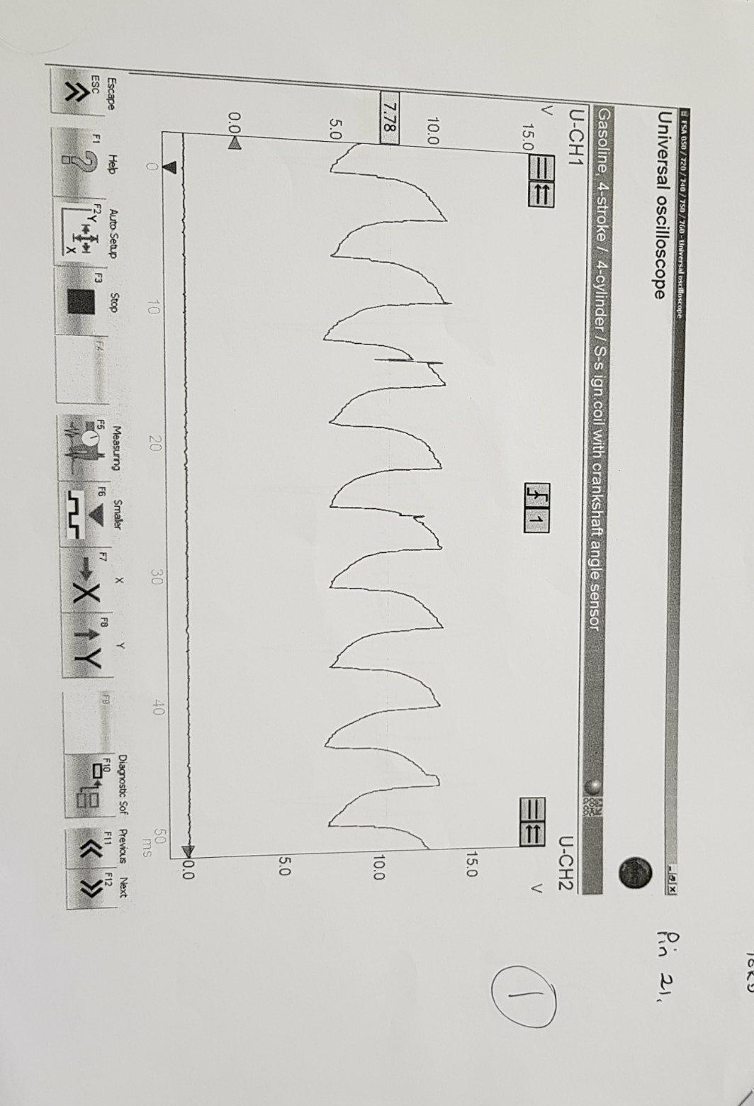

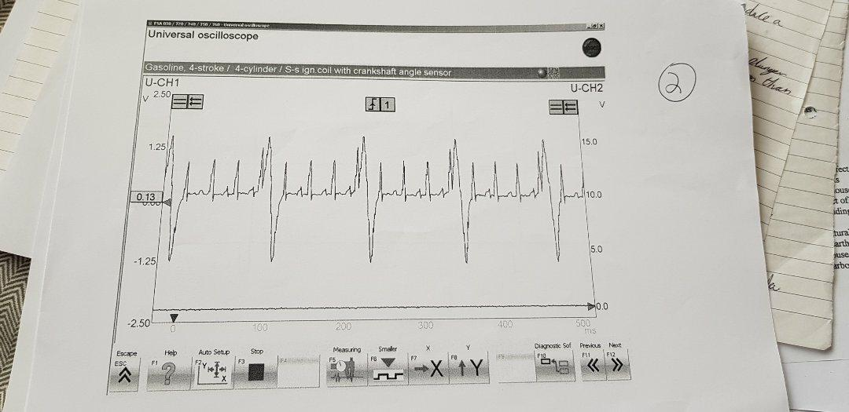
Appendix 2: Scope pattern for pin 24 (Ford)
Appendix 3: Pin 35 and 39 (Ford)
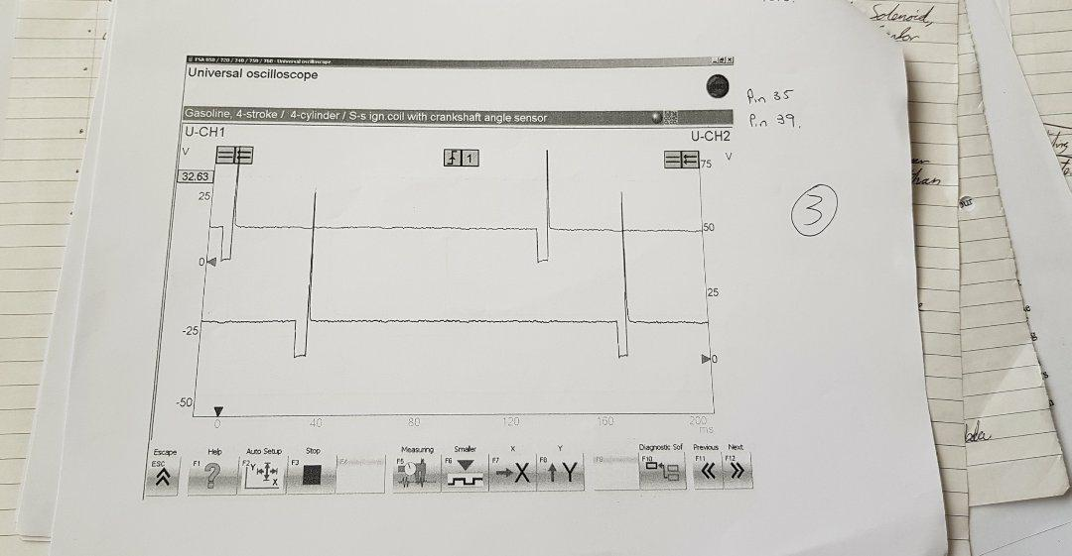

Appendix 4: Pin 42 Vauxhall Ecotec
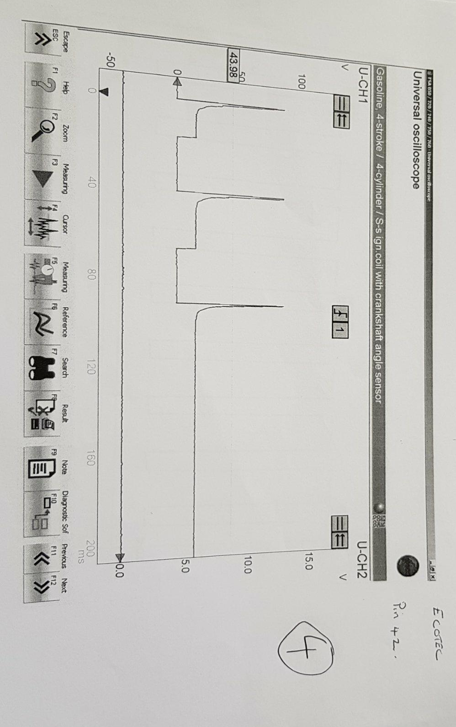

Appendix 5: Pin 52 Vauxhall Ecotec


