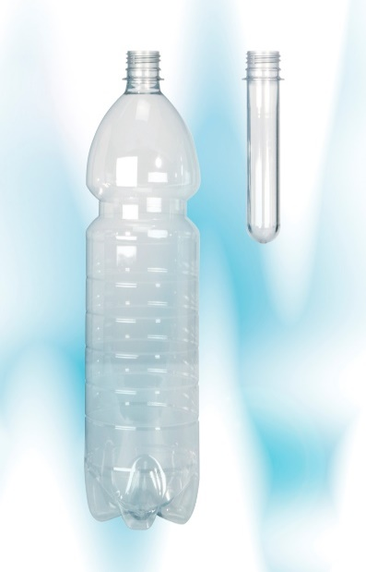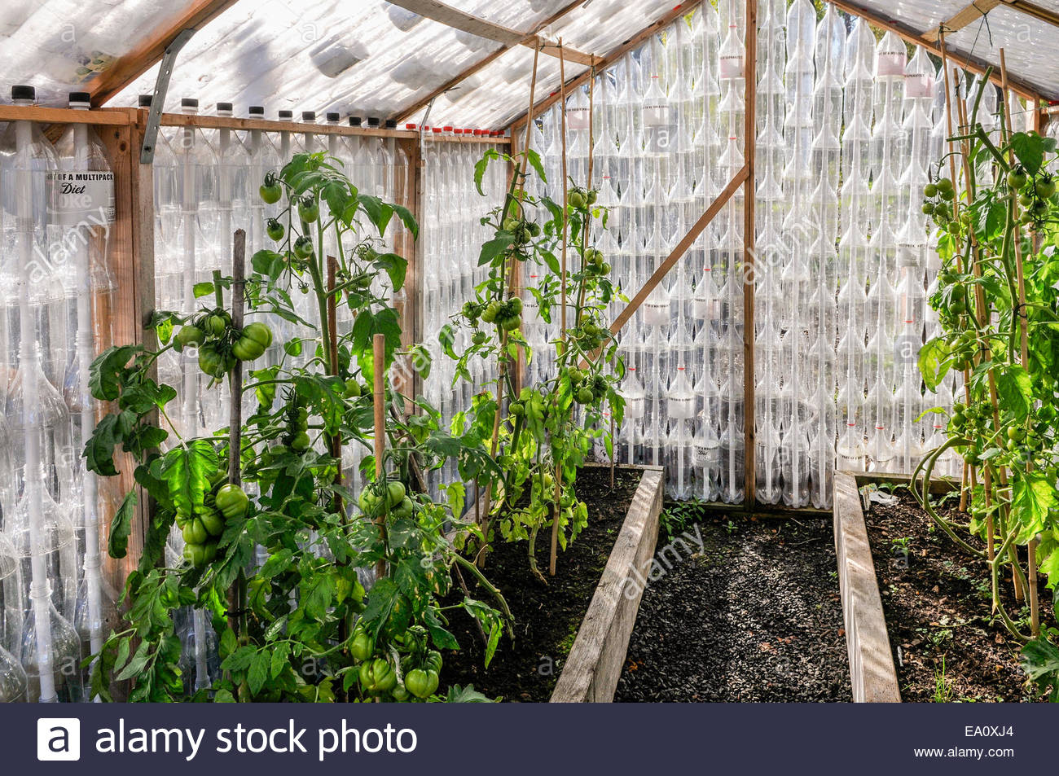
PLASTIC BOTTLES
What are the environmental consequences of your purchase and how can you effectively recycle?
- Over 8 million tons of plastic end up in our oceans every year.
- Waste plastic makes up to 80% of marine debris.
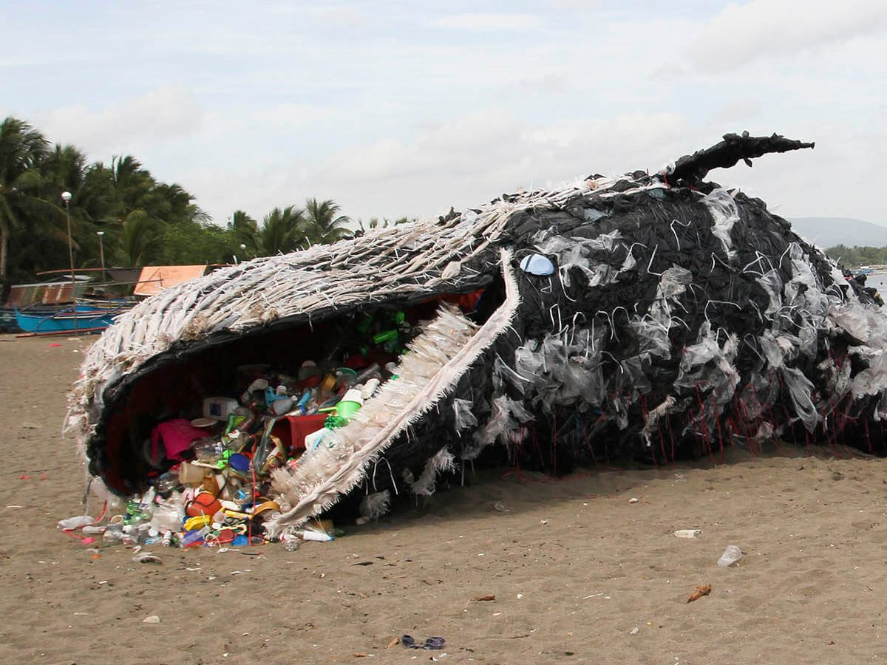

REFERENCE LIST:1) Limited, A. (2019). Stock Photo - Plants growing in a greenhouse made entirely of recycled drinks bottles. [online] Alamy. Available at: https://www.alamy.com/stock-photo-plants-growing-in-a-greenhouse-made-entirely-of-recycled-drinks-bottles-75008924.html [Accessed 4 Nov. 2019].
2) Eartheasy Guides & Articles. (2019). Plastics by the Numbers. [online] Available at: https://learn.eartheasy.com/articles/plastics-by-the-numbers/ [Accessed 4 Nov. 2019] : 3)Greenpeace USA. (2019). The Ocean Plastic Crisis. [online] Available at: https://www.greenpeace.org/usa/the-ocean-plastic-crisis/ [Accessed 4 Nov. 2019].

Above is a green house made entirely from recycled plastic bottles. It is situated at National Botanic Garden of Wales. The plants growing within it are living proof of the sustainability recycling can achieve. This project also provided educational benefits for children.
Above is the recycling classification for plastic bottles.
- Over 100,000 mammals and birds die each year as a result of plastic waste.
- Entanglement, choking and ingestion leads to poisoning and starvation.
- Human exposure to harmful chemicals in plastic leads to cancer, birth defects and impaired immunity.
- It takes thousands of years for plastic to break down.

