


Network Security (NS)

Lab 1

Faculty of Architecture, Computing & Engineering
I.Q. Building room 205
Swansea
SA1 6ED

Introduction

The labs given within this module is geared to assist you in carrying out penetration testing on systems. In a penetration test an Ethical Hacker attempts to break into a company’s network to find vulnerability or the weakest link in the network or the network system. They are also required to analyzes the company security policy and procedures and report any vulnerability to management.

An Ethical Hacker is a person who performs most of the same activities as a hacker but with the owner of the company’s permission. The distinction is important and can mean the difference between being charged with a crime or not being charged. Ethical Hackers are usually contracted to perform penetration tests or security tests. After pre-engagement activities, penetration testers begin gathering information about their targets. Often all the information learned from a client is the list of IP addresses and/or web domains that are 111 scope. Penetration testers then learn as much about the client and their systems as possible, from searching for employees on social networking sites to scanning die perimeter for live systems and open ports. Taking all the information gathered into account, penetration testers study the systems to find the best routes of attack. Tins is similar to what an attacker would door what an invading army would do when trying to breach the perimeter. Then penetration testers move into vulnerability analysis, the first phase where they are actively engaging the target.

Task 1:

Analyzing Domain and IP Address Queries Using SmartWhois

SmartWhois is a network information utility that allow you to look up most available information on a hostname, IP address, or domain.

In this lab, you will learn to use the SmartWhois tool to look up all of the available information about any IP address, hostname, or domain and using these information, penetration testers gain access to the network of the particular organization for which they wish to perform a penetration test.

In the lab you need:
- A computer running any version of Windows with Internet access
- Administrator privileges to run SmartWhois
- The SmartWhois tool; will be provided by the tutor or download the latest version.

SmartWhois is network information utility that allows you to look up most available information on a hostname, IP address, or domain, including country, state or province, city, name of the network provider, technical support contact information, and administrator.

SmartWhois helps you to search for information such as:
- The owner of the domain
- The domain registration date and the owner’s contact information
- The owner of die IP address block

Lab task:

1. Install SmartWhois – follow the wizard driven installation steps.
2. Launch or open the SmartWhois utility
3. The SmartWhois main Window appears (may vary depends on version)
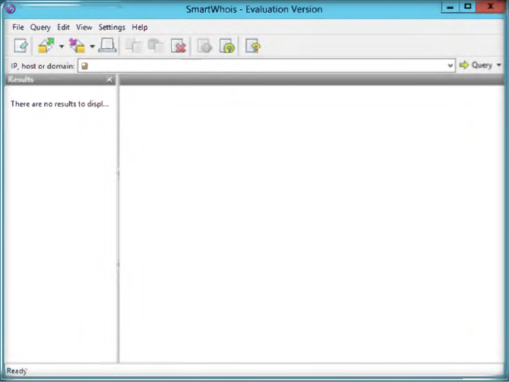

4. Type an IP address, hostname, or domain name in the field tab. An example of a domain name query is shown as follows, www.google.com.

5. Now, click the Query tab to find drop-down list, and then click As Domain to enter domain name in the field.
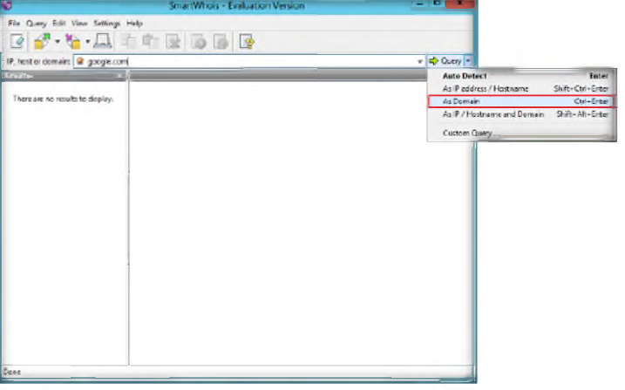

6. In the left pane of the window, the result displays, and the right pane displays the results of your query. Example:
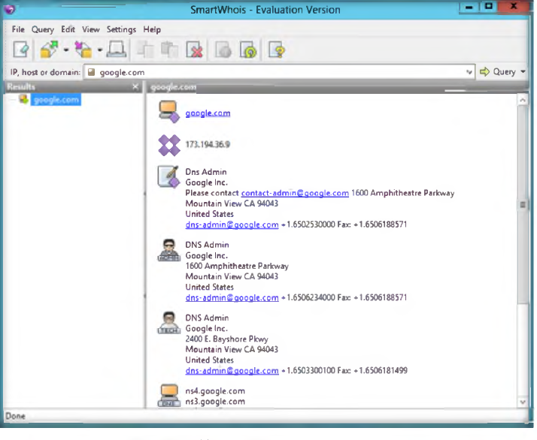

7. Click the Clear icon in the toolbar to clear the history
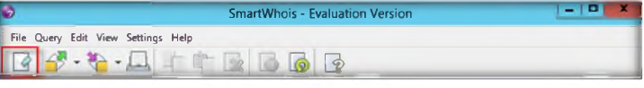
8. To perform a sample host name query, type www.facebook.com

9. Click the Query tab, and then select AS IP /Hostname and enter a hostname in the field.

10. In the left pane of the window, the result displays, and in the right pane, the text are displays and the results of your query. Example:
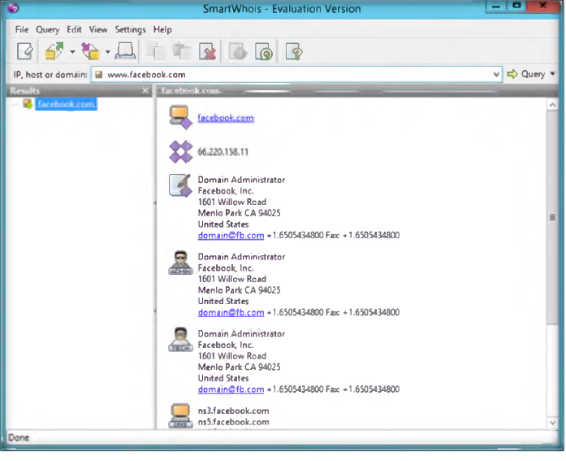
11. Click the Clear icon in the toolbar to clear the history.

12. To perform a sample IP address query, type the IP address 10.0.0.3 (Windows 8 IP address in the IP, host or domain field.

13. In the left pane of the window, the result displays, and in the right pane, the text area displays the results of your query. Example:
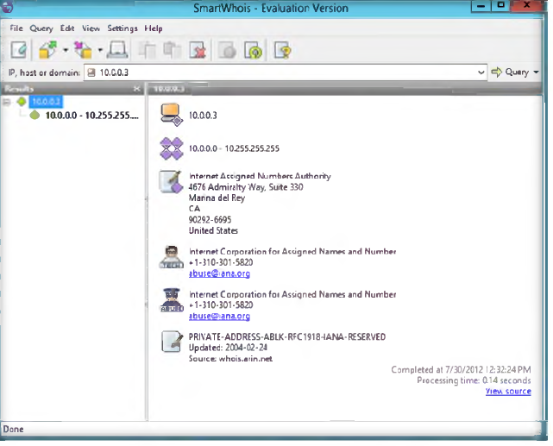

Lab Analysis

Document all the IP address/hostnames for the lab for further information.

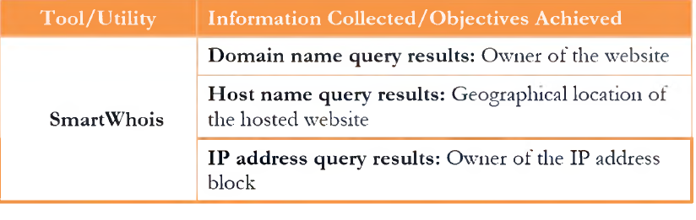

Questions

- Determine whether you can use SmartWhois if you are behind a firewall or a proxy server.
- Why do you get Connection timed out or Connection failed errors?
- Is it possible to call SmartWhois direcdy from my application? If yes, how?
- What are LOC records, and are they supported by SmartWhois?
- When running a batch query, you get only a certain percentage of the domains/IP addresses processed. Why are some of the records unavailable?

Task 2
In this lab, you will learn to trace email using the eMailTrackerPRo tool.

You will:
- Trace an email to its tme geographical source
- Collect Network (ISP) and domain Whois information for any email traced

Getting started
- The eMailTracerPro tool will be provided by your tutor or you can download the latest version of it from http:/ /www.emailtrackerpro.com/download.html
- If you download the latest version, the screenshots in this lab may differ.
- Follow the wizard-driven installation steps and install the tool
- This tool installs Java runtime as a part of the installation
- Run this tool in Windows Server 2012 preferable
- Administrative privileges are required to run this tool
- This lab requires a valid email account (Hotmail, Gmail, Yahoo, etc.).
- We suggest you sign up with any of these services to obtain a new email
- account for this lab
- Please do not use your real email accounts and passwords in these exercise

Overview of eMailTrackerPro

Email tracking is a method to monitor or spy on email delivered to the intended recipient:
- When an email message was received and read
- If destructive email is sent
- The GPS location and map of the recipient
- The time spent reading the email
- Whether or not the recipient visited any Links sent 111 the email
- PDFs and other types of attachments
- If messages are set to expire after a specified time

Lab Tasks
- After installation, launch the eMailTracerPro application
- You are now ready to start tracing email headers with eMailTrackerPro
- Click the Trace an email option to start the trace
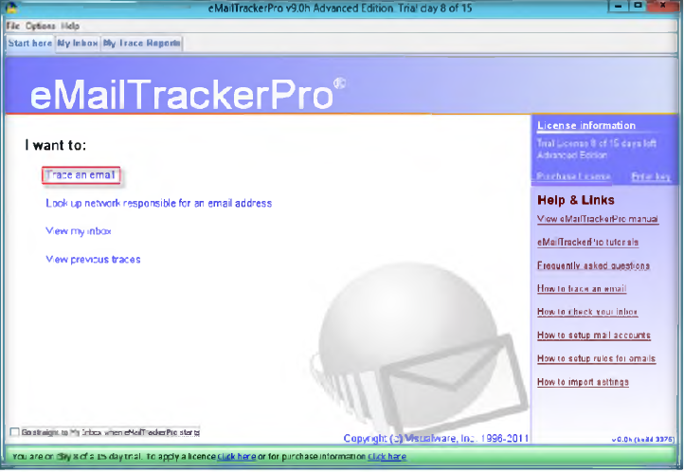

- Clicking Trace an email will direct you to the eMailTrackerPro by Visualware window
- Select Trace an email I have received. Now, copy the email header from the email you wish to trace and paste it in Email headers field under Enter Details and click Trace
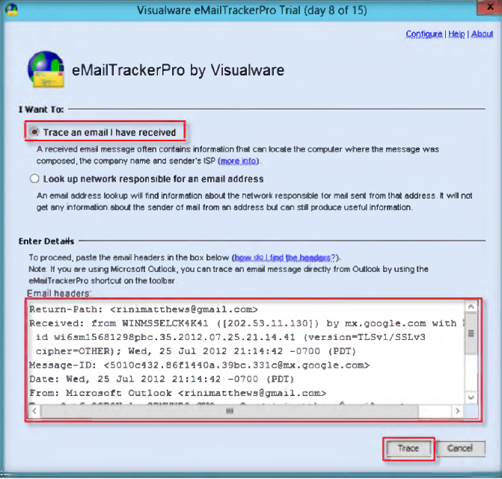
Note: In Outlook, find the email header by following these steps:
- Double-click the email to open it in a new window
- Click the small arrow in the lower-right corner of the Tags toolbar box to open Message Options information box
- Under Internet headers, you will find the Email header, as displayed in the screenshot

- Clicking the Trace button will direct you to the Trace report window
- The email location is traced in a GUI world map. The location and IP addresses may van7. You can also view the summary by selecting Email Summary section on the right side of the window
- The Table section right below the Map shows the entire Hop in the route with the IP and suspected locations for each hop
- IP address might be different than the one shown in the screenshot

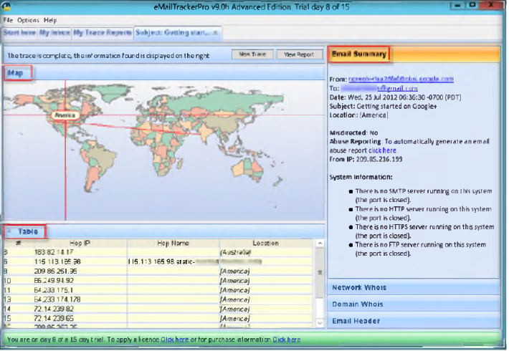

- You can view the complete trace report on My Trace Reports tab
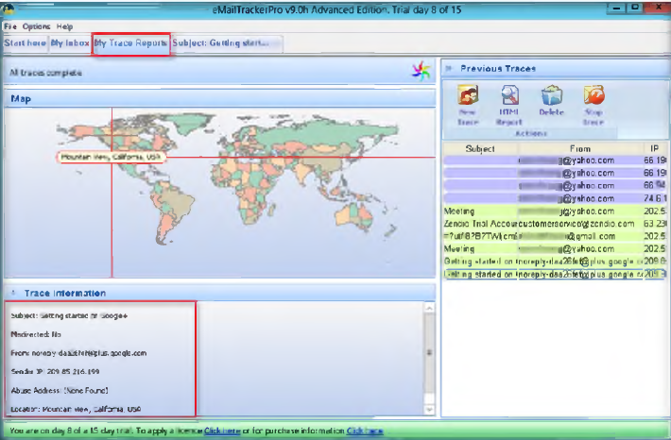

Lab Analysis

Document all the live emails discovered during the lab with all additional information.

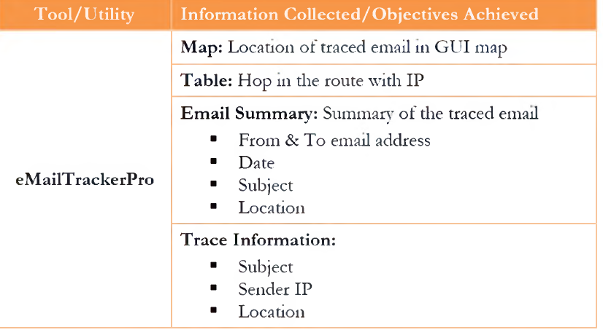

Questions:

- What is die difference between tracing an email address and tracing an email message?
- What are email Internet headers?
- What does “unknown” mean in the route table ot die idendhcation report?
- Does eMailTrackerPro work with email messages that have been forwarded?
- Evaluate wliedier an email message can be traced regardless of when it was sent.

