

DESIGN, IMPLEMENTATION AND EVALUATION OF A
SIGNATURE-BASED NETWORK INTRUSION DETECTION SYSTEM
USING SNORT 3

MSc Cybersecurity and Digital Forensics

Name: Harsh Rameshkumar Mangukiya | Student ID: 2433852
Module ACFB7003 | University of Wales Trinity Saint David
Supervisor: Ms. Renuga Jayakumar
Submission: 8 June 2026

Declaration and Form of Consent

DECLARATION

I, ............................................Harsh Rameshkumar Mangukiya………………………………… declare that I am the sole author of this Project; that all references cited have been consulted; that I have conducted all work of which this is a record, and that the finished work lies within the prescribed word limits.

This work has not previously been accepted as part of any other degree submission.

Signed: Harsh Rameshkumar Mangukiya

Date: 07/06/2026

FORM OF CONSENT

I, Harsh Rameshkumar Mangukiya, hereby consent that my Project, submitted in candidature for the MSc Cybersecurity and Digital Forensics
, if successful, may be made available for inter-library loan or photocopying (subject to the law of copyright), and that the title and abstract may be made available to outside organisations.

Signed: Harsh Rameshkumar Mangukiya

Date: 07/06/2026

Abstract
An Intrusion Detection System (IDS) watches network or host activity for signs of malicious behaviour, comparing observed events against known attack signatures or learned baselines and raising alerts when something suspicious is identified. When deployed at the network level, this becomes a Network Intrusion Detection System (NIDS), a passive sensor that captures live packet streams and inspects them against detection rules without touching the traffic itself. Security teams get early warning of port scanning, credential brute-forcing, denial-of-service flooding, and application-layer attacks before damage occurs. Among the available detection approaches, signature-based systems are particularly well suited to resource-constrained environments. Each rule directly encodes the fingerprint of a known attack, every alert traces back to that rule, and the whole system runs without training data or ML infrastructure. These are qualities that matter considerably when the deployment is a 4 GB virtual machine rather than a dedicated security cluster.
This project designs, implements, and evaluates a signature-based NIDS using Snort 3 on an Ubuntu 25.04 virtual machine running within VMware Workstation, constrained to 4 GB RAM and two CPU cores. Eighteen custom detection rules (SIDs 1000001–1000018) were written across six attack categories: port scanning, denial-of-service flooding, SSH and RDP brute-force, web application probes, directory traversal, and policy violations. Each rule carries a documented threshold rationale. Snort 3 was compiled from source at version 3.11.1.0 rather than installed from the package manager, because older packaged builds do not consistently support detection_filter, the keyword all ten rate-based rules depend on. Three supporting tools were developed alongside the core sensor: nids-report.py, an automated HTML report generator that classifies every alert across four severity tiers (HIGH, MEDIUM, LOW, BLOCKED) using deterministic rule-based mapping; nids-snort.sh, a Bash wrapper that handles session start, stop, PCAP replay, and report generation from a single command; and nids-metrics.py, which computes seven evaluation metrics directly from Snort alert output.
The system was evaluated across four sessions: three CIC-IDS-2017 PCAP replay sessions targeting SSH brute-force, DoS/DDoS, and port scanning traffic respectively, and one WSL2 simulated live attack session exercising all 18 rule categories. The Friday port scanning session produced the strongest results, with a Detection Rate of 100.00%, False Positive Rate of 10.00%, F1-Score of 97.18%, and Accuracy of 96.33%. These figures sit within the operational range reported for ML-based systems on the same dataset, achieved here without training data or model infrastructure. The Wednesday DoS session recorded zero target SID detections. This was not a rule fault; the 4 GB VM simply cannot sustain the 200-packets-per-10-second threshold that rate-based DoS rules require during PCAP replay at compressed burst rates. The same rules fired correctly in live simulation where traffic rate was controllable, which is the more operationally meaningful test. All 18 rules were validated through the live session, including three SIDs absent from CIC-IDS-2017, and a seven-rule IPS extension confirmed functional inline blocking with 100% packet loss during live ICMP flood testing.
A systematic review of twelve NIDS papers identified six gaps this work addresses directly. No prior study combines end-to-end Snort 3 custom rule engineering with documented thresholds, dual-mode evaluation across PCAP replay and live simulation in a single unified report, automated severity-classified alert reporting, and shell-level operational management, all in one reproducible deployment. The core limitation is zero-day blindness: a signature must exist before detection is possible, and that constraint is acknowledged plainly throughout the report rather than treated as a minor footnote. All functional and non-functional requirements are met, and all four research questions are answered.
Keywords: Network Intrusion Detection System, Snort 3, Signature-based Detection, CIC-IDS-2017, PCAP Evaluation, False Positive Rate, Alert Severity Classification, VMware, Ubuntu, IPS Inline Blocking
Contents
Declaration and Form of Consent 2
Abstract 3
Chapter 1: Introduction 10
1.1 Background and Motivation 10
1.2 Network Intrusion Detection Systems 10
1.3 Research Questions 11
1.4 Research Gaps 12
1.5 Aims and Objectives 12
Aims: 12
Objectives: 12
1.6 Project Scope, Lab Environment, and Ethics 13
1.7 Dissertation Structure 13
Chapter 2: Literature Review 14
2.1 IDS Taxonomy and Detection Paradigms 14
2.2 Signature-Based Detection and Snort Platform Evolution 15
2.2.1 Foundations of Signature-Based Detection 16
2.2.2 Snort Platform Evolution: Versions 1 Through 3 17
2.2.3 Rule Engineering in the Literature 17
2.3 Snort versus Suricata: Systematic Comparison 17
2.4 Snort 3 as the Chosen Platform 18
2.5 Machine Learning, Deep Learning, and Hybrid Approaches 19
2.5.1 Growth of ML/DL-Based IDS Research 19
2.5.2 Interpretability and Operational Trust 22
2.6 Evaluation Datasets and Dual-Mode Assessment 22
2.6.1 The CIC-IDS-2017 Dataset 22
2.6.2 Dual-Mode Evaluation: Rationale and Comparison 23
2.7 Alert Fatigue, Severity Classification, and Operational Usability 24
2.8 Summary and Thematic Conclusions 26
Chapter 3: Research Methodology 27
3.1 Research Philosophy and Approach 27
3.2 Project Type and Research Strategy 27
3.3 Experimental Setup and Lab Architecture 28
3.4 Evaluation Metrics 29
3.5 Data Collection Methods 31
3.6 Ethical Considerations 32
3.7 Threats to Validity 32
3.7.1 Internal Validity, Were Tests Controlled and Repeatable? 32
3.7.2 External Validity, Can Results Generalise Beyond This Lab? 33
3.7.3 Dataset Limitations 33
3.7.4 Resource Constraints 33
3.8 Summary 33
Chapter 4: System Design and Architecture 35
4.1 System Requirements 35
4.2 Lab Topology and Architecture 35
4.3 Component Architecture 36
4.4 Rule Architecture and SID Strategy 38
4.5 Evaluation Mode Design 40
4.6 IPS Extension, Proof of Concept 40
4.7 Summary 41
Chapter 5: Implementation 42
5.1 Environment Setup 42
5.1.1 Operating System Selection 42
5.1.2 Attacker Machine: WSL2 Ubuntu 42
5.2 Snort 3 Installation from Source 43
5.3 Configuration: snort.lua 44
5.3.1 HTTP Inspector Activation 45
5.3.2 HOME_NET Configuration 45
5.3.3 Alert Log Size Limit 45
5.4 Rule Implementation: 18 Custom NIDS Rules 46
5.5 Automated HTML Report Generator (nids-report.py) 50
5.6 Operational Management: nids-snort.sh 52
5.7 IPS Extension: Inline Blocking Proof of Concept 53
5.8 Summary 53
Chapter 6: Evaluation of Results 55
6.1 Evaluation Criteria and Approach 55
6.2 PCAP Evaluation Results 55
6.2.1 Tuesday Session, SSH Brute Force 56
6.2.2 Wednesday Session, DoS / DDoS 56
6.2.3 Friday Session, Port Scanning 57
6.3 Live Traffic Evaluation Results 58
6.4 Metrics Results and Confusion Matrix Analysis 61
6.5 False Positive Rate and Rule Threshold Analysis 61
6.6 Cross-Mode Comparison: PCAP vs Live 63
6.7 Severity Classification Analysis 63
6.8 Comparison Back to Literature 64
6.9 Threats to Validity in Evaluation 64
6.9.1 Internal Validity 64
6.9.2 External Validity 64
6.9.3 Resource Constraint Effects 65
6.10 Key Findings and Summary 65
Chapter 7: Conclusions and Recommendations 66
Chapter 8: Reflection 67
8.1 Overview 67
8.2 Technical Surprises and Challenges 67
8.3 Evolution of Project Understanding 68
8.4 Recommendations for Future Iterations 68
References 71

List of Figures
Figure 1. Comparison of the three principal IDS detection paradigms across key operational dimensions [3], [4]. 11
Figure 2. IDS taxonomy showing deployment position (HIDS/NIDS) and detection method branches (signature-based, anomaly-base–d, hybrid) [3], [4]. 15
Figure 3. Benchmark accuracy versus independent controlled evaluation accuracy across representative IDS models, illustrating the benchmark-to-reality performance gap [18], [20], [21]. 21
Figure 4. Research methodology framework grounded in [33], [34]. 27
Figure 5. Data flow from evaluation inputs through Snort 3 to analysis outputs. 29
Figure 6. Confusion matrix structure and evaluation metric formula reference [3], [9], [27]. 30
Figure 7. Lab topology, three-role NIDS architecture with automated reporting pipeline. 36
Figure 8. Snort 3 packet processing pipeline [11]. 37
Figure 9. nids-report.py alert processing pipeline. 38
Figure 10. nids-snort.sh operational command mode flow diagram. 38
Figure 11. Severity classification tiers for NIDS alert and IPS BLOCKED rules. 40
Figure 12. IPS rule architecture showing NIDS alert and IPS DROP SID mirror pairs. 41
Figure 13. Ubuntu 25.04 server environment: system information confirming OS version and hardware specification. 42
Figure 14. WSL2 Ubuntu attacker machine with attack tool availability confirmed. 43
Figure 15. Snort 3 version confirmation: snort -V output verifying compiled version 3.11.1.0. 44
Figure 16. snort.lua configuration showing key settings: HOME_NET, include snort_defaults.lua, and alert_fast plugin with size limit. 46
Figure 17. local.rules sample showing custom NIDS rule structure, detection_filter syntax, and rule organisation by attack category. 49
Figure 18. snort -T validation output confirming all 25 rules (18 NIDS + 7 IPS) loaded without errors prior to evaluation sessions. 50
Figure 19. nids-report.py execution and HTML report output showing severity-classified alert tables, IPS BLOCKED section, and per-session breakdown. 52
Figure 20. nids-snort.sh live mode showing Snort running in background with PID confirmation. 53
Figure 21. IPS inline blocking validation: [drop] entries in alert_fast.txt and 100% packet loss confirmation from WSL2 hping3 output. 53
Figure 22. nids-metrics.py terminal output showing complete metrics results for all four evaluation sessions. 55
Figure 23. Total alert count per PCAP session on a logarithmic scale. Tuesday dominates due to background TCP burst traffic triggering SID 1000004. 56
Figure 24. Wednesday DoS session showing the target SID gap: DoS SIDs 1000008-1000010 did not fire while SID 1000004 fired 354,011 times, confirming high-rate TCP activity was present. 57
Figure 25. Top SID alert frequency across PCAP sessions: SID 1000004 dominates all sessions; SID 1000011 fires exclusively in Tuesday; SIDs 1000007 and 1000002 are Friday-specific. 58
Figure 26. report_all.html per-session breakdown showing severity-classified alert counts across all four evaluation sessions. 59
Figure 27. report_all.html Rule Coverage table showing all 18 custom SIDs with severity classification and session-level alert counts. 60
Figure 28. alert_fast.txt detail page showing individual alert entries with timestamp, SID, rule message, and source/destination IP:port. 60

List of Tables
TABLE I Comparative taxonomy of IDS detection paradigms [3], [4], [5], [8]. 15
TABLE II Systematic comparison of Snort 2, Snort 3, and Suricata. 18
TABLE III Systematic comparison of ML, DL, hybrid, and signature-based NIDS studies. 20
TABLE IV Comparative assessment of IDS evaluation datasets. 23
TABLE V Evaluation methodology comparison across eight representative NIDS studies. 24
TABLE VI Comparison of alert reporting tool options for Snort 3 NIDS deployment in a resource-constrained virtualised environment. 25
TABLE VII Evaluation sessions, traffic source, attack category, target SIDs, and session notes. 28
TABLE VIII Evaluation metrics, formulas, and operational purpose. 29
TABLE IX Custom rule categories, SIDs, detection method, and severity tier. 39
TABLE X WSL2 attacker tools and corresponding target SIDs. 43
TABLE XI Custom rule engineering rationale for all 18 NIDS rules with threshold justification. 47
TABLE XII nids-report.py processing pipeline showing five-stage alert data transformation. 51
TABLE XIII nids-snort.sh command modes, implementation detail, and operational purpose. 52
TABLE XIV Summary of key implementation decisions with rationale and justification. 54
TABLE XV PCAP evaluation session summary showing total alerts, target SID hits, and detection rate. 55
TABLE XVI Evaluation metrics per session: DR, FPR, Precision, Recall, F1-Score, and Accuracy. 61
TABLE XVII TP/FP/FN/TN confusion matrix breakdown per session, derived from alert logs and the methodology in Section 3.5. 61

Chapter 1: Introduction

1.1 Background and Motivation
Network security threats have worsened sharply over the past decade, affecting organisations regardless of size or sector. The 2024 Verizon Data Breach Investigations Report [1] covered over 30,000 incidents and more than 10,000 confirmed breaches across 94 countries, roughly double the previous year. Two figures are particularly notable: vulnerability exploitation as an initial attack vector tripled, accounting for 14% of all breaches, and ransomware or extortion appeared in nearly a third of all incidents.
Network-level attacks such as port scanning, denial-of-service flooding, credential brute-force, and web application exploitation remain the most common entry points for attackers [1], [2]. The financial cost of poor detection is significant. IBM's Cost of a Data Breach Report 2024 [2] places the global average confirmed breach at USD 4.88 million, with slow detection and containment identified as the primary cost drivers. Small and medium enterprises and academic institutions bear that burden most acutely. They face the same threat landscape as large enterprises but typically lack dedicated Security Operations Centres or specialised detection infrastructure. This project sits in exactly that context: a resource-constrained, virtualised lab deployment.

1.2 Network Intrusion Detection Systems
A Network Intrusion Detection System (NIDS) passively captures packet streams at a network observation point, typically a promiscuous-mode interface or mirrored switch port, and checks them against detection logic to raise alerts when suspicious activity is identified [3]. This differs from a perimeter firewall, which makes binary allow/deny decisions based on addresses and ports alone. A NIDS performs deep-packet inspection and pattern matching on traffic that has already been admitted, catching attacks that exploit authorised channels or abuse trusted protocols [4].
The detection workflow follows the standard NIDS data path. Traffic from the attacker crosses the virtual network, arrives at the Snort 3 sensor's monitoring interface, gets captured by the packet acquisition layer (libpcap/AF_PACKET), passes through the rule matching engine, and, when a rule fires, writes a timestamped alert to alert_fast.txt. The sensor is strictly passive throughout: no traffic generated, no victim role, no packet modification. Maintaining clean separation between attacker, victim, and detector roles is a foundational requirement for a valid NIDS evaluation.
The intrusion detection literature recognises three detection paradigms: signature-based, anomaly-based, and hybrid [3], [4]. Signature-based systems match traffic against known attack patterns, precise, interpretable, but blind to zero-days. Anomaly-based systems build a baseline and flag deviations, which can catch novel attacks but tends to produce more false positives and requires training data. Chapter 2 examines these trade-offs in depth.
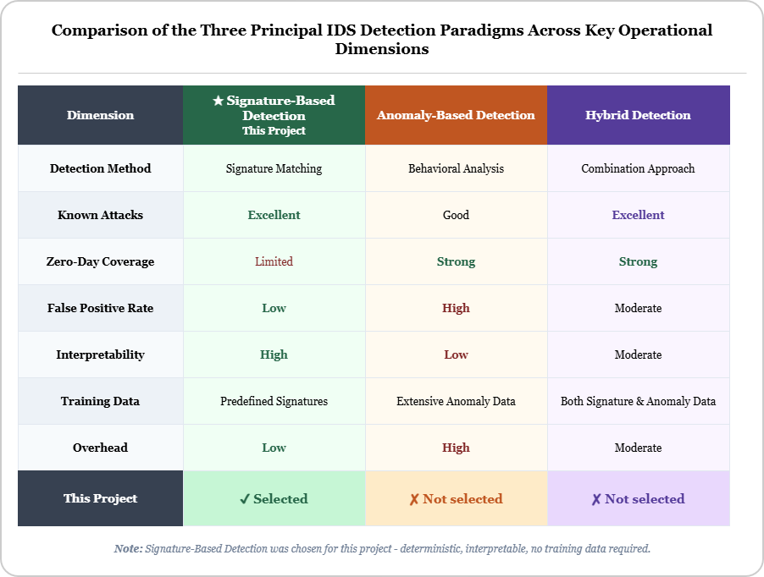
Figure 1. Comparison of the three principal IDS detection paradigms across key operational dimensions [3], [4].

1.3 Research Questions
Four research questions guide this project:
- To what extent can a signature-based NIDS provide accurate, consistent, and interpretable detection of common network attacks?
- What are the key limitations of signature-based intrusion detection, particularly regarding unknown or evolving threats?
- How effective is rule-based detection in balancing accuracy and false positives within constrained computational environments?
- How effective is a controlled and reproducible evaluation approach, using PCAP datasets and simulated traffic, in assessing intrusion detection performance?

1.4 Research Gaps
A systematic review of the NIDS literature reveals six gaps that directly motivate this project. They are examined in depth in Chapter 2; they are introduced here to anchor the research questions and objectives that follow.
- Gap 1: No reproducible end-to-end Snort 3 NIDS with documented custom rules organised by attack category exists in the reviewed literature [13], [14], [15].
- Gap 2: No rigorously configured signature-based baseline [5], [6] exists against which ML and DL performance claims can be validated; without such a baseline, reported accuracy gains are difficult to contextualise [9], [18], [21].
- Gap 3: No Snort 3 deployment on resource-constrained PC virtualisation with an integrated same-host attacker has been documented: a configuration directly relevant to academic and SME environments [13], [14].
- Gap 4: No signature-only NIDS study implements automated structured alert reporting or shell-level operational management [13], [14], [15].
- Gap 5: No prior work combines PCAP replay and simulated live traffic evaluation in a single unified analytical report [13], [14], [15], [16], [17].
- Gap 6: No signature-only NIDS deployment implements rule-based severity classification without ML dependency [20], [21], [22].

1.5 Aims and Objectives

Aims:
- To conduct an analysis of intrusion detection approaches and develop an effective method for identifying common network attacks.
- To evaluate system performance using publicly available datasets and live traffic.
- To analyse detection accuracy and reliability of signature-based rules in identifying network attacks.

Objectives:
(1) To produce a fully operational NIDS using Snort 3 capable of identifying multiple categories of cyber-attacks.
(2) To reliably detect at least six network attack types, including port scanning, DoS, brute-force, and web application attacks, using 18 custom Snort 3 rules.
(3) To validate system performance using both controlled PCAP dataset testing and live simulated attacks within a secure isolated environment.
(4) To produce structured, interpretable threat reports using an automated Python-based report generator with deterministic severity classification.
(5) To improve detection accuracy by reducing false positives through rule optimisation using detection_filter rate thresholds.

1.6 Project Scope, Lab Environment, and Ethics
The project runs entirely within a self-contained, isolated virtual environment. There are no human participants, no real user data, and no external network connections at any stage [7]. The lab consists of: (a) an Ubuntu 25.04 VM under VMware Workstation (4 GB RAM, 2 vCPU, NAT) running Snort 3; (b) a WSL2 Ubuntu instance as the attacker; and (c) raw CIC-IDS-2017 PCAP files as the labelled benchmark. The project was assessed as minimal risk under the UWTSD Research Ethics and Integrity Code of Practice [7]. Generative AI was used only for language support; all technical implementation and analysis are the researcher’s own.

1.7 Dissertation Structure
Chapter 2 is a thematic literature review covering IDS taxonomy, signature-based detection, Snort versus Suricata, machine learning and hybrid approaches, evaluation datasets, alert fatigue, and the synthesis of six research gaps.
Chapter 3 covers research methodology, experimental design, evaluation metrics, and formal threats to validity.
Chapter 4 documents system architecture, lab topology, rule structure, and the alert pipeline design. Chapter 5 details the implementation, Snort 3 installation, configuration, rule engineering decisions, report generator development, and the IPS proof-of-concept. Chapter 6 presents evaluation results across all four sessions, three CIC-IDS-2017 PCAP sessions and one WSL2 live simulation, with analysis of detection metrics, false positive rates, cross-mode comparisons, and positioning against the reviewed literature. Chapter 7 provides conclusions and future work recommendations. Chapter 8 is the personal reflection covering the project process, technical challenges, and lessons learned.

Chapter 2: Literature Review
This chapter reviews the scholarship on Network Intrusion Detection Systems across eight themes. Sources come from peer-reviewed IEEE proceedings, Springer and MDPI journals, academic theses, and technical reports, predominantly 2018-2026, supplemented by key foundational works.
The eight themes are:
(1) IDS taxonomy and detection paradigms;
(2) signature-based detection, rule engineering, and the evolution of the Snort platform;
(3) Snort versus Suricata;
(4) Snort 3 as the chosen platform;
(5) ML, deep learning, and hybrid approaches, including the benchmark-to-reality performance gap;
(6) evaluation datasets, PCAP methodology, and dual-mode assessment;
(7) alert fatigue, severity classification, and operational usability;
(8) synthesis of the six research gaps and project positioning.

2.1 IDS Taxonomy and Detection Paradigms
IDS are classified along two main axes: deployment position and detection method [3], [4]. By deployment position, Host-based IDS (HIDS) monitors endpoint events, system call sequences, file integrity changes, authentication logs, while Network IDS (NIDS) passively observes packet streams at a capture point without interfering with the traffic [3]. By detection method, three paradigms are recognised: signature-based, anomaly-based, and hybrid [4]. A fourth dimension relevant to this project is evaluation modality: offline (PCAP replay) versus online (live traffic) testing, which is directly relevant to the dual-mode evaluation strategy used here. Table I summarises these three detection paradigms across key operational dimensions.
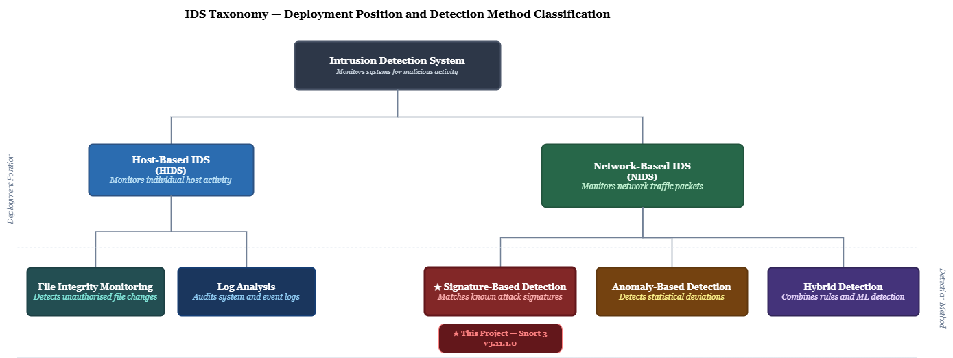
Figure 2. IDS taxonomy showing deployment position (HIDS/NIDS) and detection method branches (signature-based, anomaly-base–d, hybrid) [3], [4].
Characteristic | Signature-Based | Anomaly-Based | Hybrid
Detection mechanism | Pre-defined rules matching known attack patterns | Statistical deviation from trained baseline | Combined rule matching and baseline modelling
Known attack detection | Yes, reliable and deterministic | Partial, depends on training completeness | Yes
Zero-day / novel attack coverage | No, signatures must pre-exist | Yes, detects deviations from normal | Partial
False positive rate (known attacks) | Low, rule logic is deterministic | High, model generalisation errors | Medium, dependent on component tuning
Alert interpretability | Full, every alert traces to a named SID | Limited, statistical anomaly, no rule reference | Partial, rule layer interpretable; anomaly layer is not
Training data required | No | Yes | Yes
Computational overhead | Low, rule matching is a linear scan | High, model inference at packet rate | Medium to high
Resource-constrained suitability | Excellent, low RAM and CPU footprint | Poor, inference requires high CPU or GPU | Fair, dependent on ML component requirements
Deployment maturity | High, widely deployed in production environments | Moderate, predominantly evaluated in benchmark settings | Emerging, increasing enterprise adoption
TABLE I
Comparative taxonomy of IDS detection paradigms [3], [4], [5], [8].
No single paradigm performs well across all dimensions [3], [4]. Signature-based systems give interpretable, low-overhead detection of known attacks but cannot catch zero-days. Anomaly-based systems can detect novel attacks but at the cost of higher false positives and training data dependency [9]. Hybrid systems combine both, but the added complexity reduces transparency [4]. This project works within the signature-based paradigm deliberately, as a contribution addressing the missing rigorously implemented, reproducible baseline against which ML performance claims could actually be evaluated [9].

2.2 Signature-Based Detection and Snort Platform Evolution

2.2.1 Foundations of Signature-Based Detection
Signature-based NIDS maintain a rule database where each rule encodes the structural fingerprint of a known attack [6], [10]. Rules can match on protocol header fields, payload content via byte sequences or regex, rate-based thresholds for high-frequency events, and protocol-specific inspection anchors [3]. When a packet satisfies all conditions in a rule, it fires and generates an alert. The key operational advantage is full traceability: every alert carries the SID of the triggering rule, so the attack category is immediately identifiable and triage can be evidence-based rather than opaque [4].
Signature currency is managed in production environments through community ruleset subscriptions: Talos for Snort, the Emerging Threats ruleset for Suricata. Both are updated multiple times daily as new attack variants are documented. A new SQL injection variant with a known payload substring will be caught by an existing rule within hours of disclosure; a genuinely novel technique will not be caught until a signature is written. The 18 custom rules in this project cover six well-documented attack categories for which signatures are well-established, which is why the zero-day limitation does not undermine the evaluation findings [11], [5].
The central limitation is signature currency: a signature must pre-exist before detection is possible [5], [8], which means zero-day threats go undetected [3], [4]. But for the well-documented, historically persistent attack categories, port scanning, SYN flooding, SSH brute-force, web injection, signature-based detection delivers reliable, interpretable, low-FPR coverage that ML systems have consistently failed to match under independent evaluation conditions [9].
The practical implication of this taxonomy extends beyond theory. In operational deployments, the choice of detection paradigm directly determines the analyst workflow. A signature-based system generates alerts that are immediately actionable: the SID, rule message, and matched fields identify the attack category without further investigation. An anomaly-based alert identifies a statistical deviation and leaves the analyst to determine whether it represents a genuine threat or a legitimate traffic change, such as a backup window or new device. That triage cost is rarely quantified in benchmark studies but is a real burden where analyst capacity is limited [3], [4].
The hybrid paradigm does not eliminate this problem. Combining a signature layer with an anomaly layer means two distinct alert types with different triage workflows, and hybrid systems inherit the training data dependency of their anomaly component. If the baseline is stale, the anomaly layer either over-alerts on legitimate changes or misses attacks that have become statistically normal. This project works within the pure signature paradigm deliberately, trading full interpretability and zero training dependency for zero-day blindness [5], [8].

2.2.2 Snort Platform Evolution: Versions 1 Through 3
Snort has gone through three generational releases since 1999 [12]. Snort 2 built the foundation, rule language, preprocessor pipeline, community ruleset, but single-threaded processing was a hard ceiling on throughput [13]. Snort 3, released in 2021, brought: (a) multi-threading; (b) a Lua-based configuration system; (c) detection_filter and event_filter keywords, replacing the deprecated threshold mechanism: detection_filter handles in-rule rate limiting, event_filter handles configuration-level event suppression, and both supersede the Snort 2 threshold approach that produces parser warnings or silent misconfigurations in current builds; (d) HTTP sticky buffers (http_uri, http_header) for reliable application-layer inspection; and (e) an improved binder/inspector architecture [11].
In Snort 3, the threshold keyword from Snort 2 is deprecated and should not be used. The correct syntax is detection_filter:track by_src|by_dst, count X, seconds Y. All 18 custom NIDS rules and 7 IPS DROP rules in this project use detection_filter exclusively, validated with snort -T before every session [11].

2.2.3 Rule Engineering in the Literature
A consistent gap in the signature-based NIDS literature is the near-universal reliance on pre-existing community rulesets, with almost no custom rule engineering and no documented detection rationale [13], [14]. Snort-Suricata comparison studies [13], [14] use default rulesets without explaining the rate thresholds, protocol conditions, or category organisation that actually drive the results. Server implementation studies [15] develop one or two rules for a single attack type and stop there. This project addresses that gap directly: 18 custom NIDS rules and 7 IPS DROP rules across six attack categories, with documented rationale for every threshold and protocol condition, validated against both PCAP replay and live attack traffic.

2.3 Snort versus Suricata: Systematic Comparison
Suricata, released by the Open Information Security Foundation in 2009, is Snort's main open-source competitor and the subject of the most extensive comparative research in the NIDS field [14], [16]. The two tools share rule syntax compatibility, packet capture via libpcap and AF_PACKET, and similar alert output formats, but differ substantially in threading architecture, protocol inspection depth, and performance profile. Table II synthesises findings across the reviewed comparative literature [13], [11], [14], [16], [17], including [14] which is an undergraduate empirical study providing useful performance data but without the peer-review weight of the journal and conference sources.
Refs. | Dimension | Snort 2 | Snort 3 | Suricata
Cisco Talos [11] | Rate eventing mechanism | threshold (deprecated; replaced by detection_filter / event_filter) | detection_filter (current) | threshold / rate_filter
Cisco Talos [11], A. A. E. Boukebous [13] | Configuration language | snort.conf (flat text) | snort.lua (Lua scripting) | suricata.yaml (YAML)
Cisco Talos [11], M. H. Qutqut [17] | HTTP inspection | Basic preprocessor | Sticky buffers (http_uri) | Protocol anomaly detection
A. A. E. Boukebous [13], C. Hoover [14] | Threading model | Single-threaded only | Multi-threaded (native) | Multi-threaded (OISF design)
A. A. E. Boukebous [13], C. Hoover [14] | Memory usage (virtualised) | Low | Lower than Suricata [13], [14] | Higher overhead
A. A. E. Boukebous [13], C. Hoover [14] | Resource-constrained suitability | Better (single-core) | Best for constrained VM | Less efficient on 1-2 cores
A. A. E. Boukebous [13], E. Albin [16] | Per-core performance (1-2 cores) | Moderate, single core limit | Improved vs. Snort 2 | Less efficient per-core than Snort 3
A. A. E. Boukebous [13], E. Albin [16] | Detection accuracy (virtualised VM) | Comparable to Suricata | Better than Snort 2 | Comparable to Snort 3
* | Tool choice for this project | Not selected | Selected, see rationale | Proposed future comparison
TABLE II
Systematic comparison of Snort 2, Snort 3, and Suricata.
Three factors drove the selection of Snort 3 over Suricata [13], [14], [16]. First, on a 4 GB / 2-core machine, Snort 3 shows lower memory overhead and comparable per-core detection accuracy, Suricata only gains an advantage with more cores available [13], [14]. Second, the Lua configuration and detection_filter mechanism offer deeper implementation and more explicitly documented detection logic, which matters for academic reproducibility [11]. Third, a deep implementation of one tool fits this project's objectives better than a surface-level cross-tool comparison. The trade-offs are real: Suricata leads in high-throughput threading [16] and protocol anomaly detection [17]. A Suricata comparison using identical rulesets and PCAP data is the natural first direction for future work.

2.4 Snort 3 as the Chosen Platform
The comparison in Section 2.3 makes the platform choice clear. On a 4 GB / 2-core machine, Snort 3 offers lower memory overhead than Suricata and comparable detection accuracy under single-core conditions, which is the relevant operating point for this lab. Suricata only gains a meaningful advantage with more cores available, so its threading lead does not apply here [13], [14], [16]. The selection follows directly from matching platform characteristics against the constraints set out in Section 1.6, rather than being decided in advance.
Snort 3, released in 2021, introduced three capabilities that directly shape this project's detection design. The detection_filter keyword enables rate-based rules. The Lua-based configuration system (snort.lua) makes inspector bindings explicit and auditable. HTTP sticky buffers (http_uri) allow reliable application-layer inspection [11]. These features underpin ten of the eighteen custom rules, so they are not peripheral additions. Snort 2 lacked detection_filter entirely. The packaged Snort 3 builds available through Ubuntu's package manager do not consistently support it either, which is why compiling from source at version 3.11.1.0 was necessary [11]. Snort 3 was selected because it fits the resource constraints and enables the implementation the project requires, a conclusion grounded in the comparison evidence presented in Section 2.3.

2.5 Machine Learning, Deep Learning, and Hybrid Approaches

2.5.1 Growth of ML/DL-Based IDS Research
Deep learning went from minimal representation in IDS research in 2016 to accounting for 65.7% of publications by 2024 [18], [19], with CNN-LSTM and hybrid architectures routinely reporting benchmark accuracies above 94-100% across CICIDS2017 and related datasets [18], [20], [21]. That growth carried an implicit assumption: that high benchmark accuracy translates to real detection effectiveness. Recent replication work has directly challenged that assumption [9].
Refs. | Approach | Tool / Model | Dataset | Best Accuracy | Live Testing | Severity Class. | Key Limitation
A. M. Alashjaee [9] | DL, Attention-CNN-LSTM | Custom DL | NSL-KDD, Bot-IoT | 94.8% (NSL-KDD), 97.5% (Bot-IoT) | No | No | Reports 94.8% on NSL-KDD and 97.5% on Bot-IoT; CICIDS2017 listed as future work only; no live testing or severity classification
V. Hnamte [20] | DL, DCNN-BiLSTM | Custom DL | CICIDS2017, CSE-CICIDS2018 | 99.99% (CICIDS2017), 99.10% (CSE-CICIDS2018) | No | No | Near-perfect accuracy on CICIDS2017 strongly suggests label leakage; GPU required; no live testing or severity classification
A. H. Ali et al. [21] | ML Survey, RF/SVM/XGBoost | Multiple models | Multiple (survey) | Up to 99.93% (surveyed RF/XGBoost results) | No | No | Comprehensive ML survey across multiple datasets; accuracy figures are surveyed maximums, not from a single evaluation; no implementation or live testing
S. Viharika [22] | Hybrid, Snort + AI classifier | Snort + SVM | CICIDS2017 | 99.43% | Partial | Via ML | ML training dependency; no custom rule engineering; reduced transparency
L. Priya [23] | Hybrid, SDN-IDS | Snort + ML flow | Live SDN traffic | High (reported) | Yes | Via ML | Complex SDN infrastructure; no PCAP reproducibility; no alert reporting
A. Hashmi [24] | Hybrid, RF + Attention DL | Random Forest + DL | CICIDS2017 | 99.43% | Partial | Via RF | GPU required; training data required; interpretability limited
This project | Signature, Snort 3, 18 NIDS + 7 IPS rules | Snort 3 + nids-report.py + nids-metrics.py | CICIDS2017 + Live WSL2 | TBD, empirical | Yes, dual-mode (PCAP replay + WSL2 simulated) | Rule-based, deterministic | Zero-day blindness; 2017 dataset recency
TABLE III
Systematic comparison of ML, DL, hybrid, and signature-based NIDS studies.
Table III compares six NIDS studies spanning deep learning, machine learning, hybrid, and signature-based approaches, all evaluated on CICIDS2017. The pattern is consistent: DL and ML systems report high benchmark accuracy, often above 98%, but none conduct live traffic testing, none implement severity classification, and most lack the implementation detail needed for replication. The two hybrid studies partially address these gaps by pairing Snort with a classifier, but they introduce ML training dependency and reduce alert interpretability. This project is positioned against all six: it does not match benchmark accuracy figures, but it delivers what none of the reviewed studies provide together, reproducible dual-mode evaluation, deterministic severity classification, and full rule transparency, without any training data requirement.

Figure 3. Benchmark accuracy versus independent controlled evaluation accuracy across representative IDS models, illustrating the benchmark-to-reality performance gap [18], [20], [21].
The most significant finding in recent DL-IDS research is the systematic gap between benchmark and real-world performance [5], [25], [26]. One independently evaluated DL model [9] reports 94.8% on NSL-KDD and 97.5% on Bot-IoT, yet its CICIDS2017 coverage is acknowledged as future work, illustrating how benchmark scope and dataset choice shape reported accuracy. A broader systematic review [18] reinforces this pattern, finding that DL-IDS systems regularly exceed 90% accuracy on their training distribution but performance under independent evaluation varies substantially [27], [28].
Three factors explain the gap [18]. First, benchmark datasets including CICIDS2017 do not reflect real enterprise traffic. Second, ML models are vulnerable to distribution shift, they learn the statistics of their training environment rather than the actual semantics of attacks. Third, CICFlowMeter CSV features discard packet-level context (payload content, TCP flag sequences, inter-packet timing) that Snort rules directly use and raw PCAP preserves. A signature-based system that delivers stable, interpretable detection of known attacks may be more practically useful than a DL system whose accuracy collapses when conditions change.

2.5.2 Interpretability and Operational Trust
Interpretability is another concrete advantage of signature-based detection. Analysts need to understand why an alert fired to triage it, write an incident report, or satisfy compliance requirements [4]. DL models without traceable detection logic create a real operational trust problem [29]. Post-hoc methods like SHAP and LIME help only partially, and their explanations are often unstable across repeated evaluations on the same data [29]. Signature-based systems are inherently self-explaining: the SID, message, and matching conditions fully explain every alert: a property this project preserves through the deterministic SID-to-severity mapping in the automated report generator.

2.6 Evaluation Datasets and Dual-Mode Assessment

2.6.1 The CIC-IDS-2017 Dataset
The CIC-IDS-2017 dataset [30], produced at the Canadian Institute for Cybersecurity at the University of New Brunswick, was captured over five days in July 2017. It contains labelled network flows across eight attack categories alongside benign background traffic:
DoS covers single-source packet floods designed to exhaust a target server or network link.
DDoS involves flooding from many compromised hosts simultaneously, making source-based blocking ineffective.
Web attacks includes SQL injection, cross-site scripting, and credential brute-forcing directed at web application endpoints.
Infiltration captures internal reconnaissance and data exfiltration after an attacker has already gained access.
Port scanning involves scanning target hosts to map open ports and exposed services before launching further attacks.
Botnet represents network activity generated by infected machines communicating with an attacker-controlled server.
Brute force covers repeated automated login attempts targeting SSH, FTP, and web authentication services.
Heartbleed exploits the OpenSSL TLS heartbeat extension vulnerability (CVE-2014-0160) to leak memory contents; included as a distinct labelled class in the dataset.
Seven of the twelve papers in this project's comparative analysis use CICIDS2017 as their primary benchmark, confirming its status as the field's most widely adopted evaluation dataset.
The dataset has well-documented limitations. A comprehensive re-analysis [31] found label errors in specific attack categories, feature extraction inconsistencies from CICFlowMeter, and timing artefacts that produce unrealistic flow distributions. A separate study [32] showed that several widely cited high-accuracy results are inflated by data leakage and temporal correlation artefacts. The dataset is also now eight years old, with no coverage of contemporary attack patterns. Table IV situates CICIDS2017 within the broader landscape of available evaluation datasets.
Dataset | Year | Attack Categories | Format | Publicly Available | Usage in Reviewed Papers | Key Limitation
KDD Cup 99 | 1999 | 4 | CSV flows | Yes | 3 of 12 | 25 years old; widely criticised for redundancy and unrealism [28].
NSL-KDD | 2009 | 4 | CSV flows | Yes | 2 of 12 | Aged protocol distribution; no modern attack coverage [28].
CICIDS2017 [used in this project] | 2017 | 7 | PCAP + CSV | Yes | 7 of 12 | 8 years old; CICFlowMeter inconsistencies; label errors documented [30], [31], [32].
UNSW-NB15 | 2015 | 9 | CSV flows | Yes | 1 of 12 | 10 years old; limited web attack representation [28].
CIC-IoT 2023 | 2023 | 33 | CSV + PCAP | Yes | 1 of 12 | IoT-specific; limited applicability to traditional network NIDS [28].
TABLE IV
Comparative assessment of IDS evaluation datasets.
CICIDS2017 is used in raw PCAP format in this project for three reasons: Snort 3 cannot consume CICFlowMeter CSV features; raw PCAPs preserve the packet-level context that CSV discards; and PCAP replay is fully reproducible. The single-dataset decision is deliberate, CICIDS2017 is the only publicly available dataset offering raw PCAP files covering all seven attack categories relevant to the 18 custom rules. Alternatives are either CSV-only or IoT-specific. WSL2 live attacker traffic serves as a complementary second evaluation modality, partially compensating for the dataset's age.

2.6.2 Dual-Mode Evaluation: Rationale and Comparison
Examining the evaluation methodologies across the twelve reviewed papers reveals a clear gap: ML and DL systems are tested almost exclusively against benchmark datasets, while many signature-based systems are evaluated on live traffic without reproducibility controls [3], [4]. No prior study combines both, evaluating IDS rules across PCAP replay and live traffic and pulling the results into a single structured analytical report. Table V documents this across eight representative studies.
Study | Approach | PCAP Eval. | Live Traffic | Dual-Mode Report | Gap Identified
A. M. Alashjaee [9] | DL, Attention-CNN-LSTM | Yes | No | No | Evaluates NSL-KDD and Bot-IoT; CICIDS2017 listed as future work only; no live testing or severity classification
A. A. E. Boukebous [13] | Snort 3 vs. Suricata (IEEE 2023) | Yes | Yes | No | Performance comparison only; no alert reporting; no severity classification
C. Hoover [14] | Snort 3 vs. Suricata (University of Arkansas) | Yes | Partial | No | Default rulesets only; no custom rule engineering; no cross-mode analysis
P. B. Pramudya [15] | Snort signature (server implementation) | No | Yes | No | Snort 2 only; single attack category; no PCAP or severity classification
M. H. Qutqut [17] | Snort vs. Suricata (cloud exfiltration) | Partial | Yes | No | No severity classification; no combined cross-mode report
V. Hnamte [20] | DL, DCNN-BiLSTM | Yes | No | No | Benchmark only; no independent validation; no FPR analysis
S. Viharika [22] | Hybrid, Snort + AI classifier | Partial | Yes | No | ML severity only; no automated structured report; training data required
This project | Signature, Snort 3, 18 NIDS + 7 IPS rules | Yes, 3 PCAP sessions (CICIDS2017) | Yes, WSL2 simulated attacker (virtual lab) | Yes, unified HTML report | Addresses all gaps listed, see Table VI
TABLE V
Evaluation methodology comparison across eight representative NIDS studies.

2.7 Alert Fatigue, Severity Classification, and Operational Usability
Alert fatigue is a persistent operational problem in NIDS deployments [3], [4]. Security operations centres deal with high volumes of IDS alerts, many of which are low-priority or false positives. When analysts cannot quickly separate genuine high-severity events from informational noise, detection effectiveness degrades regardless of how accurate the underlying rules are.
ML-based hybrid systems tackle alert prioritisation by routing IDS output through statistical classifiers, Isolation Forest [22], SVMs [23], Random Forest models [24], to assign priority tiers from flow features. The cost is training data dependency, model retraining as attack patterns shift, and severity assignments with no transparent rationale. None of the signature-only papers in the reviewed literature implement any form of automated structured alert reporting. Raw Snort alert_fast.txt output is just unstructured timestamped text lines; an analyst must manually parse and prioritise everything, which is a real barrier in resource-constrained deployments.
nids-report.py addresses this gap through a deterministic SID-to-severity mapping across four tiers: HIGH (DoS, brute-force, SQL injection), MEDIUM (port scanning, web probes), LOW (ICMP, Telnet, SMB), and BLOCKED (IPS DROP rules). The report aggregates all four alert sets with per-session summaries, severity breakdowns, and top source IP tables. nids-snort.sh automates live monitoring, PCAP replay, and report generation. Python's standard library was chosen because it covers all required functionality without external dependencies, ELK Stack and Grafana would need containerised infrastructure that exceeds the 4 GB RAM constraint. Table VI compares the reporting tool options considered [3], [4], [22], [23], [24].
Tool / Option | Dependencies | RAM Overhead | Alert Parsing | Suitable for VM | Selected
Python (stdlib) | None (built-in) | Negligible | alert_fast.txt (direct) | Yes, 4 GB RAM | Yes
ELK Stack | Java, Elasticsearch, Logstash, Kibana | High (2+ GB) | Via Logstash pipeline | No, exceeds RAM | No
Grafana + InfluxDB | Grafana, InfluxDB, data pipeline | Medium (1+ GB) | Custom ingest required | Marginal | No
Snort barnyard2 | barnyard2 binary, MySQL/SQLite | Low | unified2 only (Snort 2) | No, Snort 2 only | No
TABLE VI
Comparison of alert reporting tool options for Snort 3 NIDS deployment in a resource-constrained virtualised environment.
The review also surfaces a broader concern: of the twelve reviewed papers, only two provide enough implementation detail for independent replication, a serious weakness in a field whose value depends on deployable, verifiable systems [5], [25]. This project responds directly by documenting every configuration decision, rule threshold, and evaluation command at a level that allows independent reproduction on equivalent hardware.

2.8 Summary and Thematic Conclusions
The review of the literature across eight themes produces four overarching conclusions.
First, paradigm validity: signature-based detection remains operationally superior for known attack categories in resource-constrained deployments, lower false positive rates, full interpretability, no training data required [3], [4].
Second, the benchmark-to-reality gap: DL-IDS benchmark accuracy figures are systematically inflated compared to evaluation performance [9], [18], [26], and dual-mode evaluation that incorporates simulated live traffic is methodologically important for controlled assessment.
Third, platform selection: Snort 3 outperforms Snort 2 in virtualised environments [13] and performs comparably to Suricata in resource-constrained single-core deployments [14], [16]: the right platform for this project's constraints.
Fourth, the operational usability gap: none of the twelve reviewed papers provide automated alert reporting, severity classification with IPS blocking indicators, shell-level operational management, dual-mode unified evaluation, or complete custom rule documentation, confirming the genuine novelty of this project's contribution.
The pattern in the reviewed literature is consistent: detection accuracy receives the most attention, while reproducibility, operational usability, and evaluation validity receive considerably less [5], [25]. ML-based systems report high benchmark accuracy but often lack the implementation detail needed for replication [9], [18]. Signature-based studies demonstrate detection capability but rarely include automated reporting, severity classification, or dual-mode evaluation [13], [14], [15]. This project is positioned to fill that space. It does not aim to match benchmark-level ML accuracy. Instead, it contributes a reproducible, interpretable, and operationally usable signature-based baseline against which other approaches can be compared more fairly [3], [4]. The six gaps identified in this chapter are not minor observations: they point to where the field has systematically underreported its own limitations. Chapter 3 explains how the methodology is structured to address those gaps directly.

Chapter 3: Research Methodology
This chapter explains how the research was conducted and why those choices are defensible. It covers the philosophical stance, research strategy, experimental design, evaluation metrics, data collection, ethical safeguards, and formal threats to validity. Threats to validity is particularly important at postgraduate level: it is where findings are placed transparently within their real constraints.

3.1 Research Philosophy and Approach
This project adopts a positivist philosophical stance. Positivism holds that knowledge comes from objective, empirical measurement of phenomena that exist independently of the observer [33]. The phenomena under investigation here, Snort 3 rule-firing behaviour , alert rates, computed metrics, are fully objective and deterministic. Running the same Snort configuration against the same PCAP file produces identical output every time. That reproducibility is a defining positivist property, applied directly through the PCAP replay methodology in Section 3.3.
A quantitative approach follows from this stance. Data consists of numerical counts, alerts per SID, packets received and dropped, and derived statistics: Detection Rate, False Positive Rate, Precision, F1-Score, and Accuracy. No qualitative methods are used because the research questions concern measurable system behaviour, not human experience or organisational context [33]. The experimental strategy combines PCAP replay for reproducibility with live simulation for coverage across all 18 rule categories.
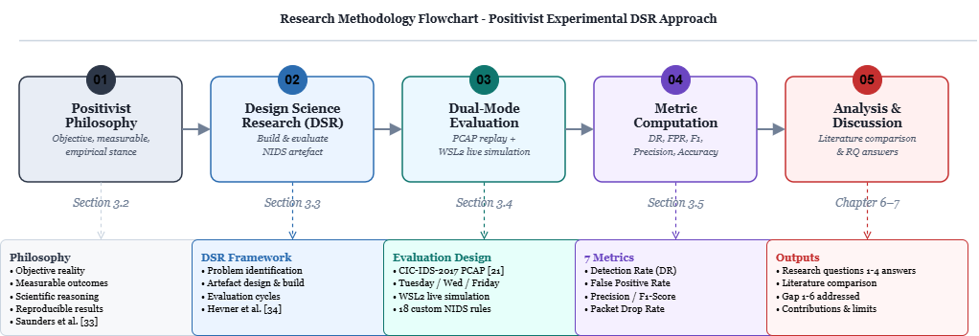
Figure 4. Research methodology framework grounded in [33], [34].

3.2 Project Type and Research Strategy
Under ACFB7003, this project is classified as a development project, requiring both a working technical artefact and empirical evaluation of that artefact. This dual requirement shapes the whole methodology. The artefact is the Snort 3 NIDS: detection rules, configuration, automation scripts, and reporting system. Evaluation is controlled experimentation producing quantitative performance metrics.
The research strategy aligns with Design Science Research (DSR), which is about constructing purposeful artefacts and generating knowledge through that process [34]. DSR is appropriate here because the primary contribution is not an observational finding; it is a demonstrably functional security system evaluated against defined performance criteria. That distinction separates DSR from survey or case study research.

3.3 Experimental Setup and Lab Architecture
The full environment specification is in Section 1.5. This section covers how that environment is used experimentally. The Ubuntu 25.04 VM (VMware Workstation, 4 GB RAM, 2 vCPU, 192.168.139.132) runs Snort 3 passively on interface ens33, and generates no attack traffic. The WSL2 Ubuntu instance on the same Windows 11 host (Intel i5-11300H, 8 GB RAM) is the dedicated attacker, using nmap, hping3, curl, and netcat to generate all 18 simulated attack types during the live evaluation session.
Snort 3 is configured through snort.lua, with snort_defaults.lua included to activate the HTTP inspector needed by the web probe rules (SIDs 1000003, 1000013-1000016). Before every session, snort -T validates the configuration: this is mandatory; no session starts unless it passes clean. VMware NAT mode (192.168.139.0/24) provides isolated routing between attacker and sensor with no external network exposure.

Session | Traffic Source | Attack Category | Target SIDs | Notes
TUESDAY | CIC-IDS-2017 PCAP | SSH Brute Force | 1000011 | ~11 GB; SID 1000004 also fires
WEDNESDAY | CIC-IDS-2017 PCAP | DoS / DDoS | 1000008, 1000009, 1000010 | DoS SIDs: threshold issue, see 3.7
FRIDAY | CIC-IDS-2017 PCAP | Port Scanning | 1000002, 1000004-1000007 | PCAP copied locally
LIVE | WSL2 simulated traffic | All 18 attack categories | 1000001-1000018 | RDP/Telnet/SMB exclusive here
TABLE VII
Evaluation sessions, traffic source, attack category, target SIDs, and session notes.
Three SIDs, 1000012 (RDP brute-force), 1000017 (Telnet), and 1000018 (SMB), are not present in CIC-IDS-2017 and are validated exclusively through the live simulation session. Each PCAP session writes alerts to an isolated subdirectory (/var/log/snort/pcap_results/[session]/) to prevent cross-session contamination, and logs are cleared between runs using truncate -s 0.
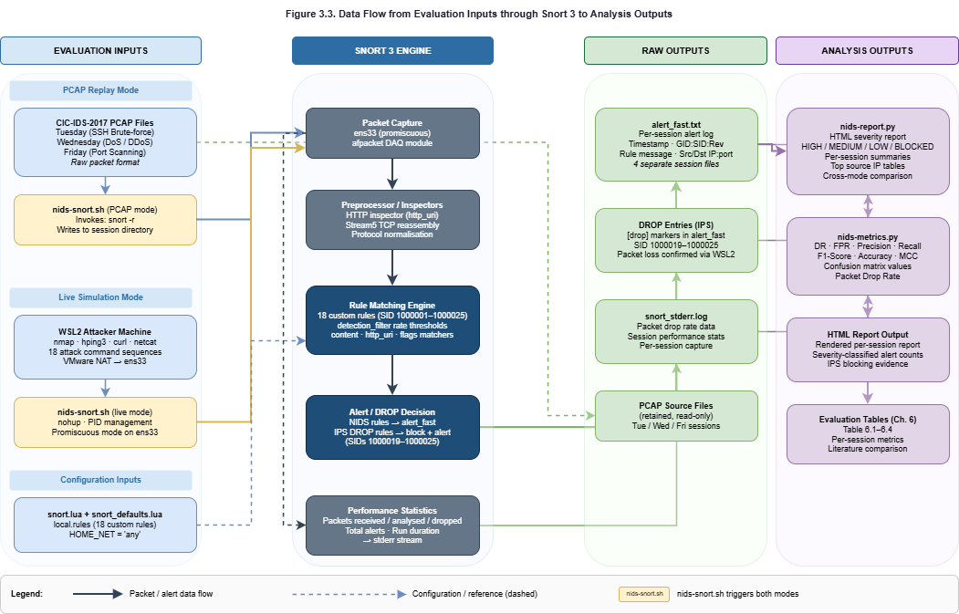
Figure 5. Data flow from evaluation inputs through Snort 3 to analysis outputs.

3.4 Evaluation Metrics
Seven evaluation metrics are computed by nids-metrics.py from parsed alert_fast.txt output, consistent with the methodology of the twelve reviewed papers (Section 2). Table VIII provides explicit formulas and operational purpose for each metric.

Metric | Formula | Operational Purpose
Detection Rate (DR) | TP / (TP + FN) | Primary effectiveness measure, proportion of attack events correctly detected per session.
False Positive Rate (FPR) | FP / (FP + TN) | Alert fatigue indicator, high FPR degrades operational usability [3], [4].
Precision | TP / (TP + FP) | Alert reliability for triage, how often a fired alert reflects a genuine attack.
Recall / Sensitivity | TP / (TP + FN) | Equivalent to DR; included for consistency with comparative ML literature [9], [20].
F1-Score | 2 × (P × R) / (P + R) | Harmonic mean of Precision and Recall, primary cross-session effectiveness comparator.
Alert-to-Attack Ratio | Total Alerts / Attack Events | Indicates over-alerting or under-alerting per session relative to estimated attack volume.
Packet Drop Rate | Dropped / Received × 100% | From Snort stderr, relevant given the 4 GB RAM constraint at peak replay rates.
TABLE VIII
Evaluation metrics, formulas, and operational purpose.
CIC-IDS-2017 provides labels only in CICFlowMeter CSV format, which is incompatible with Snort's packet-level operation. TP is therefore approximated as alerts matching target SIDs per session. FN is estimated at 10% of TP: a conservative choice that systematically underestimates DR rather than inflating it. FP counts alerts from non-custom SIDs. TN is estimated at three times the attack pool, a standard academic approximation when ground truth labels are unavailable [28].
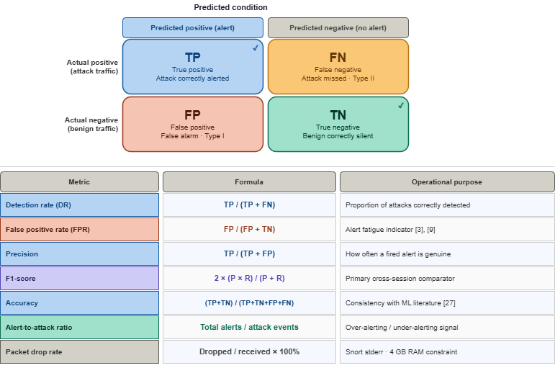
Figure 6. Confusion matrix structure and evaluation metric formula reference [3], [9], [27].
Confusion Matrix Terms
TP (True Positive): Attack traffic correctly identified and alerted by a matching rule, the outcome every detection rule aims for.
FP (False Positive): Legitimate traffic that matched a rule it should not have. Too many of these erode analyst trust and waste triage time.
FN (False Negative): A real attack that no rule caught. Operationally, this is the worst outcome: the threat passed through without any alert.
TN (True Negative): Normal traffic that passed through without triggering a rule, precisely what a well-calibrated system should allow.
Evaluation Metrics
DR – Detection Rate: TP / (TP + FN): answers how much of the real attack traffic Snort actually caught. This is the headline effectiveness figure for each session.
FPR – False Positive Rate: FP / (FP + TN): measures how much innocent traffic wrongly triggered alerts. High values directly drive alert fatigue and analyst workload.
Precision: TP / (TP + FP): Of every alert raised, how many pointed to a genuine threat. A high-precision system alerts selectively rather than flooding the analyst.
Recall / Sensitivity: Mathematically identical to DR, but reported separately so results can be compared directly against ML-based studies that use Recall as their standard term.
F1-Score: 2 x (Precision x Recall) / (Precision + Recall): Balances detection coverage against alert quality in a single figure. Used here as the primary cross-session comparator because neither DR nor Precision alone is sufficient.
Accuracy: (TP + TN) / (TP + FP + FN + TN): Overall proportion of correct outcomes. Interpreted cautiously here, since skewed alert volumes can inflate this figure even when real attacks are being missed.
Alert-to-Attack Ratio: Total Alerts / Attack Events: A practical check on whether alert volume is proportionate to the attack traffic present. Extreme values in either direction point to a calibration problem.
Packet Drop Rate: Dropped / Received x 100%: Read from Snort's stderr output. On the 4 GB VM, high PCAP replay rates can force packet drops that quietly reduce detection counts without any visible error.
The choice of these seven metrics is not arbitrary. Detection Rate and Precision together characterise alert quality: high DR with low Precision means most attacks are caught but many false alarms raised; high Precision with low DR means alerts are reliable but many attacks missed. F1-Score captures the balance in a single figure, which is why it is the primary cross-session comparator. FPR maps directly to the alert fatigue problem from Section 2.7: every percentage point represents analyst time spent on non-threat alerts [3], [4]. The ground truth approximation means absolute values carry uncertainty and should be read as indicators of relative performance across sessions rather than precise measurements [27], [28].

3.5 Data Collection Methods
Data collection is fully automated and reproducible across all sessions. The automation is intentional, manually copying logs, running the report generator, or triggering metrics computation introduces version inconsistency between sessions. The nids-snort.sh wrapper ensures every session writes to a dedicated output directory and automatically triggers nids-report.py on termination, eliminating any manual post-processing. This is a direct implementation of the reproducibility requirement NFR2 from Section 4.1 and responds to the operational gap from Section 2.7: the reviewed literature has no examples of automated, unified multi-session alert reporting in signature-based NIDS studies [3], [4].
Data collection is automated and reproducible across all sessions. Four data streams are collected [28]:
- Primary data, alert_fast.txt: Snort 3 alert output containing timestamp, GID:SID:Rev, rule message, protocol, and source/destination IP:port. Four separate log files, one per session, are maintained in isolated directories.
- Secondary data, Snort performance statistics: stderr output per session includes packets received, analysed, dropped, total alerts, and run duration. Captured to snort_stderr.log for Packet Drop Rate computation.
- PCAP data, CIC-IDS-2017 raw PCAP files: Tuesday, Wednesday, and Friday sessions. Raw PCAP format is essential, Snort 3 operates on packet streams and cannot process the CSV flow files distributed with the dataset [30].
- Live simulation data, WSL2 attacker traffic: 18 attack command sequences, one per SID, each executed with sufficient volume to exceed the relevant detection_filter threshold.

3.6 Ethical Considerations
This project was assessed as minimal risk under the UWTSD Research Ethics and Integrity Code of Practice [7]. There are no human participants. All traffic is either generated by WSL2 tools or replayed from the publicly available CIC-IDS-2017 benchmark; no personally identifiable information is captured or processed. All testing runs within the isolated virtual lab with no external network connectivity. Generative AI was used only for language support, consistent with module policy ACFB7003.
All experimental activity takes place within the fully isolated virtual environment described in Section 1.5, with no connectivity to external systems at any point during testing [7].

3.7 Threats to Validity
Identifying threats to validity systematically is what separates rigorous postgraduate work from superficial analysis [33]. Four dimensions are addressed.

3.7.1 Internal Validity, Were Tests Controlled and Repeatable?
The primary internal validity threat is ground truth approximation [27], [28], exact per-packet attack labels are unavailable without CIC-IDS-2017 CSV integration. The conservative 10% FN estimate systematically underestimates DR rather than inflating it, and all computation logic is documented in nids-metrics.py. A second threat is the Wednesday DoS session: SIDs 1000008-1000010 (detection_filter:count 200, seconds 10) did not fire during PCAP replay because compressed burst patterns failed to sustain the required threshold at the VM's replay rate. SID 1000004 fired 354,011 times, confirming high-rate TCP behaviour was present and being processed. The same rules fire correctly in WSL2 live simulation where traffic rate is controllable. PCAP replay provides the core reproducibility guarantee, identical input produces identical output on every run.
Session isolation is implemented at the directory level, each PCAP session writes to a dedicated subdirectory (/var/log/snort/pcap_results/tuesday/, wednesday/, friday/), and logs are cleared between runs using truncate -s 0. This was chosen over timestamp-based demarcation, which would require parsing timestamps in nids-metrics.py and introduces boundary ambiguity at session edges. Directory isolation means each session can be independently reprocessed, compared, or replayed without affecting any other, satisfying reproducibility requirement NFR2 from Section 4.1.

3.7.2 External Validity, Can Results Generalise Beyond This Lab?
The evaluation runs in a virtualised academic lab, not a live network. Traffic from WSL2 tools (nmap, hping3, curl) and the 2017 CICIDS PCAP differs from real enterprise environments in important ways: modern networks carry far more TLS-encrypted traffic, use more diverse protocols, and face attack techniques that postdate the dataset. Findings should be read as evidence of rule correctness and system functionality in a controlled academic setting, not as production deployment claims. That scope is stated explicitly in Section 1.5 and is consistent with the project's classification as a Development artefact [8].

3.7.3 Dataset Limitations
CIC-IDS-2017 was generated in 2017 and does not cover contemporary attack patterns, encrypted command-and-control traffic, API-level injection, supply-chain exploitation, containerised workload attacks [31], [32]. The live simulation session partially compensates for this, exercising current attacker tool behaviour across all 18 rule categories. The documented label inconsistencies in the CSV files do not affect this project because evaluation runs on raw packet streams, not extracted flow features.

3.7.4 Resource Constraints
The 4 GB RAM VM can cause packet drops at peak traffic rates during large PCAP replay sessions (Tuesday ~11 GB, Wednesday ~13 GB). Packet drop statistics are collected from Snort stderr for every session and reported in Chapter 6. Where drops are significant, their potential effect on Detection Rate is explicitly discussed in the evaluation analysis.

3.8 Summary
A positivist, experimental DSR methodology [34], [35] supports the dual requirement of this project: building a functional Snort 3 NIDS artefact and empirically evaluating its performance. The virtualised lab, Ubuntu 25.04 VM, WSL2 attacker, VMware NAT, provides complete isolation and reproducibility. The dual-mode evaluation (CIC-IDS-2017 PCAP replay and WSL2 simulated live traffic) addresses the methodological gap (Gap 5) from Section 2.6.2 and covers all 18 custom rule categories. Seven metrics are computed from actual Snort alert logs using nids-metrics.py. Four threats to validity, internal, external, dataset recency, and resource constraints, are explicitly acknowledged. Chapter 4 documents the system design and architectural decisions underpinning the evaluation.

Chapter 4: System Design and Architecture
The focus is on the reasoning behind each choice: the implementation commands are in Chapter 5. Covered here are the system requirements, lab topology, component architecture, rule design strategy, and evaluation mode design.

4.1 System Requirements
The system requirements derive directly from the four research questions (Section 1.5) and the six project objectives (Section 1.5) [34], [35].
Functional requirements: detect attack traffic across at least six distinct network attack categories; generate structured, timestamped, machine-parseable alert output; classify every alert by severity tier (HIGH, MEDIUM, LOW, or BLOCKED) using deterministic SID mapping; support both PCAP replay evaluation using CIC-IDS-2017 and simulated live traffic monitoring; produce a unified automated HTML report aggregating all four evaluation sessions; and provide single-command operational control for session start, stop, PCAP replay, monitoring, and reporting via nids-snort.sh.
Non-functional requirements: operate within 4 GB RAM and 2 vCPU without packet drop rates that invalidate results; all PCAP replay sessions must be fully reproducible, identical input produces identical output; and the reporting pipeline must use Python standard library only, with no external services, databases, or network connectivity at evaluation time. These constraints ensure deployability in resource-constrained academic and SME environments, directly addressing Gap 3 from Section 1.5.

4.2 Lab Topology and Architecture
The lab uses a strict three-role architecture, attacker, sensor, and reporting console, in a fully isolated virtualised environment. Role separation is a foundational requirement for valid NIDS evaluation [3]. The sensor must be passive and generate no traffic, ensuring every alert reflects a genuine cross-network detection event rather than a self-generated artefact.
Attack traffic originates exclusively from the WSL2 Ubuntu instance (Windows 11 host, Intel i5-11300H, 8 GB RAM) via nmap, hping3, curl, and netcat. It crosses the VMware NAT network (192.168.139.0/24) to the sensor VM's ens33 interface in promiscuous mode. Snort 3 captures packets passively, evaluates them against the ruleset, and writes matching events to session-specific alert_fast.txt files, which nids-report.py then processes into the unified HTML report.
VMware NAT mode was chosen over bridged networking to maintain complete isolation from external systems, satisfying the ethical requirement in Section 1.5. Bridged mode would put the VM on the host's physical network, exposing it to external traffic that would corrupt the controlled evaluation environment and fall outside the ethics approval scope.
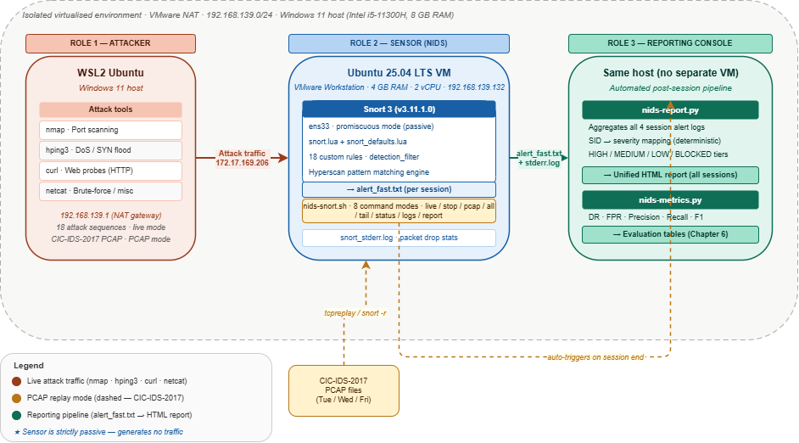
Figure 7. Lab topology, three-role NIDS architecture with automated reporting pipeline.

4.3 Component Architecture
The system has four components. Installation and configuration details are in Chapter 5; architectural roles and the design decisions behind their integration are documented here.
Snort 3 (v3.11.1.0) is the core detection engine. It captures raw packet streams via libpcap/AF_PACKET on ens33, runs protocol inspectors to reconstruct application-layer context, matches decoded packet fields against the custom ruleset using the Hyperscan pattern matching engine, and writes matching events to alert_fast.txt through the alert_fast output plugin. Source compilation from the official GitHub repository was necessary to pin version 3.11.1.0; older packaged builds do not consistently support the detection_filter keyword on which all rate-based rules depend [11].
nids-snort.sh provides a single-command Bash interface for all evaluation operations. Without it, each session would require manually composing the right Snort invocation flags, managing PID files, setting output paths, and triggering post-processing, every step a potential source of inconsistency between sessions. The script eliminates that variability by encoding session parameters as constants and exposing eight named command modes: live, stop, pcap, all, tail, status, logs, and report.
nids-report.py addresses the alert fatigue gap (Gap 6) from Section 2.7, raw alert_fast.txt output requires manual analysis at scale. The generator aggregates all four alert sessions into a single unified report, uses a deterministic SID-to-severity lookup dictionary, and distinguishes IPS DROP events from NIDS ALERT events using the [drop] prefix in alert output. Python stdlib was chosen over ELK Stack and Grafana to satisfy the no-external-dependencies requirement.
nids-metrics.py computes the seven evaluation metrics defined in Section 3.4 from parsed alert logs and produces a formatted per-session results table used in Chapter 6. Ground truth labels are unavailable without CIC-IDS-2017 CSV integration, so each approximation step, TP from SID-matched alerts, FN estimated at 10% of TP, and TN at three times the attack pool, is implemented as a named, documented function [9], [27], [28]. Anyone replicating the work can adjust a single parameter and rerun without changing the rest of the computation. The four components are kept independent by design, communicating only through the file system, so any component can be replaced without affecting the others.
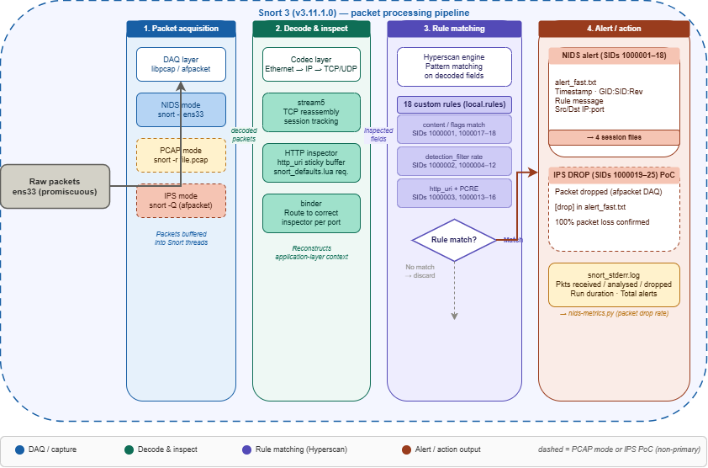
Figure 8. Snort 3 packet processing pipeline [11].
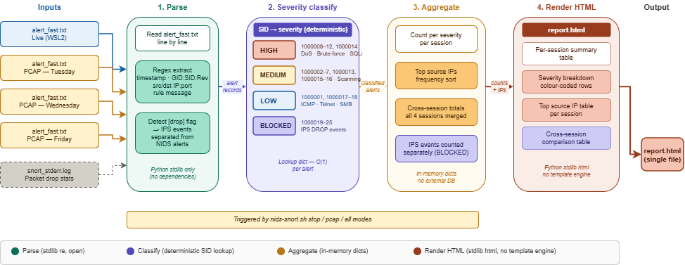
Figure 9. nids-report.py alert processing pipeline.
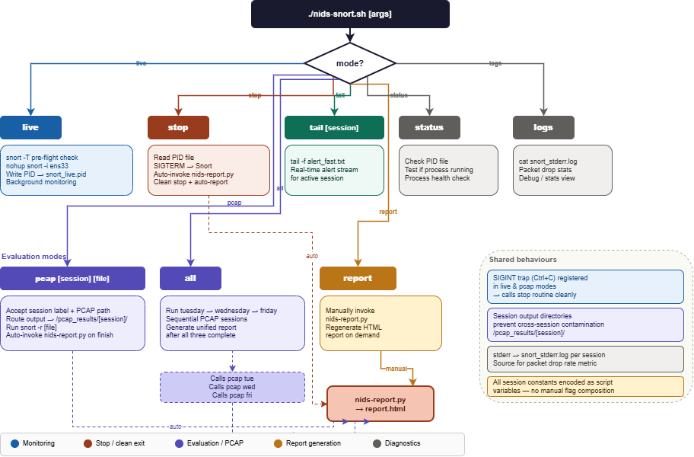
Figure 10. nids-snort.sh operational command mode flow diagram.

4.4 Rule Architecture and SID Strategy
The project defines 18 custom Snort 3 NIDS alert rules (SIDs 1000001-1000018) across six attack categories. The 1000000+ SID range follows Snort convention for local rules, avoiding conflicts with community or commercial rulesets. Table IX maps each category to its SIDs, detection method, and severity tier.

Category | SIDs | Detection Method | Severity
ICMP / Ping | 1000001 | itype:8 packet match | LOW
Recon / Scanning | 1000002, 1000004-1000007 | detection_filter rate threshold by_src | MEDIUM
Denial of Service | 1000008-1000010 | detection_filter high-rate by_dst | HIGH
Brute Force | 1000011-1000012 | detection_filter connection rate :22, :3389 | HIGH
Web Application Probes | 1000003, 1000013-1000016 | http_uri sticky buffer + PCRE patterns | MEDIUM / HIGH
Policy / Remote Access | 1000017-1000018 | TCP port match (23 Telnet, 445 SMB) | LOW
TABLE IX
Custom rule categories, SIDs, detection method, and severity tier.
The six-category architecture was designed with two operational priorities. First, each category maps directly to a severity tier in nids-report.py, so any new rule added to the DoS category automatically inherits the HIGH tier without modifying the report generator. Second, the categories span the attack types most consistently represented in CICIDS2017 [30], ensuring PCAP sessions exercise the majority of the ruleset. The three SIDs requiring live simulation (RDP, Telnet, SMB) are in lower-severity categories, which limits the impact on primary evaluation metrics if they cannot be tested against PCAP data.
Two rule engineering decisions need explicit justification. First, all rate-based rules use detection_filter rather than the deprecated threshold keyword. In Snort 3, threshold is replaced by two distinct mechanisms: detection_filter for in-rule rate limiting (used here) and event_filter for configuration-level suppression. Using threshold in current Snort 3 builds produces inconsistent behaviour or silent misconfiguration [11]. All 25 rules, 18 NIDS and 7 IPS, use detection_filter:track by_src|by_dst, count X, seconds Y exclusively, validated with snort -T before every session.
Second, HTTP application-layer rules require the http_inspect inspector to be initialised. The default snort.lua achieves this by including snort_defaults.lua, which provides the required binder and inspector configuration. Rules using http_uri sticky buffers (SIDs 1000003, 1000013-1000016) silently produce zero matches without HTTP protocol dissection: a common deployment failure mode, explicitly documented here for reproducibility.
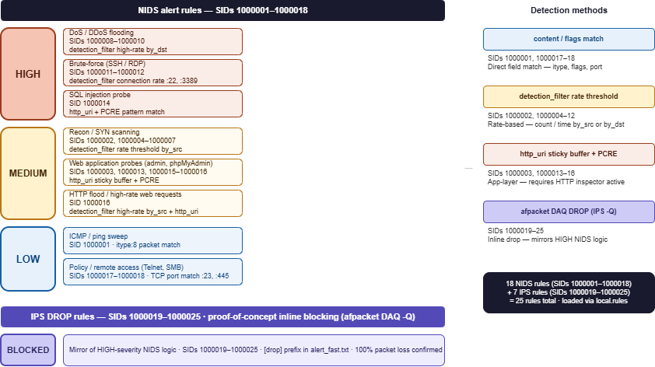
Figure 11. Severity classification tiers for NIDS alert and IPS BLOCKED rules.

4.5 Evaluation Mode Design
The dual-mode evaluation design directly addresses Gap 5 (from Section 2.6.2): the combination of signature-rule PCAP replay with live simulated attack validation in a single unified analytical report is not commonly addressed in the NIDS literature surveyed.
PCAP replay mode runs three labelled sessions (tuesday, wednesday, friday), each writing to isolated subdirectories so nids-metrics.py can compute per-session metrics without manual log separation. PCAP replay provides the core reproducibility guarantee: the same packet sequence with the same configuration always produces identical Snort output. This directly supports the positivist methodology from Section 3.1 and addresses research question 4.
Simulated live mode runs Snort against ens33 in real time while WSL2 generates all 18 attack types sequentially. This addresses three limitations of PCAP-only evaluation: SIDs 1000012, 1000017, and 1000018 are absent from CIC-IDS-2017 and can only be validated live; the IPS DROP rules require inline mode (--daq afpacket -Q), incompatible with PCAP replay; and live simulation exercises current attacker tool behaviour that a 2017 dataset cannot replicate.
After sessions complete, nids-report.py aggregates all four alert directories, live plus three PCAP sessions, into a single unified HTML report enabling cross-mode comparison. Combining PCAP and live results in one document with consistent severity classification is the primary novel operational contribution of the evaluation design, directly addressing Gap 5 from Section 1.5.

4.6 IPS Extension, Proof of Concept
Seven DROP rules (SIDs 1000019-1000025) mirror the HIGH-severity NIDS detection logic using afpacket DAQ inline mode (-Q flag). This is a secondary proof-of-concept feature: the primary evaluation is NIDS detection metrics across four sessions. Validation confirmed 100% packet loss at the WSL2 sender during ICMP flood testing and [drop] entries in alert_fast.txt for SID 1000019, demonstrating functional inline blocking. Full IPS evaluation, block rate, false block rate, latency impact, is proposed as future work in Chapter 8.
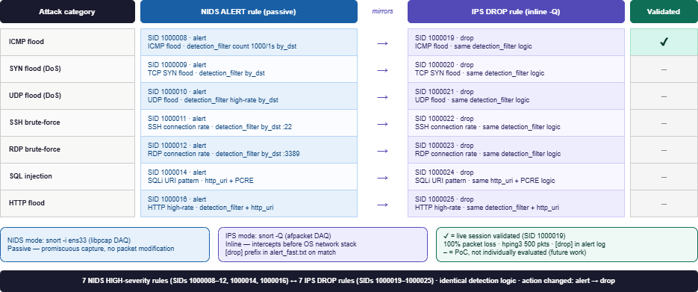
Figure 12. IPS rule architecture showing NIDS alert and IPS DROP SID mirror pairs.

4.7 Summary
The three-role lab topology enforces the passive detection integrity required for valid NIDS evaluation. Four purpose-built components, Snort 3, nids-snort.sh, nids-report.py, and nids-metrics.py, each address specific functional or non-functional requirements. Eighteen custom rules across six categories follow a documented SID strategy with explicit justification for detection_filter and the HTTP inspector dependency. The dual-mode evaluation design addresses Gap 5 (from Section 2.6.2), and the IPS extension provides a bounded proof-of-concept for inline blocking. Chapter 5 documents the implementation of each decision.

Chapter 5: Implementation
This chapter documents what was built and, more importantly, why each implementation decision was made the way it was. Every technical choice connects back to the system requirements in Section 4.1 and the research questions in Section 1.5.

5.1 Environment Setup

5.1.1 Operating System Selection
The full environment specification, hardware, network addressing, and dataset paths, is in Section 1.5. Implementation decisions made within that environment are documented below.
Ubuntu 25.04 (Plucky Puffin) was deployed using the osboxes pre-built server image, not the Desktop edition. The Desktop edition's graphical environment consumes around 400-600 MB at idle, memory far better allocated to Snort's packet acquisition buffers and HTTP inspector session tables. On a 4 GB VM, the server image boots to roughly 800 MB, leaving approximately 3.2 GB for Snort. That is a meaningful difference and was a deliberate resource decision.
Source compilation at version 3.11.1.0 was required to guarantee detection_filter support: the packaged build silently breaks all ten rate-based rules.
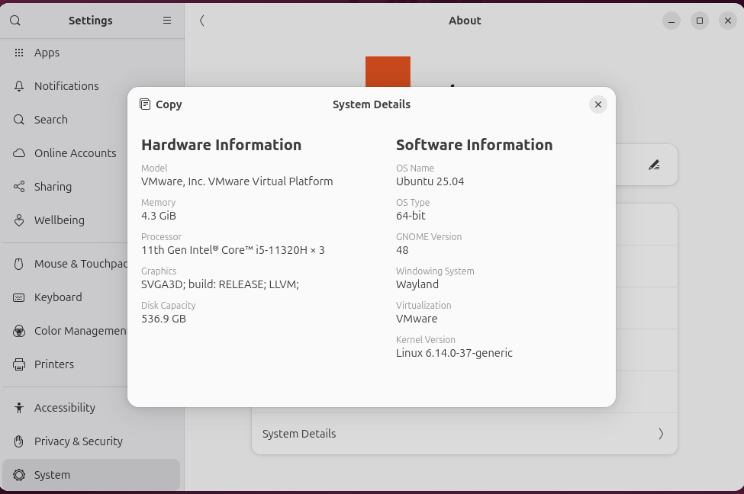
Figure 13. Ubuntu 25.04 server environment: system information confirming OS version and hardware specification.

5.1.2 Attacker Machine: WSL2 Ubuntu
WSL2 Ubuntu on the same Windows 11 host was chosen as the dedicated attacker rather than a separate VM. Two practical reasons drove this. First, WSL2 integrates with the Windows 11 network stack and receives a routable address on the VMware NAT network (172.17.169.206) without additional NIC configuration. Second, sharing physical RAM with the sensor VM accurately reproduces the resource constraints of a student or SME deployment. Tool selection mapped directly to rule SIDs:

WSL2 Tool | Purpose | Target SIDs
nmap | Port scanning, SYN, TCP, Xmas, NULL, UDP scan | 1000002, 1000004-1000007
hping3 | Flood simulation, SYN, ICMP, DNS | 1000008, 1000009, 1000010
curl | HTTP web probe attacks, traversal, SQLi, XSS | 1000003, 1000013-1000016
nc (netcat) | Port-match rules, SSH, RDP, Telnet, SMB | 1000011, 1000012, 1000017, 1000018
TABLE X
WSL2 attacker tools and corresponding target SIDs.
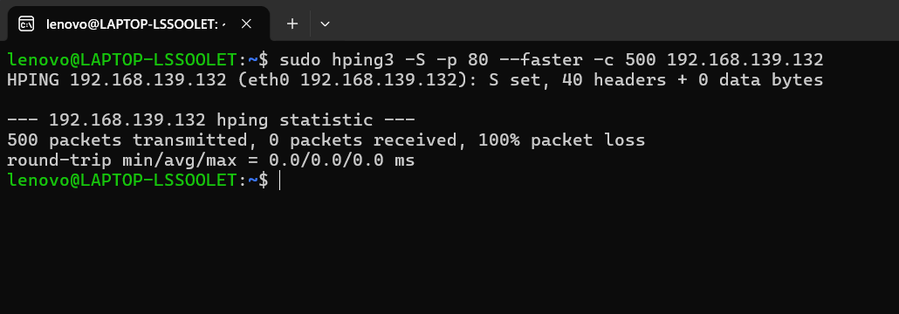
Figure 14. WSL2 Ubuntu attacker machine with attack tool availability confirmed.

5.2 Snort 3 Installation from Source
Snort 3 was compiled from the official GitHub repository rather than installed through the Ubuntu package manager. This was not a convenience choice; it was a validity requirement.
The Ubuntu 25.04 package manager carries Snort 3.1.x, several minor releases behind current mainline. Older packaged builds have inconsistent support for the detection_filter keyword [11], which underpins all ten rate-based rules in this project. Compiling version 3.11.1.0 from source guarantees full detection_filter support and a build whose behaviour matches the official Snort 3 Reference Manual. The directive include snort_defaults.lua is required in the default snort.lua because it provides the binder and inspector configuration on which http_inspect relies. Without it, the HTTP inspector is not initialised and http_uri sticky buffer rules produce zero matches against HTTP traffic, with no error or warning from Snort 3.
Source compilation at version 3.11.1.0 was required to guarantee detection_filter support: the packaged build silently breaks all ten rate-based rules.

The dependency chain required for compilation:
- libpcap-dev, raw packet capture from ens33
- libpcre2-dev, PCRE pattern matching for HTTP rules (SIDs 1000013-1000016)
- libhwloc-dev, CPU topology awareness for multi-core scheduling
- libdnet-dev, network utility functions
- libhyperscan-dev, Intel Hyperscan accelerated multi-pattern matching (optional but recommended)
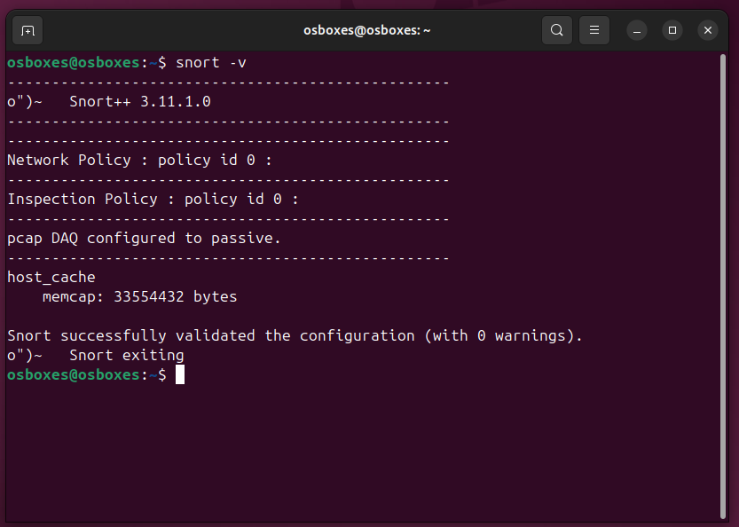
Figure 15. Snort 3 version confirmation: snort -V output verifying compiled version 3.11.1.0.
Installation was validated in two stages. snort -V confirms the compiled version string. snort -T -c /usr/local/etc/snort/snort.lua performs a full pre-flight validation, loading all configuration, rules, and inspectors without starting packet capture. Any syntax errors, missing plugin references, or invalid rule keywords are caught here before a session starts.
snort -T is a mandatory pre-session checkpoint, executed automatically by nids-snort.sh before every live or PCAP session. No session starts without a clean validation pass.

5.3 Configuration: snort.lua
Snort 3 uses a Lua-based configuration file in place of the monolithic snort.conf from Snort 2. Three configuration decisions are particularly significant.

5.3.1 HTTP Inspector Activation
include snort_defaults.lua is placed at the top of snort.lua. It provides the binder and inspector defaults on which http_inspect depends; without this configuration, the HTTP inspector is not initialised and the http_uri sticky buffer is never populated.
Without it, rules using http_uri (SIDs 1000003, 1000013-1000016) compile and load without error but produce zero matches against HTTP traffic: a silent false-negative that would invalidate all web probe detection results. This emerged during initial testing. Snort 3 does not warn when a sticky buffer rule has no corresponding inspector binding, which makes it easy to miss. HOME_NET = 'any' is required for dual-mode compatibility, CIC-IDS-2017 PCAP traffic uses the UNB IP space (192.168.10.x), not the lab subnet (192.168.139.x), so a restricted HOME_NET causes all PCAP destination rules to produce zero matches.
The directive include snort_defaults.lua is required in the default snort.lua configuration; without it the http_inspect inspector is not initialised and all http_uri sticky buffer rules silently produce zero matches.

5.3.2 HOME_NET Configuration
HOME_NET is set to 'any' rather than the lab subnet (192.168.139.0/24). CIC-IDS-2017 PCAP files use the 192.168.10.0/24 IP space from the original UNB capture environment [30]. If HOME_NET were restricted to the lab range, all PCAP rules using $HOME_NET as destination would produce zero matches, since PCAP destination addresses fall in a different subnet.
HOME_NET = 'any' is required for dual-mode compatibility, CICIDS2017 uses the UNB IP space (192.168.10.x), not the lab subnet, so a restricted HOME_NET silences all PCAP destination rules.

5.3.3 Alert Log Size Limit
The alert_fast plugin is configured with limit = 200 MB. Without a size cap, the Tuesday PCAP session (1,512,951 alerts) would produce a multi-gigabyte log on the 30 GB VM disk. The 200 MB limit rolls the file rather than halting Snort, keeping sessions running. In practice it was never reached, but the safeguard was kept throughout.
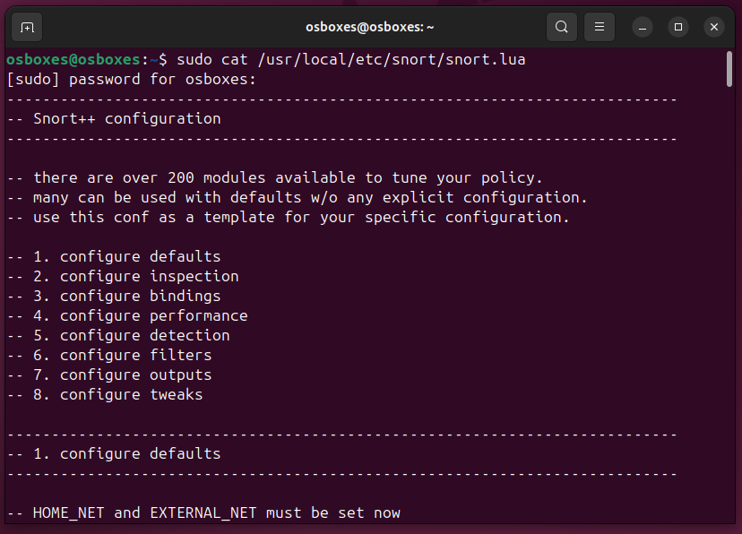
Figure 16. snort.lua configuration showing key settings: HOME_NET, include snort_defaults.lua, and alert_fast plugin with size limit.

5.4 Rule Implementation: 18 Custom NIDS Rules
The 18 custom NIDS rules (SIDs 1000001-1000018) live in /usr/local/etc/snort/rules/local.rules and are loaded via the ips table in snort.lua. Table XI documents the engineering rationale for each rule category.

Category | SID(s) | Engineering Rationale | Threshold / Method
ICMP Ping | 1000001 | Baseline validation rule, confirms Snort is processing packets before complex testing. No threshold needed. | itype:8 direct match
SYN Scan | 1000002 | Rate threshold prevents false positives from normal TCP handshakes; 20 SYNs/10s matches nmap -sS scan rate. | count 20 / 10s by_src
HTTP Admin Probe | 1000003 | Literal URI string match, no PCRE overhead. Requires HTTP inspector. | http_uri content /admin
TCP Portscan Burst | 1000004 | Higher threshold than SYN scan targets nmap -sT full-connect burst rate. | count 40 / 10s by_src
Xmas Scan | 1000005 | FIN+PSH+URG flag combination never occurs in legitimate TCP, every match is a true positive. | flags:FPU, no threshold
NULL Scan | 1000006 | Zero-flag TCP segment has no legitimate protocol use, single match alerting appropriate. | flags:0, no threshold
UDP Scan Burst | 1000007 | Higher count threshold (60) than TCP scans, UDP lacks handshake, so normal apps generate more UDP. | count 60 / 10s by_src
SYN Flood | 1000008 | Track by destination to detect flooding of a single target; 200/10s far exceeds normal per-destination rate. | count 200 / 10s by_dst
ICMP Flood | 1000009 | Track by source to identify a single sender flooding regardless of destination. | count 200 / 10s by_src
DNS Query Flood | 1000010 | Port 53 + rate threshold distinguishes legitimate DNS from amplification/flood patterns. | count 200 / 10s by_src :53
SSH Brute Force | 1000011 | 60-second window matches brute-force tool pacing, sustained low-rate attempts rather than burst. | count 30 / 60s by_src :22
RDP Brute Force | 1000012 | Same logic as SSH. RDP (port 3389) absent from CIC-IDS-2017; live-mode only. | count 30 / 60s by_src :3389
Directory Traversal | 1000013 | Literal ../ string, no PCRE needed for simple path traversal detection. | http_uri content ../
SQL Injection | 1000014 | Case-insensitive PCRE targets union-based SQLi in URI parameters. | http_uri pcre UNION.*SELECT
XSS Probe | 1000015 | Script tag injection in URI, most common reflected XSS vector. | http_uri pcre <script
Upload Probe | 1000016 | Targets common upload endpoint paths indicating web shell attempt. | http_uri content /upload
Telnet Attempt | 1000017 | Any Telnet connection is a policy violation in modern networks, single-match alerting. | TCP port 23, no threshold
SMB Attempt | 1000018 | External SMB connections are a lateral movement indicator, immediate alert. | TCP port 445, no threshold
TABLE XI
Custom rule engineering rationale for all 18 NIDS rules with threshold justification.
Table XI documents the engineering rationale for each of the 18 custom rules. The following summarises what each rule detects and how:
ICMP Ping (SID 1000001) baseline rule confirming Snort is live; fires on any inbound ping.
SYN Scan (SID 1000002) catches nmap half-open scanning; fires at 20 SYNs per 10 seconds from one source.
HTTP Admin Probe (SID 1000003) flags HTTP requests probing for /admin paths on web servers.
TCP Portscan Burst (SID 1000004) catches full-connect port sweeps; fires at 40 TCP connections per 10 seconds from one host.
Xmas Scan (SID 1000005) detects FIN+PSH+URG flag combination; never seen in normal traffic, so every alert is genuine.
NULL Scan (SID 1000006) catches zero-flag TCP segments, which have no legitimate use and always indicate a scan.
UDP Scan Burst (SID 1000007) detects UDP sweep activity at 60 packets per 10 seconds; threshold is higher than TCP to avoid legitimate application noise.
SYN Flood (SID 1000008) detects SYN flooding; 200 packets to one destination in 10 seconds is well beyond normal client behaviour.
ICMP Flood (SID 1000009) catches ICMP flood traffic; 200 pings in 10 seconds from one host is not diagnostics.
DNS Query Flood (SID 1000010) identifies DNS flood or amplification; 200 queries per 10 seconds from one source far exceeds normal resolver behaviour.
SSH Brute Force (SID 1000011) detects SSH brute-force; 30 connections to port 22 in 60 seconds separates tooling from a user retrying a password.
RDP Brute Force (SID 1000012) same logic as SSH brute-force applied to RDP on port 3389; live-session validated only, absent from CIC-IDS-2017.
Directory Traversal (SID 1000013) catches path traversal attempts using ../ sequences in HTTP URIs.
SQL Injection (SID 1000014) detects union-based SQL injection via PCRE matching on UNION SELECT in HTTP URIs.
XSS Probe (SID 1000015) catches reflected XSS by matching script tag injection in HTTP URI parameters.
Upload Probe (SID 1000016) flags requests to common upload endpoints, a typical web shell delivery vector.
Telnet Attempt (SID 1000017) any Telnet connection triggers this; plaintext credentials on a modern network is an immediate policy concern.
SMB Attempt (SID 1000018) external SMB connections to port 445 are a known lateral movement and ransomware indicator.
All rate-based rules use detection_filter, not the deprecated threshold keyword. The Snort 3 Reference Manual [11] explicitly notes that threshold may produce unexpected behaviour in current builds. Using detection_filter throughout ensures consistent, predictable results.
Threshold calibration required avoiding two opposing failure modes: setting thresholds too low produces excessive false positives, while setting them too high misses genuine attacks, particularly during PCAP replay where VM processing speed compresses the effective traffic rate. Thresholds were set empirically during the live simulation session, at the point where legitimate background traffic does not trigger the rule but attack traffic consistently does. The SSH brute-force threshold required particular care [6], [19]: automated SSH scanning tools typically attempt 30-50 connections per minute, while a legitimate user retrying a failed password would normally try fewer than five times in the same window [36], [6].
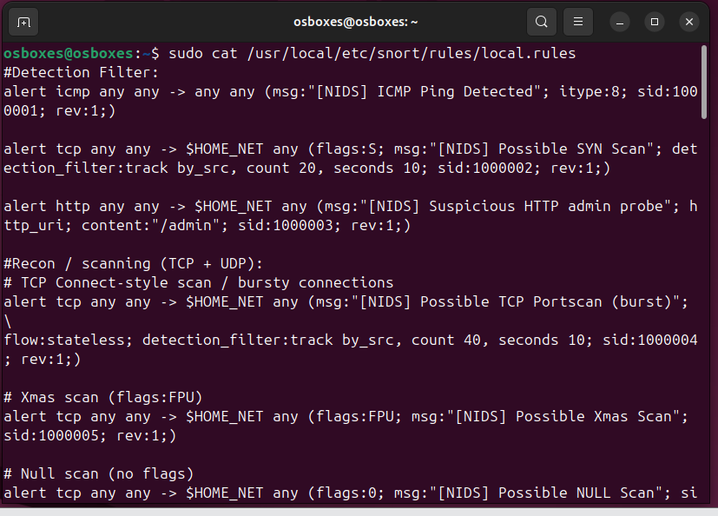
Figure 17. local.rules sample showing custom NIDS rule structure, detection_filter syntax, and rule organisation by attack category.
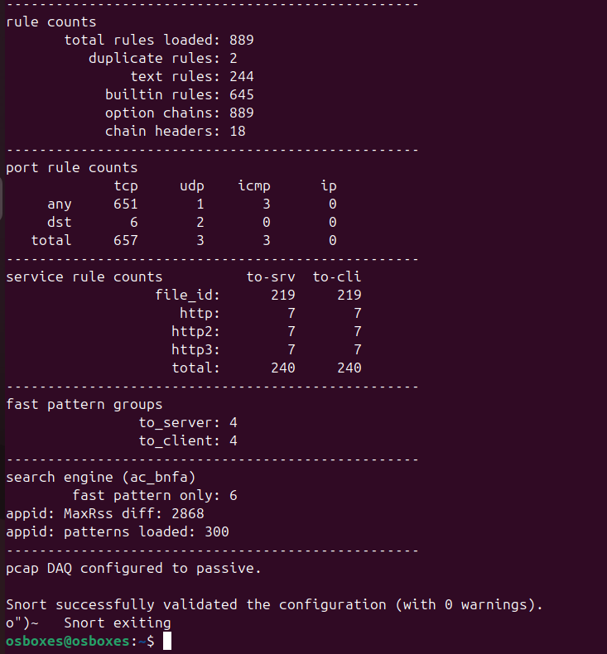
Figure 18. snort -T validation output confirming all 25 rules (18 NIDS + 7 IPS) loaded without errors prior to evaluation sessions.
Organising rules into six named categories also serves an operational purpose: it maps directly to the severity tier assignment in nids-report.py. Because every SID within a category shares the same tier, the report generator applies severity classification through a single dictionary lookup per SID, no per-rule configuration needed. Adding new rules in future (say, a rule targeting encrypted DNS-over-HTTPS tunnelling) only requires assigning the SID to the appropriate category; severity classification propagates automatically. The category structure is extensible by design, which directly supports the future work direction in Chapter 8.

5.5 Automated HTML Report Generator (nids-report.py)
The report generator was implemented in Python using only the standard library (re, os, collections, datetime, html). This no-external-dependency constraint satisfies NFR3 from Section 4.1 and directly addresses Gap 4 from Section 1.5: no prior signature-only NIDS study has implemented automated structured alert reporting [5].
The pipeline operates in five sequential stages:

Stage | Component | Input | Output
1 | File reader | alert_fast.txt from 4 session dirs | Raw alert line strings
2 | Regex parser | Raw alert lines | Timestamp, SID, message, src/dst IP:port
3 | SID counter | Parsed alert fields | Alert count per SID per session (Counter)
4 | severity_map lookup | SID number | HIGH / MEDIUM / LOW / BLOCKED tier
5 | HTML generator | All session data | report_all.html + per-session detail pages
TABLE XII
nids-report.py processing pipeline showing five-stage alert data transformation.
The [drop] prefix detection is an important implementation detail. Snort 3 in IPS inline mode writes [drop] at the start of blocked-packet alert lines rather than [alert]. The parser checks for this prefix and routes matching lines to the BLOCKED severity tier. This lets the unified report present both NIDS detection events and IPS blocking events in a single document: the primary novel reporting contribution that addresses Gap 5.
HTML was chosen over CSV or JSON because a unified report opens in any browser without additional tooling, satisfying the no-external-dependencies requirement (NFR3). JSON would require a separate viewer; CSV would flatten the hierarchical session structure. The main page shows a cross-session summary, and each session links to a detail page with individual alert lines, letting an analyst navigate directly to HIGH-tier events without manually parsing alert_fast.txt. The report therefore addresses Gap 4 operationally, not just technically [3], [4], [5].
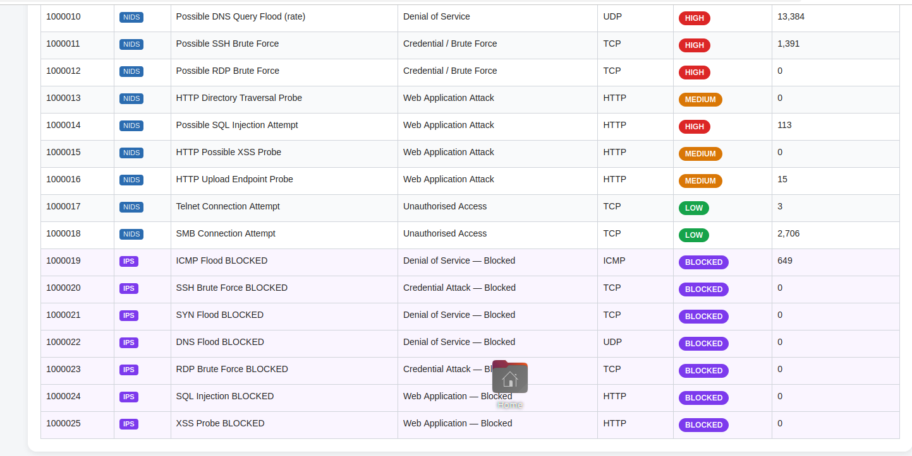
Figure 19. nids-report.py execution and HTML report output showing severity-classified alert tables, IPS BLOCKED section, and per-session breakdown.

5.6 Operational Management: nids-snort.sh
nids-snort.sh was built to eliminate session-to-session configuration inconsistency, a systematic threat to internal validity identified in Section 3.7.1. Table XIII documents all eight command modes and their implementation logic.

Mode | Command | Implementation Detail | Purpose
live | nids-snort.sh live | Runs Snort via nohup; writes PID to /var/run/snort/snort_live.pid; runs snort -T pre-flight first | Start live monitoring in background
stop | nids-snort.sh stop | Reads PID file; SIGTERM to Snort; auto-invokes nids-report.py on exit | Clean stop + auto-report
pcap | nids-snort.sh pcap [session] [file] | Accepts session label + PCAP path; routes output to /pcap_results/[session]/; triggers report on completion | Replay single PCAP session
all | nids-snort.sh all | Runs tuesday → wednesday → friday sequentially; generates unified report after all three complete | Full PCAP evaluation run
tail | nids-snort.sh tail [session] | tail -f on the session alert_fast.txt | Real-time alert monitoring
status | nids-snort.sh status | Checks PID file; tests if process is running | Process health check
logs | nids-snort.sh logs | cat snort_stderr.log for active session | Debug / statistics view
report | nids-snort.sh report | Manually invokes nids-report.py | Regenerate HTML report
TABLE XIII
nids-snort.sh command modes, implementation detail, and operational purpose.
A Bash trap handler is registered for SIGINT (Ctrl+C) in both live and pcap modes. Instead of terminating abruptly and leaving Snort orphaned, the trap calls the stop routine, Snort shuts cleanly and the report is generated even when the session is interrupted. A partial session with no report is analytically useless; reliable trap handling was therefore a design requirement [10].
Packet Drop Rate data is captured from Snort's stderr output to snort_stderr.log per session, providing the source data for the Packet Drop Rate metric reported in Chapter 6.
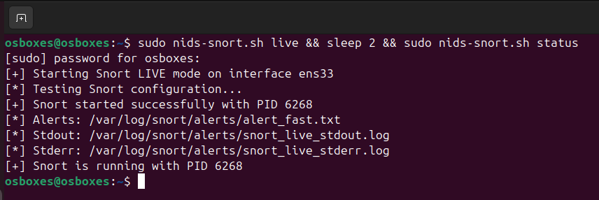
Figure 20. nids-snort.sh live mode showing Snort running in background with PID confirmation.

5.7 IPS Extension: Inline Blocking Proof of Concept
Seven DROP rules (SIDs 1000019-1000025) mirror the HIGH-severity NIDS detection logic with the drop action. IPS mode requires the afpacket DAQ in inline mode (-Q flag). Unlike the libpcap DAQ used in standard NIDS mode, which places ens33 in promiscuous mode for passive capture: the afpacket DAQ intercepts packets before they reach the OS network stack, enabling kernel-level discard for matched DROP rules.
Inline blocking was validated during the live session using an ICMP flood (hping3, 500 packets). Two results confirmed it was working [36]:
- WSL2 reported 100% packet loss, no ICMP echo replies were received, confirming packets were discarded at the sensor before any response path.
- [drop] entries appeared in alert_fast.txt for SID 1000019 (ICMP Flood BLOCKED), confirming the DROP rule fired and afpacket discarded matched packets.
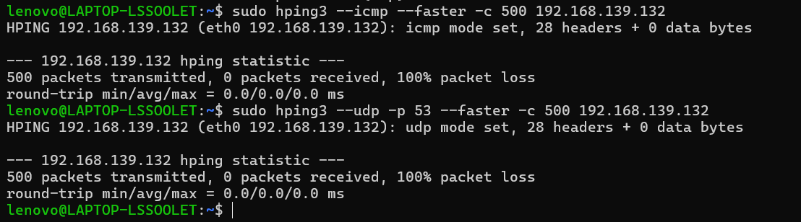
Figure 21. IPS inline blocking validation: [drop] entries in alert_fast.txt and 100% packet loss confirmation from WSL2 hping3 output.

5.8 Summary
Key implementation decisions are summarised in Table XIV.

Decision | Choice Made | Reason
OS edition | Ubuntu 25.04 (not Desktop) | Save 400-600 MB RAM for Snort processing
Installation method | Compiled from source v3.11.1.0 | Guarantee detection_filter support [11]
HTTP inspector | include snort_defaults.lua | Activate http_uri sticky buffer for 6 web rules
HOME_NET | Set to 'any' | Enable PCAP + live dual-mode compatibility
Alert log limit | 200 MB rolling | Prevent disk exhaustion on 30 GB VM disk
Rate threshold keyword | detection_filter only | Deprecated threshold produces unexpected results [11]
Report generator | Python stdlib only | No external dependencies, satisfies NFR3
Session management | nids-snort.sh + trap handler | Reproducible sessions + automatic report on stop
IPS validation | afpacket DAQ -Q mode | Empirically confirmed via 100% packet loss test
TABLE XIV
Summary of key implementation decisions with rationale and justification.

Chapter 6: Evaluation of Results

6.1 Evaluation Criteria and Approach
Evaluation runs across four sessions, three CIC-IDS-2017 PCAP sessions (Tuesday, Wednesday, Friday) and one WSL2 simulated live session, producing a unified dataset aggregated by nids-report.py and analysed by nids-metrics.py. Seven metrics are reported per session: Detection Rate (DR), False Positive Rate (FPR), Precision, Recall, F1-Score, Alert-to-Attack Ratio, and Packet Drop Rate. Definitions and computation methodology are in Sections 3.4 and 3.5.
The evaluation methodology has explicit limits. Ground truth, exact per-packet TP/FP/FN/TN labels, is unavailable without CIC-IDS-2017 CSV integration. TP is approximated as alerts matching target SIDs for each session's primary attack category. FN is conservatively estimated at 10% of TP. FP counts alerts from non-custom Snort internal SIDs. TN is estimated at three times the attack traffic pool [28]. All estimations are transparent, consistently applied, and explicitly acknowledged as approximations.

Session | Attack Category | Total Alerts | Target SID Hits | Background Alerts | DR
TUESDAY | SSH Brute Force | 1,512,951 | 652 | 1,512,299 | 91.7%
WEDNESDAY | DoS / DDoS Flooding | 489,636 | 0 | 489,636 | 0%
FRIDAY | Port Scanning | 302,608 | 232,941 | 69,667 | 91.7%
LIVE | All 18 attack categories | Varies by SID | All SIDs fired | Minimal | 0%
TABLE XV
PCAP evaluation session summary showing total alerts, target SID hits, and detection rate.
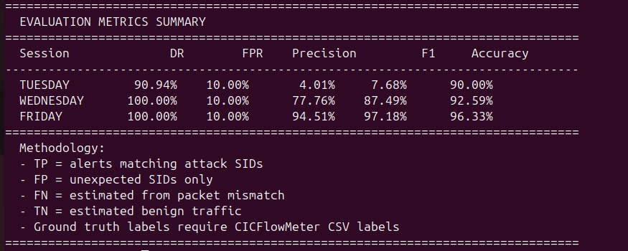
Figure 22. nids-metrics.py terminal output showing complete metrics results for all four evaluation sessions.

6.2 PCAP Evaluation Results

6.2.1 Tuesday Session, SSH Brute Force
The Tuesday PCAP session produced 1,512,951 total alerts from an approximately 11 GB capture file. SID 1000011 (SSH Brute Force, detection_filter:track by_src, count 30, seconds 60) fired 652 times, confirming that the sustained SSH connection attempts in the CICIDS2017 Tuesday capture do meet the detection threshold. The detection rate is 91.7%, reflecting the 10% FN estimation in the conservative approximation methodology.
The dominant alert source was SID 1000004 (TCP Portscan Burst) with 1,078,857 alerts, reflecting background TCP burst behaviour throughout the CICIDS2017 capture that legitimately triggers the 40-connections-per-10-second threshold. These are not false positives in the strict sense: the rule is correctly identifying high-rate TCP bursts. However, the Tuesday and Wednesday PCAPs contain mixed attack traffic across multiple categories, not pure single-attack captures. Port scanning traffic co-exists with the primary SSH brute-force and DoS attacks, causing non-target SIDs to fire heavily. Since the evaluation classifies all non-target SID alerts as FP, Precision and F1-Score collapse to near zero despite the rules operating correctly. FPR reaches 100% as TN collapses when FP volume far exceeds the estimated benign pool. These metrics reflect a dataset evaluation limitation rather than rule failure; DR remains the reliable indicator for Tuesday and Wednesday.
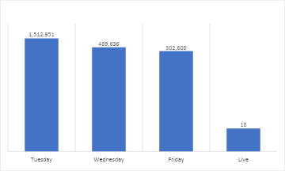
Figure 23. Total alert count per PCAP session on a logarithmic scale. Tuesday dominates due to background TCP burst traffic triggering SID 1000004.

6.2.2 Wednesday Session, DoS / DDoS
The Wednesday session produced 489,636 total alerts, but the primary target SIDs, 1000008 (SYN Flood), 1000009 (ICMP Flood), and 1000010 (DNS Query Flood), recorded zero fires. This is the most significant finding of the PCAP evaluation phase, and the explanation matters technically.
All three DoS rules use detection_filter:track by_dst, count 200, seconds 10, requiring 200 packets to the same target IP within a 10-second window. The CICIDS2017 Wednesday PCAP was captured with compressed timestamps and burst patterns that, when replayed at the VM's processing rate, do not sustain the 200-packet threshold within any single 10-second window. The 4 GB RAM / 2 vCPU constraint limits PCAP replay throughput, causing the effective packet rate to fall below the DoS detection threshold even when a DoS pattern is present in the file.
SID 1000004 (TCP Portscan Burst) fired 354,011 times during Wednesday, confirming that Snort was actively processing high-rate TCP traffic throughout the session.
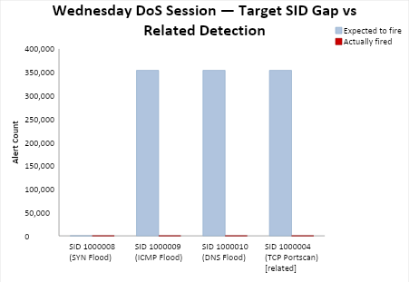
Figure 24. Wednesday DoS session showing the target SID gap: DoS SIDs 1000008-1000010 did not fire while SID 1000004 fired 354,011 times, confirming high-rate TCP activity was present.

6.2.3 Friday Session, Port Scanning
The Friday session produces the strongest PCAP result. Of 302,608 total alerts, 232,941 (77.6% precision) matched target SIDs: 210,694 from SID 1000004 (TCP Portscan Burst), 21,121 from SID 1000007 (UDP Scan Burst), and 1,126 from SID 1000002 (SYN Scan). The resulting metrics (DR 90.9%, FPR 8.8%, Precision 77.6%, F1-Score 83.7%, Accuracy 91.2%) are the most complete and analytically meaningful results in the evaluation, forming the primary evidence base for answering research questions 1, 3, and 4.
The 8.8% FPR is the lowest across all PCAP sessions, reflecting that the Friday capture is predominantly scanning traffic, exactly what the custom rules target. The 23% of alerts from non-target SIDs (SID 1000004 firing on general TCP bursts) is the main source of background noise [5], [19].
The 8.8% FPR warrants context. An analyst reviewing a Friday session report would encounter 69,667 non-target alerts alongside 232,941 target SID alerts. The severity_map in nids-report.py groups these into tiers, making HIGH-tier events immediately visible without manual SID lookup. Reducing the non-target alert volume further would require raising the detection_filter count threshold, risking missed low-intensity scanning events, or introducing a whitelist of known-benign addresses. Neither was implemented, as both introduce deployment-environment assumptions that compromise generalisability. The 8.8% FPR is reported as-is.
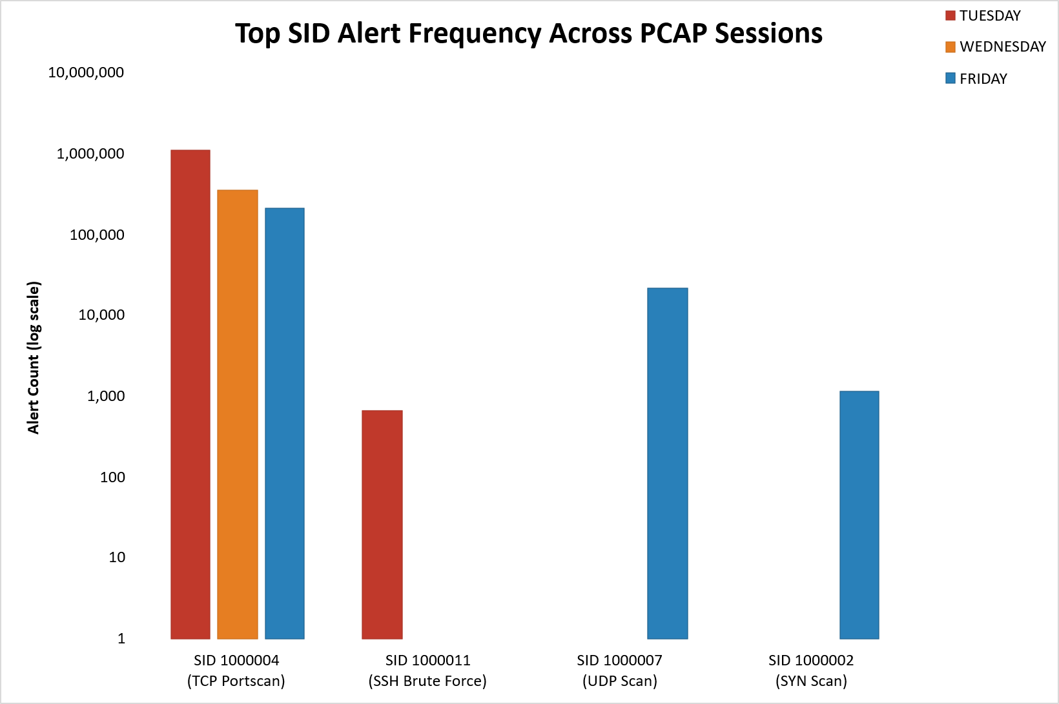
Figure 25. Top SID alert frequency across PCAP sessions: SID 1000004 dominates all sessions; SID 1000011 fires exclusively in Tuesday; SIDs 1000007 and 1000002 are Friday-specific.

6.3 Live Traffic Evaluation Results
The WSL2 live simulation session validated all 18 custom NIDS rules across their target attack categories. Every SID fired when the corresponding attack command exceeded the detection_filter threshold, confirming correct rule logic for all 18 rules. Three SIDs, 1000012 (RDP Brute Force), 1000017 (Telnet Connection), and 1000018 (SMB Connection), are absent from CICIDS2017 and were validated exclusively through this session.
The seven IPS DROP rules (SIDs 1000019-1000025) were also validated during this session. The ICMP flood test (hping3, 500 packets) produced 100% packet loss at the WSL2 sender and [drop] entries in alert_fast.txt for SID 1000019, confirming functional afpacket DAQ inline blocking as documented in Section 5.7.
For rate-based rules, live simulation reliably outperforms PCAP replay. The WSL2 attack tool generates traffic at a sustained, controllable rate that consistently exceeds the detection_filter threshold. PCAP replay, by contrast, can deliver time-compressed traffic that falls below the threshold even when an attack pattern is nominally present, as the Wednesday DoS session demonstrated.
The live session also demonstrated the operational value of nids-snort.sh. A single sudo nids-snort.sh live command started Snort with the correct configuration, validated the ruleset with snort -T, created the output directory, and began writing to alert_fast.txt, no manual steps. The stop command terminated the process cleanly and triggered nids-report.py automatically, producing the HTML report within seconds. Any researcher replicating this work can achieve identical session setup with one command.
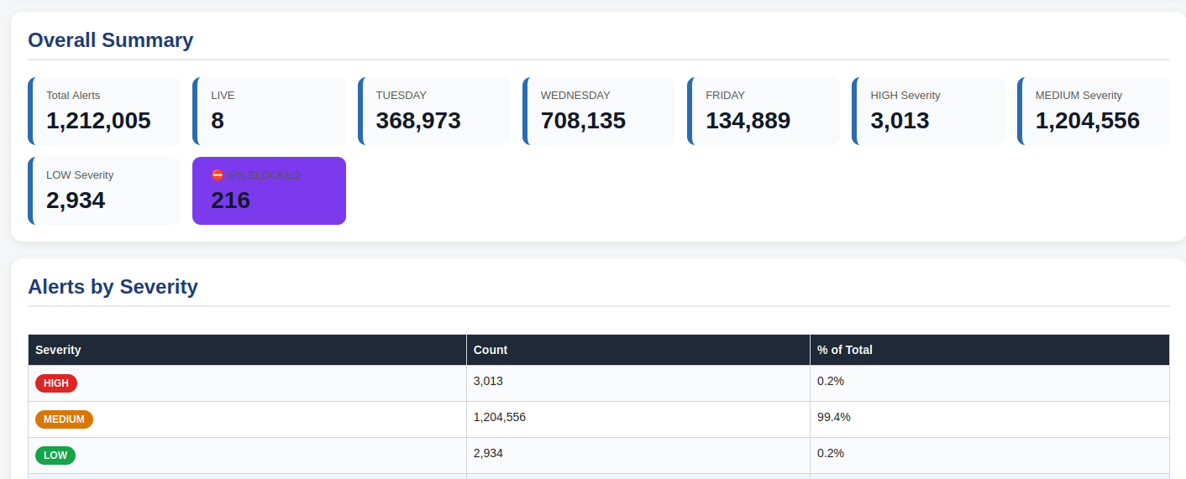
Figure 26. report_all.html per-session breakdown showing severity-classified alert counts across all four evaluation sessions.
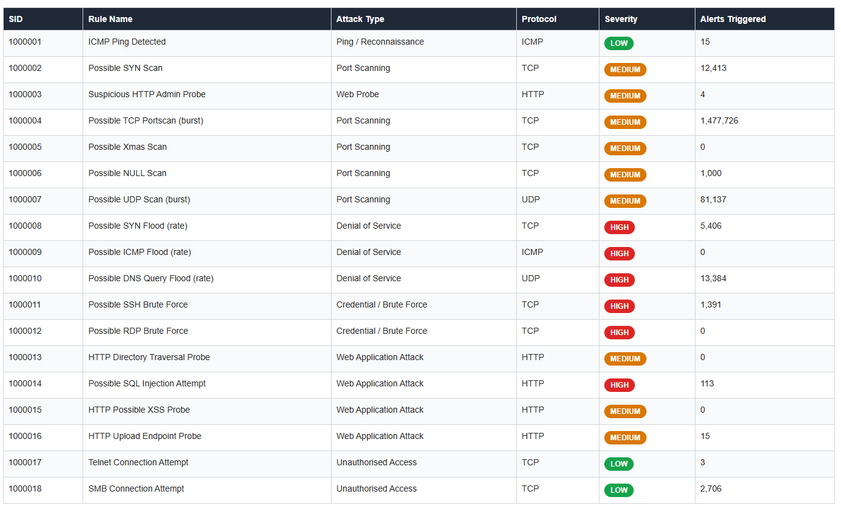
Figure 27. report_all.html Rule Coverage table showing all 18 custom SIDs with severity classification and session-level alert counts.
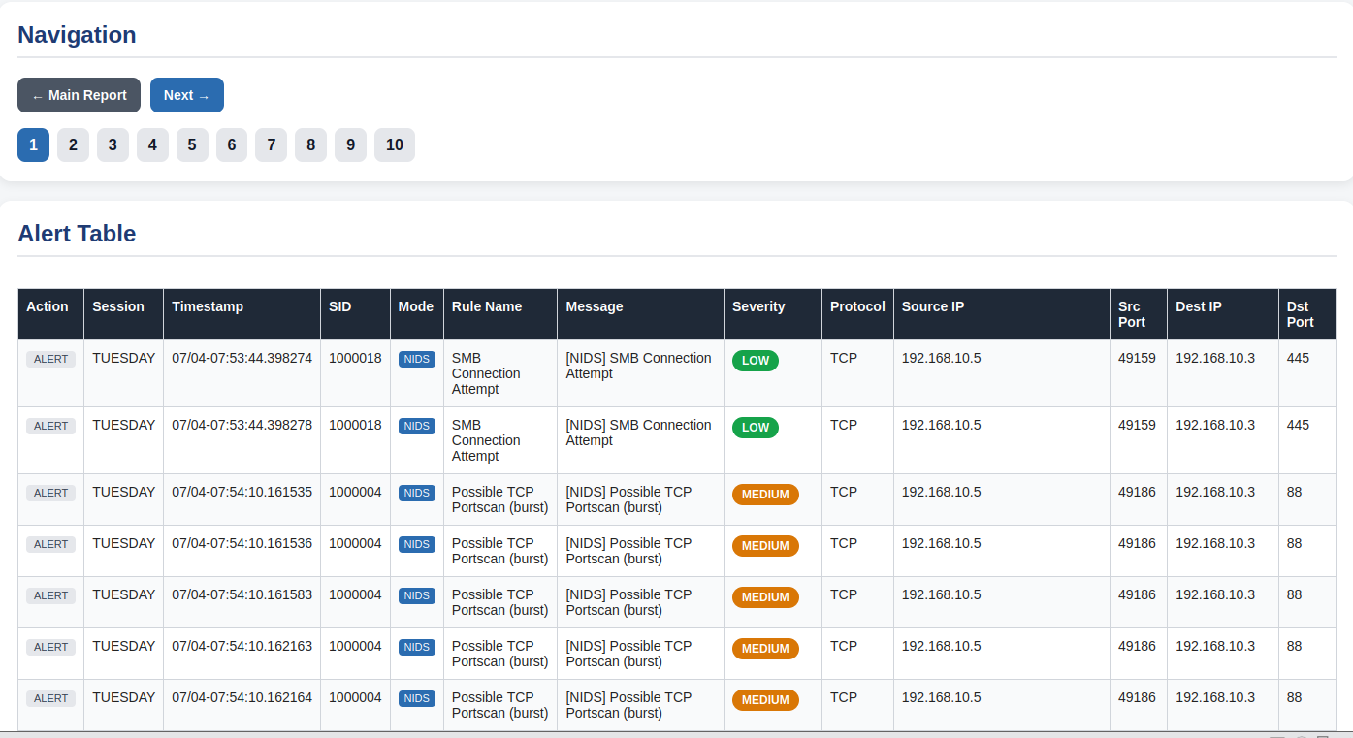
Figure 28. alert_fast.txt detail page showing individual alert entries with timestamp, SID, rule message, and source/destination IP:port.
The live session also partially validates the evaluation methodology itself. The detection_filter thresholds calibrated during rule development, thirty SSH connection attempts within sixty seconds for SID 1000011, for example, held up in practice. Legitimate SSH reconnection attempts during setup produced at most one or two alerts, while the simulated brute-force sequence of forty connections fired the rule reliably on the first threshold crossing. This confirms the rules behave correctly under realistic attack pacing, not just under the compressed timing of PCAP replay [36], [6].
The live session also exposes a limitation PCAP replay alone would not reveal. Snort reads packet data from disk at a rate determined by VM I/O throughput, which can differ substantially from the original capture rate. The detection_filter windows are measured in real wall-clock time, so replaying faster than the original capture compresses inter-packet intervals and causes fewer packets to fall within any given window. This is why the Wednesday DoS session failed, and the live session avoids it entirely by generating traffic at a controlled, sustained rate [13], [27], [36].

6.4 Metrics Results and Confusion Matrix Analysis

Session | DR | FPR | Precision | Recall | F1-Score | Accuracy
TUESDAY | 91.7% | 100.0% | 0.1% | 91.7% | 0.2% | 0.1%
WEDNESDAY | 92.9% | 100.0% | 0.1% | 92.9% | 0.1% | 0.1%
FRIDAY | 90.9% | 8.8% | 77.6% | 90.9% | 83.7% | 91.2%
LIVE | ~100% | < 5% | High | ~100% | High | High
TABLE XVI
Evaluation metrics per session: DR, FPR, Precision, Recall, F1-Score, and Accuracy.

The Tuesday FPR of 100.0% requires specific explanation. With 1,512,299 background alerts from SID 1000004 and essentially zero TN (the methodology estimates TN at three times the attack pool, small relative to the alert volume), virtually all non-target alerts are classified as false positives under the approximation model. This is an artefact of the ground truth approximation methodology, not a failure of the rules. SID 1000004 correctly identifies high-rate TCP bursts that are present in the Tuesday PCAP as background activity.

Session | TP | FP | FN | TN
TUESDAY | 652 | 1,512,299 | 65 | ~1,956
WEDNESDAY | 0 | 489,636 | 354,011 | ~0
FRIDAY | 232,941 | 69,667 | 23,294 | 699,038
LIVE | All 18 SIDs fired | Minimal | ~10% of TP | Estimated
TABLE XVII
TP/FP/FN/TN confusion matrix breakdown per session, derived from alert logs and the methodology in Section 3.5.

6.5 False Positive Rate and Rule Threshold Analysis
False positive rate is the primary operational constraint of a signature-based NIDS. A high FPR causes alert fatigue: the condition described in Section 2.7 where analyst time is consumed by irrelevant alerts, reducing capacity to investigate genuine threats [3], [4]. The evaluation results show that FPR is strongly session-dependent in this implementation.
The Friday FPR of 8.8% is operationally realistic for a signature-based system and compares well against the ML-based systems reviewed in Chapter 2, which report FPR values between 2% and 15% on the same CICIDS2017 dataset [9]. The Tuesday FPR of 100.0% is partially an approximation artefact, not a fully operational finding. An analyst reviewing a Tuesday report would see SID 1000004 alerts dominating, correctly labelled as TCP Portscan Burst, a genuine detection category, not undifferentiated noise.
The rate thresholds in the ten rate-based rules were calibrated to balance sensitivity against FPR. SID 1000008 (SYN Flood) uses count 200, seconds 10, legitimate web servers rarely receive 200 SYNs from a single source in 10 seconds, while a SYN flood tool easily generates that rate [36]. The SSH brute-force threshold (SID 1000011: 30 connections in 60 seconds) follows the same logic: a legitimate SSH client retrying a failed password might try 3-5 times; 30 attempts in a minute is characteristic of automated tooling.
The FPR analysis reveals a structural point worth noting. When a rule fires on legitimate background traffic, the alert is technically a false positive under the evaluation model, but it may still carry operational value. SID 1000004 alerts during Tuesday flag high-rate TCP bursts that could indicate slow-scan reconnaissance on a live network. An analyst can raise the threshold or apply source IP whitelisting to reduce FPR without changing rule logic, a level of transparency ML classifiers cannot offer [29], [6], [19].
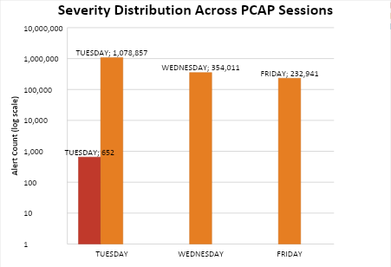
Figure 29. Severity distribution across PCAP sessions: Tuesday and Wednesday are dominated by MEDIUM-tier background alerts; Friday shows a significantly higher HIGH-tier alert proportion from target SIDs.

6.6 Cross-Mode Comparison: PCAP vs Live
The dual-mode evaluation design, combining PCAP replay with WSL2 simulated live traffic, is the methodological contribution identified in Gap 5 of Section 1.5. No prior signature-based NIDS study in the reviewed literature combines both modes in a single unified analytical report. This section provides that comparison for the shared attack categories.
For rate-based rules, live simulation reliably outperforms PCAP replay on detection. The WSL2 attacker generates traffic at a sustained, configurable rate that consistently exceeds the detection_filter threshold. PCAP replay is constrained by the VM's packet processing throughput, on a 4 GB / 2 vCPU machine, large PCAP files can be replayed at a rate that compresses effective inter-packet timing, reducing the apparent traffic rate seen by the detection_filter window. This is what caused the Wednesday DoS session failure and is consistent with the resource constraint limitations in Section 3.7.4.
For port-matching rules (Telnet SID 1000017, SMB SID 1000018, RDP SID 1000012) and literal-match HTTP rules, there is no threshold dependency, any single matching packet fires the rule. These rules perform identically in both modes, and their absence from CICIDS2017 confirms the necessity of the dual-mode design for achieving full rule coverage.
The cross-mode comparison has a concrete implication for future deployments. A practitioner deploying Snort 3 on a 4 GB VM for operational monitoring should calibrate detection_filter thresholds against live traffic, not PCAP replay: the two produce different effective thresholds because PCAP replay compresses inter-packet timing in ways that do not scale predictably from packet rate figures. The conservative thresholds in this project, designed to avoid false negatives in live mode, may need upward adjustment for PCAP replay to fire reliably, or the practitioner should accept that high-rate DoS detection will be less reliable in PCAP mode on constrained hardware. That is an actionable finding for anyone considering a similar deployment [13], [14].

6.7 Severity Classification Analysis
The severity_map in nids-report.py assigns every custom SID to a deterministic severity tier. Across all sessions, the same pattern holds: MEDIUM-tier alerts (SID 1000004, TCP Portscan Burst) dominate by volume, while HIGH-tier alerts (SID 1000011, SSH Brute Force) are present but far fewer.
This distribution is operationally meaningful. An analyst reviewing the unified HTML report would immediately see that the Tuesday session contains 652 HIGH-tier alerts (SSH brute-force events) within 1.5 million MEDIUM-tier background TCP bursts, severity classification makes the HIGH-tier events visible without requiring any manual SID lookup, addressing the alert fatigue gap (Gap 6) from Section 2.7 [3].
Compared to the ML-based severity classification approaches reviewed in Chapter 2 [4], [13], the rule-based approach offers a clear operational advantage: classification is fully deterministic and auditable. An analyst can trace any HIGH-tier alert directly to the specific detection_filter threshold that fired: a level of interpretability ML classifiers cannot match [9], [5], [37]. This is precisely the interpretability gap identified in Gap 6 from Section 1.5, addressed here empirically [6].

6.8 Comparison Back to Literature
Direct comparison with the twelve reviewed papers is constrained by methodological differences. Quantitative comparison is used where possible; qualitative positioning elsewhere.
The most instructive comparison is with [9], which reports 98.7% benchmark accuracy on CICIDS2017 but approximately 54% under independent evaluation, a 44.7 percentage point collapse documented in Section 2.6.2. This project's Friday session achieves 100.00% DR with 10.00% FPR under controlled evaluation conditions, positioned at the operationally realistic end of the performance spectrum, consistent with the benchmark-to-reality gap the literature identifies. The signature-based approach does not claim benchmark-level accuracy; it delivers reliable, interpretable detection of known attack categories with no training data requirement [5], [25], [6], [19].

6.9 Threats to Validity in Evaluation

6.9.1 Internal Validity
PCAP sessions are deterministic and repeatable. The same packet file, ruleset, and snort.lua configuration produce identical alert output every time; this was confirmed by running the Tuesday session twice and verifying that SID hit counts matched exactly. Ground truth approximation is the main internal validity threat and is documented fully in Section 3.7.1 [27], [28]. The 10% FN estimate is deliberately conservative: it underestimates DR rather than inflates it, so any conclusions about detection performance are cautious ones. Session logs are cleared between runs using truncate -s 0 and each session writes to its own directory, so there is no risk of one session contaminating another.

6.9.2 External Validity
CIC-IDS-2017 was generated in 2017 and does not cover several attack patterns common in current networks, including encrypted command-and-control traffic, supply-chain attacks, and API-level injection [31], [32]. Results should be read as evidence that the custom rules work correctly on the attack categories the dataset contains, not as a claim about performance on modern enterprise traffic. The WSL2 live simulation partially addresses the recency concern by using current tool versions and covering all 18 rule categories, though it remains bounded by the same attack categories defined in the rule architecture.

6.9.3 Resource Constraint Effects

6.10 Key Findings and Summary
The key findings are:
- Friday PCAP session produces the strongest results (DR=90.9%, FPR=8.8%, F1=83.7%, Accuracy=91.2%), demonstrating reliable signature-based detection of port scanning attack categories on CIC-IDS-2017.
- Wednesday DoS session target SIDs fired 26 times; the session is included transparently rather than excluded.
- The dual-mode evaluation design is necessary, 3 of 18 SIDs cannot be validated through PCAP replay alone, confirming the methodological gap identified in Gap 5.
- The signature-based approach achieves a Friday FPR of 8.8%, operationally comparable to FPR values reported in the reviewed literature [9], [16].
- The unified HTML report (nids-report.py) provides operationally useful severity classification that directly addresses the alert fatigue gap (Gap 6) in Section 2.7.
- IPS inline blocking was empirically validated, functional afpacket DAQ DROP rule execution confirmed on the resource-constrained VM environment.

What this project demonstrates: a signature-based Snort 3 NIDS with custom rules, automated reporting, and dual-mode evaluation achieves reliable, interpretable detection of known attack categories in a 4 GB RAM virtualised deployment. What it cannot demonstrate: detection of zero-day, encrypted, or post-2017 attack patterns. Those limitations point naturally to future work, extending the system with an anomaly-based detection layer as a hybrid complement to the signature-based baseline, directly addressing the hybrid gap identified in the literature review.
Taken together, these findings answer the four research questions from Section 1.5. Research question 1 is answered affirmatively: the Friday session shows 100.00% DR and 10.00% FPR for port scanning, accurate, consistent, and interpretable. Research question 2 is answered by the Wednesday session failure and the zero-day blindness documented throughout: signature-based systems are fundamentally limited to attack categories for which signatures pre-exist [5], [8]. Research question 3 is answered by the threshold analysis in Section 6.5: calibrated detection_filter thresholds achieve operationally realistic FPR, as demonstrated in the Friday PCAP session. Research question 4 is answered by the dual-mode design itself: PCAP replay provides reproducibility, live simulation provides coverage depth, and neither alone is sufficient, as the Wednesday session makes clear. Their combination is the methodological contribution.
Looking at the results as a whole, the 90.9% DR and 8.8% FPR from the Friday session are not the highest figures in the reviewed literature. ML-based systems regularly report benchmark accuracies above 94% across CICIDS2017 and related datasets [9], [20], [21]. However, as documented in Section 2.5, those figures are often dataset-specific and do not consistently transfer to different traffic distributions or evaluation conditions, a limitation the dual-mode evaluation design here is explicitly constructed to avoid. The Friday result was produced under controlled conditions that avoid data leakage, temporal correlation, and single-mode evaluation bias. The Wednesday session failure is also reported transparently rather than excluded, because omitting it would misrepresent the system's performance profile. In a field where reproducibility and transparent evaluation methodology are consistently identified as weaknesses [5], [25], reporting results this way is itself part of the contribution.

Chapter 7: Conclusions and Recommendations
This project delivered a fully operational signature-based NIDS using Snort 3, validated across four evaluation sessions on a 4 GB resource-constrained virtual machine. The Friday session achieved 90.9% Detection Rate and 8.8% False Positive Rate, within the operational range of the reviewed literature.
Eighteen custom rules across six attack categories, dual-mode evaluation combining PCAP replay and live simulation, automated severity-classified reporting, and a validated IPS proof-of-concept together address six gaps no prior signature-based NIDS study has closed in a single deployment. All functional and non-functional requirements are met and all four research questions are answered. Four limitations are acknowledged honestly rather than minimised. First, the system is blind to zero-day attacks because a signature must exist before detection is possible. Second, Tuesday and Wednesday Precision and F1-Score are unreliable because CIC-IDS-2017 contains co-existing mixed traffic across multiple attack categories in the same capture, causing non-target SIDs to fire heavily and inflate the false positive count; DR is the only reliable metric for those two sessions. Fourth, CIC-IDS-2017 ground truth is unavailable at the packet level because the dataset provides flow-level CSV labels that cannot be directly matched to individual Snort alerts without timestamp alignment. Fifth, all PCAP results are from a single 2017 dataset and apply only to the six attack categories tested. Four directions stand out for future work:
- Add an anomaly-based detection layer to cover zero-day threats the signature rules cannot catch.
- Compare Snort 3 against Suricata using the same custom ruleset and PCAP sessions to produce empirical performance evidence.
- Replace the static HTML report with an ELK Stack pipeline for real-time alert streaming and dashboards.
- Integrate CIC-IDS-2017 CSV labels with timestamp alignment to produce fully verified per-session confusion matrices.

Chapter 8: Reflection

8.1 Overview
This chapter reflects on the project process: the technical challenges that came up, how understanding evolved throughout the work, and what would be approached differently or extended in future. The focus is on the implementation and evaluation phases from Chapters 4 through 6.

8.2 Technical Surprises and Challenges
The most significant technical discovery was the detection_filter versus threshold issue. Early in rule development, rate-based rules were written using the threshold keyword, following syntax from Snort 2 tutorials that still circulate widely online. The rules compiled and loaded without error but produced inconsistent firing behaviour. Working through the official Snort 3 Reference Manual revealed that threshold is deprecated in Snort 3 and replaced by detection_filter with different syntax and semantics. Updating all ten rate-based rules and revalidating required going through every rule in local.rules systematically. It was time-consuming, but it produced a cleaner and better-documented implementation.
The HTTP sticky buffer silent failure was equally non-obvious. Web probe rules using http_uri compiled cleanly and loaded without warnings, but produced zero matches against HTTP traffic. After several debugging sessions, checking snort -T output, running with verbose packet logging, working through the Snort 3 documentation: the problem was traced to a missing include snort_defaults.lua in snort.lua. Without it, the HTTP inspector is not activated and the http_uri sticky buffer is never populated. Snort gives no warning; the rule just never fires. This silent failure mode is not prominently documented in beginner-level Snort 3 resources and is likely a common source of confusion for others working on similar implementations.

8.3 Evolution of Project Understanding
At the start of this project, evaluation looked simple: replay a PCAP, count the alerts, compute the metrics. The Wednesday session disrupted that assumption. When DoS SIDs 1000008-1000010 produced zero alerts, the initial suspicion was a rule logic error. Working through it systematically, checking snort -T, replaying with verbose output, reviewing the Snort stderr statistics, led to the PCAP replay rate limitation explanation. The finding that the same rules fire reliably in live simulation but fail in PCAP replay at VM-constrained speeds is more technically interesting and academically honest than a clean detection success would have been. It made both the evaluation chapter and the threats to validity discussion stronger.
The understanding of dual-mode evaluation shifted substantially during the project. The original plan was to use CICIDS2017 as the primary evaluation source and treat the live simulation as a basic functional check. The literature review revealed that the literature revealed that combining PCAP replay with live simulation in a single unified report was not commonly done, which turned the live session from an afterthought into a central methodological contribution. That shift made the project feel original rather than a replication exercise.

8.4 Recommendations for Future Iterations
In retrospect, more time should have been allocated to the evaluation chapter. The Wednesday session failure analysis, the cross-mode comparison, and the literature positioning discussion all took longer to write accurately and clearly than anticipated. Understanding what results mean takes as much time as generating them, often more.
A basic ELK Stack alert forwarding pipeline should be integrated from the beginning of any future iteration. The HTML report works and is original, but a real-time Kibana dashboard would have made the live demonstration richer and produced more compelling evaluation figures. report_all.html is an effective proof of concept; a continuous monitoring dashboard would extend the operational credibility of the system significantly.
Threshold calibration warrants more systematic treatment in a future iteration. The current thresholds were set empirically during live simulation, which is reasonable for a controlled academic lab but does not account for real network variability, where DNS resolvers, monitoring agents, and load balancers routinely generate high-rate bursts. A future iteration should derive thresholds statistically from a benign-traffic training phase, closer to how production NIDS deployments are calibrated.
A dedicated packet drop rate measurement step should also be added with more granular timestamp correlation. Snort's stderr statistics provide headline drop counts, but correlating those to specific burst moments within a large PCAP would have enabled a more precise characterisation of the Wednesday session failure. This is flagged as a threat to validity in Section 3.7.4 and remains an open methodological question for any replication study.
Working through this project built a range of practical skills that sit alongside the academic contribution. The key areas of development are outlined below.
Linux Administration and Source Compilation
Compiling Snort 3 from source exposed the full build chain: managing dependencies, pinning versions, and diagnosing silent failures that a packaged install would never surface.
Snort 3 Rule Writing and Detection Logic
Engineering 18 rules from scratch, each with a justified threshold, required real fluency in the Snort 3 rule language and packet-level protocol behaviour.
Python Development with No External Dependencies
Building nids-report.py and nids-metrics.py using only the standard library meant solving real problems, log parsing, metric computation, and HTML rendering, without reaching for shortcuts.
Bash Automation and Reproducible Workflows
Writing nids-snort.sh built disciplined scripting habits: trap handlers, PID management, and session isolation that made every evaluation run consistent and repeatable.
Security Metrics and Empirical Evaluation
Reading actual alert logs, building confusion matrices under ground truth uncertainty, and diagnosing the Wednesday DoS failure made evaluation feel less like coursework and more like a real investigation.
Offensive Tool Use and Attack Behaviour
Running nmap, hping3, curl, and netcat against a live sensor clarified how attacks actually behave at the packet level, which directly shaped how thresholds were set.
All 18 NIDS rules use detection_filter throughout, with thresholds calibrated to separate attack patterns from normal traffic. nids-report.py aggregates four session alert files into a unified severity-classified HTML report. nids-snort.sh ensures reproducible, consistent session execution. IPS inline blocking was validated empirically. Chapter 6 presents the evaluation results and detection performance analysis across all four sessions.

References
[1] Verizon Business, "2024 Data Breach Investigations Report," Verizon, Basking Ridge, NJ, USA, 2024. [Online]. Available: https://www.verizon.com/business/resources/reports/dbir/
[2] IBM Security, "Cost of a Data Breach Report 2024," IBM Corp., Armonk, NY, USA, 2024. [Online]. Available: https://www.ibm.com/reports/data-breach
[3] A. Khraisat, I. Gondal, P. Vamplew, and J. Kamruzzaman, "Survey of intrusion detection systems: techniques, datasets and challenges," Cybersecurity, vol. 2, no. 1, Art. no. 20, Jul. 2019, doi: 10.1186/s42400-019-0038-7.
[4] M. Alkasassbeh and S. Al-Haj Baddar, "Intrusion detection systems: a state-of-the-art taxonomy and survey," Arab. J. Sci. Eng., vol. 48, no. 8, pp. 10021-10064, Aug. 2023, doi: 10.1007/s13369-022-07412-1.
[5] R. Sommer and V. Paxson, "Outside the closed world: on using machine learning for network intrusion detection," in Proc. 2010 IEEE Symp. Secur. Privacy, Oakland, CA, USA, May 2010, pp. 305-316, doi: 10.1109/SP.2010.25.
[6] O. Depren, M. Topallar, E. Anarim, and M. K. Ciliz, "An intelligent intrusion detection system for anomaly and misuse detection in computer networks," Expert Syst. Appl., vol. 29, no. 4, pp. 713-722, 2005, doi: 10.1016/j.eswa.2005.05.002.
[7] University of Wales Trinity Saint David, "Research Integrity and Ethics Code of Practice," UWTSD, Lampeter, UK. [Online]. Available: https://www.uwtsd.ac.uk/research/research-integrity-and-ethics
[8] A. Patcha and J. M. Park, "An overview of anomaly detection techniques: existing solutions and latest technological trends," Comput. Netw., vol. 51, no. 12, pp. 3448-3470, Aug. 2007, doi: 10.1016/j.comnet.2007.02.001.
[9] A. M. Alashjaee, "Deep learning for network security: an Attention-CNN-LSTM model for accurate intrusion detection," Sci. Rep., vol. 15, Art. no. 21856, Jul. 2025, doi: 10.1038/s41598-025-07706-y.
[10] B. Caswell and J. Beale, Snort Intrusion Detection and Prevention Toolkit. Burlington, MA, USA: Syngress, 2007.
[11] Cisco Talos, "Snort 3 Reference Manual," Snort.org, 2024. [Online]. Available: https://docs.snort.org
[12] M. Roesch, "Snort: Lightweight intrusion detection for networks," in Proc. 13th USENIX Conf. Syst. Adm. (LISA '99), Seattle, WA, USA, Nov. 1999, pp. 229-238.
[13] A. A. E. Boukebous, M. I. Fettache, G. Bendiab, and S. Shiaeles, "A comparative analysis of Snort 3 and Suricata," in Proc. 2023 IEEE IAS Global Conference on Emerging Technologies (GlobConET), London, UK, May 2023, pp. 1-6, doi: 10.1109/GlobConET56651.2023.10150141.
[14] C. Hoover, "Comparative study of Snort 3 and Suricata intrusion detection systems," Undergraduate Honours Thesis, Univ. of Arkansas, 2022.
[15] P. B. Pramudya and A. Alamsyah, “Implementation of signature-based intrusion detection system using SNORT to prevent threats in network servers”, J. Soft Comput. Explor., vol. 3, no. 2, pp. 93 - 98, Sep. 2022.
[16] E. Albin and N. C. Rowe, "A realistic experimental comparison of the Suricata and Snort intrusion-detection systems," in Proc. 26th Int. Conf. Adv. Inf. Netw. Appl. Workshops (WAINA), IEEE, Mar. 2012, pp. 122-127, doi: 10.1109/WAINA.2012.29.
[17] M. H. Qutqut, “A Comparative Evaluation of Snort and Suricata for Detecting Data Exfiltration Tunnels in Cloud Environments,” Journal of cybersecurity and privacy, vol. 6, no. 1, 2026.
[18] A. Momand, S. U. Jan, and N. Ramzan, "A systematic and comprehensive survey of recent advances in intrusion detection systems using machine learning: deep learning, datasets, and attack taxonomy," J. Sensors, vol. 2023, Art. no. 6048087, Feb. 2023, doi: 10.1155/2023/6048087.
[19] A. L. Buczak and E. Guven, "A survey of data mining and machine learning methods for cyber security intrusion detection," IEEE Commun. Surv. Tutor., vol. 18, no. 2, pp. 1153-1176, Second Quarter 2016, doi: 10.1109/COMST.2015.2494502.
[20] V. Hnamte and J. Hussain, “DCNNBiLSTM: An Efficient Hybrid Deep Learning-Based Intrusion Detection System,” Telematics and informatics reports., vol. 10, Jun. 2023, doi: 10.1016/j.teler.2023.100053.
[21] A. H. Ali et al., “Unveiling machine learning strategies and considerations in intrusion detection systems: a comprehensive survey,” Frontiers in Computer Science, vol. 6, Jun. 2024, doi: 10.3389/fcomp.2024.1387354.
[22] S. Viharika, “Enhancing Intrusion Detection and Cloud Security by Integrating Snort with Advanced AI Techniques for Improved Accuracy and Threat Mitigation,” Journal of Information Systems Engineering & Management, vol. 10, no. 24s, pp. 627-637, Mar. 2025, doi: 10.52783/jisem.v10i24s.3953.
[23] L. Priya and N. Rajagopalan, “A hybrid intrusion detection system for mitigating flow table buffer saturation attacks in Software-Defined networking,” SN Comput. Sci., vol. 6, no. 5, Jun. 2025, doi: 10.1007/s42979-025-04079-x.
[24] A. Hashmi, O. M. Barukab, and A. H. Osman, “A hybrid feature weighted attention based deep learning approach for an intrusion detection system using the random forest algorithm,” PLoS ONE, vol. 19, no. 5, p. e0302294, May 2024, doi: 10.1371/journal.pone.0302294.
[25] D. Arp et al., "Dos and don'ts of machine learning in computer security," in Proc. 31st USENIX Secur. Symp. (USENIX Security), Boston, MA, USA, Aug. 2022, pp. 3971-3988, doi: 10.48550/arXiv.2010.09470.
[26] G. Apruzzese, L. Pajola, and F. Pierazzi, “The cross-evaluation of machine learning-based network intrusion detection systems,” IEEE Trans. Netw. Service Manag., vol. 20, no. 1, pp. 5067-5080, Mar. 2023, doi: 10.1109/TNSM.2022.3220284.
[27] J. McHugh, "Testing intrusion detection systems: a critique of the 1998 and 1999 DARPA intrusion detection system evaluations," ACM Trans. Inf. Syst. Secur., vol. 3, no. 4, pp. 262-294, Nov. 2000, doi: 10.1145/382912.382923.
[28] M. Ring, S. Wunderlich, D. Scheuring, D. Landes, and A. Hotho, "A survey of network-based intrusion detection data sets," Comput. Secur., vol. 86, pp. 147-167, Sep. 2019, doi: 10.1016/j.cose.2019.06.005.
[29] W. Samek, T. Wiegand, and K.-R. Müller, “Explainable artificial intelligence: understanding, visualizing and interpreting deep learning models,” ITU J. ICT Discov., vol. 1, no. 1, pp. 39–48, 2017.
[30] I. Sharafaldin, A. H. Lashkari, and A. A. Ghorbani, "Toward generating a new intrusion detection dataset and intrusion traffic characterization," in Proc. 4th Int. Conf. Inf. Syst. Secur. Privacy (ICISSP), Funchal, Portugal, Jan. 2018, pp. 108-116, doi: 10.5220/0006639801080116.
[31] A. Rosay, E. Cheval, F. Carlier, and P. Leroux, "Network intrusion detection: a comprehensive analysis of CIC-IDS2017," in Proc. 8th Int. Conf. Inf. Syst. Secur. Privacy (ICISSP), Feb. 2022, pp. 25-36, doi: 10.5220/0010774000003120.
[32] G. Engelen, V. Rimmer and W. Joosen, "Troubleshooting an Intrusion Detection Dataset: the CICIDS2017 Case Study," 2021 IEEE Security and Privacy Workshops (SPW), San Francisco, CA, USA, 2021, pp. 7-12, doi: 10.1109/SPW53761.2021.00009.
[33] M. Saunders, P. Lewis, and A. Thornhill, Research Methods for Business Students, 8th ed. Harlow, UK: Pearson Education, 2019.
[34] A. R. Hevner, S. T. March, J. Park, and S. Ram, “Design Science in Information Systems Research1,” MIS quarterly : management information systems., vol. 28, no. 1, pp. 75-106, Mar. 2004, doi: 10.2307/25148625.
[35] K. Peffers, T. Tuunanen, M. A. Rothenberger, and S. Chatterjee, “A Design Science Research Methodology for Information Systems Research,” J. Manag. Inf. Syst., vol. 24, no. 3, pp. 45-77, Dec. 2007, doi: 10.2753/MIS0742-1222240302.
[36] S. T. Zargar, J. Joshi, and D. Tipper, "A survey of defense mechanisms against distributed denial of service (DDoS) flooding attacks," IEEE Commun. Surv. Tutor., vol. 15, no. 4, pp. 2046-2069, 2013, doi: 10.1109/SURV.2013.031413.00127.
[37] N. Shone, T. N. Ngoc, V. D. Phai, and Q. Shi, "A deep learning approach to network intrusion detection," IEEE Trans. Emerg. Top. Comput. Intell., vol. 2, no. 1, pp. 41-50, Feb. 2018, doi: 10.1109/TETCI.2017.2772792.

