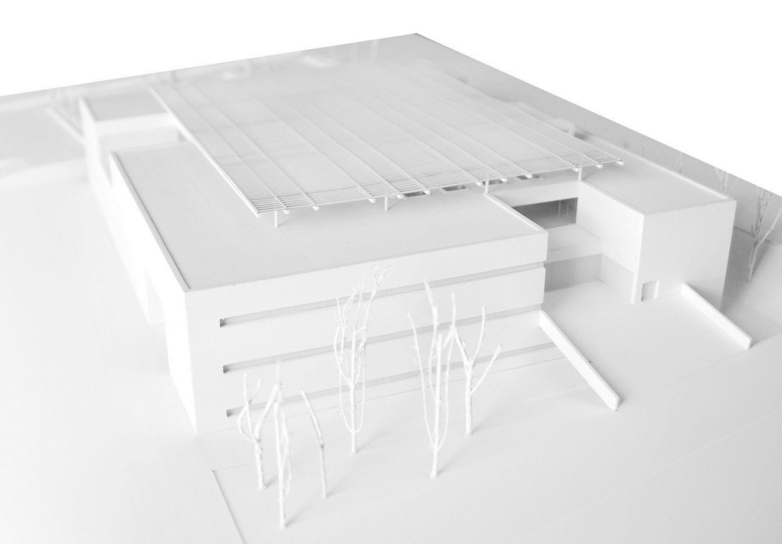

Elliott Lewis 07.03.2022
Technical report for proposed commercial building development on Swansea SA1 Site

Summary
A client wishes to build a 3-story commercial office on an SA1 site in Swansea. Plan and section drawings have been provided. See Figures below. The clients have requested a technical report illustrating and describing the primary structure and the system of enclosure.
Table of Contents
Introduction 3
Primary Structure - Substructure 3
Foundation Type 3
Primary Structure - Superstructure 3
Structural system 3
Columns 4
Splices Between Columns 4
Beams 4
Connections 4
Floor 5
Considerations 5
Composite floor system 5
Roof 6
Profiled Metal Decking 6
Enclosure 7
Fire 7
Weather resistant 7
Rain screen cladding 7
Air cavity 8
Insulation layer 8
Glass curtain walling 8
Light steel infill walling 8
Conclusion 9
Appendices 9
References 9

Introduction

This report will use technical information to describe the system of primary structure chosen for the construction of a the 3-story commercial building. By referring to the existing plan and section drawings a technical overview of the foundation type, structural elements such as columns, walls, beams, floors and roof will briefly outline the techniques and constructional forms suited to the proposed development. This report will also look at sustainability and how it can be incorporated into the design. Not only by being selective of materials chosen but also considering the use of the building and its flexibility to change to meet its user’s needs.
The second part of this report will justify an appropriate system of enclosure for the building conductive to the primary structural elements and also, it’s physical location and use.

Primary Structure - Substructure

Reviewing bore hole logs must be given consideration, see appendices (1,2 & 3) which give an understanding of the soil structure below the proposed building. The SA1 site was made redundant of its industrial use in the 1970s and the bore hole logs show anthropogenic ground and evidence the site was back filled with a mix of materials. This is shown in the logs as there are ashes, dense bricks, sand, clay and gravel up to a depth of 8m. This soil type will not be suitable as the particles range in size from 0.06 mm upwards show little or no cohesion and tend to move independently when placed under a load (Riley and Cotgarve, 2014). At a depth of 8m the stiff grey brown gravelly boulder clay which is generally considered within the broad category of fine-grained cohesive soil will have significant bearing capacity to safely transfer the load.

Foundation Type

Due to the ground being composed of boulders and the depth required, hollow steel piles should be driven in with a piling rig, piles need to be partially filled with hardcore/resin and reinforced piles caps and reinforced slab. This type of foundation is recommended as it can withstand hard driving force, unlike concrete piles, and is capable of penetrating through to boulder clay. They are expensive but there is much lesser chance of damage during installation. The steel piles also have reduced vibration levels compared to precast piles and as the surrounding ground is loose sand and gravel, this minimises the movement of the non-cohesive soil (Balfour Beatty Ground Engineering, no date).

Primary Structure - Superstructure

Structural system
Steels frames are recommended and a very common construction method used in the industry and consist of using steel columns and beams to create a support for components such as the walls, floors and roof. Also fundamentally supporting the load of the structure itself but also its imposed loads such as users and internal fixtures (Chudley and Greeno, 2016). See table below showing the factors considered when choosing material and construction method and the justification alongside for using steel over using timber or concrete.
Sustainability | All waste and scrap steel left over can be reused as it can be mettled down and recast. Also, by using computer software prior to prefabrication the amount of waste is reduced.
Faster build times | As the steel components are fabricated off site to the required specification when they arrive on site, they are ready to be fixed and welded
Space Maximisation | Steel can allow for larger spans resulting in larger open spaces
Strength | Due to steel having very good tensile strength it can carry more load meaning less steel is needed than timber or concrete to support the same load creating more internal space and reducing number of materials used.
Cost effective | As steel components are prefabricated off site it reduces the onsite labour dramatically which not only saves money but also from a CDM 2015 regulations aspect reduces the risk for worker on site. Also, quicker construction times means projects can be delivered more quickly and used sooner.
Longevity | Providing steel is treated correctly with fire retardant and water resistant it can retain its strength and last longer than timber

Stephan Emmitt Wiley Blackwell

Columns
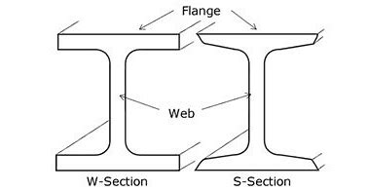
The layout of steel columns specified is based on the load imposed and required spans. There are many different sizes of steel column dependant on the design requirements. The dimensions and profiles are defined in BS 449. See image showing standard steel section of universal columns (UCs). The columns must be secured to the Pile caps by base plates which are welded to the end of the columns. As indicated in the image below, a base plate is a square/rectangular plate which is fixed to the columns and then bolted into the foundation.
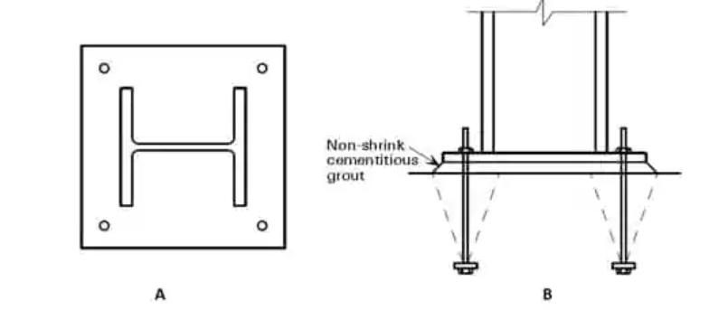

Splices Between Columns
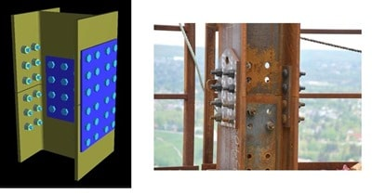
As the proposed building is 3 stories, column splices will ease the erection process on-site, off-site production and deliveries. See image below. The distance between the 2nd floor and the column splice in the proposed structure will be 60cm (The Constructor, 2021)

Beams
Beams transfer the load from floors and the roof to the columns. Steel beams have very high tensile strength allowing them to span distances as far as 18M. The calculation for dead load of a building is volume of member x unit weight of materials. By calculating the volumes of all members an accurate dead load can be determined for each component. The total dead, live and wind loads along with the required span will determine the size beam required.

Connections
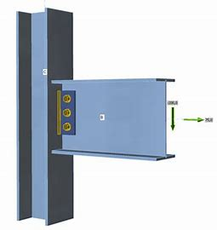
During the assembly process of the steel beams, column to beam connections and beam to beam connections are created. There are different types of columns to beam connections which vary based on the type of loads imposed on the column to beam joint. If the connection is only going to encounter vertical loads, then connections such as flexible end plates or fin plates can be used.
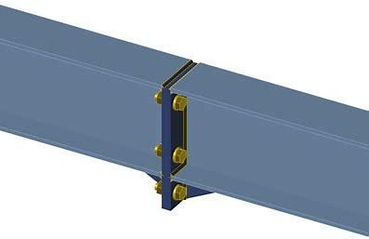

Finn Plate End Plate

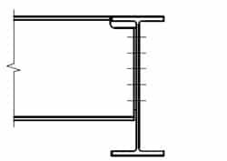
Beam to beam connections consists of the end plate beam to beam connection joining secondary steel beams to primary steel beams. The top flange of secondary beams support the floor system meaning it must be flush with the top flange of the primary beams. This can be obtained by notching the top flange of the secondary beam.

Floor

Considerations
Services integration | Due to the proposed building being used as an office the integration of service ducts for services such as ventilation should be considered. Flooring systems that allow flexibility to incorporate these services will be better suited due the intended end use of the building.
Simplicity | Using the simplest solution that meets the buildings requirements not only saves on cost and reduces error but also means less labour required.
Adaptability | As the Covid-19 pandemic has proven, the use of buildings may need to change with the many people working from home and returning to a hybrid model post pandemic. Having flexibility is not only more sustainable but more cost effective and a safer investment if the structures use can incorporate change.
Acoustics | Especially in an office environment acoustic performance is very important and this is why good detailing is an important consideration to avoid annoyance to floors below and above
Fire resistance | Time in which it can resist fire and how the steel members can be protected as much as possible to reduce the amount of their strength they lose if exposed to the intense heat of a fire. Treatment of components is vital and also designing the beams and floor supports to be sufficiently strong to retain their strength and properties for a certain amount of time.
(Steel Construction Info 2019)

Composite floor system
This flooring method is recommended and consists of lightly reinforced concrete cast on profile steel decking. A layer of mesh and if required for extra strength, dependent on the load, rebar is installed to reinforce the slabs. Spans of up to 4.5m can be gained using steel decking that are 80mm deep. Deep decking profiles also exist over 200mm deep that can span 6m (Steel Construction Info 2019)
They are quick and easy to install in comparison to using precast alternatives reducing the cranes required and also safety risk on site. When appropriately orientated and fixed to the steel beams it can restrain them against lateral torsional buckling and add rigidity to the structure (Jack Stroud Foster) Services can be suspended from the soffit of a composite slab using anchors allowing for ventilation ducts and general services if required.
Good detailing is needed to avoid flanking issues, where sound travels around a barrier (such as a floor) by passing through an adjoining wall. See figure below showing Junction of a twin light steel frame separating a wall with a shallow composite separating floor.
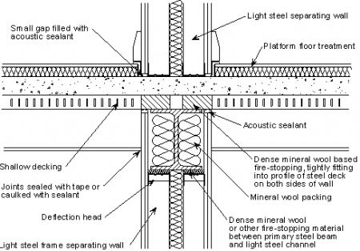

Roof

Profiled Metal Decking
Galvanised steel decking as seen below is suggested as it is lightweight, reduces the dead load of the building and can cope with large spans. The deck will support the insulation and polymeric membrane which gives it its durability and water tightness.

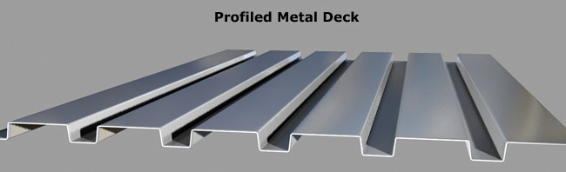

Enclosure

The building enclosure will include components such as windows, doors, walls, roofs. Cladding is required as a protective layer that insulates and protects the building against the weathers and the external environment. Cladding controls the internal setting and separates the indoor environment of a building from the outdoors allowing for a comfortable atmosphere for the occupants of the building. The enclosure of the building can help control the light that enters the building and also conduction of heat from the sun. This is achieved by ensuring the cladding system includes thermal properties allowing it to control the radiation and conduction of heat through solar gain. To control the conduction of heat the enclosure system should be constructed from a low conductivity material to avoid localised condensation on internal surfaces and thermal bridges.

Fire
The enclosure system must conform to building regulations and prevent the spread of fire through the void between the cavity and structural system.

Weather resistant
The enclosure system must have sufficient strength to support its own weight between the points of support or fixings to the structural frame. Also, the system must be able to withstand wind loads and lateral wind pressure.

Rain screen cladding
Rain screen cladding is a suitable choice of enclosure for the proposed structure as it is easy to install and also easy to maintain due to its ease of accessibility. It also performs very well in reducing heat loss due to having an air gap in the building’s exteriors façade reducing energy costs and improving the buildings efficiency. The system works as a result of temperature differences in the air cavity resulting in convection occurring making the warm air lift during summer time renewing the air inside the cavity with cooler air. During winter the air inside the cavity is not warm enough to lift, which helps the insulation layer contain the heat inside the building. This avoids overheating during summer and helps maintaining a warm and steady interior temperature during winter (cupapizarras, 2020)
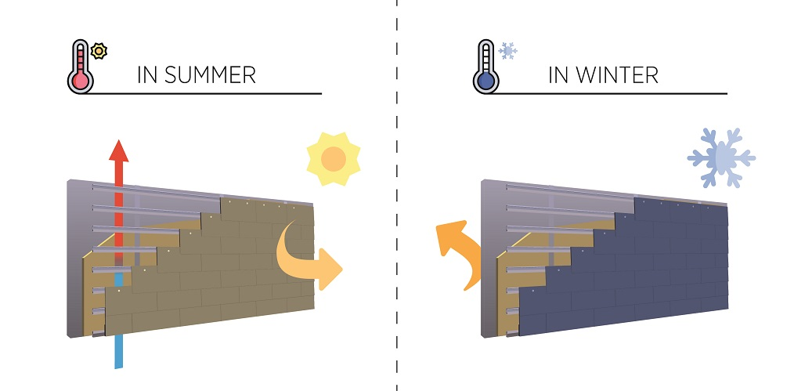

Air cavity
The vented air cavity will have openings at the top and bottom of the façade system to continually allow for constant air flow. It is important that the opening is correctly protected to prevent water ingress and debris entering the cavity.

Insulation layer
The insulation layer will go on the outside of the building and acts as a protective barrier. Having the insulation on the outside also helps it withstand structural movement.
Due to the location and high winds and rain from being on the coast, a durable and high-quality metal cladding is advised. This will help protect the structure from the elements.
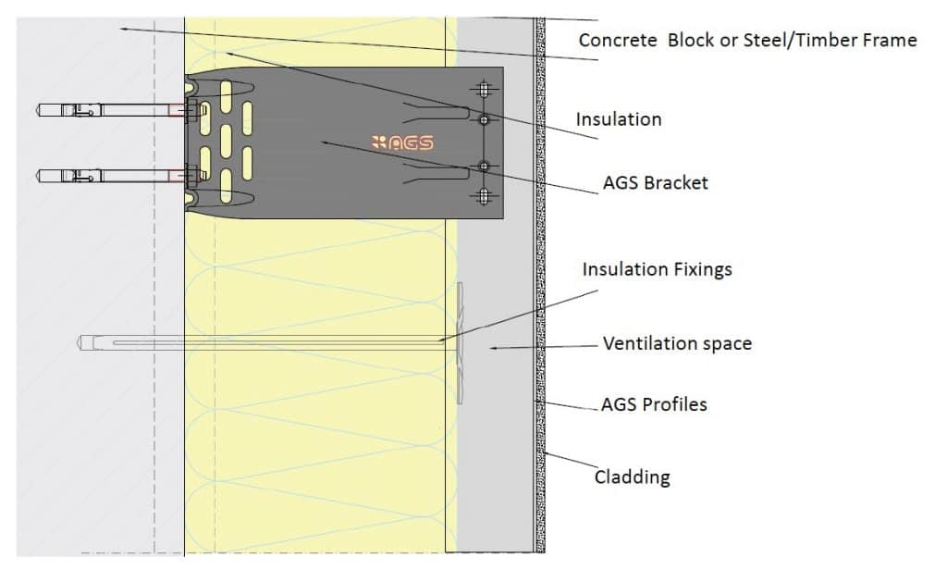

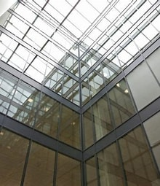
Glass curtain walling
The proposed structure will have an internal atrium. This section will be enclosed with glass curtain walling consisting of an aluminium framed with glass panels. These glazed panels will not support any structural loads. The prefabricated system will allow for light to enter the atrium.

Light steel infill walling

The external walls will be built between the floors of the steel frame and act as the support for the cladding. The infill wall will not support the cladding system but will help resist the wind loads applied against the cladding/ façade. Light steel infill walls using vertical c section studs will be used. This construction method is considerably quicker than using blockwork and is a dry process eliminating drying out and shrinkage issues. Steel infill walls with plasterboard offers good fire resistance and also acts as good sound insulation. The wall panels will be assembled on site from C sections that are delivered cut to length.
Infill walls will have a bottom track which is attached to the floor and a top track which is attached to the underside of the floor above. Vertical studs will be installed between both tracks and are designed to help withstand wind loads. The light steel sections are usually 75 to 150mm in depth and are cold roll formed from galvanised steels strip of 1 to 3.2 mm thickness.
A sheathing board will be added to the external surface of the infill wall to provide weather resistance. Also, the sheathing boards helps provide further improvements to the air tightness of the faced.
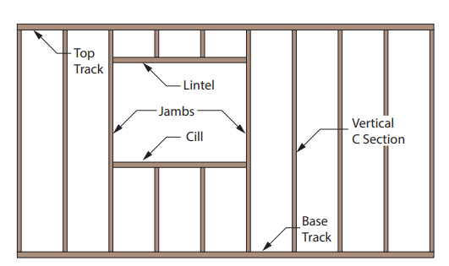

Conclusion

To conclude, hollow steel piles will form the structural support for the steel frame. A composite flooring system will be used consisting of metal decking sheets contained in concrete. To retain its thermal mass a suspended ceiling will not be installed. A profiled metal deck roof structure has been chosen, covered in a roof membrane. Curtain walling will be used around the internal atriums of the building to maximise natural light within the building. The external enclosure of the structure will be cladded in rain screen cladding with sheathing boards. The internal walls will be light steel infilled and internally clad in plaster board. This design approach has been selected to ensure a durable and efficient building bearing in mind its coastal location.

Appendices

References
The Constructor (2021) Steel Column Construction. Available at: Construction of Steel Structure Foundations, Columns, Beams, Floors (theconstructor.org) (Accessed 2nd March 2022)
Balfour Beatty Ground Engineering (no date) Driven steel piling Available at: https://www.balfourbeatty.com/media/29534/driven-steel-piling.pdf (Accessed: 01st March 2022)
Riley, M. and Cotgrave, A. (2014) Construction technology 2: Industrial & Commercial Building 3rd Ed: Palgrave Macmillan.
Steel Construction Info (2019) Floor Systems. Available at: Floor systems - SteelConstruction.info (Accessed: 01st March 2022)
Cupapizarras (2020) What is Rain Screen Cladding. Available at: What is a rainscreen cladding system and what are the advantages? | Cupa Pizarras (Accessed: 01st March 2022)

