Programme: Master of Business Administration

Module: Marketing Management

Module code: LCMB7024
LECTURER’S NAME: HAORAN LIU
Name of the student: KARANKUMAR RAMESHBHAI CHAUDHARY
Student ID: 2538332

Table of Contents
1.0 Element 1: Sustainable Brand Extension Poster Presentation 3
2.0 Element 2: Develop a Segmentation, Targeting, Differentiation, and Positioning (STDP) 4
2.1 Key market segments relevant to the brand extension 4
2.2 Detailed explanation of your chosen target audience 5
2.3 Way the brand will differentiate itself from competitors in the market 6
2.4 Positioning of the sustainable brand extension 6
3.0 Element 3: Marketing Mix (4Ps) 8
3.1 Product 8
3.2 Price 9
3.3 Promotion 10
3.4 Place 11
4.0 Element 4: Reflection 13
References 15

1.0 Element 1: Sustainable Brand Extension Poster Presentation
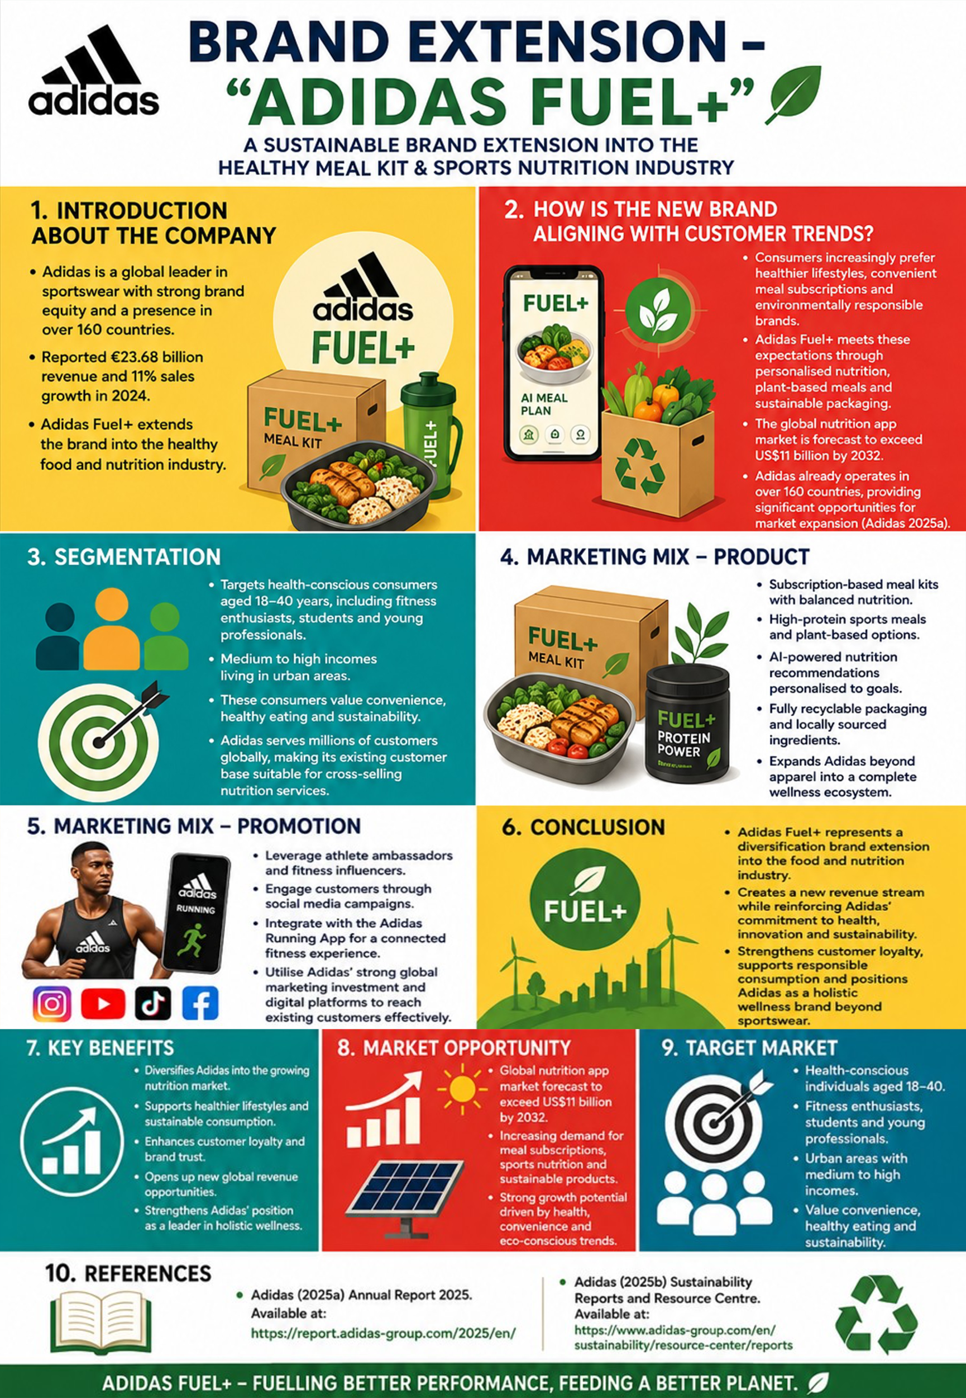

2.0 Element 2: Develop a Segmentation, Targeting, Differentiation, and Positioning (STDP)

2.1 Key market segments relevant to the brand extension
Geographic Segmentation
The main focus of Adidas Fuel+ should be on urban and metropolises where demand for healthy meal delivery, digital fitness services and sustainable lifestyles prevail. The first target areas for expansion are Europe, North America, Greater China, Japan/South Korea and major cities in Asia-Pacific where Adidas has a better established brand identity across the retail and digital channels (World Health Organization, 2025). Adidas' 2025 sales in Europe amounted to 2025 €330 million, followed by sales in North America (2025 €210 million), Greater China (2025 €150 million), Emerging Markets (2025 €140 million) and Latin America (120 million €) (Adidas, 2025a). The company is also present in more than 160 countries, allowing for the efficient rollout of the company in different markets internationally, via current distribution and ecommerce management arrangements.
Demographic Segmentation
The audience consists of men and women between the ages of 18 and 40, mainly students, young professionals and fitness enthusiasts with medium-to-high disposable incomes. These consumers are prepared to pay a premium price for ready-to-feed healthy and customized meal solutions suitable to their hectic lifestyles (Adidas, 2025b). Industry research also shows the largest meal-kit customer base to be adults aged 25–44 years, with 39% of meal-kit consumers coming from high income households, which makes them a prime target market for Adidas Fuel+.
Psychographic Segmentation
Adidas Fuel+ is especially aimed at the consumers who place emphasis on health, fitness, sustainability and technology-driven lifestyles. They exercise regularly, appreciate a balanced diet and like brands that are environmentally responsible and use recyclable packaging and local ingredients (Adidas, 2025c). Approximately 40% of meal kit consumers fall into the “innovators/early adopters” category, and many show significant worry over climate change, making them very open to personalized nutrition and sustainable wellness powered by AI (Deloitte, 2025).
Behavioural Segmentation
The brand extension targets people who are physically active, buy sports nutrition products, and are digital customers who have high brand loyalty toward Adidas, also signing up for digital fitness or meal services (Firdaus and Ramli, 2025). These users are looking for convenience, customised recommendations, and seamless wellness experiences. This reflects robust long-term demand for the proposed Adidas Fuel+ offering, with the global sports nutrition market projected to increase to USD 59.1 billion by 2025, and the meal-kit delivery market valued at USD 37.06 billion in 2026, which is expected to rise to USD 72.6 billion by 2030 (Adidas, 2025d).
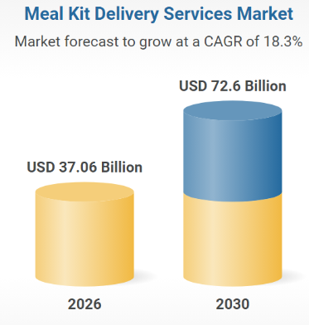
Fig 1: Meal Kit Delivery Market
Source: (Research and Markets, 2026)

2.2 Detailed explanation of your chosen target audience
Adidas Fuel+ is aimed at the health-conscious consumer aged 18-40, with a medium to high disposable income, and usually residing in urban environments – especially fitness enthusiasts, students and young professionals (Bhatnagar, 2026). These consumers are looking for easy-to-use, healthy, and personalized meal products that align with their active lifestyles and are environmentally conscious. The global meal kit market is expected to grow from nearly USD 18.7 billion in 2024 to USD 39 billion by 2033 (CAGR 8.5%) and Gen Z and Millennials are actively seeking out health and wellness brands, with approximately 62% showing a preference for such brands (Adidas, 2025e). Fuel+ will enhance customer loyalty and promote repeat purchases by combining AI-powered nutrition with Adidas' digital platform.

2.3 Way the brand will differentiate itself from competitors in the market
The key differentiator of Adidas Fuel+ is the fusion of sports nutrition, AI-driven customised meal planning and the trusted Adidas fitness ecosystem into one wellness platform. While other meal-kit services, like HelloFresh, or sports nutrition brands with only supplements, Fuel+ offers customised meal kits, nutrition recommendations, and seamless integration with the Adidas Running App to provide a seamless health and fitness experience (Rahman, 2025. The company also capitalizes on its competitive edge by using recyclable packaging, ingredients from the local area and athlete-brand marketing to attract the eco-conscious consumer (Adidas, 2025f). Adidas, as one of the world's most valuable apparel brands (USD 16 billion+ in 2025), has over 300 million members in its loyalty programme, "adiClub", so Fuel+ can build on the great level of trust and loyalty it has with customers to be competitive in the expanding nutrition market.

2.4 Positioning of the sustainable brand extension
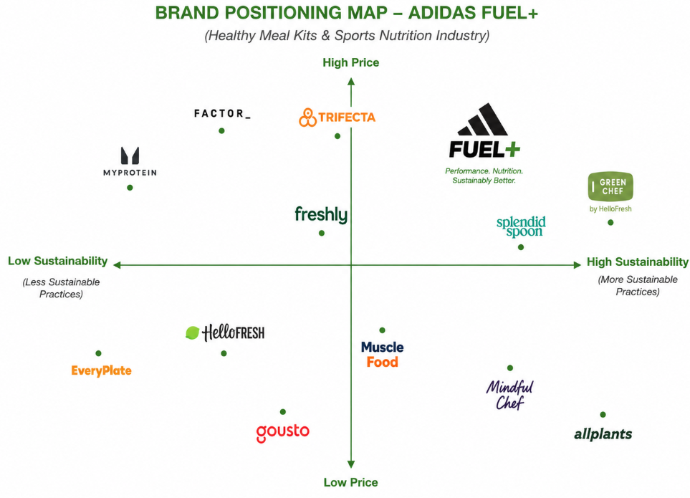
Fig 2: Positing Map
Source: (Self-Generated)
However, the positioning map positions Adidas Fuel+ in the high price segment with high sustainability, in its high price positioning in the healthy meal kit and sports nutrition market. The difference between Adidas Fuel+ and its competitors is that it's focused primarily on a meal delivery service and nutritional supplement. Adidas Fuel+ differentiates itself from competitors by integrating AI-powered personalised nutrition, sports performance support and environmentally sustainable practices into a single, comprehensive wellness solution (PwC, 2025). This positioning distinguishes the brand by innovation, high standard and sustainability and also benefits from the Adidas brand's international image of performance and well-being. Fuel+ can prove to be a significant competitive advantage and help further Adidas' transition into a lifestyle brand and a wellness brand by winning over health-conscious customers who value quality over price (International Food Information Council, 2025).

3.0 Element 3: Marketing Mix (4Ps)

3.1 Product
In addition to its sportswear products, Adidas Fuel+ brings the Adidas brand to a high-quality range of AI-powered personalised meal kits, sports nutrition products and digital nutrition coaching to help athletes and health-conscious consumers perform at their best and live healthily (McKinsey & Company, 2025). When customers take a nutrition assessment using the adidas app, the AI algorithms then provide personalised meal plans according to fitness objectives, dietary choices and activity level. The product also features plant-based meal options, high-protein foods, and recyclable packaging, further demonstrating Adidas' commitment to sustainability and establishing a comprehensive wellness ecosystem. This extension mirrors Adidas' approach of product innovation, where the needs and performance of the consumers are placed at the heart of product development (Adidas, 2025g). Consumers have high expectations of the company's innovative abilities, as proved by Adidas' 2025 net sales of €24.81 billion, with apparel sales rising 15% and running products more than 30%. Such accomplishments form a bedrock of success in neighboring health and nutrition segments. Another value added to the Fuel+ is the integration with the Adidas Running App that allows users to link dietary recommendations to training performance and recovery. As opposed to the convenience-focused meal-kit companies, Adidas Fuel+ offers a full health-care package, nutritionally complete, technologized and fit, all under the umbrella of a trusted worldwide brand. The subscription-based model is targeted to individual customers to promote re-purchasing, and can provide useful consumer data for the development of new products (Adidas, 2025h). The proposed product thus enhances customer engagement, diversifies the revenues of Adidas and solidifies its strategic vision of becoming a full-service health and wellness company instead of just a sportswear company (Sarjono et al., 2025).
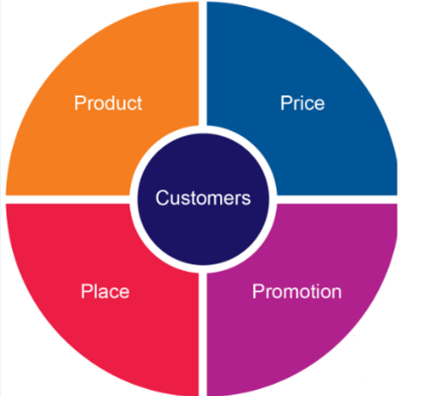
Fig 3: 4Ps of Marketing
Source: (B2B Frameworks, 2018)

3.2 Price
Adidas Fuel+ will need to price it at a premium level and based on the value it offers, considering it's designed with a personalised nutrition approach, using better ingredients and integrating with Adidas's digital ecosystem. Instead of putting itself up against the competition of offering low prices against traditional meal-kit services, the brand should sell a premium wellness subscription that can offer more value added through customised nutrition, AI-powered meal planning and sports performance optimisation (Mordor Intelligence, 2025). Various subscription packages might be available, such as student, individual/family, and advanced athlete plans that provide more in-depth nutrition coaching. This flexible pricing mechanism will make the market more accessible, while also remaining premium. The financial results of Adidas show that its consumers will pay premium prices for innovations offered by the company. Adidas' gross margin rose to 51.6% in 2025 as operating profit grew 54% to €2.06 billion, which was driven by better pricing discipline and less promotional activity (Grand View Research, 2025a). The increase of Adidas' net sales from €21.4 billion in 2023 to €24.8 billion in 2025, consumers are happy to pay premium prices, which validates Adidas Fuel+ for premium pricing and further solidifies its value-based positioning. This pricing strategy can help drive profitability and also convey higher quality, innovation and sustainability (Grand View Research, 2025b). Fuel+ will be viewed as a high quality wellness investment, not just a meal delivery service, which will help attract consumers who care more about health, convenience, and performance than the lower cost of food, and ultimately drive long-term customer loyalty and revenue growth for Adidas (Sayudha and Ramli, 2025).
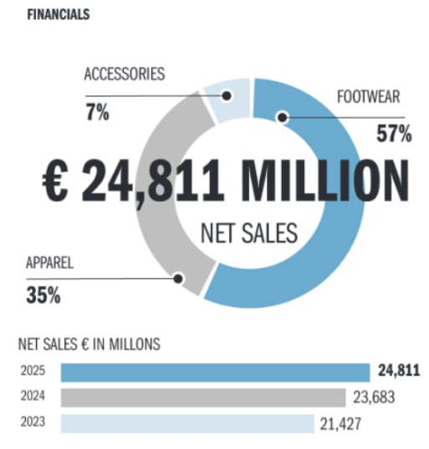
Fig 4: Adidas Financial Stats
Source: (Adidas, 2025a)

3.3 Promotion
Adidas' global brand reach can be maximized through a combination of digital marketing, athlete endorsements, influencer marketing, and mobile integration in the promotional strategy for Adidas Fuel+ (Fortune Business Insights, 2025b). The launch campaign needs to emphasize the link between personalised nutrition, sporting performance and sustainable living via the “You Got This” brand platform. By showcasing the benefits of Fuel+ in boosting athletic performance, recovery and well-being, elite athletes, nutrition experts and fitness influencers can establish a greater sense of trust among health-conscious consumers (Grand View Research, 2025c). Social media campaigns, on platforms like Instagram, TikTok and YouTube, should promote user-generated content, while the Adidas Running App gives personalised suggestions to boost consumer interaction throughout the customer journey. Adidas has proven the success in its investments in marketing and sales, which rose by 12.4%, to 8% of sales, to €3.08 billion in 2025. The investments led to key campaigns, athlete collaborations and product activations designed to deliver best-in-class business results. The existing marketing system can be leveraged by Fuel+ to enter into the nutrition communication field. Product exposure to target audience can be further enhanced through promotional ties with gyms, marathons and university fitness programmes. There can be some limited-edition meal plans that can be related to a major sporting event or an athlete ambassador that can also drive demand and build exclusivity. Across digital channels, retail outlets and the Adidas ecosystem, Fuel+ fosters emotional relationships with consumers and underscores the brand's call to action to advance health through sport (Precedence Research, 2025a). This integrated communication strategy leads to higher brand awareness, interaction with the customer and also to higher, long-term increase in the number of subscriptions.

3.4 Place
Adidas Fuel+ needs to pursue a multi-channel distribution policy – leveraging direct-to-consumer digital channels with some physical retail placements – to ensure optimal distribution and customer convenience (Fortune Business Insights, 2025a). The customer should be able to sign up via the Adidas website, App and dedicated Fuel+ platform and be delivered via the regional fulfilment centres and local delivery channels. The physical availability can be extended via flagship Adidas stores, premium fitness centres, sports clubs and selected supermarkets with refrigerated collection points (Precedence Research, 2025b). The integrated distribution can guarantee that customers can visit the nutrition products wherever and whenever they come into contact with Adidas, and that service quality is consistent. Adidas already has a wide global distribution network which can back this expansion of scale. Adidas' net sales accounted for 40% of direct to consumer sales (including retail stores and e-commerce) and 60% of wholesale sales in 2025. The company is still spending a lot of money on its physical stores and online platforms, and you can find them in other important global markets such as Europe, North America, Greater China and emerging economies. These capabilities can be used to Fuel+ to lower market entry barriers and ramp-up global expansion. This can be expanded by integration with other digital touchpoints such as the Adidas Running App and adiClub memberships, which enable customers to directly order individual food plans from existing digital platforms. This omnichannel approach not only enhances the convenience for customers but also boosts brand loyalty and provides various touchpoints for customer purchases, while simultaneously enabling efficient inventory control and facilitating international expansion (Precedence Research, 2025c). Therefore, Fuel+ can build a strong position in the quickly growing health and nutrition segment and leverage Adidas' global distribution network.

4.0 Element 4: Reflection
Description
The project is an in-depth sustainable brand extension marketing strategy for an Adidas product called Adidas Fuel+, which is a concept to enter the sports nutrition and healthy meal kit sector. The process involved in it was analysis of customer trends, identification of target market segments, development of positioning strategy and development of the 4P's marketing mix. I also made and presented a poster presentation visually and concisely conveying the proposed brand extension.
Feelings
I was inspired and challenged at the start of the project, as I had to be creative as well as strategic in creating a new brand extension. Obtaining current market data and making sure that the concept proposed would be in line with Adidas' sustainability goals was challenging initially. I was also a bit nervous about the design and presentation of my poster, as I wanted to get a lot of information across in a small space, regarding the marketing aspects of my project.
Evaluation
In general, the project was a beneficial learning experience. One of the biggest strengths were the opportunity to use marketing concepts like STP, brand positioning and the marketing mix in a real-life scenario. Both the market research and the poster design process helped me build credibility for the proposed strategy, and the design process helped me develop a visual and logical presentation of information. However, there were some issues for me in picking out some of the appropriate market statistics and balancing the content of the detailed analysis with the concise presentation.
Analysis
I was able to learn a lot about my strategic marketing skills from this project because I learned how sustainability and innovation and consumer behaviour are important factors in making a successful brand extension. I gained more analytical skills by analysing market opportunities, competitor positioning and customer segmentation through the use of academic models. The process of creating the poster also helped me develop my communication skills, since I had to create an informative and useful poster. In addition, I enhanced my digital research skills to find trustworthy industry reports and recent data to support strategic decisions.
Conclusion
Looking back on the entire experience, I have come to understand that I have gained new skills and abilities as an academic and a professional. I gained a high level of confidence in the use of marketing frameworks in real business situations, as well as improving my research, problem solving and presentation abilities. The assignment also helped me to gain insight into the concept of sustainable marketing and the need to develop a customer-centric strategy that can yield long-term competitive advantage.
Action Plan
In future projects, I will be doing more research earlier to allow me more time to study industry reports and compare the various strategic alternative choices that will be available to me. I will also be developing my data visualisation and presentation design skills utilising more advanced digital tools to create quality marketing materials. Additionally, I will practice and learn about presenting and communicate with others further and give feedback that I will find helpful. These improvements will enable me to produce better market strategies, make well presentations and be more effective while taking exams and in marketing management professions.

References
Adidas (2025a) Annual Report 2025. Available at: https://report.adidas-group.com/2025/en/
Adidas (2025b) Financial Highlights 2025. Available at: https://report.adidas-group.com/2025/en/at-a-glance/financial-highlights-2025.html
Adidas (2025c) About this Report. Available at: https://report.adidas-group.com/2025/en/at-a-glance/about-this-report.html
Adidas (2025d) Downloads – Annual Report 2025. Available at: https://report.adidas-group.com/2025/en/services/downloads.html
Adidas (2025e) Financial Publications. Available at: https://www.adidas-group.com/en/investors/financial-reports
Adidas (2025f) Financial Publications – 2025 Results. Available at: https://www.adidas-group.com/en/investors/financial-reports?tag=2025
Adidas (2025g) Sustainability Reports and Resource Centre. Available at: https://www.adidas-group.com/en/sustainability/resource-center/reports
Adidas (2025h) Sustainability. Available at: https://www.adidas-group.com/en/sustainability
B2B Frameworks (2018) 4Ps analysis – the most important marketing tool every devised. Available at: https://www.b2bframeworks.com/single-post/2018/10/09/4ps-analysis-e2-80-93-the-most-important-marketing-tool-every-devised
Bhatnagar, T., (2026). ANALYSIS OF CONSUMER BEHAVIOUR: A COMPARATIVE RESEARCH STUDY OF NIKE AND ADIDAS. Available at SSRN 6371178.
Deloitte (2025) Consumer Industry Insights. Available at: https://www.deloitte.com/global/en/industries/consumer.html
Firdaus, C. and Ramli, Y., (2025). The influence of brand image, green marketing, and environmental awareness against the green purchasing decisions of Adidas sport shoes. Business, Economics, Law, Communication, and Social Sciences, 1(1), pp.1-16.
Fortune Business Insights (2025a) Meal Kit Delivery Service Market Size, Share & Industry Analysis. Available at: https://www.fortunebusinessinsights.com/meal-kit-delivery-service-market-102529
Fortune Business Insights (2025b) Sports Nutrition Market Size, Share & Industry Analysis. Available at: https://www.fortunebusinessinsights.com/sports-nutrition-market-102082
Grand View Research (2025a) Meal Kit Delivery Services Market Size, Share & Trends Analysis Report. Available at: https://www.grandviewresearch.com/industry-analysis/meal-kit-delivery-services-market
Grand View Research (2025b) Sports Nutrition Market Size, Share & Trends Analysis Report. Available at: https://www.grandviewresearch.com/industry-analysis/sports-nutrition-market
Grand View Research (2025c) Nutrition Apps Market Size, Share & Trends Analysis Report. Available at: https://www.grandviewresearch.com/industry-analysis/nutrition-apps-market
International Food Information Council (2025) 2025 Food & Health Survey. Available at: https://foodinsight.org/food-and-health-survey/
McKinsey & Company (2025) The Future of Wellness. Available at: https://www.mckinsey.com/industries/consumer-packaged-goods/our-insights/the-future-of-wellness
Mordor Intelligence (2025) Meal Kit Market – Growth, Trends, COVID-19 Impact and Forecasts. Available at: https://www.mordorintelligence.com/industry-reports/meal-kit-market
Precedence Research (2025a) Meal Kit Delivery Services Market. Available at: https://www.precedenceresearch.com/meal-kit-delivery-services-market
Precedence Research (2025b) Sports Nutrition Market. Available at: https://www.precedenceresearch.com/sports-nutrition-market
Precedence Research (2025c) Nutrition App Market. Available at: https://www.precedenceresearch.com/nutrition-app-market
PwC (2025) Global Consumer Insights Survey. Available at: https://www.pwc.com/gx/en/industries/consumer-markets/consumer-insights-survey.html
Rahman, M.S., (2025). The Use of Social Media Platforms in Customer Relationship Management: An Analysis of Adidas (Doctoral dissertation, University of Wales Trinity Saint David).
Research and Markets (2026) Meal Kit Delivery Services Market Report 2026. Available at: https://www.researchandmarkets.com/reports/5988408/meal-kit-delivery-services-market-report
Sarjono, H., Raharja, R.R., Armelia, K.A., Sindhikara, K. and Aulia, R., (2025). Kanye West's Adidas Era: Influence on Branding, Consumers, and Market Response. Golden Ratio of Marketing and Applied Psychology of Business, 5(2), pp.371-378.
Sayudha, J.A. and Ramli, Y., (2025). The Influence of Promotion, Price, and Product Quality on the Purchase Decision of Adidas Shoes?. Business, Economics, Law, Communication, and Social Sciences, 1(2), pp.98-111.
World Health Organization (2025) Healthy Diet. Available at: https://www.who.int/news-room/fact-sheets/detail/healthy-diet

