A Critical Analysis of Organisational Culture
Briefing Paper for Bluestone National Park Resorts Ltd.
FEBRUARY 2024

Stuart Davies-Jaynes (0151126)
University of Wales Trinity Saint David
PGDip/MA in Strategic People Management
Word Count = 3,841




Contents
1.0 Bluestone National Park Resort 3
1.1 What is culture and its importance to organisations? 3
2.0 Critical Analysis of Culture at BNPR 4
2.1 Artifacts and Behaviours 5
2.2 Espoused Values 6
2.3 Basic Assumptions 10
3.0 An Analysis of BNPR’s Strategic Approach to Good Work. 12
3.1 Employee Voice 12
3.2 Pay and Benefits 13
3.3 Organisational Policies 14
3.4 Leadership Development 14
3.5 Summary of BNPR’s Strategic Approach to Good Work. 15
4.0 Recommendations 15
4.1 Recommendation One – Employee Voice 15
4.2 Recommendation Two –Flexible Working Options. 16
4.3 Recommendation Three – Work-Life Balance 16
5.0 Reference List 18

Bluestone National Park Resort
Established in 2008, Bluestone National Park Resort, also known as BNPR, is a privately owned five-star holiday destination located in Pembrokeshire. The resort offers a unique experience for guests of all ages providing a range of accommodation, including luxury lodges and cottages, as well as various amenities and activities for guests to enjoy. The resort is famous for its natural surroundings within Pembrokeshire Coast National Park and sector-leading sustainability credentials. Bluestone boasts a diverse team of more than 900 employees, spanning from Accountants, HR professionals to Housekeepers.

What is culture and its importance to organisations?

According to Buchanan and Huczynski (2019), culture can be seen as an organisation’s personality. It encompasses the daily practices within a company, influencing how tasks are carried out and impacting the way employees interact with each other, customers, and leaders. Organisational culture extends its influence beyond operational aspects, encompassing emotional and ethical dimensions as well.

Achieving genuine cultural change is nearly impossible without a clear understanding of the specific elements targeted for transformation. The annual CIPD Good Work Index, focusing on job quality throughout Wales and the UK, provides insight into these aspects to drive improvements in working lives (CIPD, 2023e). This commitment to enhancing the quality of work and organisational culture serves as a roadmap for identifying specific areas in need of change. CIPD (2023c) asserts that the measurement of good work or job quality is increasingly recognised as crucial for evaluating employment, our relationship with work, its impact on employees' lives, and identifying opportunities for enhancements in working conditions.

A favourable organisational culture enables employees to connect to the company and perceive that their input plays a crucial role in steering the business towards a shared objective (Mohanty, 2018). Consistently assessing culture is essential, as clearly articulated, and shared values impact the quality of an organisation's customer experience and contribute to the satisfaction and retention of its workforce (CIPD, 2019b).

There are considerable organisational benefits to nurturing a favourable workplace culture. Criveanu and Ivanescu (2019) identify that a robust organisational culture tends to foster a well-integrated and cohesive team, thereby increasing the level of employee retention within the company. Arena, Hines and Golden (2023) also refer to the paramount importance of a positive organisational culture in driving revenue growth and employee engagement.

A culture that promotes open communication and risk-taking not only fosters innovation and creativity but also empowers employees to contribute ideas without the fear of judgment and enhances the commitment of employees. Meyer and Allen (1997) suggest that effective commitment is part of a Three-Component Model, representing an employee's emotional connection to an organisation. It signifies a strong positive bond and genuine commitment, fostering loyalty and motivation. High effective commitment correlates with reduced turnover, emphasising the importance of cultivating positive work environments for increased satisfaction and organisational performance (Chang, Guo and Evans, 2022).

A positive workplace culture is particularly appealing to potential employees, facilitating the recruitment of highly skilled professionals (Valentine et al., 2010). Furthermore, a culture that prioritises adaptability and resilience equip the organisation to navigate changes and challenges effectively. Valuing health and well-being in the workplace contributes to a healthier and more sustainable work environment (Schein,1990).

2.0 Critical Analysis of Culture at BNPR
Culture models are a conceptual framework designed to assist leaders in understanding, analysing, and managing the underlying culture of an organisation. Such models provide a systematic method for exploring the various elements, dynamics, and characteristics of organisational culture.

In the assessment of BNPR's culture, the initial model under consideration is that of Edgar Schein (2019). Hattangadi (2021) explores Schein's culture model, it consists of three levels: artifacts and behaviours, espoused values, and basic assumptions.

This model emphasises the dynamic interplay between these levels and underscores the most enduring and powerful aspects of organisational culture reside in the basic assumptions.

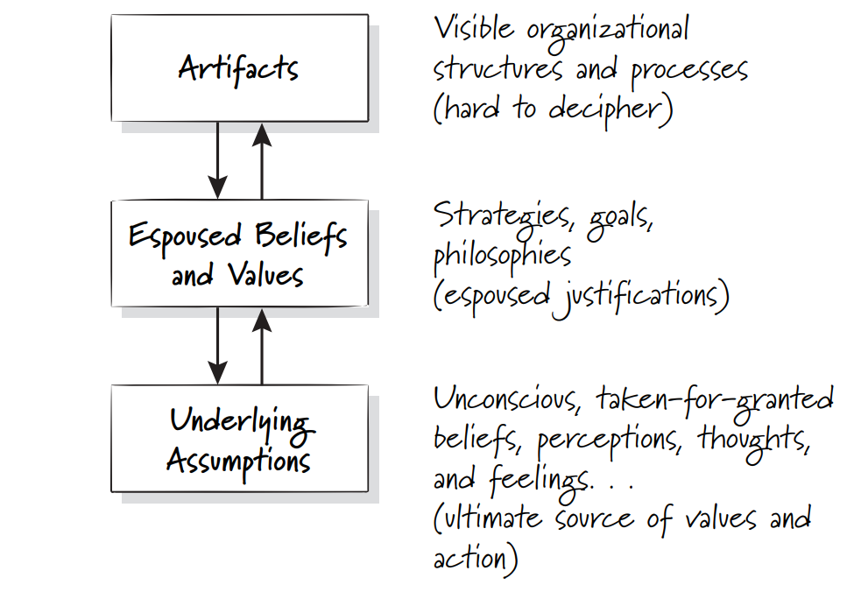
Schein (2004)

2.1 Artifacts and Behaviours

According to Buchanan and Huczynski (2019c) the artifacts and behaviours pertain to the superficial aspect of culture, involving noticeable elements such as physical attributes and observable behavioural patterns that can be perceived through sight, hearing, or touch. These facets offer valuable insight into the culture at BNPR. The prominent artifacts at BNPR are its association to nature and sustainable relaxation which is presented through the physical layout of the resort and casual / quirky tone of voice adapted through its marketing messaging across a broad range of online and digital channels.

Other notable observable culture elements include the engaging style in which employees interact and communicate with each other and guests. This is reflected in a sector leading guest Net Promoter Score (NPS) and anecdotal feedback. High trust, collaboration, and open communication play a pivotal role amongst the team at BNPR in actively transmitting culture. Pham and Tran (2023) support this notion of exuding open communication and promote that it nurtures loyalty and commitment from the workforce.

The concept and training programme embedded at BNPR, formally known as the 'The Bluestone Way,' is specifically designed to aid its leaders to assess their team dynamics rigorously and establish a heightened level of psychological safety thus enabling an engaged workforce and positive interactions, (CIPD, 2023d).

2.2 Espoused Values

Beneath the surface, espoused values represent the Company’s stated beliefs and values, typically articulated in mission statements or codes of conduct. It provides insight into the organisation's aspirations and guiding principles (Burkus, 2014).

BNPR is owned and is still largely operated by its founding family members, whose history derives from an agricultural farming background, whilst an established leisure and tourism operator within the UK, strong cultural farming values remain present within the working environment.

This is emphasised with BNPR’s profound connection to the land, prioritising stewardship, and sustainable practices to ensure the health of ecosystems. Taylor and Perkins (2021) note that organisations are increasingly embracing ‘Green HRM’ which aims to align the HR strategy of an organisation to improve its cultural outcomes. This is evident at BNPR, an employee survey conducted in 2022 showed that 89% of employees agree with the Company’s environmental strategy and 97% of employees actively contribute to energy savings whilst at work.

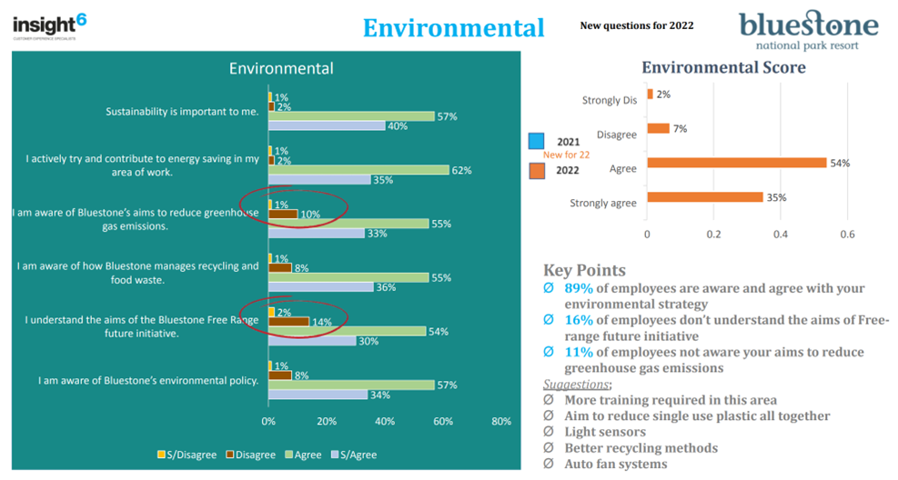
Bluestone (2022a)

Employees understanding and connecting to the Company’s sustainability credentials creates a culture of pride and loyalty within BNPR (Koster, 2011). According to Newman and Ford (2022), building organisational loyalty involves creating a team where employees feel psychologically safe, engaged, and responsive to each other's needs. This relationship has fostered trust, innovation, and a willingness to take risks and therefore employees are more likely to work harder with additional discretionary effort to exceed the goals of the business, thus creating ‘good work’.

The agricultural notion of collaboration and support is identified as an espoused value at BNPR. Fostering mutual assistance and knowledge-sharing amongst employees is actively encouraged and is the norm. This is promoted and measured through the core expected behaviours of Genuine Care, One Team and Taking Ownership.
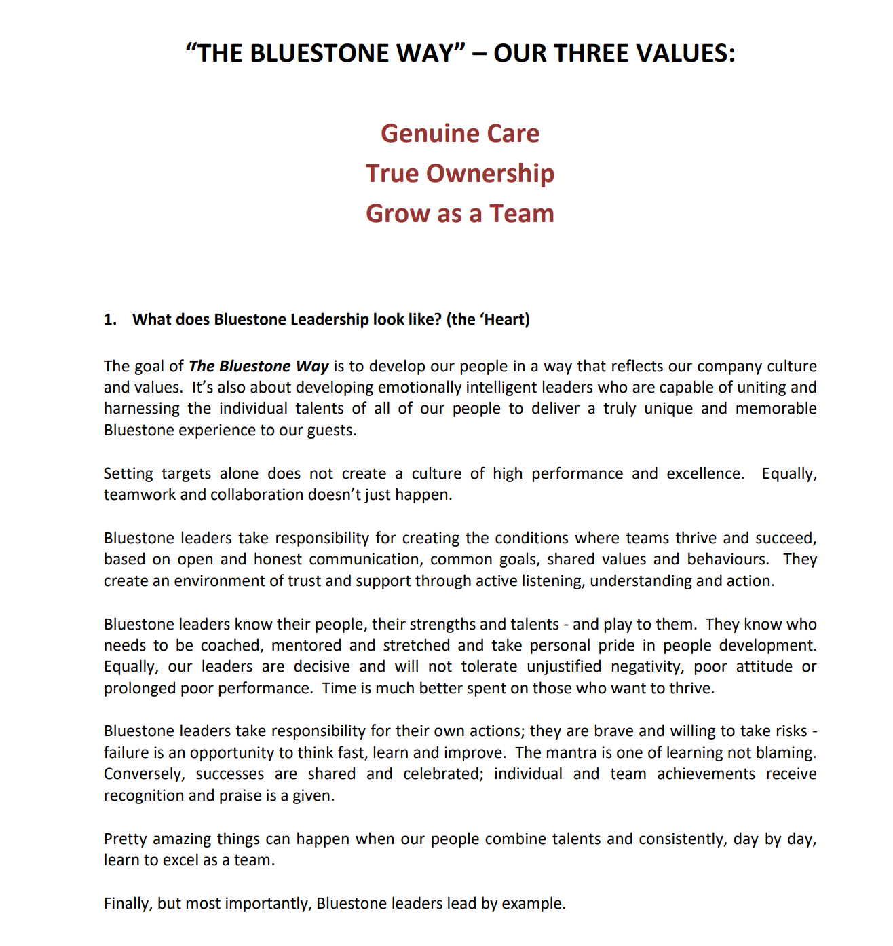 Bluestone (2020)

These behaviours are assessed during the recruitment process, introduced formally at the company induction, and monitored through employee appraisals and throughout the onward employee cycle. BNPR's ethos derives from its vision canvas which reflects the Company’s aspirations and principles, emphasising the fundamental purpose of the Company, which is to 'Make People Happy’. This threads through corporate documentation and is common language adopted across the organisation. Sharing the company vision enhances organisational culture by fostering alignment of values, motivating, and engaging employees, promoting teamwork and adaptability, empowering individuals, attracting and retaining talent, and contributing to a positive work environment (Park and Kim, 2018).

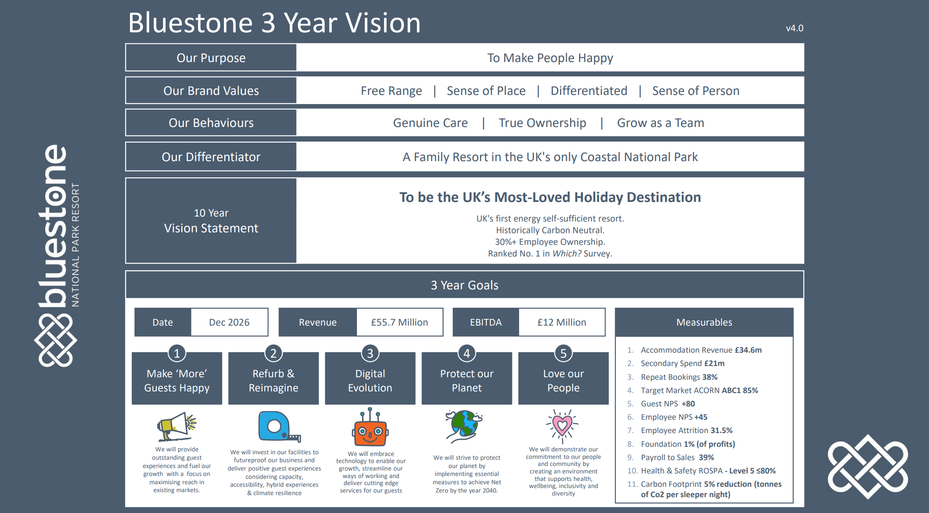
Bluestone (2024)

The extensive communication and engagement of BNPR’s vision canvas above serves to connect employees with the Company’s vision and goals. It fosters a clear understanding of employees’ individual contributions towards these objectives (Artusi and Bellini, 2021). This is underscored by findings from a 2022 employee survey, whereby 96% of respondents affirmed their understanding of the alignment between their roles and BNPR’s overarching goals and objectives.

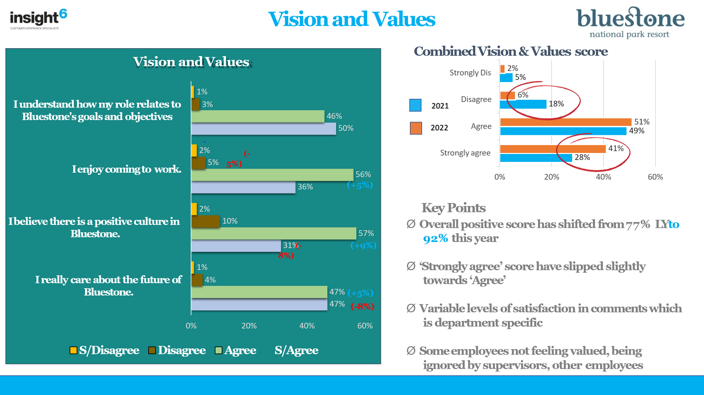Bluestone (2022b)

Taylor (2019) promotes that in years to come, employees are expected to exhibit diminished attachments to both their jobs and workplaces, along with a reduced emphasis on their prospects within any specific organisation. It is therefore fundamental that BNPR continues to share its vision to allow employees to connect to the goals of the company to create a collaborative and supportive culture, developing positive relationships at work which improve the cultural tone and employee engagement (Sitkin et al., 2011).

2.3 Basic Assumptions

Basic assumptions are deeply ingrained, unconscious beliefs that guide behaviour. They are taken for granted and rarely questioned, forming the foundation of an organisation's culture (Buchanan and Huczynski, 2019d).

At BNPR, an expectation of robust work ethic marked by hard work, dedication, and resilience is deeply ingrained in the cultural ethos, which derives from its founder and CEO. It is common for the values to stem from the viewpoints of the original founder and undergo modifications by the senior leadership team of the company as suggested by Buchanan and Huczynski (2019b).

This commitment to hard work is acknowledged and celebrated through the annual employee awards event, known as the 'Ace Awards.' As a result of such spotlight recognition employees continue to act in accordance with such values and attitudes which are now firmly embedded as basic assumptions within the Company (Grant, 2012).

While the emphasis on dedication is positively recognised, it has a negative connotation on an employee’s ability to achieve a healthy work-life balance (Gröpel and Kuhl, 2009). Given the relentless and demanding nature of the operation, employees in operational roles often find it challenging to relax in their personal time due to the nature of their responsibilities. This is supported by 17% of employees reporting little awareness of the wellbeing and work-life balance initiatives available to them at BNPR.

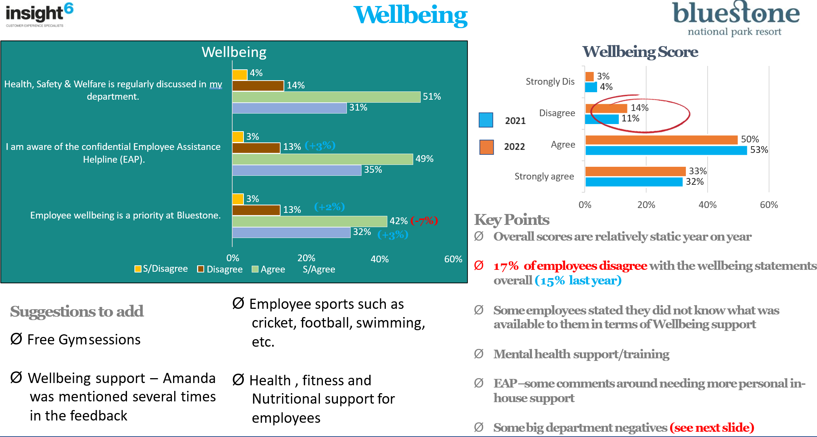
Bluestone (2022c)

Taylor and Perkins (2021) propose that achieving work-life balance has grown significantly more important for workers. Employees are increasingly prioritising roles that offer flexibility to balance work with other pursuits. Thus, presenting a cultural challenge to BNPR if the company is not able to achieve or successfully engage with such arrangements for its employees could result in poor employee engagement, employee burn-out, lower productivity and higher rates of employee absenteeism and attrition (Adame-Sánchez, González-Cruz & Martínez-Fuentes, 2016).

In addition, the inherent expectation of hard work indeed leads to employees feeling that they are not fairly compensated for their work (Lunau et al., 2014). This assertion is supported by an employee survey conducted in 2022, revealing that only 68% of respondents believe they are adequately remunerated for their work. This aspect is particularly significant given the context of the cost-of-living crisis, as highlighted in the CIPD Good Work Index (2023), which reports that fewer than half of the participants were able to manage their bills and commitments without facing difficulties, CIPD (2023e).

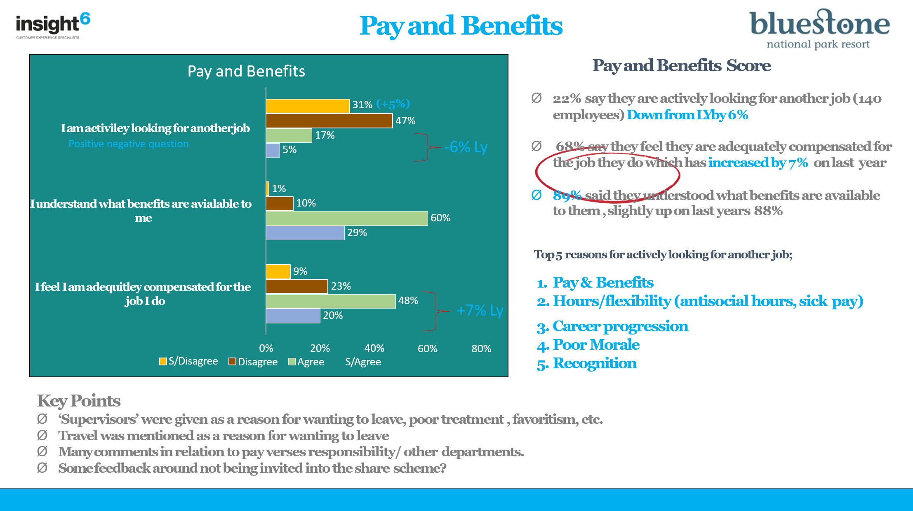
Bluestone (2022d)
Analysing BNPR's organisational culture through Edgar Schein's model reveals observable artifacts and behaviors, espoused values rooted in agricultural principles, and basic assumptions emphasisng hard work. While dedication is celebrated, it challenges employees' work-life balance, potentially impacting engagement and compensation satisfaction. The cultural emphasis on employee voice has led to concerns regarding inconsistent line manager response and actions. Addressing these challenges is crucial for BNPR's cultural adjustment, as employees' well-being and engagement are at stake, particularly considering the cost-of-living crisis outlined in the CIPD Good Work Index (2023e).

3.0 An Analysis of BNPR’s Strategic Approach to Good Work.

The CIPD Good Work Index (2023e) report proposed recommendations on defining, promoting, and legislating fair work. Its findings concluded that job satisfaction in Wales is notably high in 2023, with two-thirds of workers expressing contentment, a figure comparable to the rest of the UK. However, pay satisfaction is less favorable, as less than half of workers in Wales believe they are adequately compensated. The survey also concluded that workplace relationships in Wales are positive, with employees having strong connections with their line managers and teammates (CIPD, 2023a). The following areas review BNPR’s strategic approach to ‘good work’.

3.1 Employee Voice

3.1.1 Employee Culture Surveys

A positive organisational culture is frequently signalled by a strong employee voice, characterised by open communication, feedback systems, and inclusive decision-making (CIPD, 2023d). BNPR engages an external provider for both an annual culture survey and interim 'Pulse' survey that incorporates a range of dimensions of job quality from pay and benefits to relationships at work. This independent management of the voice platform empowers employees to freely express opinions without fear of retaliation, fostering trust and transparency, as highlighted by Duan, Xu, and Wu (2017).

Leaders at BNPR are accountable to respond to employee voice feedback, encouraging a sense of value and engagement. This dynamic encourages a motivated workforce, adaptability to change, and effective conflict resolution. However, it is crucial to emphasise that the quality of communication and organisational responsiveness are key factors. Leaders ignoring employee voices can lead to decreased morale, disengagement, lowered productivity, increased turnover, and hindered organisational growth and innovation (Barry and Wilkinson, 2015). At BNPR, this can often be inconsistent due to departmental micro-cultures or varying line manager commitment to employee voice, this notion is reflected by Carvalho, Sampaio and Rebentisch (2017).

3.1.2 Employee Consultation Group

BNPR has a recognised Employee Consultation Group, known as the ECG. The ECG is pivotal in fostering communication, supporting employee well-being, and enriching organisation culture. It actively involves employees in strategic decision-making, addresses workplace issues, and contributes to conflict resolution. Serving as a valuable feedback mechanism, the ECG evaluates policies and promotes continuous improvement, creating a collaborative and supportive work environment (Poutsma, Hendrickx and Huijgen, 2003).

Considering the perspectives of employees and their representatives is valuable for organisational culture as it empowers leaders at BNPR to make well-informed decisions. This involves considering the thoughts, concerns, and issues raised by employees and formulating strategies to address them (ACAS, 2021).

3.2 Pay and Benefits

BNPR strategically conduct an annual market pay review which is the process of evaluating and adjusting employee salaries and benefits based on current market conditions. The goal is to align employee pay with the prevailing market rates to attract and retain talent effectively (Aino Tenhiälä, Kepes and Jokela, 2023). This review involves assessing external salaries and benefits, industry benchmarks, and economic factors to make informed decisions about salary adjustments, helping the Company stay competitive in the labour market and for employees to feel fairly compensated for their work (Armstrong and Brown, 2017).

Considering the prevailing cost-of-living challenges, the Company has also proactively addressed the situation by introducing initiatives aimed at providing employees with greater flexibility in accessing their pay. This has been facilitated through the implementation of a wage stream facility, enabling employees more convenient options to access their pay. Additionally, the Company has extended its support by offering an interest-free employee welfare loan on a companywide scale. This strategic measure is designed to assist employees facing financial constraints, ultimately contributing to the overall enhancement of their financial wellbeing and resilience during the cost-of-living crisis (Estrada-Mejia, Mejı́a and Córdoba, 2023). People Management (2023) recognise that financial well-being is a growing concern, acknowledged for its unparalleled impact on enhancing employee welfare, resilience, retention, and culture. As BNPR embraces a proactive stance towards the overall well-being of its employees, there is an increased recognition of the crucial role that financial well-being plays in enhancing the general welfare of the workforce.

3.3 Organisational Policies

From review it is evident that BNPR is intentional about aligning its HR policies including well-being at work, flexible working, equality, diversity & inclusion thus promoting a culture that prioritises and supports employee well-being (Mannix, Neale and Northcraft, 1995). This positive cultural foundation results in increased morale, heightened employee engagement, and enhanced productivity, ultimately leading to an environment where employees feel valued and supported in their personal and professional growth. This can be attributed to the hierarchy of needs model developed by Abraham Maslow, since critiqued by Acevedo (2015).

As indicated by CIPD (2023b), the varied HR practices implemented by BNPR can yield different impacts on employee well-being, necessitating a delicate balance between organisational benefits and potential costs to employees. The relationship between HRM and employee well-being at BNPR is intricate, with diverse HR practices influencing well-being positively or negatively (Nielsen et al., 2017). Supporting hybrid working employees’ well-being is viewed as challenging, caution is recommended in implementing 'challenge demand' HR practices to mitigate adverse effects. This challenge is heightened as not all flexible working practices can be universally applied to every role within the Company, leading to employee discontent and a perception of inequitable treatment among various employee groups or departments (De Menezes and Kelliher, 2017).

3.4 Leadership Development

Beyond the Company’s HR policies, BNPR features a leadership development programme formally known as the ‘Bluestone Way’. This initiative is designed to furnish leaders with the necessary skills for effective people management and enhancing their overall effectiveness in their daily responsibilities.

The Bluestone Way leadership development programme significantly enhances the strategic organisational culture by shaping effective leaders who serve as positive role models. Emphasising communication skills and transparency, the programme empowers leaders to manage teams collaboratively and align decisions with the values of the Company (Krapfl and Kruja, 2015). The focus on adaptability, innovation, and conflict resolution fosters a positive work environment which correlates to continuous improvement and develops a culture that values talent and prioritises employee well-being (Dannheim et al., 2021). Overall, the leadership development programme plays a pivotal role in cultivating leaders who positively impact and reinforce a thriving organisational culture (Asadi, 2019).

3.5 Summary of BNPR’s Strategic Approach to Good Work.

BNPR strategically places a strong emphasis on cultivating good work and prioritising the well-being of its workforce through a comprehensive set of initiatives. The integration of employee voice mechanisms fosters a culture of transparency and collaboration (PWC, 2018). The annual market-pay review and initiatives addressing cost-of-living challenges demonstrate a proactive stance toward fair compensation. While the Company’s policies align with well-being, a nuanced consideration of HR practices is crucial. The Bluestone Way Leadership development programme is instrumental in shaping effective leaders, contributing to a positive work environment. BNPR's holistic approach underscores its commitment to nurturing a thriving organisational culture that values the welfare and engagement of its workforce.

4.0 Recommendations
Following the critical analysis of organisational culture at BNPR, the recommendations below have been made in priority order to enhance organisational culture.

4.1 Recommendation One – Employee Voice

Addressing the input from employees, line managers hold a vital responsibility at BNPR in deciphering and suitably addressing feedback from the annual employee voice survey. Inconsistencies arise due to varying levels of commitment among line managers to encourage employee expression and the presence of distinct departmental sub-cultures. A failure to respond appropriately to employee feedback can have adverse effects on the overall employee experience, affecting productivity, morale, guest satisfaction, and ultimately contributing to higher attrition rates (CIPD, 2023).

BNPR must adopt a more comprehensive strategy for embracing employee voice, emphasising the need to enhance the skills of line managers in understanding the theoretical significance of psychological, physical, and social indicators linked to fostering positive organisational culture. The implementation of a training workshop specifically designed for line managers is strongly recommended. This workshop, led by an external specialist, aims to underscore the role line managers play and the positive influence they can exert on organisational culture (Investors in People, 2019).

The average cost of leadership training per delegate can vary widely based on factors such as the training provider, the duration of the program, the level of customisation, and the training delivery format (in-person, virtual, or blended). A recommended fixed rate of £450 per delegate per workshop suggests that accommodating twenty two middle management roles would require allocating an approximate budget of £9,900 for this purpose and the consideration of time per delegate.

4.2 Recommendation Two –Flexible Working Options.

Highlighted in the briefing paper, the current flexible working practices in place are challenging to consistently implement across all roles. Ineffective flexible working practices can cause reduced morale, increased stress, and lower job satisfaction for employees. BNPR may experience decreased productivity, impaired teamwork, and higher turnover rates. Unequal treatment among employees may lead to dissatisfaction and harm the Company's reputation (Chung and Van der Lippe, 2020).

Implementing effective flexible working policies is crucial to address inequities and foster a healthy work environment. Unequal treatment, whether in opportunities or recognition, lowers job satisfaction, leading to reduced engagement and productivity. In contrast, promoting a fair and equitable culture enhances morale, fostering a more cohesive and motivated workforce (Zigoni, 2022). To address this issue, it is imperative to conduct an in-depth review to explore additional flexible working options that can be seamlessly integrated and offered throughout the entire company.

A comprehensive assessment of flexible working practices to a proficient independent consultant is strongly recommended. The expert would adeptly interact with employees, swiftly grasping the nuanced aspects of business requirements. Following this, the consultant would systematically present practical and feasible options. The aim is not only to enhance the employee experience but also to significantly improve the broader company culture.

Typically, external HR consultants charge a daily rate of approximately £800, and with an estimated 6 days needed for a thorough exploration of business requirements, assigning a cost of £4,800 to this recommendation is advisable.

4.3 Recommendation Three – Work-Life Balance

The intricate and challenging aspects of BNPR's operations, coupled with a culture emphasising persistent hard work, present a significant challenge for employees striving for an effective work-life balance. Addressing this challenge is essential for BNPR to promote employee welfare and cultivate a positive organisational culture (Guillén and Guillén, 2021).

To foster a culture of work-life balance at BNPR, the implementation of a diverse range of strategies is essential. This initiative should be spearheaded by a focus group, which includes a senior member of the People Team collaborating with representatives from a cross-section of employees. The focus group would aim to introduce clear communication of policies, coupled with the establishment of guidelines regarding technology use, serves to prevent employee overexertion and burnout (Koubova and Buchko, 2013).

The focus group should give priority to implementing wellness programs that address both physical and mental health, aiming to significantly improve the overall well-being of employees (Becker, 2021). Emphasis should be placed on the considerate utilisation of planned leave days and breaks, which will cultivate a supportive organisational culture. The focus group should also consider managerial training, family-friendly policies, and regular check-ins aim to establish an environment that truly values and supports employees in their pursuit of work-life harmony, underscoring the fundamental importance of maintaining a strong work-life balance (CIPD, 2020).

The implementation of work-life balance strategies at BNPR comes with various associated costs. Allocating a budget of £28,000 in the first year is proposed to cover expenses related to resource allocation, the introduction of wellness programs, training initiatives, family-friendly policies, and improved communication efforts. While there are initial financial considerations, it is essential to recognise the long-term benefits, including heightened employee satisfaction and increased productivity. A comprehensive cost-benefit analysis is imperative to evaluate financial implications and ensure alignment with overarching business objectives. This analysis should be conducted after a thorough examination and collaborative agreement on the chosen strategy.

5.0 Reference List
Acas (2021) What Consultation is: Consulting Employees and Their Representatives - Acas, Acas.org.uk. Available at: https://www.acas.org.uk/consulting-employees (Accessed: 17 January 2024).
Acevedo, A. (2018). A Personalistic Appraisal of Maslow’s Needs Theory of Motivation: From “Humanistic” Psychology to Integral Humanism. Journal of Business Ethics, 148(4), 741–763. https://doi.org/10.1007/s10551-015-2970-0

Adame-Sánchez, C., González-Cruz, T.F. and Martínez-Fuentes, C. (2016) ‘Do Firms Implement Work–life Balance Policies to Benefit Their Workers or themselves?’, Journal of Business Research, 69(11), pp. 5519–5523. Available at: https://doi.org/10.1016/j.jbusres.2016.04.164.
Aino Tenhiälä, Kepes, S. and Jokela, M. (2023) ‘Contingencies in the effects of job‐based pay dispersion on employee attitudes’, Human Resource Management, 62(6). Available at: https://doi.org/10.1002/hrm.22183.
Arena, M., Hines, S. and Golden, J. (2023) ‘The Three Cs for Cultivating Organizational Culture in a Hybrid World’, Organizational Dynamics, 52(1).
Armstrong, M. and Brown, D. (2017) ‘Job Evaluation versus Market Pricing: Competing or Combining Methods of Pay Determination?’, Compensation & Benefits Review, 49(3), pp. 153–160. Available at: https://doi.org/10.1177/0886368718765827.
Artusi, F. and Bellini, E. (2021) ‘From Vision to innovation: New Service Development through front-line Employee Engagement’, Innovation, pp. 1–26. Available at: https://doi.org/10.1080/14479338.2021.1979986.
Asadi, R. (2019) ‘The Sustainable Links of Development between Leadership and Organizational Cultures’, Journal of Economic Development, Environment and People, 8(2), p. 45. Available at: https://doi.org/10.26458/jedep.v8i2.626.

Barry, M. and Wilkinson, A. (2015) ‘Pro-Social or Pro-Management? a Critique of the Conception of Employee Voice as a Pro-Social Behaviour within Organizational Behaviour’, British Journal of Industrial Relations, 54(2), pp. 261–284. Available at: https://doi.org/10.1111/bjir.12114.
Becker, G.S. (2021) ‘Investment in Human Capital: A Theoretical Analysis’, Journal of Political Economy, 70(5, Part 2), pp. 9–49.
Bluestone (2020) ‘The Bluestone Way, Manager Guide’. Bluestone National Park Resorts Ltd. Unpublished.
Bluestone (2022a) ‘Employee Survey, Environmental’. Bluestone National Park Resorts Ltd. Unpublished.
Bluestone (2022b) ‘Employee Survey, Vision & Values’. Bluestone National Park Resorts Ltd. Unpublished.
Bluestone (2022c) ‘Employee Survey, Well-being’. Bluestone National Park Resorts Ltd. Unpublished.
Bluestone (2022d) ‘Employee Survey, Pay & Benefits’. Bluestone National Park Resorts Ltd. Unpublished.
Bluestone (2024) ‘Vision Canvas’. Bluestone National Park Resorts Ltd. Unpublished.
Buchanan, D. and Huczynski, A. (2019c) Organizational Behaviour. 10th edn. Harlow: Pearson, pp. 112,108–109, 113-120.
Burkus, D. (2014) How to Tell if Your Company Has a Creative Culture, Harvard Business Review. Harvard Business Review. Available at: https://hbr.org/2014/12/how-to-tell-if-your-company-has-a-creative-culture (Accessed: 14 January 2024).
Carvalho, A.M., Sampaio, P. and Rebentisch, E. (2017) ‘Operational excellence, Organisational Culture and agility: the Missing link?’, Total Quality Management & Business Excellence, 30(14), pp. 1–20. Available at: https://doi.org/10.1080/14783363.2017.1374833.
Chang, Y.-S., Guo, J.H. and Evans, J.M. (2022) ‘Flexible but stable: the Mediated Influence of an Organization’s Culture on Performance’, Asian Business & Management, 5(2). Available at: https://doi.org/10.1057/s41291-021-00174-y.
Chung, H., & van der Lippe, T. (2020). Flexible Working, Work–Life Balance, and Gender Equality: Introduction. Social Indicators Research, 151(2), 365–381. https://doi.org/10.1007/s11205-018-2025-x

CIPD (2020) CIPD | Working to live, not living to work, CIPD. Available at: https://www.cipd.org/uk/knowledge/bitesize-research/working-live/ (Accessed: 21 January 2024).
CIPD (2023a) CIPD | CIPD Good Work Index – Wales, CIPD. Available at: https://www.cipd.org/uk/knowledge/reports/goodwork/wales/ (Accessed: 3 January 2024).
CIPD (2023b) CIPD | Employee Voice | CIPD Viewpoint, CIPD. Available at: https://www.cipd.org/uk/views-and-insights/cipd-viewpoint/employee-voice/#:~:text=Wellbeing%2C%20commitment%20and%20innovation%20are (Accessed: 17 January 2024).
CIPD (2023c) CIPD | HR practices: What are the trade-offs for employee wellbeing? CIPD. Available at: https://www.cipd.org/uk/knowledge/bitesize-research/hr-impact-wellbeing/ (Accessed: 14 January 2024).
CIPD (2023d) CIPD | On this page, CIPD. Available at: https://www.cipd.org/en/knowledge/factsheets/organisation-culture-change-factsheet/#what-is-organisational-culture (Accessed: 3 January 2024).
CIPD (2023e) CIPD | Organisational and employee-focused voice: Why Both Matter, CIPD. Available at: https://www.cipd.org/uk/knowledge/bitesize-research/organisation-employee-voice/ (Accessed: 14 January 2024).
CIPD (2023f) CIPD | Organisational Culture, CIPD. Available at: https://www.cipd.org/uk/views-and-insights/cipd-viewpoint/organisational-culture/ (Accessed: 3 January 2024).
CIPD (2023g) CIPD | The three Cs for cultivating organisational culture, CIPD. Available at: https://www.cipd.org/uk/knowledge/bitesize-research/cultivating-organisational-culture/ (Accessed: 12 January 2024).
CIPD (2023h) Summary Report and Practical Guidance CIPD Good Work Index 2023 Wales. Available at: https://www.cipd.org/globalassets/media/knowledge/knowledge-hub/reports/2023-pdfs/2023-cipd-good-work-index-wales-report-8407.pdf (Accessed: 14 January 2024).
CIPD (2023i) Summary Report and Practical Guidance CIPD Good Work Index 2023 Wales. Available at: https://www.cipd.org/globalassets/media/knowledge/knowledge-hub/reports/2023-pdfs/2023-cipd-good-work-index-wales-report-8407.pdf (Accessed: 14 January 2024).
Criveanu, M & Ivanescu, C. (2019). The Importance of Organisational Culture in Companies. Analele Universităţii Constantin Brâncuşi Din Târgu Jiu : Seria Economie, 6, 331–336.

Dannheim, I. et al. (2021) ‘Effectiveness of health-oriented Leadership Interventions for Improving Health and Wellbeing of employees: a Systematic Review’, Journal of Public Health, 30(12). Available at: https://doi.org/10.1007/s10389-021-01664-1.
De Menezes, L.M. and Kelliher, C. (2017) ‘Flexible Working, Individual Performance, and Employee Attitudes: Comparing Formal and Informal Arrangements’, Human Resource Management, 56(6), pp. 1051–1070. Available at: https://doi.org/10.1002/hrm.21822.

Duan, J., Xu, Y. and Wu, C. (2017) ‘Transformational leadership and employee voice behavior: A Pygmalion mechanism’, Journal of Organizational Behavior, 38(5), pp. 650–670. Available at: https://doi.org/10.1002/job.2157
Estrada-Mejia, C., Mejı́aD. and Córdoba, P. (2023) ‘Financial Literacy and Financial wellbeing: Evidence from Peru and Uruguay’, Journal of Financial Literacy and Wellbeing, 6, pp. 1–27. Available at: https://doi.org/10.1017/flw.2023.15.
Gröpel, P. and Kuhl, J. (2009) ‘Work-life Balance and Subjective well-being: the Mediating Role of Need Fulfilment’, British Journal of Psychology, 100(2), pp. 365–375. Available at: https://doi.org/10.1348/000712608x337797.
Guillén, P. and Guillén, M. (2021) Motivation in Organisations Searching for a Meaningful work-life Balance. New York Routledge.
Hattangadi, Dr.V.P. (2021) Edgar Schein’s three levels of organizational culture, www.linkedin.com. Available at: https://www.linkedin.com/pulse/edgar-scheins-three-levels-organizational-culture-hattangadi (Accessed: 7 January 2024).
Investors in People (2019) Employee Voice | Why Is It Important to Sustainable success? Investors in People. Available at: https://www.investorsinpeople.com/knowledge/employee-voice/ (Accessed: 17 January 2024).
Koster, F. (2011) ‘Able, willing, and knowing: the Effects of HR Practices on Commitment and Effort in 26 European Countries’, The International Journal of Human Resource Management, 22(14), pp. 2835–2851. Available at: https://doi.org/10.1080/09585192.2011.599946.
Koubova, V., & Buchko, A. A. (2013). Life‐work balance: Emotional intelligence as a crucial component of achieving both personal life and work performance. Management Research Review, 36(7), 700–719. https://doi.org/10.1108/MRR-05-2012-0115

Krapfl, J.E. and Kruja, B. (2015) ‘Leadership and Culture’, Journal of Organizational Behavior Management, 35(1-2), pp. 28–43. Available at:https://doi.org/10.1080/01608061.2015.1031431.
Lunau, T. et al. (2014) ‘A Balancing act? Work–life balance, Health and well-being in European Welfare States’, European Journal of Public Health, 24(3), pp. 422–427. Available at: https://doi.org/10.1093/eurpub/cku010.
Mannix, E.A., Neale, M.A. and Northcraft, G.B. (1995) ‘Equity, Equality, or Need? The Effects of Organizational Culture on the Allocation of Benefits and Burdens’, Organizational Behavior and Human Decision Processes, 63(3), pp. 276–286. Available at: https://doi.org/10.1006/obhd.1995.1079.
Meyer and Allen (1997) Commitment in the Workplace: Theory, Research, and Application. Sage Publications, Inc.
Mohanty, S. (2018) ‘Individualized Employee Engagement or Collaborative Employee relations: Insights on Leadership Strategies to Manage Employees in the UK Market’, Problems and Perspectives in Management, 16(3), pp. 366–376. Available at: https://doi.org/10.21511/ppm.16(3).2018.29.
Newman, S.A. and Ford, L.R. (2022) ‘Giving to get loyalty: How organizations signal their loyalty to employees’, Organizational Dynamics, 1(1), p. 100956. Available at: https://doi.org/10.1016/j.orgdyn.2022.100956.
Nielsen, K. et al. (2017) ‘Workplace Resources to Improve Both Employee well-being and performance: a Systematic Review and meta-analysis’, Work & Stress, 31(2), pp. 101–120. Available at: https://doi.org/10.1080/02678373.2017.1304463.
Notter, J. (2012) Humanize : how people-centric organizations succeed in a social world. Indianapolis, In: Que.
Park, S. and Kim, E. (2018) ‘Organizational culture, Leaders’ Vision of talent, An HR
Functions on Career Changers’ commitment: the Moderating Effect of Training in South Korea’, Asia Pacific Journal of Human Resources, 57(3), pp. 345–368. Available at: https://doi.org/10.1111/1744-7941.12192.

People Management (2023) Home Businesses Must Find New Ways to Support Employees’ Financial Wellbeing, People Management. Available at https://www.peoplemanagement.co.uk (Accessed: 14 January 2024).
Pham, H. H., & Tran, T. T. (2023). Strengthening the Link Between Organizational Culture and Employee Loyalty: Exploring the Mediating Effects of Employee Trust and Job Satisfaction. Global Business and Finance Review, 28(3), 68–84. https://doi.org/10.17549/gbfr.2023.28.3.68

Poutsma, E., Hendrickx, J. and Huijgen, F. (2003) ‘Employee Participation in Europe: in Search of the Participative Workplace’, Economic and Industrial Democracy, 24(1), pp. 45–76. Available at: https://doi.org/10.1177/0143831x03024001599.

PWC (2018) Global Culture Survey 2018 | Strategy&, PwC. Available at: https://www.strategyand.pwc.com/gx/en/insights/2018/global-culture-survey.html
(Accessed: 4 February 2024).

Schein, E. (2004) Organizational Culture and Leadership. 3rd edn. San Francisco, Calif: Jossey-Bass, p. 26. Available at: http://www.untag-smd.ac.id/files/Perpustakaan_Digital_2/ORGANIZATIONAL%20CULTURE%20Organizational%20Culture%20and%20Leadership,%203rd%20Edition.pdf (Accessed: 7 January 2024).
Schein, E. H. (1990). Organizational Culture. The American Psychologist, 45(2), 109–119. https://doi.org/10.1037/0003-066X.45.2.109

Sitkin, S.B. et al. (2011) ‘The Paradox of Stretch Goals: Organizations in Pursuit of the Seemingly Impossible.’, Academy of Management Review, 36(3), pp. 544–566. Available at: https://doi.org/10.5465/amr.2011.61031811
Taylor, S. (2019) Resourcing and Talent Management. Editorial: London: Koganpage, pp. 30–31.
Taylor, S. and Perkins, G. (2021) Work and Employment in a Changing Business Environment. London; New York, Ny: Kogan Page, pp. 213–214.
Sitkin, S. B., See, k. e., Miller, C., Lawless, M, & Carton, A. M. (2011). The Paradox of Stretch Goals: Organizations in Pursuit of the Seemingly Impossible. The Academy of Management Review, 36(3), 544–566. https://doi.org/10.5465/AMR.2011.61031811

Valentine, S. et al. (2010) ‘Corporate Ethical Values, Group Creativity, Job Satisfaction and Turnover Intention: The Impact of Work Context on Work Response’, Journal of Business Ethics, 98(3), pp. 353–372. Available at: https://doi.org/10.1007/s10551-010-0554-6.

Zigoni, M. (2022) ‘Inconsistencies in the Perception of Fairness in the Workplace’, Management and Economics Review, 7(2). Available at: https://doi.org/10.24818/mer/2022.06-01 Accessed: 4 February 2024).

