  Component One: Student Journal (learning log)  Contribution to Overall Module Assessment: 25% | Student No: | 2232073
 | Module Title: | Hotel Administration and Front Office Operations
 | Module Code: | BMIH4004
 | Lecturer: | Muhammad Cassamo

Introduction
The best guest experiences are provided by the people who work in the front office of any hotel. Important data such as room status and guest information are also handled by this department. Several skills are needed for the smooth operation of this department hence the skills will be described through a reflective model. My journey as a front desk manager will be outlined and the skills I have learned and will improve will be included.

Discussion
I was recruited by Premier Inn Hotel which is situated at Wembley and practised my management efficiencies there as a front office manager. This placement journey has enriched my knowledge about my skill proficiencies and skill gaps. I will discuss my reflective learning journey through Gibb's reflective model which will explain my experience as a front office manager in Premier Inn hotel. This hotel is quite busy on normal days and receives lots of customers. Hence, my job role and duty was to provide a smooth experience to the clients while checking in and out. I also handled guest inquiries, oversaw reservations, addressed guests’ issues, and managed other front desk employees. Apart from this, I have received some complaints and negative feedback from the clients due to my job role. Several skills such as communication, leadership, technical, and problem-solving abilities were required for this job role (Bardi, 2011).
I felt nervous as well as excited when I initiated my job role as front desk manager. My expectation to provide an enjoyable stay to the guests and lead a team was exhilarating. Anxiety was also working in me and it was related to handling guest complaints and high-pressure circumstances. However, I gained some valuable experiences and developed some skills. I realised that the functions of the front desk can be managed by an effective leadership style. My job role was to support and provide guidance to my team, set clear expectations, and guide them by example. However, this role has helped me improve my communication skills as I have learned different communication styles while handling different situations and guests. The guests were also satisfied with my services being a front desk manager (Corgel et al., 2011).
This work experience has supported me in recognising the skill gaps and proficiencies that a front desk manager must have. I have analysed that my leadership proficiency is strong as all team members were led by me successfully. The sense of teamwork, dedication, and responsibility has been instilled in the minds of team members by my leadership skills. I tried my best to motivate my team members to deliver the best and exceptional services. My communication proficiency is advanced and I must improve my communication skills (Williams et al., 2020). This role of front desk manager needs to maintain effective communication with the staff and clients.
I have learned some skills such as resolving issues, empathising, and active listening from this job role. The way of handling difficult conversations has also added to my skill list. I have improved my problem-solving ability as I dealt with unexpected challenges and guest complaints due to my managerial role at the front office of Premier Inn. Along with this, I have learned to handle every situation calmly and identify creative solutions (Baum, 2019). My ability to navigate the check-in and reservation system prove my basic technical skill. However, the lack of in-depth technical knowledge delayed some functions such as the check-in and out procedure.
My overall journey of managing the front office was rewarding. This job role has taught me the importance of communication and leadership skills to improve guest satisfaction and the reputation of Premier Inn. My technical skills must be improved to mitigate some problems that emerge at the front desk. Hence, I have decided to make a plan to boost my technical skills through training, mentorship, continuous learning, and feedback (Tewan, 2009). The IT department of the hotel offer some training session to increase the technical knowledge of employees. I will be able to troubleshoot check-in and check-out issues efficiently. Self-research and study will help me stay updated on new technological inventions that will be used in hotel management. My team members will be encouraged to recommend some suggestions regarding system-related improvements or issues. They can help me identify required improvement areas which are important for a front desk manager.
This retrospection has taught me that several skill sets are required for front desk managers to serve customers efficiently. My communication and leadership proficiencies supported me in serving front office services well. Along with this, I also realised the significance of technical skills for the managerial job role at the front office of a hotel. My involvement in continuous learning and development has been increased by this reflective procedure. Identifying and improving my skills will help me to provide more effective guest services. This reflective learning procedure will assist me in improving front office management skills through self-awareness, actions, and self-evaluation (Gibbs and Slevitch, 2019).

Conclusion
This overall learning log has discussed the skills that are crucial for front-office employees and managers. Some skills such as customer service, problem-solving, computer literacy, and detail orientation have been identified as the most required skills in this job role. The Gibbs’ reflective model has described my experiences in Premier Inn Wembley and the improvement areas.

Component Two
Contribution to Overall Module Assessment: 25%
Trip Advisor Review Response

Reply of a positive review about Premier Inn Wembley on Trip Advisor
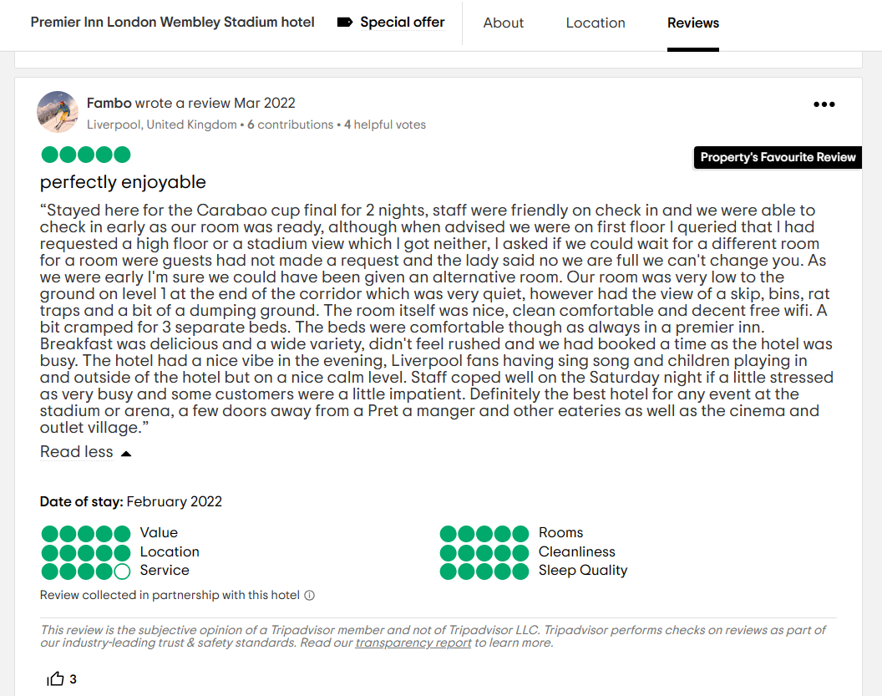
Figure: Positive review of Premier Inn London Wembley Stadium hotel in Trip Advisor
Source: (Fambo, 2022)
Response of the hotel to that positive trip advisor review
On behalf of our hotel, we must say thank you first for such an excellent review that you have written here. Our main goal is to provide the best experience to the guests by offering our customised services. Premier Inn Wembley is always pleased to have guests like you and we are happy to provide our services. We always try to provide clean rooms to the clients to maintain hygiene (Hyland and Hyland, 2019). Offering comfort like home when you are far away from home is one of our goals. We are very happy that our property and services are preferred and liked by you. Maintaining taste and hygiene while offering our restaurant service is also on our priority list. Such positive feedback from your end is very precious to us and we will be glad to serve you next time. I hope that we will be able to provide you with more customised services on your next visit (Molloy et al., 2020).

Screen shot of referenced Trip Advisor review used:
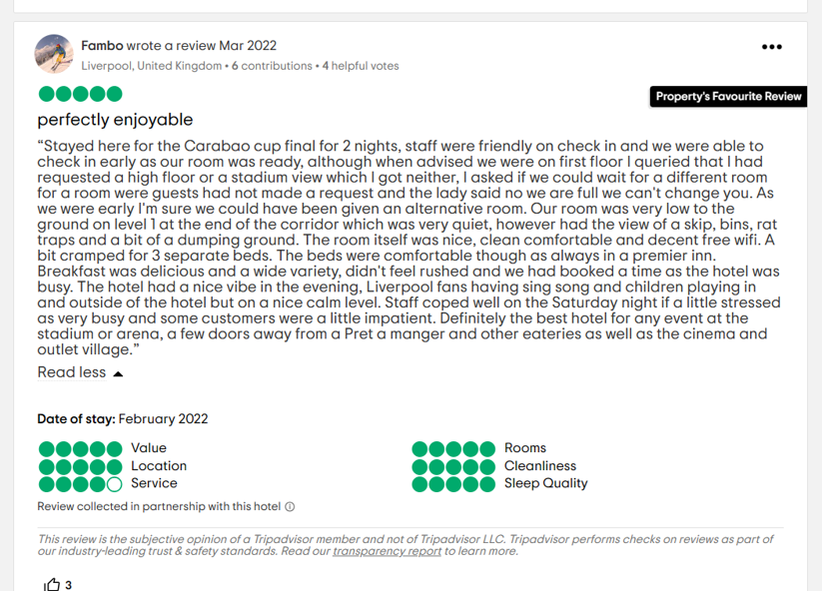
Letter of complaint response
To
Mr Ronald Federick,
17 Trinity court,
Swansea SA1 2AR
Subject: Letter of Apology

Dear Sir,
Please give me a chance to introduce myself, I am a front-office manager of Premier Inn Wembley. I have received your letter from the guest service team and I am really regretful for the services you received from our end. My whole team and I want to apologise for the inconvenience that you have faced during your stay at our property. Our basic goal is to provide the best services to our guests. These inconveniences of yours due to our room, restaurants, and other services are really regretful. I should give more attention to the services that are provided to you (Radu et al., 2019).
This letter has opened my eyes to the restaurant services that are very crucial for our hotel and guests. Most customers often like to have meals at our restaurants and room service for the food is also available. The actual reason behind serving tasteless and cold food is unknown to me till now. However, I am trying to find out the actual reasons and resolve the problems (Fernandez et al., 2020). The first lesson that I have learned from your letter is that we must upskill the existing employees and hire more efficient staff for the restaurant service. Some skills gap has been identified among the employees and they will be given proper training to minimise the inconvenience you have faced regarding the food service (Tesone, 2010).
We are extremely sorry for not providing the comfortable environment you wanted from Premier Inn Wembley Hotel. This is definitely our responsibility to look after and create a comfortable environment for the guests like you. Basically, our hotel is situated in a peaceful area and we try to provide a noise-free stay to the guests. However, sometimes the noise from other rooms creates problems for other guests. Therefore, we are working on constructing soundproof rooms to reduce the noise. I hope this will resolve these noise problems when you will visit Premier Inn Wembley next time. However, some rules and regulations will also be introduced to the guests to keep the environment of this hotel more peaceful (Johnston et al., 2012).
All the needs and demands of the customers are acknowledged by me as a front-office employee of this hotel. I informed my room service to provide the best and most personalised room service. However, the lack of proper communication between the team members and me has contributed to such mismanagement that you have faced (Robertson et al., 2023). I will maintain effective communication with the team members the next time. Proper training will be given to the employees who are associated with the room services. New employees will be hired who are more conscious about the customer's demands and experienced in the hospitality industry (Prima et al., 2023).
I hope you will forgive our mistakes and give us a chance to serve you the best services. Your feedback has contributed to us a lot and we have had a chance to improve our services. Guests like you are very special to us as you have shown us our mistakes and mismanagement that took place.
Yours sincerely
Front-office manager
Premier Inn Wembley
1 Wembley Park Blvd, London,
Wembley HA9 0GG,
United Kingdom

Component Three:
Contribution to Overall Module Assessment: 50%

Element 1 – Pre-Arrival

Different elements are required by the managers and the employees of the hotel to effectively manage all the pre-arrival proceedings of the guests. These elements help in the proper management of the guests and in making all the arrangements for the smooth arrival of the guests. The request for the reservation needs to be done and the profile of the guest is also needed to be updated in the visitor list of the hotel. That will allow the hotel to check the proper availability of the rooms and to allocate the designated room on the day of booking. The proper stages of verifying the documents of the guest must be done and the necessary documents must be collected (Lukanova and Ilieva, 2019). Before the arrival, the pick-up facilities must be arranged and the rooms must be made ready to provide smooth check-in facilities to the guests. All the necessary documents must also be prepared and made ready by all the check-in counters to carry out the proceedings of the process easily (Dimitriou and AbouElgheit, 2019). These processes will ensure the proper checking-in facilities and will also help in impressing the guest with the prompt service of the hotel. Premier Inn Wembley takes all these steps into consideration to improve the quality of the check-in options for the guests. The online booking websites are also properly looked after by the booking team of the hotel to collect the different booking details. This helps them to allocate the rooms in the desired ways and to plan future bookings effectively (premierinn, 2023).

Element 2 – Arrival

Different steps are needed to be undertaken to handle the arrival of the guests in the hotel for the staying purposes. The prime step that needs to be carried out during the arrival of the guest is the completion of the registration process to allocate the rooms (Hammer, 2016). This registration process carries out the tasks of the verification of all the identity documents of the guest and filling up the visitor’s form. The arrangement of the porter is also done and the proper luggage management system is commissioned to carry the luggage of the guest to the designated rooms. This ensures that the guests are able to get a quality staying option while staying in the hotel premises. The keys are also provided to the guests and they are escorted to the desired rooms with an attendant of the hotel (Seyitoğlu and Ivanov, 2021). This ensures that the guest does not face any difficulties while staying on the premises of the hotel and enhances the quality of the stay. The management body of the Premier Inn Wembley also performs these steps to ensure that the guests are able to get a proper check-in experience. Steps are taken to complete the registration process of the guest and they are also escorted to the different rooms to ensure their proper address. The different facilities provided by the hotel are also explained to the people and the luggage is also delivered to the respective rooms. Steps are also taken by the management of the hotel to welcome the guests with welcome drinks or special arrangements of refreshments (premierinn, 2023).

Element 3 – Duration of stay

During the stay of the people at the hotel, different steps are taken by the management of the hotel group to ensure that the people have a quality stay. The different arrangements related to the room cleaning services are also looked after by the administration to maintain cleanliness and hygiene (Sann and Lai, 2020). Provision for the different food facilities is also provided to the guests at the different points of the day to ensure the proper dining experience for the guests. The different concerns of the guests are also attended by the hotel management to ensure the people have a quality staying experience in the hotel. Additionally, the different types of extra added-on facilities are also provided to the guest on their demands. The management body of Premier Inn Wembley provides the people with different types of room services such as food options in the rooms (González et al., 2019). This is done to ensure that the people are able to receive proper staying options and to improve their positive feedback. The different added-on facilities such as conducted tours, entertainment facilities, and refreshment services are provided by the management body to the guests. Several concerns of the people are also promptly attended to by the management of the hotel to eliminate the problems of the people. These all facilities ensure that people are able to receive a quality staying option while staying in Premier Inn Wembley. Further, the fulfilment of all the needs of the people also helps the hotel to ensure the betterment of their services to serve more guests (premierinn, 2023).

Element 4 – Departure

Several steps are also carried out during the departure of the guest to ensure that the overall staying experience of the guest is enhanced. One of the major steps during the leaving of the guest is the settlement of the bills which further involves different additional steps. The bills of the several added-on services are also included in the bills and the discounts are provided if applicable. This ensures that the people are able to receive a fair benefit related to the different types of staying options from the perspective of the bills (Gómez and Veloso, 2020). The handling of the baggage is also done and the feedback is also collected from the guests to ensure that they are able to develop their services. Premier Inn Wembley performs the efficient activity of settling the bills of the guests and they also provide the baggage handling facilities. The discounts are also provided to the various guest depending on their mode of payment and the occasion they are visiting. They also provide several facilities regarding the dropping of guest in their respective places. These all features and services ensure that people are able to receive quality staying options in the hotel. The feedback is also collected from the people to let the hotel and the management know about their strengths and shortcomings. The cleaning of the rooms and making them ready for the next arrival of the guest is also done to ensure that they are able to keep up with their services (premierinn, 2023).

References
Bardi, J. (2011) Hotel Front Office Management, Wiley, London
Baum, T., (2019). Does the hospitality industry need or deserve talent?. International Journal of Contemporary Hospitality Management, 31(10),
Corgel, JB, Sturman, MC & Verma, R. (2011) The Cornell School of Hotel Administration on Hospitality: Cutting Edge Thinking and Practice, John Wiley & Sons, Incorporated, Hoboken
Dimitriou, C.K. and AbouElgheit, E., (2019). Understanding generation Z’s travel social decision-making. Tourism and hospitality management, 25(2), pp.311-334.
E., Ajjawi, R., Bearman, M., Noble, C., Rudland, J. and Ryan, A., (2020). Challenging feedback myths: values, learner involvement and promoting effects beyond the immediate task. Medical education, 54(1),
Fambo, (2022). Premier Inn London Wembley Stadium hotel. [Online] Available at: https://www.tripadvisor.in/Hotel_Review-g528820-d14127441-Reviews-Premier_Inn_London_Wembley_Stadium_hotel-Wembley_Greater_London_England.html [Accessed 22 October 2023].
Fernandez, D., Aman, A. and Omar, S., (2020). Robotic process automation: A case study of the impacts on employee skills. EasyChair Preprint,
Gibbs, L. and Slevitch, L., (2019). Integrating technical and emotional competences in hospitality education. Journal of Hospitality & Tourism Education, 31(2),
Gómez-Suárez, M. and Veloso, M., (2020). Brand experience and brand attachment as drivers of WOM in hospitality. Spanish Journal of Marketing-ESIC, 24(2), pp.231-246.
González-Mansilla, Ó., Berenguer-Contrí, G. and Serra-Cantallops, A., (2019). The impact of value co-creation on hotel brand equity and customer satisfaction. Tourism Management, 75, pp.51-65.
Hammer, J. (2016) Revenue superstar! The simple rules of hotel revenue management. Great Britain: Amazon. Solomon, M. (2018) The Heart of Hospitality. New York: SelectBooks, Inc.
Hyland, K. and Hyland, F., (2019). Contexts and issues in feedback on L2 writing. Feedback in second language writing: Contexts and issues,
Johnston, R Clark, G. Shulver, M. (2012) Service Operations Management, Pearson, London
Lukanova, G. and Ilieva, G., (2019). Robots, artificial intelligence, and service automation in hotels. In Robots, artificial intelligence, and service automation in travel, tourism and hospitality (pp. 157-183). Emerald Publishing Limited.
premierinn, (2023). Group bookings made easy with Premier Inn - book for your friends, family or everyone on the team. [Online] Available at: https://www.premierinn.com/gb/en/why/groups.html [Accessed 26 October 2023].
premierinn, (2023). Mouth-watering meals and refreshing drinks. [Online] Available at: https://www.premierinn.com/gb/en/why/food.html [Accessed 26 October 2023].
premierinn, (2023). Our rooms. [Online] Available at: https://www.premierinn.com/gb/en/sleep/our-rooms.html [Accessed 26 October 2023].
premierinn, (2023). We Value Difference at Premier Inn. [Online] Available at: https://www.premierinn.com/gb/en/terms/diversity-and-inclusion.html [Accessed 26 October 2023].
Prima, S., Hartono, D.A. and Windawaty, H., (2023). Hospitality Students’ Pragmatic Competence in Apology. Journal of English Language Teaching and English Linguistics, 8(1),
Radu, A.G., Arli, D., Surachartkumtonkun, J., Weaven, S. and Wright, O., (2019). Empathy and apology: The effectiveness of recovery strategies. Marketing Intelligence & Planning, 37(4),
Robertson, N., Rotman, J., McQuilken, L. and Ringer, A., (2023). The customer is often wrong: Investigating the influence of customer failures and apologies on frontline service employee well‐being. Psychology & Marketing, 40(4),
Sann, R. and Lai, P.C., (2020). Understanding homophily of service failure within the hotel guest cycle: Applying NLP-aspect-based sentiment analysis to the hospitality industry. International Journal of Hospitality Management, 91, p.102678.
Seyitoğlu, F. and Ivanov, S., (2021). Service robots as a tool for physical distancing in tourism. Current issues in tourism, 24(12), pp.1631-1634.
Tesone, D. (2010) Principles of management for the hospitality industry. London: Routledge.
Tewan, J. (2009) Hotel Front Office: Operations and Management, Oxford Higher Education Press
Williams, K, Woolliams, M & Spiro, J. (2020) Reflective writing, Macmillan International, Oxford.

