Systems Engineering – Work Based Group Project (WBGP)

Author: Joseph S Rula (2317963)
University of Wales Trinity Saint David
Course Code: ACDA5022
Instructor: Mr Dave Holley
Due: 1500Hrs 4th May 2026

Contents
Table of Abbreviations 3
Table of Figures 3
Abstract 4
1.0 Introduction: 4
2.0 Literature Review 4
3.0 Research and Development (R&D) 5
3.1 Customer Requirements 5
3.2 Requirement Gathering 5
3.3 Requirement Ranking 5
3.4 Required Functionality and Design Deliverables. 6
3.5 Function Means Analysis 6
3.6 Initial Concepts 7
3.7 Run-Off 7
3.8 Chosen Concept 8
3.9 Proposal of Design(s) for Trials. 9
4.0 Presentation 9
5.0 Conclusion and Reflection 10
6.0 References & Bibliography 10
Appendices 12

Table of Abbreviations
Abbreviation | Description
MANPAD | MAN Portable Air Defence(s)
MCLC | Mine-Clearing Line Charge
R&D | Research and Development
COTS | Commercial Off The Shelf
UAS | Unmanned Aerial System
EOD | Explosive Ordnance Disposal
SMART | Specific, Measurable, Achievable, Relevant and Timed
FMA | Function Means Analysis
QFD | Quality Function Deployment
T&E | Testing and Evaluation
GPR | Ground Penetrating Radar
NQR | Nuclear Quadrupole Resonance

Table of Figures
Figure | Description
1 | Graphed outcome from the requirements pairwise.
2 | Function Means Analysis
3 | Carrier System Comparison Run-off.
4 | Diagram taken from Presentation Slides
5 | The Front Page of Group 4’s Presentation.
6 | Customer Requirements
7 | Customer and Stakeholder Requirements
8 | Rationalised Requirements with Graph.
9 | Required Functionality Table.
10 | QFD1 Table.
11 | Design QFD1 Functional Importance Graph.
12 | Generic Function Means Analysis
13 | System Pugh
14 | Functional Metrics Table
15 | Graphed Functional Metrics
16 | DFMEA for Shaped Charge Release System on a UAS
17 | Design QFD2 Table
18 | Graphed Importance of Components and/or sub-systems from WFD2
19 | P-Diagram
20 | Prime/What/Why Table
21 | Control Factors Graph
22 | Noise Factors Graph
23 | Requirements Set Manufacturer
24 | Manufacturing Requirements Flow Chart
25 | Manufacturing QFD1
26 | Process Importances Chart
27 | Process Function Means Analysis
28 | Manufacturing QFD2
29 | Function Means Importance
30 | Process Pugh
31 | QFD3
32 | Graph of QFD3
33 | Technique Importance Chart
34 | QFD4 Table
35 | QFD Importances Chart
36 | Mine Clearance T&E Table
37 | Functional Importance Graph

Abstract
This report details the implementation of a systems engineering toolbox approach taken for a mine clearance report, considering the information from industry professionals to mature a concept.

1.0 Introduction:
This assignment covers an overview of a design book created by ‘Group 4’ created as a response to the customer requirements set out to develop a mine clearance system, to clear and mark a passage for a humanitarian convoy in a steep walled desert pass. Alongside other requirements the three largest are; the presence of man-portable air defences (MADPAD) restricting usage of air assets such as fixed or rotary wing aircraft.
The desert passes do not present a suitable environment for the deployment of mine-clearing line charges (MCLC) and thus are ruled out.
Due to logistic constraints the transportation of heavy equipment, is unavailable and restricts systems that are allowed to under 3 tonnes in weight.

2.0 Literature Review
Legislation, Regulations and Standards must be adhered to by all members of the group for this project, and specific design choices are subject to additional regulatory requirements.
Group 4’s concept detailed the usage of unmanned aerial system (UASs) required additional factors to be incorporated into the design to adhere to the standards. [6] [10] [16] [19] Additional factors that now had to be considered were how the UAS would communicate to the ground control station, and its interoperability and system architecture [6]. The safe operation of unmanned aircraft in UK airspace requires training for its operators under CAP 722 [10], and airworthiness assessments under DEF STAN 00-970 and STANAG 4671 [16][19].
Alongside these concept specific considerations traditional regulations in the OME field had to be adhered to by Group 4, these included the Health and Safety at Work Act 1999 [1], and for specific areas of manufacturing the HSE Explosive Regulations 2014 [3] and the HSE Control of substances hazardous to health [2]. These require manufacturers to recognise hazardous processes and areas during processing, and require manufacturers to take appropriate actions to reduce the risk of an incident occurring. Only when a suitable base of safety is established, can processing take place to construct sub-systems and components for the concept design.

3.0 Research and Development (R&D)
As this assignment follows mainly the point of view of a member on the Research and Development (R&D) Team it will discuss the strategy and objectives from that point of view.

3.1 Customer Requirements
The customer requirements were laid out as follows:
- A Medical supply convoy must cross desert terrain and pass through a narrow area that contains mines.
- Alternative routes are not viable, neither is air transport.
- A route must be made through the mined area for light vehicles to traverse.
- Heavy equipment is not viable due to limitations.
- A lightweight, vehicle-portable system must be made to detect, clear and mark mines.

3.2 Requirement Gathering
Other requirements were gathered from other teams and regulatory bodies like the Health and Safety Executive, NATO and the Ministry of Defence. These requirements were taken from relevant legislation in the fields in which the concept would be a part of.
These customer requirements were then ranked by the R&D team in a pairwise comparison in order to guide as a framework to guide the concept the R&D team will produce, as by just listening to the requirements from the customer, certain aspects of the system are completely overlooked.
- Requirements from regulatory bodies define what is legally allowed to be built and incorporated into the concept.
- Requirements from manufacturers define their manufacturing capabilities and what can and can’t be built, and at what scale they can be produced.
- Speaking with people who will use the product on the ground, such as explosive ordnance disposal (EOD) teams’ detail what they want from a design not what someone who sits above them in their organization thinks they want.
- Requirements from Disposal and end-of-life teams ensure that the system can be disposed of safely when the system retires.

3.3 Requirement Ranking
These collected requirements need to be ranked by the R&D team as some requirements may conflict with another requirement from another body and one may have to be disavowed or other requirements, particularly those from regulatory bodies have to be followed completely to avoid legal or political fallback.
This ranking was done by the R&D team in a pairwise comparison chart which was then graphed to show the priority of each requirement.

Figure 1 - Graphed outcome from the Requirements Pairwise.
From this graph, shown in figure 1, the most important requirement that the project must adhere to for its later development was compliance with regulatory requirements.
Other areas that were also identified as being important were; General testability, the mine detection and neutralisation capabilities as well as the operation field test.

3.4 Required Functionality and Design Deliverables.
Now that the R&D team know which requirements are the most important, it needs to be defined what specifically the goal is, before a method to accomplish it can be written down.
The R&D team conducted a Required Functionality Assessment, where these requirements can be specified. For example, the most important requirement was to comply with regulations and standards, including the HSE Explosive Regulations 2014 [3], and DSA 02.OME Defence Ordnance, Munitions and Explosives (OME) Regulations 3.0 [9] amongst others.
The R&D team also generated a list of design deliverables to demonstrate that the final design achieves the customer's requirements, met regulatory requirements and best adheres to other stakeholders’ requirements. These deliverables would be demonstrated through Specific, Measurable, Achievable, Relevant and Timed Goals (SMART) tangible milestones that prevent scope creep, keep development aligned with safety protocols and track progress.

3.5 Function Means Analysis
A Function Means Analysis (FMA) was performed to capture all possible solutions to the identified functions from Quality Function Deployment (QFD) 1. These can then be weighed against the other possible solutions, to select the preferred means or conducting a runoff if multiple non-compatible winners or no clear winner was found.
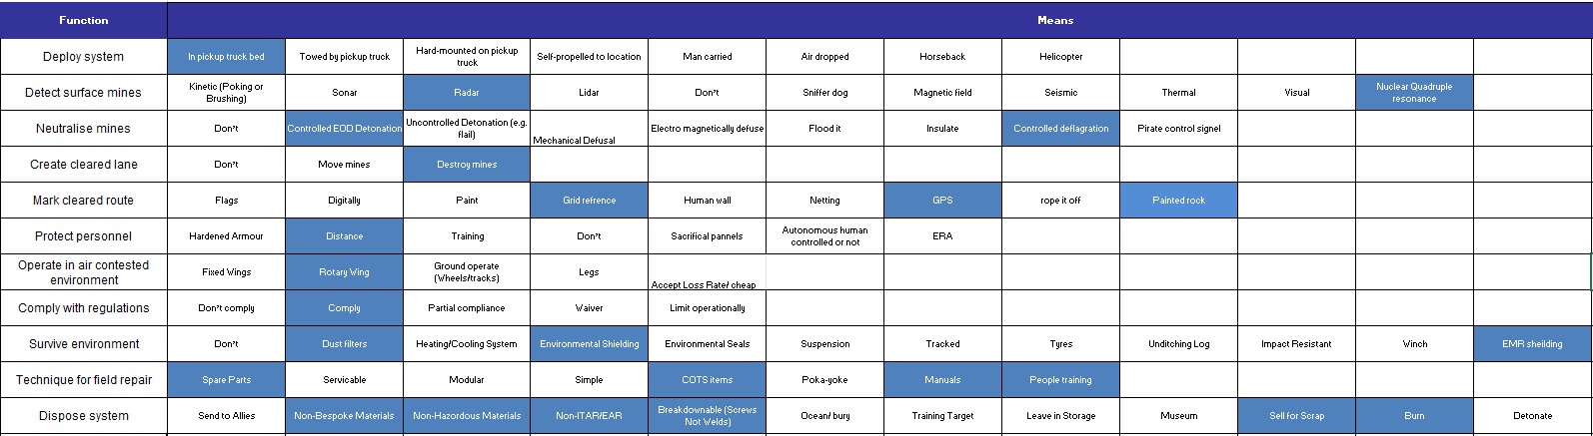
Figure 2 - Function Means Analysis.
The FMA when used by the R&D team on a project such as this, breaks down the overall system objective of find and neutralise mines. Into smaller functional requirements, allowing clear decision making to ensure all key system requirements are addressed.

3.6 Initial Concepts
The R&D team alongside the other areas of Group 4 came together to create four Initial Concepts;
- Flail Type Design
- Plow Type Design
- Tumbleweed Design
- Twin Drone Design
These concepts were debated over and a specific FMA was made for each concept to ensure that each function would have been met by the concept. When all this was completed the R&D team conducted a System Pugh to decided on a winning concept with minimal bias, by picking the concept that best achieved requirements from the customer, manufacturing, testing and evaluation (T&E) as well as legislation and regulations.

3.7 Run-Off
An area where a run-off was conducted was for the carrier system for the concept. The R&D team was having difficulties deciding on what COTS carrier system would be best for both the Detector Drone and the Neutralisation Drone for the Winning Concept. Eventually through use of the run-off the requirements of the two types of drones were deemed too different that using one platform would not be as beneficial as using two separate carrier platforms to best use the benefits of each option.
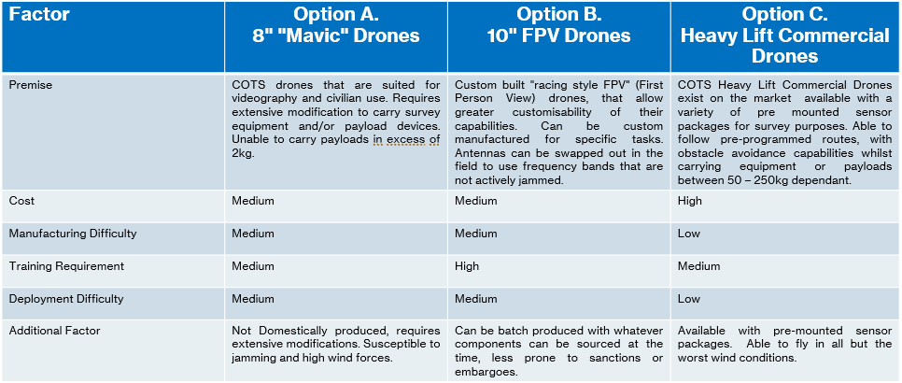
Figure 3 - Carrier System Comparison Run-off.
The 8” Mavic Style Drones were passed on due to their requirement for extensive modifications, and limited capability to deal with adverse weather conditions.
Whereas a 10” FPV style drone has been shown to be able to be produced in significant quantities, are highly modifiable and can be produced domestically.
The Heavy Lift Commercial Style drone was also chosen due to its high payload capacity and ease of modification to allow for the underslung carrying of mine detecting sensor equipment.

3.8 Chosen Concept
The chosen concept was that of a two-drone system featuring a detector type drone and an array of neutralisation drones. The detector drone would be a larger, more stable off the shelf (OTS) platform, able to hold sophisticated sensor packages to give high confidence in its mine detecting capabilities. Digitally marking detected mines for smaller drones, carrying shaped charges to neutralise the threat where they lie. The cleared area is digitally marked allowing for humans to enter the area to manually mark the route with whatever is available.
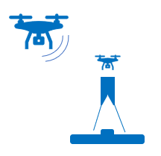
Figure 4 - Diagram taken from Presentation Slides
Other aspects of the concept that were chosen were the Dual Sensor Array, using both Ground Penetrating Radar (GPR) and Nuclear Quadrupole Resonance (NQR) to allow greater reliability for detecting mines that pose a threat to the humanitarian convoy. These sensors emit both electromagnetic and radiofrequency signals into the ground, detecting density discrepancies and metallic or nitrogen nuclei in the soil that would correlate with explosive material or mine components.
The mine defeat mechanism is a small, shaped charge that is to be carefully placed atop a suspected mine but sitting on long feet that surround but do not sit on top of a suspected mine to hopefully prevent unwanted detonation. Where the small carrier drone, with less downwash than a larger UAS can safely leave the hazardous area of 60m as identified by ISO 13855:2024 [23].

3.9 Proposal of Design(s) for Trials.
The R&D team also created a proposal of design(s) for trials to be conducted by the T&E team, with the aims of validating each sub-system before they are combined into the chosen design, where they will then be validated to ensure their compatibility with each other.
Test described in the proposal are;
- Validating mine detection performance of the QPR and NQR sensor package.
- Testing Drone Stability and Weight Capacity when sensor equipment is mounted.
- Test accuracy of sensor equipment when suspended from a UAS.
- Test optimal traversing height for sensor array to detect mines but not disrupt the floor with downwash.
- Assess accuracy of placement of shaped charges with the small carrier drone.
- Identification of technical limitations and identification of areas for improvement.
These tests in the proposal are to be conducted in as close to the conditions found in the desert pass as possible, and in a variety of weather conditions. Identifying the systems false positives and worse, false negative ratio.

4.0 Presentation
This information from the R&D team was collated along with the other information from the other teams within Group 4, to put together a presentation to discuss and show the chosen concept to a group of examiners, industry professionals and the like. The presentation was attempted to be as cohesive as possible though each team’s personal presentation style came through during rehearsals and the final presentation. Once the final presentation had been completed, the examiners and industry professionals asked several questions in which Group 4 answered to the best of their knowledge and ability.
The R&D team received feedback that their segment of the presentation seemed rushed due to the amount of context needed to be condensed into a short 6-minute section of the presentation, and that the “SMART” goals included ‘relevant’ rather than ‘realistic’ which was said in error during the presentation.

Figure 5 - The Front Page of Group 4's Presentation.

5.0 Conclusion and Reflection
In conclusion the separate design teams within Group 4 successfully worked together and each member of the teams were able to utilise their own industry skills to best aid their section of the presentation as well as inform other members of the group on areas where they may not have had an understanding. The R&D team utilised a systems engineering approach to produce a concept in which all involved could be satisfied with. And using research and industry knowledge to narrow down options in the FMA to best produce a concept for which the Manufacturing Team can take forward to best produce the concept at scale.
Feedback from industry professionals did highlight an area for improvement in some aspects of the design, replacing the once melt casted shaped charge warhead which utilised TNT to rather use a more workable compound of TNT which included wax and binders.
The presentation could also have used more practise time as, all members of Group 4 required reading off of notes in order to remember every aspect of their work in which to demonstrate to the industry professionals.

6.0 References & Bibliography
[1] Health and Safety Executive, Health and Safety at Work etc Act. 1974. Accessed: May 04, 2026. [Online]. Available: https://www.hse.gov.uk/legislation/hswa.htm
[2] Health and Safety Executive, Control of substances hazardous to health (COSHH). 2002. Accessed: May 04, 2026. [Online]. Available: https://www.hse.gov.uk/cleaning/topics/coshh.htm
[3] Health and Safety Executive, “Explosives Regulations,” 2014. https://www.hse.gov.uk/pubns/books/l151.htm (accessed May 04, 2026).
[4] U.S. Department of Defence, MIL-STD-882E. 2023. Accessed: May 04, 2026. [Online]. Available: https://quicksearch.dla.mil/qsDocDetails.aspx?ident_number=36027
[5] U.S. Department of Defence, MIL-STD-810H. 2022.
[6] M. Monteiro Marques, STANAG 4586 - Standard Interfaces of UAV Control System (UCS) for NATO UAV Interoperability. NATO, S&T Organization.
[7] Ministry of Defence, DEFSTAN 00-35 Environmental Handbook for Defence Materiel. Ministry of Defence, 1999.
[8] NATO, STANAG 4370. NATO, 2019.
[9] Defence Safety Authority, “DSA 02.OME Defence Ordnance, Munitions and Explosives (OME) Regulations 3.0,” 2024. https://assets.publishing.service.gov.uk/media/66e2bed04e4ac20112e6fbe0/DSA02.OME_regulations.pdf (accessed May 04, 2026).
[10] UK Civil Aviation Authority, “CAP 722: Unmanned Aircraft System Operations in UK Airspace - Guidance,” 2024. https://www.caa.co.uk/data-and-publications/publications/documents/content/cap-722/ (accessed May 04, 2026).
[11] U.S. Department of Defence, “Defence Code of Practice (DCOP) 104.”
[12] International Mine Action Standards, IMAS 04.10. 2024. Accessed: May 04, 2026. [Online]. Available: https://www.mineactionstandards.org/fileadmin/uploads/imas/Standards/English/IMAS_04.10_Ed.2_Am.12.pdf
[13] International Mine Action Standards, IMAS 07.30. 2016. Accessed: May 04, 2026. [Online]. Available: https://www.mineactionstandards.org/fileadmin/uploads/imas/Standards/English/IMAS_07.30_Ed.3.pdf
[14] International Mine Action Standards, IMAS 09.40. 2020. Accessed: May 04, 2026. [Online]. Available: https://www.mineactionstandards.org/fileadmin/uploads/imas/Standards/English/IMAS_09.40_Ed.3_Am.1.pdf
[15] Ministry of Defence, Defence Standard 00-56. 2007. Accessed: May 04, 2026. [Online]. Available: https://skybrary.aero/sites/default/files/bookshelf/344.pdf
[16] Paul J. Callus, DEF STAN 00-970 Requirements for the Design and Airworthiness of Composite Aircraft Structure. DSTO Platforms Sciences Laboratory, 2003. Accessed: May 04, 2026. [Online]. Available: https://apps.dtic.mil/sti/tr/pdf/ADA416786.pdf
[17] Ministry of Defence, DEF STAN 00-85.
[18] Ministry of Defence, JSP 520 Defence ordnance, munitions and explosives safety and environmental management policy. 2010. Accessed: May 04, 2026. [Online]. Available: https://assets.publishing.service.gov.uk/media/5a80a912ed915d74e622fb91/20150613-JSP520_Pt1_Directive_Issue4.2.pdf
[19] NATO, STANAG 4671 Unmanned Aircraft Systems Airworthiness Requirements - USAR. 2014.
[20] NATO, STANAG 4170 Principles and Methodology for the Qualification of Explosive Material for Military Use. 2008.
[21] NATO, STANAG 2036 Land Service Ammunition and Explosives Safety. 2005.
[22] NATO, STANAG 2897 (Restricted) Explosive Ordnance Disposal Equipment Requirements and Equipment AEODP-7. 2022.
[23] International Organization for Standardization, ISO 13855:2024. 2024. Accessed: May 04, 2026. [Online]. Available: https://www.iso.org/standard/80590.html
[24] UK Statutory Instruments, The Carriage of Explosives by Road Regulations 1996. 1996. Accessed: May 04, 2026. [Online]. Available: https://www.legislation.gov.uk/uksi/1996/2093/made

Appendices
Figure 6 - Customer Requirements.
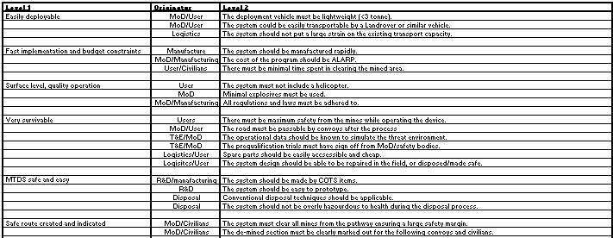
Figure 7 - Customer and Stakeholder Requirements.
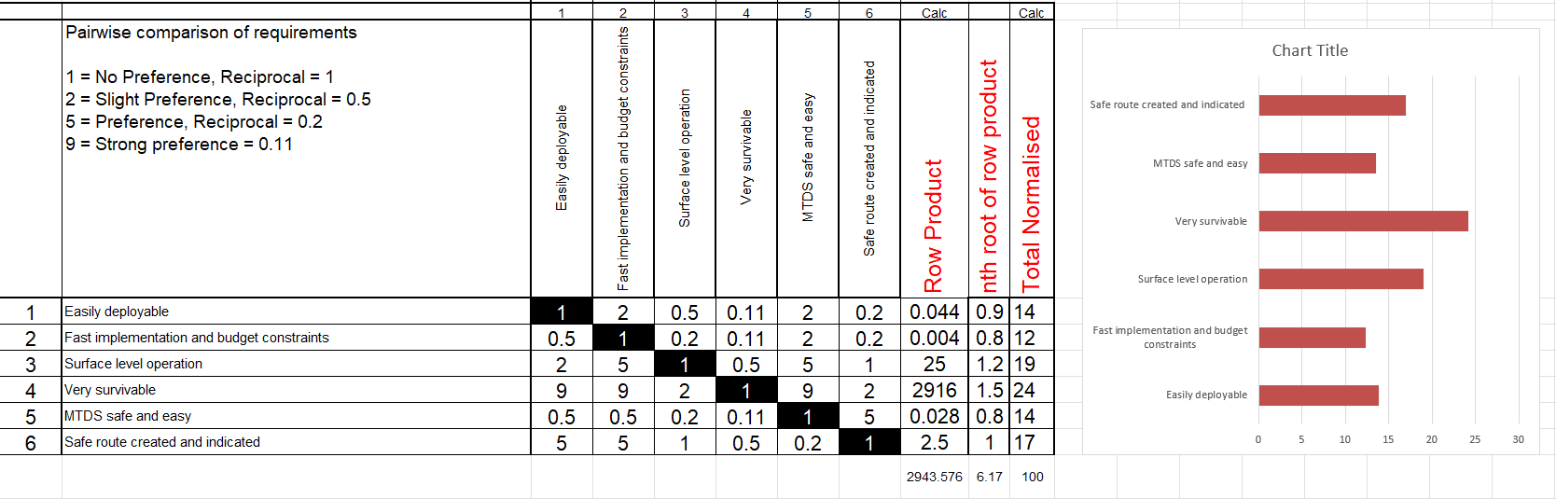
Figure 8 - Rationalised Requirements with Graph.
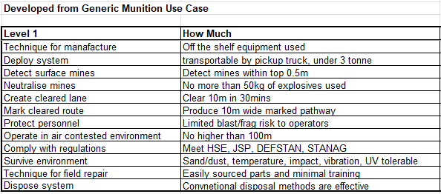
Figure 9 - Required Functionality Table.
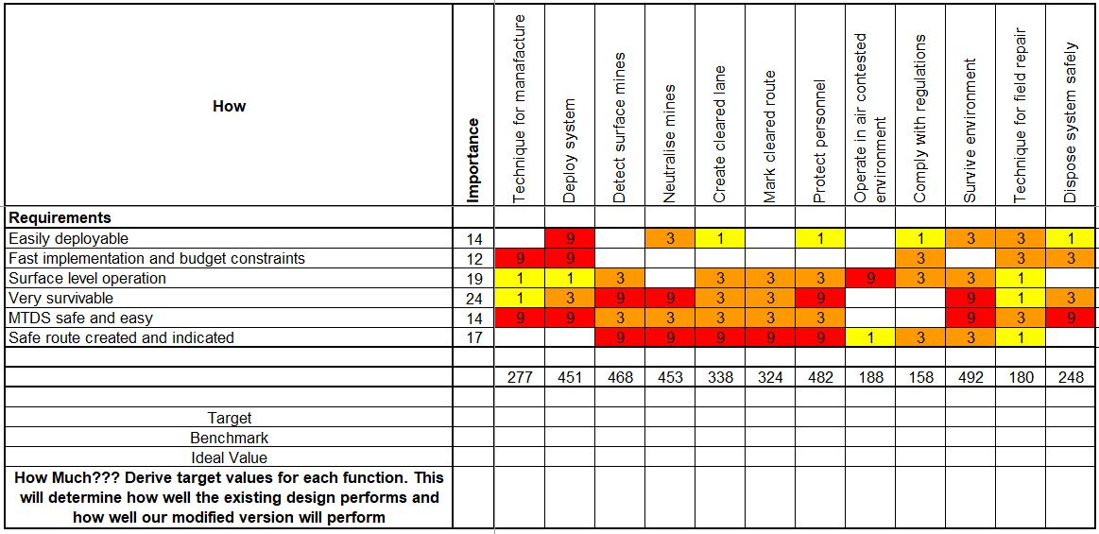
Figure 10 - QFD01 Table.
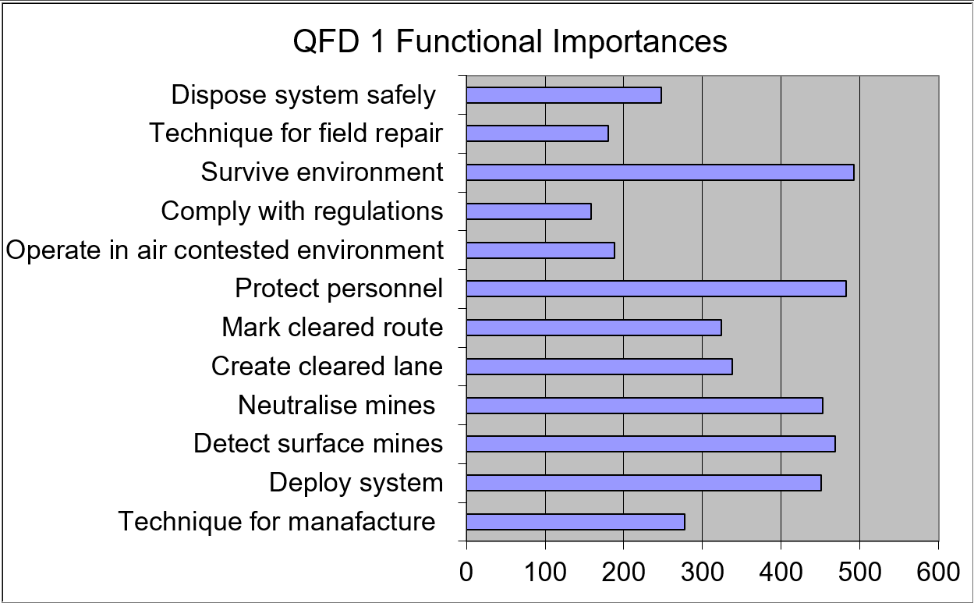
Figure 11 - QFD1 Functional Importances.
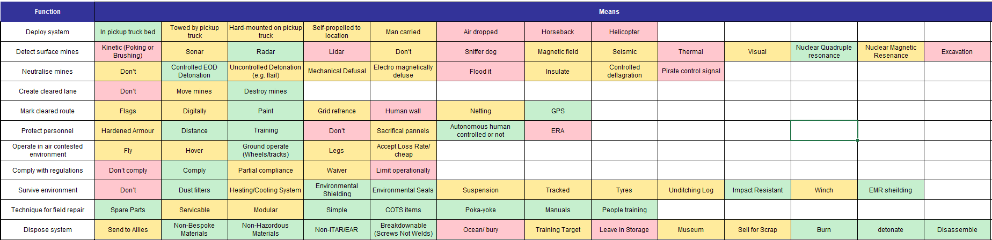
Figure 12 - Function Means Analysis Table.
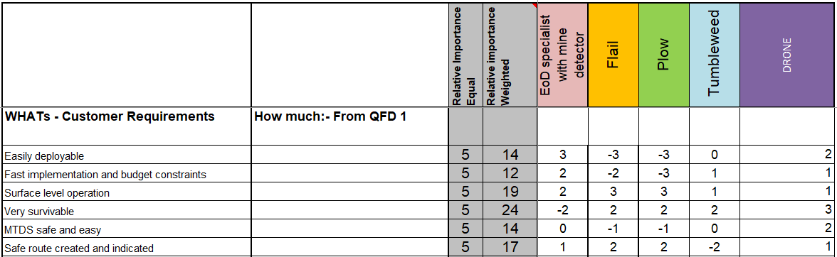
Figure 13 - System Pugh
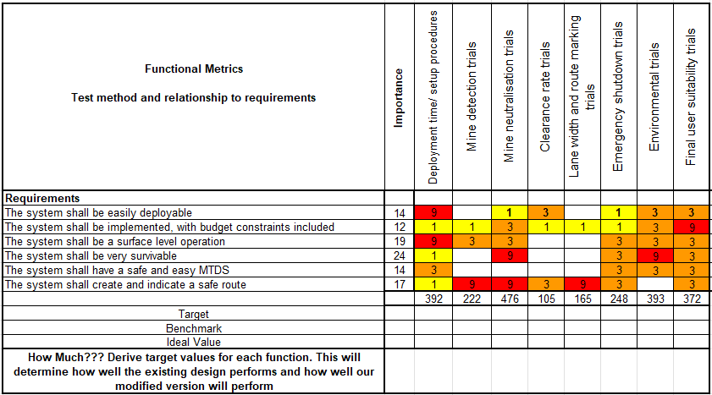
Figure 14 - Functional Metrics Table.
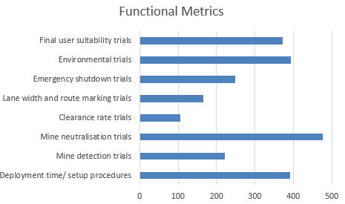
Figure 15 - Graphed Functional Metrics.
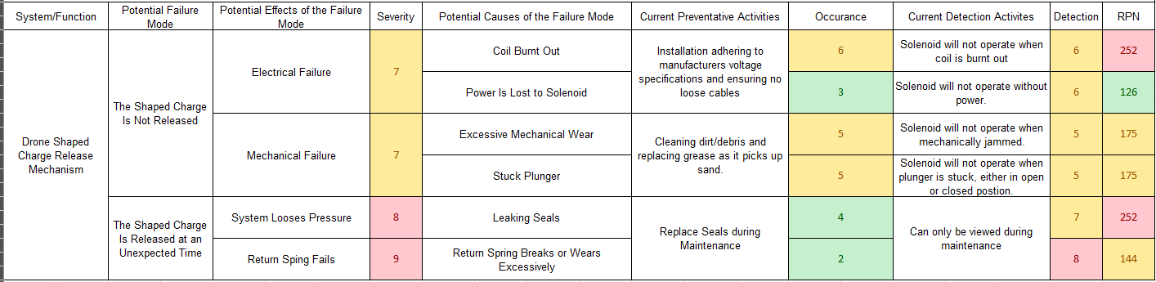
Figure 16 - DFMEA for Shaped Charge Release System on UAS.
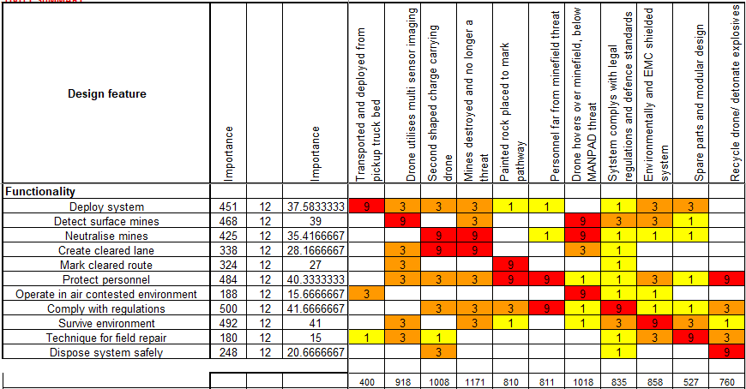
Figure 17 - Design QFD2 Table.
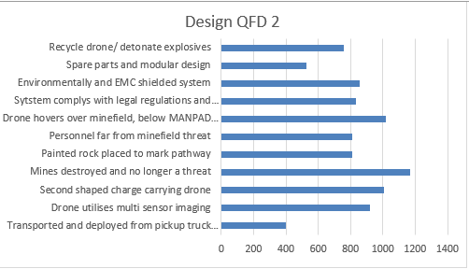
Figure 18 - Graphed Importance of Components and/or Sub-systems from QFD2.
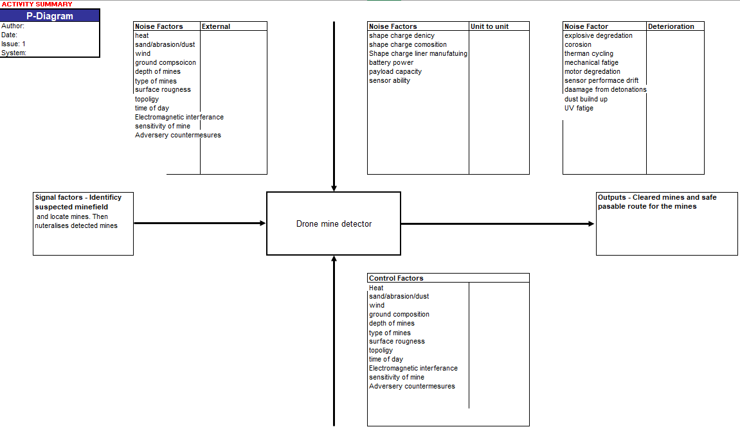
Figure 19 - P-Diagram.
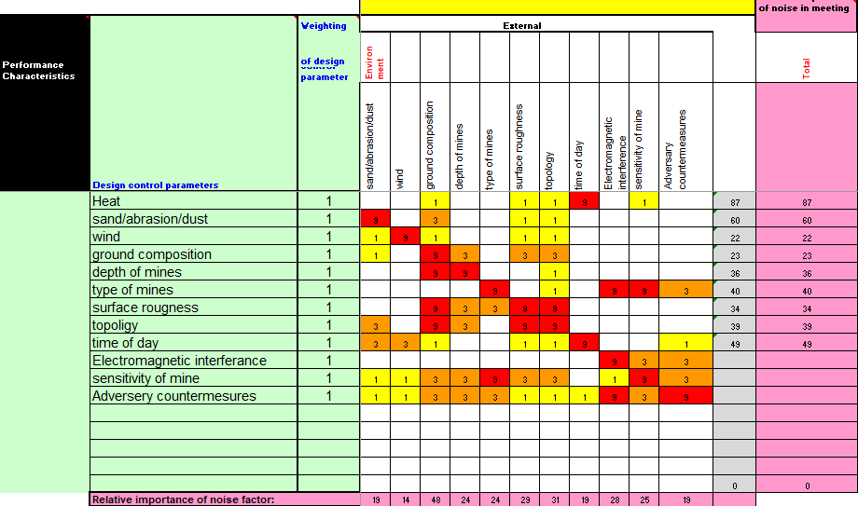
Figure 20 - Prime/What/Why Table.
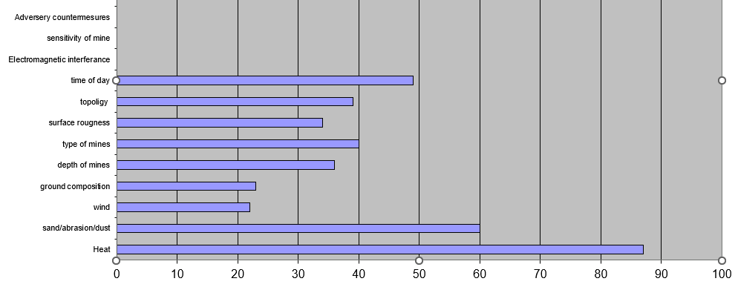
Figure 21 - Control Factors Graph.
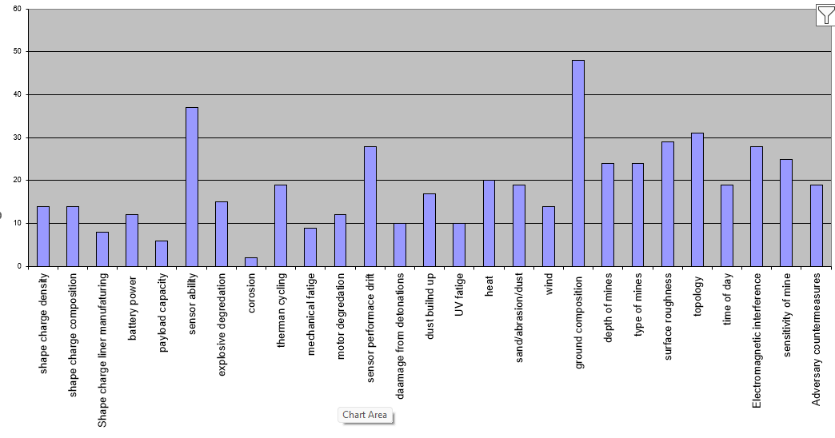
Figure 22 - Noises Factors Graph.
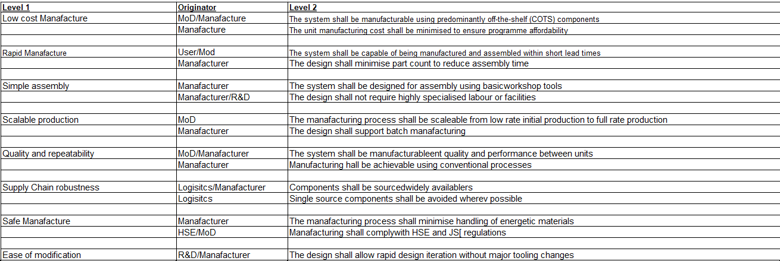
Figure 23 - Requirements Set Manufacturer.
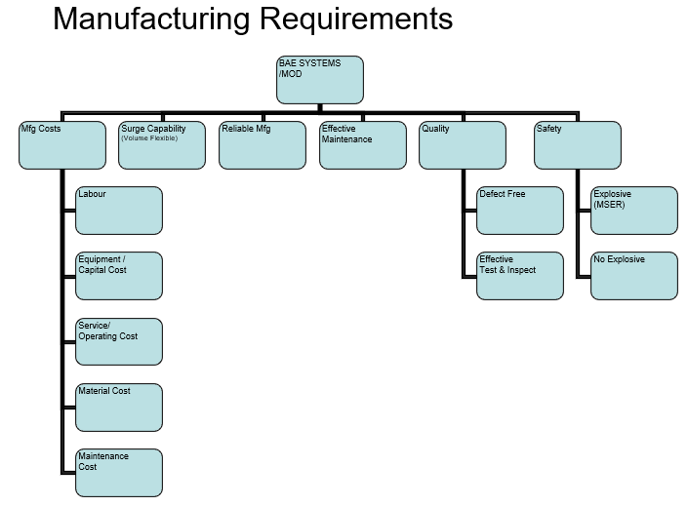
Figure 24 - Manufacturing Requirements Flow Chart.
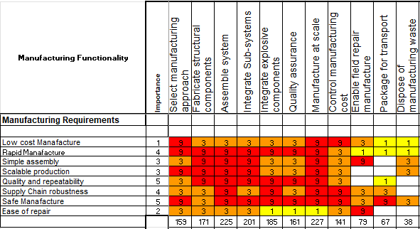
Figure 25 - Manufacturing QFD1
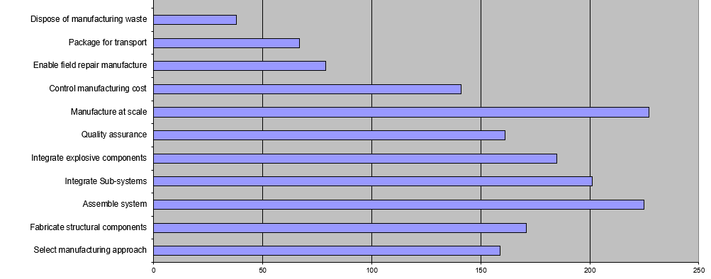
Figure 26 - Process Importance Chart.
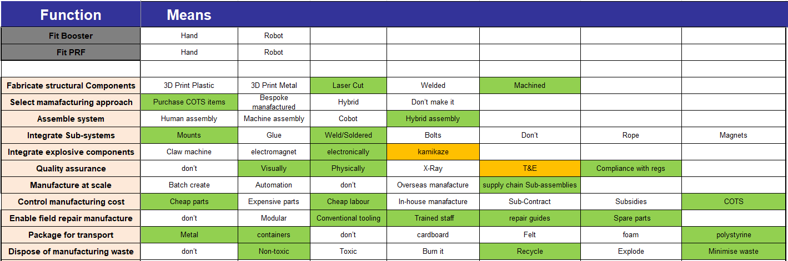
Figure 27 - Process Function Means Analysis.
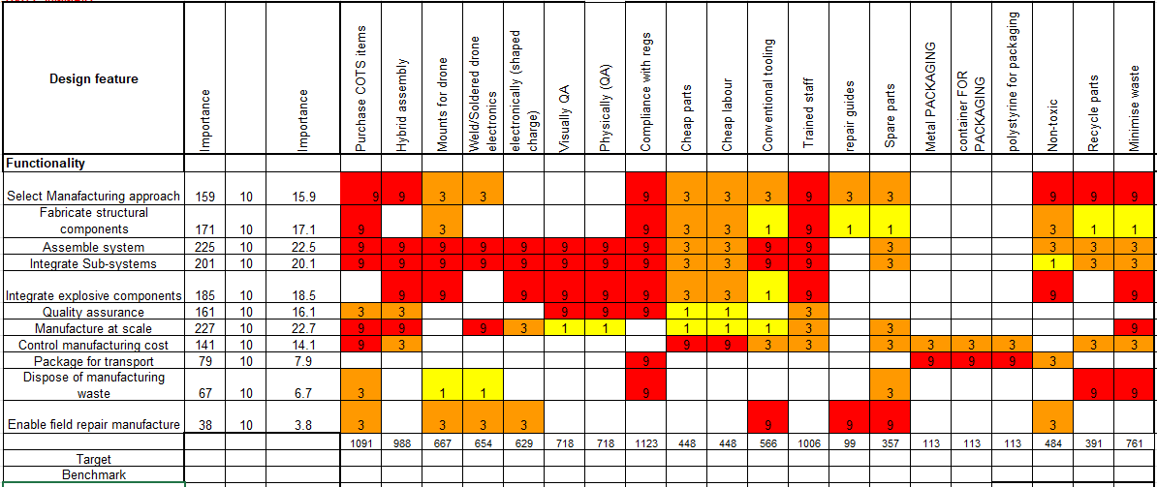
Figure 28 - Manufacturing QFD2
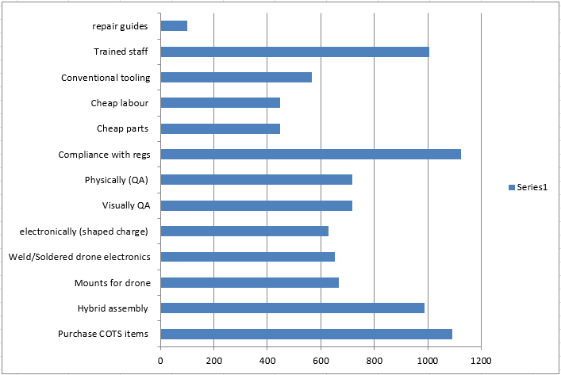
Figure 29 - Function Means Importance.
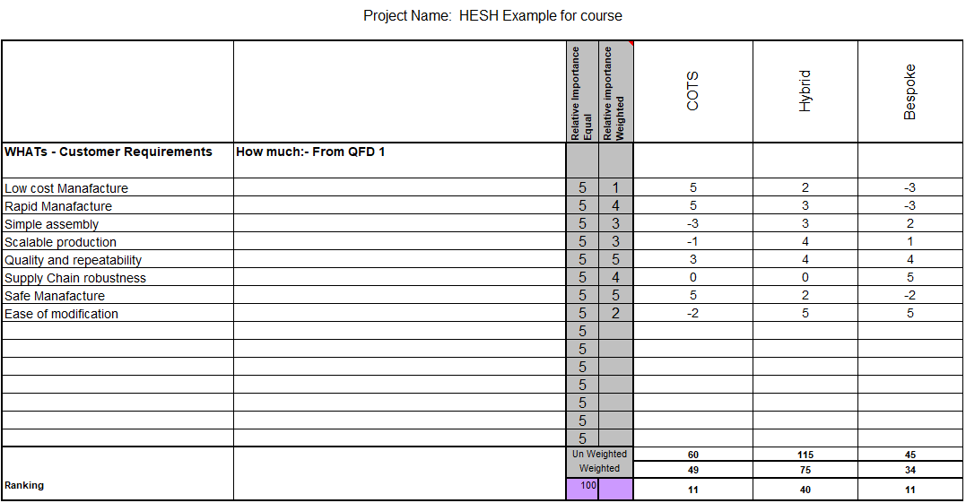
Figure 30 - Process Pugh.
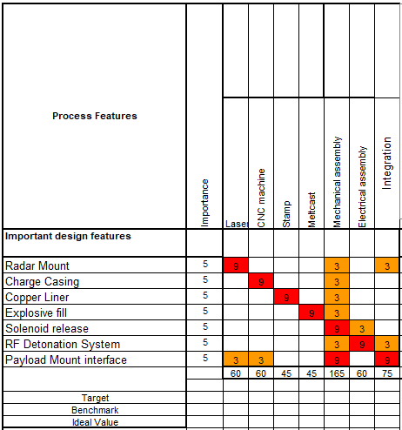
Figure 31 - QFD3
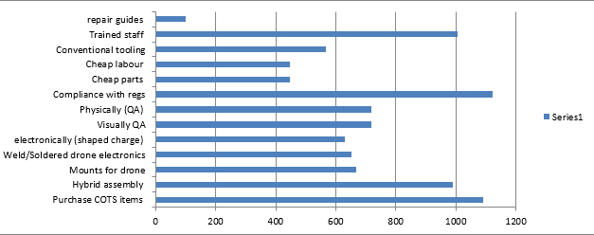
Figure 32 - Graphed QFD3
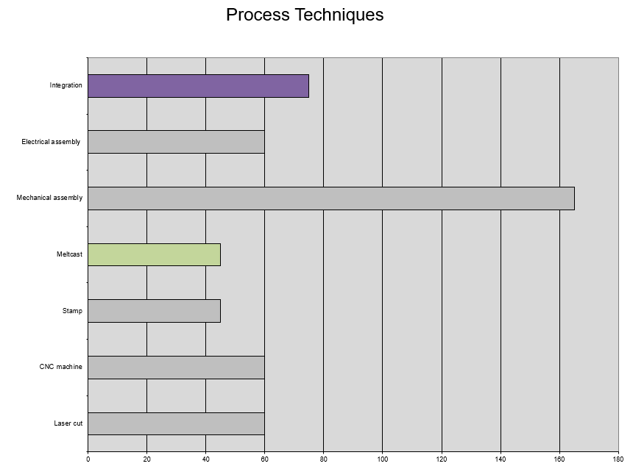
Figure 33 = Technique Importance Chart.
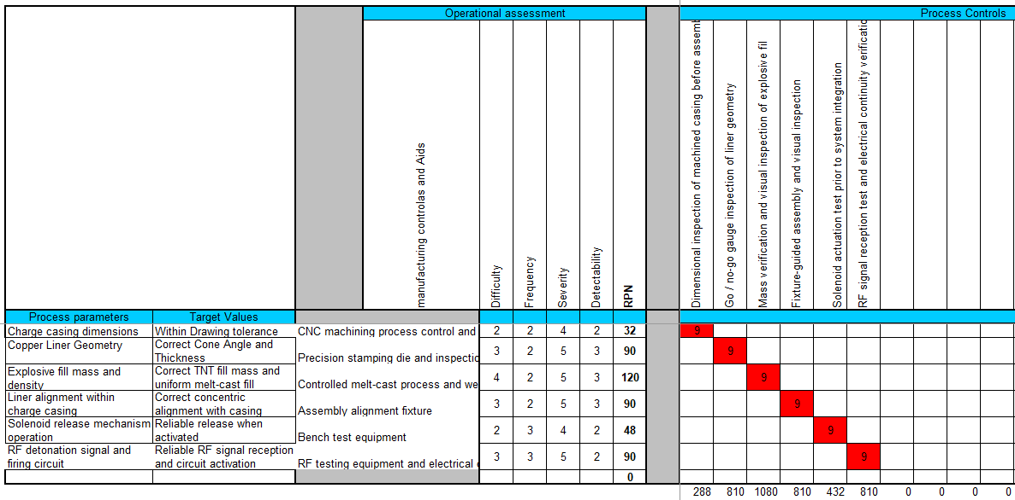
Figure 34 - QFD4 Table.
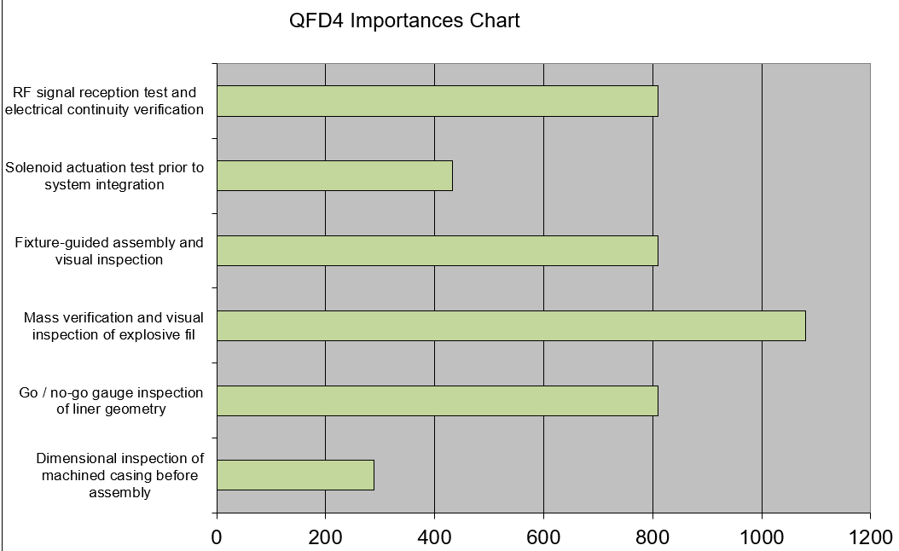
Figure 35 - QFD4 Importances Chart.
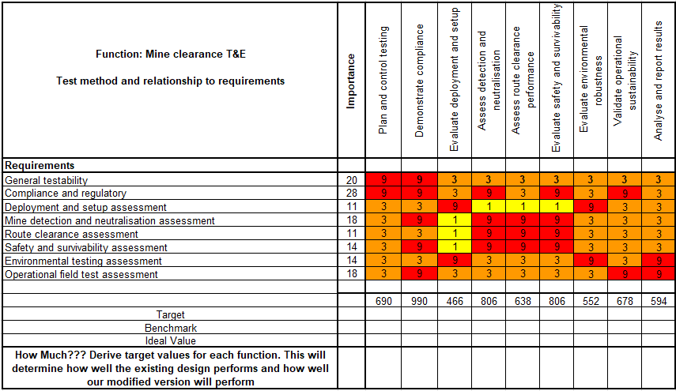
Figure 36 - Mine Clearance T&E Table.
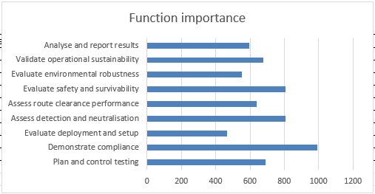
Figure 37 - Functional Importance Graph.

