HTML & CSS Web Development
Software Engineering
8/01/25
Camden Henderson (2404086)

Contents
Introduction 2
Requirements 2
Implementation 2
Design 3
Validation 5
Challenges 7
Evaluation 7
Usability 7
Accessibility 7
SEO Analysis 8
Conclusion 9
References 9
Appendices 10

Introduction
In this report, I will cover how I designed and hand coded my website about Paris titled “Camden’s Blog”. I will also make an evaluation of my website and rate it based off of several factors such as usability and SEO. The website is used for people wanting to gain insight on Paris and what the lifestyle of being Parisian is like, and highlighting important places for tourists to visit.
Throughout the report, I will explain the process of making the website and the requirements I made first along with documenting the challenges i faced when creating the code.

Requirements
The purpose of this website is to inform the masses about the city of Paris and the beautiful life and culture in France. The website contains short but information segments in each page, spanning five pages in total. Each page highlights a key aspect of Paris with images. I want the website to be very easy to understand so that anybody could navigate it, creating user friendly UI. The website will be hand coded in HTML along with a CSS file to style it accordingly.
The website targets several target audiences. The primary audience for my website is people who want to go to Paris but are uninformed about its various wonderful locations and places they can visit. This includes people such as families wanting a trip to Europe or food enthusiasts who wish to try something new. Having a wide range of people means that my website will have a lot of potential visitors that can find someone that interest them. I made my website easy to look at so people are more likely to explore each page.
The function of the site is good. It has an easy to navigate menu that sits at the top of the screen which stays for each page of the website. Each page loads extremely fast, because i made sure the image file sizes were smaller. The most important function of the website to me was making sure that the content was neat and organized in the middle, where your eyes would be focused mainly.

Implementation

Design
Regarding the design of the website, it should have a clear and consistent colour scheme that's present on each page. The website has a white background and there are other colours such as blue which is used to complement Paris and contrast the white background. I made the background white so that the text can be black making it much easier to read. I also learned that using simple fonts is best for a professional look and easy reading [1]. The website was coded using HTML and CSS styling.
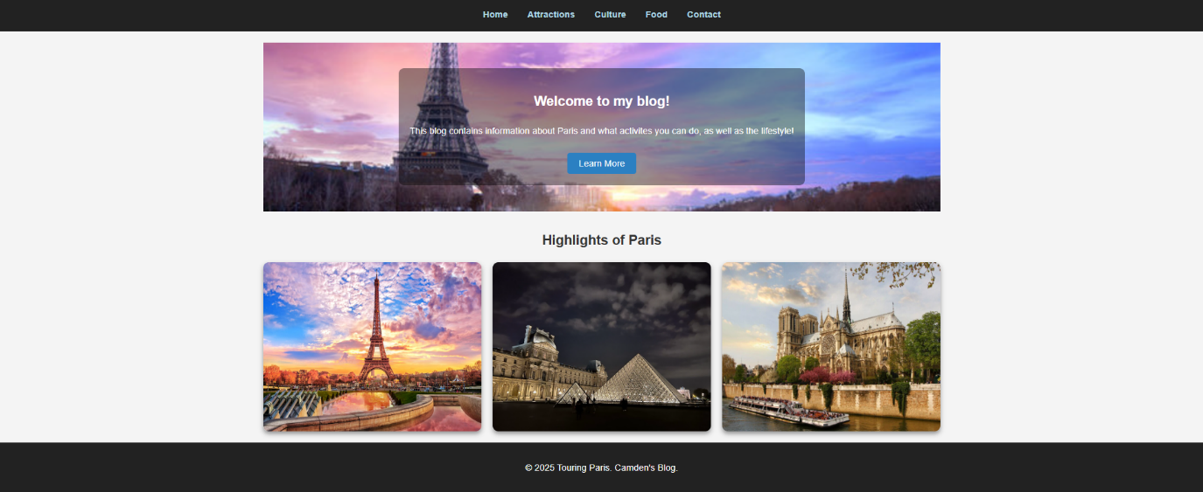
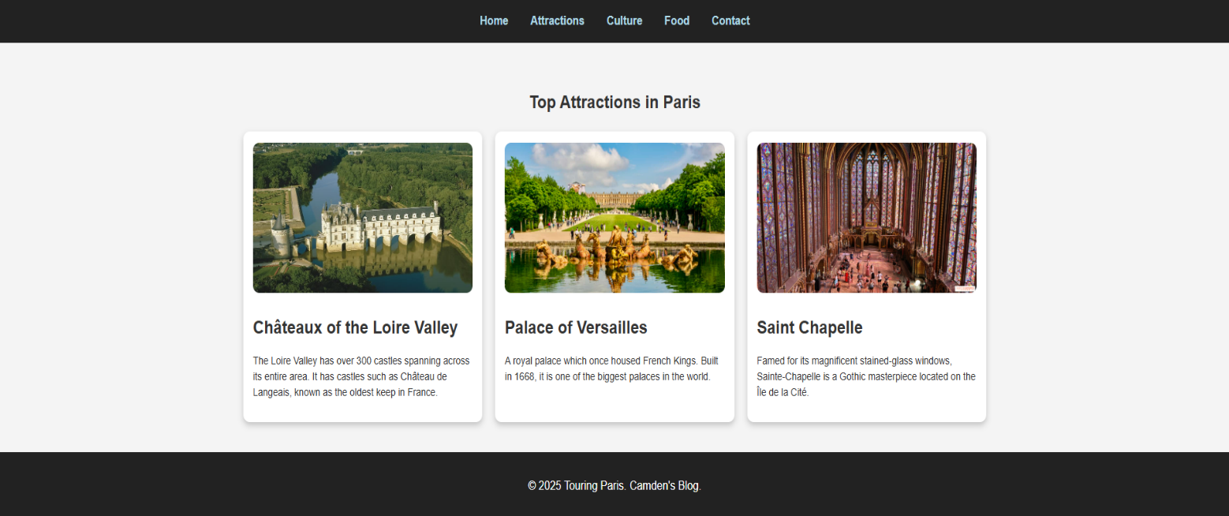
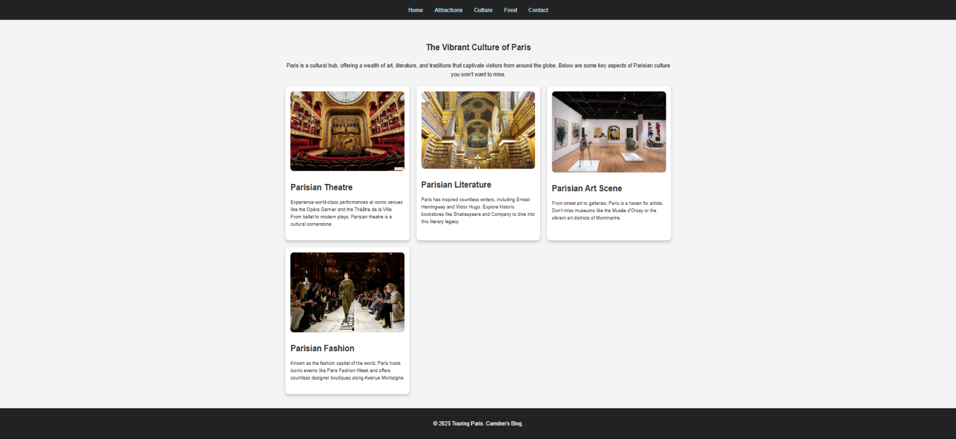
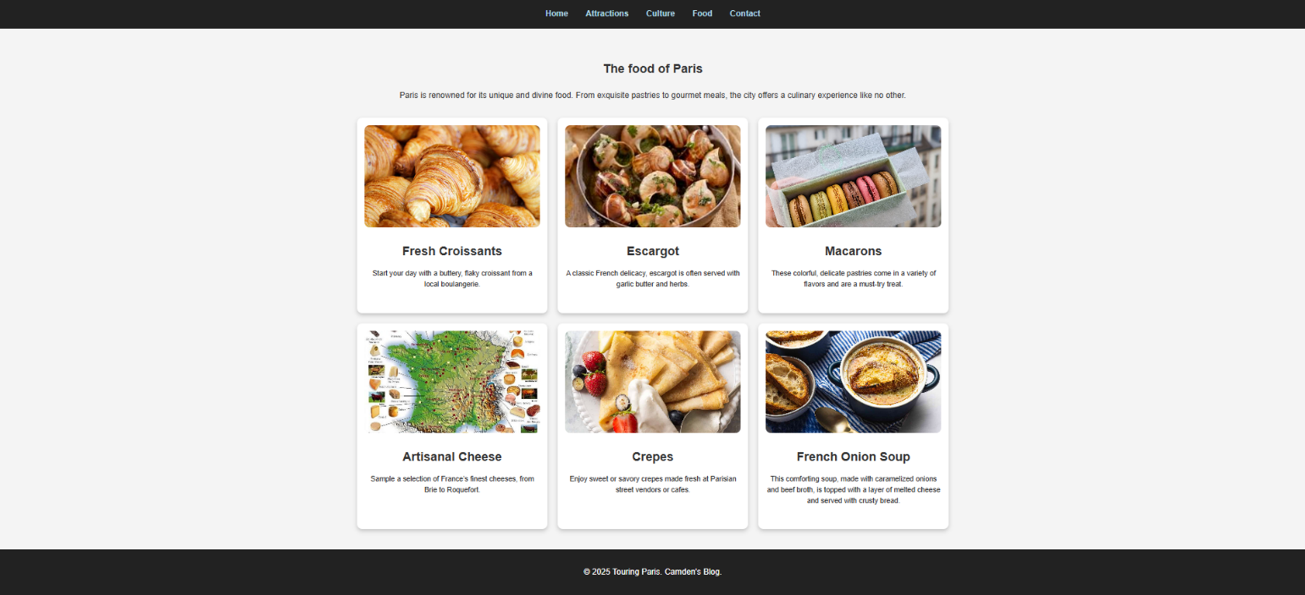
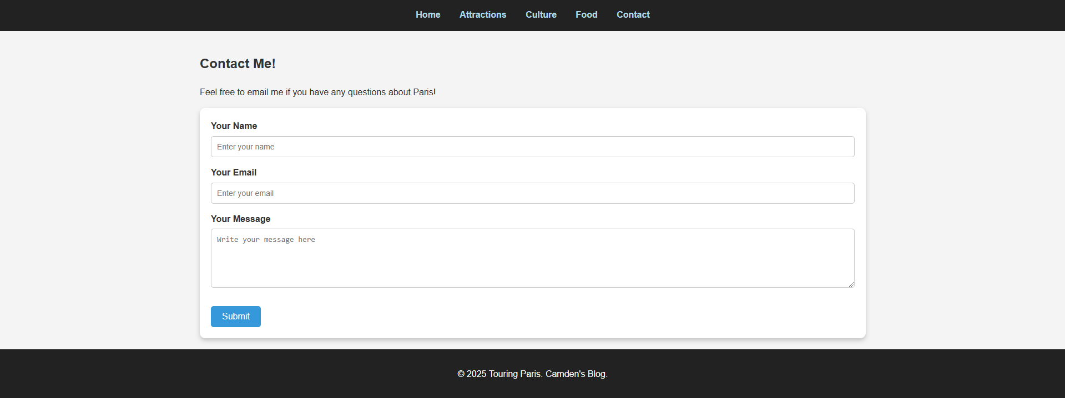
These are the five pages that I created for my blog. They are Home, Attractions, Culture, Food and Contact. The main body of all the pages use articles. I used articles and sections because it is easy to create structured content and stay neatly organized with both images and the text can go straight underneath it. I also used shadows on the articles to make it stand out against the white background. I did this by using box-shadow and using the “rgba” function to create a gradient from 4 colours. I created a simple navigation bar which changes colour when highlighted with a cursor. The navigation bar works across every page. I also used features such as image hover to give you a description of the image when hovering over it.

Validation
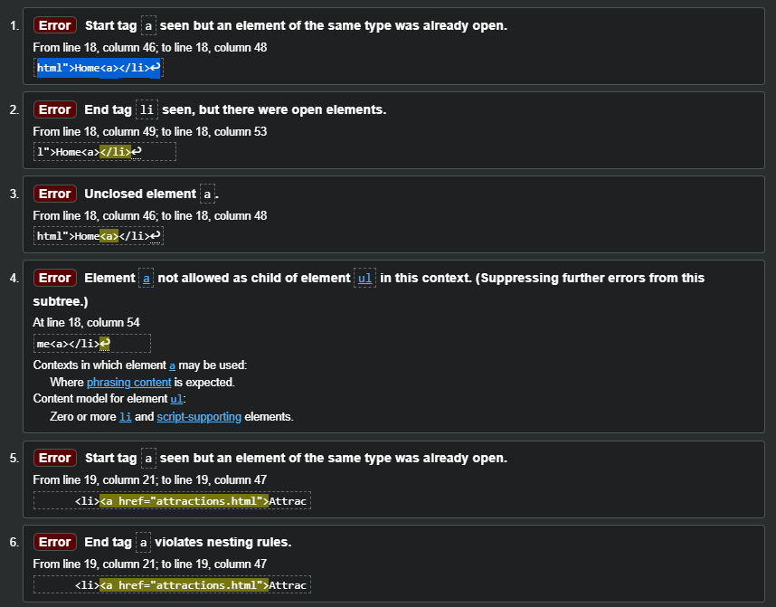Testing the home page of my website, i made a major error accidentally. I checked my code again and I forgot to close one of the elements at the beginning which caused a major number of errors to be thrown. By simply fixing this all but two of the errors were removed. The other two errors were caused by me not putting a space in one of my lines of code. When I put a space in, all of the errors were solved.
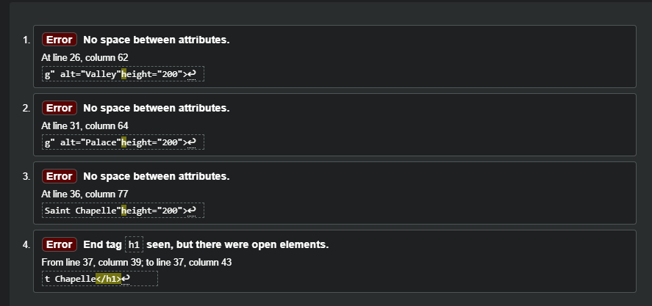My attractions page also had the same error regarding spacing, but there was a new error regarding open elements. This error was solved as I opened an element with h2 but accidentally closed it with h1. All these errors were fixed. I tested the rest of the pages and I found no errors in the code besides repeated errors such as misspelling and forgetting to put spaces in some places.

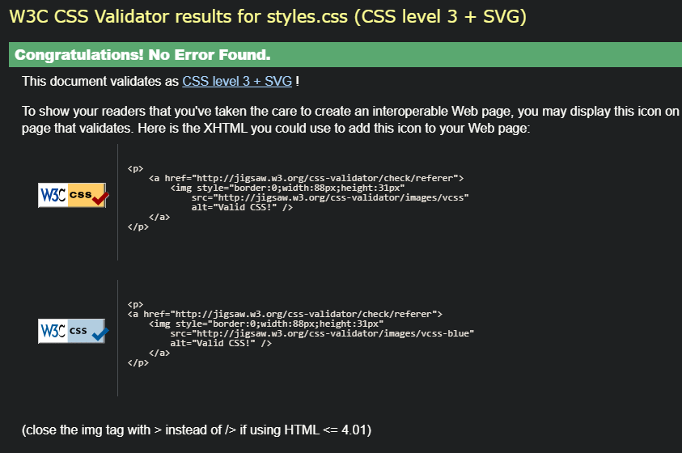
I checked my CSS using the validator provided in the assignment specification and it came back with no errors. I only validated my main CSS, and i didn't validate the CSS used in the rest of the pages, only the home page as required in the specification, so they the other pages may contain errors.

Challenges
One of the biggest challenges was finding a suitable way to provide information in a neat manner and also show photos. I present information in a short but sweet format by using articles, which allows me to section pieces of information off and put them in their own squares. This way I can keep readers attention without ranting too hard about the topics on my blog.
Another challenge I faced was trying to make my website responsive on mobile platforms on when reshaping window sizes. The content at first would overlap eachother and look very unprofessional and amateur. I fixed this using viewport. I put it on every webpage, and it would then align itself with any screen such as a phone screen when it got resized.

Evaluation

Usability
Usability is described as how a user interacts with a product [2], or in this case a website. I made sure that when i was developing my websites design that it was simple and easy to use regardless of the person browsing on it. The website has lots of free space and is straightforward regarding where the information is and how to get it. The navigation bar is in a black colour which contrasts the white background making it very easy to see for people.
In terms of online transactions, a study found that 95.5% of users expect a website to clearly show shipping and pricing information on the website [3]. This shows that usability is a greatly important factor, and a website without usability is hard for people to use.
I also made sure that the website would be usable on different devices such as laptop, tablet and phone. This is because most people use their phones for a lot of actions, meaning most of the traffic would be on phone. No matter how you resize the website, the content will always be displayed. I made sure to make my images clear and large, the main content for each page is in the middle of the website so that it is very hard to miss. This makes it easier for older users to view my page as their eyesight may be weaker than younger people.

Accessibility
Web accessibility ensures that websites are developed to let people with disabilities successfully browse and use a website [4]. The Web Content Accessibility guidelines (WCAG) outlines criteria you can follow to accommodate your website for people with blindless, hearing loss, and many different learning or cognitive impairments. The four principles of WCAG are POUR, which stands for Perceivable, Operable, Understandable and Robust. Perceivable means that your website is easy to read and helps people with visual impairments to see and distinguish. Operable means that your website can be easily interacted with and navigate. Understandable requires your website to understandable and for it to work correctly. Robust needs your website to be flexible, and work on many different platforms, for people who use wheelchairs or screen readers.
The world health organization states that 1 in 6 people have a significant disability, which is 16% of the world's population [5]. This also means that 1 in 6 people visiting your website have a form of disability, so it’s important to make sure your website is accessible to many disabilities otherwise you lose 16% of your traffic approximately.
One way I've made my website accessible is by using alt text to describe images that people with sight loss won't be able to see. The alt text can be read by their speech software and giving accurate descriptions of the image depictions.
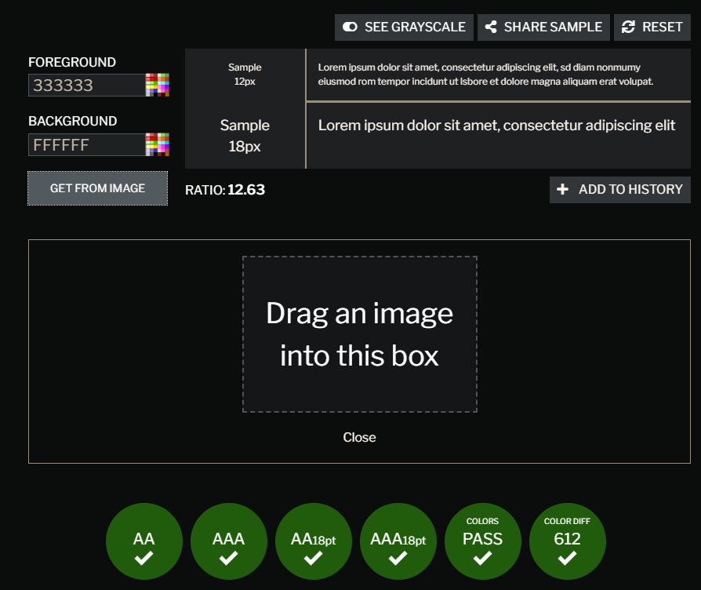 I also used online web tools to check the colour contrast between the text and the background to ensure that it is as readable as possible. I’ve made my website robust by testing it on different platforms, and it should work with assistance tools like screen readers.

SEO Analysis
SEO stands for Search Engine Optimization, it dictates how well your website appeals to search engines and how high you appear on search engines. This can be affected via factors like meta tags and keywords which if mentioned make your website appear higher when searched for. It connects your website to relevant keywords mentioned by people to boost traffic to your website [6]. A study done in 2024 analysed 10 studies between 2022 - 2024 and found that Search Engine Optimisation increases website traffic by 4.9% approximately [7].

I’ve found a few different methods of increasing Search Engine Optimisation online, and I've integrated them into my website. The main method I've used is to include keywords and descriptions using meta tags.
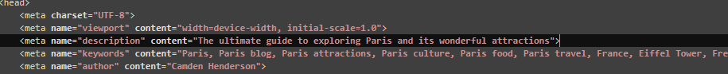 I’ve included keywords on both the front end and backend of the website. Using many keywords relevant to my website boosts my number of visitors. Without meta tags SEO would not know what my website consists of and wouldn't know the relevant audience to push my content to.

Conclusion
To conclude, the website I made was successfully made with responsiveness and usability to appeal to masses of people. It contains SEO features such as keywords and meta tags so that google knows what the purpose of the website is and can direct it to people who are interested. I've checked over the websites design using tools such as contrast checker to see if it is engaging enough. Most importantly I've made the website flexible so that it can adjust to different screens and devices.

References
[1]“27 Effective Web Design Tips for Improving Your Website,” Indeed Career Guide, 2024. https://www.indeed.com/career-advice/career-development/website-layout-tips
[2]D. Belanche, L. V. Casaló, and M. Guinalíu, “Website usability, consumer satisfaction and the intention to use a website: The moderating effect of perceived risk,” Journal of Retailing and Consumer Services, vol. 19, no. 1, pp. 124–132, Jan. 2012, doi: https://doi.org/10.1016/j.jretconser.2011.11.001.
[3]Interaction Design Foundation, “What is Usability?,” The Interaction Design Foundation, Jun. 01, 2016. https://www.interaction-design.org/literature/topics/usability
[4]W3C, “Introduction to Web Accessibility,” Web Accessibility Initiative (WAI), Mar. 07, 2024. https://www.w3.org/WAI/fundamentals/accessibility-intro/
[5]World Health Organization, “Disability and Health,” World Health Organization, Mar. 07, 2023. https://www.who.int/news-room/fact-sheets/detail/disability-and-health
‌[6]D. Goodwin, “What Is SEO / Search Engine Optimization?,” Search Engine Land, 2023. https://searchengineland.com/guide/what-is-seo
‌[7]P. Usmany et al., “The Effectiveness Of Search Engine Optimization (SEO) In Marketing: A Meta-Anlysis Study,” Journal of Economic, Bussines and Accounting (COSTING), vol. 7, no. 5, pp. 807–811, Jul. 2024, doi: https://doi.org/10.31539/costing.v7i5.11446.

Appendices

Appendix 1: index.html
<!DOCTYPE html>
<html lang="en">
<head>
<meta charset="UTF-8">
<meta name="viewport" content="width=device-width, initial-scale=1.0">
<meta name="description" content="The ultimate guide to exploring Paris and its wonderful attractions">
<meta name="keywords" content="Paris, Paris blog, Paris attractions, Paris culture, Paris food, Paris travel, France, Eiffel Tower, French, Paris Fashion, Paris Life, Paris Abroad">
<meta name="author" content="Camden Henderson">
<title>Camden Blog</title>
<link rel="stylesheet" href="styles.css">
<script>
function learnmorebutton() {
alert("Explore the beauty of Paris in detail!");
}
</script>
</head>
<body>
<header>
<nav>
<ul>
<li><a href="index.html">Home</a></li>
<li><a href="attractions.html">Attractions</a></li>
<li><a href="culture.html">Culture</a></li>
<li><a href="food.html">Food</a></li>
<li><a href="contact.html">Contact</a></li>
</ul>
</nav>
</header>
<main>
<section class="welcome">
<div class="welcome-content">
<h1>Welcome to my blog!</h1>
<p>This blog contains information about Paris and what activites you can do, as well as the lifestyle!</p>
<button onclick="learnmorebutton()">Learn More</button>
</div>
</section>
<section class="gallery">
<h2>Highlights of Paris</h2>
<div class="gallery-container">
<img src="images/eiffel.jpg" alt="Eiffel Tower" height="300">
<img src="images/louvre.jpeg" alt="Louvre Museum" height="300">
<img src="images/notredame.jpg" alt="Notre Dame" height="300">
</div>
</section>
</main>
<footer>
<p>&copy; 2025 Touring Paris.
Camden's Blog.</p>
</footer>
</body>
</html>

Appendix 2: attractions.html
<!DOCTYPE html>
<html lang="en">
<head>
<meta charset="UTF-8">
<meta name="viewport" content="width=device-width, initial-scale=1.0">
<title>Touring Paris - Attractions</title>
<link rel="stylesheet" href="styles.css">
</head>
<body>
<header>
<nav>
<ul>
<li><a href="index.html">Home</a></li>
<li><a href="attractions.html">Attractions</a></li>
<li><a href="culture.html">Culture</a></li>
<li><a href="food.html">Food</a></li>
<li><a href="contact.html">Contact</a></li>
</ul>
</nav>
</header>
<main>
<section class="attractions">
<h1>Top Attractions in Paris</h1>
<div class="attraction-list">
<article>
<img src="images/valley.jpg" alt="Valley" height="200">
<h2>Châteaux of the Loire Valley</h2>
<p>The Loire Valley has over 300 castles spanning across its entire area. It has castles such as Château de Langeais, known as the oldest keep in France.</p>
</article>
<article>
<img src="images/palacev.jpeg" alt="Palace" height="200">
<h2>Palace of Versailles</h2>
<p>A royal palace which once housed French Kings. Built in 1668, it is one of the biggest palaces in the world. </p>
</article>
<article>
<img src="images/saintchapelle.jpg" alt="Saint Chapelle" height="200">
<h2>Saint Chapelle</h2>
<p>Famed for its magnificent stained-glass windows, Sainte-Chapelle is a Gothic masterpiece located on the Île de la Cité.</p>
</article>
</div>
</section>
</main>
<footer>
<p>&copy; 2025 Touring Paris. Camden's Blog.</p>
</footer>
</body>
</html>

Appendix 3: food.html
<!DOCTYPE html>
<html lang="en">
<head>
<meta charset="UTF-8">
<meta name="viewport" content="width=device-width, initial-scale=1.0">
<title>Touring Paris - Food</title>
<link rel="stylesheet" href="styles.css">
</head>
<body>
<header>
<nav>
<ul>
<li><a href="index.html">Home</a></li>
<li><a href="attractions.html">Attractions</a></li>
<li><a href="culture.html">Culture</a></li>
<li><a href="food.html">Food</a></li>
<li><a href="contact.html">Contact</a></li>
</ul>
</nav>
</header>
<main>
<section class="food">
<h1>The food of Paris</h1>
<p>Paris is renowned for its unique and divine food. From exquisite pastries to gourmet meals, the city offers a culinary experience like no other.</p>
<div class="food-gallery">
<div class="food-item">
<img src="images/croissant.jpg" alt="Croissant">
<h2>Fresh Croissants</h2>
<p>Start your day with a buttery, flaky croissant from a local boulangerie.</p>
</div>
<div class="food-item">
<img src="images/escargot.jpg" alt="Escargot">
<h2>Escargot</h2>
<p>A classic and bountiful French dish. Escargot is often served with garlic butter and herbs.</p>
</div>
<div class="food-item">
<img src="images/macaron.jpg" alt="Macaron">
<h2>Macarons</h2>
<p>These beautiful cookies sandwiches are often stuffed with lovely fillings.</p>
</div>
<div class="food-item">
<img src="images/fromage.jpg" alt="Cheese?">
<h2>Artisanal Cheese</h2>
<p>Sample the greatest and finest French cheeses, from Brie to Roquefort.</p>
</div>
<div class="food-item">
<img src="images/crepes.jpg" alt="Crepes">
<h2>Crepes</h2>
<p>Enjoy sweet or savory crepes made fresh at Parisian street vendors or cafes.</p>
</div>
<div class="food-item">
<img src="images/frenchonionsoup.jpg" alt="French Onion Soup" class="food-image">
<h2>French Onion Soup</h2>
<p>This comforting soup is complimented with beef broth and caramelised onions, along with cheese and bread.</p>
</div>
</div>
</section>
</main>
<footer>
<p>&copy; 2025 Touring Paris. Camden's Blog.</p>
</footer>
</body>
</html>

Appendix 4: culture.html
<!DOCTYPE html>
<html lang="en">
<head>
<meta charset="UTF-8">
<meta name="viewport" content="width=device-width, initial-scale=1.0">
<title>Touring Paris - Culture</title>
<link rel="stylesheet" href="styles.css">
</head>
<body>
<header>
<nav>
<ul>
<li><a href="index.html">Home</a></li>
<li><a href="attractions.html">Attractions</a></li>
<li><a href="culture.html">Culture</a></li>
<li><a href="food.html">Food</a></li>
<li><a href="contact.html">Contact</a></li>
</ul>
</nav>
</header>
<main>
<section class="culture">
<h1>The Vibrant Culture of Paris</h1>
<p>Paris is a cultural hub, with many different special characteristics and traditions that captivate visitors from around the globe. Here i will show a few great pieces of information.</p>
<div class="culture-list">
<article>
<img src="images/parisiantheatre.jpg" alt="Parisian Theatre">
<h2>Parisian Theatre</h2>
<p>Experience world-class performances at iconic venues like the Opéra Garnier. From amazing ballet to modern plays, Parisian theatre is a cultural phenomenon.</p>
</article>
<article>
<img src="images/library.jpg" alt="Parisian Literature">
<h2>Parisian Literature</h2>
<p>Paris has inspired countless writers, such as George Sand and Victor Hugo. Explore historic and legendary bookstores! to dive into this literary legacy.</p>
</article>
<article>
<img src="images/art.jpg" alt="Parisian Art">
<h2>Parisian Art Scene</h2>
<p>From street art to galleries, Paris is a haven for artists. Don't miss museums like the Musée d'Orsay or the vibrant art districts of Montmartre.</p>
</article>
<article>
<img src="images/fashion.jpg" alt="Parisian Fashion">
<h2>Parisian Fashion</h2>
<p>Known as the fashion capital of the world, Paris hosts iconic events like Paris Fashion Week and is home to many famous fashion brands..</p>
</article>
</div>
</section>
</main>
<footer>
<p>&copy; 2025 Touring Paris. Camden's Blog.</p>
</footer>
</body>
</html>

Appendix 5: contact.html
<!DOCTYPE html>
<html lang="en">
<head>
<meta charset="UTF-8">
<meta name="viewport" content="width=device-width, initial-scale=1.0">
<title>Touring Paris - Contact</title>
<link rel="stylesheet" href="styles.css">
</head>
<body>
<header>
<nav>
<ul>
<li><a href="index.html">Home</a></li>
<li><a href="attractions.html">Attractions</a></li>
<li><a href="culture.html">Culture</a></li>
<li><a href="food.html">Food</a></li>
<li><a href="contact.html">Contact</a></li>
</ul>
</nav>
</header>
<main>
<section class="Contact">
<h1>Contact Me!</h1>
<p>Feel free to email me if you have any questions about Paris!</p>
<form action="mailto:your-email@example.com" method="POST" enctype="text/plain">
<div class="form-group">
<label for="name">Your Name</label>
<input type="text" id="name" name="name" placeholder="Enter your name" required>
</div>
<div class="form-group">
<label for="email">Your Email</label>
<input type="email" id="email" name="email" placeholder="Enter your email" required>
</div>
<div class="form-group">
<label for="message">Your Message</label>
<textarea id="message" name="message" rows="5" placeholder="Write your message here" required></textarea>
</div>
<button type="submit">Submit</button>
</form>
</section>
</main>
<footer>
<p>&copy; 2025 Touring Paris. Camden's Blog.</p>
</footer>
</body>
</html>

Appendix 6: styles.css
body {
margin: 0;
font-family: Arial, sans-serif;
line-height: 1.6;
color: #333;
background-color: #f4f4f4;
}

header {
background: #222;
color: #fff;
padding: 1em 0;
text-align: center;
}

nav ul {
list-style: none;
padding: 0;
margin: 0;
}

nav ul li {
display: inline;
margin: 0 15px;
}

nav ul li a {
color: #fff;
text-decoration: none;
font-weight: bold;
}
a {
text-decoration: none;
color: #00f;
}

a:visited {
color: #ADD8E6;
}

a:hover {
color: #f00;
text-decoration: underline;
}

a:active {
color: #ff6600;
}

main {
padding: 20px;
max-width: 1200px;
margin: auto;
}

.welcome {
position: relative;
text-align: center;
color: #fff;
background: url('images/paris.jpg') no-repeat center center/cover;
height: 300px;
display: flex;
align-items: center;
justify-content: center;
}

.welcome-content {
background: rgba(0, 0.1, 0.2, 0.4);
padding: 20px;
border-radius: 10px;
}

button {
padding: 10px 20px;
margin-top: 10px;
background: #007bff;
border: none;
color: #fff;
border-radius: 5px;
font-size: 16px;
}

button:hover {
background: #0056b3;
}

.gallery {
text-align: center;
margin-top: 2em;
}

.gallery-container {
display: grid;
grid-template-columns: repeat(auto-fit, minmax(200px, 1fr));
gap: 20px;
}

.gallery-container img {
width: 100%;
border-radius: 10px;
box-shadow: 0 4px 8px rgba(0, 0.1, 0.2, 0.4);
}

footer {
text-align: center;
padding: 1em 0;
background: #222;
color: #fff;
}
.attractions {
padding: 20px;
max-width: 1200px;
margin: auto;
text-align: center;
}

.attractions h1 {
margin-bottom: 20px;
}

.attraction-list {
display: grid;
grid-template-columns: repeat(auto-fit, minmax(300px, 1fr));
gap: 20px;
}

.attraction-list article {
background: #fff;
padding: 15px;
box-shadow: 0 4px 8px rgba(0, 0.1, 0.2, 0.4);
border-radius: 10px;
text-align: left;
}

.attraction-list article img {
width: 100%;
border-radius: 10px;
margin-bottom: 10px;
}

.attraction-list article h2 {
margin: 10px 0;
}

.attraction-list article p {
font-size: 14px;
line-height: 1.5;
}

.culture {
padding: 20px;
max-width: 1200px;
margin: auto;
text-align: center;
}

.culture h1 {
margin-bottom: 20px;
}

.culture p {
font-size: 16px;
margin-bottom: 20px;
}

.culture-list {
display: grid;
grid-template-columns: repeat(auto-fit, minmax(300px, 1fr));
gap: 20px;
}

.culture-list article {
background: #fff;
padding: 15px;
border-radius: 10px;
box-shadow: 0 4px 8px rgba(0, 0.1, 0.2, 0.4);
text-align: left;
}

.culture-list article img {
width: 100%;
border-radius: 10px;
margin-bottom: 10px;
}

.culture-list article h2 {
margin: 10px 0;
}

.culture-list article p {
font-size: 14px;
line-height: 1.5;
}

.food {
padding: 20px;
max-width: 1200px;
margin: auto;
text-align: center;
}

.food h1 {
margin-bottom: 20px;
}

.food p {
font-size: 16px;
margin-bottom: 30px;
}

.food-gallery {
display: grid;
grid-template-columns: repeat(auto-fit, minmax(300px, 1fr));
gap: 20px;
}

.food-item {
background: #fff;
padding: 15px;
border-radius: 10px;
box-shadow: 0 4px 8px rgba(0, 0.1, 0.2, 0.4);
text-align: center;
}

.food-item img {
width: 100%;
height: 200px;
object-fit: cover;
border-radius: 10px;
margin-bottom: 10px;
}

.food-item h2 {
margin: 10px 0;
}

.food-item p {
font-size: 14px;
line-height: 1.5;
}

.contact {
padding: 20px;
max-width: 800px;
margin: auto;
text-align: center;
}

.contact h1 {
margin-bottom: 20px;
}

.contact p {
font-size: 16px;
margin-bottom: 30px;
}

form {
background: #fff;
padding: 20px;
border-radius: 10px;
box-shadow: 0 4px 8px rgba(0, 0, 0, 0.2);
text-align: left;
}

.form-group {
margin-bottom: 15px;
}

.form-group label1 {
display: block;
margin-bottom: 5px;
font-weight: bold;
}

.form-group input,
.form-group textarea {
width: 100%;
padding: 10px;
font-size: 14px;
border: 1px solid #ccc;
border-radius: 5px;
box-sizing: border-box;
}

.form-group textarea {
resize: vertical;
}

button {
background: #2b80c2;
color: white;
border: none;
padding: 10px 20px;
font-size: 16px;
border-radius: 5px;
cursor: pointer;
}

button:hover {
background: #2b80c2;
}

