

Assignment Title: Computer System component specification
Module Name: Computer Systems Fundamentals
Module Code: ACCA4028
Program of Study: Certificate of Higher Education: Digital Skills
Student Name: Andrea Vargova
Student ID #: 2127239
Lecturer Name: Mr. Stalin Jacob

Table of Contents
Task 1 3
CPU and Motherboard: 3
RAM: 3
Non-volatile Storage: 3
Input/Output Features/Ports: 4
Graphics Card: 4
Case and Power Supply: 4
Monitor: 5
Network Connectivity: 5
Shopping List: 5
Task 2 7
Primary Uses: 7
Specifications: 7
Analysis/Benchmarks: 10
Conclusion 11
References 12

Task 1
To meet the needs of elderly relative, I will focus on building a system that's cost-effective, efficient for basic tasks, and user-friendly. Here's a specification for the system:

CPU and Motherboard:
For this scenario, we recommend selecting a budget-friendly yet efficient processor that can handle everyday tasks smoothly. An Intel Core i3 or an AMD Ryzen 3 processor would be suitable for this purpose, providing a balance of performance and cost-effectiveness. These processors offer enough power to handle tasks like word processing, web surfing, email, and even light multimedia activities without breaking the bank (Bedrock, 2024).
To further keep costs down, consider pairing the selected processor with a motherboard that has integrated graphics. This eliminates the need for a separate graphics card, saving you money while still providing adequate graphics performance for general use. Ensure that the motherboard is compatible with the chosen processor to avoid any compatibility issues.
Overall, this combination of a budget-friendly processor and motherboard with integrated graphics offers a cost-effective solution for a desktop PC that can handle everyday tasks with ease.

RAM:
A sensible amount of RAM for this system would be 8GB. This amount is sufficient for multitasking with basic applications without any noticeable slowdowns (CyberpowerPc, 2024).

Non-volatile Storage:
A solid-state drive (SSD) is the ideal storage option due to its speed advantages over traditional hard drives. With faster boot times and application loading, it significantly enhances overall system performance. A 240GB SSD offers sufficient space for storing the operating system, various applications, and a modest amount of data. This capacity ensures that the SSD can accommodate essential files while maintaining optimal performance. Additionally, SSDs are more durable and energy-efficient than traditional hard drives, making them a reliable and efficient choice for daily computing tasks. Overall, investing in a 240GB SSD would greatly enhance your computing experience by providing faster access to data and improving overall system responsiveness.

Input/Output Features/Ports:
For the desktop PC project, you'll need to ensure it includes a full-size keyboard and mouse for comfortable use. It should also have USB ports to connect external devices like flash drives or external hard drives, allowing easy data transfer and storage expansion. An HDMI port is essential for connecting the PC to a monitor or TV for a larger display. Additionally, including audio jacks will enable the use of speakers or headphones, enhancing the multimedia experience for activities like watching online content or video calls. These features ensure that the PC is equipped for basic tasks like word processing, email, web surfing, and video calls, making it user-friendly for an elderly relative (Studio, 2024).

Graphics Card:
Given that your relative won't be gaming, a basic integrated graphics card on the motherboard will suffice. Integrated graphics are built into the motherboard, which means they don't require a separate graphics card. This setup will handle video playback and basic graphical tasks, like web browsing and document editing, without any issues. Integrated graphics are also cost-effective, which aligns with your goal of creating a low-cost desktop PC. Additionally, integrated graphics consume less power compared to dedicated graphics cards, which is beneficial for a system designed for simple tasks. Overall, opting for a basic integrated graphics solution will meet your relative's needs for video playback and basic graphical tasks, without the need for a dedicated graphics card (Grevstad and Buzzi, 2024).

Case and Power Supply:
For your desktop PC project, a compact Micro-ATX case with a reliable power supply is recommended. Micro-ATX cases are smaller than standard ATX cases, making them suitable for your relative's simple computing needs and their desire for a small form factor. When selecting a case, consider one that provides easy access to ports and components. This accessibility will make maintenance and upgrades simpler in the future. Look for a case with front-facing USB ports and audio jacks for convenience.
Additionally, ensure that the case has enough room for the components you plan to use, including the motherboard, graphics card, and storage drives. Adequate ventilation and space for cable management are also important factors to consider to maintain optimal performance and cleanliness inside the case (Bedrock, 2024).

Monitor:
A 21.5-inch Full HD (1920x1080) monitor is a suitable choice for your relative's needs. This size strikes a good balance between providing ample screen real estate for comfortable viewing and keeping the interface user-friendly and easy to navigate. The Full HD resolution ensures crisp and clear display quality, ideal for tasks like word processing, email, web surfing, and video calls. The 21.5-inch size is also a practical option for a desktop PC setup, offering enough space for multiple windows and applications to be open simultaneously without feeling cramped. Additionally, a monitor of this size would likely fit well in most spaces, whether on a desk or a dedicated workstation, making it a versatile and practical choice for your relative's daily computing needs.

Network Connectivity:
For optimal connectivity, a combination of built-in Ethernet for wired connection and Wi-Fi capability for wireless connectivity is ideal. This setup ensures that the computer can connect to the internet and local network seamlessly, offering flexibility in how it's used. Additionally, having a motherboard with integrated Wi-Fi would be a convenient choice, as it eliminates the need for a separate Wi-Fi adapter, saving space and potentially reducing costs. This feature is particularly beneficial for users who rely on wireless connectivity or prefer a clutter-free setup. With built-in Ethernet and integrated Wi-Fi, the computer can easily adapt to various networking scenarios, providing reliable and high-speed internet access. Whether it's for work, entertainment, or communication, having both wired and wireless connectivity options ensures a smooth and efficient user experience (CyberpowerPc, 2024).

Shopping List:
Component | Name | Price ($) | Price (pounds)
CPU | Intel Core i3 or AMD Ryzen 3 | 100-150 | 80 - 120
Motherboard | Micro-ATX with integrated graphics | 70-100 | 55 - 80
RAM | 8GB DDR4 | 40-60 | 30 - 45
Storage | 240GB SSD | 30-50 | 25 - 40
Case and Power Supply | Micro-ATX Case with PSU | 40-60 | 30 - 45
Monitor | 21.5-inch Full HD Monitor | 80-120 | 65 - 95
Keyboard and Mouse | Full-size Keyboard and Mouse | 20-30 | 15 - 25
Network Card/Adapter | Wi-Fi Adapter | 15-30 | 10 - 20
Total Price (approx.) |  | 415-580 | 340 - 470

This setup should provide a reliable and efficient system for basic tasks like word processing, web surfing, email, and video calls. The components are chosen to ensure a balance between performance and cost-effectiveness, making it a suitable choice for your relative's needs.

.

Task 2
Analyzing common specifications for a typical personal computer involves considering several key components. The central processing unit (CPU) is crucial, with options ranging from budget-friendly to high-performance models. Random access memory (RAM) is essential for multitasking, with 8GB being a standard minimum for most users, while 16GB or more is ideal for heavy multitasking or gaming. Storage is another critical aspect, with solid-state drives (SSDs) offering faster performance than traditional hard disk drives (HDDs).
Graphics processing units (GPUs) are crucial for gaming and graphics-intensive tasks, with integrated GPUs suitable for basic use and dedicated GPUs for more demanding applications. Display resolution is significant, with Full HD (1920x1080) being standard, but higher resolutions like 4K becoming more popular. Connectivity options like USB, HDMI, and audio ports are essential, as is a reliable operating system like Windows 10 Home 64-bit. Lastly, antivirus software such as Bitdefender Antivirus Plus is necessary for protecting against online threats. Overall, a balance of performance, storage, and connectivity is key to a well-rounded personal computer (Studio, 2024).

Primary Uses:
The desktop PC for the elderly relative should be equipped to handle basic tasks efficiently. For web browsing, a modern web browser like Google Chrome or Mozilla Firefox should be installed, ensuring compatibility with most websites. Email functionality can be achieved with an email client such as Microsoft Outlook or webmail services like Gmail or Yahoo Mail. For word processing, Microsoft Word or a free alternative like LibreOffice Writer can be installed. Media consumption, including videos and music, can be enjoyed using built-in or third-party media players. Light gaming, if desired, can be accommodated with casual games available on platforms like the Microsoft Store or web-based games. The system should have adequate storage for media files and documents, and a reliable internet connection for browsing and email. Additionally, ensuring the system is user-friendly with a simple interface and easy access to these functions can enhance the overall user experience (Grevstad and Buzzi, 2024).

Specifications:
For the desktop PC, the recommended specifications include an Intel Core i5-10400 or AMD Ryzen 5 3600 CPU for efficient processing,
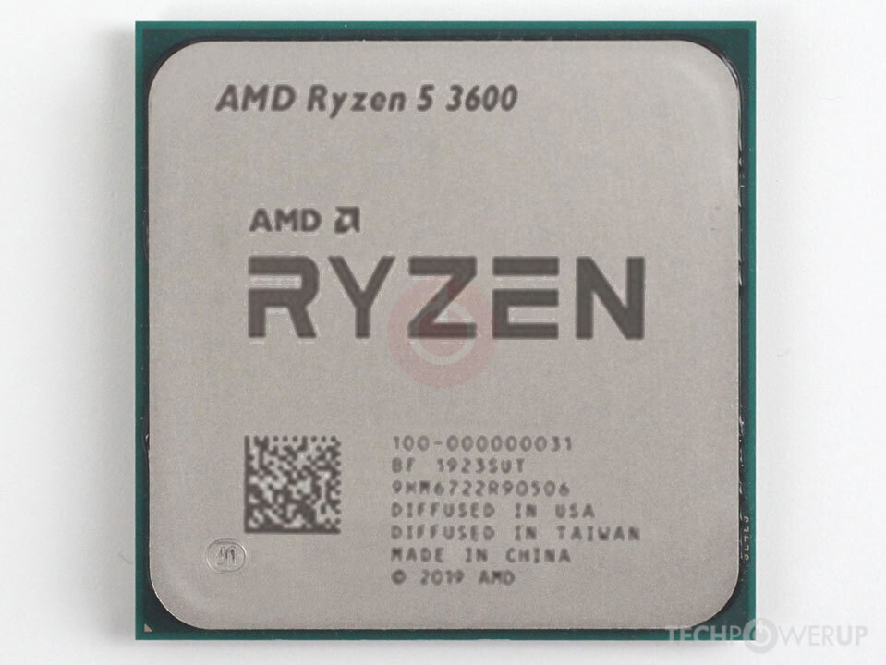,ensuring smooth operation of various applications. It is equipped with 16GB of DDR4 RAM 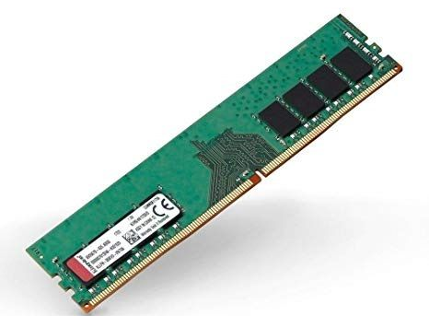 to support multitasking and handle demanding programs effectively. The storage solution consists of a 512GB NVMe SSD for the operating system and applications, 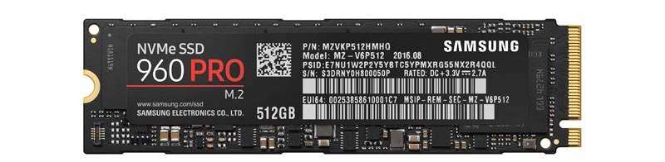 offering fast boot times and quick access to frequently used software, along with a 1TB HDD for ample data storage capacity. 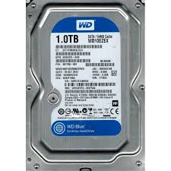
Essential peripherals include a full-size keyboard and mouse for comfortable input, along with an external hard drive for additional storage needs. The system runs on Windows 10 for a familiar user experience, supporting a range of applications.
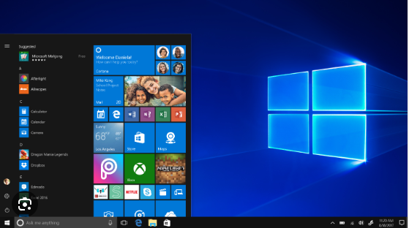
Installed software includes the Microsoft Office Suite for productivity, web browsers like Chrome and Firefox, media players such as VLC, and antivirus software for system security. Internet connectivity options include Wi-Fi 5 (802.11ac) or Wi-Fi 6 (802.11ax) for reliable wireless networking (Bedrock, 2023).

Analysis/Benchmarks:
The Intel Core i5-10400 offers a base clock speed of 2.9GHz and a boost clock speed of 4.3GHz, providing solid performance for various tasks. On the other hand, the AMD Ryzen 5 3600 features a slightly higher base clock speed of 3.6GHz and a boost clock speed of 4.2GHz, offering competitive performance. Both CPUs are capable options for a range of computing needs, with the Intel processor excelling in single-core tasks and the AMD processor delivering strong multi-core performance. Ultimately, the choice between the two will depend on specific usage requirements and budget considerations (CyberpowerPc, 2024).
NVMe SSDs offer remarkable transfer speeds, reaching up to 3500MB/s for reads and up to 3000MB/s for writes. This rapid data transfer capability greatly enhances overall system performance, enabling quicker boot times, faster application launches, and speedier file transfers compared to traditional HDDs. In contrast, HDDs exhibit slower transfer speeds, typically ranging between 100-200MBs. This speed discrepancy is due to the differing technologies: NVMe SSDs leverage flash memory for data storage, while HDDs rely on spinning disks and mechanical components, which inherently limits their speed. The superior performance of NVMe SSDs makes them ideal for demanding applications and tasks that require high-speed data processing and access.
For graphics performance, integrated graphics from Intel or AMD are sufficient for light gaming and multimedia tasks. However, for more demanding graphics needs, such as gaming at higher settings or professional multimedia work, a dedicated graphics card like the NVIDIA GeForce GTX 1660 or AMD Radeon RX 5600 XT would be recommended. These cards offer higher performance and can handle more intensive graphics processing tasks effectively, providing a smoother and more immersive experience (Studio, 2024).
Wi-Fi 5, also known as 802.11ac, offers theoretical speeds of up to 3.5Gbps, while Wi-Fi 6, or 802.11ax, can theoretically reach speeds of up to 9.6Gbps. However, these speeds are theoretical maximums and are rarely achieved in real-world scenarios. Actual speeds depend on various factors, including network congestion, distance from the router, and the capabilities of the devices involved. Wi-Fi 6 does offer significant improvements in efficiency and performance, especially in crowded environments, thanks to technologies like OFDMA and MU-MIMO. As more devices become Wi-Fi 6 compatible, the overall network experience is expected to improve, even if the maximum theoretical speeds are not always reached.
Conclusion:
This computer is designed to handle daily tasks like web browsing, email, and media consumption with ease. It features a fast NVMe SSD and generous RAM, ensuring smooth multitasking and speedy application launches. While the integrated graphics are suitable for light gaming and multimedia, a dedicated graphics card would be preferable for more demanding graphical needs. In summary, this setup strikes a good balance between performance, storage capacity, and connectivity, making it well-suited for general personal computing (Grevstad and Buzzi, 2024).

References
Bedrock, (2024) Bedrock computers. [Online]
Available at: https://bedrock-computers.co.uk/product-category/office-workstation/?gad_source=1&gclid=Cj0KCQjwq86wBhDiARIsAJhuphmhPtzpzhFZYQ5FIUbgRDJY_CmKAcJVA4Z-jbvc1tlvMx0i2icZH3oaAk9SEALw_wcB (Accessed: 21 March 2024)
CyberpowerPc, (2024) Custom Gaming PCs - Choose & Build your Own Gaming PC. [Online]
Available at: https://www.cyberpowersystem.co.uk/category/custom-pcs/?gad_source=1&gclid=Cj0KCQjwq86wBhDiARIsAJhuphl3zG-677wuXcKIbDggHevCJZMGF_rJBe4_sEpxgmoNyAG_Mnrjzo4aAllhEALw_wcB (Accessed: 20 March 2024)
Grevstad, E., and Buzzi, M. (2024) The Best Cheap Desktop PCs for 2024. [Online]
Available at: https://uk.pcmag.com/desktops/38449/the-best-budget-desktop-computers (Accessed: 24 March 2024)
Studio, (2024) PC'S, LAPTOPS & TABLETS. [Online]
Available at: https://www.studio.co.uk/shop/electricals/computers-laptops?cm_sp=CB_Electricals-_-SubCat-ComputersLaptops-_-Monitors&beginIndex=0&gad_source=1&gclid=Cj0KCQjwq86wBhDiARIsAJhuphkMINgiP_-vtuc3K9LS6XFXmjBNTsRU-0urR4hTBm0nWC-FmonhAwkaAjqNEALw_wcB (Accessed: 23 March 2024)

