Essential Skills for Study and Employment in Cyber Security

Introduction
Success in Cyber Security requires both technical expertise and transferable employability skills. While knowledge of networking, cryptography, and risk management is essential, employers increasingly prioritise communication, problem-solving, teamwork, digital literacy, and adaptability [1], [5].

Core Employability Skills in Cyber Security

1. Analytical and Critical Thinking
Cyber Security professionals must identify vulnerabilities, assess risks, and respond effectively to threats, as shown in Figure 1. Analytical thinking supports tasks such as penetration testing, threat modelling, and incident response. Research highlights problem-solving and technological competence as key future workplace skills [3]. These abilities also strengthen academic performance by improving research, lab analysis, and structured investigation.
Figure 1. Core Analytical Skills in Cyber Security

2. Communication and Teamwork
Cyber professionals often explain technical risks to non-technical stakeholders, write incident reports, and collaborate with IT and management teams, see Figure 2 for details. Effective communication and self-management significantly enhance both academic and professional success [2].
Figure 2. Communication Flow in Cyber Security Roles
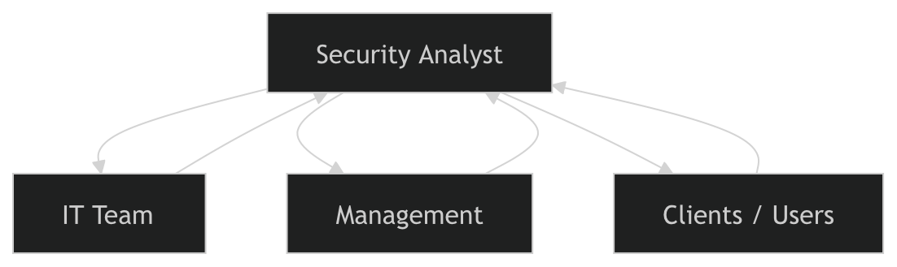

3. Digital Literacy and Adaptability
With the rapid development of artificial intelligence, cyber roles are evolving. Studies show that AI increases demand for human judgement, collaboration, and digital competence rather than replacing them [4]. The World Economic Forum identifies analytical thinking, resilience, and flexibility as critical future skills [5].
Figure 3. Future Skills for Cyber Security Professionals
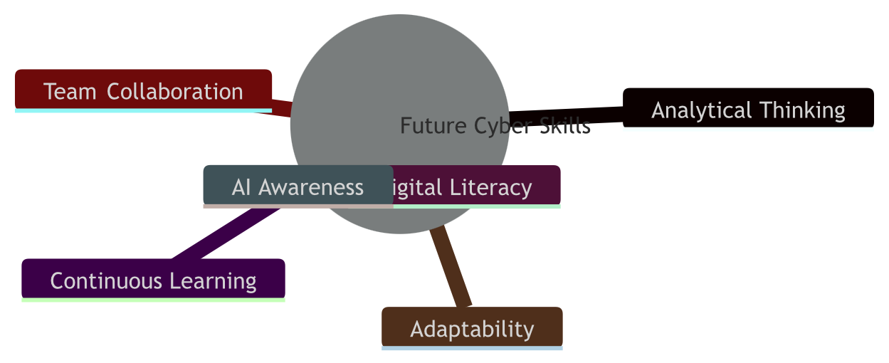

Conclusion
Developing these essential skills during university strengthens readiness for roles such as Security Analyst, Penetration Tester, or Cyber Security Consultant. By combining technical knowledge with communication, critical thinking, and adaptability, graduates become resilient professionals capable of responding to] emerging cyber threats and sustaining long-term career growth.

References (IEEE)
[1] Cambridge English, “Developing employability skills in higher education and at work,” 2018. [Online].
https://www.cambridgeenglish.org/blog/developing-employability-skills-in-higher-education-and-at-work/
[2] S. Cottrell, The Study Skills Handbook, 5th ed. London, U.K.: Palgrave Macmillan, 2019.
[3] N. Fajaryati, Budiyono, M. Akhyar, and Wiranto, “The employability skills needed to face the demands of work in the future: A systematic literature review,” Open Engineering, vol. 10, no. 1, pp. 595–603, 2020.
[4] E. Mäkelä and F. Stephany, “Complement or substitute? How AI increases the demand for human skills,” arXiv preprint, 2024.
https://arxiv.org/abs/2412.19754
[5] World Economic Forum, The Future of Jobs Report 2023. Geneva, Switzerland: World Economic Forum, 2023. [Online]
https://www.weforum.org/reports/the-future-of-jobs-report-2023/

