Report
Case Report on the Disappearance of Dr Hart


MODULE NAME: ACADEMIC SKILLS FOR THE DIGITAL ERA MODULE CODE: BMSW4013
STUDENT NAME: RAMONA ELENA MIRON
STUDENT ID:2421212
LECTURER NAME: TRISTAN HAWKINS

Table of Contents
EXECUTIVE SUMMARY 3
1. INTRODUCTION 4
3. THEORIES AND SOLUTIONS 4
3.1 Job Safety Theory 4
3.2 Utilitarianism Theory 5
6. REFERENCE LIST 7

Executive Summary
This report analyses Dr. Hart disappearance, focusing on her profession in robotics ethics and the possibility of motives associated with her disappearance. The report concludes with recommendations for further investigation that would emphasize following ethical guidelines and academic standards. The recommendations for review are related to ethical guidelines, interviewing colleagues, checking the workplace for safety, consulting with experts and developing a general ethical framework for AI research. Such procedures will help resolve problems and are such that the researcher will not feel excessively pressured or conflicted. These recommendations will also enable the development of a platform that will ensure that AI research and development are aligned with societal values and normative ethics while technical development is harmonized.

1. Introduction
This is a report on the disappearance of Dr. Diana Hart, the Novatek engineer specializing in AI and robotics. Dr. Hart is one of the major experts in AI ethics (specializing in the ethical hazards in the deployment of AI into decision-making frameworks). It backs with real life study, and credible references of the possible reasons and causes of her disappearance (Mulita et al., 2024). To make the report informative on AI ethics and the force on researchers, the assessment of ethical challenges and workplace dynamics she has undergone is used to answer potential follow up investigations that could be of utmost importance in the responsible innovation in AI research (Hosseini et al., 2023).
2. Investigation and Evidence Analysis
The disappearance of Dr. Hart was investigated on her academic work and some ethical issues she used in creating her research paper. Dr. Hart's study indicates the dangers of AI implementation in the decision-making systems, such as amplification of biases, accountabilities lost, and also misuse. Her contribution offered an approach for ethical AI implementation that relies on transparency, responsibility, and fairness (Nag, 2024). These findings indicate that pressures might have been brought to bear on Dr. Hart to pursue projects that she deemed unethical, given the general absence of an overall ethical framework for AI research. In addition, the investigation also explored the influence of workplace dynamics on the case (Nassar and Kamal, 2021). Poor safety communication and work-life stress are recognized psychosocial risk factors that may impact workplace safety and the well-being of employees. The wider implications of AI in defense were well reviewed in this investigation, where Dr. Hart's expertise proved helpful. In transforming reconnaissance to military decision making, AI plays its role profoundly in changing global security issues. In military logistics, from the ease of forecasting equipment maintenance to cutting down supply chains, the stakes are too high. This knowledge enhances an ability to understand the stresses and ethical dilemmas that might have arisen in the practice of Dr. Hart (Li, 2024)

3. Theories and Solutions

3.1 Job Safety Theory
The job safety theory emphasizes that jobs, which interact with a wide range of personal, social factors, people at work, tools, and physical environment need an interplay where safety at workplace is taken up as its overall objective to eliminate hazards through such planning, carrying out operations under control in and around their areas of responsibility. This theory states that possibly Dr. Hart's workplace had no proper safety measures or proper training, hence, a hostile environment which prompted her to leave in disappearance. The solution based on this theory is that a job safety analysis (JSA) needs to be conducted, so the hazardous area at the workplace is identified and dealt with appropriately (Hosseini et al., 2023).
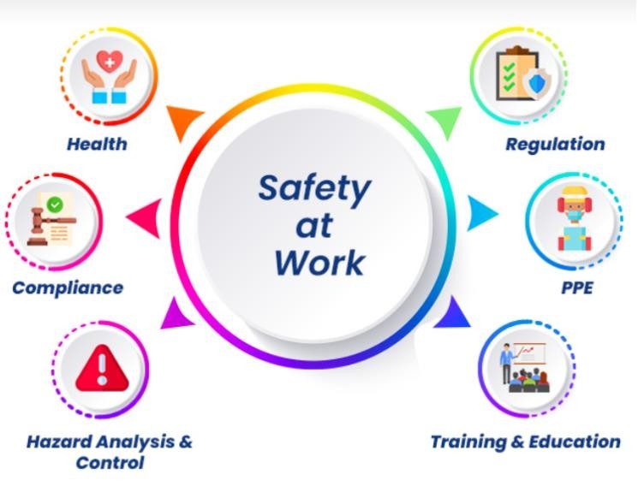
Figure 1. Job Safety Analysis

3.2 Utilitarianism Theory
Utilitarianism is a theory in ethics that postulates that a morally right action is one which maximizes happiness or well-being for the largest number of individuals. In terms of Dr. Hart's disappearance, utilitarianism could have been applied because it was in the work that she contributed towards preventing harm, especially regarding fairness while creating AI practices (Mulita et al., 2024). However, if she encountered opposition or coercion to sacrifice her ethical principles, this could have been very stressful and controversial. Solutions under utilitarianism would entail an analysis of the ethical impacts of AI projects to ensure they conform to the norms of society and ethical expectations to achieve maximum overall good (Li, 2024).
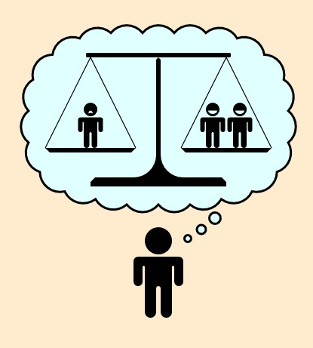
Figure 2. Utilitarianism Theory
- Conclusion
This report summarizes that the disappearance of Dr. Hart can be linked with the demands as well as moral dilemmas that she faced with her work in AI ethics. Her promotion for ethical AI standards often clashed with company goals, which may create a hostile working environment. The findings underscore the need for an inclusive ethical framework for AI research that ensures equity, accountability, and transparency.
- Recommendations
- Make a comprehensive search on the guidelines and standards applied in Dr. Hart's institution concerning ethics so that any deficit or room for improvement can be found.
- Interview Dr. Hart's colleagues to hear their thoughts regarding her working conditions and the disputes she might have encountered (Anderson and Fort, 2022).
- Assess the safety culture and communication methods at Dr. Hart's job to see if they played a role in her disappearance.
- Collaborate with specialists in AI ethics to offer context and understanding of the challenges Dr. Hart could have encountered.
- Suggest a thorough framework for AI ethics research in the future that could help prevent similar occurrences (Nag, 2024).

6. Reference List
Anderson, M.M. and Fort, K. (2022). From the ground up: developing a practical ethical methodology for integrating AI into industry. AI & Society, [online] 38(2), pp.631–645. doi:https://doi.org/10.1007/s00146-022-01531-x.
Hosseini, Z., Nyholm, S., Blanc, L., Paul and Evangelia Demerouti (2023). Assessing the artificially intelligent workplace: an ethical framework for evaluating experimental technologies in workplace settings. AI and Ethics, [online] 4(2), pp.285–297. doi:https://doi.org/10.1007/s43681-023-00265-w.
Li, Zhi (2024). Ethical Frontiers in Artificial Intelligence: Navigating the Complexities of Bias,
Privacy, and Accountability. International Journal of Engineering and Management
Research, [online] 14(3), pp.109–116. Available at:
https://www.indianjournals.com/ijor.aspx?target=ijor:ijemr&volume=14&issue=3&ar ticle=017 [Accessed 28 Jan. 2025].
Mulita, R., Nasaraia, Z., Konarivska, O., Boiko, S. and Paniuk, T., 2024. Societal Impacts And
Ethical Considerations Of AI In The Business. Business Management/Biznes Upravlenie, (4).
Nag, B. (2024). The Evolution of Ethical Standards and Guidelines in AI. Advances in computational intelligence and robotics book series, [online] pp.45–84. doi:https://doi.org/10.4018/979-8-3693-9173-0.ch003.
Nassar, A. and Kamal, M. (2021). Ethical Dilemmas in AI-Powered Decision-Making: A Deep Dive into Big Data-Driven Ethical Considerations. International Journal of Responsible Artificial Intelligence, [online] 11(8), pp.1–11. Available at:
https://neuralslate.com/index.php/Journal-of-Responsible-AI/article/view/43 [Accessed 28 Jan. 2025].

