

University of Wales Trinity Saint David
School of Engineering

Innovative Approaches (M7X01372)

George Wright
Student ID: 1804298
24th October 2019

Table of Contents
1 Introduction 1
2 Innovation Approaches 2
3 Innovation at Valero 2
3.1 Open Innovation Sources and Impact 4
3.1.1 The Unexpected 5
3.1.2 The Incongruity 7
3.1.3 Process Needs 7
3.1.4 Changes in Industry and/or Market Structure 9
3.1.5 Demographics 12
3.1.6 Changes in Perception, Mood and Meaning 12
3.1.7 New Knowledge 13
4 Change Failure and Management Models 13
4.1 McKinsey 7S Model 14
4.2 Kubler-Ross Model 14
4.3 ADKAR Model 15
4.4 Kotter’s Eight Step Model 16
4.5 Bridges Transitions Model 17
4.6 Nudge Theory Model 18
5 Conclusions 19
6 References 20

Introduction
This assignment’s main aim was to investigate the different sources of innovation open to an organisation in particular to Valero Energy in Pembroke. Specific areas of innovation explored within Valero were maintenance, operations, technical, health, environmental and safety (HES) using Drucker’s (2007) seven sources of innovation critically appraising there applicability to the industry. The different sources of innovation were further analysed on how they impacted Valero’s market position, competitive advantage, leanness and/or agility. Furthermore, the assignment addresses why 70% of change initiatives may fail with reference to possible change management models.

Innovation Approaches
There are three forms of innovation that are products, services and/or processes. Drucker (2007) describes seven sources of innovation opportunity open to an organization or industry; the first four are visibly seen within the business itself and are described as ‘symptoms’. These ‘symptoms’ are reliable signs of change needed within the organization which are unlikely to lead to a radical innovation and therefore can be carried out with minimal effort. The last three are based on changes outside the organization. The first four innovation sources seen within the organization are:
- The unexpected – unexpected success, failure or outside event
- The incongruity – what something actually is in contrast to what it should be
- Process Needs – looking at improving an existing process that may be weak or missing
- Changes in Industry and/or Market Structure – something that makes the organisation and/or industry unaware of
The final three innovation sources based on changes outside the organization are:
- Demographics – population changes
- Changes in Perception, Mood and Meaning
- New Knowledge – from science and/or other
The seven sources are sorted in descending order of reliability and predictability as seen by Drucker. Although these seven sources appear to be distinguished from one to the other Drucker states there is a substantial similarity between them. Nevertheless, each contains its own unique features which should be taken and analyzed separately with no source outweighing its importance to another. Drucker’s seven sources are acknowledged by Skibiński and Sipa (2015) as a defined list of innovation sources. It is these seven sources that demonstrate innovation as the ‘lifeblood’ of businesses in inspiring an organization to improve its market position, competitive advantage and/or leanness/agility which can be seen in Valero Pembroke.

Innovation at Valero
Valero Energy in Pembroke specialize in refining crude oil to make various products in a safe manner with the aim to minimise environmental affect. Below is a simple diagram showing the refining process of crude oil:
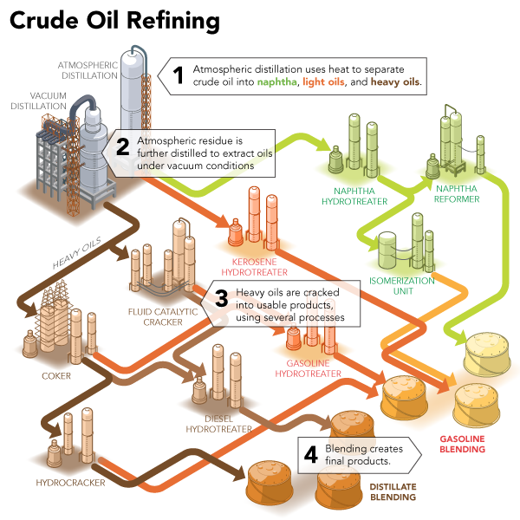
Figure 1: Products such as jet, diesel fuel, propane, fuel gas and petrol are all end products of refining crude oil (Stribling 2018).
A refinery’s typical margin for their products is revealed below in figure 2:
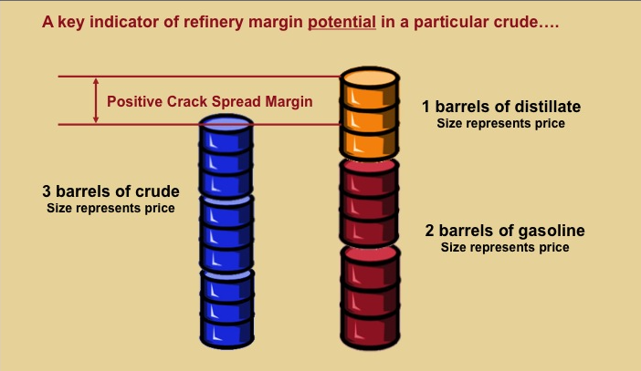
Figure 2: Refinery margin and crack spread for a typical refinery (EKT Interactive 2019).
Figure 2 demonstrates that Valero typically make small margins when selling refined crude oil to their end customers and their need to ensure they remain strong in market, with a competitive advantage over other refineries and preserve/improve leanness/agility. In order to do so Valero understand the benefits of innovation, for example increases in market shares, and without it they risk being less competitive to companies that do use it (Petrescu 2012). Hence, Valero use innovation to improve their infrastructure against a constantly changing market.

Open Innovation Sources and Impact
Drucker’s seven innovation sources can produce four different types of innovation as shown below:
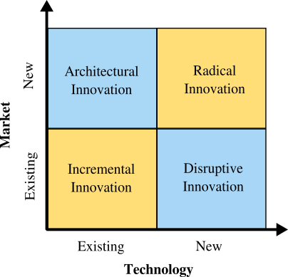
Figure 3: Types of Innovation (Lopez 2015).
Figure 3 shows that innovation can be broken down in terms of market and technology. The innovation type implemented by the organisation depends whether it uses existing or new technology in the industry along with an existing or new market in order improve its market position, competitive advantage, leanness and/or agility (Lopez 2015). For Valero their market is fairly fixed as they are unlikely to open a new market from refining crude oil that is already in the form of jet, diesel fuel, propane, fuel gas and petrol. Therefore, architectural and radical innovations are less open to Valero but incremental and disruptive innovations is widely available as an alternative.

There are benefits for both using incremental and disruptive innovation to Valero however there are limitations. Both are summarised below:-
Innovation Type | Benefits | Limitations
Incremental | - Existing organisation model reminds unchanged  - Easier to implement and sell on  - Tends to be less expensive | - Intricate to notice the change implemented to a competitive market  - Obscure what value has been added since the change  - Changes are expected to be undertaken by competitors to gain an advantage
Disruptive | - Superior to existing technology or processes in the current market  - Improves the organisation in one way or another | - Tends to be expensive  - Less features  - Difficult to use  - Less aesthetic  - Takes time to implement by which point the technology/process is superseded by new  - Improvement is not certain
Table 1: Pros and cons of Incremental and Disruptive Innovations (CEO Today 2019) (Lopez 2015).
Valero want to be the best in leading the industry and setting an example to others explaining why they highly invest in innovation. Valero already use some of the innovation sources as described in section 2 in various departments such as maintenance, operations, technical and HES with benefits tending to outweigh limitations. However, there are the other ones that could possibly be open to Valero providing benefits but will higher limitations.

The Unexpected
This source of innovation is very applicable to Valero with numerous improvements coming from success, failure and outside events. New ways of how the plant; runs; organises itself; carries out its maintenance; and other department activities can lead to unexpected innovations. Unexpected success can occur by implementing any changes in these areas but was untended to be successful. An advantage of unexpected success for Valero is exploitation in that success where other competitors maybe unaware of. However, this source could prove limiting as; some unexpected success is not always clear to exploit; it’s unlikely to occur frequently; and unlikely to have a sufficient impact on Valero’s margins.

An alternative is the unexpected is failure which can lead to innovation in maintenance, organisation structure, company policy and/or other departments resulting in untended failure. The limitations of an unexpected failure at Valero would potentially be catastrophic to workers, plant, environment and/or community if a process pipe was to lose its containment. An example of this was back in December 2018 and January 2019 when two fuel lines at Valero loss containment and spilled oil into the haven (BBC 2019); although oil spill was limited it still had an environmental impact. As a result, Natural Resource Wales issued an enforcement notice to prevent the use of two fuel lines until they were proven risk free to the environment (BBC 2019). Even though Valero’s operational capacities were unchanged by the enforcement their image within the community had a negative effect.

Nevertheless Valero used this unexpected failure to bring about incremental innovation in order to restore the two lines back into service and further guarantee such an event would not occur again. Valero implenmentated a full inspection program where all hydrocarbon lines over the jetty had scaffold access erected and pipelines; stripped of insulation; inspected; repairs that were required to be carried out; and hydro-tested. These activities had never been carried out to this extent and demonstrating an incremental innovation. After successful completion, Valero’s enforcement was uplifted and their innovation continued from this unexpected failure by modifying lines to allow future intelligent pigging to be carried out as detailed below:
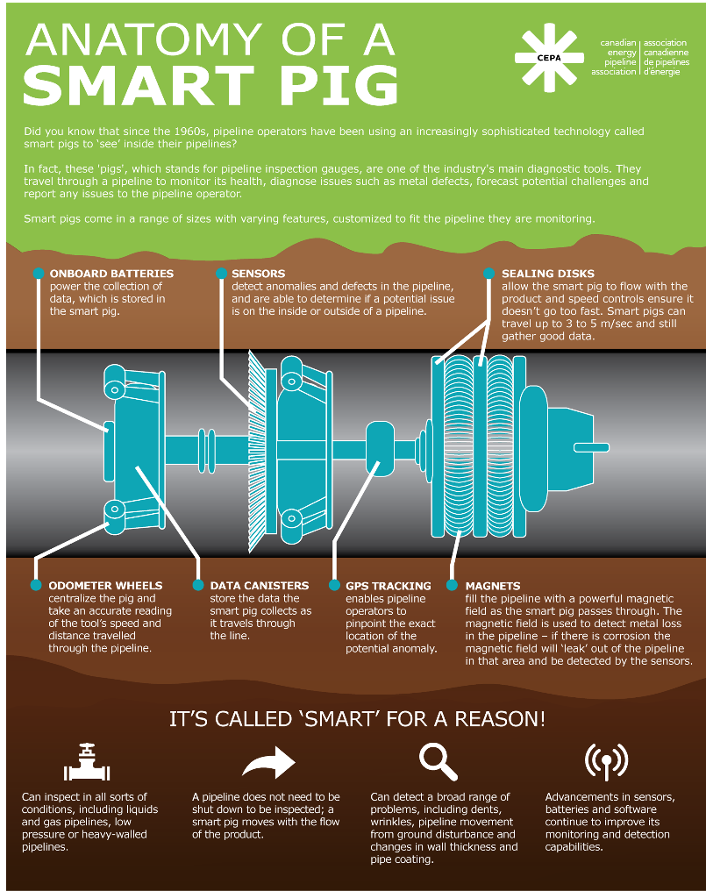
Figure 4: Intelligent Pigging Features (CEPA 2016).
By enabling the hydrocarbons lines to be intelligently pigged Valero can monitor deterioration and defects in pipes without having to shut down some lines. Hence, Valero have increased their agility in foreseeing any repairs and preventing any loss of containment in order to protect the environment.

Furthermore, Valero would have improved their leanness from this incremental innovation by using less resource in the future to carry out maintenance and inspection on these lines i.e. no requirement to carry out scaffolding or stripping insulation. Instead resource could be diverted to other areas of concern on the plant to ensure its operations continue as normal or save costs to invest in projects that result in leanness and/or agility. Overall, Valero have benefited from this unexpected failure and have done on many occasions since its construction learning from their mistakes to rectify or become a success demonstrating the importance of this source innovation.

The Incongruity
Incongruity innovation has three different types with the first being between what the organisation actually is and what it is assumed to be. An example of this is management having the misunderstanding of the organisation to what it actually is and so what it needs doing to therefore leading into unsuccessful implementations (Swaim 2011). For Valero this type of innovation is limited as a number of senior management have worked in the industry for numerous years from bottom of the hierarchy to the top in addition to being put in different roles; this is the company’s learning organisation structure. Management have comprehensive knowledge of the organisation and therefore are unlikely to implement an innovation that does not reflect the reality of the organisation.

The second type of incongruity is the difference of the customer’s values and expectations between alleged and genuine. This type is also limited to Valero as an innovation source as the products they are selling are fixed in terms of what they are supplying. However, the last type is more applicable to Valero which is the incongruity of a process (Swaim 2011); Valero have many processes in place which defer to what they actually meant to do. An example of this is Valero were able to rectify a plant process to prevent oxide build up and hot spots while also maintaining heat transfer through various equipment by introducing coatings inside pipe tubes. The innovation increased the heat efficiency and preventing equipment failure benefiting the plant by continuous operation.

Process Needs
Using process needs for innovation very much applies to Valero and is a constant focus in all departments and as a company. Valero have many processes in place where a need for innovation is required to improve reliability of equipment, maintenance, project execution and HES. An example of this is HES which is a number one priority at Valero where the need to improve the process was essential in order to accomplish zero total recordable incident rates (TRIR) and days away from work related incidents (DAFWRI). Thus, Valero changed its HES policy to incorporate the Voluntary protection program (VPP) at Pembroke in 2015. The policy is widely used in the United States particularly in the petrochemical industry and therefore is an incremental innovation.

The incremental innovation taken by the Pembroke team exceeds HES expectations with the aim of management and the workforce working as one team to achieve a safer and healthier working environment. Kretchik (2001) states by complying with VPP members tend to undergo 60%-80% reduction in injuries when compared to an organization or industry in similar size. Additionally Stanwick and Stanwick (1998) affirm by adopting VPP to a star status, the highest rating of VPP, can result in higher productivity, product quality, employee morale and financial improvements.

Valero highlighted their process needs to improve HES and by noting the benefits of VPP they implemented this. Since its start in 2015 Valero are already seeing results from adopting VPP as shown in the figure below:
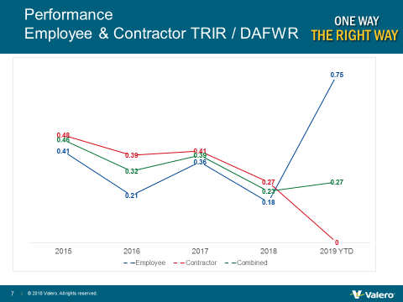
Figure 5: VPP at Valero Pembroke (Thomas 2019).
With the exception of employee TRIR/DAFWR the combined performance has decreased since 2015 a considerable improvement in HES as a result of VPP. More notably maintenance TRIR/DAFWR reached 2 years in September 2019 without a recordable injury and 2,000,000 excess in hours without a day away from work for the first time in the refinery’s history (Thomas 2019).

By reducing TRIR and DAFWR demonstrates that VPP adopted by Valero is improving its HES ensuring its employees and contractors on site are protected. This comes with advantageous benefits which would have not occurred if process needs innovation was not considered by Valero. Such benefits of VPP are:
- Reduction in absences/sick leave and as such a decrease in direct/non-direct costs from when employees/contractors take time off
- Maintaining skilled staff as there would be no requirement to backfill if an employee/contractor is off absent or sick and upholding a competitive advantage
- Market reputation which ensures customers satisfaction continues and improves resulting in increased margins in addition to improved image with the community thus strengthening Valero’s market position
- Productivity increased along with employee/contractor morale and decreasing costs
- Insurance and legal price savings Nibusinessinfo (2019).

Changes in Industry and/or Market Structure
Valero as well as the oil and gas industry face a changing and challenging market in terms of fluctuating oil prices, extensive skill range, respective statutory and international law in addition to a persistent image problem (Sertin 2019). This source of innovation is applicable and extensive to Valero where there is a need to invest in research and development to ensure their refining process, shipment of products and end product use has a lesser impact on the environment as well as increasing margins and recruitment.

An example of this innovation source is the new International Maritime Organization bunker fuel regulations that aims to reduce bunker sulphur content to 0.5wt% from 3.5wt% by 1st January 2020 (IMO 2019). The regulation aims to reduce sulphur emissions from bunkers in order to enhance air quality, increase health benefits and environment protection as described below:
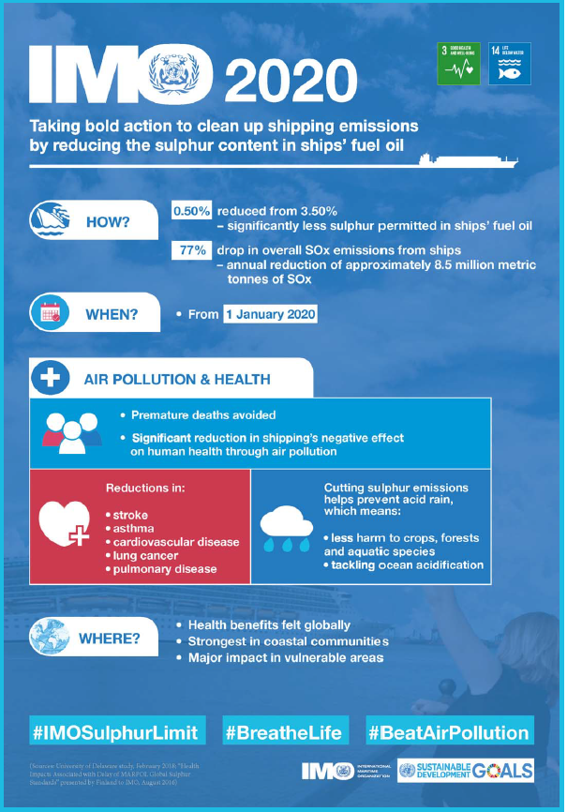
Figure 6: IMO Bunker Regulations 2020 (IMO 2019).
From this regulation Valero needed to be innovative using engineering to modify their current piping and process systems in order for their bunker fuel product to comply with the regulation. Valero are currently in the construction phase of carrying out this regulation and are on schedule to complete by January 2020. If successful Valero have improved their leanness in bunker fuel oil they sell as its impact against health and the environment will be reduced. Kalinenko and Stezhko (2019) state refiners that comply by 2020 will be able to exploit this regulation as many refiners will not be in a position to fulfil in creating low Sulphur bunker fuel and therefore allowing Valero to increase their market position and gain a competitive advantage.

Hence advantages of Valero opening to this innovation source ensures they are aware of statutory and international regulations enforcing innovative ideas and implementation to certify compliance, avoid penalties, strengthen their market position and/or competitive advantage. Additionally, by addressing such regulations improves Valero’s image with the community, customers and worldwide audiences as it shows their commitment into protecting the environment along with improving health and safety standards.

Further benefits of using this source of innovation ensures Valero are aware of the current market such as oil prices and competitors which in turn leads to innovation in order to increase profit and/or gain an advantage over their competitors. Hassani, Silva and Al Kaabi (2017) revealed that cost of refining a barrel compared to 10 years ago is an additional 60% in addition to a decrease in oil prices from its highest in 2014 by 70%. In order to adapt to this market Valero used incremental innovation to invest in a combined heat and power cogeneration unit at Pembroke as shown below:
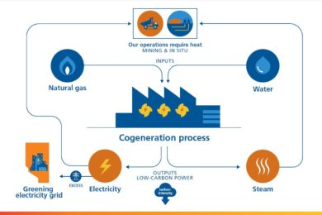
Figure 7: Cogeneration process (Gleeson 2019).
The cogeneration process will recycle the plants natural gas waste to a fired combustible turbine generator and additionally creates superheated steam in a heat recovery steam generator with both outputting electricity and steam. The 45 megawatt unit will provide power to the refinery in addition to meeting the sites steam demands. Therefore, Valero successfully used the market as an innovation source to implement the construction of this unit on site and will have a positive impact on the refinery in terms of; saving energy in particular to the national grid; reduction in the sites operational costs; upholding the refinery’s future viability; securing jobs; reduction in carbon footprint hence improvement in leanness; and gain a competitive advantage over their competitors that don’t have a similar unit.

However, there are limitations with this innovation source in particular to statutory and international regulations; without such regulations there is an argument to say whether an innovative approach would be adopted by Valero as it is now in order to protect the environment. Furthermore, if the industry and/or market stabilised it would limit Valero using this source as an innovation. Lastly, other competitive refineries are open to this innovation source so are likely adapt to the changing market as well as Valero and therefore gaining a competitive advantage is unlikely.

Demographics
Changes in population is an applicable source of innovation to Valero as this is where their end product is ultimately sold to and used by. Below shows a figure of US growth in vehicle-miles travelled and number of vehicles:
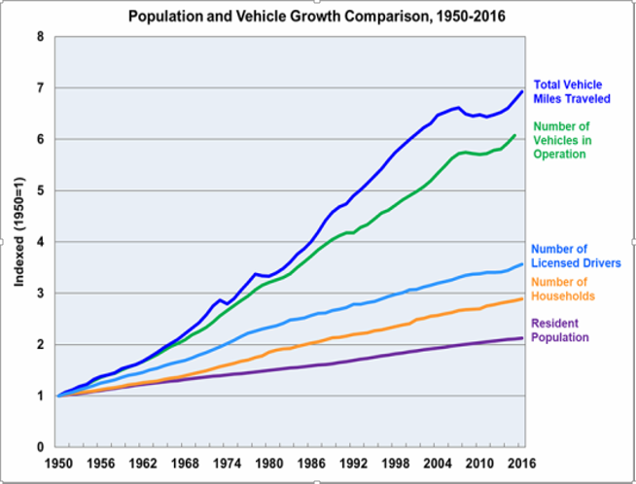
Figure 8: US Population and Vehicle Growth Comparison 1950-2016 (Green Car Congress 2019).
Valero exports their products globally in particular to the US and figure 8 demonstrates the increasing demand of gasoline and distillate usage in US vehicles. With the total vehicle miles travelled growing as well as the number of vehicles Valero’s potential capacity to export to the US is likely to rise. This could eventually lead to innovative ideas at Pembroke to optimise their export strategies and capacity at the plant to meet the increasing demand in the US. This will come with great benefits as Valero will increase their revenue along with profits and influence in the US.

Changes in Perception, Mood and Meaning
This source of innovation is applicable to Valero as they need to be aware of changes in perception, mood and meaning. An example of this, is globally the perception of fossil fuels used in vehicles is changing mainly due to its carbon emissions and contribution to global warming. This leads to global populations to invest in electric vehicles that do not have an impact on global warming. The expected increase in electric vehicles compared to normal can be seen in the figure below:
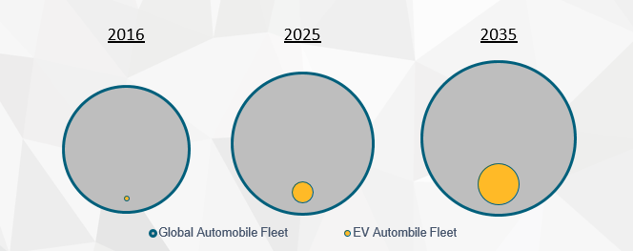
Figure 9: Global Fossil Fuel pool vs Electric (Allen 2019).
Although fossil fuel cars continue to dominate it does leave Valero a source for innovation to create cleaner fuel. Producing cleaner fuel leaves the possibility of change in fossil fuel perception and a continuation of its usage in vehicles. However, there are limitations as there is only so much you can do to prevent carbon emissions through the refining process.

New Knowledge
New knowledge is one innovation source that is not used as much as the other six sources in Valero as it tends to lead to radical changes. Although it is applicable to Valero in researching new ways of reducing its products impact against the environment therefore improving leanness it does come with limitations. Innovating from new knowledge can be time consuming and costly (Martina 2018) in which is likely to impact Valero’s market position; as discussed previously fine margins are made after refining crude oil and hence any innovations implemented through this source could be damaging to Valero’s market position and competitive advantage.

Change Failure and Management Models
Implementing innovation can lead to 70% failure in change initiatives for numerous reasons such as:
- Acknowledging complacency and believing these changes will be followed freely
- Management resistance
- Inadequate or no resources assigned to make the change happen
- Inadequate or no communication and involvement to/from employees
- Inadequate or no honesty and/or commitment from employees
- Focussed on other matters within the organisation
- Inadequate or no incentive and/or delivery to employees for complying with the change (Thorn 2019) (Ewenstein Smith and Sologar 2019)
Understanding the reasons why 70% of change initiatives may fail can aid to see if the correct change management model is being used and weighing it’s applicability to the organisation analysing the advantages against its disadvantages.

McKinsey 7S Model
McKinsey 7S is a change management model that states 7 internal features must be aligned in order to achieve success. The 7 features can be seen below:
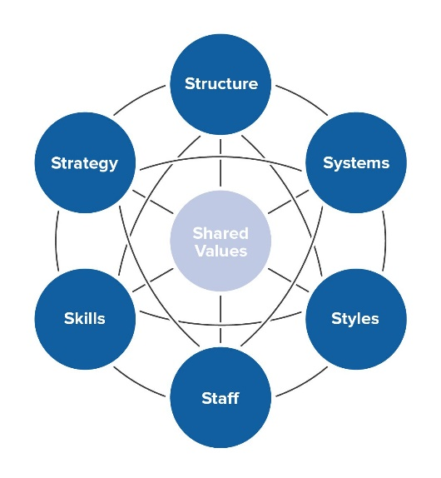
Figure 10: McKinsey 7S Change Model (Mind Tools 2019).
The noticeable point of the model highlights that all features are linked to one another and a change in one requires a change in the rest in order to be a success. The model has key benefits in terms of; revealing what an organisation is and how it operates; joins the components of emotion and practicality together when implementing change; and appreciates that the 7 features are equal to one another in importance so neither one is neglected or forgotten. However, there are limitations to this model as; if one feature fails all others do as they are linked together; it is more difficult to use than other models; and it is proven to cause more failure when adopted by organisations (Thorn 2019).

Kubler-Ross Model
Another change management model is the Kubler-Ross model that focusses on five stages identifying the reactions from people at various times due to change as shown below:
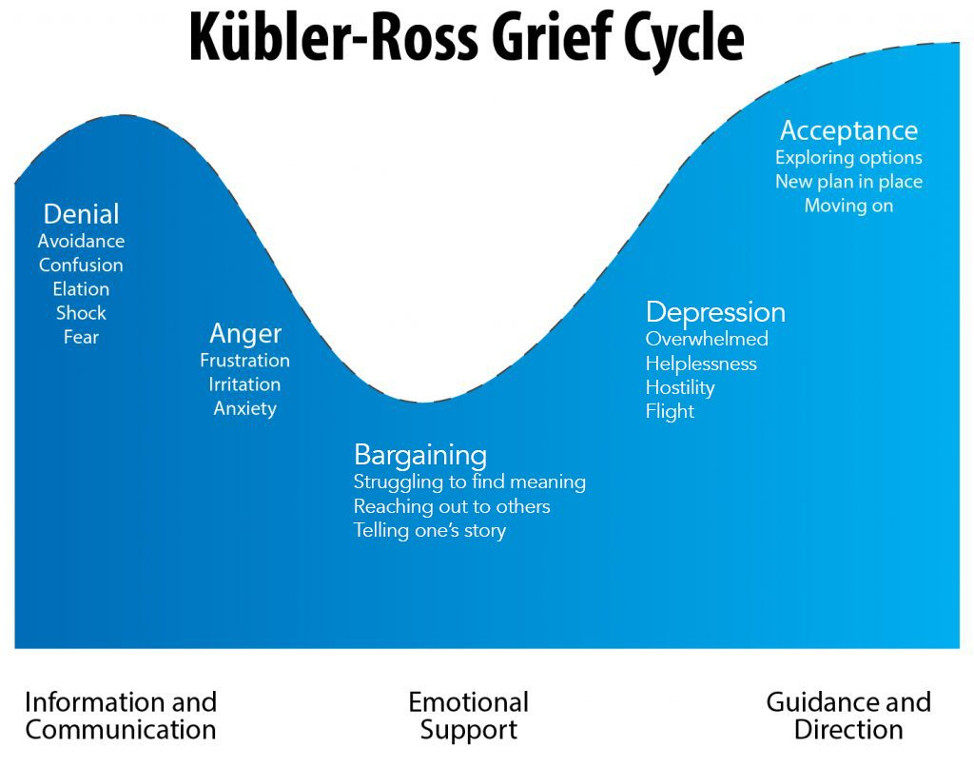
Figure 11: Kubler-Ross Model (Gregory 2019).
The model aims to understand the five areas of emotion from change and to aid people through communication and leadership to move successfully forward (Cleverism 2015). Key advantages of using this model include recognising the emotional response to change in order to plan against resistance, low morale and/or productivity. Conversely, the model has its disadvantages; not all changes result in resistance; and it’s simplified model which focuses on personnel rather than the organisation as a whole (Lock 2019).

ADKAR Model
An alternative change management model is the ADKAR that looks at five stages of change as detailed below:
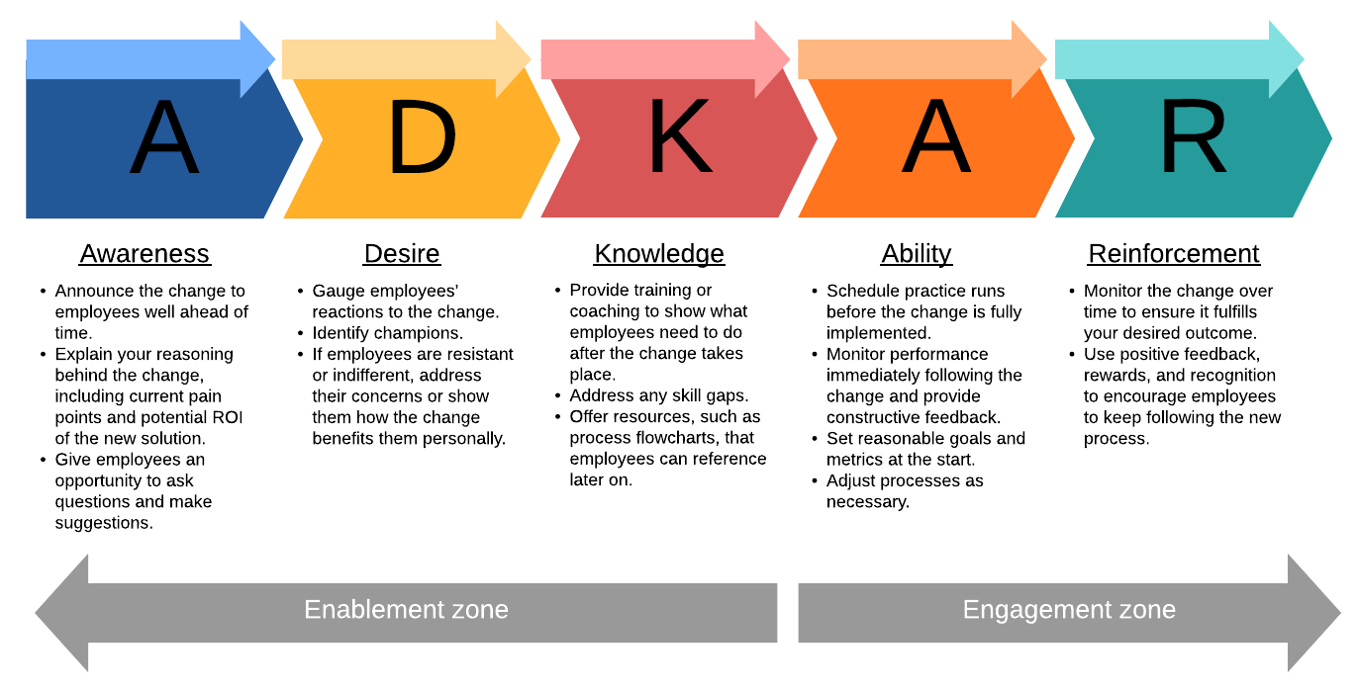
Figure 12: ADKAR Model (Lucidchart 2019).
This management model is based on making changes from the bottom up and has many benefits such as; being practical rather than theoretical; recognises an individual’s opinion; uses incremental changes rather than radical; gives recognition; proven to be popular and successful with many organisations; and comes with a lot of training. Disadvantages of the model is that it; doesn’t obtain great knowledge to change management; affected by possible restriction on time and resources; affected by possible resistance to change; affected by lack of training and skills; and doesn’t produce difficult changes in management and/or radical ones (Smith 2019) (Thorn 2019).

Kotter’s Eight Step Model
Kotter’s eight steps is another change management model using eight stages to implement change as shown below:
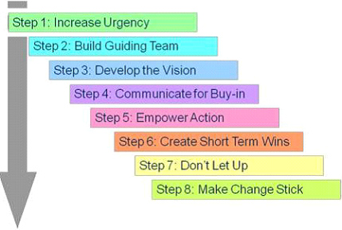
Figure 13: Kotter’s Eight Steps Model (Juneja 2009).
Kotter’s eight step model was created through key features when researching 100 organisations that were undergoing a change. The model pro’s include that; it’s an easy process to go through with defined descriptions and guidance in order to carry out a change; demonstrates employees key participation and responsibility for achievement; and focuses on planning and accepting the change proposed. In contrast, the model has its flaws in; if one step id missed the change is likely to cause other problems; timescale is long; it’s a top-down model resulting in inadequate co-creation and/or participation affecting morale (Juneja 2009).

Bridges Transitions Model
An additional change management model is Bridge’s Transitions Model as detailed below:
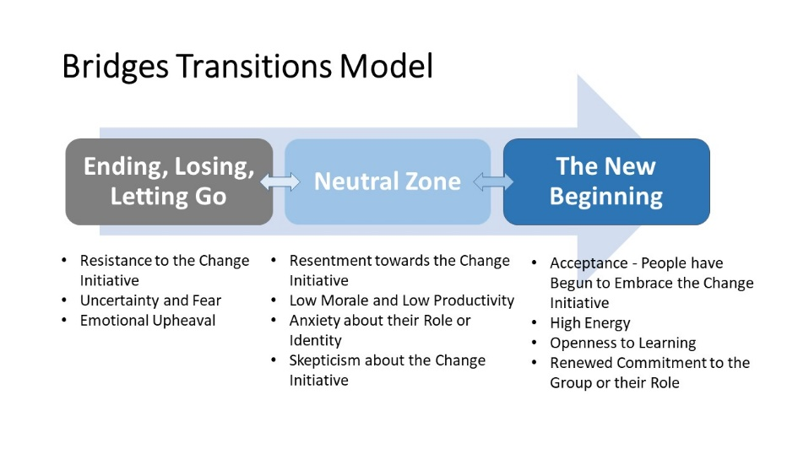
Figure 14: Bridges Transitions Model (Hughes 2018).
The model is based on three defined stages to which people eventually buy into the new change and what it brings. The model has its advantages in that it can used to appreciate, explain and help people’s emotions during the process of change in addition to considering psychological effect. Furthermore, the model builds a relationship between the hierarchy and employees in addition to showing care for the team thus sustaining morale and productivity. Although the model is beneficial into applying change it cannot be used by itself as a change management model and doesn’t contain a set process (Thorn 2019).

Nudge Theory Model
Lastly, the Nudge Theory model is a change management model that uses nudges to encourage change rather than enforcing it. The model is stepped out as below:
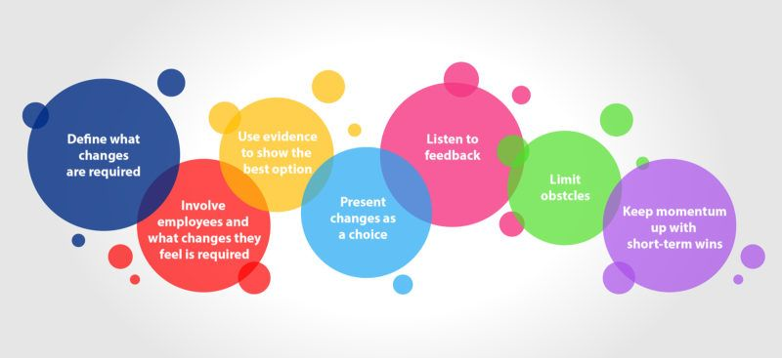
Figure 15: Nudge Theory Model (Kulkarni 2019).
The model presents numerous pros such that; it considers employees point of view in what change they want; highlights to the employees the need and significance of the change; allows the employees to select a choice for change and give a feeling of ownership; and lead to greater morale and/or productivity. Conversely, the model presents cons in that it doesn’t offer a way of analysing, managing, organising and preserving change leaving another model required to be used. Lastly, the model is time consuming and requires effort in order to create appealing changes to employees (Thorn 2019).

Conclusions
A number of innovation sources were investigated that were open to Valero Energy in Pembroke analysing their applicability to the organisation using Drucker’s seven sources of innovation. It was concluded that the internal four sources of Drucker’s innovation are currently more used at Valero than the three external sources as demonstrated by various innovation examples discussed. In addition, these four sources tended to have a more of a beneficial impact on market position, competitive advantage and on leanness and/or agility for the organisation. Furthermore, a discussion on why 70% of change initiatives result failure was taken analysing various change management models to address the problem. Using two or more change management models may prove to be a success in change initiatives for example the ADKAR, due to its proven record, and bridges transition model to consider employee emotions.

References
Allen R (2019). Maintenance Business Update October 2019.
BBC News 2001. Esso fined over fatal explosion. [online] p.1. Available at: http://news.bbc.co.uk/1/hi/world/asia-pacific/1464123.stm [Accessed 25 Oct. 2019].
BBC (2019). Seabed to be assessed after oil spill. [online] BBC News. Available at: https://www.bbc.co.uk/news/uk-wales-46824967 [Accessed 29 Oct. 2019].
CEO Today (2019). Effective Innovation Management: Disruptive vs Incremental Innovation. [online] CEO Today. Available at: https://www.ceotodaymagazine.com/2019/07/effective-innovation-management-disruptive-vs-incremental-innovation/ [Accessed 1 Nov. 2019].
Nibusinessinfo (2019). Business benefits of good health and safety at work. [online] Available at: https://www.nibusinessinfo.co.uk/content/business-benefits-good-health-and-safety-work [Accessed 30 Oct. 2019].
Canadian Energy Pipeline Association (2016). Inside the smart pig – detecting potential pipeline problems before they happen (part 1). [image] Available at: https://www.aboutpipelines.com/en/blog/inside-the-smart-pig-detecting-potential-pipeline-problems-before-they-happen-part-1/ [Accessed 29 Oct. 2019].
Cleverism (2019). Understanding the Kubler-Ross Change Curve. [online] Cleverism. Available at: https://www.cleverism.com/understanding-kubler-ross-change-curve/ [Accessed 2 Nov. 2019].
Drucker P (2007). Innovation and Entrepreneurship: Practice and Principles. Oxford, England: Routledge Elsevier/Butterworth-Heinemann, pp.19-121.
EKT Interactive (2019). Oil 101 – A Free Introduction to Oil and Gas. [image] Available at: https://www.ektinteractive.com/refining/refining-business-drivers/ [Accessed 4 Nov. 2019].
Ewenstein B, Smith W and Sologar A. (2019). Changing change management. [online] McKinsey & Company. Available at: https://www.mckinsey.com/featured-insights/leadership/changing-change-management [Accessed 2 Nov. 2019].
Gleeson D (2019). Suncor to cut GHG emissions by 25% with natural gas project. [image] Available at: https://im-mining.com/2019/09/10/suncor-to-cut-ghg-emissions-by-25-with-natural-gas-project/ [Accessed 1 Nov. 2019].
Green Car Congress (2019). DOE: Growth in US vehicle-miles of travel and number of vehicles outpaces population growth. [image] Available at: https://www.greencarcongress.com/2019/05/20190529-fotw.html [Accessed 1 Nov. 2019].
Gregory C. (2019). The Five Stages of Grief. [image] Available at: https://www.psycom.net/depression.central.grief.html [Accessed 2 Nov. 2019].
Hassani H, Silva E and Al Kaabi A (2017). The role of innovation and technology in sustaining the petroleum and petrochemical industry. Technological Forecasting and Social Change, 119, pp.1-17.
Hughes C. (2018). Leading and Communicating Change in Organizations. [image] Available at: https://healthinclusion.com/back-up-leading-and-communicating-change/ [Accessed 2 Nov. 2019].
IMO (2019). Sulphur 2020 – cutting Sulphur oxide emissions. [online] Available at: http://www.imo.org/en/MediaCentre/HotTopics/Pages/Sulphur-2020.aspx [Accessed 25 Oct. 2019].
Juneja P (2019). Kotter's 8 step Model of Change. [online] Managementstudyguide.com. Available at: https://www.managementstudyguide.com/kotters-8-step-model-of-change.htm [Accessed 2 Nov. 2019].
Kalinenko E and Stezhko K (2019). Key trends and innovations in refining and petrochemicals industry. [online] Refining & Petrochemicals Middle East. A
vailable at: https://www.refiningandpetrochemicalsme.com/petrochemicals/25562-key-trends-and-innovations-in-refining-and-petrochemicals-industry [Accessed 1 Nov. 2019].
Kretchik J. (2001). OSHA’s voluntary protection program. Chemical Health and Safety, 8(6), p.30.
Kulkarni A (2019). Leveraging Immersive Technology To Drive Behavioral Change. [image] Available at: https://elearningindustry.com/immersive-technology-drive-behavioral-change-leveraging [Accessed 2 Nov. 2019].
Lock D (2019). Kubler-Ross Change Curve. [online] Daniel Lock's blog. Available at: https://daniellock.com/kubler-ross-change-curve/ [Accessed 2 Nov. 2019].
Lopez J (2015). Types of Innovation. [image] Available at: https://techblog.constantcontact.com/software-development/types-of-innovation/ [Accessed 4 Nov. 2019].
Lucidchart (2019). Using the ADKAR Model for Change Management. [image] Available at: https://www.lucidchart.com/blog/using-the-adkar-model-for-change-management [Accessed 2 Nov. 2019].
Martina A (2018). 7 Lessons From “Innovation and Entrepreneurship” By Peter F. Drucker. [online] Medium. Available at: https://medium.com/@antoniomartina/7-lessons-from-innovation-and-entrepreneurship-by-peter-f-drucker-d7953127b3b5 [Accessed 1 Nov. 2019].
Mind Tools (2019). McKinsey 7-S Framework. [image] Available at: https://www.mindtools.com/pages/article/newSTR_91.htm [Accessed 2 Nov. 2019].
Petrescu I (2012). Analysis of types of innovation in organizations. Annals of the Academy of Romanian Scientists – Series on Engineering Sciences, 4(1), pp.115-122.
Sertin C (2019). Comment: The oil & gas industry is not dying, it is transforming. [online] Oil & Gas Middle East. Available at: https://www.oilandgasmiddleeast.com/drilling-production/34535-comment-the-oil-gas-industry-is-not-dying-it-is-transforming [Accessed 25 Oct. 2019].
Skibiński A and Sipa M (2015). Sources of Innovation of Small Businesses: Polish Perspective. Procedia Economics and Finance, 27, pp.429-437.
Smith C. (2019). The ADKAR Model of Change Management: Pros and Cons. [online] Change! Change Management News & Tips. Available at: https://change.walkme.com/adkar-model [Accessed 2 Nov. 2019].
Stanwick P and Stanwick S (1998). Using OSHA's Voluntary Protection Program to improve financial performance. Journal of Corporate Accounting & Finance, 10(1), pp.83-89.
Stribling R 2018. Chemistry 1010-013. [online] Richard Stribling's Eportfolio. Available at: https://richardstribling.weebly.com/chemistry-1010-013.html [Accessed 24th Oct. 2019].
Swaim R (2011). Failure and the Seven Sources of Innovation. [online] Process Excellence Network. Available at: https://www.processexcellencenetwork.com/innovation/columns/failure-and-the-seven-sources-of-innovation [Accessed 1 Nov. 2019].
Thomas A. (2019). Valero Protection Program 2019.
Thorn A (2019). Models of Change Management.

