SOFTWARE DEVELOPMENT

Executive Summary
The study mainly shed light on the OOPs concepts. Here, several programs have been provided for demonstrating the basic features of OOPs concepts. Various programming languages have been used here for demonstrating the programs. For the development of Glazier App, C# has been used. Along with that, the study also provided a flowchart for showing the calculation of grade in the universities. Here, the concepts of loops, methods as well as functions has also been elaborated.

Table of Contents
Section 1 4
Introduction 4
Part A 4
1. Explain the difference between setting a variable to a constant number and using the keyword CONST to define a constant in c# 4
2. Explain data types and mention why these are necessary? With the use of suitable examples, discuss how to convert from one type to another (include both implicit and explicit type conversion) 6
3. Explain the different types of control structures in programming. With reference to repetition, compare and contrast the different types of loops in programming 8
PART B (INTERPRETATION) 8
PART C (IMPLEMENTATION) 11
Exercise 1 11
Exercise 2 13
Exercise 3 14
Conclusion 17

Section 1

Introduction
The C programming can be subjected to different operations and those simple operations can be subjected to the development of complex operations of mathematics or several other aspects that have been discussed and implied in the assignment. The data types and the functions are assessed in the context.

Part A

1. Explain the difference between setting a variable to a constant number and using the keyword CONST to define a constant in c#
There is a major difference between setting a variable to a constant number and using the keyword ‘const’ to define a constant. In the prior, the constant number is subjected to the variable that acquires different values when applied to the program and hence, the value assigned to the variable can be changed or modified in the program (Bau et al. 2017, p. 80). The value assigned to a constant variable cannot be changed and the value will be the same in the whole program. The keyword ‘const’ is used to create constant fields and setting the constant number to a variable. The other aspect refers to the random variables that are subjected to a development of changeable random values.
In the time of compilation, the variable created with the ‘const’ keyword remains the same and there is no garbage value assigned to it if no value is given to the variable. It always remains the same. In the variable without the ‘const’ command, the variable is subjected to changing values according to the program while compiling it (Preidel et al. 2017, p. 114). The constant values are unchanged integers and the common integers can be replaced by assigning a new value or an operation subjected to the program. The constant integers can be implied in the program by putting a specific value and cannot be performed with a static modifier. On the other hand, static modifiers can be changed with the random variable.

Example
Random Variable
using System;
class Random
{
public int var1;
public int var2;
public Random (int j, int k)
{
var1 = j ;
var2 = k;
Console.Writeline (“Display var1 (0)”+”var2 (1)”, var1, var2);
}
public static void main ()
{
Random obj = new Random (50, 75)
}
}
Output
Display var1 50 var2 75
Comment
The values are sent to the function and assigned to the variable in the runtime.
Constant Variable
using System;
class Constant
{
public const int C = 10;
public static void main ()
{
Console.Writeline (“Display var1 (0)” var1)
}
}
Output
Display var1 10
Comment
The display depicted that the value is directly assigned to the constant and it cannot be assigned in the runtime.

2. Explain data types and mention why these are necessary? With the use of suitable examples, discuss how to convert from one type to another (include both implicit and explicit type conversion)
There are primarily three data types in the C programming and those are fundamental data types, derived data types, and user-defined data types. These three data types are further divided in different data types related to the differences in the data. The fundamental data have three types: integer, floating, and character type of the data. The derived data types are of three types that are function, arrays, and pointer. The user-defined data types are structure and union.

Figure 1: Data Types
(Source: Aparicio et al. 2018, p. 142)
The necessity of the different types of data is that there are several types of numerical and non-numerical data present in the program that are required to be processed in different aspects. The integers denote the complete numbers or a whole number like 50, 100. Floats are numbers with points like 10.65, 5.97. The character data types are A, a, B, b, etc. Hence, different types of data denote different types of the programming (Song et al. 2018, p. 1590). Functions are data types that are used for performing different operations on the numbers. Array is the series of data that can be integer or character to form numbers and words. Structure and Union are used to form a major database by combining arrays and strings and several other types of the data.

Example for Implicit Conversion
Explicit Conversion of the data refers to the enforced transformation of data from one data type to another.
int main()
{
float p = 52.64
int q = (int)p +5
ptintf (“value of q is = %d”, q)
}
Output
value of q is = 57
Comment
The p is a float data type that is implicitly transformed to integer to adjust the value.
Example for Explicit Conversion
Implicit Conversion of the data refers to the automatic transformation of data from one data type to another.
int main()
{
float p = 52.64
int q = p +5
ptintf (“value of q is = %d”, q)
}
Output
value of q is = 57
Comment
The p is a float data type that is explicitly transformed to integer to adjust the value.

3. Explain the different types of control structures in programming. With reference to repetition, compare and contrast the different types of loops in programming
There are several programming structures in the c language and there are operations that are performed in the context of the programming. The repetition operations like do while, while and for loop that can be used for repeating the same operation. The comparison operation can be done as an if-else statement (Braccia et al. 2017, p. 112214). This is also a type of loop when the if-else-if formation is used. The do while and for loops are effective also with the conditioning statements. There are selection and jump statements like break, return, and continue that are subjected to the programming. The functions can be used as a tool with the combinations of the function and several operations can be performed using the different types of loop of the programming. Hence, these are effective in the formation of control structure to the programming.

PART B (INTERPRETATION)
Code for Glazier application
using System;
namespace Glazier_App
{
class Program
{
static void Main(string[] args)
{
double width, height, woodLength, glassArea;
const double MAX_WIDTH = 5.0;
const double MIN_WIDTH = 0.5;
const double MAX_HEIGHT = 3.0;
const double MIN_HEIGHT = 0.75;
string widthString, heightString;
do
{
Console.Write("Give the width of the window between " + MIN_WIDTH + " and " + MAX_WIDTH + " : ");
widthString = Console.ReadLine();
width = double.Parse(widthString);
} while (width < MIN_WIDTH || width > MAX_WIDTH);
do
{
Console.Write("Give the height of the window between " + MIN_HEIGHT + " and " + MAX_HEIGHT + " : ");
heightString = Console.ReadLine();
height = double.Parse(heightString);
} while (height < MIN_HEIGHT || height > MAX_HEIGHT);
woodLength = 2 * (width + height) * 3.25;
glassArea = 2 * (width * height);
Console.WriteLine("The leng of the wood is " + woodLength + " feet");
Console.WriteLine("The area of the glass is " + glassArea + " Square metres");
}
}
}
Working of Glazier Application
The given below screenshot shows the program for Glazier application. This application has been designed for the glass industry that assists the workers in recording the glass measurements, the choice for hardware and detailed information of the site straight into their device. In order to run the program for Glazier application, the source code has been copied and pasted in the online C# compiler. Then, on clicking on the run option, the program asks for providing the value of width and height for the window. On giving the value, the length of wood and area of the glass gets calculated.
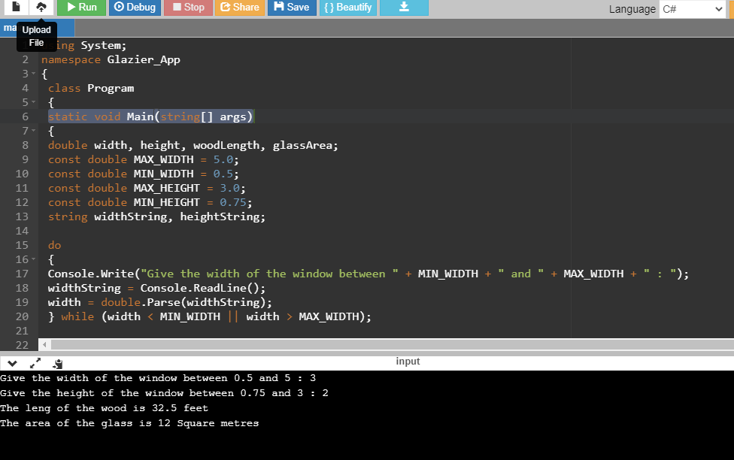
Figure 2: Executing the program for Glazier App
Explanation of entire process undertaken in the app
From the source code, it can be observed that the program starts by typing the command using System. This command here allows the user for typing the name of methods with respect to the members of System. Then, the namespace is used for organizing too many classes that can make it easier for handling the application. So here, Glazier_App is the namespace. The next line static void main is the crucial part as it is considered to be the entry point from where the execution process gets started. This must be kept as static as it is method of class level. Each of the variable required for this application is having datatype as double and for each of them, the value has been set. Then, comes the calculation part for the application. Do-while has been used here for double parsing. From this, it is further found that the length of the wood is 2* (width+height) *3.25 and the area of glass is calculated as 2* (width* height).

PART C (IMPLEMENTATION)

Exercise 1
Calculate the average marks for students
Source Code
#include<bits/stdc++.h>
using namespace std;

// Function to find the
// list of students having maximum average score
// Driver code
void getStudentsList(string file[],int n)
{
// Variables to store average score of a student
// and maximum average score
int avgScore;
int maxAvgScore = INT_MIN;

// List to store names of students
// having maximum average score
vector<string> names;

// Traversing the file data
for (int j = 0; j < n; j += 4) {

// finding average score of a student
avgScore = (stoi(file[j + 1]) +
stoi(file[j + 2]) +
stoi(file[j + 3])) / 3;

if (avgScore>maxAvgScore) {
maxAvgScore = avgScore;

// Clear the list and add name of student
// having current maximum average score in the list
names.clear();
names.push_back(file[j]);
}

else if (avgScore == maxAvgScore)
names.push_back(file[j]);
}

// Printing the maximum average score and names
// of students having this maximum average score
// as per the order in the file.
for (int j = 0; j <names.size(); j++) {
cout<<names[j] + " ";
}

cout<<maxAvgScore;
}

// Driver code
int main()
{
string file[] = { "Mirza", "60", "50",
"10", "Rico", "100", "70", "20" };

// Number of elements in string array
int n= sizeof(file)/sizeof(file[0]);

getStudentsList(file,n);
}

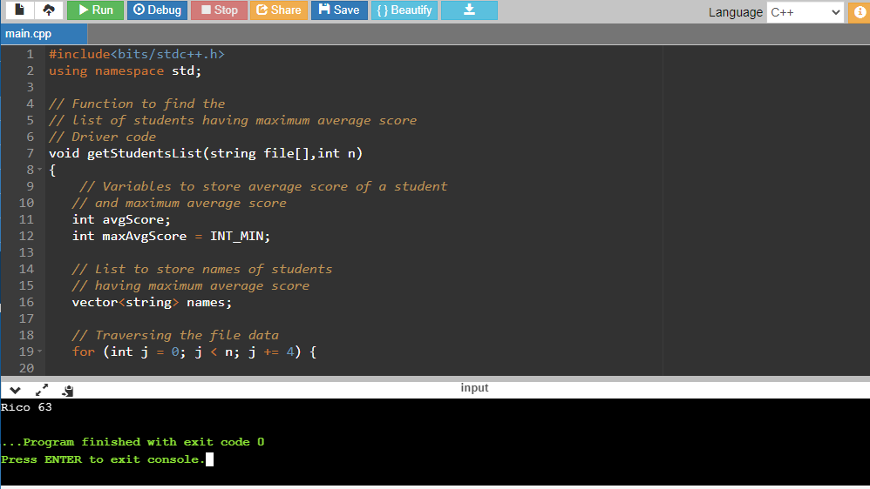
Figure 3: Calculating the average marks for Student
The above screenshot shows the calculation of average marks for two students named as Mirza and Rico. Here. Computer Architecture has been chosen as the subject module.

Exercise 2
Program for calculating the area of the shaded region in circle
from math import pi
r = float(input ("Provide the radius of Circle : "))
print ("The area of the circle with radius " + str(r) + " is: " + str(pi * r**2))

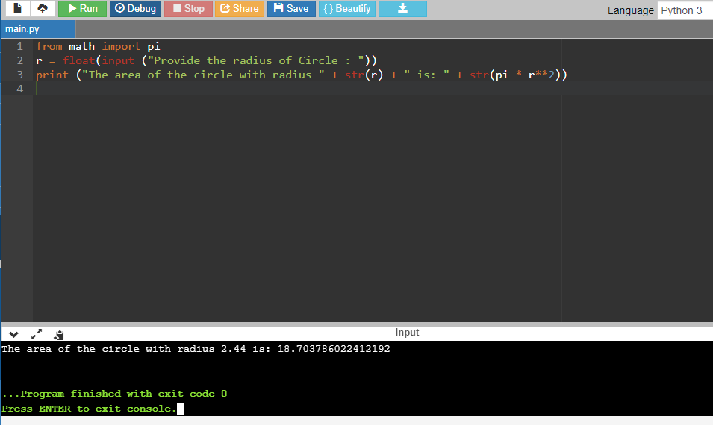
Figure 4: Calculating the shaded area
The given program asks the user to enter the value of the radius at the beginning. After giving the value, the area of circle is calculated. From the screenshot, it can be observed that the area of the circle is 18.70.

Exercise 3
Task 1
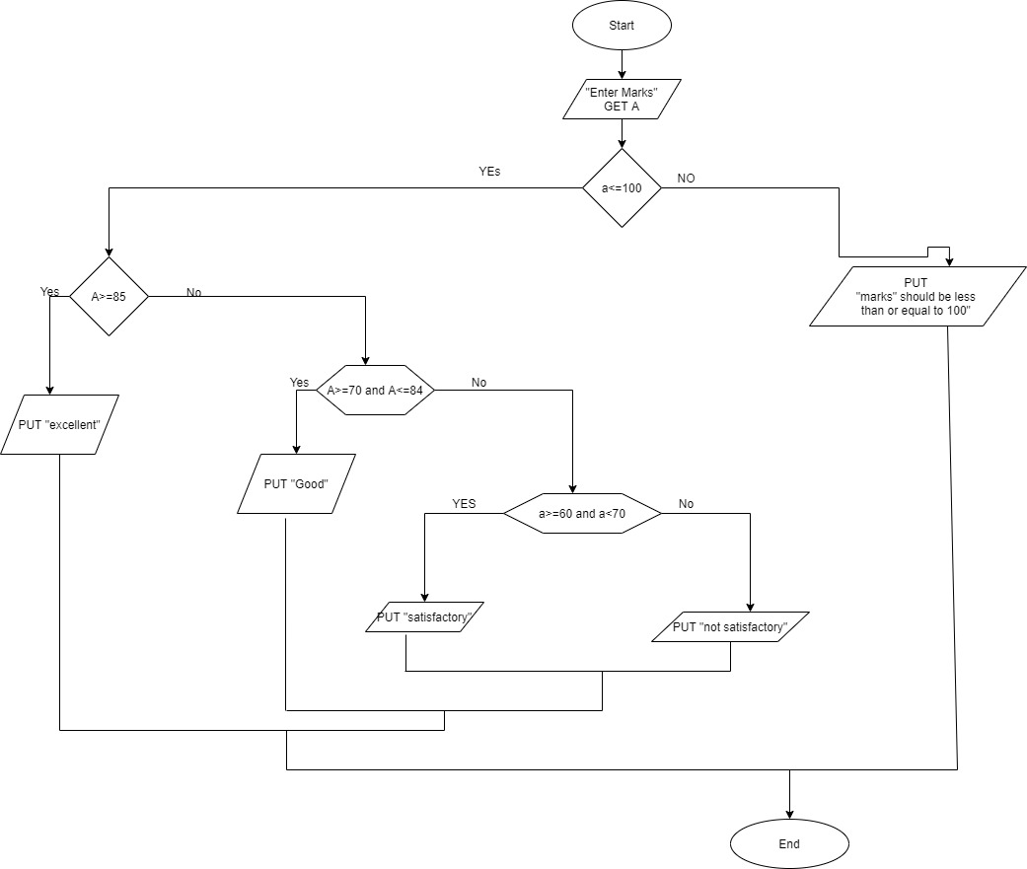
Figure 5: Flowchart for Student’s Marks
From the above flowchart, it can be observed that the basis of this drawing is Name, Marks with respect to the course and Marks obtained in an exam.
Task 2
On feeding the relevant data, marks can be calculated and hence it is highlighted in the output section specifying the information about the student who scored poor marks or got failed in the examination.
Task 3
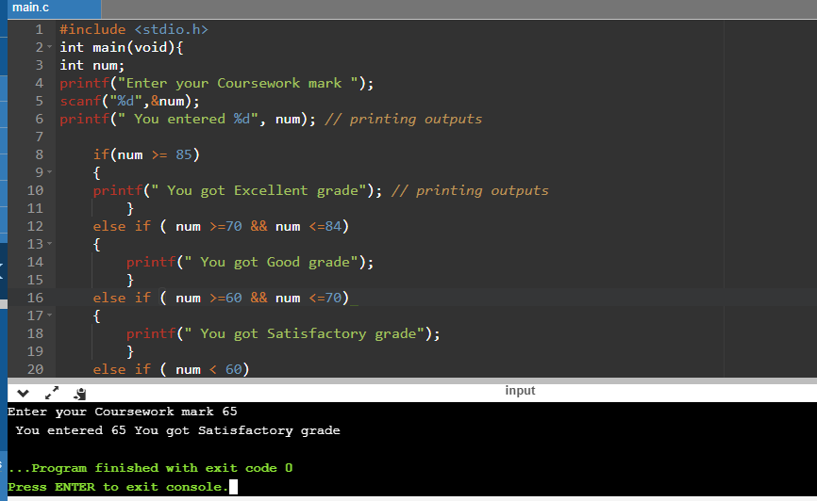
Figure 6: Displaying the result
From the above program, it can be observed that certain parameters have been set for calculating the grades of the student. Above 85, the score is judged as Excellent, score lying between 70 to 84 is said to be good and marks in the range 60 to 70 is referred to as satisfactory. Below 60, the student is declared as fail.
Task 4
The above program is mainly implemented on C. Prior to programming, a flowchart has been created here by the researcher that has helped in learning the approach for writing the code. Here, if-else condition has been applied. This has helped in getting the output between the range of two numbers. From the above section, it can be observed that certain range has been set like above 85, the result is declared as Excellent if the score is lying between 84 to 70, then it is considered to be the good score if it is between 70 to 60, then considered to be satisfactory, and if the score is below 60, then the student fails in the entire subject or in one subject.

Conclusion
Conclusively, this is evident from the assignment that the c programming can be subjected to the development of different data types and functions that have been described in the context suitable examples. Different coding and operations have been assessed in the context of the programming. Different problems have been solved with the help of C programming in the assignment.

References
Bau, D., Gray, J., Kelleher, C., Sheldon, J. and Turbak, F., 2017. Learnable programming: blocks and beyond. Communications of the ACM, 60(6), pp.72-80.
Preidel, C., Daum, S. and Borrmann, A., 2017. Data retrieval from building information models based on visual programming. Visualization in Engineering, 5(1), pp.1-14.
Aparicio, J.T., Aparicio, M. and Costa, C.J., 2018. A virtual robot solution to support programming. A virtual robot solution to support programming, pp.139-142.
Song, D., Yang, J., Fan, X., Liu, Y., Liu, A., Chen, G. and Joo, Y.H., 2018. Maximum power extraction for wind turbines through a novel yaw control solution using predicted wind directions. Energy conversion and management, 157, pp.587-599.
Braccia, L., Marchetti, P.A., Luppi, P. and Zumoffen, D., 2017. Multivariable control structure design based on mixed-integer quadratic programming. Industrial & Engineering Chemistry Research, 56(39), pp.11228-11244.

