
Course: Doctor of Business Administration (DBA)
Module: Applied Qualitative Business Research (BMDB7002)
Assignment 1
Blog 1
1.0 Introduction
This blog evaluates the strengths and weaknesses of qualitative research approach over other approaches to my proposed research topic – The Impact of Organisational Culture on Employee Retention in the UK Hospitality Industry: The Case of Travelodge. This is necessary to explore the viability of qualitative approach to this topic.
1.1 Research Methodologies
There exist three research approaches namely, qualitative, quantitative, and mixed methods (Buchholtz, 2019; Maxwell, 2019). Qualitative approach investigates the ‘quality’ of a phenomenon such as a concept or people’s thoughts or experiences and these are conveyed using words (Leslie, 2015a; Creswell, 2013). On the other hand, quantitative research approach investigates a phenomenon by measuring ‘quantity’ in forms of numbers and statistics (Morgan, 2018). Mixed methods research is the combination of some components of qualitative and quantitative approaches (Jose, 2017; Simpson, 2017). For this evaluation, the three research approaches are described in terms of their philosophies (paradigms), methods of data collection, data analysis, research approach and ways of determining credibility and validity.
1.2 Research Philosophies/Paradigm
There are three main issues usually discussed under research philosophy/paradigm - ontology, epistemology, and axiology. Ontology construes how a researcher describes, classifies, and explains an entity he encounters (Creswell, 2013). Epistemology in research depicts the realities of knowledge – what constitutes acceptable knowledge; while axiology could mean the way the value of the researcher affects the research process such as data collection and analysis (Zeng, Deschênes and Durif, 2020).
Quantitative approach focuses on objective empirical investigations by employing data collection methods such as experiments and surveys and this favours the positivist view which proposes that truth is real and the only way to uncover the truth is through objective means (Brian, 2018). Therefore, if the objective methods such as mentioned above are employed, then, the researcher is obviously detached completely from the data collection process and the truth is void of their believes. Hence, for quantitative approach, ontology is objective, epistemology is positivist, and the axiology is value-free. On the other hand, the data collected from qualitative research approach are always subjective, meaning, the respondents respond based on their own experiences and thoughts through interview and focus groups (Leslie, 2015c; Leslie, 2015d; Carminati, 2018). The subjectivity in qualitative research supports some epistemological stances such as interpretivist/constructivist, hermeneutics, and relativist. In addition, the researcher is part and parcel of the data collection process. Therefore, in qualitative research, ontology is subjective, epistemology can be interpretivist (my favourite) then axiology is value – bound (Baškarada and Koronios, 2018; Carminati, 2018). Moreover, if mixed approach is a combination of some elements of qualitative and quantitative approach then, its ontology can be both objective and subjective or one of them; its epistemology can be pragmatist (Simpson, 2017) which supports anyone that solves the problem; and its axiology can be value – free or value – bound or both, depending on which one best matches the research context.

Based on the above explanations, as a qualitative research, the proposed research can, therefore, supports the subjective ontology because it is believed that reality is multiple and obtained from the thoughts of the respondents and this in turn aligns with interpretivist stance, because it is aimed at discovering the truth which are hidden in the experiences and thoughts of the respondents. Also, the most suitable axiology for this research is value-bound (biased) because the researcher cannot be detached from the data collection and data analysis processes.
1.3 Methods of Data Collection
The methods of data collection in quantitative research are clearly different from those of qualitative research. The commonly used methods of data collection in quantitative research are questionnaires, interviews, and surveys, while in qualitative research, interviews, participants observation, ethnography, focus group and so on are used (Morgan, 2018; Maxwell, 2019; Creswell, 2018). After a careful study of the pros and cons of the possible methods of qualitative data collection, the most appropriate method for the proposed research is interview.
1.4 Methods of Data Analysis
Quant data are numerical and analysed using statistical analysis in forms of descriptive and inferential statistics; Qual data are analysed using content analysis, thematic analysis, and discourse analysis (Buchholtz, 2019; Creswell, 2018; Leslie, 2015e). The data of the proposed research can be analysed through thematic analysis as the researcher has been taught how to do this especially with the help of NVivo.
1.5 Research Approach
Deductive approach is employed in quantitative research when the researcher formulates hypotheses based on pre-existing theory and then test the hypotheses empirically; in qualitative research, the researcher employs inductive approach by generating theories after empirical observations (Morgan, 2018; Creswell, 2013; Leislie, 2015a). The proposed research can be approached using inductive method.
1.6 Reliability and Validity
It has been observed that reliability and validity are easier to determine in quantitative research than qualitative research because, quantitative data are numerical and easier to measure than qualitative data which are words obtained subjectively from different perspectives (Kalu and Bwalya, 2017). Therefore, qualitative researchers, instead of focusing on reliability prefer to strive for trustworthiness (Nowell, et al., 2017; Kalu and Bwalya, 2017). Some criteria for trustworthiness are prolonged engagement, persistent observation, member checking, triangulation, peer debriefing, negative case analysis, thick contextual description, use of software, among others (Maher, et al., 2018; Kalu and Bwalya, 2017; Amin, et al., 2020). This proposed research will, therefore, adopt these criteria of trustworthiness to ensure reliability and details are found in blog 3.
Summary of Blog 1
The aim of blog 1 was to evaluate the strength and weaknesses of qualitative research in the context of my proposed research. From the forgoing, it has been proven that the proposed research can be conveniently carried out using qualitative research in terms of research philosophy (interpretivist), method of data collection (interview), method of data analysis (thematic), research approach (inductive) and reliability/validity (trustworthiness). However, the explanations in blog one is not sufficient to conclude whether qualitative research is the best option for the proposed topic. Therefore, there is a need to complete the tasks in blogs 2 and 3 before taking a stand.
Blog 2
2.0 Introduction
This blog identifies the strengths and weaknesses of some identified qualitative research methods in the context of my proposed research topic. The areas of focus include the features of the methods, methods of data collection, method of data analysis, need for theoretical framework, and implication for the proposed topic.
There exist in the literature a pool of different qualitative methods. The typologies identified, described, and recommended by Creswell (2013) are chosen for this discussion because, Creswell claims they do not only cut across many research fields, but also for the fact that he has successfully applied them in different research and taught students who have also successfully applied them in research. The methods include Narrative research, Phenomenology research, Grounded Theory research, Ethnography research and Case Study research. A comparative guide is found in appendix 2.
2.1 Narrative Research
Clandinin, (2006) and Creswell, (2013) have observed that a narrative research involves the collection of stories of the experiences of people in the context of a phenomenon; the stories can come in forms of biographical study, autoethnography, life history, and oral history and can be collected orally or in written forms; from the stories, the past, present and future experiences of the respondents can be determined; and in the case where the stories are not chronological told, the researcher can retell them to make them logical.
Data Collection and Procedure
Clandinin and Connelly (2000) note that the methods of data collection in narrative research are interview, conversations and photographs and recommended that the researcher should first select the respondents who have the experience and stories in the context of the phenomena under investigation. In addition, Creswell (2013) and Riessman (2008) have stated that the researcher is also expected to spend quality time with the respondents in the field which could be a hospital, classroom, or meeting room to establish a mutual trusting relationship with them, then record their stories, rearrange them logically and analyse them thematically. They add that there is a need to collect extensive information about the respondents and a clear picture of the context. From the above explanations, it can be inferred that conceptual frameworks are needed to underpin guide the study.
Implication for the Proposed Topic
This method seems good for the proposed topic as it enables the researcher to gather the experiences of the workers in Travelodge which can give insights into why workers have left in the past and some others are planning to leave. However, this method does not seem to be the most appropriate because, first, it is not easy to build a mutual relationship with workers judging from their busy schedules, especially during this pandemic. Second, not many workers are willing to share their personal experiences especially when the meeting point is their workplace. Third, purposive sampling is required to locate those who have experienced the phenomena under study, so how are we sure we are going to meet the right persons for the research?
2.2 Phenomenology Research
According to Adams and van Manen (2017) and Moustakas (1994) this method investigates a phenomenon as it is experienced by a group of persons; it emphasises that the truth or reality of an object or phenomenon is determined by the experiences and the consciousness of the people towards it; it is required that the researcher states their own personal experiences with the phenomenon before beckoning on the respondents to state theirs.; and the shared experiences provide universal meanings which are valid for decision making.
Data Collection Procedure
In-depth and multiple interviews (involving 5 – 25 persons), in addition to observation, journals, and music have been recommended (Polkinghorne, 1989; Creswell, 2013). The procedure for data collection includes identifying the phenomenon, identifying the suitable philosophical assumptions for the phenomenon, identifying the respondents who have had the experience, tell them your own share of the experience, then, ask them to state their experiences (Adams and van Manen, 2017; Creswell, 2013). Conceptual frameworks are needed to underpin the study and the method of data analysis is thematic (Cypress, 2018).
Implication for the Proposed Topic
This method can reveal the reasons why workers leave Travelodge for better workplace through stories of their personal experiences. However, it may be difficult to access the right people with the target experience as some have left already. Besides, the interview will likely be conducted in their workplaces and they may not feel free to say the whole truth. Therefore, this method also seems good but not perfect for the proposed research.
2.3 Grounded Theory research
Grounded theory method involves the collection and analysis of data for the purpose of generating a theory; large number of respondents is required; it is ideal for a research field where theories are scarce; the focus of the researcher is to investigate the process of an action; and the researcher goes back and forth the field to conduct new interviews in order to compare and validate data ( Glaser and Strauss 1967 cited in Chun, Birks and Francis,2019; Coşkun, 2020)
Data Collection
Interview is best because, it describes processes and actions; the researcher formulates questions asking the experiences of the respondents after an incident and what action they took, and these are recorded; there is no need to use pre-existing theories or models for this method as it aims to develop one; for data analysis, the researcher identifies the open codes found in the data, narrows the codes to categories which form the theories. (Creswell, 2013).
.
Implication for the Proposed Topic
This method is also capable of revealing the workers experiences in Travelodge. However, it is not the ideal method for the proposed research because the research is not intended to generate theories as there already exists numerous theories on staff motivation in workplaces. Besides, the proposed research describes the experiences of people and not any process.
2.4 Ethnography Research
The focus of this method is to describe the shared culture – behaviour, belief and language of a group; and it requires the researcher to be immersed in the target culture to ensure extensive observation of the social behaviours of the respondents (Ploder and Hamann, 2021).
Data Collection and Procedure: The methods of data collection are basically observation and interview; the researcher begins by identifying a study group, select the theme/theory to guide the investigation, collects the data and transcribes it for analysis; pre-existed theoretical frameworks or themes are required to guide the investigation and the method of data analysis is thematic (Fetterman, 2019; Creswell, 2013).
Implication for the Proposed Topic
This method is also capable of revealing the true causes of employee turnover in Travelodge but only if the researcher decides to work in the organisation to enable extensive observation, then conduct interviews. Unfortunately, this is not possible as the researcher does not intent to work in Travelodge in the time being. In addition, it is very time consuming, and the time allocated for the research is not enough to accommodate this.
2.5 Case Study research
This method involves the investigation of a case(s) in the real-life and current state; it involves an in-depth description of a case which may be an individual, organisation, a group or community using many sources; current time and space are used for accuracy; intrinsic case study is where the subject of study itself is the main interest while instrumental case study is when the intention of the research is to understand an issue of concern (Yin, 1994; Morgan, et al., 2017; Creswell, 2013).
Data Collection
Interview, observation, documents, reports and so on are employed for data collection (Yin, 1994). The researcher identifies a case or cases to be studied; decides on the type of case study- intrinsic or instrumental; identifies the themes/models to guide the investigation; identifies the best respondents for the study through purposeful sampling; decides the best techniques for data collection and then collect the data; conceptual framework/models are required to guide the study and method of data analysis is thematic (Creswell, 2013).
Implication for the Proposed Topic
Though it entails the use of many data collection techniques, this method is the most appropriate for this study. The identified case comprises the workers in Travelodge and the issue of concern is employee turnover. It will be, therefore, a single instrumental case study. It is very convenient for the researcher to conduct a one-off interview with the respondents who do not need to tell personal stories about themselves and the researcher does not need to visit them many times to establish any relationship with them as in some other methods. Also, ethical issues are reduced because the meeting is only once.
2.6 Research Techniques
In-depth interview is a conversation between the researcher and the respondents which gives access to the respondents’ experiences and perception and can be used to address sensitive issues; focus group is the interaction between the researcher and a group of small number of carefully selected respondents who share experiences and social norms; observations enable the researcher to examine behaviours and interactions of persons in their natural inhabitant (Leslie, 2015). This research is not able to choose focus group because of the workers’ busy schedules, it is not possible to gather them together at a time to discuss issues. Observation is also not a good idea because it is time consuming and salient issues bothering the workers cannot be accessed through observation. Therefore, the most appropriate technique for this research is interview, which enables the workers to participate at their own convenient time and they are also able to discuss sensitive phenomena without fear of been punished. In addition to interview, some documents in the organisations will be examined to understand the practiced culture.
Blog 3
3.0 Introduction
This blog presents a plan of how the proposed research will be carried out qualitatively in terms data collection, data analysis, validity, reliability and ethical issues. As mentioned in blog 2, the best research method for the proposed topic is case study and the best technique for data collection are interview and documents. It is wise to present these items in a fully written research proposal, and some contents of the qualitative research proposal guide found in Creswell (2018) are used. The guide is in appendix 1.
3.1 Introduction
3.1.1 Background
The hospitality industry in the United Kingdom has experienced a high rate of employee turnover over the years despite ample research on business strategy and human resources management. This study opines that the employee turnover in the UK hospitality has existed and persisted due to poor organizational culture which has not been sufficiently explored. The aim of this dissertation, therefore, is to investigate the impact of organizational culture on employee retention in Travelodge.
3.1.2 Statement of the Problem
It has been observed that about three out of ten employees leave their jobs within one year of employment in the UK hospitality industry (Birkin, 2019; Lobel, 2018). Apart from production crisis, research also suggests that staff turnover causes loss of talents and a lot of money to replace and train new employees (Torrington, 2020; Odetha, 2018). This study investigates the factors characterizing the organizational culture which hinder staff retention.
3.1.3 Purpose of the Study
The purpose of this study is to examine the internal environment of Travelodge to ascertain whether its culture can retain staff for long or not.
3.1.4 The research Questions
The following questions will guide the study:
- Does the culture of Travelodge in terms of policies and systems support employee retention?
- Does the culture of Travelodge in terms of motivation support employee retention?
- Does the culture of Travelodge in terms of employee relation support employee retention?
- Does the culture of Travelodge in terms of leadership style support employee retention?
3.2 Procedure
3.2.1 Philosophical Assumptions
As seen in blog 1, the ontology of this research is subjective, epistemology is interpretivist while axiology is value-bound.
3.2.2 Qualitative Research Approach
The qualitative approach chosen for this research is case study. This is to enable the researcher to limit the research to a single and manageable case (Travelodge organisation). It does not require many visits to the respondents or the need to form any mutual relationship with them and the need to bracket out- telling them my own personal experiences to prompt them to say theirs.
In addition, case study allows the researcher to use pre-existing theories and models to guide the formulation of the interview questions. The conceptual framework used to underpin this study comprises the two-factor theory, self-determination theory and transformational leadership.
3.2.3 Data Collection Procedures
The methods of data collection for this research are interview and some official documents of the organisation. The researcher will also approach the managers of the hotel branches to request for necessary documents to support the interview.
The documents include minutes of previous meetings, internal memos, periodic bulletins, and whatever documents which can reveal the organisation’s policies and systems.
Three workers in non-managerial positions in three Travelodge branches will be interviewed. This is easy because Travelodge branches are found in every city in the United Kingdom.
3.2.4 Data Analysis Procedure
Thematic analysis using NVivo. The researcher hopes to look for themes- the salient points or ideas in the data (Nowell, et al., 2017
3.2.5 Strategeis for Validating Findings
The strategies for ensuring trustworthiness are A) Prolonged engagement – the researcher will spend a reasonable amount of time with the respondent during the interview to give them a listening ear, clear all their doubts and make them feel free and confident to respond correctly to the questions. B) Member checking – The researcher, after writing out the thoughts and experiences of the respondents calls back to check with them whether her reports are correct. C) Triangulation – the researcher uses more than one method of data collection- interview and official documents to solidify her claims. D) Peer debriefing- the researcher will call on research experts who are not part of the research programme to vet the research process. The researcher’s supervisors are experts at doing this. E) Negative case analysis- the researcher will identify and discuss the elements in the data which do not support the general explanation to strengthen the typical case. F) Thick contextual description- the researcher will give a detailed explanation of the contexts and scenarios. G) Use of software – the researcher will do data analysis using NVivo to achieve rigor.

3.3 Anticipated Ethical Issue
Some ethical issues are presumed to show up during the recruitment, field work and reporting. A) It will be unethical if the respondents are not adequately informed about the details and benefits of the research. B) The respondents may feel emotional/mentally stressed if the language and tone of the interview questions are rude or difficult. C) The respondents may be embarrassed and punished if confidentiality is not ensured. D) The respondents may feel frustrated if at any point they find it difficult to reach the researcher or wish to withdraw their consents. E) The respondents will feel bad if their ideas and experiences are not reported accurately. F) The respondents may not want to participate if the organisation does not give them the permission.
To mitigate these ethical issues, Flinder’s (1992) ethical framework will be adopted. It includes acquiring of proper and informed consent of the respondents; preservation of respondents’ anonymity, avoidance of mental stress or any other form of stress, giving the respondents detailed information about the research, including the benefits of the research, making participation to be voluntary and feedback the findings of the research to the respondents if they so desire. The researcher will also avoid plagiarism and academic fraud during analysis and compilation of findings.
3. 4 Significance of the Study
The findings of this dissertation will not only position the hospitality industry to retain staff and serve better, but will also assuage the funds, energy and time spent on employee replacement. The hospitality industry will as well be positioned better to contribute immensely to the UK economy like the other industries and this will in turn boost the UK economy.
Conclusion
The primary aim of this assignment was to examine the viability of my chosen research topic in the context of qualitative research. In blog one, it was established that, qualitative approach fits the topic in terms research philosophy, method of data collection, method of data analysis, research approach, and trustworthiness. In blog 2, out of the 5 qualitative methods examined in the context of the proposed topic, case study appeared to be the most appropriate. In addition, out of some techniques of data collection examined, interview and documents seemed most appropriate. In blog 3, the proposed topic can also be carried out in terms of validity, reliability and ethical risks using qualitative inquiry. Therefore, it is hoped that, if the researcher so desires to carry out the proposed topic using qualitative research approach, it is possible.

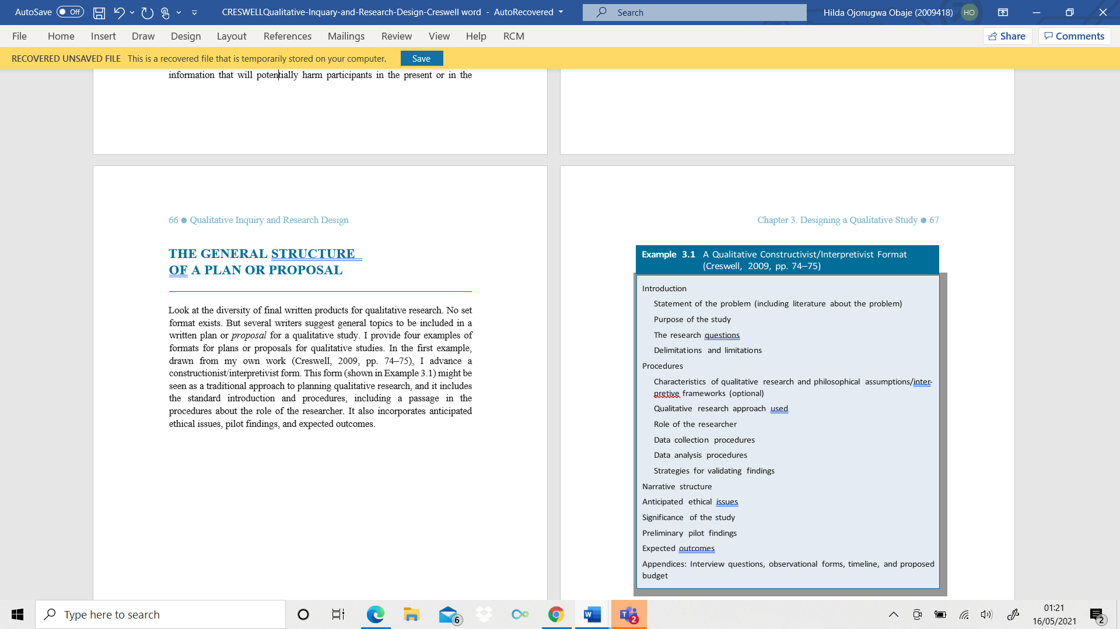
Appendix 1: An Interpretivist Qualitative Research Format
Adapted from Creswell (2013, P.67).

Appendix 2 Qualitative Research Approaches Compared by Cresswell (2013)
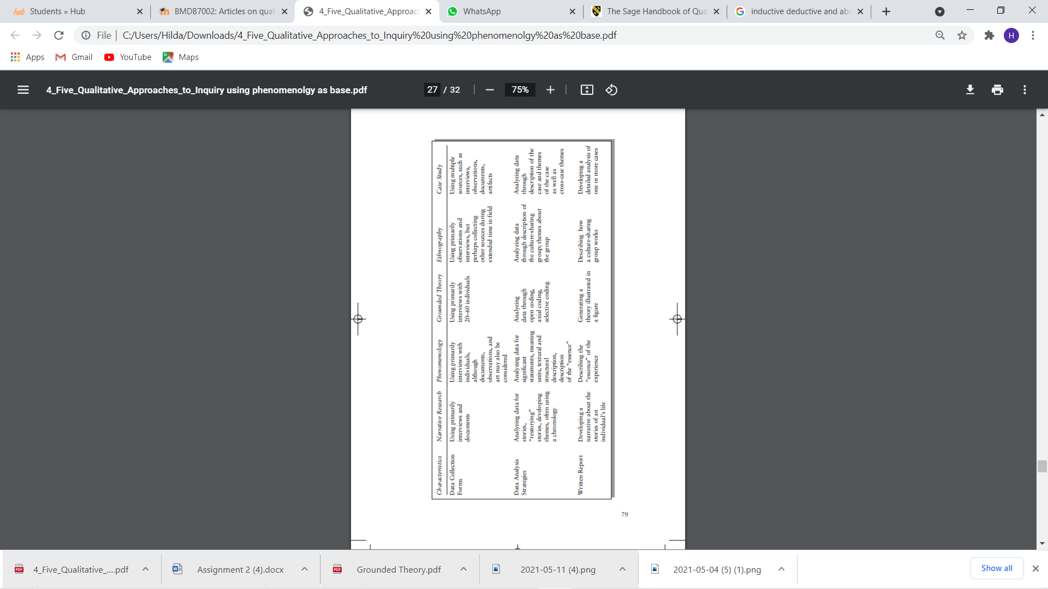

Bibliography
Adams, C. and van Manen, M.A. (2017) ‘Teaching phenomenological research and writing,’ Qualitative Health Research, 27(6), pp.780-791.
Amin, M.E.K., et al. (2020) ‘Establishing trustworthiness and authenticity in qualitative pharmacy research,’ Research in Social and Administrative Pharmacy, 16(10), pp.1472-1482.
Baškarada, S. and Koronios, A. (2018) ‘A philosophical discussion of qualitative, quantitative, and mixed methods research in social science', Qualitative Research Journal, Vol. 18, No. 1, pp. 2-21.
Birkin, H. (2019) “Retaining staff”, UK hospitality [blog]. 17 June. Available at: https://www.ukhospitality.org.uk/ (Accessed: 17 February 2021).
Brian, D. H. (2018) The Philosophy of quantitative methods. Oxford University Press.
Buchholtz, N. (2019) ‘Planning and conducting mixed methods studies in mathematics educational research’, in Kaiser, G. and Presmeg, N. (ed.) Compendium for Early Career Researchers In Mathematics Education. Hamburg: Springer.
Carminati, L. (2018) ‘Generalizability in Qualitative Research: A Tale of Two Traditions’, Qualitative Health Research; Qual Health Res, Vol. 28, No. 13, pp. 2094-2101.
Chun Tie, Y., Birks, M. and Francis, K. (2019) ‘Grounded theory research: A design framework for novice researchers,’ SAGE Open Medicine, 7, p.2050312118822927.
Clandinin, D.J. (2006) ‘Narrative inquiry: A methodology for studying lived experience,’ Research Studies in Music Education, 27(1), pp.44-54.
Clandinin, D.J. and Connelly, F.M. (2000) Narrative Inquiry: Experience and Story in Qualitative Research. San Francisco: Jossey-Bass, 2000.
Coşkun, K. (2020) ‘A new explanation for the conflict between constructivist and objectivist grounded theory,’ International Journal of Qualitative Methods, 19, p.1609406920938280.
Creswell, J.W. (2013) Qualitative inquiry and research design: Choosing among five approaches. Sage publications.
Creswell, J.W. (2018) Research design: qualitative, quantitative and mixed methods approaches, 5th edn. Los Angeles : SAGE.
Cypress, B. (2018) ‘Qualitative research methods: A phenomenological focus,’ Dimensions of Critical Care Nursing, 37(6), pp.302-309.
Flinders, D.J. (1992) ‘In search of ethical guidance: Constructing a basis for dialogue’, Qualitative Studies in Education, 5(2), pp.101-115.
Fetterman, D.M. (2019) Ethnography: Step-by-step. Sage Publications.
Glaser, B.G. and Strauss, A.L. (2017) Discovery of grounded theory: Strategies for qualitative research. Routledge.
Herzberg, F. (2005) ‘Motivation-hygiene theory’, in Miner, J. B. (ed) Organizational behavior one: Essential Theories of Motivation and Leadership. Armonk: ME Sharpe.
Jose, F. M. (2017) ‘Mixed Methods’, The SAGE Handbook of Qualitative Business and Management Research Methods. Cassell, C., Cunliffe, A.L. and Grandy, G. eds., Sage, pp.102-118.
Kalu, F.A. and Bwalya, J.C. (2017) ‘What makes qualitative research good research? An exploratory analysis of critical elements,’ International Journal of Social Science Research, 5(2), pp.43-56.
Leslie, C. (2015a) Fundamentals of qualitative research: What is Qualitative Research (Module 1) [video]. Available at: https://www.youtube.com/watch?v=wbdN_sLWl88 (Accessed: 21 April 2021).
Leslie, C. (2015b) Fundamentals of qualitative research: Developing a Qualitative Research Question (Module 2) [video]. Available at: https://www.youtube.com/watch?v=_0HxMpJsm0I (Accessed: 21 April 2021).
Leslie, C. (2015c) Fundamentals of Qualitative Research Methods: Interviews (Module 3) [video]. Available at: https://www.youtube.com/watch?v=6PhcglOGFg8 (Accessed: 21 April 2021).
Leslie, C. (2015d) Fundamentals of Qualitative Research Methods: Focus Groups (Module 4) [video]. Available at: https://www.youtube.com/watch?v=cCAPz14yjd4 (Accessed: 21 April 2021).
Leslie, C. (2015e) Fundamentals of Qualitative Research Methods: Data Analysis (Module 5) [video]. Available at: https://www.youtube.com/watch?v=opp5tH4uD-w&t=35s (Accessed: 21 April 2021).
Lobel, B. (2018) ‘Fixing staff retention issues in the hospitality industry’, Small businesses [blog] 16 August. Available at: https://smallbusiness.co.uk/ (Accessed: 17 February 2021).
Maher, C., et al. (2018) ‘Ensuring rigor in qualitative data analysis: A design research approach to coding combining NVivo with traditional material methods,’ International Journal of Qualitative Methods, 17(1), p.1609406918786362.
Maxwell, J.A. (2019) Distinguishing between quantitative and qualitative research: A response to Morgan,’ Journal of Mixed Methods Research, 13(2), pp.132-137.
Morgan, D.L. (2018) ‘Living within blurry boundaries: The value of distinguishing between qualitative and quantitative research’, Journal of Mixed Methods Research, 12(3), pp.268-279.
Morgan, S.J., et al. (2017) ‘Case study observational research: A framework for conducting case study research where observation data are the focus,’ Qualitative Health Research, 27(7), pp.1060-1068.
Moustakas, C. (1994) Phenomenological research methods. Sage publications.
Nowell, L.S., et al. (2017) ‘Thematic analysis: Striving to meet the trustworthiness criteria,’ International Journal of Qualitative Methods, 16(1), p.1609406917733847.
Odetha, D. A. (2018) Strategy for Low Employee Turnover in the Hotel Industry. Unpublished Phd thesis. Walden University. Available at: https://scholarworks.waldenu.edu/cgi/viewcontent.cgi?article=6348&context=dissertations (Accessed 7 March 2021).
Ploder, A. and Hamann, J. (2021) Practices of Ethnographic Research: Introduction to the Special Issue.
Polkinghorne, D.E. (1989) ‘Phenomenological research methods,’Existential-phenomenological perspectives in psychology (pp. 41-60). Springer, Boston, MA.
Riessman, C.K. (2008) Narrative methods for the human sciences. Sage.
Robert, P. G. (2017) ‘Qualitative research as Interpretive social science Mixed Methods,’ The SAGE Handbook of Qualitative Business and Management Research Methods. Cassell, C., Cunliffe, A.L. and Grandy, G. eds., Sage, pp.33-53
Simpson, B. (2017) ‘Pragmatism: A philosophy of practice’, The SAGE Handbook of Qualitative Business and Management Research Methods. Cassell, C., Cunliffe, A.L. and Grandy, G. eds., Sage, pp.54-68
Torrington, D. (2020) Human resource management, 11th Edn. Harlow: Pearson
Yin, R.K. (1994) Case study research: Design and methods, applied social research. Methods series, 5.
Zeng, T., Deschênes, J. and Durif, F., (2020) ‘Eco-design packaging: An epistemological analysis and transformative research agenda’, Journal of Cleaner Production, p.123361.

