Executive Summary
This report brief provides a high-level overview of information system security, governance, and compliance frameworks such as ITIL, ISO/IEC 27001, the NIST Cybersecurity Framework, and CIS Controls. The literature study delves into each framework's core components and actions, emphasizing their importance in strengthening organizational cybersecurity. The suggested security framework incorporates critical aspects for complete security. Finally, the paper calls for a proactive and dynamic approach to information security, emphasizing the significance of maintaining current of evolving risks and regulatory changes. Adopting a flexible and constantly improving approach is critical for organizations to successfully traverse the evolving digital landscape.

Contents
Executive Summary 1
Introduction 1
Literature Review 1
Information Technology Infrastructure Library (ITIL) 1
ISO/IEC 27001 – Information Security Management System (ISMS) 2
NIST Cybersecurity Framework 4
CIS Controls (Center for Internet Security Controls) 6
Proposed Security Framework 8
Conclusion 11
References 11

Introduction
In today's changing corporate context, where digital transformation is a critical aspect of operations, ensuring the security, governance, and compliance of an organization's information system is critical. This long executive summary delves into a variety of strategies and frameworks aimed at improving information security. Internationally recognised standards such as the NIST Cybersecurity Framework, ISO/IEC 27001, ITIL (Information Technology Infrastructure Library), and CIS (Centre for Internet Security Controls) are discussed.
ITIL (Information Technology Infrastructure Library): ITIL is a comprehensive collection of principles developed by the Office of Government Commerce in the United Kingdom that focuses the alignment of IT services with business needs. By including strategic factors such as service strategy and service design, the framework ensures that consumers obtain value and that service quality increases over time. Controlling information availability, confidentiality, and integrity, as well as aligning IT security with business security goals, are central to ITIL security management.
ISO/IEC 27001 Information Security Management System (ISMS)
ISO 27001, developed by the International Electrotechnical Commission (IEC) and the International Organisation for Standardisation (ISO), provides a methodical way to dealing with secret company data. It specifies the requirements for developing, implementing, maintaining, and constantly improving an information security management system (ISMS). Important components include scope definition, commitment and leadership, risk assessment and management, document control, monitoring and measurement, and continuous improvement.
The National Institute of Standards and Technology (NIST) created the NIST Cybersecurity Framework, which uses a risk-based approach to managing cybersecurity threats. In understanding their assets, putting safety measures in place, identifying and reacting to cybersecurity events, and recovering from incidents, organizations are directed by its functions—Identify, Protect, Detect, Respond, and Recover. The framework prioritises adaptability, a single language of communication, and continuous security infrastructure improvement.
CIS Controls, or the Centre for Internet Security Controls
The Centre for Internet Security developed the CIS Controls, which provide an organized collection of security safeguards and advice to protect businesses from common internet assaults. Data protection, access control, incident response, inventory, and management of hardware and software assets are all components of a comprehensive cybersecurity posture. The controls give businesses with a realistic and flexible roadmap for enhancing their cybersecurity defenses.
Proposed Security Framework
To address the company's security requirements, a proposed security framework is given. Adherence to legal and ethical requirements, strategic planning and governance, security policies, risk assessment, security management models and processes, backup plans, protections, and service level agreements are all covered.

Literature Review

Information Technology Infrastructure Library (ITIL)
ITIL is a comprehensive set of guidance and practices, which are widely used to handle IT assets in the business environment. It has been developed by the United Kingdom’s Office of Government Commerce, and currently is a part of Axelos. It provides a framework used for the planning, delivery, and support IT services with the major goal of aligning IT services with the needs of the business. The framework emphasis on the importance of delivering a value to customers, and able to improve service quality over the time. Numerous components are associated to this framework, in which one is service strategy, in which author described that it focuses on defining the strategic objectives of the business, and guidelines developed of how IT services can be able to contribute to these objectives. There is another component named Service Design, in which customer needs are addressed for IT services development, in which the components like architecture, processes, and policies are available.
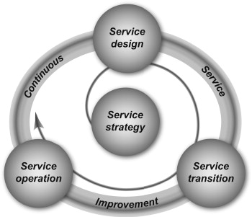
Figure 1: Components of ITIL
The author also highlights some of the key components as named service transition, in which the services can be transitioned services from development to production. Further, another major component is the service operation, in which activities or policies are defined for managing day-to-day activities and IT services delivery.
Security management in ITIL
It is one of the critical security components which can be used for the overall management of IT services. The security aspects can be addressed in the service design phase and followed via the ‘Information Security Management’ process. This process is dedicated to ensuring that information security aligns with the business security objectives and is able to manage information’s confidentiality, integrity and availability securely. The following are objectives, and activities of security management in ITIL
- Objectives:
  - Align IT security with business security objectives.
  - Define and implement security policies and standards.
  - Manage and control access to information and IT services.
- Activities:
  - Conducting risk assessments and defining security requirements.
  - Designing and implementing security controls and measures.
  - Monitoring and managing security incidents and vulnerabilities.
- Integration with Other ITIL Processes:
  - ISM is closely integrated with other ITIL processes, such as risk management, service level management, and change management.
  - Ensures that security considerations are embedded throughout the service lifecycle.

ISO/IEC 27001 – Information Security Management System (ISMS)
The author described that this model or framework is developed by International Organization for Standardization (ISO) and the International Electrotechnical Commission (IEC). This standard will specify the requirements to establish, implement, maintain and continuously improve the security management system (Khaleefah & M. Al-Mashhadi, 2023). ISMS is a systematic approach through which sensitive company information can be managed to ensure confidentiality, integrity and availability. ISO 27001 is designed to offer a structured and comprehensive framework for business by establishing the security practices. The key components of ISO/IEC 27001 (Taherdoost, 2022) have been designed to handle operations as described below the activities:
- Scope Definition
To begin the process of obtaining ISO 27001 certification, the first step is to determine the scope of the Information Security Management System. The internal ISMS boundaries and applicability of the organization must be determined in order to accomplish this function.
- Leadership and Commitment
A significant amount of emphasis is placed on the guidelines on how important it is for top management to be committed to information security. The establishment of a policy for the protection of information, the assurance (Campos et al., 2016) of the availability of resources, and the exercise of leadership are all required.
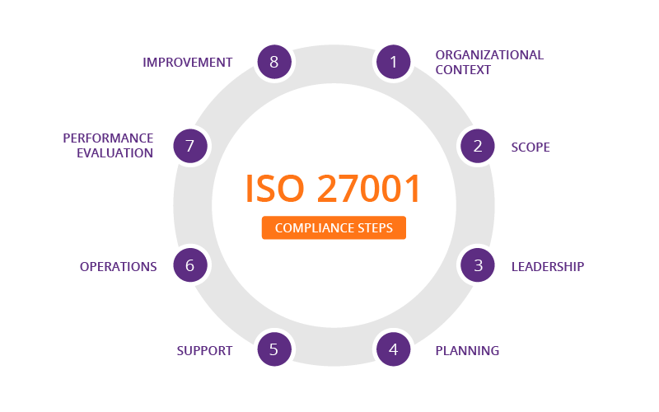
Figure 2: Compliance steps of ISO27001
- Risk assessment and treatment
Information security is addressed by ISO 27001 through the utilization of a risk-based strategy. In order to ensure the safety of their information, companies need to systematically identify, investigate, and evaluate potential threats. Following the completion of a risk assessment, organizations take the time to develop and put into action risk treatment strategies in order to effectively manage any dangers that are detected.
- Document and Control
One of the requirements of the standard is that documentation pertaining to ISMS must be created and maintained. This includes the information security management procedures, the conclusions of the risk assessment, and the policy that governs the protection of sensitive data. For the purpose of mitigating risks, established controls are implemented.
- Monitoring and Measurement

ISO 27001 places an emphasis on the relevance of monitoring and assessing the performance of the information security management system (ISMS). The establishment of key performance indicators (KPIs) pertaining to information security, the monitoring of security measures, and the execution of frequent internal audits are all required steps this takes.
- Continuous Improvement
The standard calls for the use of the Plan-Do-Check-Act (PDCA) cycle in order to encourage ongoing development. Organizations routinely evaluate the effectiveness of the information security management system (ISMS) by conducting management reviews and internal audits. This allows them to identify areas that might be improved and implement both corrective and preventative measures.

NIST Cybersecurity Framework
NIST (National Institute of Standards and Technology) (Taherdoost, 2022) is a set of guidelines and best practices designed to help businesses to manage and improve their cyber-security risk management processes. It has been created in response to orders to develop a framework to improve cyber-security for critical infrastructure in the United States. This framework adopted a risk-based approach (Hutchins et al., 2015), which focuses on identifying, assessing and managing the risks. The organizations are encouraged to develop a framework according to their needs by considering unique risk profiles and business processes. The following are the components of this framework:
Identify: -
- In order to successfully manage cybersecurity risks, the objective is to have an understanding of assets, hazards, and vulnerabilities and to prioritise them.
- Administration of assets, with the goal of determining and ranking the importance of essential assets.
- Conducting a risk assessment in order to comprehend and rank the various cybersecurity dangers.
Protect:
- The goal is to guarantee the delivery of essential services while also protecting against potential cybersecurity threats by putting protections into place.
- Access control measures are those that are implemented in order to restrict and manage user access (Puteho & Gamundani, 2022).
- The implementation of data protection measures, such as encryption and controls for data integrity.
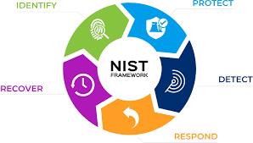
Figure 3: NIST Framework
Detect
- Identifying and responding to cybersecurity events in a timely manner is the objective of the implementation of processes and technologies by the organization.
- Continual monitoring for irregularities and potential security breaches is one of the activities described here.
- capabilities for detecting incidents and responding to responses.
Respond
- The objective is to devise and put into action a response plan in order to immediately handle any cybersecurity incidents that are discovered.
- The activities include planning and preparedness for responding to incidents.
- During a cybersecurity event, communication and collaboration are essential features.
Recover
- The goal is to create and put into action recovery strategies in order to restore capabilities and services that have been disrupted as a result of a cybersecurity event.
- Continuity of operations and system recovery planning are the activities that are being planned.
- In order to achieve continual development, post-incident analysis and lessons learned are performed.
The benefits of the NIST cyber-security framework (Alshar'e, 2023) have been analyzed by the author and identified as follows:
- This framework has been designed to be flexible, and adaptable to the numerous organisations with respect to its size and industry type.
- It will provide a common language and framework on which the business can manage cyber-security risks and facilitate communication among the stakeholders.
- Continuous improvement can be facilitated in the security infrastructure of the organisation, and able to adopt the cyber-security, which manages impact to the business environment.

CIS Controls (Center for Internet Security Controls)
This framework offers a set of cyber-security best practices, which have been developed by the Centre for Internet Security, a non-profit business (Woods et al., 2017). These controls offer a prioritized and prescription approach that can be followed to enhance the cyber-security posture and able to address common cyber threats. A major goal is to provide a practical framework which can be used to improve their cyber-security defenses. The key components described for the business are provided below:
Inventory and Control of hardware assets:
- Achieve the goal of actively managing and controlling the hardware assets that are located on the network of the organization.
- Activities include the management of inventory and the discovery of assets.
- Update and monitor the configurations of the hardware on a regular basis.
Inventory and Control of Software Assets:
- To actively manage and exercise control over the software assets that are located on the network of the organization.
- The management of software licenses and software inventories are the activities.
- Always be sure to patch and update your software.
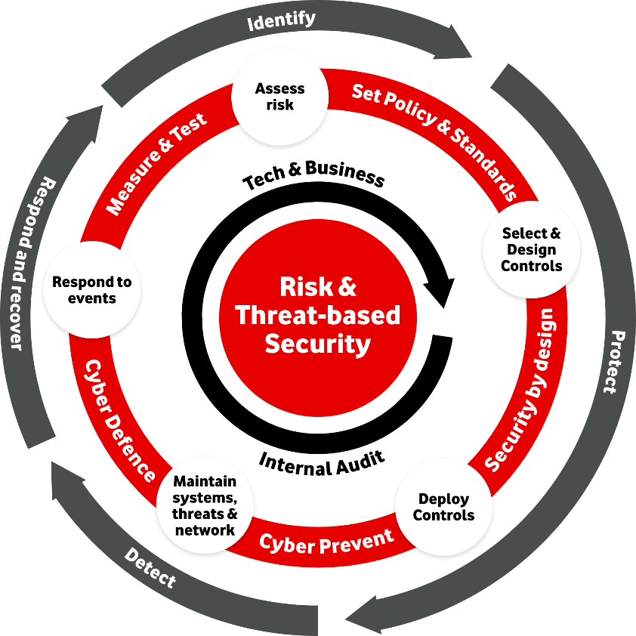
Figure 4: CIS Controls (Center for Internet Security Controls)
Data Protection
- Assure the protection of sensitive data during its entire lifecycle is the goal of this assignment.
- Implementing data encryption is one of the activities.
- Data transmissions should be monitored and controlled.
Access Control
- Access to systems and data should be restricted and controlled in accordance with user roles and responsibilities, as this is the objective.
- It is recommended that the principles of least privilege access be implemented.
- Employ multi-factor authentication, often known as MFA.
Secure Configuration of hardware and software
- The goal is to create and maintain secure settings for the hardware and software on computers and other electronic devices.
- Construct and put into action secure baseline configurations as part of the activities.
- Assess insecure settings on a regular basis and take corrective action.
Security Awareness and Training
- The goal is to educate people and provide them with the ability to become aware of the best practices and risks inherent in cybersecurity.
- The activities include conducting security awareness training on a regular basis.
- Ensure that there is continuous communication regarding cybersecurity.
Email and Web browser Protections
- By exercising control over the operation of web browsers and email clients, the goal is to reduce the attack surface and the chances available to attackers.
- Implementation of email screening and validation is one of the activities.
- Control the execution of the web browser.
Incident Response
- In order to effectively respond to and recover from cybersecurity issues, the objective is to develop and implement a plan for incident response.
- The activities include putting together a team to deal with incidents (ZAMFIROIU & SHARMA, 2022).
- The incident response plans should be developed and tested.
Security Assessments and Penetration Testing
- The purpose of this objective is to verify and validate the effectiveness of security mechanisms by conducting frequent assessments and penetration testing (PT).
- In the activities, vulnerability assessments will be carried out.
- To test for penetration, do tests.
Data Recovery Capabilities
- In the event that a cyber incident occurs, the goal is to guarantee that the organisation will be able to retrieve data and restore system operation.
- Backups of essential data should be performed on a regular basis.
- Perform tests and checks on the data recovery procedures.

Proposed Security Framework
1. Compliance (Laws and Ethics):
- Objective: Ensure adherence to relevant laws, regulations, and ethical standards.
- Activities:
  - Regularly review and update policies based on changes in legal and regulatory requirements.
  - Conduct ethical training for employees.
2. Governance and Strategic Planning for Security:
- Objective: Establish a robust governance structure and align security with organizational objectives.
- Activities:
  - Develop a governance framework outlining roles, responsibilities, and decision-making processes (Maynard et al., 2018).
  - Integrate security into strategic planning initiatives.
Key Elements | Governance and Strategic Planning
Policies | Governance framework policies
Processes | Decision-making processes
Roles | Defined roles and responsibilities
Alignment | Integration with strategic planning
3. Security Policies:
- Objective: Develop and enforce comprehensive security policies (Alotaibi et al., 2016).
- Activities:
  - Create policies covering data protection, access controls, and incident response (Javaid, 2013).
  - Regularly review and update policies based on evolving threats.
Key Elements | Security Policies
Data Protection | Data handling policies
Access Controls | User access policies
Incident Response | Response procedures
4. Risk Management:
- Objective: Identify, assess, and manage security risks.
- Activities:
  - Conduct regular risk assessments.
  - Implement risk treatment plans.
Key Elements | Risk Management
Assessments | Periodic risk assessments
Treatment | Risk treatment plans
5. Security Management Models and Practices:
- Objective: Implement recognized security management models.
- Activities:
- Adopt frameworks like ISO 27001 or NIST Cybersecurity Framework.
- Align security practices with industry standards.
Key Elements | Security Management Models and Practices
Framework | Adoption of ISO 27001, NIST CSF, etc.
Alignment | Aligning practices with industry standards
6. Contingency Planning:
- Objective: Develop plans to ensure business continuity in the face of disruptions.
- Activities:
  - Create and test contingency plans for data breaches or system failures.
  - Establish backup and recovery processes.
Key Elements | Contingency Planning
Plans | Comprehensive plans for disruptions
Testing | Regular testing of plans
7. Protection Mechanisms:
- Objective: Implement technical measures to protect information assets.
- Activities:
  - Deploy firewalls, encryption, and intrusion detection/prevention systems (Demirel et al., 2022).
  - Regularly update and patch systems.
Key Elements | Protection Mechanisms
Technologies | Firewalls, encryption, IDS/IPS
Patching | Regular system updates
8. Service Level Agreement (SLA):
- Objective: Establish SLAs for security-related services.
- Activities:
  - Define security service levels for vendors and service providers (Ahmad & Abawajy, 2014).
  - Monitor and enforce SLAs.
Key Elements | Service Level Agreement
Definition | Clear definition of security service levels
Monitoring | Continuous monitoring and enforcement

Conclusion

In conclusion, the purpose of this study was to investigate significant aspects of information system security, governance, and compliance. Specifically, the paper focused on well-known frameworks such as the NIST Cybersecurity Framework, ISO/IEC 27001, ITIL, and CIS Controls. In addition to shedding light on the primary characteristics, objectives, and activities of each framework, the comprehensive literature review highlighted the significance of these frameworks in terms of strengthening the cybersecurity postures of organisations.
The examination of ITIL underlined its purpose in aligning IT services with business requirements, with a particular emphasis on security management. This one was highlighted in the analysis. An explanation was given that the ISO/IEC 27001 standard is a methodical technique that is widely acknowledged for the purpose of managing vital company information while simultaneously assuring its availability, confidentiality, and integrity was provided. The National Institute of Standards and Technology (NIST) Cybersecurity Framework outlined procedures for identifying, protecting against, detecting, responding to, and recovering from cybersecurity incidents within the context of a risk-based methodology. The Cybersecurity Information System (CIS) Controls were also investigated since they are a set of security controls that are rated in order of significance and are designed to protect against frequent cyberattacks. The security framework that was suggested covered all of the essential components that are necessary, such as risk management, governance, security policies, contingency planning, protection mechanisms, service level agreements, and compliance. The provision of an all-encompassing and adaptable strategy for the protection of information systems is dependent on each and every component participating. Organizations that operate in the rapidly evolving digital realm, where they are required to deal with a wide variety of sophisticated cyber threats, are required to create a comprehensive security architecture. Providing businesses with useful best practices and direction, the frameworks and suggested security model that are outlined in this article aid organisations. The deployment of resilient information security infrastructures is founded on the core concepts of adaptability, flexibility, and a commitment to the ongoing enhancement of security measures.

References
- Ahmad, M. and Abawajy, J.H. (2014) ‘Service level agreements for the Digital Library’, Procedia - Social and Behavioral Sciences, 147, pp. 237–243. doi:10.1016/j.sbspro.2014.07.166.
- Alotaibi, M., Furnell, S. and Clarke, N. (2016) ‘Information security policies: A review of challenges and influencing factors’, 2016 11th International Conference for Internet Technology and Secured Transactions (ICITST) [Preprint]. doi:10.1109/icitst.2016.7856729.
- Alshar’e, M. (2023) ‘Cyber Security Framework Selection: COMPARISION of NIST and ISO27001’, Applied computing Journal, pp. 245–255. doi:10.52098/acj.202364.
- Campos, J. et al. (2016) ‘The challenges of cybersecurity frameworks to protect data required for the development of Advanced Maintenance’, Procedia CIRP, 47, pp. 222–227. doi:10.1016/j.procir.2016.03.059.
- Demirel, H.C., Leendertse, W. and Volker, L. (2022) ‘Mechanisms for protecting returns on private investments in public infrastructure projects’, International Journal of Project Management, 40(3), pp. 155–166. doi:10.1016/j.ijproman.2021.11.008.
- Hutchins, M.J. et al. (2015) ‘Framework for identifying cybersecurity risks in manufacturing’, Procedia Manufacturing, 1, pp. 47–63. doi:10.1016/j.promfg.2015.09.060.
- Javaid, M.A. (2013) ‘Incident response planning for data protection’, SSRN Electronic Journal [Preprint]. doi:10.2139/ssrn.2391677.
- Khaleefah, A.D. and M. Al-Mashhadi, H. (2023) ‘Methodologies, requirements and challenges of Cybersecurity Frameworks: A Review’, International Journal of Wireless and Microwave Technologies, 13(1), pp. 1–13. doi:10.5815/ijwmt.2023.01.01.
- Maynard, S.B. et al. (2018) ‘Towards a framework for strategic security context in information security governance’, Pacific Asia Journal of the Association for Information Systems, pp. 65–88. doi:10.17705/1pais.10403.
- Puteho, C.S. and Gamundani, A.M. (2022) ‘Applying the NIST cybersecurity framework in developing a digital forensic incident response roadmap for the security sector in Namibia’, Proceedings of International Conference on Information systems and Emerging Technologies, 2022. [Preprint]. doi:https://papers.ssrn.com/sol3/papers.cfm?abstract_id=4332936.
- Taherdoost, H. (2022a) ‘Understanding cybersecurity frameworks and information security standards—a review and Comprehensive Overview’, Electronics, 11(14), p. 2181. doi:10.3390/electronics11142181.
- Taherdoost, H. (2022b) ‘Understanding cybersecurity frameworks and information security standards—a review and Comprehensive Overview’, Electronics, 11(14), p. 2181. doi:10.3390/electronics11142181.
- Woods, D. et al. (2017) ‘Mapping the coverage of security controls in Cyber Insurance proposal forms’, Journal of Internet Services and Applications, 8(1). doi:10.1186/s13174-017-0059-y.
- ZAMFIROIU, A. and SHARMA, R.C. (2022) ‘Cybersecurity management for incident response’, Romanian Cyber Security Journal, 4(1), pp. 69–75. doi:10.54851/v4i1y202208.

