Transition Guidance

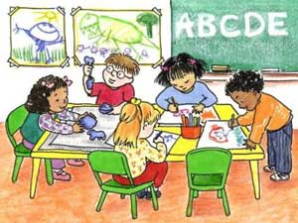

For Keyworkers and parents of Reception aged children.

Contents

- Introduction

- All about Transitions

- The Role of the adult

- The needs of the child

- Partnerships

- Interventions

- Proposed outcomes

Introduction: How to use this handbook
This handbook is designed for use by both keyworkers and parents when supporting young children with transition into full time school, from nursery to reception.
It highlights the importance of effective communication with children, parents, practitioners and other professionals throughout the process of transition. Welsh government (2015) recognises the importance of partnerships with parents and promotes an appreciation of parents as the child’s first educators.
Throughout the handbook we will focus on:
- What transitions are, and the type of transitions that children may experience during the early years.
- How children cope with transitions and the impact it can have on them and their overall development in both the short term and longer term.
- The importance of effective communication, both with children and between adults when promoting a smooth transition for children.
- Difficulties that children may face specifically when moving into full time school, how they may make us aware of this and what we can do to help.
- The role of adults in supporting young children’s development and ensuring their needs are met at all times.
- Interventions to increase the chance of meeting the desired outcomes.
This handbook will give an insight into transitions and provide practical advice and strategies to assist keyworkers and parents to understand their role in supporting children’s learning and development during transitions. Guidance will emphasise the importance of effective communication with children and families, keyworkers should use this to enhance their knowledge and to inform their practice in ensuring smooth transitions and achieving the desired outcome of happy settled and confident children.
All About Transitions
Young children will experience many transitions during the first years of their life. This can be starting at childcare or going to school, but can also be moving home, the birth of a sibling, parents separating, the death of a pet or many other changes that will affect their usual routine. They will also go through smaller transitions during the day, such as going to bed, moving from outdoor play to quiet time etc. Helping children cope with transitions and experience as smooth a transition as possible can help shape their future resilience to change. (Professional Association for Childcare and Early Years, 2017).
This guide will focus on the transition to full time school, a time that some children manage seamlessly while others will struggle and experience many difficulties.
You cannot overemphasise the importance of successful transition. Transition is said to be successful when a child moves into the next phase without difficulty. Successful transition will occur when the child is ready and able to settle into school on all levels, emotionally, psychologically, physically and intellectually. (Yeboah, 2002).
“Transition is a process, not an event”. (Bateson, 2013). While a transition can be linked to certain events in a child’s life, it is more than just the event itself. Transition is experienced as a process that is likely to influence the individuals’ life as they move through further changes. (Trodd, 2013).
Transitions and the way they are handled can affect the child in the longer term as well as the short term and can affect how they respond to future transitions. According to Bridges (1991, cited in Bateson, 2013, p52) a child may experience lasting effects on emotional, social and academic development as the result of a badly handled transition. Therefor it is important that young children are supported through this process in a way that suits their needs and ensures as smooth a transition as possible.
There are many factors that contribute to and influence children’s development and how a child will cope during times of transition. It is important that adults are aware of the many challenges that children may face and how the environment they live in impacts on this.
Bronfenbrenner (date!) developed a bioecological model of development. He worked to describe how children’s development can be affected by the environment. Children do not develop in isolation, and the ecological approach is a reminder of this. Bronfenbrenner’s model includes a series of concentric circles, where the child is at the centre. The innermost circle he calls the microsystem, this is where socialisation occurs and is made up of the direct daily experiences and contacts of the child, such as, family, peers, friends, teachers, keyworkers. The next layer is the Mesosystem and reflects the relationships between the influences of the microsystem, for example where an activity in school relies on a child bringing in specific items for example wellies/baby photo. This would only be possible if the child’s parents remembered and were able to provide the item. The third layer is called the Exosystem and refers to direct or indirect influences and social systems that affect development. This includes the extended family, friends of parents, parents’ economic situation, school boards and neighbourhood. These may impact the child’s development indirectly, for example a parent who is under pressure at work may be in a rush to get there and not as responsive to their child’s needs and efforts at communication. Next is the Macrosystem which consists of broader social structures such as cultural values, the economic system, laws and customs of given culture.
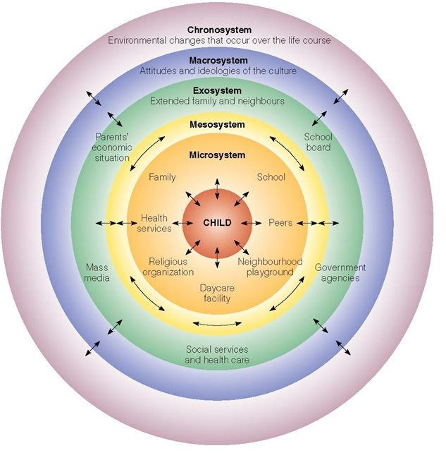

(Source: Pinterest, no date).
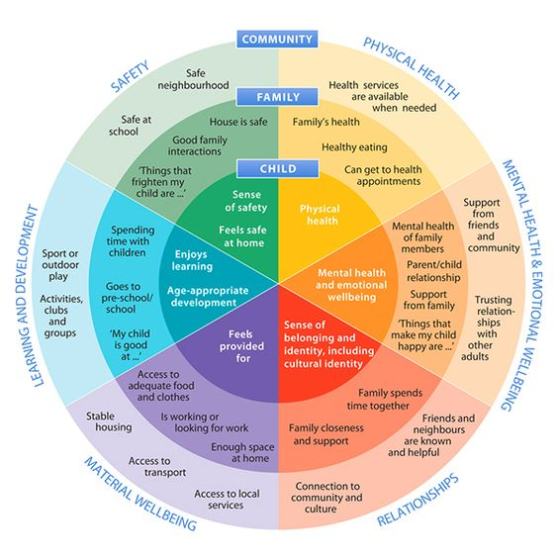

(Source: Pinterest, no date)

All of these environmental factors can have an impact on how well a child copes or doesn’t cope with transitions and change. The diagram shows all the outside influences and how they can support and contribute to how the child develops in different areas.

The Role of the Adult
Adults play an important role in supporting children through transitions, there are in fact many adults that have an influence during these times including, parents, teachers, keyworkers, social workers or health visitors and many others. It is important that all adults involved communicate and share information to work together in the best interests of the child. EVIDENCE
Recognising that transition to school can be a big change for parents as well as children is important, if a parent feels uninvolved and anxious then they may transfer this anxiety onto the child. Parents that are informed, involved and supported are more likely to be able to support their child. Baras (2010, cited in Bateson, 2013, p.51) states that Children are more likely to learn effectively if they are happy, and that happy parents induce happiness in their children. This is also supported by Thomas (2019) who suggests that parents often find the transition to school more problematic than the child themselves. Part of the keyworkers’ role is to communicate with parents the importance of projecting a positive perspective of school to the child to enable them to feel at ease and enjoy the process.
Keyworkers and parents should have established close relationships with each other. Building on this close relationship, keyworkers are more able to provide emotional support for both parents and children when needed. Working closely and having effective communication links with parents puts the keyworker in a stronger position to support the child as they will be able to pass on and receive significant information from parents. Where these links are not made, further pressure is put on the child as they themselves will need to become the bridge between the two (Gunning, 2018).
It is important that the adults around the child are responsive to the behaviour, communication and needs of the child. Simply making eye contact and offering a reassuring smile can go a long way to making a child feel more confident and reassured. “Responsive relationships early in life are the most important factor in building sturdy brain architecture” (Havard University, 2017) When an adult is responsive to a child there are lots of back and forth interactions, also known as “serve and return”. For example, where a young child points to an object and the adult notices and responds by naming it and interacting with the child. The child will have provided the ‘serve’ by pointing and the adult the ‘return’ by responding appropriately. (Havard, no date). These responsive relationships build strong foundations in the brain and contribute to developing resilience through childhood and into adulthood (Havard, 2017).
All children are individuals and will display different behaviours during times of stress and anxiety. Being responsive and alert to the signs of worry and helping the child deal with this early on will prevent it escalating and causing further or prolonged distress. Children will not always communicate verbally when something is bothering them, they may not know how to. Good communication with children and their families can help to build trust and is central to building positive relationships. It is important to communicate appropriately according the needs of the individual and the context, and should involve listening, questioning, understanding and responding. (Children’s Workforce Development Council, 2010). Body language and tone is as important as actual words, a child may avoid eye contact, speak quietly when they are feeling upset or anxious.
While some children will settle after some encouragement, routine and support from their keyworker, teacher and parents, others may require additional or more specialised support. Recognising signs of possible development delay or regression and being aware of when to take individual action to support a child further is important. Practitioners should know where to obtain necessary information and advice to support parents and children. (Children’s Workforce Development Council, 2010).

Needs of the Child
Maslow (1943) developed a model of human needs using a 5 tiered pyramid consisting of hierarchical levels of needs. With the idea that the lower level needs must be met to a certain degree, but not necessarily 100% in order to progress further up. (McLeod, 2018).

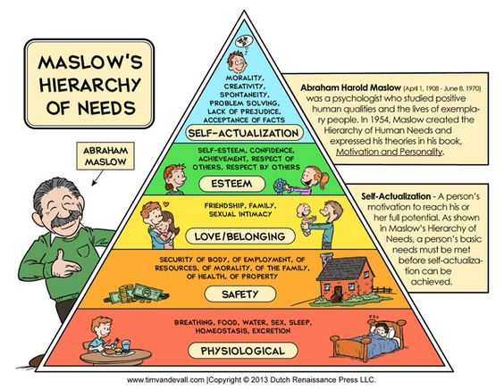

(Source, Pinterset, no date)
If children’s needs are not met on a basic level, they are unlikely to be able to develop in the expected manner. Children will struggle to develop self-esteem and confidence to reach their full potential if they do not first have their physiological needs met with sufficient food, shelter, water and sleep, and feel warmth, security and a sense of belonging. They may become clingy, anxious, aggressive, withdrawn and can even suffer problems with brain development. They are likely to have difficulty with attachments and may continue to have problems with relationships throughout their life. (NSPCC, 2020). According to Corrigan (2009, cited in Bateson, 2013, p.51) Children are unable to access higher order thinking if they are unhappy and under stress. Therefor if children are to settle and do well at school it is important that support is in place for a smooth, happy and settled transition.
According to Issacs (2013) Children need warm human relationships, security, real and active experience, opportunity for self assertion and independence, and to play with other children.
Warm human relationships Issacs (2013) states are what a child needs above everything else. Security she suggests is provided by an adult who provides order and routine, which to a young child means love and safety. The adults around the child should have a stable attitude and consistently show love (Issacs, 2013). This is supported by Tovey (No date) who states that children “thrive when they are emotionally secure and in close relationships with others, including the family and wider community” (Tovey, no date). Secure attachments with a familiar adult such as a keyperson are vital in supporting children’s development especially at times of transition where there they will experience much uncertainty and change. Having the support of a familiar adult will enable the child the feel secure and confident to communicate concerns and worries they may have. According to Havard University (2017) where children and teens are able to overcome serious hardship, the single most common factor is having at least one supportive relationship with a parent or other adult.
Real and active experience
foundation phase. First-hand experiences allow children to develop an understanding of themselves and the world in which they live
– Monterssori

Opportunities for self assertion and independence
– voice—active listening reggio
UNCRC 12 –

Play with other children – Froebel
NMS Nurture and wellbeing 8.5 the settling-in process is appropriate for the individual child, and separation from parents or carers minimises any distress and anxiety; (Welsh Government, 2016)
Children learn through first-hand experiential activities with the serious business of ‘play’ providing the vehicle (Foundation phase)
PLAY TOVEY - froebel
He saw the earliest years of a child’s life as the most formative and play as the leading form of development (NEEDS PLAY)
In play the whole child is active - moving, feeling, thinking and willing are integrated. He argued that play helps children to relate their inner worlds of feelings, ideas and lived experiences with the wider world of things and people and to see a connection between them. Froebel saw play as being ‘deeply significant’ because: ● Play helps children reflect on and understand themselves as well as the people and world around them. ● Play develops awareness of symbols and symbolic thought where children operate at their highest level. ● Self-chosen play activities help develop determination, concentration, persistence and satisfaction, which are important features of work-like activities in adult life. ● Play is increasingly social and fosters friendship, fairness, understanding of rules and care for others.

Partnerships

personal social and emotional well-being and developing a sense of belonging to the school community are significant factors in the transition process in terms of the impact this has on children’s learning. Informative communication with all those involved is a central element in the transition process if children’s well-being is to be supported effectively and continuity of learning uninterrupted. (Buckley and Fabian, 2006). (PARTNERSHIPS)
. Children thrive when there is a close connection between the kindergarten and the family and culture of each child. Respectful partnerships with parents were therefore essential. (PARTNERSHIPS) tovey froebel

Interventions
- Sense of belonging – familiarise with routine and environment, try on uniform, attend settling in sessions/open days … P10

- Communication – Encourage questions from children, pass on relevant info to school/parents. Introduce yourself to the school/teacher.

- Promote independence – using toilet, dressing, opening packets to eat lunch box, knife and fork, buttons/zips

Outcomes

Confident happy children
Smooth transition

