

Programme name: Master of Business Administration
Name: Marketing Management
Module code: LCMB7024
Marketing Strategy for Spotify Fit: Integrating Music and Fitness through Innovation
Lecturer’s name: Dr Laila Maazouz
Name:Keyur Mukeshbhai Bodar
ID of the student:2435243
Submission date:17 December, 2025

Table of Contents
Introduction 3
Element 1: Segmentation, Targeting, Differentiation, and Positioning (STDP Analysis) 3
1.1 Company Overview: Spotify 3
1.2 New Brand Concept: Spotify Fit 3
1.3 Segmentation 3
1.4 Targeting 4
1.5 Differentiation 5
1.6 Positioning 5
Element 2: Marketing Mix (4Ps) 6
2.1 Product 6
2.2 Price 7
2.3 Place 8
2.4 Promotion 8
Element 3: Marketing Strategy Pitch 10
Element 4: Reflection 10
References 12
Appendix-poster 14

Introduction
In this assignment, the emphasis is placed on the creation of the overall marketing plan of Spotify Fit, a new wearable fitness device that will be a combination of customized music and biometric monitoring. On the basis of the brand strength and market knowledge of Spotify, this portfolio will discuss numerous essential marketing concepts, such as Segmentation, Targeting, Differentiation, and Positioning (STDP), the Marketing Mix (4ps), and the development of an effective marketing pitch. Moreover, the critical reflection of the brand development process will also be included to outline the most important lessons learned and possible improvement in the future.

Element 1: Segmentation, Targeting, Differentiation, and Positioning (STDP Analysis)

1.1 Company Overview: Spotify
Spotify, which was established in 2006, has been able to become one of the most popular music streaming platforms in the world, and currently, it has more than 450 million active users around the world (Brainvire, 2022). Spotify is a massive library of music and customized playlists with podcasts and has also increased its content to wellness and other media. This would put the company in a good place to introduce Spotify Fit, a new wearable that combines personalized music with real-time fitness tracking to tap into the developing health tech market.

1.2 New Brand Concept: Spotify Fit
Spotify Fit is a wearable fitness device that measures such vital variables as heart rate, steps, and sleep behavior and correlates exercising music with physical information. The gadget applies AI technology to change the music tempo and genre based on the intensity of the workouts of the user to provide a personalized and engaging workout experience. Integrating fitness and personalized music, Spotify Fit will target consumers that want a more engaging and encouraging workout solution.

1.3 Segmentation
In order to achieve targeting of the right audience, we will divide the market in terms of demographic, psychographic, and behavioral factors:
Demographic Segmentation:
Age: The main target audiences are Generation Z (18-24) and Millennials (25-35). These are tech-savvy and health-conscious groups in which 80 per cent of Gen Z already has fitness trackers or health apps (Statista, 2025). This shows their willingness to be integrated on the fitness and music product.
Income: Middle and upper-middle-income customers are the best as they are ready to spend on health and technology products. This is integrated with Spotify Premium, which means that it would be aligned with the purchasing behavior of the existing users of Spotify.
Behavioral Segmentation:
Fitness Enthusiasts: These are the ones who are involved in fitness activities and have fitness devices to monitor their progress. They will value the fact that Spotify Fit will be able to match the intensity of the workout with the music so as to complement their physical activity.
Tech Enthusiasts: This category of consumers cares about wearable technology and customized experiences and, therefore, Spotify Fit will be attractive to them once the music is introduced that adjusts to their physical activity.
Psychographic Segmentation:
Wellness-Conscious Consumers: these individuals are more focused on both mental and physical well-being and are interested in new products that promote their well-being.
Lifestyle-Oriented: These are consumers driven by personal development and desire products that would blend with their active and healthy lifestyles (Hossain, Akter and Muzareba, 2024).

1.4 Targeting
Spotify Fit will take a different marketing approach with two main groups as the focus:
- Fitness-Engaged Millennials and Gen Z: both groups are highly inclined towards health and fitness technology, and they are gaining interest in personalized work-out options.
- Tech Enthusiasts: A secondary group of customers who are early adopters of wearable technology and fitness devices and have an interest in the fusion of fitness and music technology.
These segments have a substantial potential given that the wearable fitness technology market is projected to grow to 87.9 billion by 2028 (Fortune Business Insights, 2023) and is a large developing consumer base.

1.5 Differentiation
Spotify Fit is different to its market rivals such as Fitbit and Apple Watch:
- Music Integration: Spotify Fit is an innovation compared to the conventional methods of tracking a person’s fitness; it integrates biometric tracking with personalized music. The music adjusts to the real time fitness statistics of the user, thus ensuring an exclusive and inspiring experience.
- AI-Powered Personalization: The device uses AI to adjust the music according to the heart rate and intensity of the workout, which other devices do not do.
- Spotify Ecosystem Integration: Perfect integration into Spotify Premium will enable the user to experience a wide range of music library that will be filtered to their workout without requiring extra applications or subscriptions (Kotler et al., 2020).

1.6 Positioning
The market position of Spotify Fit will be:
Positioning Statement: To young, digitally-engaged consumers seeking a motivating fitness experience, there is no smarter band than Spotify Fit that can offer a combination of accurate biometric tracking and music intelligence to create a fully personalized workout experience.
The brand will also capitalize on the prior awareness of Spotify in the music streaming market and focus on its innovative feature to be a combination of music and fitness tracking. Through this approach of prioritizing the emotional value of personalized music and inspiration, Spotify Fit will be converted to a complete fitness companion, as opposed to being another fitness tracker.
The positioning of Spotify Fit is an articulated fusion of both fitness and entertainment whereby it is the ideal companion to individuals who would like to improve their workouts and listen to their favorite music at the same time. This distinction guarantees that Spotify Fit will be able to compete in the market of fitness trackers (Hooley et al., 2020).
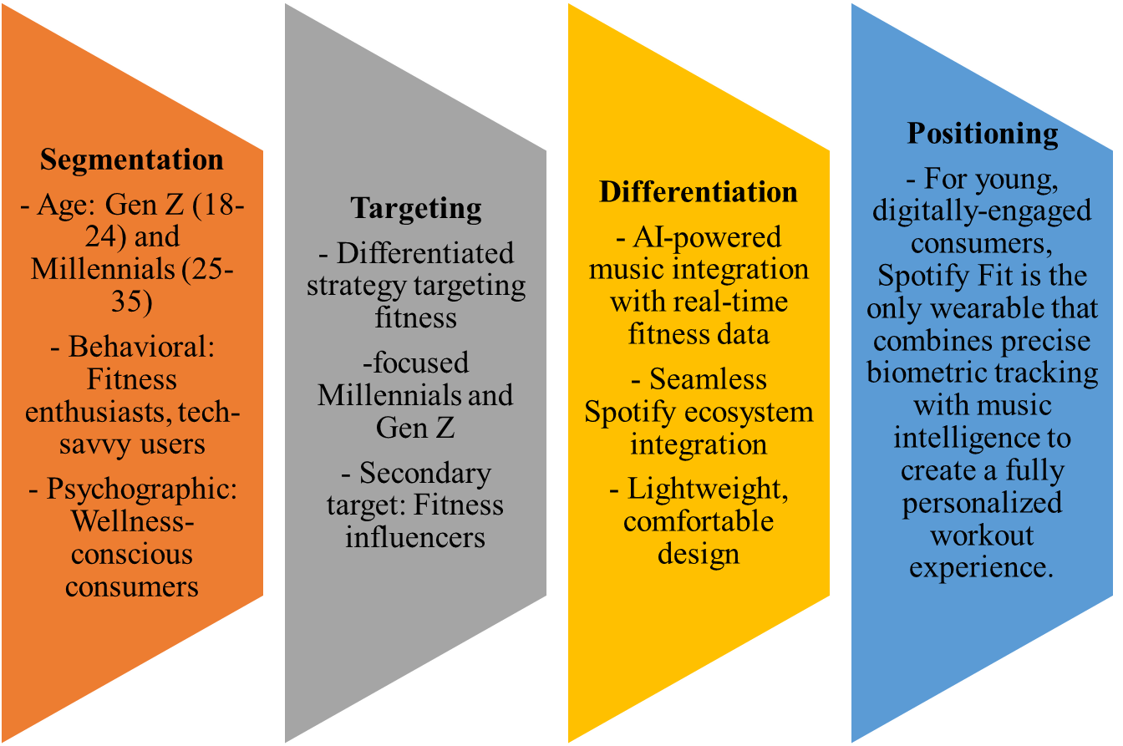
Figure 1: STDP for Spotify fit

Element 2: Marketing Mix (4Ps)

2.1 Product
Spotify Fit is an exercise bracelet that monitors the most important physiological indicators heart rate, number of steps, sleep behavior, and stress. It uses the music intelligence of Spotify to change the tempo of the music, genre, and style according to the real-time data on fitness. This personalized music integrated with biometric tracking gives the user a personalized and interesting workout experience. The major characteristics of Spotify Fit are:
1. Biometric Tracking: The device can track the heart rate, calories burned, steps and sleep patterns giving the user a comprehensive picture of their health process.
2. AI Music Integration: Spotify Fit can use AI to adjust the music playlist to the intensity of the workout, providing the user with a dynamic, inspirational workout experience (Ahmad and Burke, 2025).
3. Spotify Linear Integration: Spotify Fit will interconnect with Spotify Premium and allow users to easily connect their workout playlists and listen to customized music suggestions throughout their workout (Till, 2023).
4. Light, Comp, and Responsible: The band is made to be worn all day, and it is comfortable during exercising and sleeping.
5. Long Battery Life: Spotify Fit has a battery life that lasts through many activities and day tracking, and this is considered an ideal product among the active consumers.
It will also have Spotify-exclusive features like access to the large music library and workout suggestions generated by an algorithm of Spotify. The product is not only promoted as a fitness tracker, but as an entire workout tool, further improving the fitness experience with music that inspires and adjusts according to the performance of the user (Amalina, 2019).

2.2 Price
Spotify Fit pricing will utilize a market-penetration pricing model to gain a large market share in the wearable fitness tracker market in the shortest time possible. The product will also be priced to be competitive at 120, targeting the main target group of tech-savvy Millennials and Gen Z who are already using Spotify Premium packages and are more likely to purchase the product. Such a pricing is also in line with the overall pricing of other well-established fitness trackers such as Fitbit and Xiaomi where the products range between 50-200 dollars, and Spotify Fit can fit into this price range.
Spotify Fit will also come in a bundle deal with Spotify Premium at a discounted price of $160 (20 discounted) whereby current Spotify customers can buy the device as part of their musical and fitness experience. It is also possible to charge a premium price in future on the specialized editions or features of the product such as the limited edition model which will have more colors or accessories.
Promotional deals will also be part of the pricing strategy, including promotional deals like seasonal deals or student-spots, as the user base of Spotify is very large and the youth is the prime target. With the increasing popularity of wearable activity devices that are expected to reach a value of 87.9 billion by 2028 (Fortune Business Insights, 2023), the low cost policy is meant to serve as a means of reaching out to the first-movers as they expand to a more significant market segment.
Table 1: Pricing Strategy for Spotify Fit
Pricing Option | Price | Details
Standard Price | $120 | Affordable price for broad market penetration
Bundle with Spotify Premium | $160 | $20 discount when bundled with Spotify Premium
Special Promotions | Varies | Seasonal discounts and student pricing offers

2.3 Place
Spotify Fit will be sold using the multi-channel distribution strategy, which involves the combination of direct and indirect channels to give it the widest coverage and reach. The product will be sold online via:
1. Spotify Website and App Store: We will sell directly through the Spotify app and the Web site and take advantage of the already acquired customers of the Spotify premium users, as it will make the process of buying easy and seamless (Hu, 2024).
2. Online Amazon and Major Retailers: The product will also be distributed through big online stores such as Amazon, and in-store retailers such as Best Buy among others, so that there is a wide coverage of the market and access to the product by consumers. Such retail collaborations will make Spotify Fit reach more people than the core user base of Spotify.
3. Exclusive Spotify Channels: Exclusive channels, including Spotify in-apps advertising, will be offered to those who are already on the platform and the probability of conversion to the product will be higher (Li, 2022).
4. University Partnerships: Spotify Fit can work with universities to provide student discounts and package offers on fitness-related programs or gym memberships, which would utilize the younger generation, who place great importance on fitness and technology.
As wearable fitness technology is projected to take off in the coming decade, with massive billions of dollars in revenue, distribution channels like the ones mentioned above will make sure that Spotify Fit reaches as many consumers as possible, at a variety of different touchpoints.

2.4 Promotion
In order to raise awareness and encourage the use of Spotify Fit, a combined approach of the promotion strategy will be used, involving both the use of both traditional and online marketing channels:
1. Influencer marketing: Collaborating with fitness influencers on Instagram, Tik Tok, and YouTube will need to create brand credibility and access young and fitness-driven customers. Influencers will demonstrate how Spotify Fit will improve their workouts by aligning their favorite music with the level of exercise, which will tap into the emotional resonance that users feel when listening to music (Munsch, 2021).
2. Social Media Advertising: A defined advertisement is set to be employed on social media platforms such as Instagram, Facebook, and Snapchat to reach out to Millennials and Gen Z. The advertisement will be displayed by utilizing eye-catching images and testimonials to emphasize that Spotify Fit is the personalized music incorporation, fitness tracking, and fits well with the Spotify platform (Spotify advertising, 2025).
3. University Partnerships: Association with universities to provide special discounts to students will bring more awareness of the product to younger consumers, who represent one of the targeted audiences. The college ambassadors might be used to market the product within the college gyms and campus fitness programs.
4. Email and App Marketing: Spotify can use the existing email subscriber base, in-app notifications to promote to its current users with special offers and promotions to use Spotify Fit. To make the promotion reach the potential customers, it will be necessary to incorporate customized messages based on their usage habits and interests in the content related to fitness.
5. Seasonal Campaigns: Special holiday deals, like Black Friday deals, may be used as another incentive to attract the customers to buy Spotify Fit at a reduced cost and boost sales on the high-shopping seasons (Edobor and Sambo-Magaji, 2025).
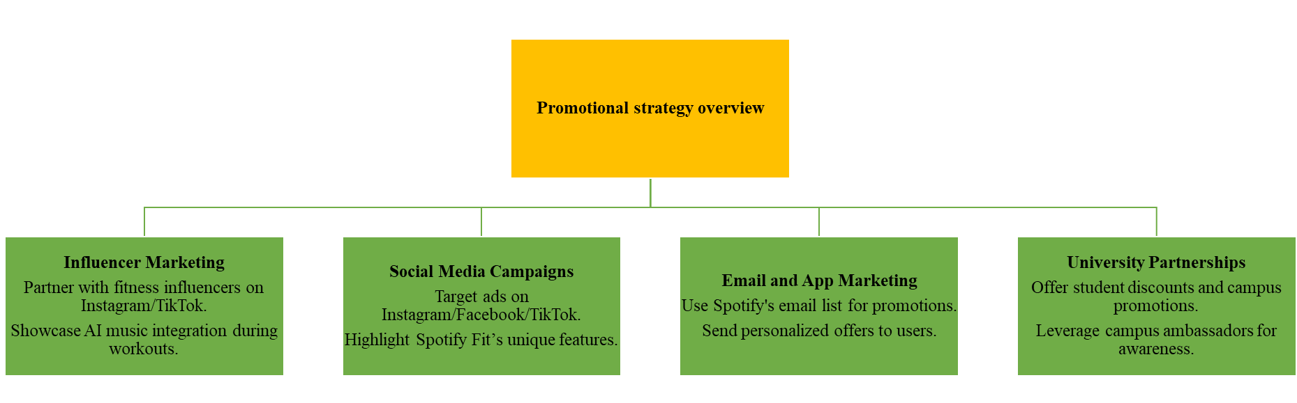
Figure 2: Promotional strategy overview (Spotify).
The marketing approach will establish a high level of brand awareness and create hype within the audience of tech-charged, fitness-conscious consumers, and will also capitalize on the high brand recognition of Spotify and its activity on the digital platform.

Element 3: Marketing Strategy Pitch
Launching Spotify Fit, the new wearable fitness band that will be combined real-time biometric tracking together with Spotify music intelligence. Spotify Fit, which personalizes your music according to your heart rate, steps, and pace, is, naturally, the perfect product to target the digitally-driven, wellness-conscious Gen Z and Millennial consumers. Spotify Fit is your all-purpose workout companion regardless of the activity you are engaged in as long as you are running, cycling, or practicing yoga. Spotify Fit connects your workout and music in a manner like no other fitness band, with intelligence-assisted music sync, real-time health data, and perfect compatibility with Spotify Premium (Spotify, 2023). It is light, fashionable and packs long battery life making it the ideal companion in every workout. They are available at only $120, and spotify premium members have a unique bundle. Take your exercise to the next level, take your music to the next level Spotify Fit is not only a fitness band it is an adventure.
The focus of this pitch should be on the peculiarities of the brand the combination of AI-based music sync and biometric tracking, with an accent on the emotional appeal of a personalized fitness experience.

Element 4: Reflection
The evolution of Spotify Fit into a new brand concept has been an uphill and a downhill task. Integrating biometric tracking with customized music offered a rare chance to discuss how to combine technology, fitness, and entertainment to create one product. Another most interesting part of this project was the attention to Segmentation, Targeting, and Positioning (STP), during which I needed to find out the major consumer segments, including Millennials and Gen Z and personalize the product to their needs in terms of technology and health. This made me know how crucial it is to study the behavior of the consumers and how the brands need to modify their products to suit the evolving market trends.

The marketing mix (4Ps) part was also quite informative since it made me think of how the current ecosystem of Spotify can be incorporated into the design of the product. To illustrate, combining Spotify Fit and Spotify Premium will enable one to experience a unified user experience, which will make the transitioning process of current customers simple. This again confirmed in the importance of using brand equity and consumer loyalty in the introduction of a new product. It also emphasized the fact that, strategic pricing was required to attract younger consumers in a trade-off between affordability and perceived product value.
In the process, the biggest struggle was how to make Spotify Fit stand out against market competitors such as Fitbit and Apple watch which had already established themselves in the market through their wearable devices. I understood that the most important feature of differentiation is the integration of music with AI, which is a characteristic of Spotify Fit. It strengthened my perception of the necessity of innovations in very competitive markets, where it is essential to offer something specific to be successful.
The pitch of the marketing strategy meant that I had to integrate all aspects of the marketing plan and make a solid and compelling case of the product. It was an experience that helped me to become more critical in my thinking, and capable of modifying marketing approaches and changing them according to the needs of the consumers and the business objectives.
Altogether, the given assignment has improved my perception of the need to incorporate technology into marketing practices and increased my awareness of the comprehensive vision required to create successful products.

References
Ahmad, Y. and Burke, B. (2025). Investigating AI Personalization in Music Streaming. [online] DIVA. Available at: https://www.diva-portal.org/smash/record.jsf?pid=diva2:1962199.
Amalina, N. (2019). PROPOSED MARKETING STRATEGY BASED ON BEHAVIORAL INTENTION IN USING SPOTIFY; DIFFERENCES BETWEEN FREE AND PREMIUM USERS. International Journal of Education and Research, [online] 7(5). Available at: http://www.ijern.com/journal/2019/May-2019/07.pdf.
Brainvire (2022). Key Spotify Statistics Driving Music Streaming Adoption in 2023. [online] Brainvire.com - A Website Development, Mobile Apps and Digital Marketing Company. Available at: https://www.brainvire.com/blog/key-spotify-statistics/.
Edobor, F. and Sambo-Magaji, A. (2025). Digital Entrepreneurship: Opportunities and Challenges. 12(7), pp.63–99. doi:https://doi.org/10.1007/978-981-96-1721-0_5.
Fortune Business Insights (2023). Fitness Tracker Market Size, Share, Trends | Global Analysis, 2020-2027. [online] www.fortunebusinessinsights.com. Available at: https://www.fortunebusinessinsights.com/fitness-tracker-market-103358.
Hooley, P.G., Nicoulaud, B., Rudd, J. and Lee, N. (2020). Marketing Strategy and Competitive Positioning, 7th Edition. [online] Google Books. Pearson UK. Available at: https://books.google.com/books/about/Marketing_Strategy_and_Competitive_Posit.html?id=J63jDwAAQBAJ.
Hossain, M.I., Akter, N. and Muzareba, A.M. (2024). Segmentation, Targeting, and Positioning. Segmentation, Targeting, and Positioning, 22(1), pp.115–154. doi:https://doi.org/10.1007/978-981-97-3553-2_4.
Hu, X. (2024). Individual Case Study & Report: Spotify. International Journal of Global Economics and Management, 4(1), pp.424–437. doi:https://doi.org/10.62051/ijgem.v4n1.51.
Kotler, P., Armstrong, G., Harris, L. and He, H. (2020). Kotler, Principles of Marketing, 8th European Edition. [online] www.pearson.com. Available at: https://www.pearson.com/nl/en_NL/higher-education/subject-catalogue/marketing/kotler-principles-of-marketing-european-edition-8e.html.
Li, J. (2022). Analysis of the Trend of Spotify. BCP Business & Management, [online] 34(21), pp.919–926. doi:https://doi.org/10.54691/bcpbm.v34i.3112.
Munsch, A. (2021). Millennial and Generation Z Digital Marketing Communication and Advertising effectiveness: a Qualitative Exploration. Journal of Global Scholars of Marketing Science, 31(1), pp.10–29. doi:https://doi.org/10.1080/21639159.2020.1808812.
Spotify (2023). Spotify and Strava Team Up for a First-Place Integration. [online] Spotify. Available at: https://newsroom.spotify.com/2023-04-12/spotify-strava-integration-stream-track-workout/.
Spotify advertising (2025). Audio content and health-conscious listeners | Spotify Advertising. [online] ads.spotify.com. Available at: https://ads.spotify.com/en-US/news-and-insights/mind-body-stream-wellness-and-fitness-insights/.
Statista (2025). Development of the world population until 2050| Statista. [online] Statista. Available at: https://www.statista.com/statistics/262875/development-of-the-world-population/?srsltid=AfmBOopPfJ2T6mmOXA6sMAaLBjLNS89KyzuQRv4Fu5SK31HVXJhTCECW [Accessed 15 Dec. 2025].
Till, C. (2023). Spotify as a technology for integrating health, exercise and wellness practices into financialised capitalism. Big Data & Society, 10(2). doi:https://doi.org/10.1177/20539517231210278.

Appendix-poster


