Student Name: Anita Addo
Student number :2423859
Module code : BMHP5016
Lectures: Aishat Bakre

Principles of Health and Social Care Practice

Principle of Health and Social care in Uk Practice Reflective Report
Reflection on the importance of principles of Health and social care
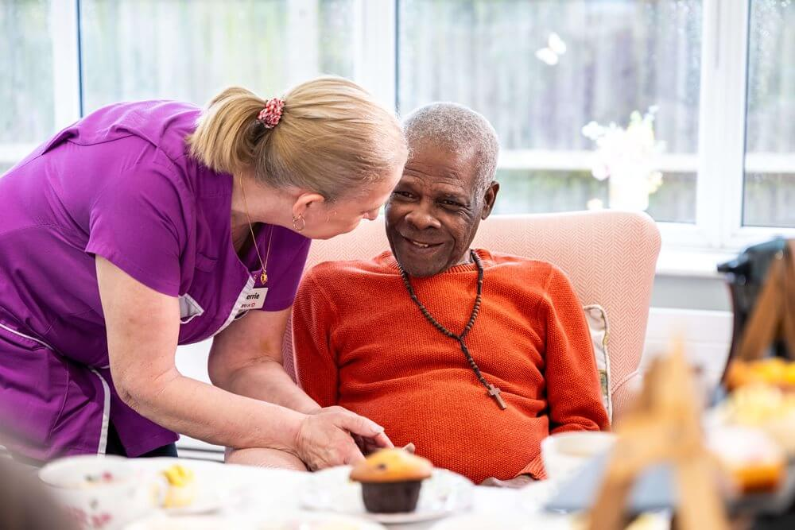
The principles and values of health and social care are the foundation of how care and support are delivered in the UK. These principles guide the behaviour, decisions and professional standards of everyone working in health and social care and other services. The principles ensures that care is safe, person-centred, person centred and respectful especially for those vulnerable. The principles are supported through the legislation such as the Care Act 2014, Health and care Act 2022 and many more (admin, 2026).
Person centred care is holistic approach that places individuals at the heart of decision making but also the centre. By putting people in the heart of their care the care quality would improve, as people have access to services when they know they need it. By tailoring support to meet person’s needs, values and preferences rather than seeing everybody issues are the same ands applying one size fit all models (Vivid Administrator, 2025). This approach ensures that service users and families as equal partners in their care, empowering them to make decisions and actively take care of themselves therefore putting less pressure in the health care system (Skills for Health, 2025). When individuals are felt like they are all treated the same but individual it can make them feel not appreciated and not heard therefore reducing their input in their decision making. This principle aligns with the Maslow Hierarchy of needs, his theory suggest that our human needs can be organised into clear hierarchy often depicted as a pyramid. From the bottom to the top is physiological needs this is the essential physically such as food, water, shelter and rest. Once these are satisfied individuals can focus on safety needs this is when individuals should feel stable, secure and free from fear. The third social belonging needs it’s the emotional connection through friendship, intimacy and acceptance. Esteem needs are the want for respect, recognition from other around and status. The top is self-actualisation needs it is when a person achieves their full potential. Maslow suggested that the lower levels have to be satisfied before the higher levels can become motivators (Bitesize Learning, 2024).

Person centred care is important under the Care Act 2014. It is the law that shapes the social care in England, and this act combines serval existing pieces of legislation. It sets out some principles on how health and social care professionals should work with service users, but care must be personalised and coordinated to an individual’s unique circumstances. Some these principles are service users wishes, feelings and beliefs should always be considered, professionals should ensure that an action taken to support individuals affect their rights and freedom as little as possible. These principles are there to protect adults from abuse and neglect therefore high-quality care is given. (Peoplefirstinfo.org.uk, 2016)
Partnership working infers different groups together to share resources and influence. It is the collaboration between professionals, service users and families. Partnership ensures that services given are better and at a high quality so that an individual is receiving holistic care that covers mental, feeling related and surroundings parts as well at medical needs. The health and care 2022 is a UK legislation that emphasises integrated care system and reshaped how the NHS and the system work together. It was created to remove barriers and improve accountability this strengthens service users’ safety (Department of Health and Social Care, 2022). Integrated system is the joint working between NHS, council and voluntary sectors that can create better services. When professionals work together it can help bring out new ideas, teamwork and respect this will provide individuals receive more holistic support which are essential when caring for service user (NHS England, 2022).
Ethics is the normal principles that guide the actions and decisions of professionals in health and social care. It involves considering the wellbeing and rights of individuals but also the border implication of a person’s actions on society as a whole. There are ethic principles these are justice, autonomy, beneficence and non-maleficence (Celestine, 2024). Autonomy is the power given to the service users to make decisions about their health and this decision making should not be done by force by anyone but the service user. Professionals must ensure that individuals know the information about the risks and benefits of their care. Justice is offering unbiased health care and fair practices when providing care to an individual. This means providing fair and equal treatment no matter their circumstances and these are protected under the Equality Act 2010. Beneficence is the intent of doing good for an individual by protecting and defending the rights of others. Non maleficence is the obligation if a professional not to harm a service user an example of this is not to cause pain or suffering, risk assessments or deprive others (Jacob, 2022). Ethics is crucial because it prevents discrimination, increases safeguarding and promotes trust confidence between service users and professionals.
Practical Examples of concepts in practice
An example of person-centred care, partnership working and ethics practice can be seen in the NHS England personalised care study of Mrs Davis, an older woman who experienced repeated leg ulcers that has affected her mobility, independence and confidence. Her condition has led to frequent hospital visits, and a district nurse would visit her 2-3 times a week until she would heal. Personalised care would take in all her needs and find ways to help Mrs Davis to recover (www.england.nhs.uk, n.d.).
A personalised care plan will explore Mrs Davis living experience, daily routines and goals she needs to achieve. The people involved in her care should not just into consideration of the physical aspects but the rest like her emotional, social and intellectual aspects. They need to understand what she’s going through and what mattered to her before these conditions happened like being abler to go shopping and personal activities. A personalised care plan would include compression therapy, lifestyle and her preferences so that Mrs Davis feels comfortable, but her opinions are taken in into considerations.
A multidisciplinary team would support Mrs Davis by involving different professionals such as a district nurse, care worker and occupational therapist. District nurse was an important part of Mrs Davis care because they have visited 2-3 times to her house to provide clinical treatment to treat her leg ulcers. The treatment could include dressing her wound and monitoring how her legs is doing. Once discharged Mrs Davis would have trouble in maintaining her legs by washing, creaming and compression hosiery. A care worker provides support in her daily living and doing things she may have struggle doing. A care worker can support her washing and dressing her leg, moisturising and put on a compression stocking that she has difficulty doing. An occupational therapist role is there to assess Mrs Davis home and add equipment’s that could help her to live independently such as hoist or handrails. An advantage of multidisciplinary teams provides room for improved outcomes for Mrs Davis by adopting holistic approach. Each professionals utilises their specialities to treat her issues therefore leading to reduced recovery team. A disadvantage is there may be challenges in communication because each professional may have different communication styles that may not work for everyone. This may lead to misunderstandings, conflict when caring for Mrs Davis(Openshaw, 2025)
Ethic practice would support Mrs Davis by ensuring that decisions made about her care is to protect her safety, dignity and respect. Autonomy is involving Mrs Davis in every decision that is made about her care, she is understood about her treatment and professionals respects her decisions. Justice is ensuring that she is receiving opportunities and access to support not disadvantages because of her condition. But also, her information is kept confidential for her safety and has an advocate to speak out for her. Beneficence was demonstrated when the district nurse recognised the cycle of deterioration and taking actions to break it. Also, Mrs Davis was referred to an Age Uk living well services so that she receives daily help with the washing, compression hosiery and moisturising these reduces the risk of further ulcers. Non maleficence is professionals have to avoid causing harm towards service users. For Mrs Davis this includes by doing a risk assessment to evaluate potential harmful outcomes to prevent her ulcers from worsening and she is receiving consistent care for her leg (Apax Support, 2025).
Self-reflection as a health and social care professional
Reflecting on my development has a health care professional, I recognise that person centred care, partnership working and ethics practice can influence my day-to-day practice. It would change the way to interact with service users, collaborate with colleagues and provide support. Reflecting on my current skills, strength and areas for improvement so that I can provide high quality care.
Person centred care would help to know my patients better but to treat each one from their own preferences and experiences. For person centred care it requires me to active listening, and this is listening to what the other person is saying without interrupting would help me to gather information and understand the experience the service user is going through. As a good listener I would ask open ended questions to know more about the individuals preferences likes and dislikes and practicing non-judgmental listening to reduce me being biased or making my own opinions (Martins, 2024). This aligns with Maslow’s hierarchy of needs is meeting psychological needs is just as important as physical health. One of my strengths is communication skills because I am able to explain information and instruction s clearly, change the way I talk either by my tone of voice or body language and using active listening to understand my service users. This improves person centred care as individuals feel like their feelings are taken into account and respected. Another strength is I am able to show empathy its where I relate to someone’s experience and understand emotions of others. I showing empathy would build more trusting relationships that would allow individuals to open up about their concerns (Anon, n.d.). However, I can improve on my skills is aside from the verbal communication I could focus more on the nonverbal communication. This means noticing individuals body language, tone of voice and facial expression when they may feel uncomfortable or anxious. This would change the way I approach individuals when providing support. Another is I can improve my advocacy skills when for service users when they may feel like things may be going on but may be afraid to speak out. Developing this skill would ensure that service users voices are heard and understood.

Partnership is an important part of my role as I have to collaborate with different professionals from different fields in order to provide a holistic care to an individual. One of my strong skills I have in partnership working is teamwork it’s when professionals work together care becomes safer, services run better and people feel more supported. I contribute to partnership working by supporting other in the care. Healthcare worker is demanding physically, emotionally but in partnership working the team shares load, I will check in with others and step in when needed. This can reduce stress and make the work more manageable. I will also contribute to partnership working by sharing information appropriately, clearly and respecting others roles (Morgan, 2025). A strength I bring to partnership working is that I am resilient and open minded. This means that I am able to learn from others but also my own mistakes so that I won’t repeat it. Sometimes when it comes to meetings with other professionals I may sometimes feel hesitant to speak up because I don’t have the confidence to do so. To improve this, I could attend workshops that teach mee how to improve this, ask for feedback from colleagues and practice. Another skill I would improve on is my time management skills because it would affect my contribution to the team if I were unable to meet deadlines and submit documents on time. This can impact an individual’s health if the right things aren’t done on time and proper care isn’t done. I can improve my time management by prioritising tasks from sectioning from important to high priority. Managing my schedule and meeting deadlines.
Ethical principle shapes my day-to-day work as a health and social care professional it influences how I make decisions, interact with others and collaborating with professionals. In my practice I rely on ethical principles such as autonomy, beneficence, justice and non-maleficence which will allow me to understand safeguarding, advocating and providing care. Autonomy is an important part of my role a a professional I must respect individuals right to make choice even if it goes against my ideas. To support an individual, I have to provide clear information, ensure that their understanding and allow them to express themselves if their choices differ what professionals believe. Beneficence and non-maleficence allow to me act on the service users best interest by keeping them safe by doing risk assessments, reporting malpractice and follow procedures. Justice helps me to treat every individual fairly no matter what their circumstances are or their facing. A strength I bring to ethics is that I am good at problem solving as I am able to overcome a challenge as many situations aren’t straight forward it requires critical thinking and making balancing the risks. With my problem solving when a service users faces a problem I am able to break the information down into steps and find ways that could be sought out. Breaking down the information would avoid me being biased and consider the situation from different perspective. I need to improve on my awareness of unconscious bias to ensure that my decisions aren’t based on my opinion but always on the interest of the individuals and not to assumptions. But also another skill I need to improve on is making decisions under pressure because the health and social care is a fast-paced setting I need to make quick decisions so that I don’t delay the care and affect the service users. To improve this I would ask for feedback from my colleagues and service users about the advice I’ve given, attend training and workshops.
Conclusion

I want to continue to develop my person-centred care, partnership working and ethics. I will do this by being updated and attending trainings, setting goals that I would have a specific time to achieve and deepening my understandings of legislation. This reflection has made to understand that health and social care isn’t about the physical, but it includes emotional, intellectual and social aspects if an individuals. By reflecting and evaluating I will be able to produce high quality care towards service users in the UK.
Reference
- admin (2026). Principles and Values in Health and Social Care: A Complete UK Guide | Unique Mark - Education Consultancy. [online] Unique Mark - Education Consultancy. Available at: https://uniquemark.co.uk/principles-and-values-in-health-and-social-care-a-complete-uk-guide/.
- ‌ Skills for Health (2025). Person Centred Care Meaning & Implications. [online] Skills for Health. Available at: https://www.skillsforhealth.org.uk/article/person-centred-care-meaning-implications/.
- ‌ Vivid Administrator (2025). Tanglewood Care Services Ltd. [online] Tanglewood Care Services Ltd. Available at: https://www.tanglewoodcarehomes.co.uk/the-importance-of-person-centred-care-in-health-and-social-care/.
- ‌ Bitesize Learning (2024). Maslow’s Hierarchy of Needs. [online] BiteSize Learning. Available at: https://www.bitesizelearning.co.uk/resources/maslows-hierarchy-of-needs-theory.
- ‌Peoplefirstinfo.org.uk. (2016). The Care Act - an overview | People First. [online] Available at: https://www.peoplefirstinfo.org.uk/money-benefits-and-legal/money-benefits-and-legal/care-act-2014/care-act-overview?utm_source=copilot.com [Accessed 28 Feb. 2026].
- ‌ Health and Care Act 2022 Impact assessments summary document and analysis of additional measures. (2022). Available at: https://assets.publishing.service.gov.uk/government/uploads/system/uploads/attachment_data/file/1115453/health-and-care-act-2022-summary-and-additional-measures-impact-assessment.pdf?utm_source=copilot.com [Accessed 28 Feb. 2026].
- ‌ NHS England (2022). What Are Integrated Care systems? [online] NHS England. Available at: https://www.england.nhs.uk/integratedcare/what-is-integrated-care/.
- ‌ Jacob, D. (2022). What Are 4 Pillars of Medical Ethics? Examples & Principles. [online] MedicineNet. Available at: https://www.medicinenet.com/what_are_the_4_pillars_of_medical_ethics/article.htm.
- ‌ Celestine (2024). The Role of Ethics in Health and Social Care Decision-Making - London School of Planning and Management. [online] London School of Planning and Management. Available at: https://blog.lspm.org.uk/2024/09/09/the-role-of-ethics-in-health-and-social-care-decision-making/.
- Openshaw, E. (2025). What is a multidisciplinary team? Pros, cons & setup tips. [online] TopCV.co.uk. Available at: https://topcv.co.uk/career-advice/what-is-a-multidisciplinary-team.
- ‌www.england.nhs.uk. (n.d.). NHS England» Mrs Davis’ story. [online] Available at: https://www.england.nhs.uk/personalisedcare/comprehensive-model/case-studies/mrs-davis-story/.
- ‌Apax Support (2025). Ethical Principles in Health and Social Care. [online] Apax.org.uk. Available at: https://www.apax.org.uk/article/ethical-principles-in-health-and-social-care?utm_source=copilot.com.
- ‌Martins, J. (2024). Listening to understand: How to practice active listening (with examples). [online] Asana. Available at: https://asana.com/resources/active-listening.
- ‌Anon, (n.d.). The Most Important Empathy Skills (With Examples) – Zippia. [online] Available at: https://www.zippia.com/advice/empathy-skills/.
- ‌Morgan, M. (2025). The Role of Teamwork in Delivering Effective Health and Social Care Services. [online] Academy for Health & Fitness. Available at: https://uk.hfonline.org/the-role-of-teamwork-in-delivering-effective-health-and-social-care-services/.
- ‌

‌Picture
- Isla Health. (2025). Isla Health - Turning strategy into delivery: what the NHS Plan means for clinical teams. [online] Available at: https://isla.health/resource/turning-strategy-into-delivery-nhs-long-term-plan/ [Accessed 28 Feb. 2026].
- ‌ www.careuk.com. (n.d.). Person-centred care | Care UK | Care UK. [online] Available at: https://www.careuk.com/our-approach-to-care/person-centred-care.
- Istockphoto.com. (2025). iStock. [online] Available at: https://www.istockphoto.com/search/2/image-film?phrase=doctor+hands+above&tracked_gsrp_landing=https%3A%2F%2Fwww.istockphoto.com%2Fphotos%2Fdoctor-hands-above [Accessed 1 Mar. 2026].
- ‌

‌

