  Theories of Elastic failure  M6x00420 | Peter Temple (1809106) B Eng. Mechanical and Manufacturing

Table of Contents
Table of Contents 2
Introduction 3
Elastic failure 4
Theories of failure 4
Maximum principle stress theory (Rankine’s Theory) 4
Yielding 5
The Maximum Shear strain energy theory (Von Mises Theory) 6
Maximum shear stress theory (Guest/Tresca’s theory) 7
24 Tonne Crane hook 9
Conclusion 17
Reference list 18
Bibliography 23
Appendix 1 – Science direct research Paper details 25
Appendix 2 - Strain Energy 26
Appendix 3 – Definition of forces 27

Introduction
When dealing with the design of components and structures the physical properties of the materials are found from results from laboratory experiments, where the components are subjected to simple stress conditions such as a tensile test. This test easily determines the value of stress at yield or fracture. A machine part is normally subjected to different types of stresses at the same time and are combined. It is required to be able to determine the allowable working stresses so that failure will not occur. The function of elastic failure is to predict from the behaviour of material, from a tensile test when elastic failure will occur under any conditions of applied stress
(idc-online.com,2020) .

Elastic failure

Theories of failure
Theories of failure are those theories which help us to determine the safe dimensions of a machine component when it is subjected to combined stresses due to various loads acting on it during its functionality (engr.mun.ca,2020).
(engweb.swan.ac.uk,2020) also states that a theory of failure is a theory for predicting the conditions under which the materials fail under the action of external loads.

Figure 1 - Failure modes
Excessive elastic deformation | Yielding | Fracture
- stretch, twist, or bending  - buckling  - vibration | - plastic deformation at room temperature  - creep at elevated temperatures  - yield stress is the important design factor | - sudden fracture of brittle materials  - fatigue (progressive fracture)  - stress rupture at elevated temperatures  - ultimate stress is the important design factor

(classes.mst.edu,2020)

During the latter part of the 19th century and continuing up to the present, a number of basic failure theories were proposed and tested on a few materials.¹ Most of the theories were based on the assumption that failure occurs when some physical variable such as stress, strain, or energy reaches a limiting value (classes.mst.edu,2020).

There are 5 well known theories of elastic failures:
- Maximum Principle theory (Rankine’s Theory)
- Maximum shear stress theory (Guest/Tresca theory)
- Maximum Principle strain theory (St. Venant’s Theory)
- Maximum Principle energy theory (Haigh Theory)
- Maximum shear strain energy theory (Von Mises-Hencky Theory)
(mesubjects.net,2014)
As stated above, a number of failure theories have been proposed to explain the ways components of different materials can fail. Some materials have greater strength in compression than in tension (David J Grieve,2014). Although the main theories are stated above, only the following are widely used;

Maximum principle stress theory (Rankine’s Theory)
Rankin stated that the Maximum principle stress theory by saying “a material fails by fracturing when the largest principle stress exceeds the ultimate strength (σu) in a simple tension test. So at the start of a fracture σ1 = σu or σ3 = σu, and is used to describe fractures of brittle materials, where the crack will start at the most highly stressed point, when the largest principle stress at that point reaches σu (drvsr.files.wordpress.com,2020).
(bcrec.net.in,2019)also states that this theory is suitable for the safe design of machine components made of brittle materials under all loading conditions because brittle materials are weak in tension, but also states that it is not suitable for the safe design of components made of ductile material as they are weak in shear. (bcrec.net.in,2019) also states they can only be used for the safe design of
components made of ductile materials in the following conditions; uniaxial state of stress (Absolute max = σ₁ /2 ), Biaxial state of stress when principle stresses are like in nature (Absolute max = σ₁ /2 ) and under hydrostatic stress conditions (shear stress in all planes is zero). (thegateacademy.com,2020) also agrees with this statement.

Figure 2 - Maximum principle stress theory (Rankine’s Theory) plot

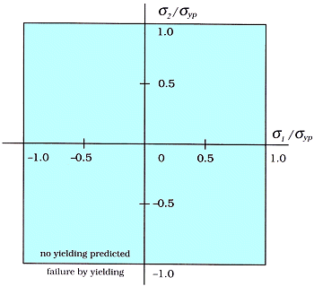
(classes.mst.edu,2020)

Yielding
(iue.tuwien.ac.at,2020) stated that the study of yielding is motivated by the wish to predict mechanical failure of materials. Yielding is considered as the beginning of a process that will lead to failure, by the breaking of the bonds between atoms and leading to material separation. (iue.tuwien.ac.at,2020) also says it takes roughly 1/3 of the young’s modulus to do this but ductile materials fail with stress values far smaller, stating instead of the rupture of atomic bonds, the material is separated by the sliding of atoms shown in figure 2 below.
Figure 3 -
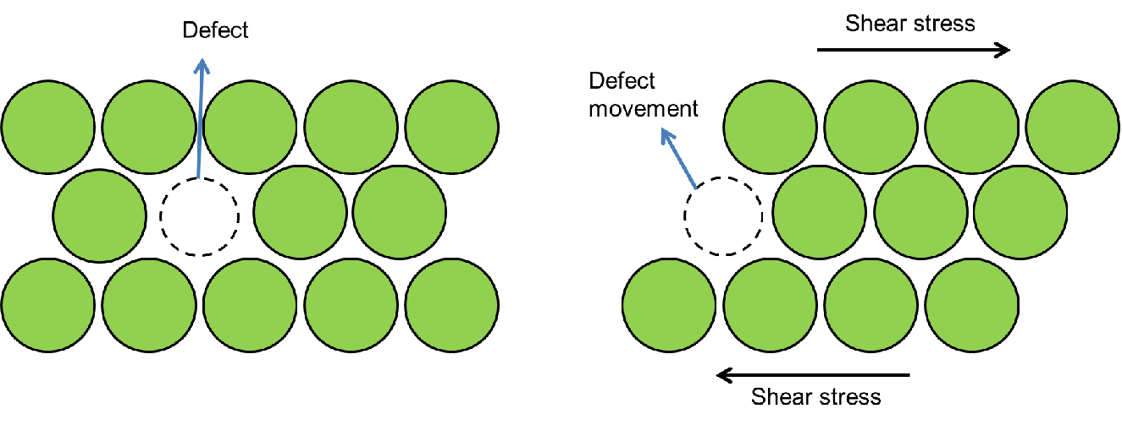
(iue.tuwien.ac.at,2020)

The Maximum Shear strain energy theory (Von Mises Theory)
This is also known as the Von Mises Theory and is the value used to determine if a given material will yield or fracture and is mostly used for ductile materials such as metals. The Von Mises theory states that if the stress of a material under load is equal or greater than the yield limit of the same material under simple tension the material will yield (www.simscale.com,2020).
The Objective of this theory is to develop a yeild criterion for ductile metals that works for complex 3D loading conditions regardless of the mix of normal and shear stresses. The Von Mises stress does this by reducing the complex stress state down into a single scalar number value that can be compared to a metals yield strength (continuummechanics.org,2020).
(learneasy.info, 2020) also supports this by stating that the Von Mises criterion predicts when yield will occur in an isotropic and ductile material. The Von Mises stress value must stay under the materials tensile yield stress. Von Mises handles any complex 3D loading condition regardless of how the stresses are mixed and converts them down to a single number so it can be compared to the components tensile yield stress, which is said to be the best known property of the material.

VMS=
and yielding occures when VMS SY (David J Grieve,2014)
The (mechanisttimes.blogspot.com,2014) also states that ‘The maximum distortion energy theory’ for yielding is expressed as:-
(σ₁ – σ₂)² + (σ₂ – σ₃)² + (σ₃ – σ₁)² = 2σ_{e}²

All that this formula does is convert each of the six numbers that you input into a single value.
The von Mises stress is used as a default stress plot because it’s a way to show one value we’re concerned about, resolved stress. Von Mises is credited with producing, what is arguably the most accepted yield criterion. He designed the equation to produce a single value which can be compared to yield strength of a material , so if the value is higher than the yield strength the part will fail and if it is lower the part will not fail (design-point.com,2019). The theory is mostly used for ductile materials in place of maximum strain energy theory.

Figure 4– The Von Mises Stress plot
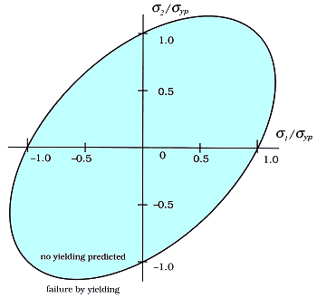

(classes.mst.edu,2020)

Maximum shear stress theory (Guest/Tresca’s theory)
This Criteria is often used to predict the yeilding of ductile material, this yeild in ductile materials is usually caused by slippage of crystal planes along the maximim shear stress surface. Due to this fact a given part is considered safe as long as the maximum shear stress at that point is under the yeild shear stress obtained from a tensile test. The maxium shear stress in 2D is related to the differnece in princiapl stresses, so the princiapl stress differnce and the principal stresses has to be less than the yeild shear stress (efunda.com,2020).
The maximum shear stress must be within the green area below to prevent failure by yielding.

Figure 5 - The Maximum Shear stress plot
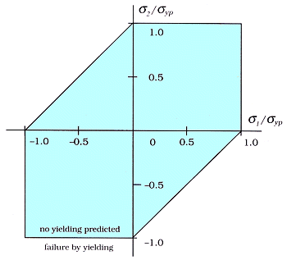(classes.mst.edu,2020)

(mechanisttimes.blogspot.com,2014) also states that the elastic failure occurs when the greatest shear stress exceeds or reaches the value of the shear stress at elastic limit in a simple tension test, and the theory is considered for ductile materials as shearing doesn’t occur in brittle materials.
(½)(σ₁ – σ₃) = (½)σ_{e} or σ₁ – σ₃ = σ_{e}
(mechanisttimes.blogspot.com,2014)

24 Tonne Crane hook
One component which is subjected to large forces within Trostre is our lifting devices. We require the use of overhead cranes for the movement of our product (coils) ranging up to 24 tonnes per coil.
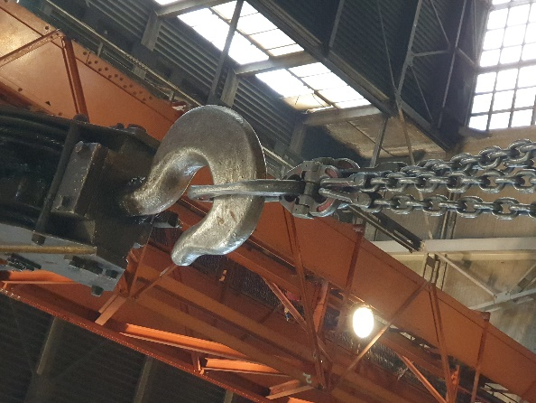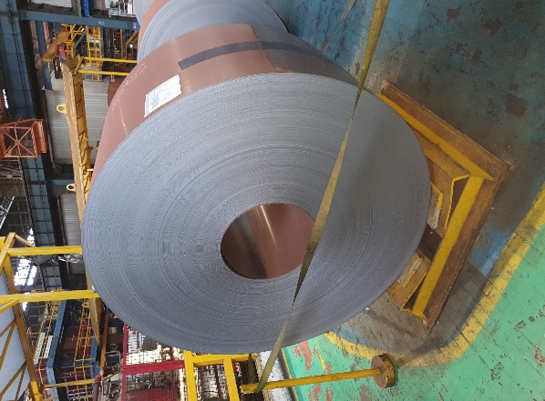
For us to use these safely, and to ensure the hooks we use can handle this weight without failing, a rigorous design process and testing must be applied.
Most lifting gear components consist essentially of curved beams of very ductile material, the radius of curvature often being small in comparison with the dimensions of the beam (H. J. Gough,1934).
(E. Narvydas, 2012) also agrees by stating that there is a requirement for the production of lifting hooks to use ductile materials such as low carbon steel to avoid brittle fractures, and in addition welding procedures are not allowed to avoid material embrittlement. Not adhering to these rules can cause dangerous failures.

(Abhijit Devaraj1, 2015) states that in ductile failure, the crack propagates continuously and therefore easier to detect and hence preferred over brittle fracture. In Brittle fractures there is a sudden propagation and the hook suddenly fails, which is very dangerous and difficult to detect.
(Abhijit Devaraj1, 2015) also states that the continuous use of crane hooks which increase the magnitude of stresses and eventually results in failure can be prevented if the stress concentration areas are well predicted and therefore design modifications can be made to reduce stress in these areas.

There are two well-known failure theories that cover the use of ductile materials, they are: The Maximum Shear strain energy theory (Von Mises Theory) and the Maximum shear stress theory (Guest/Tresca’s theory).

Figure 6 – Von Mises theory vs Tresca’s theory
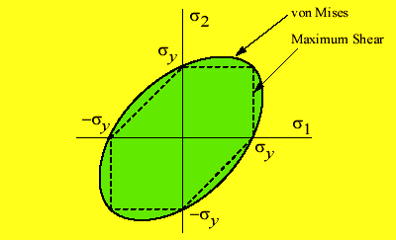
(mechanisttimes.blogspot.com,2014)
(The efficient engineer,2020) states that while both Tresca and Von mises theories agree well with experimental observations, The Von Mises Theory agrees better with the experimental observations while the Tresca theory is more conservative and therefore is the safer option with a maximum difference between the two theories of 15.5%.
(Richard M. Christensen, 2019) also supports this by saying that the difference between the Von mises and Tresca is about 15% but it is on the part of Tresca criterion and it should not be used for any isotropic materials or even ductile materials and also states that it is inappropriate to place the Tresca Criterion on the same level as the von mises criterion. (Richard M. Christensen, 2019) also states that the Tresca criterion only merits a historical reference and classes the Von mises criterion as a classical result.

Figure 7- Comparison of failure theories
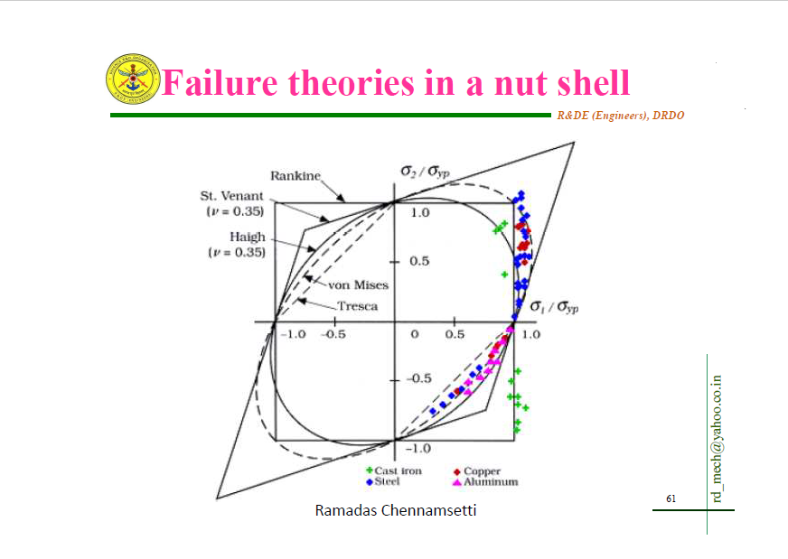
(Ramadas chennamsetti,2019) also supports this claim stating that for Aluminium, mild steel and copper experimental data shows good agreement with Von-mises theory and also states that Tresca comes back as conservative leading on to state that the Von mises theory is more accurate and generally used in design.
(Abhijit Devaraj1, 2015) says that the Von mises stress theory is considered in design work as the factor of safety in this theory is high which allows a safer design.

(Tony Abbey,2016) says the Von Mises stress is used as an overall indicator of stress distribution and to show the stress concentration location (shown in figure 7). (Tony Abbey,2016), also states the big advantage of the Von Mises stress plot is that it allows us to identify problem areas and the Von Mises stress level can be compared directly to the tensile yield stress, and gives good indications of its plastic performance. But, the disadvantage of using the Von Mises stress plot is that all the stresses are put into one scalar value, so only using the Von Mises stress plot could lead to not fully understanding the stress state such as tensile or compressive and we do not know if the stress state is Direct stress or Shear stress dominated.

Figure 8– Von Mises stress distribution in a component (A Crane Hook) in a CAD design.
(K. Kishore, 2020)

(K. kishore,2020) Also took this approach while analysing the design of a 24 tonne crane hook used in one of Trostre’s sister Plants in India. While studying the design specification as part of a root cause analysis to understand why the hook had failed and to pick up any design inefficiencies. To fully understand how the hook behaves under loading, many different aspects were looked at and the Von Mises stress was used to identify areas of stress concentrations and also play out different design scenarios to understand how they effected the performance/strength of the hook design.
In the design study, dimensional checks were carried out between the physical crane hook and its design drawing and also a visual inspection, where it was noted that where the hook failed there was a step, and change in the cross section, it was also noted that deep machining grooves were present near the fracture location (shown in figure 8). (K. kishore,2020) stated that the roll of surface finish on fatigue life of components is well documented.

Figure 9- Point of failure of the crane hook and location of machine tool marks.
(K. kishore,2020)

During the design study Fractographic analysis was carried out which concluded that the crack propagated under very low stress amplitude and points towards high cycle fatigue as it was calculated between 2.16x10*6 (lower) and (3.61x10*6). (K. kishore,2020) states that failures greater than 10*5 cycles/stress reversals is considered to be in the High Cycle Fatigue band.
Microstructural and chemical analysis was carried out and both complied with the specification of the steel grade. The Mechanical properties of the material were studied and a young’s modulus of 200 GPA was noted and a table showing the other properties such as Ultimate tensile strength, yield strength and total elongation where displayed (These values were found from a tensile test). It was noted that the mechanical properties complied to the steel specification.
To understand how the stresses were acting on the hook (K. kishore,2020) then modelled the hook as a curved beam (shown in Figure 9). (K. kishore,2020), stated that curved beam geometries experience two different stresses. The first is the bending stress experienced by the curved section of the beam and the second is the shaft portion subjected to direct stress. It was also stated that bending stress profiles are such that at the extreme ends experience maximum stress. In this case, the cross section there are two locations that experience the maximum stress, the outer section and the inner section.

Figure 10 – Hook modelled as a curved beam
(K. kishore,2020),
It was calculated using the Winkler Bach formula that the outer section experiences compressive bending stress and the inner section will experience tensile bending stress. As the failure location was in the stepped shaft region, this stress concentration was also calculated which was a lot higher than the curved section. By doing these calculations it justified why the hook failed at the stepped shaft and not the curved section. (K. kishore,2020) stated that the calculated stress was below the endurance limit of the hook material and therefore came to the conclusion that the tool marks identified on the visual inspection would have increased the stress at the failure location.
FEA was used to compare results obtained from analytical methods. The Von Mises stress distribution was used to compare this. The Von Mises stress (74MPa) closely agrees with the analytical result (61.9MPa). The FEA model was then used to plot the Von mises stress with the different size tool marks on the crane hook shaft.

Figure 11 – Distribution of Von-Mises stress with notch/ tool mark of 1 mm depth.
(K. kishore,2020),

From the FEA models it was noted that the tool marks up to 2mm increase the von mises stress with the maximum stress at 2mm (170MPa) and beyond this depth there is a reduction in stress concentration (as shown in figure 11).
Figure 12 – maximum Von-Mises stress compared with the depth of the machine tool damage.
(K. kishore,2020)

(K. kishore,2020), concluded that the fracture occurred from the threaded root near the step which is a potential stress concentration site. Finite Element analysis and the use of Von mises stress distribution confirmed this theory. The Finite Element Analysis and von mises stress (74MPa), showed good agreement with the analytical calculation (61.9MPa) and proved that the original hook design was correct. The deep tool marks (up to 2mm/170MPa) were proven to increase the stress concentration in that area. Leading to the recommendation of stringent visual inspections and no cranes with deep tool marks or notches should be allowed to operate, ultrasonic testing should also be incorporated into maintenance practices to detect the presence of cracks.

Conclusion
There are 5 well known theories of elastic failures, but the main 3 principles considered are Rankins (brittle), Tresca (ductile) and Von Mises (Ductile) theories . The aim of these principles is to predict how and when a component will fail when exposed to its working stresses to allow the component to be designed to prevent this failure. These criterion have different strengths and draw backs and some are aimed to be used with ductile material and some for brittle material.

Out of the design methods looked at, the Von mises Criterion was found to be the most accurate and widely used for design purposes but while this criterion is credited for its accuracy and ability to express complex stresses as a single value and identify stress concentration area’s it does not able the end user to understand how the stresses are acting on the part, for example there is no negative Von mises number so you will never know if the component is experiencing compressive or tensile stress (see appendix 3). For this reason it would be good practice to incorporate other analysis tools along side the von Mises criterion and FEA to further understand how the stresses are acting. (K. kishore,2020), adopted this approach while investigating the failure of a crane hook in a TATA Steel plant in India and used FEA and the von mises stress to compare against other analytical methods. It is also important to consider strain when designing components (see appendix 2).

Reference list
Abbey. Tony, 2016. Stress in FEA: Part 3 [online] available at;
https://www.digitalengineering247.com/article/stress-in-fea-part-3
[Accessed 20 November 2020]

bcrec.net.in, 2019. Theories of failure [online] available at;
https://www.bcrec.net.in/ME/design/19.pdf
[Accessed 14 November]

byjus.com, 2020. Strain energy [online] available at;
https://byjus.com/strain-energy-formula/
[Accessed 15 November 2020]

Bhagyaraj's. G, 2017. Crane Hook Design and Analysis [online] available at;
https://www.researchgate.net/publication/328880467_Crane_Hook_Design_and_Analysis
[Accessed 20 November 2020]

Christensen. Richard M, 2019. How Do Mises and Tresca Fit In [online] available at; https://failurecriteria.com/misescriteriontr.html
[Accessed 19 November 2020]

classes.mst.edu,2020. Failure theories [online] available at;
https://classes.mst.edu/civeng2211/lessons/failure/theories/index.html 2020
[Accessed 15 November 2020]

continuummechanics.org, 2020. What is Von Mises Stress [online] available at;
http://www.continuummechanics.org/vonmisesstress.html 2020
[Accessed 14 November 2020]

Chennamsetti. Ramadas, 2019. – theories of elastic failure [online] available at;
https://imechanica.org/files/theories%20of%20failure.pdf
[Accessed 14 November 2020]
Devaraj1. Abhijit, 2015. Design of a Crane Hook of Different Materials and
Stress Analysis Using ANSYS Workbench [online] available at;
https://www.ijraset.com/fileserve.php?FID=3160
[Accessed 18 November 2020]

drvsr.files.wordpress.com, 2020. Maximum principal Stress theory [online] available at;
https://drvsr.files.wordpress.com/2017/12/unit-5-lecture-3.pdf 2020
[Accessed 15 November 2020]

design-point.com, 2019. What is Von Mises stress [online] available at;
https://www.design-point.com/resource/blog/solidworks-simulation-what-is-von-mises-stress-part-2-of-2/
[Accessed 14 November 2020]

engweb.swan.ac.uk, 2020. Failure Theories [online] available at;
https://engweb.swan.ac.uk/~c.kadapa/teaching/2017-2018/EGF316/week4/EGF316%20Theories%20of%20Failure%20and%20Stress%20Concentrations.pdf
[Accessed 16 November 2020]

efunda.com, 2020. Ductile failure criteria [online] available at;
https://www.efunda.com/formulae/solid_mechanics/failure_criteria/failure_criteria_ductile.cfm 2020
[Accessed 14 November 2020]

Grieve. David J, 2014. Von Mises [online] Available at;
http://www.mechengdesign.co.uk/PlannedWeb/lec5fail.htm
[Accessed 15 November 2020]

Gough. H. J, 1934. Design of Crane Hooks and Other Components of Lifting Gear [online] available at;
.(1934https://journals.sagepub.com/doi/abs/10.1243/PIME_PROC_1934_128_014_02?journalCode=pmea
[Accessed 18 November 2020]

idc-online.com, 2020. Theories of Elastic failure [online] Available at;
http://www.idc-online.com/technical_references/pdfs/mechanical_engineering/Theories_of_Elastic_Failure.pdf
[Accessed 12 November 2020]

iue.tuwien.ac.at, 2020. Yield Criteria [online] avalable at ;
https://www.iue.tuwien.ac.at/phd/singulani/disssu8.html 2020
[Accessed 12 November 2020]

learneasy.info, 2020. Introduction into FEA [online] available at;
http://www.learneasy.info/MDME/MEMmods/MEM09155A-CAE/010-Intro-FEA/Intro-FEA.html
[Accessed 21 November 2020]

languages.oup.com, 2020. Strain Energy [online] available at;
https://languages.oup.com/google-dictionary-en/
[Accessed 9 November 2020]
Lothar. Wolf, 2015. INTRODUCTION TO STRUCTURAL MECHANICS [online] available at;
https://ocw.mit.edu/courses/nuclear-engineering/22-312-engineering-of-nuclear-reactors-fall-2015/readings-and-assignments/MIT22_312F15_note_L4.pdf
[Accessed 23 November 2020]

mesubjects.net, 2014. Theories of Elastic Failures [online] Available at;
http://www.mesubjects.net/theories-elastic-failures/
[Accessed 10 November 2020]

mechanisttimes.blogspot.com,2014. Hencky – Von mises theory [online] Available at;
https://mechanisttimes.blogspot.com/2014/07/hencky-von-mises-theory.html
[Accessed 12 November 2020]

mechanisttimes.blogspot.com, 2014. Tresca Theory [online] available at;
https://mechanisttimes.blogspot.com/2014/07/guests-or-trescas-theory.html
[Accessed 12 November 2020]

Narvydas. E, 2012 . Volume 18(2): 152-157. Circumferential stress concentration factors at the asymmetric shallow notches of the lifting hooks of trapezoidal cross-section [online] available at;
http://dx.doi.org/10.5755/j01.mech.18.2.1574
[Accesses 15 November 2020]

simscale.com, 2020. What is Von Mises Stress [online] available at;
https://www.simscale.com/docs/simwiki/fea-finite-element-analysis/what-is-von-mises-stress/
[Accessed 15 November 2020]

The efficient engineer, 2020. Understanding Failure Theories [online] Available at ; https://www.youtube.com/watch?v=xkbQnBAOFEg
[Accessed on 16 November 2020]

Kishore. K, 2020. Shri Guru Gobind Singhji Institute of Engineering and Technology, Nanded, Maharashtra, India, Failure analysis of a 24 T crane hook using multi-disciplinary
Approach [online] available at;
.https://pdf.sciencedirectassets.com/271094/1-s2.0-S1350630720X00070/1-s2.0-S1350630720300984/main.pdf?X-Amz-Date=20201117T164848Z&X-Amz-Algorithm=AWS4-HMAC-SHA256&X-Amz-Signature=6f114b3098db284eba68721731ffb995b0429359150318757364d4b060b36fd8&X-Amz-Credential=ASIAQ3PHCVTYUW2IWVX5%2F20201117%2Fus-east-1%2Fs3%2Faws4_request&type=client&tid=prr-422cab22-3c08-4d69-ab40-99bbb8e1e433&sid=a9ea646f5b83d84d9409c8105f12263aa3d4gxrqb&pii=S1350630720300984&X-Amz-SignedHeaders=host&X-Amz-Security-Token=IQoJb3JpZ2luX2VjELj%2F%2F%2F%2F%2F%2F%2F%2F%2F%2FwEaCXVzLWVhc3QtMSJIMEYCIQDGH57DrYoLF2vIqCRii%2BJU5tD0ad5M7b9%2ByywF0BV8RQIhAMzdvpCPnjcKvHq5PE1F1YmsDyq%2B6TnvvCmNgzJWyXlsKrQDCDEQAxoMMDU5MDAzNTQ2ODY1IgyT%2BMtVS4n9NM9wWIEqkQPFAOHKi7CX0oUgirBKP296ZSQqfayywPRCOAhQiQVFq6o2vndSOOrEnflPa6%2BbMzl3PTRXWshUccGQefn9HeHqBSuHb7Sm4ngOLxi3h7Z9IY31oOyzNdV48tS4GQ7uLj4kWyVSIDmtEB4DvzBhOHZP4Huxb5WAaylKWw8AvLTW76qFCb2eaW65YGD8Czj7xCx1VBsl%2Fh5UeD2SyJ%2FnCZo%2FrfaF8143w0RD6bjlpPj8vLFerTpg%2BX4RsQRbfOc%2FKPvWFRxE8PezaL%2Bb3GSsaCBi8c5uthE5GS%2FUD7wL%2FFy141BMEFdx%2BhZ6b0fuSxmr9%2FphVCzaUWqjQ7vwq6DtEORh3kE%2BMdi4hGvaCq0LGX776fxV2fWJtTiCAD7pH%2FEq787F5xLf6y2dOOeSCRPxKzQonnpUESAof1N954w%2BcqB6PhYDAO6Q4ZNz1lrmFNuuyADyN27tsEGAwP3py%2BpEmyjKcCe%2FI%2FOAxdN0KYLSVIwliCUD9rKIzp%2FFQogFJyTO1Owlg%2FaAje9h2P3DFO5EN3nr3zDG58%2F9BTrqAZRWPJEuiXjpKm6ixUKIBYJ1OtvGPLgreGCRTKC5xSWABkNvp%2FdBs0tsd3bCeEY1f8pbG%2Bz8Dp660GCt4tgkcf6E4fM8J9SyrfW3Xgy0kM6XewWt6RXGXJnxkCS2O92MKyxJcHqn4zuPY73mkxU1YwjI2WvGbGMeWQbtvD3u5%2BmSK5E%2FNpK0Bj1eeAAnTOm%2BSyoBCYvjt8dXuxcSJor55zaastdGagKSq2Cpql7BMdjMXA87grulIlrUIUcAhSHoBuu7NdifNELY%2Fu7g%2Bv3ZL3Krj6GNpSGWACglef%2BxIJGIsi6ptHAc70M%2FzA%3D%3D&host=68042c943591013ac2b2430a89b270f6af2c76d8dfd086a07176afe7c76c2c61&X-Amz-Expires=300&hash=a83e3ccb9ec5a7628f89be38c36a157329f36b4b90cee99c2897b84daf12de80
[Accessed 17 November 2020]

Bibliography
engr.mun.ca, 2020. Maximum principle theory [online] available at;
https://www.google.co.uk/search?q=Maximum+principal+theory+(Rankine%E2%80%99s+Theory)&rlz=1T4AWVA_enGB835GB903&ei=yxixX-3OFIfBgQbIpp3oCg&start=10&sa=N&ved=2ahUKEwit4NLEwITtAhWHYMAKHUhTB60Q8tMDegQIEBA6&biw=1366&bih=666#spf=1605441761502
[Accessed 15 November 2020]

failurecriteria.com, 2017. Von Mises Criterion [online] available at;
https://failurecriteria.com/misescriteriontr.html 2017
[Accessed 15 November 2020]

google.com, 2018. Maximum principal theory [online] available at;
https://www.google.co.uk/search?q=Maximum+principal+theory+(Rankine%E2%80%99s+Theory)&rlz=1T4AWVA_enGB835GB903&ei=yxixX-3OFIfBgQbIpp3oCg&start=10&sa=N&ved=2ahUKEwit4NLEwITtAhWHYMAKHUhTB60Q8tMDegQIEBA6&biw=1366&bih=666#spf=1605441761502
[Accessed 15 November 2020]

Jadhav. Prof. M. V., 2017. THEORIES OF ELASTIC FAILURE [online] available at;
https://maheshjadhav903086836.files.wordpress.com/2017/11/theories-of-elastic-failure.pdf
[Accessed 15 November 2020]

Theories of failure, 2018. Theories of failure [ online] available at;
file:///C:/Users/NEWUSE~1/AppData/Local/Temp/Theories%20of%20Failure2.pdf
[Accessed 15 November 2020]

unm.edu, 2020. Von Mises stresses [online] available at ;
http://www.unm.edu/~bgreen/ME360/von%20Mises%20Stresses.pdf.
[Accessed 14 November 2020]

thegateacademy.com,2020. Theories of failure [online] available at;
http://thegateacademy.com/files/wppdf/Theories-of-failure.pdf
[accessed 21 November 2020]

Appendix 1 – Science direct research Paper details

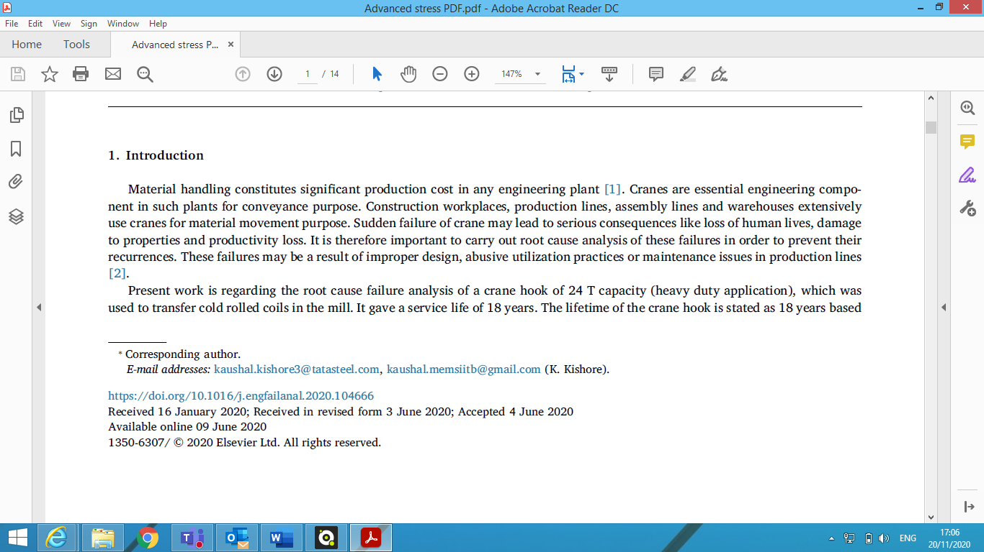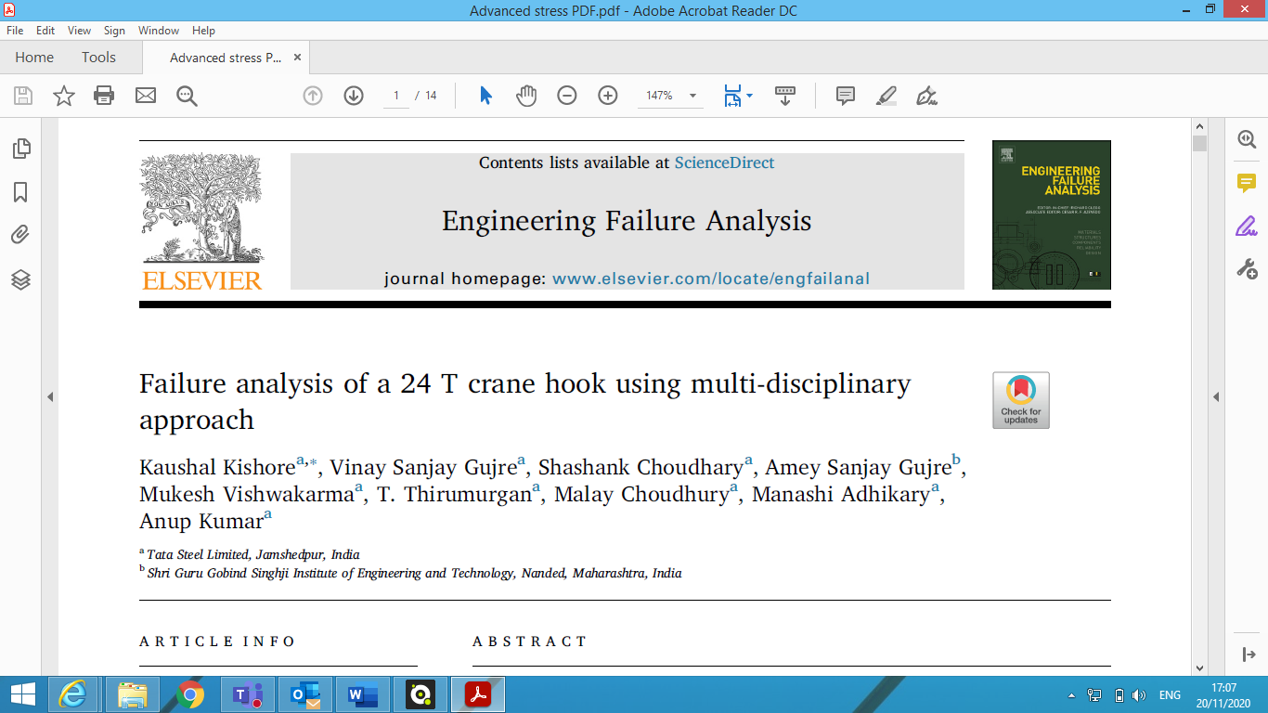

Appendix 2 - Strain Energy

is energy stored in an elastic body under loading (languages.oup.com, 2020). The application of a load produces strain in the component which increases the energy level. Strain energy is defined as the energy absorbed by the component during the loading process (idc-online.com,2020).
(byjus.com,2020) also states that strain energy is defined as the energy stored in a body due to deformation and the strain energy per unit volume is known as the strain energy density and it’s the area under the stress/strain curve towards the point of deformation. When the force applied is released the component returns back to its original state.
In brief the Strain energy is calculated by the Applied load squared times by the length divided by 2 times the product of the related constants.
(Lothar Wolf, 2015) stated that the concept of strain is fundamentally important to the engineer in respect to deformations and deflections. A component may prove unsatisfactory in service as a result of excessive deformations even though the stresses are well within the allowable limits in regards to stand point of fracture or yielding. Strain is a directly measurable quantity, stress is not.

Appendix 3 – Definition of forces
(Lothar Wolf, 2015) states that forces are vector quantities so therefore have direction and magnitude;
- Compressive forces act normal and into the plane;
- Tensile forces act normal and out of the plane; and
- Shear forces act parallel to the plane.
- Pairs of oppositely directed forces produce twisting effects called moments
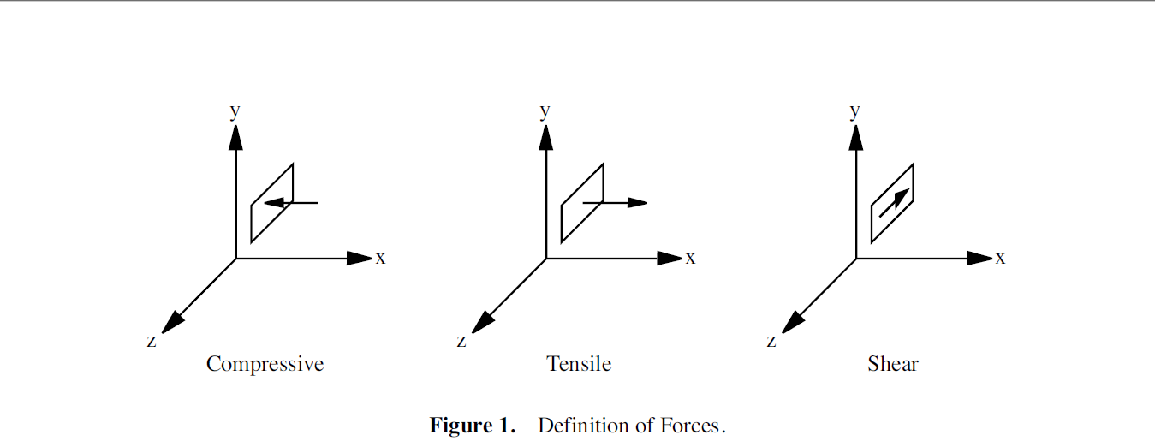
(Lothar Wolf, 2015)

