Module | Marketing Management
Module Code | LCMB7024
Student Name/ ID | Harsh Pyarelal Dhabhai/ 2541472
Assignment Title | Marketing Strategy for IKEA EcoLoop: Developing a Sustainable Circular Brand Extension for Long-Term Competitive Advantage
Submission Date | 08/08/2026

Table of Contents
Element 1: Sustainable Brand Extension Poster Presentation 2
Element 2: Segmentation, Targeting, Differentiation and Positioning (STDP) 3
2.1 Introduction 3
2.2 Market Segmentation 3
2.3 Targeting Strategy 4
2.4 Differentiation Strategy 5
2.5 Positioning 5
Element 3: Marketing Mix 6
3.1 Product 6
3.2 Price 7
3.3 Place 8
3.4 Promotion 8
Element 4 Reflection (Gibbs' Reflective Cycle) 10
4.1 Description 10
4.2 Feelings 10
4.3 Evaluation 10
4.4 Analysis 11
4.5 Conclusion 11
4.6 Action Plan (SMART) 11
Reference 13

List of Tables
Table 1: IKEA EcoLoop Target Segments 6
Table 2: IKEA EcoLoop Pricing Strategy 10
Table 3: SMART Action Plan 13

List of Figures
Figure 1:IKEA 5
Figure 2: VRIO 7
Figure 3: Perceptual Map 8
Figure 4: Gibbs' Reflective Cycle 12

Element 1: Sustainable Brand Extension Poster Presentation
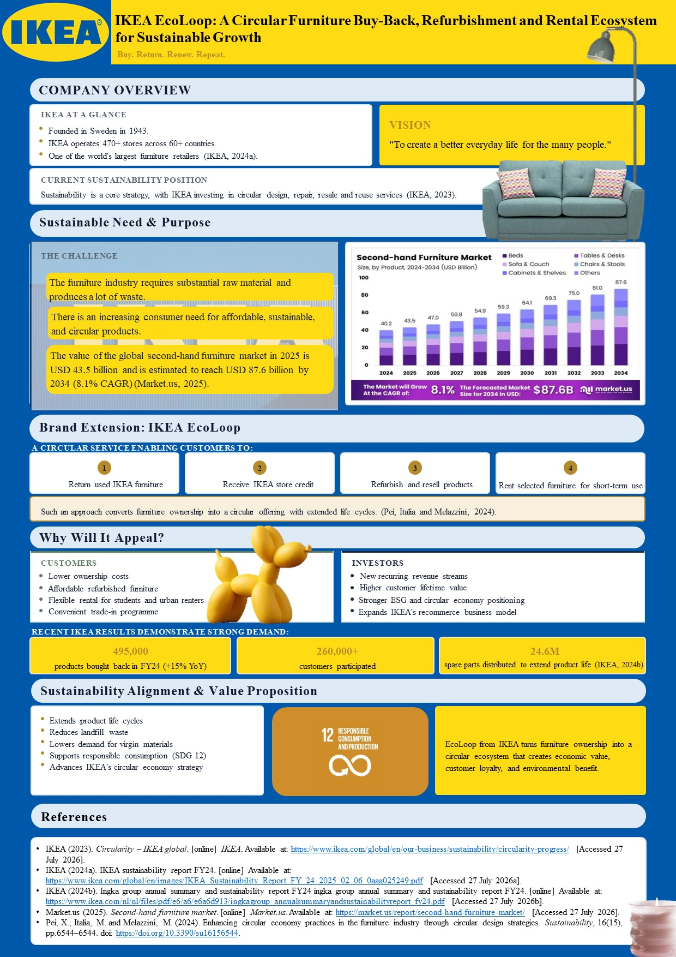

Element 2: Segmentation, Targeting, Differentiation and Positioning (STDP)

2.1 Introduction
IKEA is among the biggest players in the global furniture retail market, with over 470 stores in more than 60 countries. In FY2024, IKEA further enhanced its circular strategy and successfully resold over 495,000 used items from 260,400 customers, indicating growing consumer interest in sustainable services (Ingka, 2025b). With increasing competition and consumer expectations of sustainable services, a well-structured marketing strategy becomes very important. Kotler et al. (2024) claim that through the Segmentation, Targeting, Differentiation and Positioning (STDP) process, firms are able to find attractive target segments, develop greater customer value and secure better competitive position (Anderluh et al., 2025).
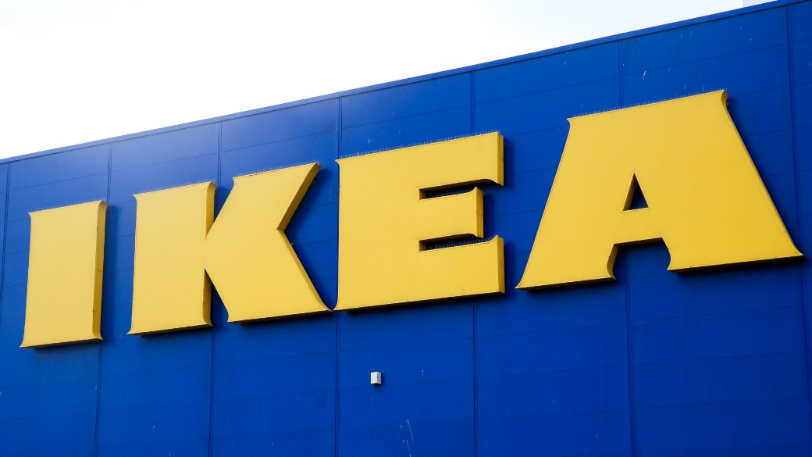
Figure 1:IKEA
Source: (Clifford, 2019)

2.2 Market Segmentation
As mentioned by Kotler et al. (2024), proper segmentation makes marketing resource allocation more efficient and allows for better customer value creation. But in the sustainability-oriented market environment, demographic factors are not enough anymore, as values and practices of circular consumption become increasingly important drivers of buying decisions. Regarding geographical segmentation, the largest urban markets will be of interest for IKEA EcoLoop owing to greater population density, urban apartment renting and the need for flexibility of furniture possession. In terms of demographics, students, young professionals, and young families of 18-45 with average income will stay commercially attractive due to frequent relocation and budget constraints, yet these characteristics explain who customers are rather than why they adopt circular services. The empirical research indicates that psychological factors, especially environmental consciousness, functionality, and aesthetics, greatly affect the intentions of the consumers to buy used furniture (Slaton, Testa and Garrett, 2024). Behaviourally, IKEA has already proved the validity of the identified opportunity: in FY2024, more than 260,400 customers in 28 markets returned more than 495,000 products, whereas more than 24.6 million spare parts were distributed to prolong product lifecycle (Ingka, 2025a). Thus, psychographic and behavioural segments should be used preferentially compared to demographics since they reflect the likelihood of adopting circular business models.

2.3 Targeting Strategy
Differentiated targeting strategy will be the most effective one for IKEA EcoLoop due to varying requirements of consumers for furniture and sustainable practices. Mass marketing will treat all customers in the same manner, which will dilute the sustainability image of EcoLoop, whereas the niche strategy will restrain growth. Using differentiated targeting strategy, IKEA can offer varied solutions to different segments while applying the same circular business model. The effectiveness of this targeting strategy has been proven by market data as well. In FY2024, there was a 15% growth in the number of products that were returned via IKEA's Buyback service, accounting for more than 495,000 products in 28 countries. IKEA also distributed 24.6 million spare parts to help customers repair and reuse furniture, showing growing demand for circular services (IKEA, 2024).
Table 1: IKEA EcoLoop Target Segments
Segment | Customer Group | Why They Matter
Primary | Students & young professionals | Need affordable, flexible furniture and are more open to rental and resale.
Secondary | Small families | Want durable, lower-cost furniture with buy-back and repair options.
Future | Businesses & property developers | Increasing demand for sustainable furnishing solutions and circular procurement.

2.4 Differentiation Strategy
In contrast to other furniture sellers, second-hand shops, and rent-a- furniture companies, IKEA EcoLoop provides a combination of all of these services under one brand name into a circular economy system. Traditional retailers earn money mostly from selling new products, whereas second-hand shops cannot provide any guarantees regarding the quality of their goods and after-sale services (Bhagat, Ravi and Sankar, 2024). Using VRIO analysis, it can be said that IKEA’s global brand name, large retail network, and circular system features are valuable and hard to imitate. In FY25, IKEA collected around 686,500 used items of IKEA products through the company’s Buyback program, opened As-Is areas in 424 stores, and introduced a Peer-to-Peer IKEA Second-hand Marketplace in three countries across Europe (Ingka, 2025c).
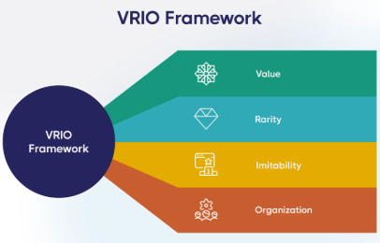
Figure 2: VRIO
Source: (Messineo, 2024)

2.5 Positioning
For environment-conscious urban consumers looking for budget-friendly and flexible furniture solutions, IKEA EcoLoop can be regarded as a circular furniture ecosystem which allows buying, returning, repairing, refurbishing, selling and renting of IKEA furniture in an economically viable and eco-efficient manner. While conventional furniture stores mostly cater to one-time sales and used furniture markets lack quality assurance, IKEA EcoLoop provides a dependable and efficient circular solution supported by IKEA’s brand name and stores. Thus, the position statement supports IKEA’s mission of offering affordable sustainable lifestyles to the many people.
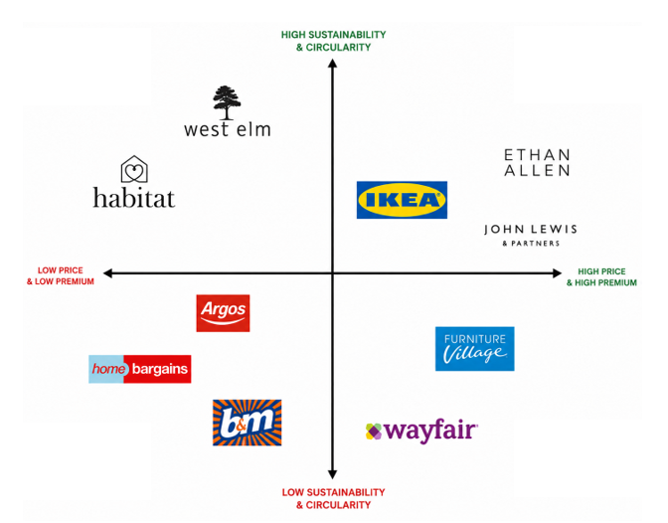
Figure 3: Perceptual Map
Source: Self-made
In Figure 3, IKEA EcoLoop is positioned in the high sustainability and high affordability quadrant. Whereas West Elm and Habitat offer high sustainability, they are positioned as not being very affordable. On the other hand, Ethan Allen and John Lewis are positioned based on the high quality of their offerings at a relatively higher price, while Argos, B&M, and Home Bargains are mostly focused on competing on price and offering low sustainability positioning. The two furniture firms of Furniture Village and Wayfair are positioned as premium with lower circularity. In order for IKEA EcoLoop to gain competitive advantage, it is positioned on the basis of offering affordable price, circular services and a global brand.

Element 3: Marketing Mix

3.1 Product
The primary product offered by IKEA EcoLoop is the eco-friendly and cost-effective way of home furnishing. This product allows its customers to get what they need without any waste. The extended product includes the process of buying back, refurbishing, reselling, repairing, renting, and providing spare parts. Augmented product increases the value of customer experience through the use of the IKEA app, digital product information, warranties, assembly advice, and after-sales support. According to research, PSS increases efficiency of resource utilization and develops a relationship with customers through shifting the focus of value creation from possession to product utilization and lifecycle management (Alfarisi, Shimomura and Masudin, 2024).
From the strategy standpoint, the concept of circular economy is being achieved through extending life cycle of products, decreasing dependence on the production of new material, and getting profits from providing circular services instead of selling furniture one time only. According to the results of IKEA FY2025, this strategy can be scaled as the company successfully processed almost 686,500 used products using the Buyback service, opened As-Is areas in 424 stores, and introduced the IKEA Second-hand Marketplace in Norway, Portugal, and Spain.
Nonetheless, there are difficulties when employing a PSS strategy. Research shows that reverse logistics, cost of refurbishment, quality control, and digital tracking of the product need substantial financial investment to earn customers’ trust and make profits (Sonar et al., 2024). Hence, competitive advantage for IKEA depends on providing as well as managing the circular services.

3.2 Price
An appropriate pricing approach that should be used by IKEA EcoLoop is value-based pricing, considering the value customers receive in terms of furniture and circular services. In order to ensure that refurbished products are attractive enough to the target customers, they should be priced 20–40% lower than new products. Store credit offered within the Buyback programme can be used to stimulate repeat purchases and foster loyalty. In addition, monthly rental subscription will allow customers to use the needed furniture temporarily, especially students and city residents. Also, dynamic pricing should be considered for refurbished products depending on their condition, age and market demand to maximize inventory rotation. This pricing approach will help the company to achieve its goal of affordability, leading to a 3% rise in the number of customers and sales volumes in FY25, due to 10% prices reduction over two years. However, too frequent discounting can lead to lowering of the quality perception of the product and low profit margins, dynamic pricing can raise some issues with price fairness. Thus, IKEA should find a balance between affordability and quality assurance.
Table 2: IKEA EcoLoop Pricing Strategy
Pricing Element | Application | Strategic Benefit
Store Credit | Credit for returned furniture | Encourages repeat purchases and customer retention
Rental Subscription | Monthly payment for selected furniture | Increases affordability and recurring revenue
Refurbished Pricing | 20-40% lower than new products | Attracts price-sensitive and sustainability-conscious customers
Dynamic Pricing | Prices vary by condition, demand, and product age | Improves inventory turnover and profitability

3.3 Place
IKEA EcoLoop should implement an integrated omnichannel distribution model including physical stores, the IKEA website, mobile application, collection centres, warehouses and reverse logistics to ensure accessibility of circular services. It would be possible to sell, rent, return and trade furniture via different distribution channels; at the same time returned goods would be delivered to the warehouses to undergo inspection, refurbishment and resale. According to research, reverse logistics and closed-loop supply chains play a key role in resource recovery and circular business models implementation (Rouhani, Wardley and Amin, 2025). In addition, IKEA has sufficient capacity to implement such a strategy. In FY25, the company had 620 customer meeting points, received 739 million store visits, 4.0 billion online visits, and its revenue was EUR 41.5 billion, proving the developed omnichannel model for providing EcoLoop services (Ingka, 2019). Nevertheless, multiple channels of reverse logistics increase transportation expenses, the complexity of inventory management and refurbishment lead times. Moreover, in its FY25 report, the company stated that there are logistic, infrastructure, and regulatory difficulties in the process of scaling circular services. Thus, the company needs to invest in digital supply chain visibility, warehouse and reverse logistics operations in order to satisfy the customer’s needs.

3.4 Promotion
EcoLoop from IKEA requires implementing an Integrated Marketing Communications (IMC) approach that promotes the circular value proposition at all customer points of contact. The communications should not be only about promoting products but about getting customers to move from the possession of the furniture to the use, return, repair, and reuse of it. Sustainability communication should show the benefits that EcoLoop offers environmentally and financially, giving the customers an understanding of how they contribute to reducing waste and building a circular economy. The FY25 IKEA sustainability strategy highlights marketing and communications as essential tools for sustainable living affordability and attractiveness.
The digital marketing campaign through the IKEA website and app should involve personalised suggestions while the e-mail marketing and IKEA Family loyalty program can offer rewards for furniture returns, product rentals, and refurbished products. UGC and customer reviews can increase brand trust through evidence of true experiences with the EcoLoop, while collaboration with influencers who focus on sustainability can enhance credibility in the young generation. The latest empirical research has proven that influencer marketing increases consumer engagement and purchase intention in case when consumers consider content as genuine and credible (Migkos, Giannakopoulos and Sakas, 2025).
However, it should be ensured that greenwashing does not become part of the promotion process. Statements about sustainability that lack facts may damage the reputation of companies and affect customer relations negatively. For this reason, all communications should be followed up by real environmental accomplishments and reports.
Marketing Mix Integration
IKEA EcoLoop success is determined by the interaction between Product, Price, Place, and Promotion; altogether, they provide customers with a consistent experience. While the Product the circular product ecosystem is made possible through pricing based on cost-effectiveness and buyback (Price), making sustainability an easier option for customers, IKEA's omni-channel strategy, comprising brick-and-mortar shops, digital presence, and reverse logistics (Place), ensures that customers will be able to reach their products. Lastly, integrated marketing communications (Promotion) ensure that customers are motivated and educated towards circular consumption. These four factors consolidate IKEA's positioning as a furniture retailer with affordability, accessibility, and sustainability.

Element 4 Reflection (Gibbs' Reflective Cycle)
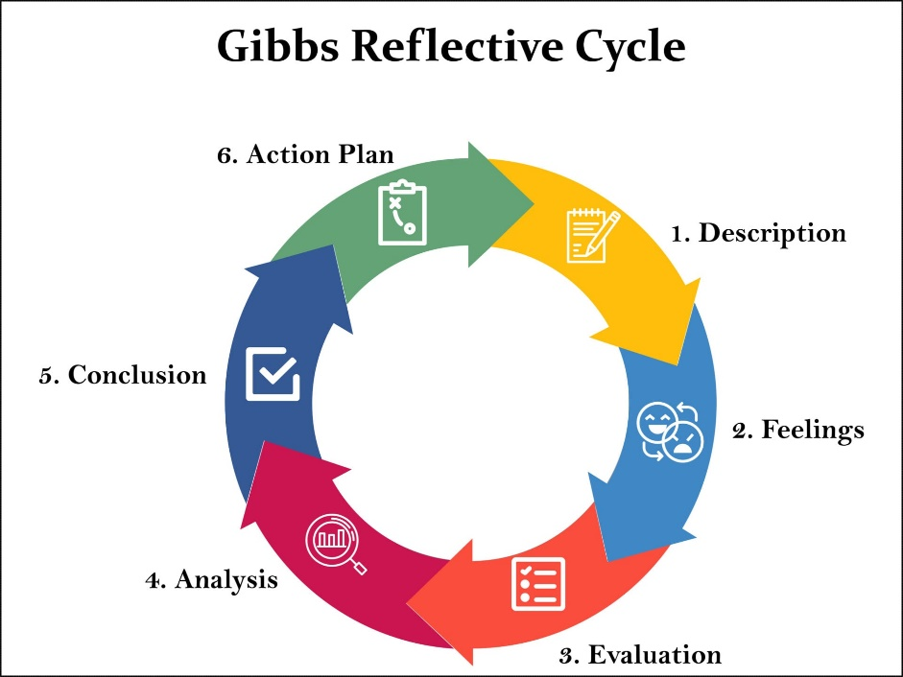
Figure 4: Gibbs' Reflective Cycle
Source: (McLeod, 2025)

4.1 Description
In this assessment, I was asked to come up with IKEA EcoLoop, a sustainable brand extension consistent with the circular economy approach of IKEA. The assessment process comprised the use of the STDP model and the marketing mix in coming up with a real marketing strategy based on contemporary research in the field of marketing. Creating the poster also meant explaining difficult marketing concepts in a concise manner in order to present a viable solution.

4.2 Feelings
At the early stage of my project, it was quite difficult for me to integrate sustainability, brand, and strategic marketing into a single concept. My initial confidence on IKEA's vision on sustainability remained the same, but there were concerns whether I could analyse the situation from a higher level marketing framework perspective rather than just describing things.

4.3 Evaluation
One of the strengths of this project was tying sustainability into all marketing decisions rather than making it into an additional goal for business. The STDP model and marketing mix enabled me to see the effects of every decision on the customers' value and competitive advantage. Working on the poster also made me better at expressing complex ideas in an understandable and clear way. At first, I was concentrating more on presenting the theory of marketing concepts than evaluating alternatives. With the help of continuous academic research, I understood that in order to do postgraduate research, one should be able not only to present but also to critically compare and justify different options for action based on evidence (Trimasse, 2024).

4.4 Analysis
Through this assessment, I was able to enhance my strategic thinking capability through understanding that in order for marketing to be successful, there is a need for proper alignment between the needs of the customer and the capability of the organisation as well as sustainability issues. Academic research on this issue helped me to develop my critical thinking skills since there was a need to consider other perspectives before coming up with strategic decision-making recommendations. Moreover, through the presentation of the proposal, my communication skills were developed through being required to give concise and persuasive arguments.

4.5 Conclusion
In summary, this evaluation has helped me gain the skills that enable the application of theory to practice by coming up with marketing strategies that yield value to both business and environment. Even more important is that it has helped me gain analytical thinking skills, research skills, communication skills, and strategic decision-making skills, which are crucial for future professional practice.

4.6 Action Plan (SMART)
Table 3: SMART Action Plan
SMART | Action Plan
Specific | Strengthen my critical analysis, presentation, and strategic decision-making skills in future marketing projects.
Measurable | Support every major recommendation with at least 20 recent peer-reviewed sources and critically compare alternative viewpoints.
Achievable | Review recent marketing literature weekly and practise presentations before each assessment to improve confidence and delivery.
Relevant | These actions will improve my ability to develop evidence-based marketing strategies and communicate recommendations effectively.
Time-bound | Implement these actions throughout the next academic semester and evaluate my progress after each assessment.

Reference
Alfarisi, S., Shimomura, Y. and Masudin, I. (2024). Advancing product service systems - Life cycle assessment: Robust method for sustainability assessment. Cleaner Production Letters, [online] 7, p.100081. doi: https://doi.org/10.1016/j.clpl.2024.100081.
Anderluh, A., Hackl, R., Mesbahi, Z., Pellegrini, T. and Raffler, C. (2025). Consumers’ affinity to the circular economy: empirical evidence utilizing the circular economy cube. Journal of Cleaner Production, 525, p.146539. doi: https://doi.org/10.1016/j.jclepro.2025.146539.
Bhagat, S., Ravi, S.S. and Sankar, M. (2024). Decoding Retail Realities: Traditional Retailers” Outlook on Sales Erosion to Modern Retail Economy. Theoretical and Practical Research in Economic Fields, 15(1), pp.17–17. doi: https://doi.org/10.14505/tpref.v15.1(29).02.
Clifford, C. (2019). The psychology behind IKEA’s iconic success. [online] CNBC. Available at: https://www.cnbc.com/2019/10/05/psychology-behind-ikeas-huge-success.html [Accessed 29 July 2026].
IKEA (2024). IKEA Sustainability Report FY24. [online] Available at: https://www.ikea.com/global/en/images/IKEA_Sustainability_Report_FY_24_2025_02_06_0aaa025249.pdf [Accessed 29 July 2026].
Ingka (2019). IKEA retail | ingka. [online] Ingka. Available at: https://www.ingka.com/what-we-do/ikea-retail/ [Accessed 29 July 2026].
Ingka (2025a). Ingka Group Annual Summary and Sustainability Report FY24 Ingka Group Annual Summary and Sustainability Report FY24. [online] Available at: https://assets.site.ingka.com/ingka-com/reports/ingkagroup_annualsummaryandsustainabilityreport_fy24.pdf [Accessed 29 July 2026a].
Ingka (2025b). Ingka group reporting – reduction in climate footprint by 30.1% while growing the business | ingka group. [online] Ingka Group. Available at: https://www.ingka.com/newsroom/ingka-group-reporting-reduction-in-climate-footprint-by-30-1-while-growing-the-business/ [Accessed 29 July 2026b].
Ingka (2025c). ​Ingka Group Annual Summary and Sustainability Report FY24 | Ingka Group. [online] Ingka Group. Available at: https://www.ingka.com/annual-summary-and-sustainability-report/ [Accessed 29 July 2026c].
Kotler, P., Keller, K.L. and Chernev, A. (2024). Marketing management. Harlow: Pearson.
McLeod, S. (2025). gibbs reflective cycle. [online] Simply Psychology. Available at: https://www.simplypsychology.org/gibbs-reflective-cycle.html [Accessed 29 July 2026]
Messineo, R. (2024). VRIO analysis: The framework to identify competitive advantages. [online] ClearPoint Strategy. Available at: https://www.clearpointstrategy.com/blog/vrio-framework [Accessed 29 July 2026].
Migkos, S.P., Giannakopoulos, N.T. and Sakas, D.P. (2025). impact of influencer marketing on consumer behavior and online shopping preferences. Journal of theoretical and applied electronic commerce research, [online] 20(2), pp.111–111. doi: https://doi.org/10.3390/jtaer20020111.
Rouhani, S., Wardley, L.J. and Amin, S.H. (2025). A comprehensive survey into reverse logistics and closed-loop supply chain aspects to provide analyses and insights for implementation. Journal of Cleaner Production, [online] p.144743. doi: https://doi.org/10.1016/j.jclepro.2025.144743.
Slaton, K., Testa, D.S. and Garrett, S. (2024). The secondary home furnishing consumer: An investigation into psychological motivations and purchase intention. Sustainability, 16(18), p.8169. doi: https://doi.org/10.3390/su16188169.
Sonar, H., Sarkar, B.D., Joshi, P., Ghag, N., Choubey, V. and Jagtap, S. (2024). Navigating barriers to reverse logistics adoption in circular economy: an integrated approach for sustainable development. Cleaner Logistics and Supply Chain, 12, pp.100165–100165. doi: https://doi.org/10.1016/j.clscn.2024.100165.
Trimasse, N. (2024). The use of reflective reports in higher education. Reflective Practice, 26(1), pp.1–18. doi: https://doi.org/10.1080/14623943.2024.2424520.

