INTEGRATING PROJECT

Designing a Welcome Board using LCD

Assessment 1

Introduction
Welcome boards are an essential element of any establishment, be it an office, a hotel, a school, or a public venue. They serve as a visual greeting, providing information, directions, and a warm welcome to visitors. Traditional welcome boards often use printed signs, but with advancements in technology, modern welcome boards can now be designed using Liquid Crystal Display (LCD) screens [1]. Designing a welcome board using an LCD screen opens up a world of possibilities for creative and dynamic displays that can capture attention and convey information in a visually appealing way.
The LCD screen can be programmed to display various content, including text, images, videos, and animations, which can be customized to suit the specific needs and branding of the establishment. The project will involve selecting an appropriate LCD screen size, designing the user interface and content, programming the LCD screen to display the desired content, and integrating it into a physical welcome board design. The end result will be a visually stunning and informative welcome board that enhances the aesthetics and functionality of any establishment.

Aim and objectives
Aim
This project aims to design a welcome board using an LCD screen, utilizing the capabilities of modern LCD technology to create a dynamic and engaging display.
Objectives
- To develop a welcome board using an LCD screen that can be used in a variety of settings.
- To create a visually engaging and informative display that can be customized for different environments.
- To use modern LCD technology to create a dynamic and interactive experience for users.
- To integrate the board with user-friendly software for easy content editing and management.
- To ensure the board is secure, reliable, and cost-effective.

Literature review

Concepts of LCD technology and its impact on visual displays
LCD (Liquid Crystal Display) technology is a widely used display technology that has revolutionized visual displays across various industries, including consumer electronics, telecommunication, automotive, medical, and more [2]. LCDs offer several advantages, such as high resolution, fast response times, and energy efficiency, making them the preferred choice for many applications. One of the key concepts of LCD technology is the use of liquid crystals to control the passage of light. Liquid crystals are a unique state of matter that exhibits properties of both liquids and solids. They can be manipulated to control the orientation and alignment of their molecules using electric fields, which in turn controls the passage of light through the display [3]. This allows for precise control over the intensity and color of the displayed image.
LCD technology has had a significant impact on visual displays. One of the major advantages of LCDs is their ability to produce high-resolution images, making them ideal for applications that require sharp and detailed visuals, such as in smartphones, tablets, computer monitors, and televisions [4]. LCDs also offer fast response times, which make them suitable for applications that require smooth motion reproduction, such as gaming and multimedia.
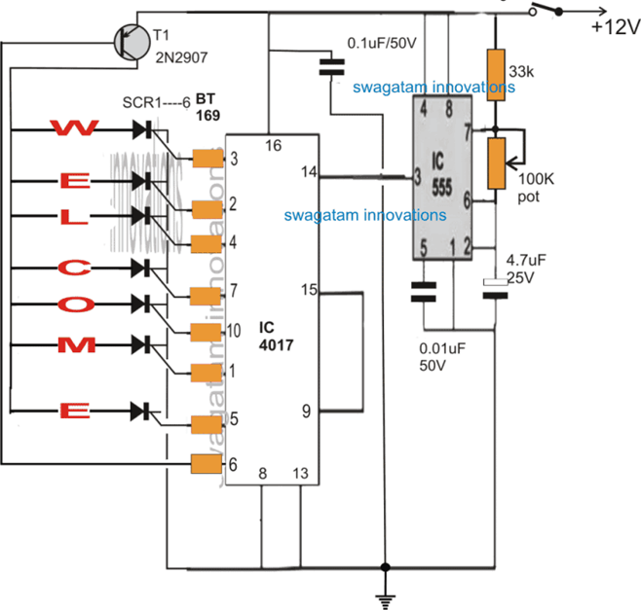
Figure 1: Circuit for developing welcome board using LCD
(Source: [2])
Energy efficiency is another significant impact of LCD technology. Compared to other display technologies, such as cathode ray tube (CRT) displays, LCDs consume significantly less power, making them more environmentally friendly and cost-effective in the long run. This has led to increased adoption of LCDs in various industries, contributing to energy conservation efforts and reducing greenhouse gas emissions [5]. Moreover, LCDs have enabled the development of thinner and lighter displays, allowing for sleeker and more portable devices. This has transformed the design of consumer electronics, such as smartphones, tablets, and laptops, making them thinner, lighter, and more aesthetically appealing to users.

User-friendly software for developing welcome board using LCD
One popular technology used for developing welcome boards is Liquid Crystal Display (LCD), which offers high-quality visuals and versatility in design. In order to create user-friendly software for developing welcome boards using LCD, several key considerations should be taken into account. First of all, the software should have a user-friendly interface that is intuitive and easy to navigate. It should provide a range of design tools and customization options that allow users to create visually appealing welcome boards without requiring extensive technical skills or coding knowledge. Drag-and-drop functionality, pre-designed templates, and other editors can greatly simplify the design process and make it accessible to users with varying levels of expertise [6].
Additionally, the software should provide a wide range of features that cater to different use cases. For example, it should allow users to easily upload and display images, videos, and text on the LCD screen. It should also support various multimedia formats and provide options for resizing, cropping, and formatting content to fit the LCD screen properly [7]. The software should also offer scheduling features that allow users to set up automatic display changes, such as rotating welcome messages or displaying different content at different times of the day.
Another important aspect of user-friendly software for developing welcome boards is responsiveness. The software should be compatible with different screen sizes and resolutions, and it should provide tools for previewing how the content will look on different devices, such as LCD displays with varying aspect ratios. Responsive design features, such as automatic content scaling and alignment, can ensure that the welcome board looks visually appealing and professional on any LCD screen [8]. Moreover, the software should offer seamless integration with other systems or technologies commonly used in welcome board setups.

Security, reliability and cost-effectiveness of the welcome board developed using LCD
Security is an important consideration in any public or private setting. With an LCD welcome board, information can be displayed securely without the need for physical access or tampering. The information on the welcome board can be easily controlled and updated remotely, reducing the risk of unauthorized changes or tampering. Additionally, LCD technology allows for password protection and user authentication, ensuring that only authorized personnel can access and modify the content displayed on the welcome board [9]. This helps to protect sensitive information and maintain data integrity.
Reliability is another key factor in the effectiveness of a welcome board. LCD technology is known for its durability and long lifespan, making it a reliable choice for displaying important information. LCD screens are less prone to damage from external factors such as moisture, dust, and sunlight, which can affect other types of displays [10]. LCD screens also have a low failure rate, reducing the need for frequent repairs or replacements. This ensures that the welcome board remains functional and effective for an extended period of time, minimizing downtime and maximizing its reliability.
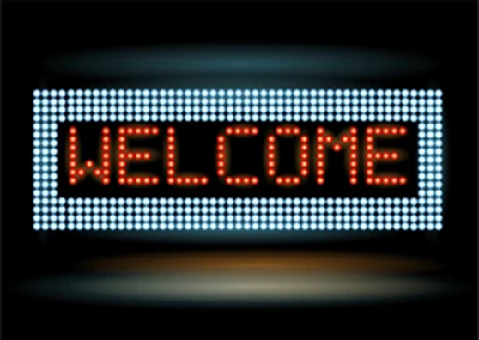
Figure 2: Welcome board using LCS
(Source: [3])
Cost-effectiveness is also a significant benefit of using LCD technology in welcome boards. While the initial investment for installing an LCD welcome board may be higher compared to other types of displays, the long-term cost savings can outweigh the upfront costs [5]. LCD screens are energy-efficient, consuming less power compared to other types of displays, which can result in lower electricity costs over time.

Design considerations of LCD for the welcome board
Design considerations for an LCD (Liquid Crystal Display) used in a welcome board play a crucial role in creating an effective and visually appealing communication tool. Here are some key considerations for designing an LCD for a welcome board:
- Display Size and Orientation: The size and orientation of the LCD should be carefully considered based on the available space for the welcome board and the viewing distance of the audience. A larger display may be needed for a larger viewing area or a larger audience, while a smaller display may be sufficient for a smaller space. The orientation of the display, such as landscape or portrait, should also be chosen based on the content and aesthetics of the welcome board [4].
- Resolution and Image Quality: The resolution and image quality of the LCD are important factors in delivering clear and sharp visuals. A higher resolution display with good color reproduction and contrast ratio can enhance the overall visual appeal of the welcome board [6]. It is important to select an LCD with sufficient resolution to ensure that text, graphics, and images are legible and visually appealing from the viewing distance.
- Durability and Reliability: The durability and reliability of the LCD are important considerations, especially for a welcome board that may be exposed to different environmental conditions, such as temperature variations, humidity, and dust. The display should be designed to withstand such conditions and be protected against potential damage, such as scratches or impact [5]. A robust and reliable display can ensure that the welcome board operates smoothly and consistently over time.
- User Interface and Ease of Content Update: The user interface and ease of content update are important factors to consider when designing an LCD for a welcome board. The display should have an intuitive and user-friendly interface that allows for easy content creation, editing, and scheduling [6]. This can include features such as touch screen capability, remote content management, and compatibility with various content formats. An easy-to-use interface can simplify the process of updating content on the welcome board and ensure that the information is always current and relevant.
- Power Consumption and Energy Efficiency: Power consumption and energy efficiency are important considerations for an LCD used in a welcome board, especially if it operates continuously for extended periods [9]. A display with low power consumption and energy-saving features, such as automatic brightness adjustment or sleep mode, can help reduce energy costs and minimize the environmental impact.

Methodology
The methodology for designing a welcome board using an LCD screen can be divided into several stages:
- Requirement Analysis: The first step in the methodology is to define the requirements of the welcome board. This includes determining the size, resolution, and orientation of the LCD screen, as well as the desired content to be displayed, such as text, images, animations, and videos [3]. It also involves identifying any technical constraints, such as the available hardware and software resources, budget, and timeline for the project.
- Design and Prototyping: Once the requirements are defined, the next step is to design the layout and aesthetics of the welcome board. This includes creating a visual mockup of the content to be displayed on the LCD screen, and selecting the appropriate fonts, colors, and graphics that align with the intended purpose and audience of the welcome board [4]. Prototyping can be done using software tools that allow for creating and editing visual content, such as graphic design software or LCD simulation software, to get a realistic preview of the final result.
- Hardware Integration: After finalizing the design, the next step is to integrate the LCD screen with the necessary hardware components. This includes connecting the LCD screen to a microcontroller or a single-board computer, such as Arduino or Raspberry Pi, that will serve as the brain of the system [2]. The hardware integration may also involve connecting additional components, such as sensors, buttons, or speakers, depending on the desired functionalities of the welcome board.
- Software Development: Once the hardware is integrated, the next step is to develop the software that will drive the LCD screen and display the content. This includes writing code to control the LCD screen, handle user interactions, and manage the display of dynamic content, such as animations and videos. The software development may involve using programming languages, such as C++, Python, or JavaScript, depending on the hardware platform and software libraries used [9].
- Testing and Optimization: After the software is developed, the welcome board should be thoroughly tested to ensure that it meets the defined requirements and functions as expected [7]. This includes testing the display of different types of content, checking for any bugs or glitches, and optimizing the performance of the welcome board for smooth operation. Any necessary adjustments or refinements should be made based on the testing results.

Conclusion and Reflection
From the above discussion, it can be concluded that the project involves selecting an appropriate LCD screen size, designing the user interface and content, programming the LCD screen, and integrating it into a physical welcome board design. Key considerations for designing an LCD include display size and orientation, resolution and image quality, brightness and viewing angle, durability and reliability, user interface, ease of content update, power consumption and energy efficiency. The methodology for designing a welcome board using an LCD involves requirement analysis, design and prototyping, hardware integration, software development, testing and optimization, and deployment and maintenance. Therefore, I can say that this project has helped me understand the various aspects involved in designing a welcome board using an LCD, from selecting the appropriate hardware to developing the software and integrating it into a physical design.

Assessment 2

Title Slide:
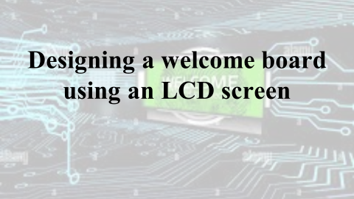

Slide 1: Introduction
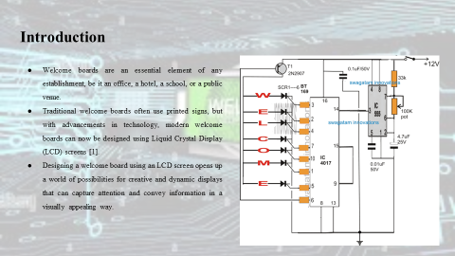
The LCD screen can be programmed to display various content, including text, images, videos, and animations, which can be customized to suit the specific needs and branding of the establishment. The project will involve selecting an appropriate LCD screen size, designing the user interface and content, programming the LCD screen to display the desired content, and integrating it into a physical welcome board design. The end result will be a visually stunning and informative welcome board that enhances the aesthetics and functionality of any establishment.

Slide 2: Aim and Objectives
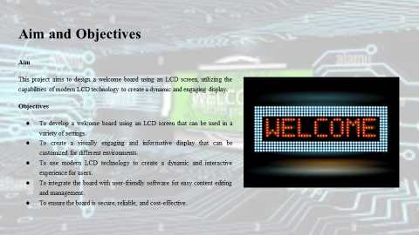
These are the aim and objectives of the project.

Slide 3: Literature Review
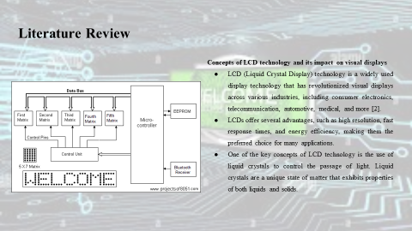
They can be manipulated to control the orientation and alignment of their molecules using electric fields, which in turn controls the passage of light through the display [3]. This allows for precise control over the intensity and color of the displayed image.
LCD technology has had a significant impact on visual displays. One of the major advantages of LCDs is their ability to produce high-resolution images, making them ideal for applications that require sharp and detailed visuals, such as in smartphones, tablets, computer monitors, and televisions [4]. LCDs also offer fast response times, which make them suitable for applications that require smooth motion reproduction, such as gaming and multimedia.
Energy efficiency is another significant impact of LCD technology. Compared to other display technologies, such as cathode ray tube (CRT) displays, LCDs consume significantly less power, making them more environmentally friendly and cost-effective in the long run. This has led to increased adoption of LCDs in various industries, contributing to energy conservation efforts and reducing greenhouse gas emissions [5]. Moreover, LCDs have enabled the development of thinner and lighter displays, allowing for sleeker and more portable devices. This has transformed the design of consumer electronics, such as smartphones, tablets, and laptops, making them thinner, lighter, and more aesthetically appealing to users.

Slide 4: CONTD.
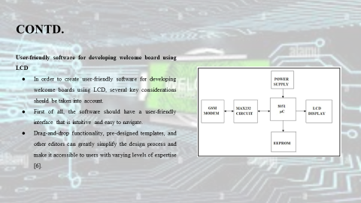
Additionally, the software should provide a wide range of features that cater to different use cases. For example, it should allow users to easily upload and display images, videos, and text on the LCD screen. It should also support various multimedia formats and provide options for resizing, cropping, and formatting content to fit the LCD screen properly [7]. The software should also offer scheduling features that allow users to set up automatic display changes, such as rotating welcome messages or displaying different content at different times of the day.
Another important aspect of user-friendly software for developing welcome boards is responsiveness. The software should be compatible with different screen sizes and resolutions, and it should provide tools for previewing how the content will look on different devices, such as LCD displays with varying aspect ratios. Responsive design features, such as automatic content scaling and alignment, can ensure that the welcome board looks visually appealing and professional on any LCD screen [8]. Moreover, the software should offer seamless integration with other systems or technologies commonly used in welcome board setups.

Slide 5: CONTD.
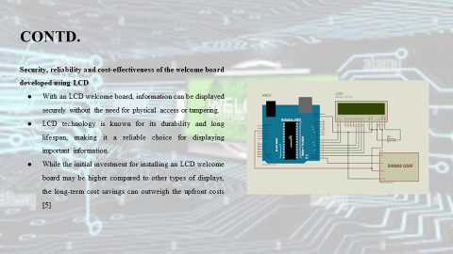
The information on the welcome board can be easily controlled and updated remotely, reducing the risk of unauthorized changes or tampering. Additionally, LCD technology allows for password protection and user authentication, ensuring that only authorized personnel can access and modify the content displayed on the welcome board [9]. This helps to protect sensitive information and maintain data integrity.
LCD screens are less prone to damage from external factors such as moisture, dust, and sunlight, which can affect other types of displays [10]. LCD screens also have a low failure rate, reducing the need for frequent repairs or replacements. This ensures that the welcome board remains functional and effective for an extended period of time, minimizing downtime and maximizing its reliability.
LCD screens are energy-efficient, consuming less power compared to other types of displays, which can result in lower electricity costs over time.

Slide 6: CONTD.
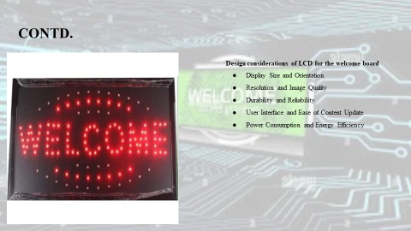
The size and orientation of the LCD should be carefully considered based on the available space for the welcome board and the viewing distance of the audience. A larger display may be needed for a larger viewing area or a larger audience, while a smaller display may be sufficient for a smaller space. The orientation of the display, such as landscape or portrait, should also be chosen based on the content and aesthetics of the welcome board [4]. The resolution and image quality of the LCD are important factors in delivering clear and sharp visuals. A higher resolution display with good color reproduction and contrast ratio can enhance the overall visual appeal of the welcome board [6]. It is important to select an LCD with sufficient resolution to ensure that text, graphics, and images are legible and visually appealing from the viewing distance.
The durability and reliability of the LCD are important considerations, especially for a welcome board that may be exposed to different environmental conditions, such as temperature variations, humidity, and dust. The display should be designed to withstand such conditions and be protected against potential damage, such as scratches or impact [5]. A robust and reliable display can ensure that the welcome board operates smoothly and consistently over time. The user interface and ease of content update are important factors to consider when designing an LCD for a welcome board. The display should have an intuitive and user-friendly interface that allows for easy content creation, editing, and scheduling [6]. This can include features such as touchscreen capability, remote content management, and compatibility with various content formats. An easy-to-use interface can simplify the process of updating content on the welcome board and ensure that the information is always current and relevant.
Power consumption and energy efficiency are important considerations for an LCD used in a welcome board, especially if it operates continuously for extended periods [9]. A display with low power consumption and energy-saving features, such as automatic brightness adjustment or sleep mode, can help reduce energy costs and minimize the environmental impact.

Slide 7: Methodology
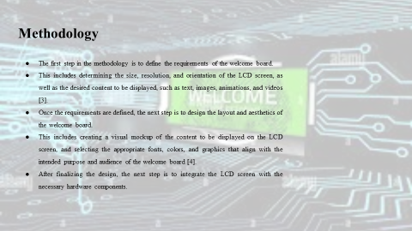
It also involves identifying any technical constraints, such as the available hardware and software resources, budget, and timeline for the project. Prototyping can be done using software tools that allow for creating and editing visual content, such as graphic design software or LCD simulation software, to get a realistic preview of the final result. The hardware integration may also involve connecting additional components, such as sensors, buttons, or speakers, depending on the desired functionalities of the welcome board.

Slide 8: CONTD.
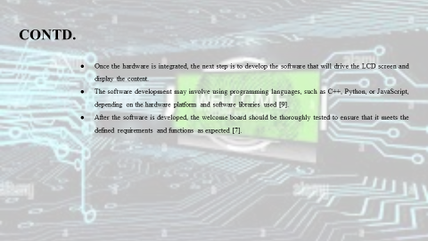
This includes testing the display of different types of content, checking for any bugs or glitches, and optimizing the performance of the welcome board for smooth operation. Any necessary adjustments or refinements should be made based on the testing results.

Slide 9: Conclusion and Reflection
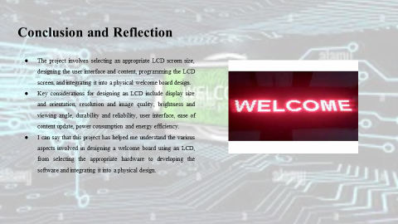
The methodology for designing a welcome board using an LCD involves requirement analysis, design and prototyping, hardware integration, software development, testing and optimization, and deployment and maintenance.

Slide 10: Reference List
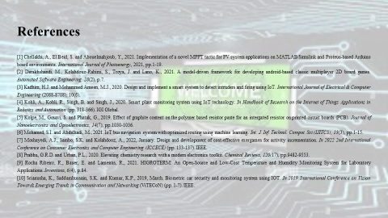

References
[1] Chellakhi, A., El Beid, S. and Abouelmahjoub, Y., 2021. Implementation of a novel MPPT tactic for PV system applications on MATLAB/Simulink and Proteus-based Arduino board environments. International Journal of Photoenergy, 2021, pp.1-19.
[2] Derakhshandi, M., Kolahdouz-Rahimi, S., Troya, J. and Lano, K., 2021. A model-driven framework for developing android-based classic multiplayer 2D board games. Automated Software Engineering, 28(2), p.7.
[3] Kadhim, H.J. and Mohammed Ameen, M.J., 2020. Design and implement a smart system to detect intruders and firing using IoT. International Journal of Electrical & Computer Engineering (2088-8708), 10(6).
[4] Kohli, A., Kohli, R., Singh, B. and Singh, J., 2020. Smart plant monitoring system using IoT technology. In Handbook of Research on the Internet of Things Applications in Robotics and Automation (pp. 318-366). IGI Global.
[5] Kolpe, M., Gosavi, S. and Phatak, G., 2019. Effect of graphite content on the polymer based resistor paste for an intergated resistor on printed circuit boards (PCB). Journal of Nanoelectronics and Optoelectronics, 14(7), pp.1030-1036.
[6] Mohamed, S.I. and Abdelhadi, M., 2021. IoT bus navigation system with optimized routing using machine learning. Int. J. Inf. Technol. Comput. Sci.(IJITCS), 13(3), pp.1-15.
[7] Moshayedi, A.J., Sambo, S.K. and Kolahdooz, A., 2022, January. Design and development of cost-effective exergames for activity incrementation. In 2022 2nd International Conference on Consumer Electronics and Computer Engineering (ICCECE) (pp. 133-137). IEEE.
[8] Prabhu, G.R.D. and Urban, P.L., 2020. Elevating chemistry research with a modern electronics toolkit. Chemical Reviews, 120(17), pp.9482-9553.
[9] Rocha Ribeiro, R., Bauer, E. and Lameiras, R., 2021. HIGROTERM: An Open-Source and Low-Cost Temperature and Humidity Monitoring System for Laboratory Applications. Inventions, 6(4), p.84.
[10] Srianusha, K., Saddamhussain, S.K. and Kumar, K.P., 2019, March. Biometric car security and monitoring system using IOT. In 2019 International Conference on Vision Towards Emerging Trends in Communication and Networking (ViTECoN) (pp. 1-7). IEEE.

