Classroom Management ECIE6003

Ieuan Morgan

2214077

Self-Regulation Strategy Board

INTRODUCTION
Effective classroom management is essential for inclusive educational practice, incorporating not only behaviour regulation but also creating a supportive environment where children feel safe and supported. In classrooms where pupils display a diverse range of complex needs, strategies which empower learners to be active participants in their own development are increasingly important. This resource pack introduces a self-regulation strategy board which is designed to help learners to identify their emotions and then empower them to create or identify a solution. By encouraging emotional literacy and methods of self-regulation, this resource will aim to contribute to a positive classroom environment in which learners can thrive through developing emotional resilience, communication skills and building effective relationships. In this pack, the writer will aim to describe how to use this resource, who this resource is suitable for and how this can be linked to educational theorists such as Skinner, Rogers and Ginott and how this can be considered best practice through educational frameworks such as the curriculum for Wales (Welsh Government, 2021).

DESCRIPTION
The Self-Regulation Strategy Board is a physical resource which can be described in two parts.
The board itself Acts as a template where pupils can express their emotions by completing statement sentences. They will do this by using the attached emotion and action cards to form a complete sentence which addresses their feelings and what they feel they will need to do so that they can regulate. For example, the first section may start with “I feel” written next to a blank space for the emotion card to be placed. This will be followed with “I need to” which is also followed by a blank space for the corresponding action card to be placed (See Appendix A). This sentence structure is an example of one which is suitable to a learner who may benefit from short and simple sentences. This can be customised to cater for more complex emotions and individual strategies based on the user and their complex needs.
Secondly, the cards provided within this pack correspond to their emotions and the action which they believe to be necessary for them to regulate. For example, “Angry” which may be followed by “Speak to a teacher” (See Appendix B).

RATIONALE
The self-regulation strategy board was selected due to its ability to support pupils in recognising and managing their emotions independently or co-operatively with practitioners. Emotional regulation is a foundational skill for development and is particularly relevant in a classroom setting where pupils may experience a wide range of social, behavioural and emotional challenges. By providing a consistent, visual method for pupils to identify how they feel and choose a corresponding plan, this resource promotes independence, emotional literacy, resilience and autonomy.
Emotional resilience and problem-solving skills are key areas in which Estyn have identified as important for learners in all educational environments. In a report from 2020, Estyn stated “The most successful schools understand that building resilience is a continual process that begins with developing good relationships between adults and pupils and between pupils themselves” (Estyn, 2020).
Further research has also shown that problem solving and learning are integrated. It is the belief of the writer that this strategy board can be categorised as an exercise in problem solving since it is helping the learner to recognise their current emotional state and then creating a goal to achieve a desired state of being (Garton, 2004).
Additionally, research has shown that exposure to stress and challenges are not necessarily always bad for children. Emotional resilience can be developed over time through exposure to stress, in the same way that the immune system can get stronger through exposure to bacteria. The role of the practitioner is not to create stress for the purpose of exposure, but when stressful situations arise, a responsible adult can play a significant role in guiding the learner through overcoming challenges (Masten, et al., 1990). The self-regulation strategy board acts as good example of this practice as teachers or Teaching Assistants can guide the learner to create a solution focused, growth mindset rather than becoming overwhelmed by the negative emotions.
It's visual and interactive nature makes it particularly suitable for pupils with additional learning needs such as autism. Autistic pupils often experience challenges with emotional regulation, sensory processing and communication. These difficulties can lead to heightened anxiety, behavioural issues or disengagement. To support such learners, this resource provides predictability and routine while reducing reliance on verbal communication which can be a barrier for some pupils with ASD (National Council for Special Education , 2021).
Furthermore, by gradually introducing learners to enhanced emotional vocabulary, the self-regulation strategy board supports learners within their zone of proximal development A theory proposed by Vygotsky, with the support of the practitioner (Vygotsky, 1978). Through consistent use, pupils may grow to understand that what they are feeling could be expanded on using ambitious vocabulary. For example, rather than just feeling “sad”, learners could identify other emotions which better suit their situations such as “loneliness” or “over-stimulated”. This is a good example of how this resource can grow along with the user and links to effective classroom management.
The strategy board also reflects educational theory, particularly Skinner whose behaviourist approach emphasises reinforcement of shaping behaviour (Skinner, 1953). When pupils are supported in using the board consistently and receive positive reinforcement for engaging with it, they are more likely to internalise self-regulation strategies which will help them to recall this information and build upon it using their own experiences. For the learner who will utilise this resource, this can be adapted for home use as well as in education which invites collaboration with parents/guardians to feel involved and able to provide consistency for their child.
Since this resource can be easily modified and recreated through the use of ICT, the practitioner or guardian can work co-operatively with the individual to personalise the images or wording so that it becomes an inclusive experience. The Curriculum for Wales Act (2021) promotes this as emotional regulation can aid the development of healthy, confident individuals who are able to understand and manage their emotions and form positive relationships (Welsh Government, 2021).
This resource could also be supported by Haim Ginott’s congruent communication theory as the individual demonstrates respectful communication using “I” statements when discussing their emotions. In doing this, the user is taking responsibility for their own emotions and not assigning blame onto peers for the way they feel. If utilised in communication with peers, this resource can provide effective social modelling and promote respectful interaction. For example, “I feel like I need more support” rather than “You never help me” (Ginott, 1972). Another key educational theorist whose work aligns with this resource is Carl Rogers. By communicating their needs, the individual can work cooperatively and respectfully with the supporting staff member. By demonstrating empathy in listening to the user express their needs, the adult is also modelling positive behaviours for the student to observe and learn from (Rogers, 1951).

Instructions for use:
These instructions are designed to help support staff to implement the Regulation strategy board effectively with individual learners and whole class groups.

When using resource to support an individual:
- Place the self-regulation strategy board in front of the student / display board in visible area of the classroom
- Provide the emotion and solution cards to the learner
- Ask them to pick which emotion they feel currently
- Once they have communicated their emotion either verbally or physically, ask them to pick a suitable solution (This can be discussed).
- After implementation of solution, reflect with student to see if they feel better.
- If needed, repeat process until a suitable solution has been found.

If using resource as part of whole class practice:

- place the self-regulation strategy board in a central visible location of the classroom
- explain the purpose of the board which is to help them identify their emotions and choose positive solutions
- Model how to use the board by giving an example
- Suggest that through the day, pupils can show a trusted adult how they used the board and explain how it helped them
- If pupils do not respond well to resource, encourage them to give constructive feedback so that collaboration on adapting the resource can take place.

Notes:
- To begin, the supporting staff member can model this and give an example to give the student a template for use. This can act as a reminder or as part of initial introduction to the resource.
- If multiple card packs have been produced by supporting staff, select a group of emotions/solutions which are suitable for the level of emotional literacy of the user.
- It is important to celebrate use with praise or classroom rewards for positive reinforcement. This will encourage the learners to consistently use this model of problem solving which will set them up for success in future.
- To aid practitioners in the use of this strategy board, notes for reflection may be kept in a booklet or online document. In these notes the practitioner may reflect by answering questions such as “how did the pupils respond to the strategy board today” or “what could be improved/ adapted?”.

Here is an example form
Date | Pupil | Communicated by | Feeling expressed | Solution chosen | Staff Response | Outcome | Next steps
01.03.25 | Child A | Pointing | overwhelmed | Movement break | Took Child A for walk | Child A felt calmer | N/A
02.03.25 | Child B | Speaking | Sad | Speak to teacher | Took time to speak with Child B | Child B still unhappy | Teacher will look at antecedent

It may not be necessary to document each time this resource is used as this may become unmanageable but by keeping record, this allows the supporting staff to see if the resource has been used consistently. Additionally, when supporting a pupil who may benefit from regular use of this resource, documentation allows staff to see if there is consistency in supportive steps taken by staff.

Critical reflection of resource
While the self-regulation strategy board offers a valuable tool for supporting emotional literacy and behaviour regulation it is important to consider its limitations on the conditions required for its effective use. One potential challenge is that some pupils may initially struggle to identify and articulate their emotions, particularly those with limited emotional vocabulary or communication difficulties. In these cases, the resource may require additional scaffolding such as adult modelling or simplified visuals to ensure accessibility for the student. Another consideration is the consistency of implementation as for the board to be effective it must be embedded into daily routines and supported by all staff members. Inconsistency in its implementation may reduce its impact and lead to confusion or disengagement among pupils. Furthermore, while the resource encourages autonomy, some pupils may rely heavily on adult guidance in the early stages which could limit its immediate effectiveness as a self-directed tool.
It should be noted that to maximise the impact of this strategy board, it should be complemented by a classroom culture that values emotional expression, respectful communication and positive relationships. However, despite these challenges the resource remains a flexible and inclusive tool that could be adapted to see the complex needs of each individual.

CONCLUSION
In conclusion, the writer believes this resource pack is effective as it supports learners by improving emotional literacy, resilience and communication skills while building relationships. This resource pack is suitable for a range of age groups, ability levels and complex needs as it can be adapted to better suit the user through introducing more complex vocabulary or learner specific solutions. While this resource could be limited by inconsistency in its implementation, the writer believes that introducing problem solving skills effectively in a student's development will prepare them for real world scenarios in which these skills will be useful (Masten, et al., 1990).

Appendices

- Strategy Board

- Cards

(Twinkl, 2025)

- Alternative feelings chart
(Twinkl, 2025)

- Image of Action cards
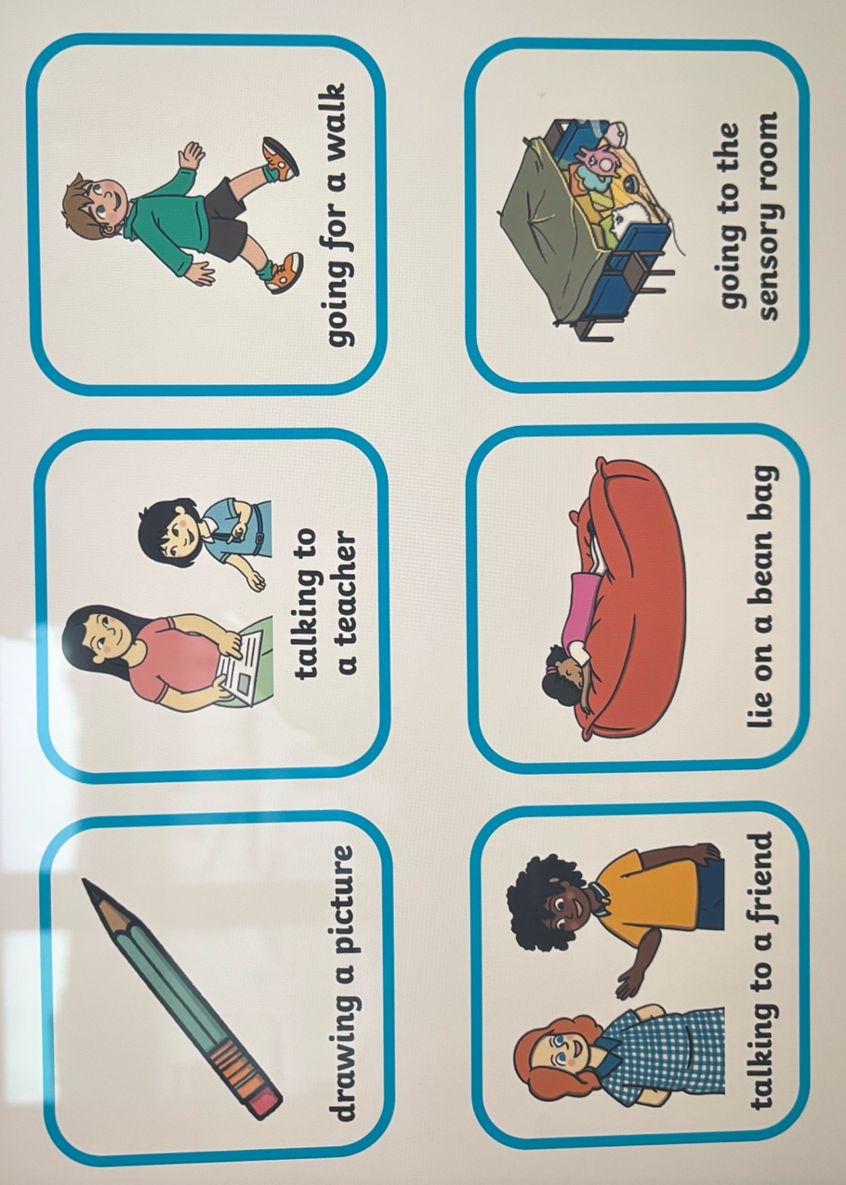 (Morgan, 2025)

References
Estyn, 2020. Learner resilience - building resilience in primary schools, secondary schools and pupil referral units. [Online]
Available at: https://www.estyn.gov.wales/system/files/2021-08/Learner%20resilience%20en.pdf
[Accessed 2nd November 2025].
Garton, A. F., 2004. Exploring cognitive development: the child as problem solver. 1st Edition ed. Oxford: Wiley-Blackwell.
Ginott, H., 1972. Teacher and Child. New York: The Macmillan Company .
Masten, A. S., Best, K. M. & Garmezy, N., 1990. Resilience and development: Contributions from the study of children who overcome adversity. Development and psychopathology, 2(4), pp. 425-444. Available: https://www.cambridge.org/core/journals/development-and-psychopathology/article/abs/resilience-and-developmet-contributions-from-the-study-of-children-who-overcome-adversity/9D84A6A2339F9B66E7B0B0D910F841CC
Morgan, I., 2025. Image of Solutions. [Art] (University of Wales Trinity Saint David).
National Council for Special Education , 2021. Sensory Spaces. [Online]
Available at: https://ncse.ie/wp-content/uploads/2021/10/NCSE-Sensory-Spaces-in-Schools-2021.pdf
[Accessed 28 10 2023].
Rogers, C., 1951. Client-Centered Therapy: Its Current Practice, Implications and Theory. 1st ed. Boston: Houghton Mifflin.
Skinner, B., 1953. Science and Human Behaviour. 1st ed. New York: Macmillan.
Twinkl, 2025. Feelings Chart. [Online]
Available at: https://www.twinkl.co.uk/resource/t-s-1133-feelings-chart
[Accessed 2nd November 2025].
Twinkl, 2025. Twinkl Symbols: Self-Regulation Strategy Board. [Online]
Available at: https://www.twinkl.co.uk/resource/twinkl-symbols-self-regulation-strategy-board-t-s-1642771591
[Accessed 2nd November 2025].
Vygotsky, L., 1978. Mind in Society : Development of Higher Psychological Processes. 1st Edition ed. s.l.:Harvard University Press.
Welsh Government, 2021. Curriculum and Assessment (Wales) Act. [Online]
Available at: https://www.legislation.gov.uk/asc/2021/4/pdfs/asc_20210004_en.pdf
[Accessed 31 December 2024].

