
The Role of Digital Marketing in enhancing Branding and Customer Loyalty: An analysis of the Fast-Food Industry

Student Name: VRAJ ASHWINKUMAR PANDYA
Student ID: 2244599

Acknowledgments

I would like to express my sincere gratitude and appreciation to those who assisted me in completing this research work “The Role of Digital Marketing in enhancing Branding and Customer Loyalty: An analysis of the Fast-Food Industry.” All my professors, my family members, and my peers were among the credible persons who helped me to complete this dissertation despite their tight schedules. With the greatest support and kind permission of all people engaged in the dissertation, the research process has been carried out appropriately.

University of Wales: Trinity Saint David

E-Thesis Deposit Agreement

Details of the Work
I would like to deposit the following item in the digital repository maintained by the University, and/or in any other repository authorized for use by the University:

Title - “The Role of Digital Marketing in enhancing Branding and Customer Loyalty: An analysis of the Fast-Food Industry.”

This item is a product of my own research endeavours and is covered by the agreement below in which the item is referred to as “the Work”. It is identical in content to that deposited in the Learning Resources Centre, subject to point 4 below.

I agree that the University of Wales: Trinity Saint David may electronically store, copy or translate the Work to any approved medium or format for the purpose of future preservation and accessibility. The University is not under any obligation to reproduce or display the Work in the same formats or resolutions in which it was originally deposited.

UW: TSD Digital Repository
I understand that work deposited in the digital repository will be accessible to a wide variety of people and institutions, including automated agents and search engines via the World Wide Web.

I understand that once the Work is deposited, the item and its metadata may be incorporated into public access catalogues or services, such as national databases of electronic theses.

I agree as follows:
- That I am the author or have the authority of the author/s to make this agreement and do hereby give the University of Wales: Trinity Saint David the right to make available the Work in the way described above.
- That the electronic copy of the Work deposited in the digital repository and covered by this agreement, is identical in content to the paper copy of the Work.
- That I have exercised reasonable care to ensure that the Work is original, and to the best of my knowledge, does not breach any laws including those relating to defamation, libel and copyright.
- That I have, in instances where the intellectual property of other authors or copyright holders is included in the Work, gained explicit permission for the inclusion of that material in the Work, and in the electronic form of the Work as accessed through the open access digital repository, or that I have identified and removed that material for which adequate permission has not been obtained and which will be inaccessible via the digital repository
- That University of Wales: Trinity Saint David does not hold any obligation to take legal action on behalf of the Depositor, or other rights holders, in the event of a breach of intellectual property rights, or any other right, in the material deposited.
- That I undertake to indemnify the University of Wales: Trinity Saint David against all actions, suits, proceedings, claims, demands and costs occasioned by the University in consequence of any breach of this agreement

Signature ……… TUSHARA BALENDRAN ………….

Date - 16/06/2024

Declaration
I, VRAJ ASHWINKUMAR PANDYA, declare that this dissertation has been composed by myself, that the work contained herein is entirely my own except where explicitly stated otherwise in the text, and that this work has not been submitted for any other degree or qualification, in whole or in part, except as specified.
Student ID: 22445599
Signature: TUSHARA BALENDRAN
Date: 16/06/2024

Abstract
Aim:
With the help of the data gathered from businesses like McDonald’s, Subway and Tom Hortons, this study aims to determine the role that digital marketing plays in building customer loyalty and enhancing brand recognition in the fast-food industry.
Methods:
The research techniques that were utilised by the researcher are discussed in this chapter. With the help of the positivism deductive approach descriptive research design, qualitative strategy, and primary data collection it collects the information for the research.
Findings:
This chapter describes the different opinions of consumers regarding the fast-food industry utilising digital marketing tools. Different levels of consumer engagement and their preferences for digital marketing platforms are mentioned in this chapter.
Conclusion:
This potion explains the results and provides a brief rationale for the objectives. It also provides recommendations which can help the fast-food industry to strengthen its customer engagement. This chapter also highlights the shortcomings of the research.

Table of Contents
Chapter 1 Introduction 7
1.1 Chapter Introduction 7
1.2 Background 7
1.3 Research Problem 8
1.4 Significance of the Study 9
1.5 Rationale of the Study 9
1.5.1 Theoretical Rationale 9
1.5.2 Practical Rationale 10
1.6 Research Aims and Objectives 10
1.7 Research Questions 11
1.8 Chapter Overview 11
Chapter 2: Literature Review 12
2.1 Introduction to Digital Marketing in the Fast-Food Industry 12
2.2 Role of Digital Marketing Channels 13
2.3 Literature Gap 15
2.4 Theoretical Framework: The RACE Model 15
2.5 Building Consumer Trust and Brand Reputation 17
2.6 Consumer Perception and Satisfaction 19
2.7 Challenges and Future Directions 21
Chapter 3: Research Methodology 23
3.1 Chapter Introduction 23
3.2 Research Onion 23
3.3 Research Philosophy 24
3.4 Research Approach 24
3.5 Research Design 25
3.6 Time Horizon 26
3.7 Research Strategy 26
3.8 Data Sampling 26
3.9 Data Collection 27
3.10 Data Analysis 28
3.11 Ethical Consideration 29
3.12 Validity and reliability of data 29
3.13 Chapter summary 30
Chapter 4 Research Findings 31
4.1 Chapter Introduction 31
4.2 Result Analysis 31
4.3 Chapter Summary 40
Chapter 5: Discussion 41
5.1 Chapter Overview 41
5.2 Chapter Discussion 41
5.2.1 Discussion regarding Digital Marketing in the Fast-Food Industry 41
5.2.2 Discussion on Role of Digital Marketing Channels like Social Media Platforms, Email Campaigns, and Mobile Application 42
5.2.3 Critical Discussion on RACE model in the Digital marketing of Fast Food Industry 44
5.2 4 Discussion on building of brand reputation and consumer trust in the fast food industry 45
5.2.5 Discussion of the satisfaction and the perception of the customers that influence digital marketing in fast food industry 46
5.2.6 Discussion on challenges and future directions of digital marketing in the fast food industry 48
5.3 Chapter Summary 49
Chapter 6: Conclusion 51
6.1 Chapter Introduction 51
6.2 Linking with Objectives 51
6.3 Recommendations 53
6.4 Limitations of the Research 54
6.5 Future research 54
6.6 Chapter Summary 54
Chapter 7 Reference 55
Chapter 8 Appendices 63

List of Figures
Figure 1: The Spending on Advertisements in the Food Industry in the UK 8
Figure 2: Digital Marketing 13
Figure 3: Email Marketing 16
Figure 4: Race Model in Digital Marketing 18
Figure 5: Brand Loyalty 19
Figure 6: Research Onion 24

Chapter 1 Introduction

1.1 Chapter Introduction
The present chapter will provide general background about the effect of digital marketing on brand building, and customer loyalty in the specific fast-food industry. In addition, this chapter will provide the aims and objectives of the research. The research rationale will be provided in this chapter which will present comprehensive insights regarding the topic.

1.2 Background
There has been potential growth when this comes to the use of different channels related to social media including Instagram, WhatsApp, Facebook, and so on over the past decades. People in different industries can also be found to have been using these kinds of platforms for communication or interactions with one another while the most popular brands use them for various marketing activities regarding the products or services. Social activities can also be assumed to have been seen from the courtesy of the real world shifting to the virtual world of the sites of social networking and so on. Social media marketing can also be considered to effectively impact effective communications between the customers and the marketers besides the various enabling the different activities that can significantly improve the awareness of the brand effectively (Jamil et al. 2022). With the aid of using the different channels of digital marketing, new channels of communication have also been created and brought. Apart from that the potential growth and changes have been witnessed in the ways how people generally interact due to the various tools and applications developed on the internet over time.
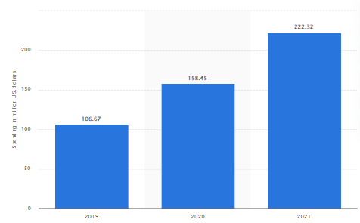
Figure 1: The Spending on Advertisements in the Food Industry in the UK
Source: (Statista 2023)
From the above picture, this can be said that the spending on the advertising of the different companies stood at around 222.32 million U.S. Dollars in the United Kingdom in 2021 (Statista 2023). In this context, it should be mentioned that the food business is considered to be important and basic to every nation (Kaur and Singh 2023). Digital marketing in the food business is considered to be the process of marketing services or goods offered by different businesses online with the aid of using different kinds of digital technologies such as display advertisements, mobile devices, and other digital media like Facebook and Google ads. Marketing related to food and beverage can also be considered to be the major contributor to the establishment of preferences along with the driving to eat energy-dense foods of the nutrient-poor (Maksi et al. 2024). The marketing strategies are driven by the data on the platforms related to social media that are being used by the brands of the foods and beverages for marketing to the customers directly in a manner that can encourage the consumption of fast-food meals, energy drinks, snack foods, and sugary beverages. These types of marketing strategies in the food industries can be seen to target adolescents and children with the aid of using social influence, emotional appeals, interactive features, and so on.

1.3 Research Problem
In the scope of the study, the present research study will consider the influence of digital marketing on branding and customer loyalty, significantly for the fast-food industry. However, the problem has been determined by the consideration that tools of consumer knowledge, awareness, and engagement in the hast good environment have been identified to have a significant impact. Online marketing channels such as social media, email campaigns, and mobile applications are not efficient in the promotion of the business (Bigné et al. 2023). Overall, this study intends to examine the effects of brand values and customer satisfaction on consumers' thoughts regarding the brand itself. However, this study will provide in-depth explanations of how user-generated content and reviews online affect consumer trust and the image of a respective brand in the fast-food market. Through this research, the study aspires to contribute insight into the best possible use of digital marketing by fast-food brands in their efforts to achieve a high degree of brand identification, customer loyalty, and overall market leadership. Overall, the problem of the research is to know the complicated relationship between digital marketing, branding, and consumer behaviour in the fast-food industry to create a platform for healthy competition, sustainability, and success in this sector.

1.4 Significance of the Study
The research study provides a crucial implication for both the academic and fast-food industry. Particularly, it adds to the academic knowledge due to its sensitivity to the primary issue which is connected to the ever-changing nature of digital marketing practices and its influence on branding and customer loyalty. Through the investigation of this phenomenon, the present study provides useful information regarding current marketing methods which contribute to the evolution and the development of digital marketing theoretical framework. In addition to its academic significance, the present research study has direct implications for those who are involved in the fast-food industry as well as marketing practitioners. According to Quoquab et al. (2020). The efficiency of digital marketing practices is responsible for the growth of brand identity and customer loyalty which can be an input to the strategic decision marketing process of fast-food organisations. Furthermore, the study also investigates the role of personalised digital marketing campaigns in consumers' perceived brand value and satisfaction. This type of marketing provides actionable insights to marketers which they can use to develop more personalised and effective marketing campaigns. In addition, analysis of the impact of user-generated content and internet reviews on consumer trust and brand reputation will provide a direction for fast-food brands in terms of managing their online presence and reputations as per Sharifirad (2023). The results and findings of the research study can contribute to innovation in the fast-food industry marketing practices and enhance brands’ competitiveness as well as performance.

1.5 Rationale of the Study

1.5.1 Theoretical Rationale
The theoretical background underlying the role of digital marketing in attaining consumer satisfaction using brand image among teenage consumers is based upon several established marketing concepts as highlighted by (Romadhoni et al. 2024). Thus, the theory of brand image highlights the importance of promoting activities as a significant factor in how customers look at a certain brand. Digital marketing, considered the digital face of any company, is a mighty device for digitally presenting the face of a company and communicating it in cyberspace, especially for a local business that can now reach a wider audience and hopefully have a better brand image. Also, Ryan (2020), has stated that digital marketing has a close relationship with brand image and customer satisfaction as one of the features of digital marketing is that customers are more likely to buy again and exhibit positive behavioural attributes when they have a satisfying experience. Therefore, the digital marketing strategy could well bolster the brand image, which in turn could help sustain high customer satisfaction and develop loyalty among adolescent customers. Generally, the theoretical rationale is highlighting the role that digital marketing and company brand image play in customer satisfaction thus the need of marketers to use the digital platforms effectively to build the brand and ensure customer satisfaction.

1.5.2 Practical Rationale
The increase in online activity in the United Arab Emirates particularly emphasises the roles of the younger generation. The data show that about 99% of the worldwide population relies on the internet for communication, entertainment, and information. Thus, this fact proves that the counterpart is the digital media platforms (Hanaysha, et al. 2021). Smartphone and social media users aged between 25 to 34 are the most active, accounting for 47.4% in total followed by the nearest age group 35 to 44 accounted for 23.6%: a strong indication that the youth segment of the population is the most active component underpinning this social media and smartphone landscape (Hanaysha et al. 2021). This ethnic group dominance shows a strong relationship between digital platforms, especially social networks, in determining how people communicate and obtain their information. Businesses and marketers must adapt their digital approach to suit the needs and inclinations of this technologically oriented segment of their audience.

1.6 Research Aims and Objectives
Aims
This research aims to identify the role of digital marketing in increasing brand identification and establishing customer loyalty with the aid of shaping brand reputation within the first Food Industry with a reflection of data extracted from companies like McDonald's, Subway as well and Tim Hortons.
Objectives
- Brand recognition and awareness are affected through digital marketing approaches in the fast-food sector.
- Different digital marketing platforms such as social media, and other email campaigns, as well as mobile apps, promote repeat business and client loyalty.
- Influence of individualised digital marketing on perceived brand value and satisfaction among consumers.
- Fast-food industry, user-generated content as well as internet reviews influence consumer trust and brand reputation.

1.7 Research Questions
- How are brand recognition and brand awareness affected through digital marketing approaches in the fast-food sector?
- How different digital marketing platforms such as social media, and other email campaigns, as well as mobile apps, promote repeat business and client loyalty?
- What is the influence of individualised digital marketing on perceived brand value and satisfaction among consumers?
- How the fast-food industry, user-generated content as well as internet reviews influence consumer trust and brand reputation.?

1.8 Chapter Overview
This research includes multiple chapters that help the researcher to successfully conduct the study. It includes the introduction chapter, literature review chapter, methodology chapter, findings and discussion chapter, and the conclusion chapter.
The introduction chapter focuses on the overview of this research which includes research aim and objectives.
The literature review chapter highlights the information related to the research objectives and the opinion of other researchers in this field.
The methodology chapter showcases the methods that are used by the researcher for conducting this study.
The finding and discussion chapter helps to provide answers regarding the research questions. Moreover, the conclusion chapter concludes the entire research and provides suggestions for the future research.

Chapter 2: Literature Review
Definitions
Based on the perspective of Peter and Dalla Vecchia (2021), digital marketing implies the utilisation of the digital channels which includes social media platforms, search engines, mobile application, websites, and email.

Bernarto et al. (2020) advocated that brand recognition indicates the standard or the level of the familiarity or the awareness of the consumers with a specific brand.

2.1 Introduction to Digital Marketing in the Fast-Food Industry
According to Adam et al. (2020), the fast-food sector has in the past couple of years experienced a significant transformation upon the introduction of digital marketing campaigns. The role of digital marketing in generating better relationships between fast food marketers and the target audience by allowing for more personalised and interactive processes is hard to underestimate. Building a strong fast-food brand via social media, email marketing channels and mobile applications allows the company to reach consumers directly and emotionally bonds them. The power of brand awareness cannot be underestimated in a country where the fast-food industry is a significant entity. Brand awareness not only makes the customers come but also make them faithful buyers who can be trusted, thus the repeated business, and a long-term success becomes possible (Ilyas et al. 2021).
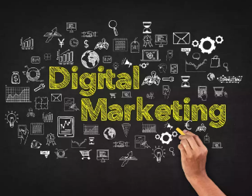
Figure 2: Digital Marketing
Source: (Onkar, 2022)
Digital marketing is the major brand recognition game changer since fast food chains apply these methods. With purposeful implementation of digital marketing channels including Instagram, Facebook, and Twitter, brands have the opportunity to touch and excite numerous consumers. With the help of visual storytelling and user-generated content, fast-food brands can develop specific brand image that allows them to stand out from other competitors. As per the viewpoint of Quoquab, Mohamed Sadom, and Mohammad (2020), brand loyalty implies the devotion and the allegiance of the patrons towards a specific brand that represents the likelihood of the consumers to consider purchasing services and products of a brand. On the other hand, that digital marketing enables fast-food chains to reach out to specific markets and customise their content according to the needs and preferences of various consumer groups. Email campaigns and mobile apps can be used for delivering personalised promotions and offers directly to the customers’ devices, thus increasing user engagement and sales.
Digital marketing strategies don’t only attract but also keep the existing customers. Through sustaining regular presence on social networks brands can create significant relationships with their customers and also ensure loyalty (Ebrahim 2020). Customers’ response to concerns such as complaints and enquiries, especially when resolved immediately, symbolises a brand’s dedication to customer satisfaction, which ultimately leads to brand loyalty.

2.2 Role of Digital Marketing Channels
Social Media Platforms
As per the opinion of Puspaningrum (2020) Social media platforms are the talking stick for fast food companies to boost brand recognition and create deeper relationships with the customer base. Platforms such as Instagram, Facebook, and Twitter give un-quantified possibilities for interaction and engagement of brands, with the opportunity to share their product vision, publish their brand message and create a consistently active following. Instagram, due to its visually intensive elements, provides an ideal medium for fast-food companies. Companies can utilise visually striking visuals in combination with catchy content to provide a persuasive glimpse of their menu list, ultimately motivating their fans to dine in or order online. Similar to other social media platforms, Facebook still reigns supreme in the social media marketing of fast-food chains. Facebook Ads provides a brand an opportunity to create targeted campaigns that respond to its audience’s interests and behaviour, with the intention of redirecting such audience to websites or physical outlets (Suharto et al. 2023).
Twitter, which is embraced for its breakthroughs in real time release and for its interactive nature, gives fast food to brands the luxury of communicating with customers at just one go and at the same time. A brand is able to join in on a trending topic, respond instantly to questions from customers as well as post promotional or special offers on social media without delay. Twitter also creates a platform for brands to provide exceptional customer service and to respond to customer queries and suggestions.

Email Campaigns and Mobile Applications
According to Deepa (2021) Besides social media use, emails and mobile apps also prove vital in the digitally driven campaigns of companies in the fast-food industry. These sources present us with a myriad of possibilities to send targeted content and offers straight to the inboxes and devices of customers, creating more repeat customers and brand loyalty. Email campaigns provide a fast-food brand with an opportunity to conduct ongoing interaction with their customer base, ensuring they are updated on new products, discounts or special events. Brands can send mixed content to a segmented list based on user preferences and behaviour. This targeted content can attract clients from each specific market and increase the profitability of the brands.

Figure 3: Email Marketing
Source: (Sara 2023)
In addition, mobile applications, which have become the heart of the fast-food system, enable customers to order fast, collect points and benefits, and take part in special promotions. Brands can implement the mobile app features to simplify ordering, customise the client experience and encourage reorders by providing loyalty points and rewarding models, among other game-like elements. In addition to that, mobile apps are the source of data and analysis. so that brands can easily track user’s behaviour, preferences and their transaction history (Fetais et al., 2023). Such information allows brands to know the right direction in their marketing efforts and provides them with an opportunity to provide the most relevant offerings according to the wants and needs of their customers.

2.3 Literature Gap
The literature gap indicates the area or the content of the research that has not been focused properly and had limited or insufficient research. The research of Melović et al. (2021) primarily focused on the decision-making process of the consumer in the fast-food industry. However, the study missed the opportunity to address the concept of brand perception and digital marketing which would have been more beneficial for the current study. This would have helped the study to consider digital marketing strategies and customer-centric approaches. On the other hand, the study by Ibrahim and Aljarah (2020) discussed the concept of user-generated content of UGC which is an essential element of the digital marketing strategy. The study focused on the role of UGC in the fast-food chain which helps with brand loyalty. However, the study did not mention the models that can be used for digital marketing. The research could have considered brand reputation and the consumer trust and loyalty of the fast-food chain. Moreover, the research work of Nuseir and Elrefae (2022) significantly addressed the theoretical framework, the RACE model which is considered as the marketing tool of digital marketing. This study has been a good reference for the current research. However, this study lacks a detailed explanation of the role of the diverse digital marketing channels that have now become effective social media platforms for fast-food businesses. Nevertheless, the study of Dülek and Aydın (2020) has helped with the application of the RACE model in the current subject matter. However, it missed the opportunity to address the challenges related to digital marketing in the fast-food industry. The study had the chance to deliver some suggestions regarding this.

2.4 Theoretical Framework: The RACE Model
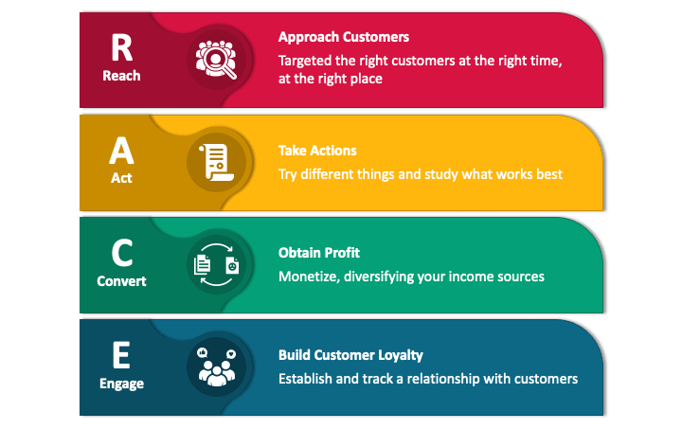
Understanding the RACE Model
As reported by Nuseir and Elrefae (2022), the RACE model, namely, Reach, Act, Convert, and Engage, is an integrative strategy that conducts Digital Marketing campaigns and accelerates the brand image reputation. The RACE model, as a brand-new marketing tool for digital marketing, can present a new way of overcoming the difficulties of online marketing as well as enhancing the connection between fast food companies and their users.
- Reach: This period is the time and location of the brand to show and spread in all the digital channels, and digital channels. Fast food chains apply strategies such as search engine optimization (SEO), social advertising, and the collaboration of influencers in their digital promotion among the most populated class.
- Act: The primary attention is on the Act Phase. In this regard, the audience has to accomplish a specific goal, for instance, visiting the brand's website, watching the content, and using the offered benefits. Fast food brands integrate CTAs into the content and session tracking technology to promote customer communication and interaction.
- Convert: Convert stage basically seeks to have buyers who are already engaged and turn them into paying customers. Such approaches can involve curbing internet orders, drawing more customers to the physical stores and encouraging them to make repeated purchases. The fast-food businesses can achieve conversions and drive sales with the help of promotional offers, discounts and loyalty programs (Haudi et al., 2022).
- Engage: The stage Engage stands for the nurturing of an existing bond with the customers, and thus, the creation of loyalty to a brand. The following process entails the constant interaction, individual engagement with customers, feedback collection and evaluation. Fast-fooderies utilise social media engagement; email marketing campaigns, and customer service efforts to cultivate relations and bond with their consumers.

Application of the RACE Model in Fast Food
As per the opinion of Dülek and Aydın (2020), Fast food businesses could very well utilise the RACE model’s principles to flourish their digital advertising tactics and thus, customer devotion. By developing their strategies in line with each of the four AIDA stages, brands can craft an integrated digital marketing strategy that connects with the customers. Such as in the Reach stage, fast-food companies could employ strategic social media ad campaigns to reach specific demographics or geographic locations. Through data analysis and proximity, brands can discover what spots are the most fitting to achieve their goal of outreach and being seen more often (Budiman 2021). The Act stage is where interactivity could be used in fast food chains through whether polls, quizzes, or contests to call for consumer participation. Through implementation of attractive CTAs and step-by-step conversion trails, brands will be able to direct consumers towards their digital assets and encourage conversions.
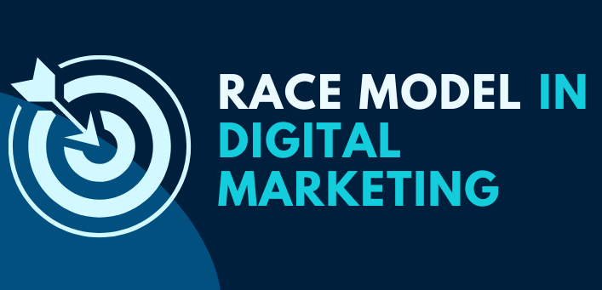
Figure 4: Race Model in Digital Marketing
Source: (Digital Drushti 2024)
In the Convert phase, fast food retailers would employ selling strategies like providing discounts or promotional offers to coax customers and make the desired sale. Through applying the data of customers such as their behaviour and analytics, brands can offer grouped targets to a specific segment of audience and lead to the goal of conversion rate. Feedback seeking, answering questions, and giving added value through content can help establish loyalty and potential brand advocates. Generally, RACE provides a strategic base to fast-food chains for boosting their digital marketing capabilities among the crowded market environments. Doing this will afford companies a stronghold in the market, as well as help them build trust among their audiences.

2.5 Building Consumer Trust and Brand Reputation
User-Generated Content
In the opinion of Ibrahim and Aljarah (2020), the concept of user-generated content (UGC), being a foundational element of digital marketing strategy for fast food restaurant chains, is directly connected to consumers' attitude and reputation of the brand. UGC stands for any content created by consumers, which is reviews, photography, videos, and social media posts containing the brand or its products. In the fast-food industry, UGC plays a significant role because of the visual appeal of food itself as well as spreading and creating content on social networks. In the recent times, many consumers have shared their dining experience on Facebook, Instagram, and Yelp, with photos of food, reviews and discussions on the best fast-food brands.
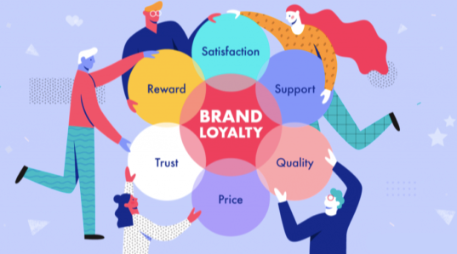
Figure 5: Brand Loyalty
Source: (Marketing Management 2023)
This influence of UGC on customer trust within the fast-food industry cannot be blurred. Content which is original and relevant for the targeted audience can be more persuasive and credible than the words of the selling company. People nowadays are more willing to believe the recommendation and praise by their peers than the counterpart, that is to say the content produced by brands and the advertisements. However, not only creates social proof by UGC, but also allows the fast-food brands to use testimonials of other happy customers for their advertising (Rimadias et al. 2021). Brands may use techniques like branded hashtags, user-generated contests, and reposting customer’s content to brag about their authentic experiences and build a community around their brand.

Reputation Management Strategies
According to Ting et al. (2021), the fast-food brands will in addition to viably developing UGC criteria should also proactively manage their brand reputation in the digital age to ensure that they maintain a favourable brand image. Brands will monitor the social media sites, review sites, and forums in order to identify and deal with the customers' feedback on the spot. Trademarks advertise the customers to leave reviews on forums such as Yelp and Google My Business and show positive reviews on the website or social media.
Additionally, fast food companies can use digital marketing channels to learn about customer behaviour and preferences and then to refine their offerings, thereby improving the general customers' experience (Lou and Xie 2021). Through audience listening and a careful revision of their strategies, companies can make certain that their digital marketing efforts keep a pace with the market.

2.6 Consumer Perception and Satisfaction
Influence of Digital Marketing on Brand Perception
As per the review of Melović et al. (2021), the fast-food sector relies very much on consumers’ decision-making process and purchase intent towards brands which depends on how digital marketing has an influence on the said processes. Through digital marketing tools, which are tailor-made for fast-food brands, the speed at which the consumers are able to perceive them will be increased. Such tools as well numeral mention include targeted advertising, email campaigns and social media interactions. As targeting ads allows the fast-food companies to design ads in a way that suits the likings, interests, and the behavioural patterns of their prospects, this kind of promotional messages is more likely to entice them. Tailored digital marketing that is unified towards customers getting pleasure out of a brand’s identity and sincerity through their messages is likely to develop a positive impression of the company’s identity and values.
As an additional benefit, digital marketing allows fast-food chains to establish an emotional connection with customers through the branding story acting as the window (Dastane 2020). By telling stories that are entertaining, video clips that illustrate work processes, and their customers' feedback, brands get the time to humanise their brand, gain trustworthy audiences, and convey their long-term messages. Moreover, personalised digital-marketing sites that are designed to cater to individual customers’ choices and requirements improve client satisfaction, leading, ultimately, to customer satisfaction and loyalty. Using the vehicles which include timely, pertinent content, promotion and offers, the brands can have direct and personal engagements with the customers that will give them a very high level of satisfaction and they will become loyal to the brands.

Customers-Centric Approach
According to Ibrahim (2021), the fast-food restaurant concentrates on customer engagement and satisfaction, which involves the application of digital marketing strategy. In this regard, it is expected to have a great and sustainable eventual result, as a result of keeping the customers happy. Through a customer-centric approach you should find out the challenges of clients, accomplish their desires and fulfil their issues at all stages of customer experience from the first contact till brand commitment. Online marketing platforms such as social media email and mobile apps provide a way to do that through; for example, direct communications, enabling the chains to request feedback or questions. So, the chains can respond instantaneously, automatically and uniquely to satisfaction or dissatisfaction. Hence, the manner of approach of sales and to communicating portrays a high level of accountability towards customers’ satisfaction and aides in forming customers’ belief and trust.

Honeycomb Model
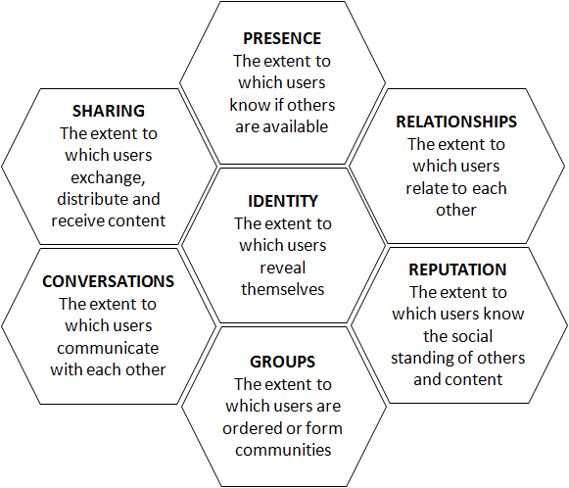
Comparison between RACE model and Honeycomb model
The logical and sequential arrangement of the strategy in the RACE model including Reach, Act, Convert, and Engage makes it particularly suitable for an industry that requires a sequential and systematic approach to selling its fast foods to consumers (Forbes-Bell, Bardey, and Fagan, 2020). The RACE model can be effectively applied to fast-food brands and reach interested consumers through social media banner ads and post promotions and specific offers. The fast-food industry can take action, by locking the lead and offering customers an enticing deal. The organisations can have a conversion, by providing the individual with a memorable personal experience that turns customers into loyal followers and engages as one to continuously be connected to the fast-food brand (Hanaysha, 2022). For instance, there is an opportunity to reach out to the target audience through advertising, encouraging them to order through promotions, building brand recognition through loyalty programs, and interacting with customers through the creation of posts, discussions, and communities in social networks such as Instagram.
On the other hand, Talwar et al. (2020) stated that the strength of the Honeycomb model is the attention paid to the development of genuine relationships and the cultivation of an audience that will spread the word about the brand, and such a model correlates effectively with the goals of the fast-food industry that seeks to engage customers emotionally. Advertising fast-food brands can leverage the Honeycomb model to ensure they create a brand that is easily recognizable and prominent at every touch point. It provides significant value through product and service quality, amuses shoppers individually, forms a positive image, facilitates buyers to spread the word on social media, and in the process, turns the patrons into brand representatives.

2.7 Challenges and Future Directions
Challenges in Digital Marketing
As per the opinion of Hanaysha and Momani (2021), while digital marketing delivers various benefits to fast-food brands, it is also important to consider some of its challenges when executing successful strategies. One of the main issues is the preservation of brand features across different platforms. However, amidst the multiple platforms and rich touch points, creating a brand voice that remains uniform and consistent throughout can prove difficult. Digital brand presence management involves striking a balance between cohesion and unity and conflicting and repelling their audience. The third problem is achieving users’ privacy and avoiding regulations including the GDPR, which is growing even stricter. Fast-food companies have to take privacy regulations into account while looking for their clients by implementing data-driven marketing measures. This involves full disclosure of personal data collection processes and the confirmation of agreement before making any marketing campaign using the information of a specific consumer.
In addition, fast food marketers are faced with the continuous changes on the digital arena and the emerging technologies. Tracking the latest trends and platforms is dynamic and necessitates ongoing education and adjustments. It is important that brands are agile, responsive and proactive in their changing consumer behaviour and technology to maintain their competitiveness in the digital age.

Future Directions and Recommendations
As per the opinion of Ertemel et al. (2021), the future has a lot in store for Digital Marketing advancement and growth within the fast-food industry. AI and machine learning are the two new things that are being seen among the people. These tools allow fast-food brands to master big data, personalise run ad campaigns and automate recurring tasks thus leading to the most effective and productive digital marketing strategies. Furthermore, the ability of AR and VR technologies to create realistic and interactive environments opens new avenues for fast-food brands to interact with consumers in exciting new ways. Through creating an immersive experience, brands will not only give customers more engagement, but brands will also be equipped in a more effective way to compete with the market.
On top of that, fast food companies need to give more focus on whether their digital marketing strategies are sustainable and responsible as well. Modern consumers are getting more and more interested in ethical and environmental problems, and the brands which show this trend are more likely to appeal to their audience. Sustainability messages and activities can be embedded into brands digital marketing campaigns which will help brands to reach their target market and to build their brand image. In summary, fast-food brands have to overcome these challenges: ensuring brand consistency across all channels, tackling privacy issues, and keeping up with ever-changing technologies on the Internet. By adapting forward-thinking, considering user privacy and security, and remaining flexible in their practices, fast-food brands can stand up well in a constantly changing digital marketplace.

Chapter 3: Research Methodology

3.1 Chapter Introduction
The research methodology chapter illustrates the cognition of the research guides and the understanding of the research hypotheses that underlie the research procedure and design. This chapter comprises the research approaches that the researcher has employed for executing this study which are time horizon, data collection, research philosophy, research approach, research strategy, data sampling method, data analysis, research design, and research ethics.

3.2 Research Onion
A research onion is a theoretical construct that assists researchers in transitioning through the process of planning and implementing investigations. This framework was authored by Saunders and his co-researchers to facilitate the processes of methodological choice-making (Abdelhakim, 2021). The study onion, here, has several layers, and each layer represents a different phase of the research procedure. The concepts such as the philosophy of research, research approach, research design, research strategy, methodological choice, time horizon, specific techniques, and procedures have been analysed and understood (Alturki, 2021). Hence, the layers will show the efficiency of the process and further require that each level is separately taken into account.
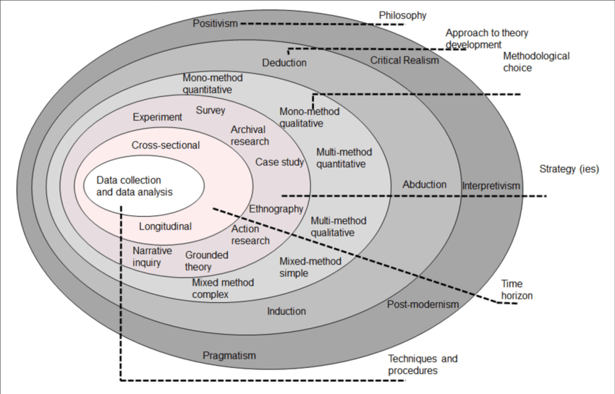

Figure 6: Research Onion
Source: (Abdelhakim, 2021)
The research onion is the foremost aid for the researcher in the present research of digital marketing in the fast-food industry. It confines the methodological pathway, induces readable breakdown, and ultimately directs to powerful analysis output. The research onion has aided the researcher in the process of selecting appropriate methods, minding identifying the time horizons and the well-matched theories in the study. The research onion was able to convince the researcher to adhere to a standard approach in research design. The researcher breaks down the research methodology into each of the layers. As a result, the whole research process evolves clear and organised.

3.3 Research Philosophy
The research philosophy is a set of basic assumptions and beliefs that determine how the research study is designed and implemented and the interpretation of research findings (Junjie and Yingxin, 2022). It grants a mechanism through which the formation, gathering, analysing, and use of knowledge in research is brought into perspective. The types of research philosophy include positivism, pragmatism, interpretivism, and realism research philosophy. The researcher of the current study undertook the positivism research philosophy.
The main idea of positivists is that knowledge can be observed in an objective and measurable way. Learning positivism's purpose is to determine cause-and-effect relationships (Corry, Porter, and McKenna, 2019). The researcher has picked the digital marketing strategies for example, social media campaigns, and email promotions that lead to specific results like increased brand awareness and customer loyalty by analysing them. This approach attained objectivity by ensuring that the researcher places little or even no influence on the research. In the diversity of the digital marketing field, replicated insights can help out industry professionals. This research philosophy has emphasised the practical relevance through which qualitative aspects like brand sentiments and customer perceptions have been analysed. The positivist research philosophy has delivered a structured approach for examining the impact of digital marketing on the loyalty of the customers', brand recognition, and prestige of the fast-food industry.

3.4 Research Approach
The research approach describes how researchers frame their studies in a systematic and structured way. It involves the fundamentals of epistemology and research methodology. The types of research approaches are deductive, inductive, and abductive research approaches. For this study, the researcher has adopted a deductive approach. The deductive approach starts with the theory or hypothesis. Researchers design their experiments based on this theory to test the hypothesis and gather their data.
Here, the researcher started with the hypothesis related to the impact of digital marketing on branding as well as consumer loyalty. The study posited that efficacious digital marketing leads to a higher recognition of the brand and loyal customers. Deductive research has been used to figure out the values of various variables that are measured quantitatively. Data pertaining to traffic, number of likes, hits, applications downloaded, and the number of customers has been collected. These figures generate the tangible numbers for the research analysis. Subjecting hypotheses to testing and quantitative data collection has led the research to develop generic conclusions. Insights about this study are not only the fast-food industry inhabitants but also the sectors in which digital marketing is of great importance. This deductive approach has enabled the researcher to inquire about the digital marketing effect on branding and customer loyalty in a point-by-point approach. Through the testing of the hypotheses and the collection of quantitative data, the research served as an important source for the evolving marketing strategies of the fast-food industry.

3.5 Research Design
The research design is the general plan or scheme that directs the research methodology. An organised research design helps ensure that the designed methods reflect the objectives of the research, and that the researcher can identify appropriate analysis approaches for the collected data. The types of research designs are descriptive, diagnostic, explanatory, correlational, and experimental research design. Explored the current scenario of digital marketing in the fast-food industry through a descriptive research design. By observation, description, and analysis of practices, the researcher has given industry practitioners and researchers good ideas to use. The descriptive research design has determined the trends and patterns and assisted the researcher in benchmarking the brands in the fast-food industry. It has helped to compare the engagement levels, digital presence, along customer interactions. This research approach has helped the researcher to analyse the digital marketing data which has delivered in-depth insights regarding customer behaviours.

3.6 Time Horizon
The time horizon signifies the timeframe or the period that is required for the research work. It mainly specifies the overall duration that is intended for the researcher to study (Da, Huang, and Jin, 2021). In this present research, the time horizon has depended on the research objectives, the practical consideration, and the type of analysis and investigation. Around 3 months were required to conduct this research in an appropriate manner. The researcher has followed the cross-sectional time horizon through which the research assembled data and information from individuals. In the present research regarding digital marketing in the fast-food industry, this cross-sectional time horizon has included information from multiple fast-food brands and analysis of the involvement levels, branding strategies, and present digital marketing practices.

3.7 Research Strategy
Research strategy is the purposeful method that guides the researcher in research allocation and analysis to have valuable insights related to the research topic (Khoa, et al. 2023). There are three different types of research strategies which are quantitative, qualitative, and mixed methods. Qualitative strategy is a type of research strategy that focuses on gathering and analysing nonnumerical data to achieve valuable insights into an individual's social reality. The researcher has followed a quantitative strategy in the present research study. The Quantitative research strategy focuses on gathering numerical data which tests theories through data collection and analysis influenced by empiricist and positive philosophies (Kumatongo, and Muzata, 2021). Through the application of databases, surveys, polls, questionnaires, or computational algorithms, the researcher has been able to analyse the quantitative data. The researcher conducted a survey to get the quantitative data among 50 participants. Through this quantitative strategy, the researcher has been able to evaluate the effectiveness of various digital marketing initiatives in terms of the achievement of the brand’s immediate and long-term goals. Measures like engagement tactics measure the outcome of marketing actions. In addition, with the use of quantitative method like surveys, the researcher has provided comparative analysis among different age groups or market situations which can be beneficial for the review of digital marketing tactics used for optimising the effectiveness of brand disposition and customer engagement.

3.8 Data Sampling
According to the perspective of Bordoloi and Biswas (2023), data sampling is an essential statistical method that applies to a multitude of domains such as identifying market trends or political surveys. There are mainly two kinds of data sampling methods present and those are, probability sampling and non-probability sampling in this study, the researcher has targeted 50 respondents who’s personal and location details align with the present study’s demographic and geographic criteria. The survey participants are within the age group of 18-40 years old. The researcher of the present study selected non-probability convenience sampling for conducting this research.
Non-probability convenience sampling: Non-probability convenience sampling method has been useful in this research topic for the fast-food industry as it enabled the researcher to get participants with an experience within this field on the impressions of the diverse fast-food brand’s digital marketing strategies. Using this method, the researcher was easily able to collect essential data from respondents who interact with these brands often on the internet, hence giving the researcher insight into the effectiveness of digital marketing in creating brand identity and loyalty among customers to brands (Lehdonvirta et al., 2021). Besides, convenience sampling also ensures that opinions are gathered from different demographic backgrounds and assists in comprehensively understanding the implications of digital marketing to the fast-food sector.
This approach has been beneficial or advantageous as the data sampling method is cost-effective which has offered the researcher a possibility to easily collect data even without some of the logistical situations which characterize the other techniques. In addition, the selection of easy access subjects with a wide range of perspectives is achieved within the selected demographic and geographic boundaries. The researcher has implemented this sampling method through Microsoft Forms which is an online survey platform. The web-based technology makes it easy for data to be collected through the deployment of 8 to 10 questions which uses both close-ended and open-ended formatting. Using a mixture of question types the survey aimed at evaluating participants’ standpoints generally, to achieve their multi-dimensionality.

3.9 Data Collection
Data collection involves systematic gathering and measurement of variables to answer research questions, test hypotheses and evaluate outcomes. Primary data are collected for the first time, while secondary data are previously collected by another person (Dufour and Richard, 2019). The use of an online survey platform has facilitated a researcher with many respondents of at least 50 respondents for the experiment. In addition, the flexibility in using different question types has provided a broader view and analysis of participants' views which may lead to a comprehension of the research issue. The survey questionnaires have been related to the digital marketing, brand recognition, customer loyalty in the fast food industry. The responses of the survey participants have been gathered. Through the survey questionnaire, the researcher was willing to comprehend the perception of the respondents regarding their utilisation of multiple digital marketing channels. contents, and social media engagement. The survey questions were relevant to the present subject matter so that the research will be able to provide answers to the research questions of this study. Moreover, the internet-based framework works across geographical boundaries and has created the possibility of data collection from various sites to arrive at a representative sample. In addition, short-running surveys for 10 to 15 minutes to have detailed responses from the participants is also a factor in considering the participant's interests so that the outcome will be better. The adoption of an online Microsoft Forms survey for primary data collection indicated several benefits like accessibility, flexibility, geographical diversity, and quickness that eventually enhanced the quality and value of research.

3.10 Data Analysis
Data analysis is a key step in the research process as it is the one that reveals important insights and patterns from the obtained numerical information (Mezmir, 2020). Excel is therefore chosen in the present research study as an intuitive and user-friendly software for this purpose due to its prevalence. Excel has functions that are designed specifically for the analysis of survey data, such as sorting, filtering, and pivot tables. The researcher had considered the thematic data analysis for analysing the assembled primary data for conducting this research. According to the perspective of Xu and Zammit (2020.), thematic data analysis implies the appropriate analysis of the relevant data and facts of the research work so that meaningful information can be highlighted. The thematic data analysis in the surveys of branding for fast-food corporations and the impact of digital marketing in the branding process made it possible to identify the patterns systematically and sequentially. The detailed categorization of various responses assisted the researcher in gaining an improved understanding of customers’ impressions and attitudes towards a particular product and service. It helped the researcher to broaden the perspectives of digital marketing and the effects on brand loyalty by carrying out the study from different views. Sub-themes were generated from the interpretation of codes to align with theory propositions, thus being useful in advancing comprehension of how digital strategies construct the branding of fast foods. This data analysis method enabled the researcher to extract enhanced information and identify its significance and implications as a tool for efficient decision-making and business planning and strategizing for the fast-food industry.
The primary data collection has been advantageous as it has provided the recent data and information and avoided data collected by the other researchers. It has helped the researcher to understand the perspective of the participants regarding digital marketing, brand loyalty, and customer loyalty. The effectiveness of Excel in data analysis relies on the comprehensiveness and beautiful usability of this software, which would be a good tool for this purpose as well. While the researcher has utilised the Excel ability to assess the different statistical functions and hence the researcher has performed these analyses faster as compared to the realisation that they no longer need specialised software.

3.11 Ethical Consideration
An ethical researcher schedules the study procedures in a way that participants are not obliged to involve themselves in, and they get to be voluntarily and clearly aware of what will happen every step of the way. Participants have been given detailed information on the primary aim of the study, the methods used, risks and benefits involved as well as the rights during the study. Ethical concerns have allowed the researcher to confirm not only a good understanding of the participants on their participation but also that they have not been compelled to choose to participate without doing so on their own accord. Additionally, the researcher ensured no personal information is revealed by privacy and anonymity principles. Throughout the investigation the researcher has implemented different mechanisms of anonymity to ensure confidentiality of the studied participants and any other sensitive data. This type of adherence to the ethical concerns demonstrates the researcher's sense of ethics, which implies respecting the autonomy of the participants, maintaining their privacy and being ethical by following the ethical conduct rules.

3.12 Validity and reliability of data
With reference to the overall validity of survey data in the research area of the effects of digital marketing on branding and loyalty to fast foods, the questionnaire’s ability to measure the intended construct accurately is always a key question. Internal validity justified that the collected survey data accurately reflects participants’ attitudes and actions in influencing digital marketing tactics and brand allegiance. It is further increased through standardisation, pretesting, and restructuring of questionnaires to correspond with research aims and objectives. Internal reliability means, the degree to which the results of the given survey would remain invariant when it is conducted over time and or under different circumstances. It is accomplished through employing trustworthy types of measures, being precise in giving instructions, and reducing response distortion.

3.13 Chapter summary
This current chapter of the methodology has specified the research techniques that were used in the study by the researcher. The researcher has made conscious decisions which are based on premises, the time of analysis, and the exact aims that the researcher wants to achieve. Ethical factors have been the foundation for the data collection and analysis process of this research. Thus, the chapter on the methodology has been a key aspect in establishing the research's validity and dependability.

Chapter 4: Research Findings

4.1 Chapter Introduction
The findings chapter would provide the context for the readers with the aid of reiteration of the questions of the research and the statement of the problem of the research as well. This would provide the foundations for understanding the purpose of the research with the aid of the analysis of the data that has been collected through a survey.

4.2 Result Analysis

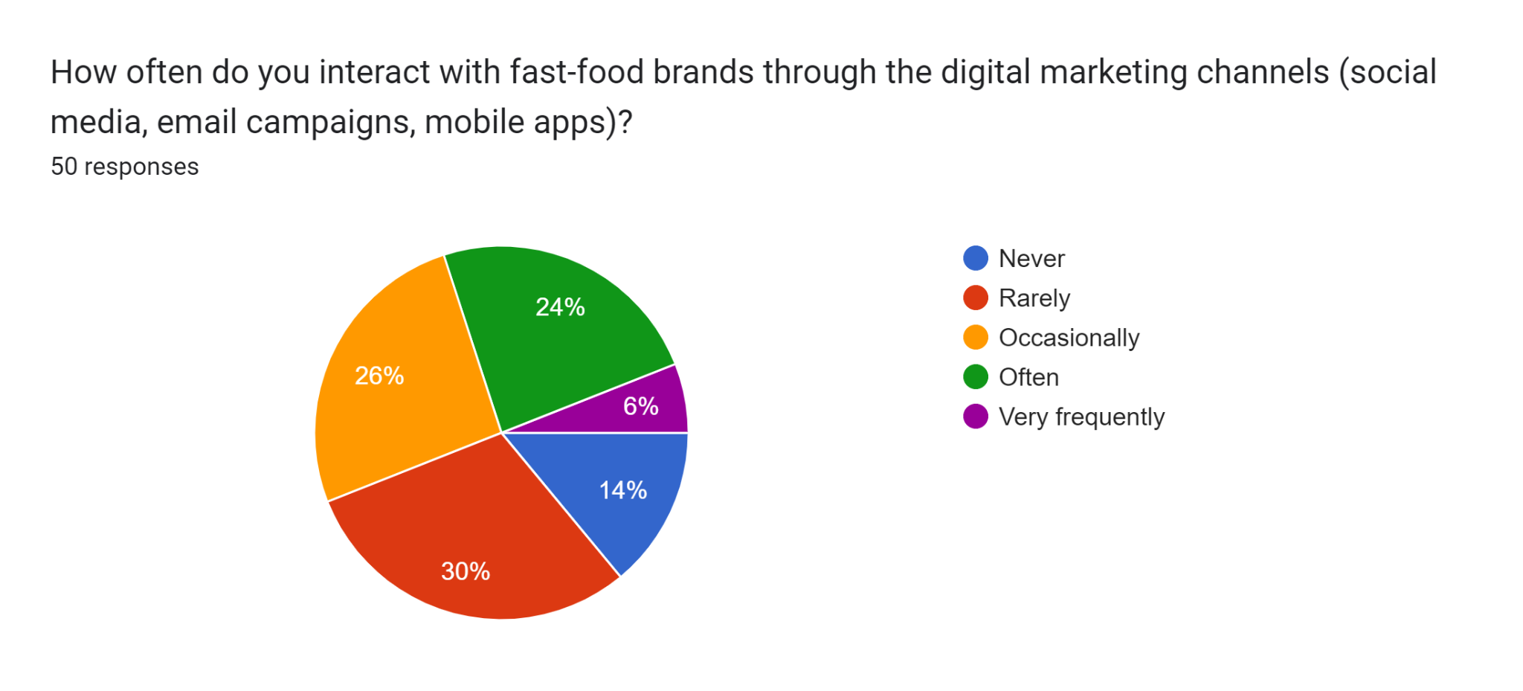
Analysis: The above figure showcases the pie chart of different people's responses regarding the topic. The survey was conducted with 50 participants associated with the fast-food industry to gauge the level of interaction with fast food brands through various digital marketing channels such as media, email, and mobile applications. The data describes a range of audience engagement items. It is significant to mention that approximately 30% of respondents rarely get in touch with fast food brands online. This implies a significant portion of a given industry may not largely be open to digital marketing for engagement but depend completely on traditional media. About 26% of people believe that they occasionally interact with the brand through digital channels. The respondents admitted they used such channels irregularly or rarely, giving an idea of how often they engage with digital marketing. This part could engage with brands online but not always, which may signal the need for improving marketing strategies and enhancing consistency in digital. In addition, 24% of people frequently use digital marketing channels to interact with fast food brands. Thus, implying that a considerable number of respondents are actively engaging with fast-food companies through online platforms. This segment can be a powerful one for the campaign to reach out and influence. The rest of the 14% claimed that they do not practise often, and very few 6% said that they are very often engaged digitally. Through these segments, it could be concluded that only one of the groups would be completely disaffected by digital platforms, and the other more digitally capable. Overall, the data from the survey confirms the trend of using conventional techniques more than modern ones in this kind of industry. Though digital platforms cover the needs of a part of the consumers, the phenomenon of people still choosing to visit fast food outlets physically is also a phenomenon. This implies that brands can exploit these digital marketing opportunities while also maintaining the physical locations to cater to the customers' diverse needs.

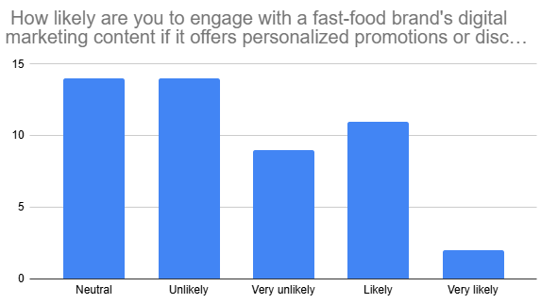

Analysis: The above figure showcases the pie chart of different people's responses regarding the topic. The survey was conducted with 50 participants associated with the fast-food industry to gauge the likeliness of people engaging with a fast-food brand’s digital marketing content if it offers personalised promotions or discounts. This data can tell something more than just a simple perspective among the respondents. The research showed that about 46% of participants were moving away from the brands if there were personalised coupons or discounts offered by fast food. It seems a sizable part of the respondents could lead behaviour that blocks the offers landing via personalised digital marketing. On the contrary, more than 40% of people will be more likely to engage with fast food brands if they offer personalised promotions and discounts. This finding reveals the substantial number of sample participants who think that the digital content of fast-food brands with personalised incentives is attractive and interesting. This segment of the population will likely seek personalised perks that suit their unique taste and demands. And rest of the people responded neutral which indicates that people may engage with the fast-food brand if the organisations offer personalised promotions as well as discounts. On the other side, some responders in neutral meaning, show readiness to acceptance when they receive personalised promotions or discount services. The neutrality of this part conveys the possibility of individualised digital offers, whereas additional factors or stimulating incentives might be required. However, it has been observed that most people would be less likely to engage with the fast-food industry if they offered personalised promotions as well as discounts. On the one hand, there is a sizable number of respondents who express a desire for personalised discounts and promotions. However, the finding that many people would be less likely to interact with fast-food brands if such offers were made shows a noteworthy trend. In addition, it indicates that although personalised incentives can fuel the involvement of a considerable portion of customers, they may not motivate the engagement of everyone. Other aspects like brand loyalty, product quality, and overall consumer experience can very well be the controllers behind the engagement of individuals with the digital marketing content of fast-food companies.
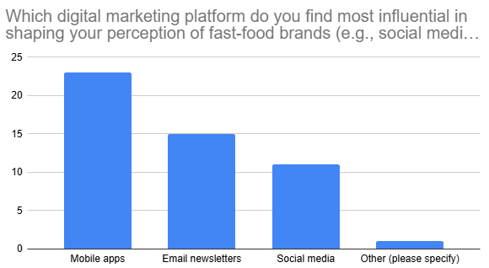
Analysis: The above figure showcases the pie chart of different people's responses regarding the topic. The survey was conducted with 50 participants associated with the fast-food industry to gauge the types of digital marketing that affect people’s perception of fast-food brands such as social media, email newsletters, and mobile applications. According to the observation, about 22% of them believe that social media platforms influence their opinion. It cannot be ignored that social media's impact is substantial, even though some campaigners argue that widespread use of Facebook, Instagram, and Twitter makes it less relevant. Social networks are the gateways to fast food brands as they use them for promoting the brand, engaging their customers, and advertising making them the crucial tool to shape consumer perceptions. Generally, in today’s world people are more engaged with social media activities which significantly influence their minds towards various things. On the other hand, 46% of people believe that people are mostly influenced in shaping their perception of fast-food brands with the use of mobile applications. In today’s world, there are various fast-food brands such as Burger King, McDonald's, Domino, and many others, have implemented applications for their brands where their customers can easily order their food at one tap. The applications of smartphones and the accessibility that is offered by these applications have given these apps the unique ability to make them possible as tools for consumers’ engagement and building positive consumer impressions. About 30% of the people responded that they are influenced by email newsletters. However, email marketing might look antiquated compared to social media or mobile apps, but it’s still an optimal means of direct communication with customers for fast food brands. Newsletters through email usually include personalised deals and discounts and the latest updates. They are valuable for subscribers and increase the brand name by incorporating the fast food by consumers positively. Overall, the survey data indicates that fast-food brands use different digital marketing avenues to determine specific consumer responses. The most powerful channel is provided by mobile applications, which means that the industry's adaptation to technological advancement and shift of the consumers' preferences from time to convenience is proven. Email newsletters and social media may also contribute to different degrees, but the point to note is that those with more channels are more likely to attract the consumers and this puts an importance on having marketing strategies that are multi-channel for enhancing consumer engagement. Using the overall combined efforts of digital channels is essential for fast-food brands aspiring to improve their image, connect with customers, and sell more products. Through the utilisation of mobile apps, social media platforms, and email newsletters brands can successfully influence consumer viewpoints and sustain competitiveness in the dynamic digital market of the fast-food business.
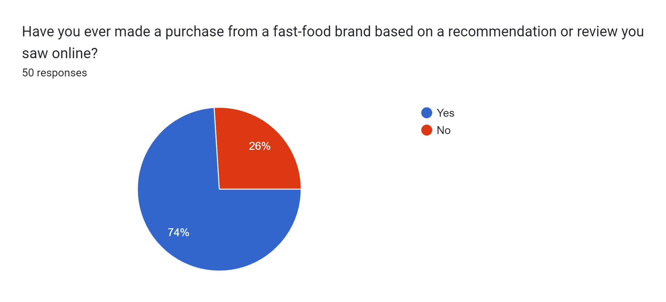
Analysis: The above figure showcases the pie chart of different people's responses regarding the particular topic. The survey was conducted with 50 participants associated with the fast-food industry to identify whether they have made a purchase from a fast-food brand based on a recommendation or review online. The statistics indicate a strong trend, with the largest proportion of respondents, about 74%, definitely saying that they selected fast food products whose brands have been advertised online due to positive feedback. On the other hand, a high majority strongly suggests how powerful online reviews are in terms of affecting consumer decisions in the fast-food sector. In this way, the research result is in alignment with the broader trends in consumer behaviour, where social media mentions and recommendations play a significant role in decision-making across different industries. The realm of fast-food organisations is one in which customers make impulsive and immediate choices. Therefore, the recommendation power becomes especially vital online. There are many factors influencing the use of online recommendations in fast food ordering. Firstly, the convenience and accessibility of reviews available online make it a go-to resource for consumers looking for information about fast food options. In addition, the influence of the opinions and behaviours of consumers cannot be underplayed. When customers read about positive reviews or hear about others' experiences with a certain product, they tend to trust it and therefore, feel more confident about their decision to buy it. The lifestyles of street food are dynamic. The validation of customers becomes an important aspect of the quality and appeal of the brand.
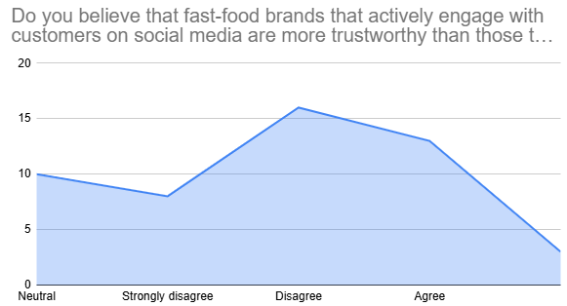

Analysis: After conducting the in-depth analysis of the associated data from the fifth question of the survey, it can be said that most of the participants do not believe in the fact that the companies of fast foods that are actively involved in social media are quite trustworthy as those that are not. Among the 50 responses, around 32 percent of participants disagree with the importance of the social media presence of fast-food companies for showing trustworthiness among customers. Ebrahim (2020) argued that with the aid of sustaining regular presence on social networks brands can create significant relationships with their customers and ensure loyalty. On the other hand, when it comes to creating trustworthiness among the people, around 20 percent of people remain neutral when this comes to understanding the importance of social media presence for the creation of trustworthiness. On the other hand, 26 percent of the total participants agree with the significance of social media in the creation of trustworthiness among the customers of these fast-food companies. This can be justified by the opinion of Puspaningrum (2020) demonstrating that platforms of social media are the talking stick for fast food companies to boost brand recognition and create deeper relationships with the customer base. Furthermore, around 16 percent of the total 50 responses can be found to disagree with the importance of social media platforms for the creation of trustworthiness among the customers of the company. The remaining 6 percent strongly believe that fast food companies can create trustworthiness among customers with the aid of the creation of an effective presence on the different platforms of social media. The findings from the responses of the participants related to the question can show that presence of the social media cannot create trustworthiness among the customers of the fast-food companies across the globe. The companies are required to create more sustainable digital platform strategies for making the people aligned with the trustworthiness of the companies.
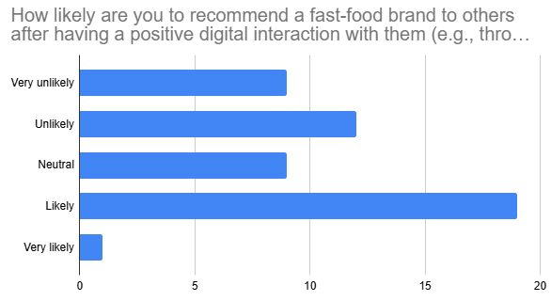
Analysis: The above analysis of the responses that can be found from the sixth question of the survey, can be said that around 38 percent of the respondents believed in the importance of digital interaction for generation of the value. Most of the respondents agree with the fact that effective digital interaction with customers can create a positive impression of a brand. This positive impression would enable the customers to recommend the brand to others. On the other hand, around 24 percent of respondents among the 50 respondents disagree with the value that can be generated by positive digital interactions. Furthermore, around 18 percent of the total respondents of the survey were found to remain neutral regarding the role of digital interaction in making the positive reputation of the brand that can be recommended to others. On the contrary, Dastane (2020) argued that digital marketing gives a chance to fast-food chains to establish an emotional connection with customers through the branding story acting as the window. This can be justified by the opinion of Suharto et al. (2023) regarding the fact that Facebook Ads provide a brand an opportunity to create targeted campaigns that respond to its audience’s interests and behaviour, to redirect such audience to websites or physical outlets. With the aid of effective digital interactions, the brand can build credibility along with strengthening the brand. With the aid of the adoption of digital technology, the company can also enhance the experience of the customers which can lead them to recommend the brand to other people. This is how the brand can reach its target audience effectively.

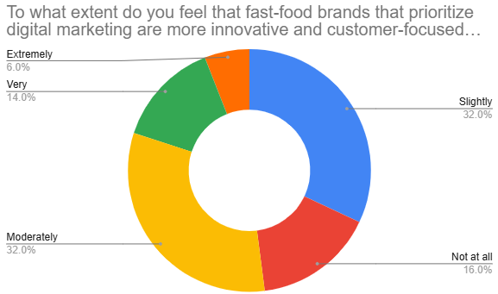

Analysis: After gaining insight into the responses to the seventh question of the survey, this can be said that most people believe in the significance of digital marketing in bringing innovation and a customer-centric approach. Among the 50 responses to this question around 32 percent agree with the fact that digital marketing can bring innovation for fast-food companies which can provide services or products based on the customer's preferences. On the other hand, around 32 percent of people slightly agree with the value of digital marketing for delivering innovative products and services to the value-added customers of the company. Apart from that 16 percent of the total respondents do not feel it is important to bring digital marketing for the innovation and customer-centric approaches when this comes to the generation of value for the customers of the company. Similar findings can be found by Fetais et al., (2023) demonstrating that mobile apps are the source of data and analysis. so that brands can easily track user’s behaviour, preferences, and transaction history. Most of the participants of the survey can be found to be effectively aligned with the importance of digital marketing for bringing innovation in the different services and products that can enable the customers to choose to buy a particular product or service. This has become quite vital for organisations to exceed and deliver the expectations of the organisation with a robust and digital mindset that can be backed up by innovation through digital marketing. Due to the fierce competition in the market, fast-food companies are thus required to create novel content through digital marketing which would enable greater interactions among the customers of the company. Among the 50 responses around 14 percent responses can be found to agree with the importance of digital marketing in bringing innovation and the customer-centric approach for enhancement of the customer's experience of the company. 6 percent found this extremely important to adopt digital marketing strategies for innovative and customer-focused services and products for the efficiency of the customer experience effectively.
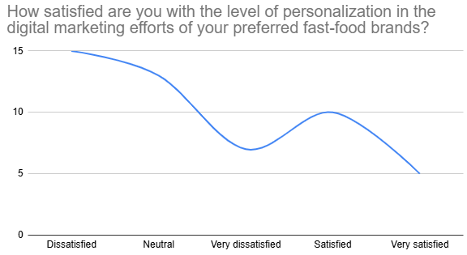
In this portion of the survey, the players were questioned concerning their satisfaction status of personalization in the digital marketing measures of their selected fast-food brands. As per the answers from the 50 participants, 14% of them were highly disappointed and 30% of them were aggrieved. This kind of reviewer indicates their unhappiness with the process of personalization. The possible causes can be mentioned as non-personalized or generic content, irrelevant experiences, and privacy issues. They can get messages or offers that don’t hit the right spot. Maybe those participants weren’t exposed to the product’s personalised recommendations or offers. On the other hand, 26% of the participants were in a neutral state this group perched on the fence. They are in the middle of the scale regarding the level of personalization. Their neutrality may come from the back-and-forth and the indifference. They would not be focused on personalising the fast-food interactions of their brand. Moreover, 20% of the participants were satisfied and 10% of them were very satisfied. This indicates such respondents do value these personalization efforts. Reasons can be content focus, easy to use, and strong reputation.

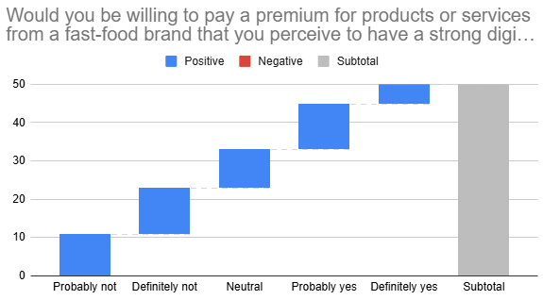
The survey participants were asked about their willingness to pay or spend for premium products or services from a fast-food brand that the participant perceived to have a powerful digital presence along with the customer engagement strategy. Based on the collected information from the 50 survey participants regarding this matter, 24% of the respondents stated definitely not and 22% of the participants remarked probably not. These respondents are the people who will not pay higher prices at all. The fears of digital communities may result from doubts about the supposed benefits of virtual communication. Maybe they attach digital methods with low-cost measures or a lack of personal connection. On the other hand, 20% of the respondents were neutral which signifies this group of respondents remained undecided. They are neither positive nor negative about the idea of paying more with this insurance.

4.3 Chapter Summary
Therefore, this chapter has effectively discussed the context for the readers with the aid of reiteration of the questions of the research and the problem statement of the research as well. This is how the chapter can help the researcher to meet the objectives of the research effectively.

Chapter 5: Discussion

5.1 Chapter Overview
In-depth discussion and analysis of digital marketing's function, obstacles, and prospects in the fast-food sector are covered in Chapter 5 of the dissertation. Fast-food companies now recognize the importance of digital marketing, which offers chances to improve consumer involvement, brand awareness, and customized experiences. Digital marketing does, however, come with drawbacks as well. These include creating a cohesive message, reaching customers who do not need to be more active on social media, and protecting customer privacy. Notwithstanding these obstacles, the sector may use machine learning and artificial intelligence developments to offer tailored content and immersive experiences. This chapter examines these many facets to give readers a thorough grasp of digital marketing in the fast-food industry.

5.2 Chapter Discussion

5.2.1 Discussion regarding Digital Marketing in the Fast-Food Industry
Digital marketing has played an important role in enhancing the reach of fast-food chains digitally. In the literature review section of 2.1 Adam et al. (2020) advocated that digital marketing invariably enables companies to locate and interact with consumers on a worldwide level, thereby facilitating business expansion and consumer relationship enhancement. Digital media platforms such as Facebook, Instagram, and Twitter give fast-food chains a chance to be creative and present their brands and values through social media. As per the perspective of Ilyas et al. 2021, sustained and meaningful approaches to digital marketing generally help boost the visibility of fast-food brands in the market and help the customer to easily, and conveniently associate with the brands that are most preferred by them.

As per the survey result around 30% of the participants stated that they rarely interact with the fast-food brand through the digital marketing channels or platforms. On the other hand, 24% of them often interact with the brands and 6% of the participants frequently do this. This signifies that digital marketing is enabling the fast-food brands to meet the requirements of the consumers. It has been identified that fast-food chains will be able to communicate with customers cultivating a sense of togetherness. By using e-mail to answer customers’ questions, get their feedback, and send special offers, the fast-food brands can engage consumers and tempt them back to a business multiple time. Based on the viewpoint of Onkar (2022) in the literature review section 2.1, digital marketing is also promising because it can adapt the message to the customer. By incorporating consumer behaviour into data analysis coupled with the advertising approach, fast-food chains stand to gain by delivering unique messages that appeal to the intended customers. This can enhance the prospects of conversion and thus customer loyalty.
On the other hand, the fast-food industry has also been motivated by the presence of online food delivery. As per the survey results, 22% of the survey participants are likely to be involved with the digital marketing content of fast-food chains if the brand proposes or delivers personalised deals and promotions. However, 28% of the participants are unlikely and 18% of the participants are very unlikely to engage with the fast-food brand. This signifies that the majority of the participants possess the desire for personal discounts, however, they do not prefer to interact with the fast-food brands. Even though these services of fast-food brands can enhance the loyalty of the customers, it can also negatively impact the customers' perspectives. Marketing through digital media has a significant role in supporting such services and attracting more people to order food from online apps and applications and to try new foods and products that may be available only in delivery services. Based on the stances of Ebrahim (2020), digital marketing contributes useful information and impact assessment to the fast-food chain kind of business. Applying the corresponding indicators like visitors’ traffic, social share, and conversion, fast-food brands can make profits, understand trends, and improve their marketing approaches, investing their capital correctly.

5.2.2 Discussion on Role of Digital Marketing Channels like Social Media Platforms, Email Campaigns, and Mobile Application
Social media provides two-way communication between fast-food brands and consumers which includes responses to questions and answers, feedback, and interaction. As per the perspective of Puspaningrum (2020) in the literature review section 2.2, fast food brands should focus on developing an online community of customers who are committed to the brand to create brand support. Collaborating with influencers on social media outlets can upgrade the reach and credibility of a fast-food chain in the industry. Nevertheless, influencers with a considerable following can publicize sponsored content or considerations to entice the attention of their followers to the brand’s websites and social media platforms.
As per the survey result it has been identified that 22% of the survey participants have advocated that they prefer social media platforms, 46% primarily considers mobile applications, and 30% mainly prefer Email newsletters. Many fast-food brands like Subway, McDonald's, and Tim Hortons have implemented mobile application services that are aiding the consumers as well as the brands. On the other hand, mobile applications also provide fast-food consumers with a prospect to view the menus, order for, and pay for their feasts utilising their smartphones. Moreover, mobile apps increase overall customer satisfaction by simplifying the order process and providing tools such as order tracking and choice of options for customization. Fetais et al. (2023) discussed in the study that mobile applications allow fast-food chains to have loyalty programs, reward options, and offer options, and the options can be based on the customers’ preferences and buying habits. Nevertheless, through data compilation and analysis of consumer information, brands may offer coupons, birthday promotions, and other options that inspire repeat purchases and customer loyalty.
Through email campaigns, fast-food chains can easily send out tailored messages and offers to the customers’ email accounts. Through email campaigns, fast-food chains can easily send out tailored messages and offers to the customers’ email accounts. Deepa (2021) advocated in the literature review section 2.2 that it can also help brands divide their email lists according to different criteria like previous buying behaviour, interests, and age. Aside from promotional material, it is possible for fast-food chains to use email campaigns to disseminate information concerning updates, new products, or any other information the brands wish to pass on to the consumers. On the other hand, the study of Sara (2023) mentioned that the email newsletters can help the customers be informed and in touch with the brand whether it is through announcing new products on the menu, sustainable practices, or achievements by the company.
Social media platforms, email marketing, and mobile applications are paramount to the fast-food industry as a mechanism of reaching customers, selling products, and strengthening brand identity with the help of promotions, content, and other relevant content that meets customers’ preferences. Thus, the implementation of these digital marketing channels helps fast-food chains remain relevant in the present constantly evolving environment and growing trend of digital customer engagement.

5.2.3 Critical Discussion on RACE model in the Digital marketing of Fast-Food Industry
The RACE model is primarily considered a strategic framework that stands for Reach, Act, Covert, and Engage. As per the perspective of Nuseir and Elrefae (2022) in the literature review section 2.3, the RACE model is generally utilized in digital marketing which assists in planning as well as executing the plan effectively. The fast-food brands can identify and reach the target audience segments through digital marketing efforts which can include demographics like age, location, customer preferences, and lifestyles. For instance, the fast-food chain Mcdonald’s targets young adults, children, and families considering affordability and convenience. On the other hand, the fast-food brand Subway especially targets individuals who are health-conscious like healthiness enthusiasts as it offers more nutritious meal choices to the consumers. As per the survey results, 20% of the survey respondents marked that they are pleased with the personalization in the digital marketing measures. However, it has been determined from the survey outcomes that a total of 44% of the respondents are disheartened with the personalization in the digital marketing endeavours of fast-food brands.
The study by Budiman (2021) mentioned that through digital marketing, fast-food chains facilitate consumers to contend with digital content. Most of the fast-food chains consider the call-to-action or CTA optimization for facilitating the desired actions of the consumers which may include signing up for customer loyalty programs, ordering online through social media platforms, or visiting physical stores. For instance, McDonald considers the CTA optimization in the posts through social media which direct the customers to the official website of McDonald’s for food ordering and promotional purposes.
On the other hand, by analysing the survey results, it has been identified that 26% of the participants agree with the fact that fast food chains are actively involved with consumers through social media platforms. However, a total of 48% of the participants disagreed with the fact. As per the viewpoint of Haudi et al. (2022) in the literature review section 2.3, streamlining the process of online ordering helps consumers to convert to paying clients. The fast-food industry significantly analyses the performance of discounts and promotional offers which help the brands to compare the incentives that hold the potential to drive the conversion rates. Up-selling and cross-selling strategies can be useful for the brands to increase the value of transactions of the fast-food chains.
The Engage stage of the RACE model includes social media engagement, nurturing customer relationships, and community building. Based on the viewpoint of Dülek and Aydın (2020), the brands try to engage with the consumers through social media platforms by sharing user-generated content, delivering timely updates, and responding to the messages and comments of the consumers. By adequately applying the RACE model in the fast-food industry for digital marketing efforts, the brands can have the potential to efficiently reach, act, engage, as well as convert consumers. This can foster brand loyalty and drive overall business growth in the market.

5.2 4 Discussion on building of brand reputation and consumer trust in the fast-food industry
According to Ibrahim and Aljarah's (2020) in the study, stats that the customers' perceptions of fast-food businesses have significantly shifted in the digital era. User-generated content (UGC) is a significant influencer and includes consumer evaluations, images, and social media posts. The reputation of the company is greatly impacted by this material, which frequently includes scrumptious pictures of meals. UGC influences consumers due to the perceived authenticity that is associated with it and not refined advertising. Receiving recommendations from friends is more credible than the message received from corporations; therefore, UGC acts as a tool that strengthens the sense of trust. The study by Rimadias et al. (2021) explores young consumers' compliance with COVID-19 guidelines. It is far more convincing to follow a friend who has recently discovered a new dish on Instagram. This is mainly because fast-food chains can benefit from the following strategies: displaying this UGC as social proof in their future campaigns to include positive customer reviews or endorsements. This forms social evidence that consumers are assured of the pertinency of a brand preferred by fellow consumers.
However, while being positive, one contemporary study by Ting et al. (2021) implies a positive brand image is equally important and cannot be achieved by simply collecting happy customer posts. Fast-food chains must establish a systematic approach to assessing the external image that affects them. This implies staying connected to channels such as social networks, review sites, and forums to respond to customer complaints positively and efficiently. Sensitively replying to emails, calls, and online reviews shows that the brand is considerate of its customers’ feedback. Also, satisfied patrons are often encouraged to provide positive reviews on the Yelp page to help improve brand visibility. Similarly, the article by Lou and Xie (2021) reveals how these fast-food chains can systematically acquire valuable insights about consumers using digital marketing platforms. It enables them to fine-tune and improve services to be provided to the customers as a way of improving the lives of the customers. In a sense, someone channelled the latest customer demographics, enabling one to figure out what they want and give it to them through a personal brand. It benefits business as a long-term strategy, focusing on the customer, personalisation processes, and engaging customers in the brand’s processes, increasing brand value. From the collected data, and more specifically from the survey results of the 50 participants, crucial information regarding the consumers in the fast-food industry can be extrapolated.
Moreover, one-third (30%) seldom engage with brands virtually, thus suggesting a possible dependence on conventional media sources; at the same time, a steadily increasing number of consumers (24%) find it possible to access brands and companies’ digital platforms often. This points to increased internet use efficiency through targeted campaigns and advertisements. The impact of tailored marketing was also investigated in the survey. It is interesting to note that although over 40% of respondents found personalised offers appealing. Almost half 46% were less inclined to interact only because of these benefits. This implies that customers will continue to place a high value on brand loyalty and product quality. Specifically, the survey sought to access the impact of different digital marketing channel. Another crucial fact of the use of social media was that 22% of the respondents considered its strategic for brand promotion. However mobile apps emerged atop the list with 46%, attributable to the fact that they are the more convenient than website science they provide a direct interference. Email marketing is also an important tool and 30% of the respondents admitted it affected their purchase choices.
These findings are complemented by survey data that substantiate the influence that UGC, reputation management, and digital marketing have on consumers’ trust and the reputation of fast-food brands. This is where fast-food brands should focus on embracing UGC, learning to manage the online presence diligently, and adhering to the customer-first approach. This way, the brands can foster a significant presence and enhance loyalty within the new worldwide web.

5.2.5 Discussion of the satisfaction and the perception of the customers that influence digital marketing in fast food industry
The study emphasised on how UGC significantly affects the brand impression, with 74% of respondents basically purchasing on Internet recommendation. This is emphasised by Melovic et al. (2021), who point out that digital marketing tool can speed up customer perception of business. Customer decisions are greatly influenced by positive reviews and social media mentions, which serve as a type of social proof. Encouraging happy customers to write good reviews and utilising user generated content in their marketing campaign. Should be fast food firm top priorities. One of the remarkable findings that come out from the survey is that although 40% of the respondents are interested in target advertisement, 46% are likely to interact only because of these promotional messages. This remains the harmony of the study by Ibrahim (2021), who highlights the need to take a more customer-centric approach to experience map, whereby the customer faces challenges and experiences solutions to their needs. As per the finding by Dastane (2020) found out that creating engagement and trust into a product, which may involve good storytelling, could be important for sending targeted offers to the customers.
According to a survey, mobile apps are at the forefront of customer engagement with fast-food brands by 46%. This aligns with Fetais et al. (2023), who claimed that data generated from mobile apps helps capture the user's behaviour and preferences. Mobile apps are an essential aspect of the fast-food industry, where the focus should be on intuitive and feature-rich mobile apps where the client can order food, get recommendations based on their past choices, or join a loyalty program. The role of social media is a multifaceted challenge. This view about the effects of social media or contrasting the survey result shows that 22% of the people think that it is a significantly contributing factor to the issue. Others feel that there is a need for another approach to trust building for online media, 32% of people disagree that social media promotes news. This means that it is more important to be active on social media platforms. State the type of post accountant shared on the business. Social media accounts must be specific. According to the findings of Puspanigrum (2020), said that brands should participate in customer related conversation, respond appropriately and speedily to customer concerns and create a good image of the customers.
The importance of productive digital communication, according to the poet, the majority 38% think that favourable digital encounters foster referral and favourable participation. This is collaborated by Suharto et al. (2023), who point out that focused digital marketing initiatives may raise brand identification and awareness. Fast-food chains ought to place a high priority on offering top-notch customer support via internet platforms, establishing a smooth online presence that encourages brand loyalty. Promoting Innovation through Digital Marketing Shows a Customer-Centric Importance The surveyed data responses directly correlate with the customer-centric importance of innovation through digital marketing, with 32% agreeing with the proposition. By analysing data accumulated from mobile applications and other related technologies, corporations involved in the fast-food sector can learn about their client’s characteristics and adapt their products to suit them. This is in line with Fetais et al. (2023), who presented that the data generated by a mobile app assists in revealing customer behaviour and, in turn, product development. Marketing experts also firmly believe that brands incorporating data and embracing digital marketing strategies can develop good products and services responsive to ever-changing consumer needs.
By analysing the poll result, it is advisable to state that digital marketing has become the crucial factor influencing customer perception and satisfaction levels with the fast-food industry. Fast Food brands can improve customer engagement, customer loyalty and increase competitiveness through the active promotion of UGC, the management of positive review section, the focus on mobile application, concept, and the big data personalisation technique. However, one must be careful to get that finding between personal branding and organisational overall branding right and not forget the need to have a positive and credible online presence

5.2.6 Discussion on challenges and future directions of digital marketing in the fast-food industry
Although digital marketing can provide several benefits, it can also create several challenges for the brand. Similar views can be observed in the study by Hanaysha and Momani (2021), where they stated that digital marketing can provide ample advantages to the fast-food industry, but it can offer certain challenges along with this. Due to different digital marketing platforms, creating a unified message becomes difficult for the brand. Some of the people who do not interact much with social media, the fast-food industry cannot reach them through digital marketing. The same idea can be observed in the findings. 14% of the participants never use the digital marketing channel to interact with the brands’ strategies and 30% of the respondents rarely check the digital marketing tools. this portion of the consumers who rarely or never check the digital marketing tools, cannot be easily targeted by the fast-food industry through digital marketing campaigns.
On the other hand, the privacy of consumers often gets ignored when utilising digital marketing campaigns by different industries. However, effective engagement with consumers can build trust for the brand. Contrasting opinions can be observed in the views of the participants. 16% of the participants strongly disagree and 32% disagree on the fact that the fast-food brands which interact with consumers are more trustworthy than those brands that do not engage. Apart from these, 6% of the participants strongly agree and 26% of the respondents agree that engagement is a must to gain the trust of consumers. On a different note, one of the main challenges of using digital marketing tools is the continuous learning about the advancement of the technologies. They need to use different mediums of digital marketing tools to attract consumers. The findings also provide similar views where the consumers think of different goal marketing tools to create influence on them. Furthermore, 46% of respondents think that mobile applications can influence the decisions of the public. Whereas 30% agreed with email newsletters and 22% of them agreed with social media. These differences of opinion in the public are making the fast-food industry continue their education in the technical field which might create difficulties for them.
Apart from the challenges, Ertemel et al. (2021) provided the idea that digital marketing has a lot of potential within the fast-food industry. With the utilisation of AI and machine learning technology, the fast-food industry can provide realistic pictures and interactive environments to its consumers. The industry can also offer personalised content and advertisements to them. However, contrasting opinions have been recorded in the findings. 18% of participants like to engage with fast-food brands if they offer personalised recommendations. On the other hand, 28% of the respondents are unlikely to support the idea. The fast-food industry needs to think about the preferences of its consumers and then target them to captivate with their offers and discounts.
It is fundamentally evident that, on the one hand, there are several opportunities for the fast-food industry included in digital marketing; on the other hand, there are several threats. Some of the challenges they have outlined include the issue of cohesiveness, where the company desires to relay separate messages through the different platforms it uses, the inability to target consumers that are not part of the social media, and the fact that the company has to be knowledgeable in the changes that are constantly being unveiled in the technological world. Privacy concerns are also acknowledged, but with the proper engagement, the concept assists in creating trust. The opportunities are still derived from AI and machine learning since such platforms enable delivering realistic experiences and customized content. However, consumer perceptions still need to be fully unified on these issues, which only underlines the necessity to study individual characteristics as the key factors to achieve maximum results in implementing digital marketing strategies and tools.

5.3 Chapter Summary
This chapter concludes by identifying the opportunities and threats that digital marketing offers to the specific context of the fast-food industry. Social networking sites, applications for portable devices, and e-mail marketing are some of the critical trends for target market communication and brand advertising. Employing the RACE model in planning and executing digital marketing communication activities is possible. However, there are also some difficulties, such as how to create a single strong brand message and how a company can guarantee its customers’ privacy. Looking into the future, the possibility of expanding digital marketing in the fast-food industry using artificial intelligence and machine learning to offer more personalized and unique customer experiences is high.

Chapter 6: Conclusion

6.1 Chapter Introduction
This chapter focuses on providing information about the impact of digital marketing tools on the engagement of consumers. It provides a brief overview of the findings and justifies the objectives used in this research. It also offers necessary suggestions for the fast-food industry to improve its engagement with consumers and sheds light on the limitations of the research.

6.2 Linking with Objectives
Objective 1: Brand recognition and awareness are affected through digital marketing approaches in the fast-food sector.
Linking with objective 1, digital marketing tools have the capacity to successfully captivate the minds of consumers. The fast-food industry is utilising digital marketing tools to interact with their consumers and establish connections with them. In the middle of the intense competition of the fast-food industry, digital marketing tools can help the brands in creating a unique identity which can differentiate them from other existing companies. Through digital marketing tools, fast-food brands can voice their opinions and influence consumers to make purchases from the brands. The findings exhibit the different opinions of consumers regarding their engagement with the fast-food industry through digital marketing tools. In a survey of 50 participants, various viewpoints have been captured for the purpose of the research. A large portion of the participants never or rarely interact with the fast-food brand through digital marketing tools which suggests that the industry needs to improve its content and digital marketing strategies. Majority of the participants are not interested in the personalised promotions, or the discounts exhibited in digital marketing by the fast-food industry. Social media, email newsletters and mobile apps are the most influential digital marketing platforms recommended by the participants.
Objective 2: Different digital marketing platforms such as social media, and other email campaigns, as well as mobile apps, promote repeat business and client loyalty.
Linking with objective 2, different digital media platforms are contributing in their own way to influencing consumers. Through social media platforms like Facebook, Instagram, Twitter and others, the fast-food industry can share the descriptions of their products and post the message of the brand which can attract consumers to make a purchase. The email newsletters target the existing consumers with the continuous discounts and special offers of the brand. This continuous message would not let the consumer forget about the brand and there is a chance that those consumers would visit again in the brand. With the use of the mobile application, the consumers can be engaged with loyalty points and other special offers which would make them purchase the products again. These digital marketing tools are effective in making consumers loyal to their digital presence and offerings. A large segment of participants would make a purchase after checking a positive review online. Different opinions can be captured in identifying the trustworthy brand according to their engagement rate which implies that some consumers are more interested in the quality of the products and services to feel the trust that those who engage with the digital marketing platforms. A huge chunk of the participants does not want to recommend the fast-food brand to others even if they have positive interactions with the brand through digital marketing platforms. Only a small portion of participants agreed that the fast-food brands are prioritising digital marketing, are innovative and put their focus on their consumers.
Objective 3: Influence of individualised digital marketing on perceived brand value and satisfaction among consumers.
Linking with objective 3, the fast-food industry is heavily relying on user-generated content to make videos and attractive descriptions of the products. This strategy ensures that consumers get a review of the products and influence them to increase the purchase rate. People are largely relying on online reviews to make a purchase decision. The fast-food industry also manages its reputation through digital marketing platforms. With the increase of online users, user-generated content and addressing the reviews of consumers are making consumers loyal towards the fast-food industry. As per the findings from the survey result, 24% of the participants stated probably yes, and 10% remarks yes regarding willingness to spend more for the premium products. They understand the relevance of digital marketing and how it shapes the brand's image. Whereas some consumers continue to maintain doubt about it, others understand that a good internet presence of a fast-food brand can help it shape the public perception of itself. This could be one of the reasons why customer objectivity could be based on an insufficient understanding of the role digital techniques could play in brand value.
Objective 4: To explore how the fast-food industry, user-generated content as well as internet reviews influence consumer trust and brand reputation.
Linking with objective 4, the online reviews and the user-generated content can heavily influence consumers to make a purchase from the industry. The attractive videos of the users, and their reviews after eating the food and getting the services generate trust in other consumers that their services are genuine, and they make a purchase. As per the survey outcomes, 38% of the respondents believed in the importance of digital interaction for generation of the value for the fast-food industry and organisations. On the other hand, 18% found this quite unlikely to recommend the brand of fast food after having the effective digital interaction with the brand. After the analysis of the data, most people understand that digital interaction is quite important to improve the awareness of the brand and recognition of the brand. This improvement in brand awareness can lead the customers to recommend the brand to other customers which increases the trust of the consumers and uplift the reputation of the brand.

6.3 Recommendations
- Hiring influencers to promote the products and services of the fast-food industry can be effective. Belanche et al., (2021) described that influencers can attract their followers to make a purchase for the brands. The food bloggers provide reviews to promote the brand for a specific consumer base.
- The industry needs to post more engaging content like live question-answer sessions, quizzes or behind-the-scenes moments to make the consumers attached to the brand. According to Zhang, (2022), behind-the-scenes content can be an effective strategy to build connections with consumers. The fast-food brand also exhibits the description of the products and menus on social media to make consumers aware of every single detail.
- leveraging data analytics should be effective in understanding the behaviour and preferences of consumers. Kim et al., (2021) stated that AI algorithms can be effective in understanding the preferences of consumers. Machine learning and big data analytics can also help the fast-food industry to understand the shopping behaviour and tastes of consumers. This valuable information can be utilised by the fast-food industry to adjust their marketing strategies for making the products.

6.4 Limitations of the Research
The research mainly focuses on specific digital marketing platforms for conducting the research. However, the advancement of technologies has been introducing new mediums of digital marketing which is unexplored in the research. The findings of the information are completely based on the opinions of the participants which might contain bias for the digital marketing platforms or the fast-food industry. The recommendations were also made as per the findings. The cultural backgrounds and personal preferences of consumers were not considered in this research.

6.5 Future research
More studies in the future could be conducted on how the new trends such as the use of augmented reality (AR) or artificial intelligence (AI) affect the branding of fast-foods and customer loyalty. Further, there may be value in research concentrated on assessing the efficacy of person-based marketing strategies based on consumers’ inclinations. It will also be useful to undertake a further investigation of how user-generated content and influencer marketing can influence the perception of brands in the fast-food sector. Furthermore, claiming existing research on consumers’ attitudes and behaviour over periodical intervals could be helpful in understanding the changing trends of digital marketing and its impact on brand loyalty in the fast-food sector.

6.6 Chapter Summary
The main objective of this chapter is to enlighten readers on how digital marketing tools affect customer engagement. It explains the research’s goals and gives a summary of its findings. It also clarifies the limitations of the research and makes the essential recommendation for fast food businesses to increase customer engagement.

Reference

Abdelhakim, A.S., (2021). Adopted Research Designs by Tourism and Hospitality Postgraduates in The Light‎ of Research Onion. International Journal of Tourism and Hospitality Management, 4(2), pp.98-124. Available at: https://doi.org/10.21608/ijthm.2021.206774 (Accessed: 5th May 2024)

Adam, M., Ibrahim, M., Ikramuddin, I. and Syahputra, H., 2020.The role of digital marketing platforms on supply chain management for customer satisfaction and loyalty in small and medium enterprises (SMEs) at Indonesia. International Journal of Supply Chain Management, 9(3), pp.1210-1220. Available at:http://download.garuda.kemdikbud.go.id/article.php?article=1730558&val=13549&title=THE%20ROLE%20OF%20DIGITAL%20MARKETING%20PLATFORMS%20ON%20SUPPLY%20CHAIN%20MANAGEMENT%20FOR%20CUSTOMER%20SATISFACTION%20AND%20LOYALTY%20IN%20SMALL%20AND%20MEDIUM%20ENTERPRISES%20SMES%20AT%20INDONESIA (Accessed: 5th May 2024)

Alturki, R., (2021). Research onion for smart IoT-enabled mobile applications. Scientific programming, 2021, pp.1-9. Available at: https://doi.org/10.1155/2021/4270998 (Accessed: 5th May 2024)

Belanche, D., Casaló, L.V., Flavián, M. and Ibáñez-Sánchez, S., 2021. Building influencers' credibility on Instagram: Effects on followers’ attitudes and behavioural responses toward the influencer. Journal of Retailing and Consumer Services, 61, p.102585. Available at: https://doi.org/10.1016/j.jretconser.2021.102585 (Accessed: 24 May 2024)

Bernarto, I., Berlianto, M.P., Meilani, Y.F.C.P., Masman, R.R. and Suryawan, I.N., 2020. The influence of brand awareness, brand image, and brand trust on brand loyalty. Jurnal Manajemen, 24(3), pp.412-426. Available at: https://doi.org/10.24912/jm.v24i3.676 (Accessed: 11 June 2024)

Bigné, E., Ruiz-Mafé, C. and Badenes-Rocha, A., (2023). The influence of negative emotions on brand trust and intention to share cause-related posts: A neuroscientific study. Journal of Business Research, 157, p.113628. Available at: https://doi.org/10.1016/j.jbusres.2022.113628 (Accessed: 24 April 2024)

Bordoloi, M. and Biswas, S.K., (2023). Sentiment analysis: A survey on design framework, applications and future scopes. Artificial Intelligence Review, 56(11), pp.12505-12560. Available at: https://doi.org/10.1007/s10462-023-10442-2 (Accessed: 5th May 2024)

Budiman, S., 2021.The effect of social media on brand image and brand loyalty in generation Y. The Journal of Asian Finance, Economics and Business, 8(3), pp.1339-1347. Available from: Available at: https://koreascience.kr/article/JAKO202106438543818.pdf (Accessed: 5th May 2024)

Da, Z., Huang, X. and Jin, L.J., (2021). Extrapolative beliefs in the cross-section: What can we learn from the crowds? Journal of Financial Economics, 140(1), pp.175-196.Available at: https://doi.org/10.1016/j.jfineco.2020.10.003 (Accessed: 5th May 2024)

Dastane, D.O., 2020. Impact of digital marketing on online purchase intention: Mediation effect of customer relationship management. Journal of Asian Business Strategy, DOI, 10, pp.142-158. Available from: https://www.researchgate.net/profile/Omkar-Dastane/publication/341479818_Impact_of_Digital_Marketing_on_Online_Purchase_Intention_Mediation_Effect_of_Customer_Relationship_Management/links/5ec36a53458515626cb4cf1e/Impact-of-Digital-Marketing-on-Online-Purchase-Intention-Mediation-Effect-of-Customer-Relationship-Management.pdf (Accessed: 5th May 2024)

Deepa, E., 2021. Digital marketing a catalyst in creating brand image through customer. Turkish Journal of Computer and Mathematics Education (TURCOMAT), 12(4), pp.1308-1315. Available from: https://www.turcomat.org/index.php/turkbilmat/article/view/1196 (Accessed: 5th May 2024)
Digital Dhrusti. (2024) Understanding the RACE Model in Digital Marketing.Digital Dhrusti. Available from: https://www.digitaldrushti.com/understanding-the-race-model-in-digital-marketing/ [Accessed on: 29/04/2024]

Dufour, I.F. and Richard, M.C., 2019. Theorizing from secondary qualitative data: A comparison of two data analysis methods. Cogent Education, 6(1), p.1690265. Available at:https://doi.org/10.1080/2331186X.2019.1690265 (Accessed: 5th May 2024)

Dülek, B. and Aydın, İ., 2020. Effect of social media marketing on e-wom, brand loyalty, and purchase intent. BingölÜniversitesiSosyalBilimlerEnstitüsüDergisi, (20), pp.271-288. Available from: http://busbed.bingol.edu.tr/en/download/article-file/1094154 (Accessed: 5th May 2024)

Ebrahim, R.S. (2020) The role of trust in understanding the impact of social media marketing on brand equity and brand loyalty. Journal of Relationship Marketing, 19(4), pp.287-308. Available from: https://www.researchgate.net/profile/Reham-Ebrahim-2/publication/338192138_The_Role_of_Trust_in_Understanding_the_Impact_of_Social_Media_Marketing_on_Brand_Equity_and_Brand_Loyalty/links/5e7f6d1d299bf1a91b865676/The-Role-of-Trust-in-Understanding-the-Impact-of-Social-Media-Marketing-on-Brand-Equity-and-Brand-Loyalty.pdf?origin=journalDetail&_tp=eyJwYWdlIjoiam91cm5hbERldGFpbCJ9\ (Accessed: 5th May 2024)

Ertemel, A.V., Civelek, M.E., EroğluPektaş, G.Ö. and Çemberci, M., 2021.The role of customer experience in the effect of online flow state on customer loyalty. PloS one, 16(7), p.e0254685. Available at: https://doi.org/10.1371/journal.pone.0254685 (Accessed: 5th May 2024)

Fetais, A.H., Algharabat, R.S., Aljafari, A. and Rana, N.P., 2023. Do social media marketing activities improve brand loyalty? An empirical study on luxury fashion brands. Information Systems Frontiers, 25(2), pp.795-817. Available at: https://doi.org/10.1007/s10796-022-10264-7 (Accessed: 5th May 2024)

Forbes-Bell, S., Bardey, A.C. and Fagan, P., 2020. Testing the effect of consumer-model racial congruency on consumer behavior. International Journal of Market Research, 62(5), pp.599-614. Available at: https://doi.org/10.1177/1470785319865892 (Accessed: 5th May 2024)

Hanaysha, J.R. and Momani, A.M., (2021). An exploration of social media marketing features and brand loyalty in the fast-food industry. Journal of content community and communication, 14(8), pp.81-92. Available at: https://doi.org/10.31620/JCCC.12.21/08 (Accessed: 24 April 2024)

Hanaysha, J.R. and Momani, A.M., 2021. An exploration of social media marketing features and brand loyalty in the fast food industry. Journal of content community and communication, 14(8), pp.81-92.Available from: https://www.researchgate.net/profile/Alaa-Momani/publication/357725453_AN_EXPLORATION_OF_SOCIAL_MEDIA_MARKETING_FEATURES_AND_BRAND_LOYALTY_IN_THE_FAST_FOOD_INDUSTRY/links/61dff1c13a192d2c8afa66a0/AN-EXPLORATION-OF-SOCIAL-MEDIA-MARKETING-FEATURES-AND-BRAND-LOYALTY-IN-THE-FAST-FOOD-INDUSTRY.pdf (Accessed: 5th May 2024)

Hanaysha, J.R., 2022. Impact of social media marketing features on consumer's purchase decision in the fast-food industry: Brand trust as a mediator. International Journal of Information Management Data Insights, 2(2), p.100102. Available at: https://doi.org/10.1016/j.jjimei.2022.100102 (Accessed: 5th May 2024)

Haudi, H., Handayani, W., Musnaini, M., Suyoto, Y., Prasetio, T., Pitaloka, E., Wijoyo, H., Yonata, H., Koho, I. and Cahyon, Y., 2022. The effect of social media marketing on brand trust, brand equity and brand loyalty. International Journal of Data and Network Science, 6(3), pp.961-972. Available from: https://growingscience.com/ijds/Vol6/ijdns_2022_15.pdf (Accessed: 5th May 2024)

Ibrahim, B. and Aljarah, A., 2023. The era of Instagram expansion: matching social media marketing activities and brand loyalty through customer relationship quality. Journal of Marketing Communications, 29(1), pp.1-25. DOI: Available at: https://doi.org/10.1080/13527266.2021.1984279(Accessed: 5th May 2024)

Ibrahim, B., 2022. Social media marketing activities and brand loyalty: A meta-analysis examination. Journal of Promotion Management, 28(1), pp.60-90. Available at: https://doi.org/10.1080/10496491.2021.1955080 (Accessed: 5th May 2024)

Ilyas, G.B., Munir, A.R., Tamsah, H., Mustafa, H. and Yusriadi, Y., 2021. The influence of digital marketing and customer perceived value through customer satisfaction on customer loyalty. Pt. 2 J. Legal Ethical &Regul.Isses, 24, p.1. Available from: https://heinonline.org/HOL/LandingPage?handle=hein.journals/jnlolletl2424&div=50&id=&page= (Accessed: 5th May 2024)

Jamil, K., Dunnan, L., Gul, R.F., Shehzad, M.U., Gillani, S.H.M. and Awan, F.H., 2022. Role of social media marketing activities in influencing customer intentions: a perspective of a new emerging era. Frontiers in Psychology, 12, p.808525. Available at https://www.frontiersin.org/journals/psychology/articles/10.3389/fpsyg.2021.808525/pdf [Accessed 24 April 2024]

Junjie, M. and Yingxin, M., (2022). The Discussions of Positivism and Interpretivism. Online Submission, 4(1), pp.10-14. Available at: ERIC - ED619359 - The Discussions of Positivism and Interpretivism, Online Submission, 2022 (Accessed: 5th May 2024)

Kaur, H. and Singh, R., 2023. Role of Digital Marketing in Food Business. Available at https://www.researchgate.net/publication/370230233_Role_of_Digital_Marketing_in_Food_Business [Accessed 24 April 2024]

Khoa, B.T., Hung, B.P. and Hejsalem-Brahmi, M., (2023). Qualitative research in social sciences: data collection, data analysis and report writing. International Journal of Public Sector Performance Management, 12(1-2), pp.187-209. Available at: https://doi.org/10.1504/IJPSPM.2023.132247 (Accessed: 5th May 2024)

Kim, S.S., Kim, J., Badu-Baiden, F., Giroux, M. and Choi, Y., 2021. Preference for robot service or human service in hotels? Impacts of the COVID-19 pandemic. International Journal of Hospitality Management, 93, p.102795. Available at: https://doi.org/10.1016/j.ijhm.2020.102795(Accessed: 24 May 2024)

Kumatongo, B. and Muzata, K.K., (2021). Research paradigms and designs with their application in education. Journal of Lexicography and Terminology (Online ISSN 2664-0899. Print ISSN 2517-9306)., 5(1), pp.16-32. Available at: https://medicine.unza.zm/index.php/jlt/article/view/551/482 (Accessed: 5th May 2024)
Lehdonvirta, V., Oksanen, A., Räsänen, P. and Blank, G., 2021. Social media, web, and panel surveys: using non‐probability samples in social and policy research. Policy & internet, 13(1), pp.134-155. Available at: https://doi.org/10.1002/poi3.238 (Accessed: 5th May 2024)

Lou, C. and Xie, Q. (2021) Something social, something entertaining? How digital content marketing augments consumer experience and brand loyalty. International Journal of Advertising, 40(3), pp.376-402. Available at: https://doi.org/10.1080/02650487.2020.1788311 (Accessed: 5th May 2024)

Maksi, S.J., Keller, K.L., Dardis, F., Vecchi, M., Freeman, J., Evans, R.K., Boyland, E. and Masterson, T.D., 2024. The food and beverage cues in digital marketing model: special considerations of social media, gaming, and livestreaming environments for food marketing and eating behavior research. Frontiers in Nutrition, 10, p.1325265. Available at https://www.frontiersin.org/articles/10.3389/fnut.2023.1325265/pdf [Accessed 24 April 2024]

Marketing Management. (2023) BUILDING BRAND LOYALTY: NOT TO BE OVERLOOKED. Marketing Management. Available from: https://marshall-johnstonmm.com/2023/02/13/building-brand-loyalty-not-to-be-overlooked/[Accessed on: 29/04/2024]

Melović, B., Jocović, M., Dabić, M., Vulić, T.B. and Dudic, B., 2020.The impact of digital transformation and digital marketing on the brand promotion, positioning and electronic business in Montenegro. Technology in Society, 63, p.101425. Available at: https://doi.org/10.1016/j.techsoc.2020.101425 [Accessed 24 April 2024]

Mezmir, E.A., 2020. Qualitative data analysis: An overview of data reduction, data display, and interpretation. Research on humanities and social sciences, 10(21), pp.15-27. Available at: Microsoft Word - RHSS-Vol.10 No.21 2020 (core.ac.uk) (Accessed: 5th May 2024)

Nuseir, M. and Elrefae, G., 2022.The effects of facilitating conditions, customer experience and brand loyalty on customer-based brand equity through social media marketing. International Journal of Data and Network Science, 6(3), pp.875-884. Available from: http://m.growingscience.com/ijds/Vol6/ijdns_2022_24.pdf [Accessed 24 April 2024]

Onkar, R. (2022) Top 5 digital marketing trends. Brand Equity. Available from: https://brandequity.economictimes.indiatimes.com/blog/top-5-digital-marketing-trends/89866356 [Accessed on: 29/04/2024]

Peter, M.K. and Dalla Vecchia, M., 2021. The digital marketing toolkit: a literature review for the identification of digital marketing channels and platforms. New trends in business information systems and technology: Digital innovation and digital business transformation, pp.251-265. Available at: https://doi.org/10.1007/978-3-030-48332-6_17 (Accessed: 11 June 2024)

Puspaningrum, A. (2020) Social media marketing and brand loyalty: The role of brand trust. The Journal of Asian Finance, Economics and Business, 7(12), pp.951-958. Available from: https://koreascience.kr/article/JAKO202034651879491.pdf [Accessed 24 April 2024]

Quoquab, F., Mohamed Sadom, N.Z. and Mohammad, J., (2020). Driving customer loyalty in the Malaysian fast food industry: The role of halal logo, trust and perceived reputation. Journal of Islamic Marketing, 11(6), pp.1367-1387. Available at: https://doi.org/10.1108/JIMA-01-2019-0010 (Accessed: 24 April 2024)

Quoquab, F., Mohamed Sadom, N.Z. and Mohammad, J., 2020. Driving customer loyalty in the Malaysian fast food industry: The role of halal logo, trust and perceived reputation. Journal of Islamic Marketing, 11(6), pp.1367-1387. Available at:https://doi.org/10.1108/JIMA-01-2019-0010 (Accessed: 11 June 2024)

Rimadias, S., Alvionita, N. and Amelia, A.P., 2021. Using social media marketing to create brand awareness, brand image, and brand loyalty on tourism sector in Indonesia. The Winners, 22(2), pp.173-182. Available at: https://doi.org/10.21512/tw.v22i2.7597 [Accessed 24 April 2024]

Romadhoni, B.R., Akhmad, A., Rusydi, M.R. and Mustaking, M., (2024). Result of Digital Marketing, Product Quality and Mediation Customer Satisfaction. EKOMBIS REVIEW: Jurnal Ilmiah Ekonomi dan Bisnis, 12(1), pp.1145-1156. Available at: https://doi.org/10.37676/ekombis.v12i1.5031 (Accessed: 24 April 2024)

Ryan, D., (2020). Bt. bm. 534 Understanding Digital Marketing Marketing Strategies for Engaging the Digital Generation.
Sara, H. (2023) The Future of Email Marketing: Trends to Watch in 2024. Medium. Available from: https://medium.com/@hadani.articles/the-future-of-email-marketing-trends-to-watch-in-2024-363dc6412b8e [Accessed on: 29/04/2023]

Sharifirad, K., (2023). The Impact of Digital Marketing Practices on Building Customer-Based Brand Equity: A Systematic Literature Review. Available at: http://hdl.handle.net/10292/16651 (Accessed: 24 April 2024)

Statista, 2023. Food Industry Digital ad spend in the UK 2021, Statista. Available at: https://www.statista.com/statistics/1356020/food-ad-spend-digital-display-uk/ (Accessed: 24 April 2024).

Suharto, S., Junaedi, I., Muhdar, H., Firmansyah, A. and Sarana, S. (2022) Consumer loyalty of Indonesia e-commerce SMEs: the role of social media marketing and customer satisfaction. International Journal of Data and Network Science, 6(2), pp.383-390. Available from: https://growingscience.com/ijds/Vol6/ijdns_2021_114.pdf (Accessed: 24 April 2024).

Talwar, S., Dhir, A., Singh, D., Virk, G.S. and Salo, J., 2020. Sharing of fake news on social media: Application of the honeycomb framework and the third-person effect hypothesis. Journal of Retailing and Consumer Services, 57, p.102197. Available at: https://doi.org/10.1016/j.jretconser.2020.102197 (Accessed: 5th May 2024)

Ting, D.H., Abbasi, A.Z. and Ahmed, S., 2021.Examining the mediating role of social interactivity between customer engagement and brand loyalty. Asia Pacific Journal of Marketing and Logistics, 33(5), pp.1139-1158. Available at: https://doi.org/10.1108/APJML-10-2019-0576 (Accessed: 24 April 2024).

Xu, W. and Zammit, K., 2020. Applying thematic analysis to education: A hybrid approach to interpreting data in practitioner research. International journal of qualitative methods, 19, p.1609406920918810. Available at: HTTPs (Accessed: 24 April 2024)

Zhang, Y., 2022, January. A study on the para-social interaction between idols and fans in virtual applications. In 2021 International Conference on Social Development and Media Communication (SDMC 2021) (pp. 1118-1124). Atlantis Press. Available at: https://doi.org/10.2991/assehr.k.220105.205 (Accessed: 24 May 2024)

Chapter 8 Appendices
Survey Question
1. How often do you interact with fast-food brands through the digital marketing channels (social media, email campaigns, mobile apps)?
● Never
● Rarely
● Occasionally
● Often
● Very frequently
2. How likely are you to engage with a fast-food brand & digital marketing content if it offers personalized promotions or discounts?
● Very unlikely
● Unlikely
● Neutral
● Likely
● Very likely
3. Which digital marketing platform do you find most influential in shaping your perception of fast-food brands (e.g., social media, email newsletters, mobile apps)?
● Social media
● Email newsletters
● Mobile apps
● Other (please specify)
4. Have you ever made a purchase from a fast-food brand based on a recommendation or review you saw online?
● Yes

● No
5. Do you believe that fast-food brands that actively engage with customers on social media are more trustworthy than those that do not?
● Strongly disagree
● Disagree
● Neutral
● Agree
● Strongly agree
6. How likely are you to recommend a fast-food brand to others after having a positive
digital interaction with them (e.g., through social media engagement or personalized
offers)?
● Very unlikely
● Unlikely
● Neutral
● Likely
● Very likely
7. To what extent do you feel that fast-food brands that prioritize digital marketing are more innovative and customer-focused compared to those that do not?
● Not at all
● Slightly
● Moderately
● Very
● Extremely
8. How satisfied are you with the level of personalization in the digital marketing efforts of your preferred fast-food brands?
● Very dissatisfied
● Dissatisfied
● Neutral
● Satisfied
● Very satisfied

9. Would you be willing to pay a premium for products or services from a fast-food brand that you perceive to have a strong digital presence and customer engagement strategy?
● Definitely not
● Probably not
● Neutral
● Probably yes
● Definitely yes

Screenshot of filled survey
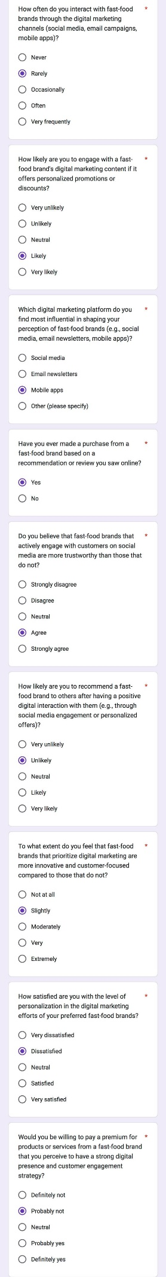
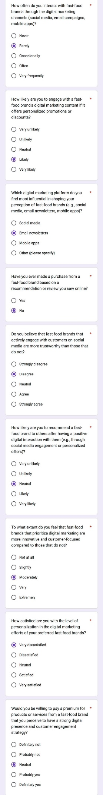
1.
2.

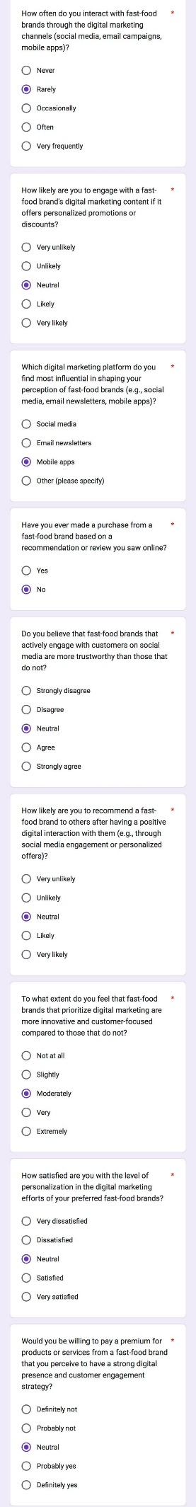
3.

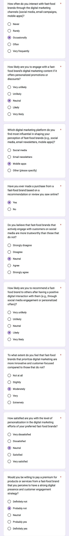
4.

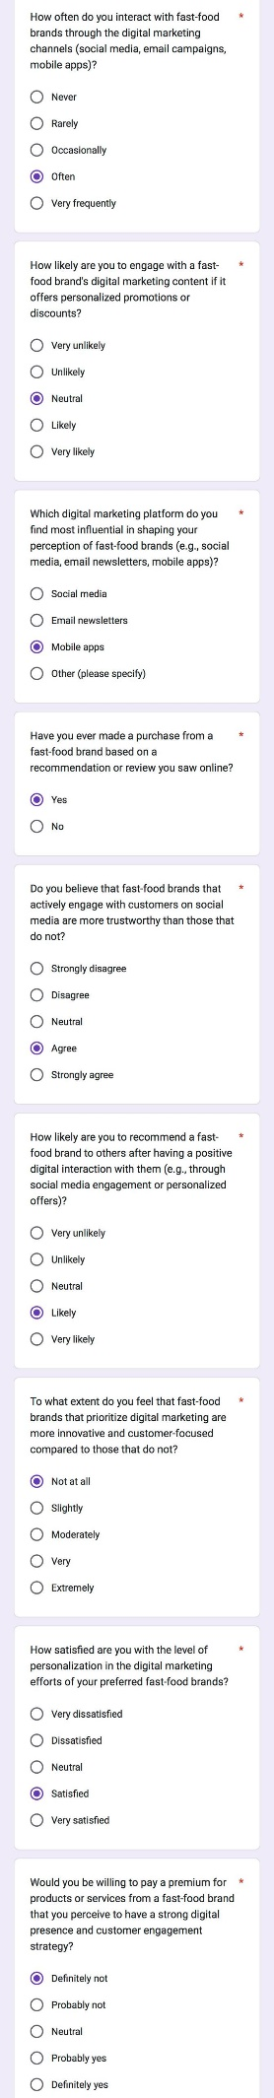
5.

