

Student name: Janat Kiconco

Student ID: 2426595

Module name: Principles of Health and Social Care Practice
Component: 1
Module code: BMHP5016

Lecturer name: Mark Kane

Table of Contents
1. Introduction 3
2. Task 1: Importance of Key Principles 3
2.1 Person-Centred Care 3
2.2 Partnership Working 3
2.3 Ethics in Health and Social Care 4
3. Task 2: Practical Case Study 6
3.1 Case Description 6
3.2 Application of Principles 6
3.3 Impact on Care 7
4. Task 3: Self-Reflection Using Gibbs Reflective Cycle 8
4.1 Description 8
4.2 Feelings 8
4.3 Evaluation 8
4.4 Analysis 9
4.5 Conclusion 9
4.6 Action Plan 9
5. Conclusion 10
References 11

1. Introduction
The practice of health and social care is supposed to help individuals to stay healthy and well. It is anchored on major principles that can direct professionals to provide quality and safe care. Person-centred care appeals to personal needs and desires. Partnership working facilitates the collaboration of various services and professionals. Ethics make certain dignity, respect, and confidentiality in any situation. This report will explain these principles, explore one of the obesity case studies, and offer a reflection on the ways the ideas can be applied in professional practice in the future.

2. Task 1: Importance of Key Principles

2.1 Person-Centred Care
Person-centred care is a care approach in which the plan revolves around the person and his/her needs and choices and values, rather than just the illness. It is significant in the UK health and social care since it makes people feel that they are respected, heard, and part of the decision-making process (NHS England, 2026a). This increases the quality and trust by ensuring care is more joined up and more responsive to what is important in real life. The studies indicate that person-centred models may enhance patient satisfaction, engagement, and favourable health outcomes, particularly in long-term conditions (Søgaard et al., 2021). People have more chances to communicate with treatment and live independently when professionals address their needs appropriately and formulate the care that suits the individual. Due to these reasons, person-centred care is an important element of the safe, effective, and good-quality care in the UK and can serve to alleviate the misunderstandings between the staff and the service users.

2.2 Partnership Working
Partnership working refers to the collaboration of health and social care workers, services, families and community organisations to address the needs of the people. In the UK, it is at the heart of integrated care and 42 integrated care systems bring together NHS organisations, local authorities, voluntary organisations and others to plan joined-up services (NHS England, 2026b). Such collaboration makes the passage of services between services easier, less care gaps, and also aids in quicker decision making. It also enhances service delivery through the fact that information can be shared among the partners, pool of skills and is more responsive to complex needs. The CQC has recently advised that the services should cooperate in such a way that care will flow smoothly to people (CQC, 2024). Partnership working has the potential to improve patient safety and trust as well as make the support more coordinated, more efficient, and more person focused when the partnership working is strong.

2.3 Ethics in Health and Social Care
Health and social care ethics imply doing what is right and just, safeguarding dignity, respect and confidentiality. It directs the practitioners to approach every individual as an individual and to ensure the security of personal information. This is important in the UK since good care needs to ensure that the people are able to obtain results that are important to them, and the services must be associated with dignity (GOV.UK, 2025). The issue of ethical practice also aids in improved decision-making, particularly where the staff are confronted with decisions regarding consent, privacy, or safe practice. This is explained with the assistance of Maslow's Hierarchy of Needs since the fundamental needs like the feeling of safety and belonging, are to be fulfilled before the individual can concentrate on recovery and self-improvement (Sowmya and Anokha, 2025). Care may be unsafe and impersonal when these needs are not taken into consideration. It is due to this reason that ethics enhances a greater trust, protects service users, and promotes better quality care in both health and social care contexts. It also assists staff to think and act before acting, adhere to professional guidelines and give a voice to a person in decision making regarding treatment and support. This is notably essential in obesity care that respect and dignity can have an impact on engagement.
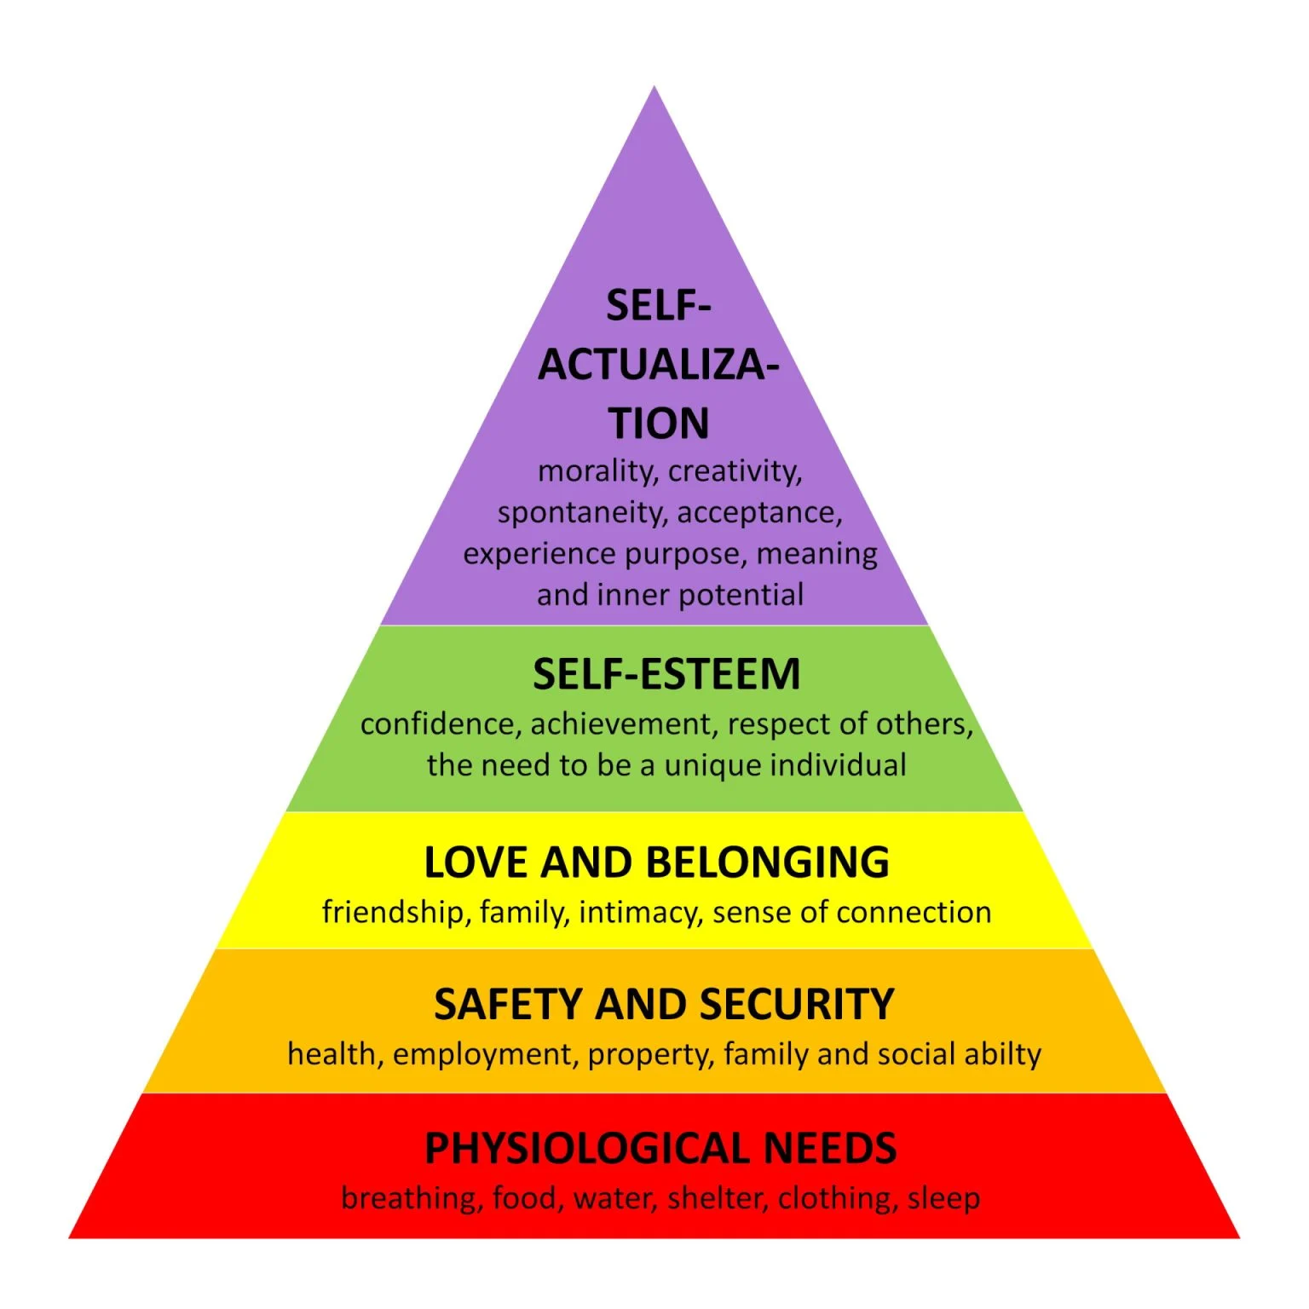
Figure 1: Maslow’s Hierarchy of Needs
(Source: McLeod, 2026)

3. Task 2: Practical Case Study

3.1 Case Description
The patient was a 38-year-old female who was severely obese and had a metabolic syndrome. The BMI was extremely high, and she has excess body fat, which puts her at a higher risk of diabetes type 2, hypertension, and low mobility. Past efforts of losing weight did not work. They introduced a structured programme which included education of diet and lifestyle, regular follow up as well as dietary support. The strategy was designed to meet her requirements. This case demonstrates that with the help of structured aid and support, weight management and health outcomes could be improved in the long term.

3.2 Application of Principles
Person-Centred Care
Here, the care was designed with regards to the health condition, lifestyle and personal goals of the individual. The support was oriented towards assisting her in her eating habits and behaviour change. Education rendered the process easier to understand and handle. The offered follow-up helped to remain motivated and encouraged. Person-centred approaches have significance in the UK since obesity is the condition that influences a large number of people with approximately 30% of adults living with obesity (NHS England, 2026c). In case of personalised care, people will engage and adhere to the treatment strategies. This intervention helped her become more confident and allowed her health management in the long term.
Partnership Working
Teamwork was used to assist the individual by partnership working. The patient adhered to a plan and changed their lifestyle, with the healthcare professional guiding her to do so. Periodic check-ups ensured that progress was monitored and care also changed whenever necessary. Obesity is a significant concern to the UK population because approximately 66% of adults are overweight or obese (NHS England, 2026c). This demonstrates the importance of great cooperation between individuals and professionals. There was enhanced engagement and performance due to good communication and shared responsibility. Consequently, the patient became supported and more determined towards her health improvement.
Ethics
It was considered with regard and not judgemental care. The person was handled with dignity and her confidentiality was upheld. This is significant in the sense that obese individuals are usually stigmatised in healthcare. The care act of 2014 accords fairness and favours wellbeing through ethical care. Information was provided to the patient in a clear way, and that is why she made informed choices. This gained trust and enhanced her confidence. Equal access to care is also one of the ethical practices that should be practised, as it is relevant to the UK where obesity is on the increase (Mayes and Williams, 2025). This meant that she felt secure, valued and open to be more accepting of the programme.

3.3 Impact on Care
Altogether, the positive results of health in obese individuals may be achieved through the means of structured and supportive care. The outcome of the programme in the case was massive weight loss and an improved physical health. The patient acquired improved lifestyle choices such as improved eating habits and physical exercise. These changes could be sustained through regular follow up. Consequently, she became more confident and is now more involved in the management of her health. It indicates that active support, individual treatment, and advice can be used to bring people towards long-term wellbeing and quality of life improvement.

4. Task 3: Self-Reflection Using Gibbs Reflective Cycle

4.1 Description
The issue of obesity management can be difficult and hard to achieve without structured and continuous support. Here, an adult with intensive obesity and metabolic syndrome was guided by means of the education process, frequent follow-ups, and his diet. These were interventions which assisted in enhancing her health and she lost weight gradually. As a health care professional, I would help the individual by giving uncomplicated advice, following up, and promoting the change of behaviour. The care plan would also be individualised and practical, as I would make sure.

4.2 Feelings
Reading about this case concerned me that obesity can get out of proportional levels in case it is supported later. It also taught me how valuable consistent motivation is as behaviour change is not easy without advice. I learned that numerous patients experience shame, lack of confidence, and physical constraints, and in such cases, change can become agonising. Research on weight management reports the same results regarding engagement and results with the continuous follow-up and realistic advice (Everitt et al., 2025). This case has served to remind me that the patient requires patience, respect and overt support. It was also able to demonstrate that good care does not just consist of treatment, but rather about assisting a person to feel that he/she can go on.

4.3 Evaluation
A number of care aspects were effective in this case. The individual was also provided with customised guidance, which was in accordance with her needs, which simplified the plan to follow. In my opinion, it is an individualised care in which the patient participates in making choices concerning her health. Follow up sessions were also used on a regular basis to keep the motivation and keep track of the improvement over time. In my opinion, it demonstrates that the importance of continuous support is a reality in practice. Partnership working was productive, because both the professionals of healthcare and patients collaborated towards common purposes (Seaton et al., 2021). This enhanced communication and earned trust among them. Ethical treatment was also evident because she was attended to with dignity, respect and without judgement. Nevertheless, the previous attempts of losing weight have failed, which implies that support has not been systematic and appropriate everywhere. I believe that this point suggests the importance of improved long-term and coordinated care in order to improve the outcomes.

4.4 Analysis
I believe that the programme was effective as it was organised, supportive, and aimed at the needs of the person. The care plan was accommodated to her lifestyle thus easier to follow and adhere to in the long run. Follow-up gave her the momentum and routines and kept her going. It can be attributed to the Hierarchy of Needs proposed by Maslow, where the fundamental needs: safety, support and confidence should be provided to an individual before a person could work on long-term health enhancement (Zhang et al., 2022). Motivation was also a significant factor according to me, with the changes being manageable due to continual urging. Another recommendation outlined in the Care Act 2014 is the emphasis on fostering wellbeing and assisting people in making personal decisions (Caiels et al., 2021).
Another aspect that played a significant role in the case was teamwork. Responsibility was shared among the patient and the health professional which enhanced effective communication and made the plan more realistic. I believe that that is a good partnership that works since the two parties were involved in the process. Ethical care was a major issue too since obesity may result in judgement and stigma (Westbury et al., 2023). Being respectful and not judgmental is a way of protecting dignity and making the person feel more willing to proceed.

4.5 Conclusion
The things I have learned in this case are that with the help of structured and supportive care, it can turn out to be a genuine success in obesity management. The interpersonal approach to plans and frequent follow-up can be used to ensure that individuals are kept motivated and make long-term changes. I also learnt the values of teamwork and respectful caring in establishing trust. Nonetheless, the support provided in the past was not as successful, since the previous attempts had failed. More regular recommendations and intervention at the early stages can enhance the result in future and help people to control their health better over time.

4.6 Action Plan
Goal | Action Steps | Timeline | Resources/Support | Expected Outcome
Improve communication skills | Practice active listening, use simple language, and give clear advice to patients | Short-term (3–6 months) | Training sessions, guidance from senior staff | Better understanding between patient and professional
Enhance patient support skills | Provide encouragement, regular follow-up, and emotional support during care | Ongoing | Mentorship, clinical experience | Increased patient motivation and engagement
Develop professional knowledge | Attend training on obesity care and behaviour change strategies | Medium-term (6–12 months) | Workshops, online courses | Improved knowledge and confidence in practice
Apply person-centred care | Involve patients in decisions and tailor care plans to individual needs | Ongoing | NHS guidelines, supervision | More personalised and effective care
Strengthen teamwork | Communicate regularly with team members and share responsibilities | Ongoing | Team meetings, feedback | Better coordination and improved patient outcomes
Table 1: Personal Development Action Plan
(Source: Self-developed)

5. Conclusion
In this report, major tenets of health and social care were addressed such as person-centred care, partnership working and ethics. It demonstrated how these principles can be put to good and safe care practices. The case study established the value of individualised support, team work, and respect in the treatment of obesity. The reflection also indicated how the ideas can enhance professional practice. All in all, these values contribute to better patient outcomes, trust, and high-quality care in health and social care environments in the UK.

References
Caiels, J., Milne, A. and Beadle-Brown, J., (2021). Strengths-based approaches in social work and social care: Reviewing the evidence. Journal of Long Term Care, pp.401-422.
CQC (2024) Partnerships and communities, Care Quality Commission. Available at: https://www.cqc.org.uk/guidance-regulation/providers/assessment/single-assessment-framework/well-led/partnerships-communities (Accessed: 31 March 2026).
Everitt, J., Battista‐Dowds, E., Heggs, D. and Squire, A., (2025). Understanding How Patient Experiences of Support While Attending a Weight Management Service Impacts Engagement, Dropout and Retention: A Semi‐Structured Interview Study. Journal of Human Nutrition and Dietetics, 38(6), p.e70159.
GOV.UK (2025) Care and support statutory guidance, GOV.UK. Available at: https://www.gov.uk/government/publications/care-act-statutory-guidance/care-and-support-statutory-guidance (Accessed: 31 March 2026).
Mayes, C. and Williams, J., (2025). Obesity: ethical issues. British medical bulletin, 153(1), p.ldae022.
McLeod, S. (2026) Maslow’s hierarchy of needs, Simply Psychology. Available at: https://www.simplypsychology.org/maslow.html (Accessed: 31 March 2026).
NHS England (2026a) Person-centred care, NHS England. Available at: https://www.hee.nhs.uk/our-work/person-centred-care (Accessed: 31 March 2026).
NHS England (2026b) Person-centred care, NHS England. Available at: https://www.hee.nhs.uk/our-work/person-centred-care (Accessed: 31 March 2026).
NHS England (2026c) Health Survey for England, 2024, NHS England. Available at: https://digital.nhs.uk/data-and-information/publications/statistical/health-survey-for-england/2024/adults-overweight-and-obesity (Accessed: 31 March 2026).
Seaton, J., Jones, A., Johnston, C. and Francis, K., (2021). Allied health professionals’ perceptions of interprofessional collaboration in primary health care: an integrative review. Journal of Interprofessional Care, 35(2), pp.217-228.
Søgaard, M.B., Andresen, K. and Kristiansen, M., (2021). Systematic review of patient-engagement interventions: potentials for enhancing person-centred care for older patients with multimorbidity. BMJ open, 11(12), p.e048558.
Sowmya, D.S. and Anokha, V., (2025). Maslow's Hierarchy of Needs. In Coaching in Communication Research (pp. 117-140). IGI Global Scientific Publishing.
Westbury, S., Oyebode, O., Van Rens, T. and Barber, T.M., (2023). Obesity stigma: causes, consequences, and potential solutions. Current obesity reports, 12(1), pp.10-23.
Zhang, T., Liu, Y., Wang, Y., Li, C., Yang, X., Tian, L., Wu, Y., Lin, L. and Li, H., (2022). Quality indicators for the care of older adults with disabilities in long-term care facilities based on Maslow’s hierarchy of needs. International journal of nursing sciences, 9(4), pp.453-459.

