
Sports Independent Project
Applied Portfolio

Student Name  Taylor John | Project Title  Bounce Back Cymru
Project Aim (1)
Develop an online, multidimensional support structure for senior athletes during injury rehabilitation.

Objectives (3/4)
- Devise a video proposal explaining the website idea, with considerations of ethical implications.
- Highlight the main findings regarding the mental health challenges athletes experience while injured.
- The creation of website to support athletes with mental health during injury rehab.

Contents Page
 | 1.1- Element 1 - Individual Presentation (5 minutes – Online) |  |  | 2
 | 1.2- Element 1 – Ethics Form |  |  | 3
 |  | 1.2a About You (Principal Researcher) |  | 3
 |  | 1.2b Details of Research Activity |  | 4
 |  | 1.2c Scope of Research Activity |  | 5
 |  | 1.2d Intended Participants |  | 6
 |  | 1.2e Anticipated Risks |  | 8
 |  | 1.2f Feedback, Consent and Confidentiality |  | 9
 |  | 1.2g Data Protection and Storage |  | 10
 |  | 1.2h Declaration |  | 12
 | 2- Element 2 - Literature Review (3000 words) |  |  | 14
 | 2.1 Introduction |  |  | 14
 | 2.2 Rehabilitation and sport science |  |  | 14
 | 2.3 Mental Wellness |  |  | 16
 | 2.4 Nutrition |  |  | 17
 | 2.5 Theoretical Frameworks |  |  | 17
 |  |  | 2.5a The Biopsychological model | 17
 |  |  | 2.5b Self-determination theory | 18
 | 2.6 Technology in sport |  |  | 18
 | 2.7 Return to Sport |  |  | 19
 | 2.8 Website Design |  |  | 20
 | 2.9 Conclusion |  |  | 21
 | 3- Element 3 – 5000 Word Document or 30-minute Video (Bounce Back Cymru) |  |  | 22
 |  |  | 3.1- Front Page | 22
 |  |  | 3.2- About Bounce back Cymru | 22
 |  |  | 3.3- Why is it important? | 23
 |  |  | 3.4- Our goal | 23
 |  |  | 3.5- Stretching | 24
 |  |  | 3.6- Mental wellbeing | 25
 |  |  | 3.7- Supporting athletes | 26
 |  |  | 3.8- Nutrition | 28
 |  |  | 3.9- Services | 29
 |  |  | 3.10- Reviews | 30
 |  |  | 3.11 Frequently asked questions | 31
 | 4- Reflection/Conclusion/Recommendation |  |  | 32
 | 5- Reference list |  |  | 34

1.1- Element 1 - Individual Presentation (5 minutes – Online)

Youtube Video Link- https://youtu.be/tP17GlXzRtM?si=ELu_K_L4EgVhtQpx

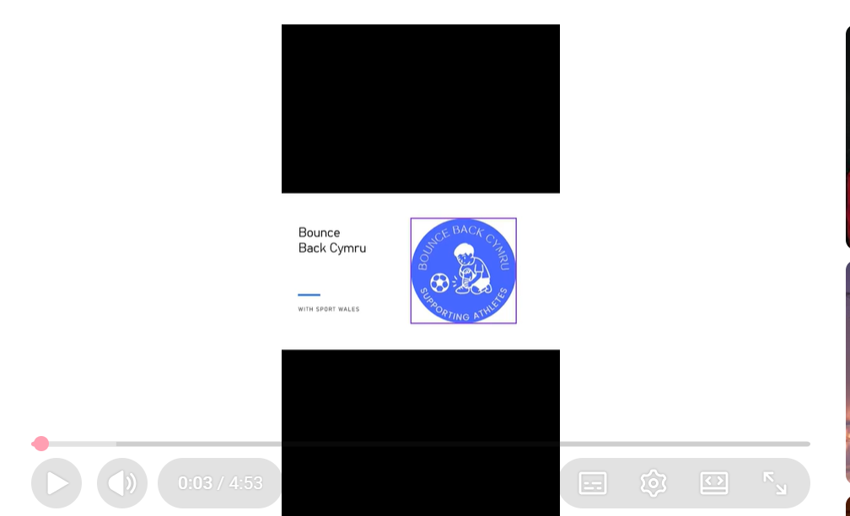

1.2- Element 1 – Ethics Form (All Pages)
ETHICAL CONSIDERATIONS

Youtube Video Link- https://youtu.be/tP17GlXzRtM?si=ELu_K_L4EgVhtQpx

In order for research to result in benefit and minimise risk of harm, it must be conducted ethically. A researcher may not be covered by the University’s insurance if ethical approval has not been obtained prior to commencement.

The University follows the OECD Frascati manual definition of research activity: “creative work undertaken on a systematic basis in order to increase the stock of knowledge, including knowledge of man, culture and society, and the use of this stock of knowledge to devise new applications”. As such this covers activities undertaken by members of staff, postgraduate research students, and both taught postgraduate and undergraduate students working on dissertations/projects.

The individual undertaking the research activity is known as the “principal researcher”.

Ethical approval is not required for routine audits, performance reviews, quality assurance studies, testing within normal educational requirements, and literary or artistic criticism.

Please read the notes for guidance before completing ALL sections of the form.

This form must be completed and approved prior to undertaking any research activity. Please see Checklist for details of process for different categories of application.

SECTION A: About You (Principal Researcher)
1 | Full Name: |  | Taylor John
2 | Tick all boxes that apply: |  | Member of staff: | ☐ | Honorary research fellow: | ☐
 | Undergraduate Student | ☒ | Taught Postgraduate Student | ☐ | Postgraduate Research Student | ☐

3 | Institute/Academic Discipline/Centre: | Institute
4 | Campus: | Swansea Waterfront
5 | E-mail address: | 2304795@student.uwtsd.ac.uk
6 | Contact Telephone Number: | 07504 238707
 | For students:
7 | Student Number: | 2304795
8 | Programme of Study: | BA Sport Management
9 | Director of Studies/Supervisor: | Andrew Thomas
Where research activity is carried out in collaboration with an external organisation
10 | Does this organisation have its own ethics approval system? | YES | ☒ | NO | ☐
 | If Yes, please attach a copy of any final approval (or interim approval) from the organisation (this may be a copy of an email if appropriate).

SECTION B: Details of Research Activity
1 | Indicative title: | Bounce Back Cymru
2 | Proposed start date: | 28-8-2025 | Proposed end date: | 29-3-2026
Introduction to the Research (maximum 300 words per section)
Ensure that you write for a Non-Specialist Audience when outlining your response to the points below:
- Purpose of Research Activity
- Aims of Research Activity
- Objectives of Research Activity
Demonstrate, briefly, how Existing Research has informed the proposed activity and explain
- What the research activity will add to the body of knowledge
- How it addresses an area of importance.
3 | Purpose of Research Activity  Athletes are always at risk of injuries and will need a platform to connect with other athletes to support. I have also suffered with injuries and felt unsupported during the recovery process, so creating a website will hopefully help other athletes in same situations.  (this box should expand as you type)
5 | Aim of Research Activity  The creation of a website to support athletes during injury recovery with Sport Wales.  (this box should expand as you type)
6 | Objectives of Research Activity  Devise a video proposal explaining the website idea, with considerations of ethical implications.  Highlight the main findings with research about the mental health challenges athletes experience while injured.  The creation of website to support athletes with mental health during injury rehab.  (this box should expand as you type)
Existing Research

Having research will back up my proposal with statistics on how athletes are sometimes unsupported during recovery and need a community to connect with other athletes to gain information and emotional support.

 | Does your research relate to one or more of the seven aims of the Well-being of Future Generations (Wales) Act 2015? | YES | NO
12 | A prosperous Wales | ☐ | ☒
13 | A resilient Wales | ☒ | ☐
14 | A healthier Wales | ☒ | ☐
15 | A more equal Wales | ☐ | ☒
16 | A Wales of cohesive communities | ☒ | ☐
17 | A Wales of vibrant culture and thriving Welsh language | ☐ | ☒
18 | A globally responsible Wales | ☐ | ☒
19 | If YES to any of the above, please give details:
It will make athletes more resilient by giving them a platform to gain strength and confidence during injury recovery. It will also bring athletes together in a community environment and will them to support each other through the good and bad times in recovery. It will link to a healthier Wales as this website will look to reduce the mental health issues with athletes in sports.

(this box should expand as you type)

SECTION C: Scope of Research Activity
 | Will the research activity include: | YES | NO
1 | Use of a questionnaire or similar research instrument? | ☒ | ☐
2 | Use of interviews? | ☐ | ☐
3 | Use of focus groups? | ☒ | ☐
4 | Use of participant diaries? | ☐ | ☐
5 | Use of video or audio recording? | ☒ | ☐
6 | Use of computer-generated log files? | ☐ | ☒
7 | Participant observation with their knowledge? | ☒ | ☐
8 | Participant observation without their knowledge? | ☐ | ☒
9 | Access to personal or confidential information without the participants’ specific consent? | ☐ | ☒
10 | Administration of any questions, test stimuli, presentation that may be experienced as physically, mentally or emotionally harmful / offensive? | ☐ | ☒
11 | Performance of any acts which may cause embarrassment or affect self-esteem? | ☐ | ☒
12 | Investigation of participants involved in illegal activities? | ☐ | ☒
13 | Use of procedures that involve deception? | ☐ | ☒
14 | Administration of any substance, agent or placebo? | ☐ | ☒
15 | Working with live vertebrate animals? | ☐ | ☒
16 | Procedures that may have a negative impact on the environment? | ☐ | ☒
17 | Other primary data collection methods. Please indicate the type of data collection method(s) below. | ☐ | ☒
 | Details of any other primary data collection method:  (this box should expand as you type) | ☐ | ☒
If NO to every question, then the research activity is (ethically) low risk and may be exempt from some of the following sections (please refer to Guidance Notes).

If YES to any question, then no research activity should be undertaken until full ethical approval has been obtained.

SECTION D: Intended Participants
If there are no participants then do not complete this section, but go directly to section H.

 | Who are the intended participants: | YES | NO
1 | Students or staff at the University? | ☒ | ☐
2 | Adults (over the age of 18 and competent to give consent)? | ☒ | ☐
3 | Vulnerable adults? | ☒ | ☐
4 | Children and Young People under the age of 18? (Consent from Parent, Carer or Guardian will be required) | ☐ | ☒
5 | Prisoners? | ☐ | ☒
6 | Young offenders? | ☐ | ☒
7 | Those who could be considered to have a particularly dependent relationship with the investigator or a gatekeeper? | ☐ | ☒
8 | People engaged in illegal activities? | ☐ | ☒
9 | Others. Please indicate the participants below, and specifically any group who may be unable to give consent. | ☐ | ☒
 | Details of any other participant groups:  (this box should expand as you type) | ☐ | ☒

Participant numbers and source
Provide an estimate of the expected number of participants. How will you identify participants and how will they be recruited?
10 | How many participants are expected? | 1000  (this box should expand as you type)
11 | Who will the participants be? | Athletes from a range of different sports.  (this box should expand as you type)
12 | How will you identify the participants? | Will be participants who will be looking for support during their recovery process.  (this box should expand as you type)

 | Information for participants: | YES | NO | N/A
13 | Will you describe the main research procedures to participants in advance, so that they are informed about what to expect? | ☐ | ☐ | ☒
14 | Will you tell participants that their participation is voluntary? | ☐ | ☐ | ☒
15 | Will you obtain written consent for participation? | ☐ | ☐ | ☒
16 | Will you explain to participants that refusal to participate in the research will not affect their treatment or education (if relevant)? | ☐ | ☐ | ☒
17 | If the research is observational, will you ask participants for their consent to being observed? | ☐ | ☐ | ☒
18 | Will you tell participants that they may withdraw from the research at any time and for any reason? | ☐ | ☐ | ☒
19 | With questionnaires, will you give participants the option of omitting questions they do not want to answer? | ☒ | ☐ | ☐
20 | Will you tell participants that their data will be treated with full confidentiality and that, if published, it will not be identifiable as theirs? | ☒ | ☐ | ☐
21 | Will you debrief participants at the end of their participation, in a way appropriate to the type of research undertaken? | ☐ | ☐ | ☒
22 | If NO to any of above questions, please give an explanation
 | (this box should expand as you type)

 | Information for participants: | YES | NO | N/A
24 | Will participants be paid? | ☐ | ☒ | ☐
25 | Is specialist electrical or other equipment to be used with participants? | ☐ | ☒ | ☐
26 | Are there any financial or other interests to the investigator or University arising from this study? | ☐ | ☒ | ☐
27 | Will the research activity involve deliberately misleading participants in any way, or the partial or full concealment of the specific study aims? | ☐ | ☒ | ☐
28 | If YES to any question, please provide full details
 | (this box should expand as you type)

SECTION E: Anticipated Risks

Outline any anticipated risks that may adversely affect any of the participants, the researchers and/or the University, and the steps that will be taken to address them.

If you have completed a full risk assessment (for example as required by a laboratory, or external research collaborator) you may append that to this form.
1 | Full risk assessment completed and appended? |  | Yes | ☐
1 |  |  | No | ☒
2 | Risks to participants  For example: sector-specific health & safety, emotional distress, financial disclosure, physical harm, transfer of personal data, sensitive organisational information
 | Risk to participants:  Emotional distress, sensitive information and transfer of personal data.  (this box should expand as you type) | How you will mitigate the risk to participants:  Correct information to support participants  Guidance from professionals to give athletes further support.  Protection of data that is transferred on our website.  (this box should expand as you type)
3 | If research activity may include sensitive, embarrassing or upsetting topics (e.g. sexual activity, drug use) or issues likely to disclose information requiring further action (e.g. criminal activity), give details of the procedures to deal with these issues, including any support/advice (e.g. helpline numbers) to be offered to participants. Note that where applicable, consent procedures should make it clear that if something potentially or actually illegal is discovered in the course of a project, it may need to be disclosed to the proper authorities
Helplines and guidance for athletes who need further support such as mental health issues.

(this box should expand as you type)
4 | Risks to the investigator  For example: personal health & safety, physical harm, emotional distress, risk of accusation of harm/impropriety, conflict of interest
 | Risk to the investigator:  Emotional distress  Conflict of interest  (this box should expand as you type) | How you will mitigate the risk to the investigator:  Have the right support line and guidance to the investigator if needed.  (this box should expand as you type)
5 | University/institutional risks  For example: adverse publicity, financial loss, data protection
 | Risk to the University:  Data protection  Publicity  (this box should expand as you type) | How you will mitigate the risk to the University:  Correct guidance to any data being used on the website.  Make sure any information on the website is accurate to not tarnish the university reputation.  (this box should expand as you type)
6 | Environmental risks  For example: accidental spillage of pollutants, damage to local ecosystems
 | Risk to the environment:  n/a  (this box should expand as you type) | How you will mitigate the risk to environment:  n/a  (this box should expand as you type)

 | Disclosure and Barring Service
 | If the research activity involves children or vulnerable adults, a Disclosure and Barring Service (DBS) certificate must be obtained before any contact with such participants. | YES | NO | N/A
7 | Does your research require you to hold a current DBS Certificate? | ☒ | ☐ | ☐
8 | If YES, please give the certificate number. If the certificate number is not available, please write “Pending”; in this case any ethical approval will be subject to providing the appropriate certificate number. | pending

SECTION F: Feedback, Consent and Confidentiality

1 | Feedback  What de-briefing and feedback will be provided to participants, how will this be done and when?
Comments for participants to give any feedback on pros and cons of the website. This can be done on a review page.
Questionnaires to specify any needs certain individuals are looking for when entering the website.

(this box should expand as you type)
2 | Informed consent  Describe the arrangements to inform potential participants, before providing consent, of what is involved in participating. Describe the arrangements for participants to provide full consent before data collection begins. If gaining consent in this way is inappropriate, explain how consent will be obtained and recorded in accordance with prevailing data protection legislation.
You will need to provide consent before taking part in any questionnaire to protect personal data, as any information provided could be used for feedback or used to help others who are need help in a similar situation.

(this box should expand as you type)
3 | Confidentiality / Anonymity  Set out how anonymity of participants and confidentiality will be ensured in any outputs. If anonymity is not being offered, explain why this is the case.
Participants will be able to enter the website anonymously to have a look at the services we offer and to see if anything can be useless for their needs. Can also have their questionnaire answers kept anonymous, but the answers can be used to help others.

(this box should expand as you type)

SECTION G: Data Protection and Storage

 | Does the research activity involve personal data (as defined by the General Data Protection Regulation 2016 “GDPR” and the Data Protection Act 2018 “DPA”)? | YES | NO
1 | “Personal data” means any information relating to an identified or identifiable natural person (‘data subject’). An identifiable natural person is one who can be identified, directly or indirectly, in particular by reference to an identifier such as a name, an identification number, location data, an online identifier or to one or more factors specific to the physical, physiological, genetic, mental, economic, cultural or social identity of that natural person. Any video or audio recordings of participants is considered to be personal data. | X | ☐
 | If YES, provide a description of the data and explain why this data needs to be collected:
2 | This data could be used to connect people to each other who are struggling with the same issues and are looking for help, as our website will be used as community for people in the same situation and build relationships with others.  (this box should expand as you type)
 | Does it involve special category data (as defined by the GDPR)? | YES | NO
3 | “Special category data” means sensitive personal data consisting of information as to the data subjects’ –  (a) racial or ethnic origin,  (b) political opinions,  (c ) religious beliefs or other beliefs of a similar nature,  (d) membership of a trade union (within the meaning of the Trade Union and Labour Relations (Consolidation) Act 1992),  (e) physical or mental health or condition,  (f) sexual life,  (g) genetics,  (h) biometric data (as used for ID purposes), | X | ☐
 | If YES, provide a description of the special category data and explain why this data needs to be collected:
4 | Our website could need data based on their physical and mental health condition to provide them with the correct guidance to get the help they need.  (this box should expand as you type)

 | Will data from the research activity (collected data, drafts of the thesis, or materials for publication) be stored in any of the following ways? | YES | NO
5 | Manual files (i.e. in paper form)? | ☐ | ☒
6 | University computers? | ☐ | ☒
7 | Private company computers? | ☒ | ☐
8 | Home or other personal computers? | ☐ | ☒
9 | Laptop computers/ CDs/ Portable disk-drives/ memory sticks? | ☐ | ☒
10 | “Cloud” storage or websites? | ☒ | ☐
11 | Other – specify: | ☐ | ☒
12 | For all stored data, explain the measures in place to ensure the security of the data collected, data confidentiality, including details of backup procedures, password protection, encryption, anonymisation and pseudonymisation:
The data provided will be kept in secure computers and cloud storage to make sure any data will not be leaked to the public. We will also have password protection where it will require a specialised ID to get access to our data that has been obtained.

(this box should expand as you type)

 | Data Protection
 | Will the research activity involve any of the following activities: | YES | NO
13 | Electronic transfer of data in any form? | ☐ | ☒
14 | Sharing of data with others at the University outside of the immediate research team? | ☐ | ☒
15 | Sharing of data with other organisations? | ☐ | ☒
16 | Export of data outside the UK or importing of data from outside the UK? | ☐ | ☒
17 | Use of personal addresses, postcodes, faxes, emails or telephone numbers? | ☐ | ☒
18 | Publication of data that might allow identification of individuals? | ☐ | ☒
19 | Use of data management system? | ☐ | ☒
20 | Data archiving? | ☐ | ☒
21 | If YES to any question, please provide full details, explaining how this will be conducted in accordance with the GDPR and Data Protection Act (2018) (and any international equivalents, where appropriate):
 | (this box should expand as you type)
22 | List all who will have access to the data generated by the research activity:
There will be an assigned team who will investigate the data provided by athletes from questionnaires and will gather statistics based on this information.

(this box should expand as you type)
23 | List who will have control of, and act as custodian(s) for, data generated by the research activity:
An assigned team who will work as part of Sport Wales to gather data from any questionnaires.

(this box should expand as you type)
24 | Give details of data storage arrangements, including security measures in place to protect the data, where data will be stored, how long for, and in what form. Will data be archived – if so how and if not why not.
Password protection with limited access.
Any answers from questionaries will be stored in a secure cloud storage and will only be looked at by an assigned team.

(this box should expand as you type)
25 | Please indicate if your data will be stored in the UWTSD Research Data Repository (see https://researchdata.uwtsd.ac.uk/ ). If so please explain. (Most relevant to academic staff)
n/a

(this box should expand as you type)
26 | Confirm that you have read the UWTSD guidance on data management (see https://www.uwtsd.ac.uk/library/research-data-management/) | YES | ☐
27 | Confirm that you are aware that you need to keep all data until after your research has completed or the end of your funding | YES | ☐

SECTION H: Declaration
The information which I have provided is correct and complete to the best of my knowledge. I have attempted to identify any risks and issues related to the research activity and acknowledge my obligations and the rights of the participants.

In submitting this application I hereby confirm that I undertake to ensure that the above named research activity will meet the University’s Research Ethics and Integrity Code of Practice which is published on the website: https://www.uwtsd.ac.uk/research/research-ethics/
1 | Signature of applicant: | Taylor John | Date:  28-10-2025

Checklist: Please complete the checklist below to ensure that you have completed the form according to the guidelines and attached any required documentation:
☒ | I have read the guidance notes supplied before completing the form.
☒ | I have completed ALL RELEVANT sections of the form in full.
☒ | I confirm that the research activity has received approval in principle
☒ | I have attached a copy of final/interim approval from external organisation (where appropriate)
☒ | I have attached a full risk assessment (where appropriate) ONLY TICK IF YOU HAVE ATTACHED A FULL RISK ASSESSMENT
☒ | I understand that it is my responsibility to ensure that the above named research activity will meet the University’s Research Ethics and Integrity Code of Practice.
☒ | I understand that before commencing data collection all documents aimed at respondents (including information sheets, consent forms, questionnaires, interview schedules etc.) must be confirmed by the DoS/Supervisor, module tutor or Academic Director.

RESEARCH STUDENTS ONLY
Once complete, submit this form via the MyTSD Doctoral College Portal at (https://mytsd.uwtsd.ac.uk).

STUDENTS ON UNDERGRADUATE OR TAUGHT MASTERS PROGRAMMES should submit this form (and receive the outcome) via systems explained to you by the supervisor/module leader.

2- Element 2 - Literature Review (3000 words)

2.1 Introduction
The aim of the project is to develop an online, multidimensional support structure for senior athletes during injury rehabilitation. The rationale for this project is due to injuries will always occur, at all levels of sports, with around 50% of athletes suffering at least one injury during their career that would require time out of the sport or medical attention (Yang et al., 2014b). Breistol et al., (2017) states that participation in sport can lead to reduced mental health problems, better eating habits and increase in support from friends that have come through playing sport. However, when injured, this can lead to mental health symptoms such as depression and anxiety due to the physical and mental distress an injury can cause to the body (Yang et al., 2014a).
A study from Palmer, D. et al. (2024) showed that 93.6% out of 544 elite level youth athletes in USA had suffered more than one injury in their career, with 46.2% dropping out of sport due to injuries. A study on a youth track and field team in France showed that 19.5% of athletes had dropped out of athletics, with injury being the reason for 46% of the athletes who dropped out (Edouard et al., 2024). Other reason for athletes dropping out could include injuries, time, expenses, lack of fun, poor levels of intrinsic motivation, high levels of amotivation, and low levels of basic psychological needs, according to a report with 23 quantitative studies from Balish et al. (2014). Rees et al., (2016) states that characteristics such as height and weight could lead to athletes dropping out of sport, with the physical demands of certain sports such as rugby and football.

2.2 Rehabilitation and sport science
Rehabilitation is crucial in an injury recovery process, with poor rehabilitation leading to a longer time out the sport, an increased risk of reoccurring injuries and unlikely positive return to sport (Jack et al., 2010). According to Barke and Davis (2025), Young athletes will stick to recovery and will return with confidence and resilience if they are in an environment where they feel supported both physically and mentally. Peterson and Renstrom (2010) state that the main process should start with reducing the pain before increasing flexibility and strength in that injured area before returning to sport. Caparros et al., (2017) talks about how injuries in different areas of the body can require a longer recovery process and this is essential information for athletes to understand when injured. To strengthen during recovery, isometric exercises that are light or body weight and proprioceptive exercises are common for most athletes during rehabilitation (Jones and Wilson, 2019). Anderson et al., (2009) mentions how interventions such as manual therapy, compression techniques and stretching exercises can all be effective in enhancing the recovery process. Sarlis et al., (2021) states that injuries will affect clubs and organisations financially each year, with a statistics showing that an average Premier League team will spend £45 million a year on injuries (Eliakim et al., 2020).
Appropriate training programmes are important to reduce the risk of injury and to manage overload (Lauersen et al., 2018). Research by Bahr (2016) states that the training programme must match every athlete’s needs to be successful, by identifying particular risk factors using testing. Other interventions could include contracting and relaxing exercises, stretching exercises and joint mobility exercises to improve range of motion (Jones and Wilson, 2019). Furthermore, Gokeler et al., (2018) states that interventions should be based on improving performance and reducing the risk of reinjury, with elements of sport-specific tasks as the injury usually occur in a sporting environment.
It has been reported that a variety of rehabilitation programmes do not provide athletes with the right overload and training to allow them to return to sport confidently, as only physical conditions are exercised (Sheppard and Young, 2006). Buckthorpe et al., (2019) says that a rehabilitation programme needs to involve a progression in complex functional movements in uncertain environments to allow the athlete to regain physical and perceptual-cognitive abilities to allow them to be fully prepared to return to competitive sport.

2.3 Mental Wellness

Injuries can also contribute to mental health issues, with injured athletes experiencing problems such as sleep issues, emotional distress, and poor concentration when out of sport (Li et al., 2017). A study from Foskett and Longstaff, 2017 on UK elite athlete's states that 47.8% showed signs of anxiety/depression, and 26.8% showed signs of psychological distress. Ardern et al., (2016) states that during anterior cruciate ligament injuries, athletes will have feelings of anger, depression, and fear of the future, with 56% of athletes not returning to sport after this injury (Ardern et al., 2011). Another study from Nedder et al., (2025) showed that athletes are 13 times more likely to suffer another anterior cruciate ligament injury when returning to sport within 2 years if they suffer elevated level of stress. Furthermore, according to a study from Gouttebarge et al., (2019), there are between 16% - 34% of high-performance athletes suffering with mental disorders, with anxiety and depression the common diagnoses. Research from Dennis et al., (2016) states that injured athletes will sleep less than non-injured athletes, leading to athletes potentially not being able to recover from injuries due to insufficient rest (Copenhaver and Diamond, 2017). Athletes could face up to 600 stress factors when playing, which include life events, issues with management and lack of confidence with performance, according to Gouttebarge et al., (2017).
Furthermore, Ivarsson et al., (2014) states that stress is one of the variables that can cause injuries, with stress also damaging quality of life with performance and risk of injuries (Nunez et al., 2021). A study from Kessler et al., (2018) shows that 1 in 5 people will suffer with mental health, with 75% of people experiencing mental health issues by the time they turn 24. Another study on athletes from Kern et al., (2017) showed that 62.5% of athletes had their performances decline due to mental health issues. The rates of depression vary from each gender, with males being as high as 26.7% and women being as high as 36.5% (Ghaedi et al., 2014). In a model by Keyes on mental health, it states that mental wellbeing can be a combination of emotional, psychological, and social aspects in life (Keyes, 2002). The emotional wellbeing is the individual feeling good with indicators including self-satisfaction and positive actions (Keyes, 2007). Ryff (1989) states that the psychological aspects of mental health relate to what is going on in an individual's personal life, with six indicators such having a purpose in life, personal growth, positive individual relationships in life, self-acceptance, independence and adapting well to situations around them. The social aspects relate to how the individual is adapting to society and has five aspects to consider such as, social acceptance, contribution, integration, coherence, and actualisation (Keyes, 1998).
2.4 Nutrition
The importance of nutrition is crucial with it being key in speeding up the rehab process, according to Papadopoulou et al., (2018), with poor nutrition leading to setbacks during recovery and therefore delay the return to sport (Gleeson, 2016). English et al., (2016) states that the importance of protein in your diet to allow the body to heal, with 20-25g per meal being enough. A varied diet with a correct number of micronutrients is key to building a strong immune system (Maggini et al., 2018), with a strong immune system being essential during rehab to reduce the risk of poor sleep, low energy expenditure and an increased chance of being ill, which will have a negative effect on the rehab process (Walsh, 2019). Calder (2020) states that all the micronutrients play a vital role in building a strong immune system due to low levels of vitamins and nutrients in the body, which effects the body’s ability to recover from injuries.
Kloubec and Harris (2016) talk about the importance of improving athletes eating habits during injury recovery to enhance their recovery and performance when recovered. When injured, athletes will have decline in their energy intake which will then lead to a decline in their protein intake and could potentially lead to potential muscle mass loss (Wall et al., 2013a), leading to a loss of 150-400g of muscle tissue loss in the first two weeks of injuries (Wall et al., 2013b). Mamerow et al., (2014) explains that muscle synthesis rate is 25% more effective in when protein is evenly distributed throughout the day, compared to an unbalanced diet where protein is inconsistent throughout the meals. Tang et al., (2009) states that protein sources from whey, soy and casein can have an improvement the rate of muscle protein synthesis during rest and after resistance training, with Kerksick et al., (2018) stating that 30-40g of casein protein before sleep can lead to an increase in muscle protein synthesis in men, both younger and elderly.

2.5 Theoretical frameworks

2.5a The Biopsychosocial Model
Injuries can be a major negative event in the life of athletes, according to Brewer et al., (2017), with injuries triggering feelings of fear, anger, and depression (Park et al., 2023). Rosen et al., (2018) mentions how athletes with recent injuries will have a lack of confidence in their recovery and a feeling of anxiety about injuries returning compared to athletes with no recent injury. One of the key frameworks is the Biopsychosocial Model, which considers the biological, psychological, and social responses. Santi and Pietrantoni (2013) states that the model also consists of several dimensions such as injury characteristics, the results of sports injury therapy, and sociodemographic variables. Biological responses can be linked to how injuries will trigger an increase in stress that causes hormonal, metabolic, and neurological alterations that impact all the systems in the body (Yaribeygi et al., 2017). Hannibal and Bishop (2014) states that the body’s ability to start the relaxation response can be affected by a constant exposure to stress situations such as constant injuries, which leads to disruption to cortisol levels in the body. The psychological responses links to the cognitive, emotional and behaviour disruptions (Chang et al., 2020). The social responses is one of the key responses during injury recovery, with the main aim to give the athletes a clear insight into a positive outcome (Brewer and Redmond, 2016). According to research by Goodard et al., (2020), giving athletes support in a socially is essential to give them a productive coping mechanism and links to reducing physiological stress and enhance adherence with recovery programmes.

2.5b Self-determination theory
Self-determination theory is psychological theory on the way we understand human motivation and the factors that shape personality development (Ryan, 2023). This theory explains how individuals might not comply with programmes due to lack of knowledge, not enough time, and lack of facilities, which will then affect an individual's injury recovery (Owoeye et al., 2020). Research from Donaldson et al., (2019) states that addressing these needs is important for both coaches and individuals to have an understanding on the process of certain rehab programmes. Ryan and Deci (2017) states that the actions must be coherent with the individuals own interests and values for it to be effective, which is important in ensuring a successful recovery from injuries. A study from Sweet et al., (2011) showed that individuals who used the self-determination theory had an increased chance of maintaining physical activity 2 years after cardiac rehabilitation.

2.6 Technology in Sport
Over recent years, technology has become effective in the injury recovery, with Alam and Schindler (2020) stating that models can identify early indicators of injury risk by examining past imaging data, making the process of adjusting training plans to individuals easier to improve performance and prevent injuries. Further techniques like edge detection, template matching, and morphological analysis are also used to identify any abnormalities in medical images (Azad et al., 2023). Technologies such as MRI and CT scans are vital for professionals to identify injuries such as ligament tears and fractures, according to Cao et al., (2021). AI has become important in recovery, with it improving the speed and accuracy of diagnosis but also making it possible to create injury prevention strategies, which could be the future for sports science (Mazurowski et al., 2023), with Lambert (2022) stating that AI is evolving on a regular basis for it meet the demands needed for medical diagnostics and especially in sports science with the high stake scenarios. There are some things to consider when using AI models, with Patera et al., (2020) mentioning that ethical and legal implication such as data protection, maintaining a transparency in the model and avoiding a bias must be considered when using AI technology. Another issue could be AI not being able to adapt to uncommon injuries and combining data from multi-modal imaging, making it difficult to be effective in certain sporting environments (Li et al., 2023). Technology devices such as accelerometers, gyroscopes, and GPS can used to record movement and physiological patterns, identifying any issues such as poor form, exhaustion or biomechanic stress which could lead to injuries (Nirthika et al., 2022).

2.7 Return to play
The significance of evaluating an athlete’s psychological condition is important for the athlete to return to competitive sport following recovery (Lentz et al., 2018). Paterno et al., (2018) states that athletes who have an elevated level of fear during their return to sport protocols due to an increase in biomechanical asymmetries, which lead to an increased risk of suffering further injuries within 2 years of returning to sport. A study from McPherson et al., (2019) on 329 athletes based on returning from sport after anterior cruciate injury, showed that 52 people sustained a second injury, with the 52 people having a lower psychological readiness compared to the ones who survived. Fear of reinjury is a common reason athletes do not return to sport after suffering an anterior cruciate injury (Kvist et al., 2005). Ardern et al., (2014) states that athletes who have a strong psychological readiness both before and during the early stages of rehabilitation have a higher chance of returning to sport after injury. A study shows that 35% do not return to competitive sport post injury, with 20% not returning to any physical activity (Walden et al., 2016). Drummond et al., (2021) states that testing such as physical assessments will significantly reduce the risk of reinjury compared to people who do not test before returning to physical activity.
Positive psychological reactions such as self-confidence, motivation and lack of fear are all linked to having a more successful return to competitive sport after injury (Ardern et al., 2013). For Shoulder Injuries, it is common to use to a SI-RSI scale (The Shoulder Instability Return to Sport after Injury), which allows the athlete to be psychologically prepared to return the sport by testing for features such as fear of reinjury, emotional considerations, risk perception, and self-assurance (Gerometta et al., 2018). Having a rehabilitation profile shows the physical and psychological components in a graphic representation, which can then allow goal setting and track progress during all stages of the recovery process (Kamphoff et al., 2013).

2.8 Website design
When looking at creating a successful website, Rose et al., (2011) states that the website must identify the elements or states that make up an experience’ to be an informative website model for customer service. Visual design is important for both users and designers, with it having an impact on the way users’ attitudes and behaviours towards the website (Martin et al., 2015). Pengerate et al., (2019) suggests that users’ thoughts of the website will be influenced by the visual display of the website, on the other hand, others found that visual design indirectly influences how they act instead of directly (Chopdar and Balakrishnan, 2020). Cheng et al., (2019) suggests that websites with colour will attention from users’ and having a huge impact on users’ first impressions. Colourful website will gain more attention than a website that is black and white due to it being more stylish and exciting for the user (Kandambi, 2022).
Based on research from Yan et al., (2023), users prefer a more rounded shape button compared to sharper shapes, with it being a more attractive and playful design. The shape of the button can also be linked to having an increased user satisfaction, more clicks and improvement on input accuracy (Biswas et al., 2023). Social Commerce is a business model that has been developed through the use of social media (Wu and Li, 2018) and can be used to engage with customers and create communities online by using tools such a video and virtual chat, group calls and review systems to promote a greater connection and collaboration with customers (Zhang et al., 2014). When designing a website, it is important to retain customers by allowing the customer to develop a connection with brand to keep them interacted long term (Xue et al., 2020). Molinillo et al., (2019) says that customer retention comes from a positive act towards the company such as repurchasing products, willingness to recommend to others and positive feedback of the company, which leads to a strong foundation for a company to thrive.

2.9 Conclusion
To conclude, this literature review has examined a range of processes that need to be considered for injured athletes, explaining the reasons why athletes might not return to sport post injury to the considerations needed during rehab that will allow the athletes to come back fitter and stronger. It also highlights the increase in injury prevention techniques such as strength and conditioning and how an individual looks after their body (Brunker and Khan, 2017), and how effective they are for injured athletes, with key focuses on player and coach education, neuromuscular training, and managing the body load (Steffen et al., 2024). Overall, the research highlights how an interdisciplinary approach to rehabilitation that integrates medical and coaching perspectives is important, with continued research being important to enhance the safety of every athlete, improve prevention strategies and allow athletes to return from sport for a long-term future in performing, with the aim of offering a service that can allow athletes to have that support to return confidently.

Element 3 – 5000 Word Document or 30-minute Video
https://bouncebackcymru.my.canva.site/bounce-back-cymru
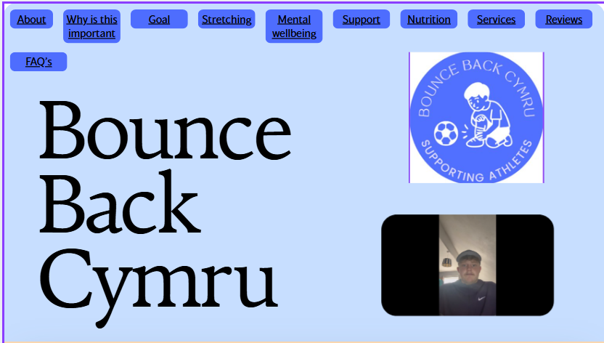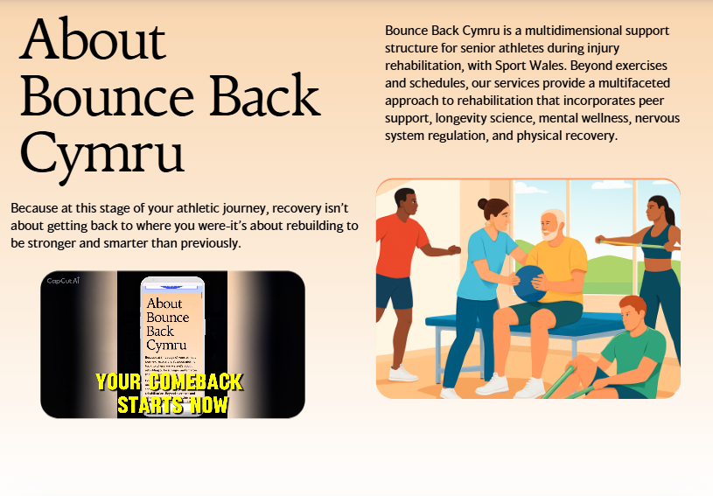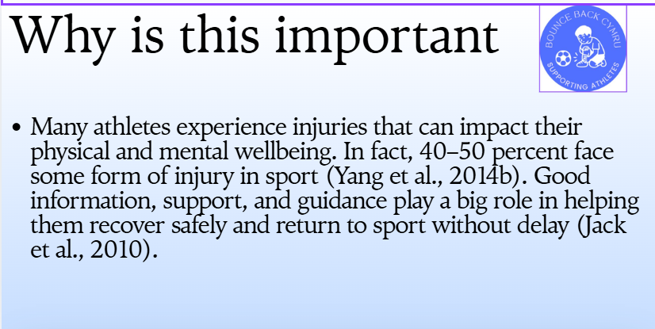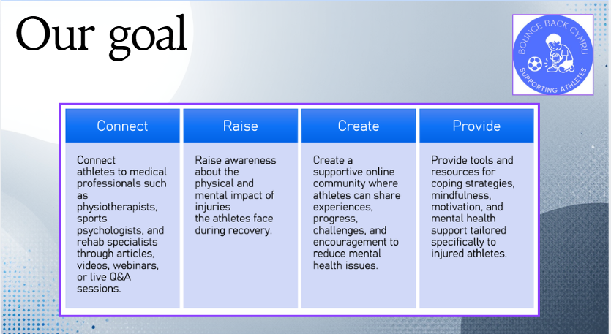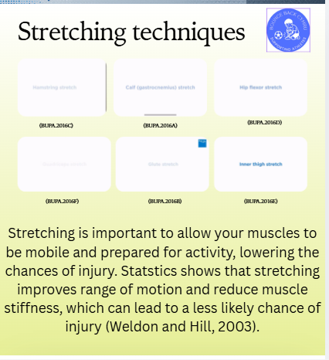
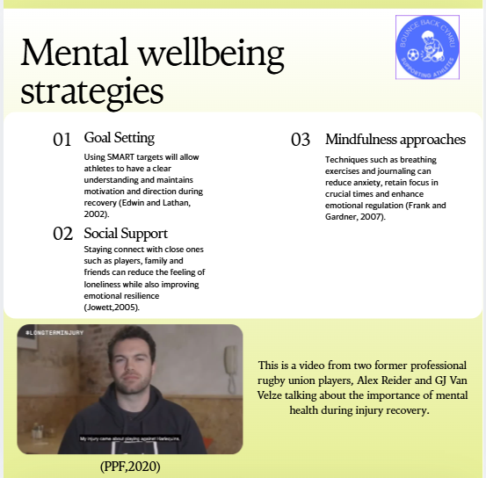
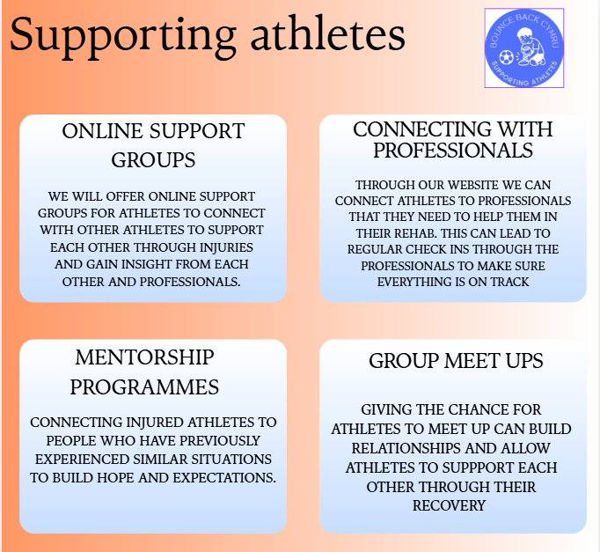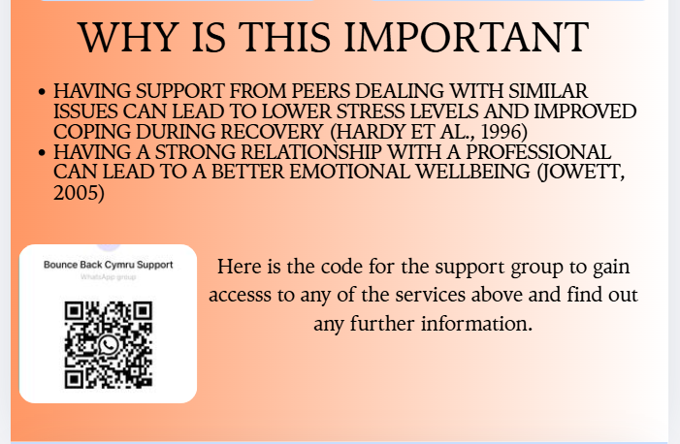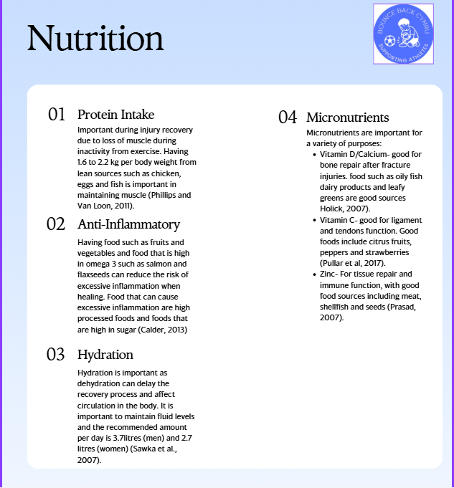
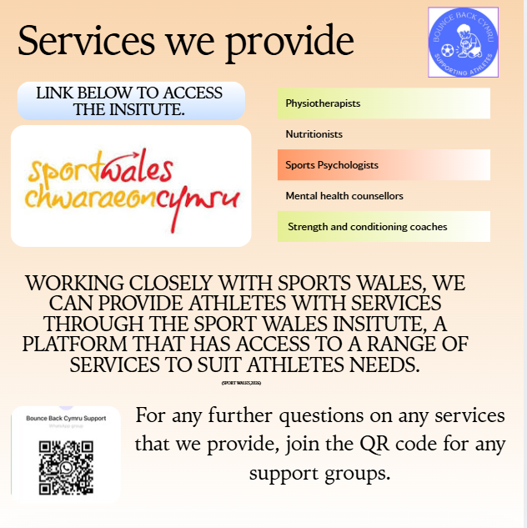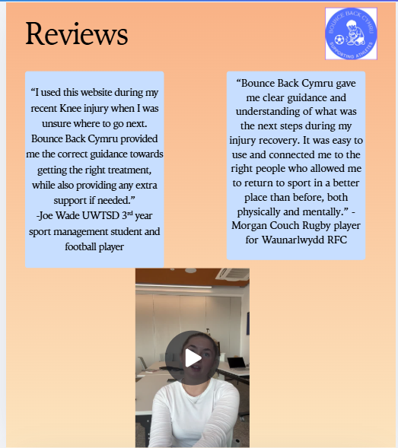
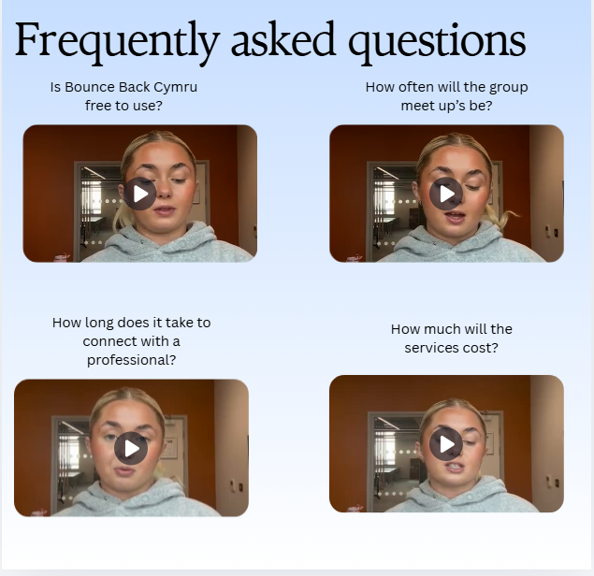

Reflection / Conclusion / Recommendations (key learning points)
To conclude, I decided to create a multidimensional support structure for athletes in senior sport during injury rehabilitation. At the first proposal, I decided to create a website for injured athletes and then decided to make a slight change to make it into more of a support structure based on the feedback from the pitch. Our goals were to connect injured athletes together to not feel alone during rehabilitation, raise awareness of the key information needed to get through injury rehabilitation correctly, create a safe online community for people to interact and provide tools and resources to injured athletes. This was something I decided on based on personal experiences with injuries as I have struggled with a range of injuries during my time playing sport and based on the research I found, such as 40 to 50% of athletes suffering with some sort of injury during their career (Yang et al., 2014b). An ethics form was completed upon completion of the project to make sure that the project matched the university standards and minimise the risk of any data protection protocols being broken.
When creating my literature review, it was important that I covered the key areas which will be needed when creating my support structure for athletes. The areas I aimed at were mental wellbeing, nutrition, rehabilitation and sports science and the technology in sport, which put me on the right track when creating my support structure. Statistics from this section that helped me in my support structure was 47.8% showed signs of anxiety/depression, and 26.8% showed signs of psychological distress (Foskett and Longstaff, 2017) and the importance of micronutrients in the body’s ability to recover from injuries (Calder, 2020).
The final part was creating my support structure which I decided to do on Canva, as I felt this allowed me to present all the essential information in a clear and presentable format. I split my sections into pages with relevant statistics, videos to give extra insight into each section and services that can be provided from our product. Overall, this project is built to give athletes more of an understanding of how to deal with injuries and provide support with both physical and mental issues.
On a personal reflection, I believe I have managed this project with a level of professionalism that was needed for this project to be completed within the timeframe given. Key learnings from this project have been my ability to create content online which was a weakness for me before starting this project and I will continue to practise these skills for further development. I have also gained more of understanding into how to deal with injuries and gained some key information from my research which I will take into my personal challenges with dealing from injuries.
The opportunity for this project is to potentially develop it further by offering our services across more areas in Wales and build more partnerships with local companies such as physiotherapists and nutritionists, which can allow us to offer a wider range of products to more athletes. Potential limitations are lack of interest from athletes due to the potential prices of some the services that we are providing through our platform.

Reference List (use relevant numbers of pages)
Alam, T. & Schneider, J. (2020). Social network analysis of hadith narrators from Sahih Bukhari. In 7th International Conference on Behavioural and Social Computing (BESC) (pp. 1–5). IEEE.
Anderson, M. K., Parr, G. P., & Hall, S. J. (2009). Foundations of Athletic Training: Prevention, Assessment, and Management. Lippincott Williams & Wilkins.
Ardern, C. L., Taylor, N. F., Feller, J. A., & Webster, K. E. (2013). A systematic review of the psychological factors associated with returning to sport following injury. British Journal of Sports Medicine, 47(17), 1120–1126.
Ardern, C. L., Taylor, N. F., Feller, J. A., & Webster, K. E. (2014). Fifty-five per cent return to competitive sport following anterior cruciate ligament reconstruction surgery. British Journal of Sports Medicine, 48(21), 1543–1552.
Ardern, C. L., Webster, K. E., Taylor, N. F., et al. (2011). Return to sport following anterior cruciate ligament reconstruction surgery. British Journal of Sports Medicine, 45, 596–606.
Azad, R. et al. (2023). Advances in medical image analysis with vision transformers. Medical Image Analysis.
Bahr, R. (2016). Why screening tests to predict injury do not work—and probably never will. British Journal of Sports Medicine, 50(13), 776–780.
Balish, S. M., McLaren, C., Rainham, D., & Blanchard, C. (2014). Correlates of youth sport attrition. Psychology of Sport and Exercise, 15(4), 429–439.
Barke, D. S., & Davis, A. (2025). Recovering from injury: The importance of athlete wellbeing. Return2Play.
Biswas, D., Abell, A., & Chacko, R. (2023). Curvy digital marketing designs. Journal of Consumer Research.
Breistøl, S., Clench-Aas, J., van Roy, B., & Kjærsti Raanaas, R. (2017). Association between participating in sports and mental health among adolescents. Scandinavian Journal of Child and Adolescent Psychiatry and Psychology, 5(1), 28–38.
Brewer, B. W. (2017). Psychological responses to sport injury. In Oxford Research Encyclopedia of Psychology. Oxford University Press.
Brewer, B. W., & Redmond, C. (2016). Psychology of Sport Injury. Human Kinetics.
Brukner, P., & Khan, K. (2017). Clinical Sports Medicine. McGraw-Hill Education.
Buckthorpe, M., Frizziero, A., & Roi, G. S. (2019). Update on functional recovery process for the injured athlete. British Journal of Sports Medicine, 53(5), 265–267.
Bupa (2016a) YouTube. Available at: https://youtu.be/S37HKFbpx4U?si=ernUcoem-Ot_5WBc
Bupa (2016b) YouTube. Available at: https://youtu.be/y01ri_43G50?si=BU902MH7wMr-fmLK
Bupa (2016c) YouTube. Available at: https://youtu.be/DxBDqHL5NlM?si=cD1N1qUeTv_zD1Z3
Bupa (2016d) YouTube. Available at: https://youtu.be/eRCpceBhcm0?si=sAC81rIVooYfd8sM
Bupa (2016e) YouTube. Available at: https://youtu.be/T_l0AyZywjU?si=WUkxF-BDyHSSLPZG
Bupa (2016f) YouTube. Available at: https://youtu.be/DXuStgWuJV8?si=v-0dmt4tyn93t79j
Business Plan (2025) Athletic Recovery Business Plan 2025, Business Plan Templates. Available at: https://businessplan-templates.com/products/athletic-recovery-business-plan
Calder, P. C. (2020). Nutrition, immunity and COVID-19. BMJ Nutrition, Prevention & Health, 3(1), 74–92.
Calder, P.C. (2013) ‘Omega-3 fatty acids and inflammatory processes’, Nutrients, 5(4), pp. 1303–1315.
Caparrós, T., Pujol, M., & Salas, C. (2017). General guidelines in the rehabilitation process for return to training. Apunts Medicina de l’Esport, 52(196), 167–172.
Chang, C., Putukian, M., Aerni, G., et al. (2020). Mental health issues and psychological factors in athletes. British Journal of Sports Medicine, 54, 216–220.
Cheng, F. F., Wu, C. S., & Leiner, B. (2019). The influence of user interface design on consumer perceptions. Computers in Human Behavior, 101, 394–401.
Chopdar, P. K., & Balakrishnan, J. (2020). Consumers response towards mobile commerce applications. International Journal of Information Management, 53, 102106.
Copenhaver EA, Diamond AB. (2017) The value of sleep on athletic performance, injury, and recovery in the young athlete. Pediatr Ann. 2017 Mar;46(3).
Dennis, J., Dawson, B., Heasman, J., et al. (2016). Sleep patterns and injury occurrence. Journal of Science and Medicine in Sport, 19(2), 113–116.
Donaldson, A., Callaghan, A., Bizzini, M., et al. (2019). Barriers to implementing injury prevention programmes. Injury Prevention, 25(4), 244–251.
Drummond Junior, M., Popchak, A., Wilson, K., et al. (2021). Criteria-based return-to-sport testing. Journal of Shoulder and Elbow Surgery, 30(7), S14–S20.
Edouard, P. et al. (2024). Understanding the first injury in athletics and its effect on dropout from sport. BMJ Open Sport & Exercise Medicine.
Edwin A. Locke, E.A. and Gary P. Latham, G.P. (2002) ‘Building a practically useful theory of goal setting and task motivation: A 35-year odyssey’, American Psychologist, 57(9), pp. 705–717.
Eliakim, E., Morgulev, E., Lidor, R., & Meckel, Y. (2020). Estimation of injury costs. BMJ Open Sport & Exercise Medicine, 6(1), e000675.
English, K. L., et al. (2016). Leucine partially protects muscle mass during bed rest. American Journal of Clinical Nutrition, 103(2), 465–473.
Foskett, R. L., & Longstaff, F. (2017). The mental health of elite athletes in the United Kingdom.
Frank L. Gardner, F.L. and Zella E. Moore, Z.E. (2007) The psychology of enhancing human performance: The Mindfulness-Acceptance-Commitment (MAC) approach. New York: Springer.
Gerometta, A., Klouche, S., Herman, S., et al. (2018). The SIRSI scale. Knee Surgery, Sports Traumatology, Arthroscopy, 26(1), 203–211.
Gleeson, M. (2016). Immunological aspects of sport nutrition. Immunology & Cell Biology, 94(2), 117–123.
Goddard, K., Roberts, C., Byron-Daniel, J., & Woodford, L. (2020). Psychological factors in adherence to rehabilitation. International Review of Sport and Exercise Psychology, 14(1), 51–73.
Gokeler, A., Seil, R., Kerkhoffs, G., & Verhagen, E. (2018). A novel approach to enhance ACL injury prevention programs. Journal of Experimental Orthopaedics, 5(1), 22.
Gouttebarge, V., Aoki, H., Lambert, M., et al. (2017). Concussions and mental disorders. British Journal of Sports Medicine, 51(4), 324.
Gouttebarge, V., Castaldelli-Maia, J. M., Gorczynski, P., et al. (2019). Mental health symptoms in elite athletes. British Journal of Sports Medicine, 53(11), 700–706.
Hannibal, K. E., & Bishop, M. D. (2014). Chronic stress and pain. Physical Therapy, 94(12), 1816–1825.
Hardy, L., Richman, J.M. and Rosenfeld, L.B. (1991) ‘The role of social support in sport injury’, Journal of Sport and Exercise Psychology, 13(3), pp. 278–291.

Holick, M.F. (2007) ‘Vitamin D deficiency’, New England Journal of Medicine, 357(3), pp. 266–281.
Ivarsson, A., Johnson, U., Lindwall, M., et al. (2014). Psychosocial stress as a predictor of injury. Journal of Science and Medicine in Sport, 17(4), 366–370.
Jack, K., McLean, S. M., Moffett, J. K., & Gardiner, E. (2010). Barriers to treatment adherence. Manual Therapy, 15, 220–228.
Jones, G., & Wilson, E. (2019). Everyday Sport Injuries. DK Publishing.
Jowett, S. (2005) The coach–athlete partnership. The Psychologist, 18(7), pp. 412–415.
Kamphoff, C. S., Thomae, J., & Hamson-Utley, J. J. (2013). Integrating psychological and physiological aspects. In The Psychology of Sport Injury and Rehabilitation.
Kandambi, K. A., Charles, J., & Lekamge, L. S. (2022). Kansei colour concepts for ecommerce website design. In MERCon 2022 Proceedings.
Kessler, R. C., Berglund, P., Demler, O., et al. (2005). Lifetime prevalence of DSM-IV disorders. Archives of General Psychiatry, 62, 593–602.
Keyes, C. L. M. (1998). Social well-being. Social Psychology Quarterly, 61, 121.
Keyes, C. L. M. (2002). The mental health continuum. Journal of Health and Social Behavior, 43, 207–222.
Keyes, C. L. M. (2007). Promoting and protecting mental health. American Psychologist, 62, 95–108.
Kloubec, J., & Harris, C. (2016). Whole foods nutrition for injury prevention. ACSM’s Health & Fitness Journal, 20, 7–11.
Kvists, J., Ek, A., Sporrstedt, K., & Good, L. (2005). Fear of re-injury. Knee Surgery, Sports Traumatology, Arthroscopy, 13(5), 393–397.
Lambert, B. et al. (2022). Trustworthy clinical AI solutions. Artificial Intelligence in Medicine.
Lauersen, J. B., Andersen, T. E., & Andersen, L. B. (2018). Strength training as injury prevention. British Journal of Sports Medicine, 52(24), 1557–1563.
Li, H., Moreland, J., Peek-Asa, C., & Yang, J. (2017). Preseason anxiety and injury risk. American Journal of Sports Medicine, 45(9), 2148–2155.
Maggini, S., Pierre, A., & Calder, P. C. (2018). Immune function and micronutrients. Nutrients, 10(10).
Martin, J., Mortimer, G., & Andrews, L. (2015). Re-examining online customer experience to include purchase frequency and perceived risk. Journal of Retailing and Consumer Services, 25, 81–95.
McPherson, A. L., Feller, J. A., Hewett, T. E., & Webster, K. E. (2019). Psychological readiness to return to sport. American Journal of Sports Medicine, 47(4), 857–862.
Molinillo, S., Ekinci, Y., & Japutra, A. (2019). Consumer-based brand performance model. International Journal of Market Research, 61(1), 93–110.
Nedder, V. J., Raju, A. G., Moyal, A. J., et al. (2025). Psychological factors in ACL rehabilitation. Sports Health, 17, 291–298.
Ohio State Medical Center (2018) Nutrition is key to sports perfornance, YouTube. Available at: https://youtu.be/3XMh6f0xB7A?si=P3ltjhl3DgaJdVh6
Owoeye, O. B. A., Emery, C. A., Befus, K., et al. (2020). Adherence to injury prevention programs. Journal of Sports Sciences, 38(20), 2329–2337.
Palmer, D. et al. (2024). Understanding the first injury in athletics. BMJ Open Sport & Exercise Medicine.
Papadopoulou, S. K., et al. (2018). Nutrition strategies in ultra-endurance events. Scandinavian Journal of Medicine & Science in Sports, 28, 881–892.
Pengnate, S., Sarathy, R., & Lee, J. (2019). The engagement of website initial aesthetic impressions: An experimental investigation. International International Journal of Human–Computer Interaction, 35(16), 1517–1531.
Peterson, L., & Renstrom, P. (2017). Sport Injuries: Prevention, Treatment and Rehabilitation. Taylor & Francis.
Phillips, S.M. and Van Loon, L.J.C. (2011) ‘Dietary protein for athletes: From requirements to optimum adaptation’, Journal of Sports Sciences, 29(sup1), pp. S29–S38.
Prasad, A.S. (2008) ‘Zinc in human health: Effect of zinc on immune cells’, Molecular Medicine, 14(5–6), pp. 353–357.

PPF (2020) Long term injury with Alex Reider and GJ Van Velze, YouTube. Available at: https://youtu.be/eO3kRipmf98?si=vyoZx2x16ze39Pmo

Pullar, J.M., Carr, A.C. and Vissers, M.C.M. (2017) ‘The roles of vitamin C in skin health’, Nutrients, 9(8), p. 866.

Rees, T., Hardy, L., Gullich, A., et al. (2016). The Great British Medalists Project. Sports Medicine, 46, 1041–1058.
Rose, S., Hair, N., & Clark, M. (2011). Online customer experience: A review of the business-toconsumer online purchase context. International Journal of Management Reviews, 13(1), 24–39.
Rosen, P., Kottorp, A., Fridén, C., et al. (2018). Young, talented and injured. European Journal of Sport Science, 18(5), 731–740.
Ryan, R. M., & Deci, E. L. (2017). Psychological needs and SDT. In Self-Determination Theory. Guilford Press.
Ryan, R. M. (2023). The Oxford Handbook of Self-Determination Theory. Oxford University Press.
Santi, G., & Pietrantoni, L. (2013). Psychology of sport injury rehabilitation. Journal of Human Sport and Exercise, 8(4), 1029–1044.
Sheppard, J. M., & Young, W. B. (2006). Agility literature review. Journal of Sports Sciences, 24(9), 919–932.
Sport Wales (2018) Sport Wales- My Welsh Sport, YouTube. Available at: https://www.youtube.com/watch?v=7BRHKYFXzZM&feature=youtu.be
Sport Wales (2025) What is Sport Wales?, Sport Wales. Available at: https://www.sport.wales/what-is-sport-wales/
Sport Wales (2026) Support for welsh athletes, Sport Wales. Available at: https://www.sport.wales/the-sport-wales-institute/

Steffen, K., et al. (2024). Best practices for the dissemination and implementation of neuromuscular training injury prevention warm-ups in youth team sport: A systematic review. British Journal of Sports Medicine, 58(11), 615–625.
Sweet, S. N., Tulloch, H., Fortier, M. S., et al. (2011). Patterns of motivation in cardiac rehabilitation. Annals of Behavioral Medicine.
Tang, J. E., Moore, D. R., Kujbida, G. W., et al. (2009). Protein ingestion and muscle synthesis. Journal of Applied Physiology, 107, 987–992.
UK Sport (2025) Sport wales, UK Sport. Available at: https://www.uksport.gov.uk/about-us/who-we-work-with/sport-wales
Walden, M., Hägglund, M., Magnusson, H., & Ekstrand, J. (2016). ACL injuries in professional football. British Journal of Sports Medicine, 50(12), 744–750.
Wall, B. T., Dirks, M. L., & van Loon, L. J. C. (2013a). Skeletal muscle loss during disuse. Acta Physiologica, 210, 600–611.
Wall, B. T., Snijders, T., Senden, J. M. G., et al. (2013b). Disuse and muscle protein synthesis. Journal of Clinical Endocrinology & Metabolism, 98, 4872–4881.
Weldon, S.M. & Hill, R.H. (2003). The efficacy of stretching for prevention of exercise-related injury.
Wu, Y.L., Li, E.Y., 2018. Marketing mix, customer value, and customer loyalty in social commerce: a stimulus-organism-response perspective. Internet Res. 28 (1), 74–104.
Xue, J., Liang, X., Xie, T., Wang, H., 2020. See now, act now: how to interact with customers to enhance social commerce engagement? Inf. Manag. 57
Yang, J., Cheng, G., Zhang, Y., Covassin, T., Heiden, E., & Peek-Asa, C. (2014a). Depression, anxiety, and injury hazard. Research in Sports Medicine, 22, 147–160.
Yang, J., Schaefer, J. T., Zhang, N., Covassin, T., Ding, K., & Heiden, E. (2014b). Social support and mental health. Journal of Athletic Training, 49(6), 773–779.
Yaribeygi, H., Panahi, Y., Sahraei, H., et al. (2017). Impact of stress on body function. EXCLI Journal, 16, 1057–1072.
Zhang, H., Lu, Y., Gupta, S., & Zhao, L. (2014). Social commerce participation. Information & Management, 51, 1017–1030.



Sports Management Portfolio

Independent Project

UWTSDSport

