Sian Broderick (1707947)
Confirmative Praxis
M7X02024
The Black Dog - Report

The Black Dog

“A light seen suddenly in the storm, snow
coming from all sides, like flakes
of sleep, and myself
on the road to the dark barn
Halfway there, a black dog is near me.”
— Robert Bly, ‘Melancholia, in The Light Around the Body,’ 1967

Preface
Throughout this report the Black Dog will be used as a metaphor for depression. Although the whole project will be based on my own personal journey through depression alongside the Covid 19 pandemic, it is in no way a project about myself alone ... by utilising my own ill health, fight and experiences during my struggle throughout this period, I attempt to create a truthful and artistic documentary of Depression, the highs and lows of the Covid, the loneliness and the animals that are there helping in their own way to counteract depression.

Introduction
The purpose of this report is to examine depression and how animals have become an important part of the healing process for this debilitating disease. It is an investigation into depression and how animals, particularly dogs are so important in easing loneliness, stress, anxiety and depression. The title The Black Dog will be examined and questioned.

The report will focus on work from several relevant artists that have been researched in the course of this project. Firstly, Polish artist Dawid Planeta (b.1990), himself a sufferer of depression, who used animals in his art to help him with his mental health. Then, Louis Wain (1860 - 1939) an illustrator wellknown for his illustrations of anthropomorphic cats, his struggle with depression and how his art changed through his struggles with mental illness.Also,Laurent Baheux (b.1979) a French photographerknown for his high contrast black and white photographs of nature, and Elke Vogelsang (b.1972) a French modern day pet photographer.

The report will be divided into three parts followed by a conclusion. Part one will broadly focus on the blackdog’s historical connection with humans and myth, briefly centring on the pivotal effect the dog had within history and the human race. Part two will examine mental health, the Covid pandemic and how this has had an impact on mental health. The concept of the black dog in history held credibility when it was initially presented, and I will be considering if it still holds currency and credibility now. Part three will look at the jobs animals now have in society, followed by a final concluding chapter.

Part One
Depression was initially called ‘melancholia’. The earliest accounts of melancholia appeared in ancient Mesopotamian text in the second millennium B.C. (Mesopotamia – Bronze Age). In this period mental illnesses were thought to be caused when a person was taken over by demons (possessions), they were treated by priests. As time and cultures moved on The Black Dog became used as a metaphor for Melancholia – depression. (Preston, 2013)
Melancholy could drive one mad, yet it also produced the sensitivity required for creativity. Marsilio Ficino (1433 – 1499) (Italian scholar and Catholic priest and influential humanist philosophers of the early Italian Renaissance). Ficino wrote, “All truly outstanding men, whether distinguished in philosophy, in statecraft, in poetry or in the arts, are melancholic’s.” (Khan 2022)
Melancholy was believed to result from an excess of a bodily fluid known as “black bile.” (Minneapolis Institute of Art, 2022) But many factors play a role in mental illnesses - “Our adversaries are not demons, witches, fate, or mental illness. We have no enemy whom we can fight, exorcise, or dispel by ‘cure.’ What we do have are problems in living.” (MFI 2019) There isn’t one particular cause of any mental illness, it is suggested it can be one of many causes – Genetics, Environment, Childhood Trauma, Stressful Events, Negative Thoughts, Unhealthy Habits, Drugs and/or Alcohol, Brain Chemistry. (MHA, 2020)

According to folklore - The Black Dog was a supernatural, spectral or demonic entity. It was a large dog with glowing red or yellow eyes and often connected with the Devil. Black dogs were in general regarded as sinister or malevolent, and a few were said to be directly harmful. Throughout history, ‘Death Omens’ have been referred to as Guardians or Gatekeepers of the Underworld. Greeks, Romans, Egyptians, Middle-East and Norse, the black dog can be found in all of their folklore. (Preston, 2013)
The bite of the black dog can be worse than its bark. To some, the black dog is man’s best friend, a faithful companion in the rear of a pickup truck. To others it is a metaphor for the shadows of depression. (Bly,1967)

History is intermingled with concepts, but there is no single point of origin. Sir Winston Churchill used the black dog as a symbol for his depression, referring it as the ‘black dog sitting on his lap’.

The term ‘The Black Dog’ was believed to have come from Sir Winston Churchill, but it was in fact first coined by the poet Horace (Horace, Latin in full Quintus Horatius Flaccus, born December 65 BC, Venusia, Italy - died Nov. 27, 8 BC Rome), outstanding Latin lyric poet and satirist under the emperor Augustus. (Britanica, 2021). Churchill later adopted it to describe his own depression, the metaphor of the “black dog” has been used for centuries. (McVeigh, 2011)

Gatekeepers of the Underworld (Sian Broderick 2021)

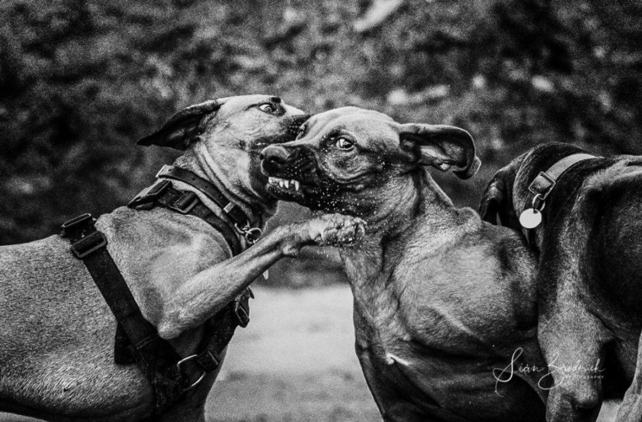
Image 1
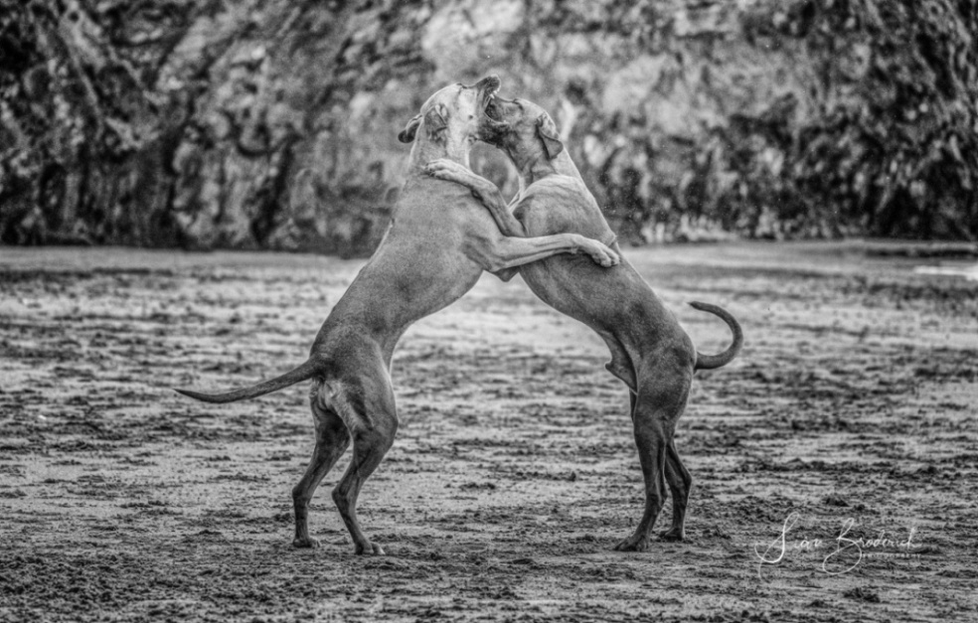

Image 2

Part Two
“Depression is being colour blind
And constantly told how colourful the world is” (Atticus)

“It must be observed, that the cessation of pleasure affects the mind ... if the object be totally lost that there is no chance off enjoying it again, a passion arises in the mind, called grief.” (Burke p. 32)

Depression is a real illness with real symptoms. It is not a sign of weakness or something you can “snap out of” by “pulling yourself together”. At its most severe, depression can make you feel suicidal, and that life is no longer worth living.
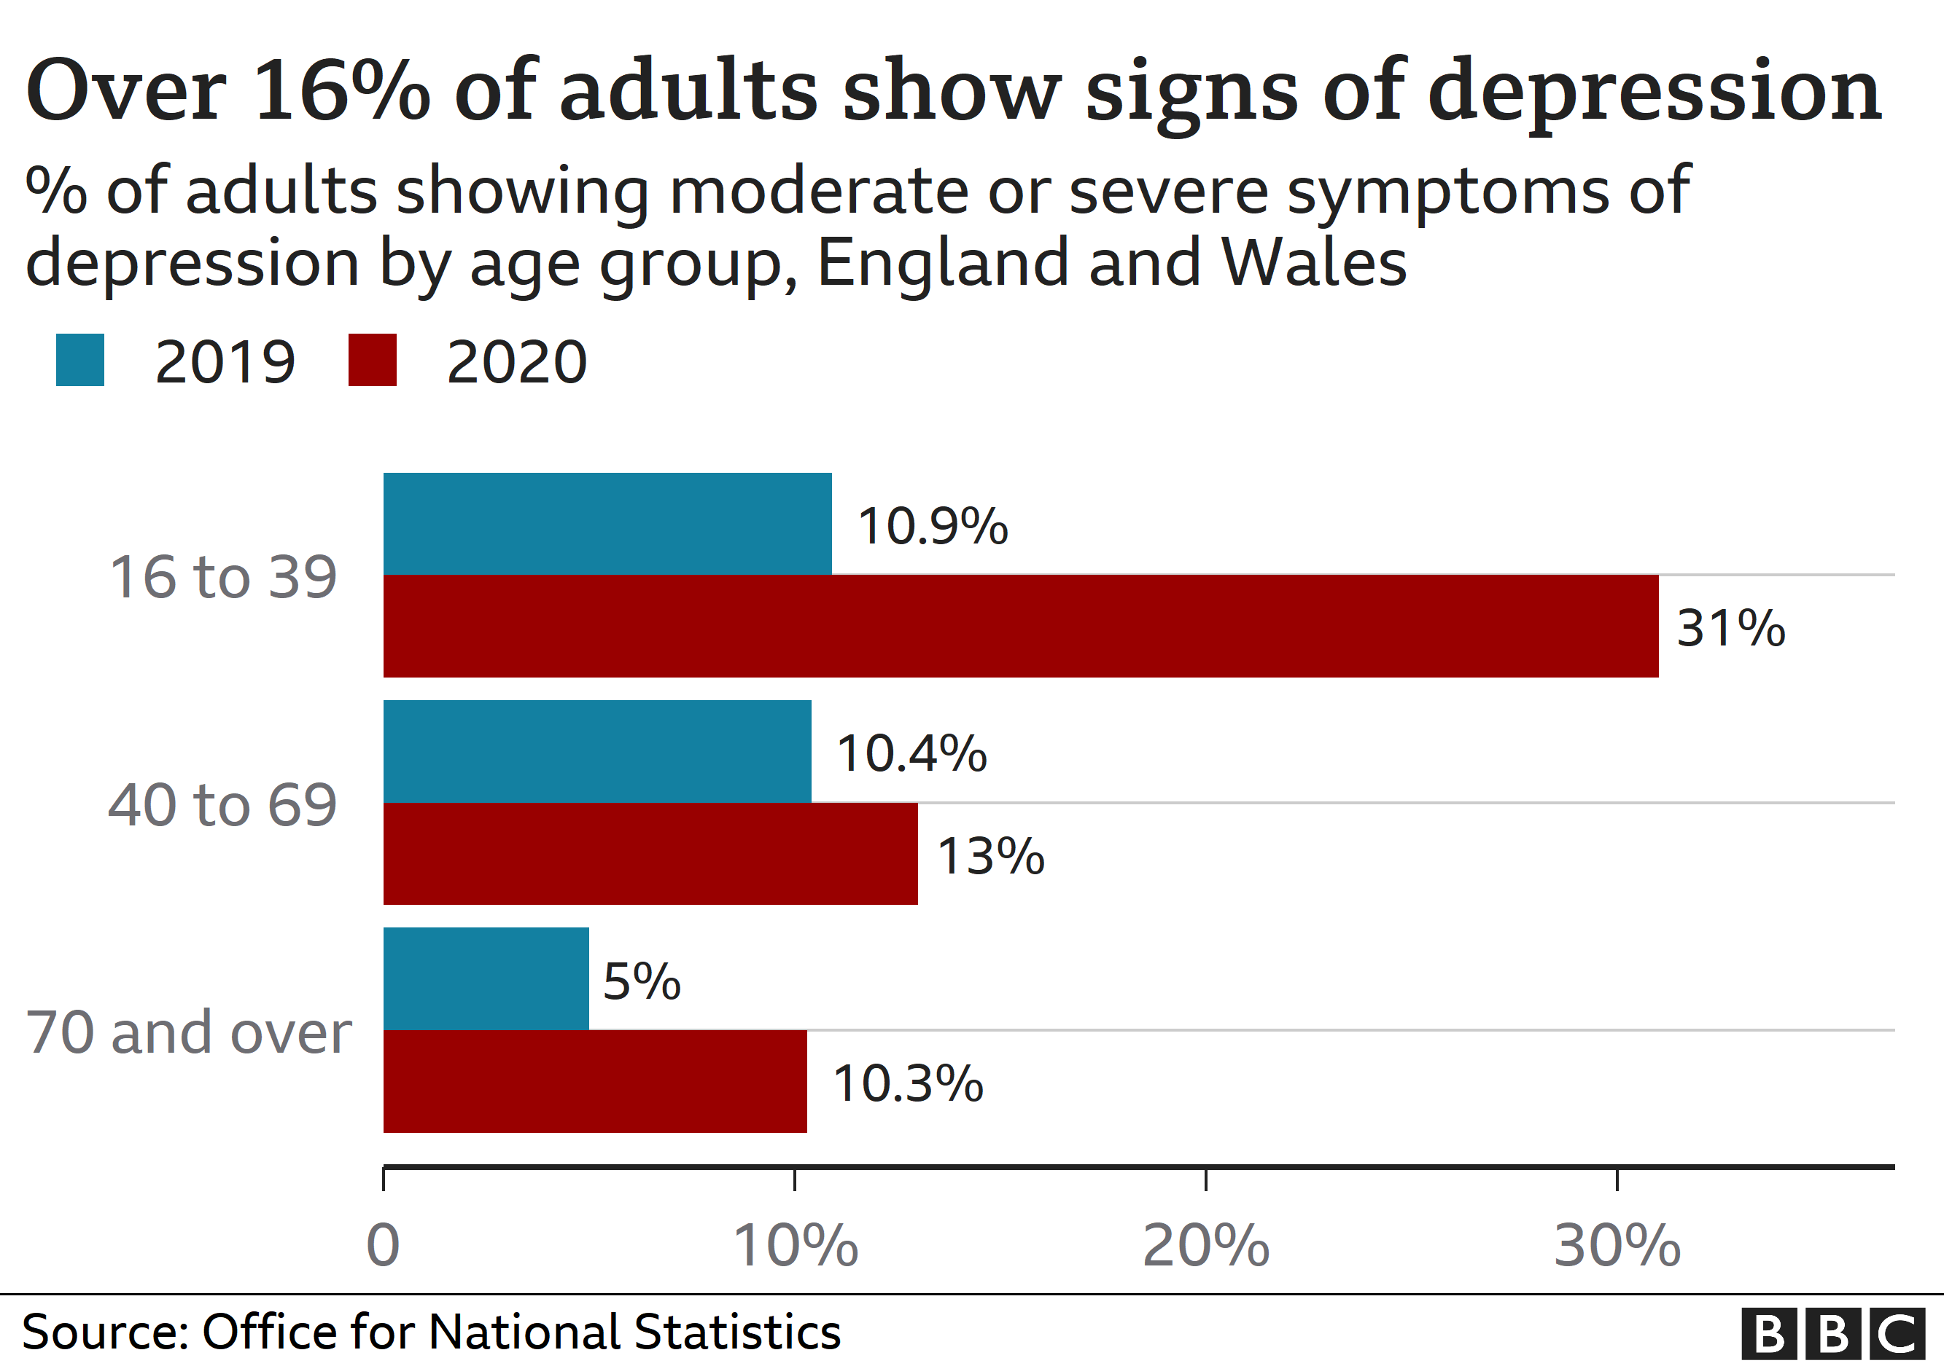
BBC(2021) (Image 3)
Depression is on the increase as shown in the graph (Image 3) it illustrates the cost the recent Covid pandemic has had on mental health.

The Governments reports that - ‘One in six adults experienced some form of depression in summer 2021 (21 July to 15 August, Great Britain), compared with one in ten before the pandemic (July 2019 to March 2020). Younger adults, women, disabled adults, unemployed adults, those who could not afford an unexpected expense of £850 and adults living in the most deprived areas of England were more likely to experience some form of depression.’ (Ref- Office for National Statistics 2021)
So what is depression? It affects people in different ways and can cause a wide variety of symptoms. It ranges from lasting feelings of unhappiness and hopelessness, to losing interest in the things you used to enjoy and feeling very tearful. Many people with depression also have symptoms of anxiety.
There can also be physical symptoms, the feeling of being constantly tired, sleep deprivation, no appetite or sex drive, and a variety of aches and pains.
The symptoms range from mild to severe. Its mildest form, you may just experience continual low spirit, at the same time severe depression can make you feel suicidal.
Occasionally there's a cause for depression, like a life-changing events, perhaps bereavement, loss of job or giving birth, these are all capable of all bringing it on.
Perhaps people with a family history of depression are more likely to experience it themselves. But on the other hand you can also become depressed for no obvious reason. (NHS 2019)

The Covid Pandemic
According to the Samaritans, corona virus is having a profoundeffect on the economy. During the previous recession, suicide rates have risen, and those who are hardest hit by economic downturn are also those who are at greatest risk of suicide – i.e., middle-aged men. The UCL Covid-19 Social Study, which has run weekly throughout the time since restrictions began, consistently found that around 2% of people report self-harming in the past week.(Samaritans, 2021)
Personal well-being remained stable (8 to 19 September 2021), but all remain worse than the pre-pandemic (February 2020) levels. (Office for National Statistics, 2021).

In 2012 the term ‘The Back Dog’ was used again in a campaign to createawareness of depression, there was a large advertising campaign and even a short video was made on ‘you tube’ video (please see link below) https://www.youtube.com/watch?v=XiCrniLQGYc (World Health Organisation, 2021)
Creativity and artistic expression have shown to have a significant benefit to people with depression. Creative personalities with unusual perceptual experiences and impulsive nonconformity rated themselves higher on a creativity scale than others, and a 2013 study called “Creativity and Schizotypy From the Neuroscience Perspective” suggests that the mental process during the creative process are similar to those that occur in “psychosis proneness.” (Nittle 2021)
One of the most famous artist who battled with depression is Vincent Van Gogh (1853-1890) He once wrote - “I put my heart and my soul into my work, and lost my mind in the process.” He suffered from anxiety, depression and poverty throughout his life, dying at the age of 37 from suicide (he shot himself). In a letter to his brother in 1888 he stated that he was unable to describe exactly what the matter was with him. How he had occasional terrible fits of anxiety without apparently any cause, he felt tired and empty headed with attacks of melancholy and atrocious remorse. (1000 museums...2020)
There was also Norwegian painter, Edvard Munch (1863-1944) his most famous for his painting The Scream. Mental illness ran in his family. His grandfather suffered from depression and his aunt was schizophrenic. Munch’s childhood was marred by sadness, as his mother and one of his sisters died of tuberculosis, another of his sisters were also mentally ill. In 1889, Munch’s father died, leaving the family destitute. By 1908 through excess drinking his anxiety became acute; he experienced hallucinations and feelings of persecution. But he saw his mental illness as an important motivation for his art. He wrote in his diary: “My fear of life is necessary to me, as is my illness. They are indistinguishable from me, and their destruction would destroy my art.” (1000 museums...2020)
Many photographers have used depression/mental illness to create amazing photography.
Photographer Gabriel Isak uses his own fight with depression as the catalyst for his project called The Blue Journey. Inspired by the artist Magritte as well as surrealism, he created it after facing the disease for seven years. HIs subconscious mind inspired most of the images in the series, the images he created “feel like small memories of what I went through during my depression.” (Barnes 2017)
Edward Honaker Photographer said “Your mind is who you are,” he explains, “and when it doesn’t work properly, it's scary.” (Barnes 2017)
Image 4 - Edward Honaker “Depression through photography” 
Artist Dawid Planetahas said: “Depression – it’s not an easy illness to deal with, but when you try, you can stop thinking about it as a weakness and turn it into something brilliant,” (Colossal, 2018)

Planeta, whilst suffering from depression, turned his mental illness into creativity and produced a series of images called Mini People in the Jungle; all the animals were created to appear larger than life and had glistening eyes. Looking at these and the description of the Gate Keepers of the underworld- “It was a large dog with glowing red or yellow eyes” (Preston, 2013), it is possible that he also had researched melancholy before embarking on this series.
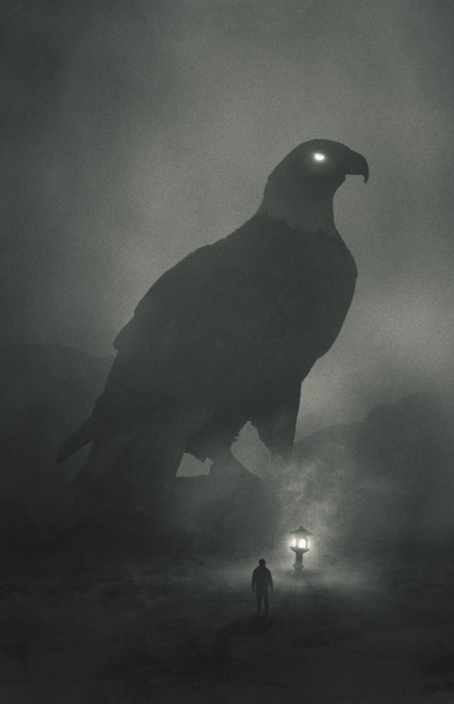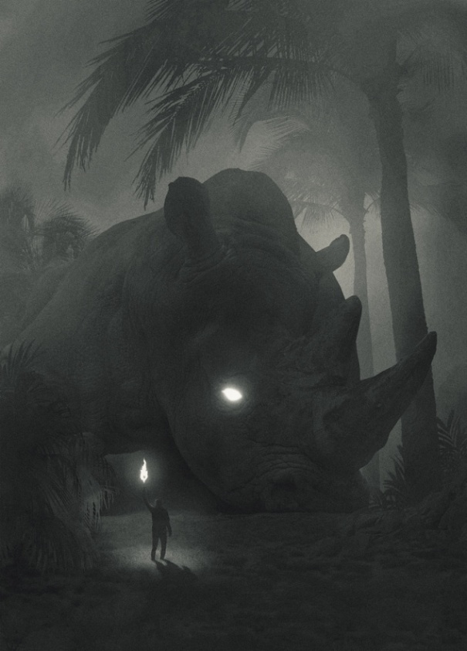
Images 5 and 6: Planeta, Returning to the Jungle(Evans, 2017)

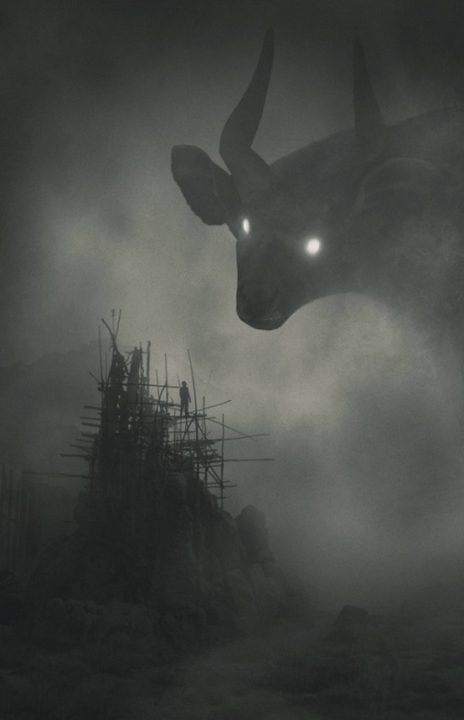
Image 7 : Planeta, Returning to the Jungle(Evans, 2017)

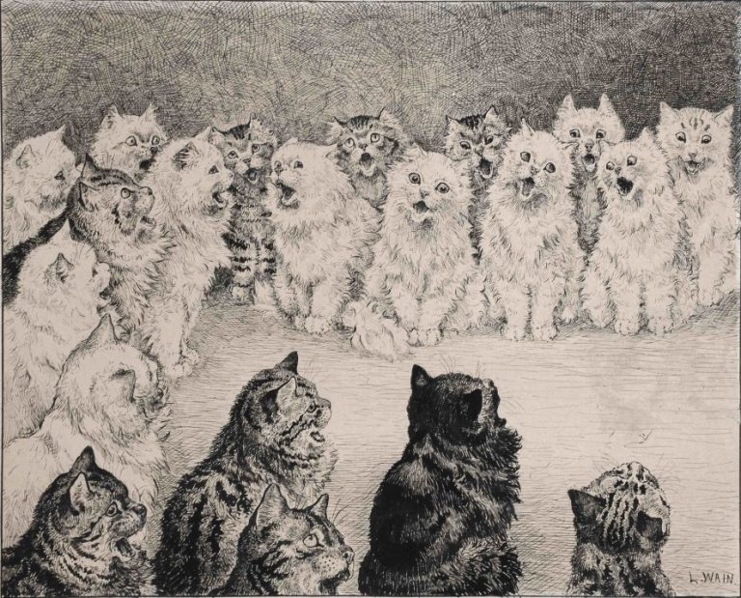
Image 8: Louis Wain, Shortears Began and Sung A Solo. Then All The Cats Joined And Sung The Chorus To Madame’s Satisfaction, (1886)

In 1883 Louis married Emily Richardson, who at that time was his sister’s governess. Not so long after their marriage Emily became ill, suffering from breast cancer. Emily had her own “support” animal, a stray cat called Peter, the couple adopted. One of the cats portrayed in Madame Tabby’s Establishment was based on Peter’s character. This apparently made Emily so happy that Louis decided to devote his life to sketching kittens, uplifting his wife’s spirit. (Bryll, 2020)

Could an animal cause depression rather than elevate the symptoms? After the death of Wain’s wife he became very depressed and his artwork changed completely, although still using cats in his illustrations they took on a dark sombre presence. Later he was admitted to a mental hospital and it is unknown if he had “schizophrenia due to the Toxoplasma gondii, parasite known to be carried and excreted by cats” it was suggested that he died of a broken heart. (Bryll, 2020) Images 9 and 10 were drawn by Wain after the death of his wife.
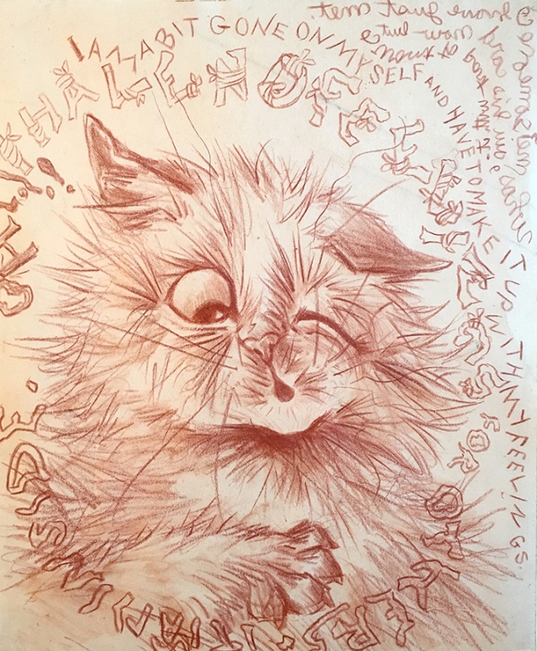
Image 9: Louis Wain, I am a bit gone on myself (date unknown)
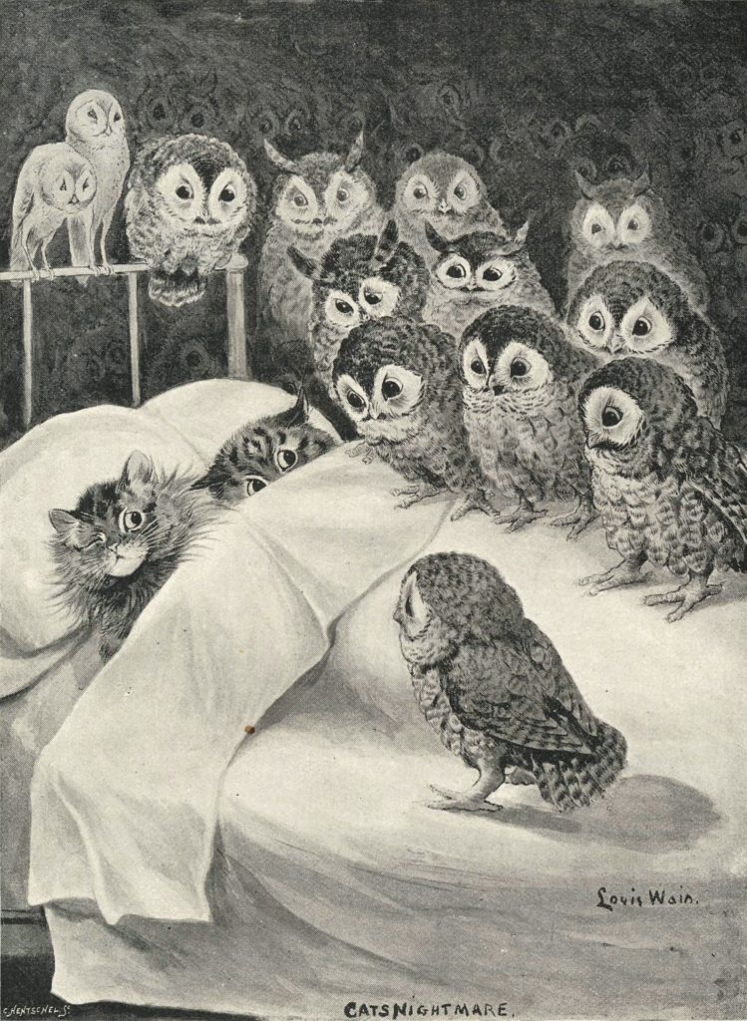
Image 10: Louis Wain, Cat’s Nightmare, (c.1890)
Laurent Baheux, a photographer specializing in black and white images of nature and wildlife, uses high contrast with very deep black in his images; his work is often compared to the portraits of the French photographer Studio Harcourt, an example of her style Image 10.



Image 11: Studio Harcourt, Dalian, China, (1934)

Baheux’s dark images of wild and domestic animals give the viewer a clear close-upinspection of these animals as they are in their natural habitat, which is a far cry from the domestic and sometimes cute imagesmade by cat and dog photographers now. Images15, 16 and 17 are examples of cute modern photographs, taken by Elke Vogelsang (b.1972) German pet photographer. But it’s doubtful if these images would have been taken if it was not for her own dogs. ‘On Christmas Day 2009, Elke Vogelsang husband suffered a brain haemorrhage. It was her dogs who found him just in time to save him. He spent weeks in a coma and months with no short-term memory.’ (Vogelsang, 2016)
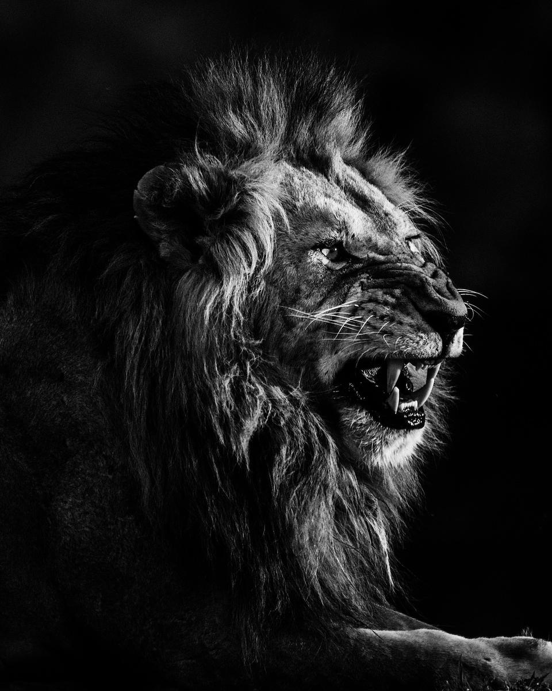
Image 12: Laurent Baheux, Lions (2019)
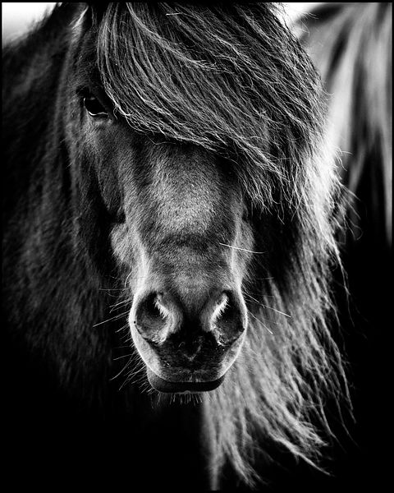
Image 13: Laurent Baheux, Focus on horses ears (2015)
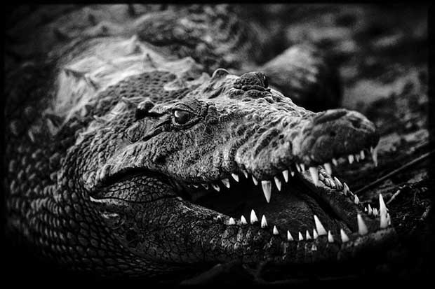
Image 14: Laurent Baheux Crocodile, Botswana(2010)

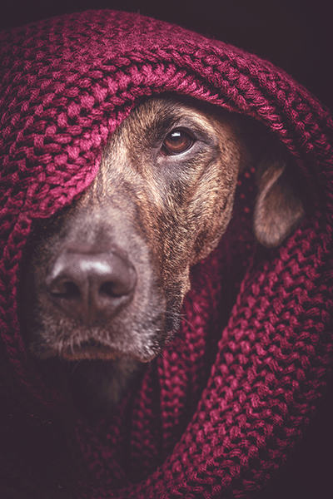
Image 15: Elke Vogelsang, The Quiet Rambler (2009)
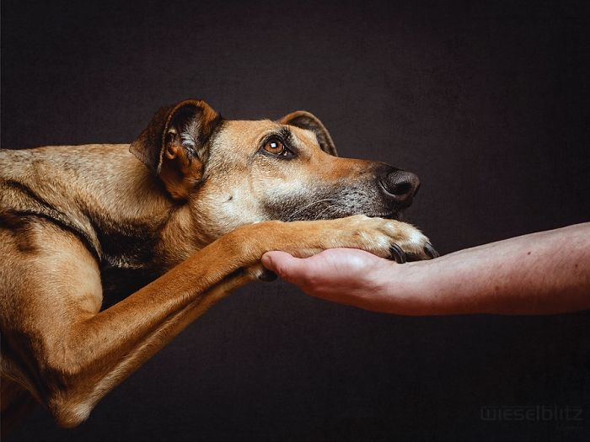
Image 16: Elke Vogelsang, Expressive Dog (2009)

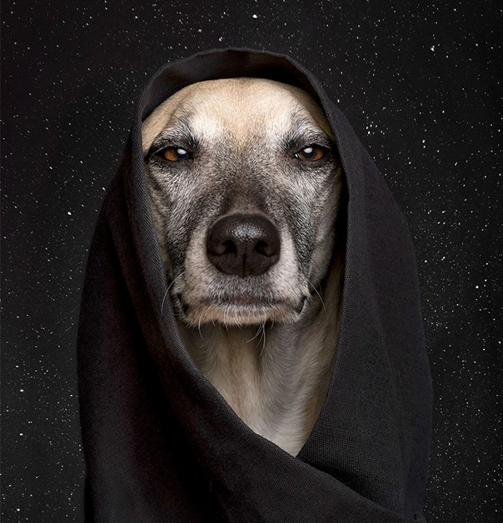
Image 17: Elke Vogelsang (2009)

Part Three
A dog is the only thing on earth
That loves you more than
He loves himself

Josh Billings nee Henry Wheeler Shaw (1818 – 1885)

A man’s best friend, that’s how dogs are thought of now, the gatekeepers of hell, has moved on somewhat from the ‘demonic entity’ history will have us believe.
However the saying a dog is man’s best friend hasn’t always been the case. 16th-century Spanish explorers show how the Aztecs had a taste for dogs. They were repeatedly bred specifically for their meat which farmers sold in city markets. In the 18th century a major economic downturn forced Germans to consume dog meat as a cheaper alternative to beef. In modern day China the country has continuously allowed its people to farm and eat dogs. Chinese appetite for dog meat is best illustrated in the events of the Yulin Dog Meat Festival; Yulin residents spend over a week insatiably consuming dogs in the name of good fortune and good health. (Kageyama 2021)
It doesn’t just thrive in China; countries like South Korea, Nigeria, and Vietnam all eat dog meat according to the Humane Society International. An estimated 30 million dogs across Asia, including stolen family pets, are still killed for human consumption every year. Another example is South Korea; dog meat dishes are so common that they have their own name - Gaegogi. The country has an estimated 17,000 dog farms, according to the Humane Society, where animals are routinely prepared for human consumption.
The practice of eating cats and dogs has become less common as pet ownership rises, and new generations have different attitudes to eating domestic animals. (BBC 2017)
Nowadays Europeans may see this as barbaric, but in so many countries dogs are thought of as livestock and it is the same to them as eating beef or pork. Taiwan has banned the selling and eating of cats and dogs after a series of cruelty cases that caused widespread outrage.

Taiwan is the first Asian country to stop the practice of the consumption of dogs; they have pioneered an Animal Protection Act if anyone is witnessed selling, eating or buying dogs for consumption facing fines of up to £6,500, and found guilty of animal cruelty could also receive a huge fine of £52,000 and two years in prison. (BBC 2017)

Dogs have evolved to be highly sensitive to humans their behaviours, emotions, and thoughts. In addition to understanding many of our words, dogs are also able to comprehend our tone of voice, body language, and gestures. They can relieve stress, anxiety, and depression, ease loneliness, encourage exercise and playfulness, and even improve cardiovascular health. (Lundgren 2021)
Numerous dog books declare that Greek and Roman armies fought numerous wars assisted by large, dangerous war dogs. The end of the 19th century dogs were brought into action in military operations once more. The dogs’ senses of hearing and smell were significant. Modern warfare, dogs have been used as messenger dogs, patrol dogs, guard dogs, mine dogs, Red Cross dogs or as draught dogs for the transportation of weapons, ammunition, food and medical supplies. (Smith 2018)

“For centuries, dogs have been bred specifically to help man with all sorts of practical tasks: from hunting and herding to fishing and farming. In recent years, many familiar breeds have been deployed in more unusual canine roles.” (Scoular 2018)
Dogs are now used in health and social care, such as assisting people with disabilities or guiding the visually impaired, as well as detecting life-threatening diseases like cancer and type one diabetes. used as guide dog for the blind. Horses are also used to assist people in riding for the disabled, so it isn’t just dogs that are here to help.
According to Grenley G of the National Alliance on Mental illness -
“Dogs can contribute happiness. Studies show that dogs reduce stress, anxiety and depression, ease loneliness, encourage exercise and improve your all-around health. People with dogs have lower blood pressure and are less likely to develop heart disease, just playing with dogs has been shown to elevate oxytocin and dopamine, creating positive feelings and bonding for both the person and their pet.” (Grenley 2018)
“Dogs perform many different services for people, including helping us when we’re down. It isn’t uncommon to see a therapy dog wandering down the halls of a nursing home, cheering up the patients inside. New research has shown that dogs can help alleviate everything from depression to anxiety to aggression and other mental health problems.” (Evans 2020)
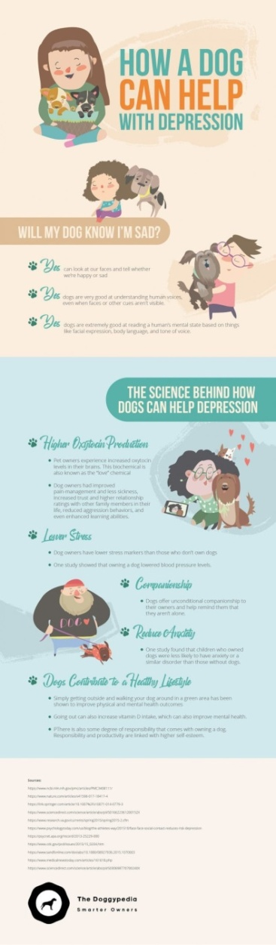
Image 18 (Ref – Evans R How can a dog help with depression (2020)

According to PTSDUK - Post Traumatic Stress Disordered is estimated that as many as 1 in 10 people develop post traumatic stress disorder (PTSD) at some stage in their life. Typical treatments include cognitive behaviour therapy Eye Movement Desensitisation Reprocessing (EMDR), but research increasingly highlights the fact that dogs can be effective at supporting people with PTSD.
Pets, in particularly dogs offer many forms of support to PTSD sufferers, depending on the exact needs of the person. An example of this - assault survivors may be hesitant to go out in public without the aid of a companion dog who can encourage in them assurance and a feeling of safety.
Experts state that dogs have been successful in aiding the healing of sexual assault victims, being distinctively suited to aid them in overcome trust and relationship concerns. Additionally, dogs are a great way for individuals to practise controlling stress levels and adapting the tone of voice.
Investigation offers strong support for the common value of pets, with data showing that PTSD patients with a dog don’t just sleep more, but have higher levels of oxytocin and dopamine with reduced cortisol, the stress hormone. (PTSDUK 2022)

Part 4 – Conclusion
In conclusion, this report has examined depression and mental illnesses and the part pets have in the relieving of the symptoms. Explored melancholia in history and the manner dogs were perceived arrived at the conclusion that dogs/pets really are man’s best friend. Through their heightened senses they are far more in tuned to their human counter parts and are able to alert, protect and stand by us.
Historically dogs, in particularly black dogs were known as evil, sinister demonic creatures that were to be avoided at all costs. It has also been discussed how dog were and in some countries still are consumed for their meat, although this practice is on the wane.
Melancholia the first word used for depression it was believed that a person with it was possessed by demons; it was assumed to be caused by demonic possession, as such, it was dealt with by priests rather than physicians.
“The idea of depression being caused by demons and evil spirits has existed in many cultures, including those of the ancient Greeks, Romans, Babylonians, Chinese, and Egyptians. Since this belief, it was often treated with methods such as beatings, physical restraint, and starvation in an attempt to drive the demons out.
1621, Robert Burton ((1577–1640) an English writer and fellow of Oxford University), published "Anatomy of Melancholy," he outlined the social and psychological causes of depression (such as poverty, fear, and loneliness). In this book, he made recommendations like diet, exercise, travel, purgatives (to clear toxins from the body), bloodletting, herbs, and music therapy in the treatment of depression.” (Schimelpfening 2020)

By the 20th century dogs were thought of as man’s best friend and were not only regarded as pets but had a wide variety of jobs to do. From being used on farms herding sheep and keeping predators away from livestock, to working in the armed forces for used in sniffing out drugs and bombs, social care dogs helping the visually impaired and assisting people with physical disabilities, hearing impairments to assistance dogs for alerts and emergencies for example. (Sunrise medical 2018)
Study researcher and psychologist Deborah Custance said in a statement. "The fact that the dogs differentiated between crying and humming indicates that their response to crying was not purely driven by curiosity. Rather, the crying carried greater emotional meaning for the dogs and provoked a stronger overall response than either humming or talking." (Pappas 2012)
Dogs have as many as 300 million olfactory receptors in their nose, as opposed to 6 million for the average person. This is how dogs are able to detect drugs etc whilst working. But they are also able to ‘smell’ a difference in their owners when for example they have an illness or disease (i.e. cancer). In saying this when people are depressed although it is impossible for another human to ‘smell’ anything different dogs are able too.
‘Researchers have also found that a person’s mood, which can be an indicator of a larger illness, triggers a dog’s sense of smell. Human emotions manifest physically in chemo signals that are emitted by the body, and dogs are adept at deciphering those changes.’ (Mull 2019)
Horses have been used for therapeutic purposes since the time of the ancient Greeks. The Greek physician Hippocrates wrote about the therapeutic potential of horseback riding. (Clark 2021)
Although more is written about the ability of dogs to help humans through illnesses, not so much is said regarding horses. But they are important to mental health sufferers. Although through the sheer size of them can put many off, but once over this the horse has a way of calming a person, just touching a horse and ease many anxious minds.
Equine-assisted psychotherapy includes horses into the healing process. People take on actions such as grooming, feeding, and leading a horse whilst being supervised by a mental health professional.
Objective of this type of treatment includes assisting people develop skills such as emotional guidelines, self-confidence, and responsibility.
"The horse is the perfect mirror, they are very emotional beings; we're only starting to realise how intelligent they are," said therapy counsellor Gabrielle Gardner. Horses pick up on the way people are feeling, mirroring their emotions and responding. (McVeigh 2012)
"It has been clinically documented that just being around horses changes human brainwave patterns. We calm down and become more centred and focused when we are with horses," horse trainer Franklin Levinson
Using animals as therapy is not new: the Greeks documented the horse's therapeutic value in 600BC and French physician Cassaign concluded in 1875 that equine therapy helped certain neurological disorders. By the 1950s British physiotherapists were exploring the possibilities of horse therapy for all types of disorders. Whether scientists will ever prove that they offer real medical value, our love of animals shows no sign of abating. Churchill said: "There's something, about the outside of a horse that is good for the inside of a man." (McVeigh 2012)
Although there are many animals used to help sufferers of all mental health problems, from cats to horses, nevertheless it is the dog that is the main focus of aid to people with these medical problems. They have been food to keep us alive, used in battles when there have been wars, companions to millions and eyes for those who can’t see. These sensory, loyal animals deserve so much recognition for all the help they give humans. Mans best friend.

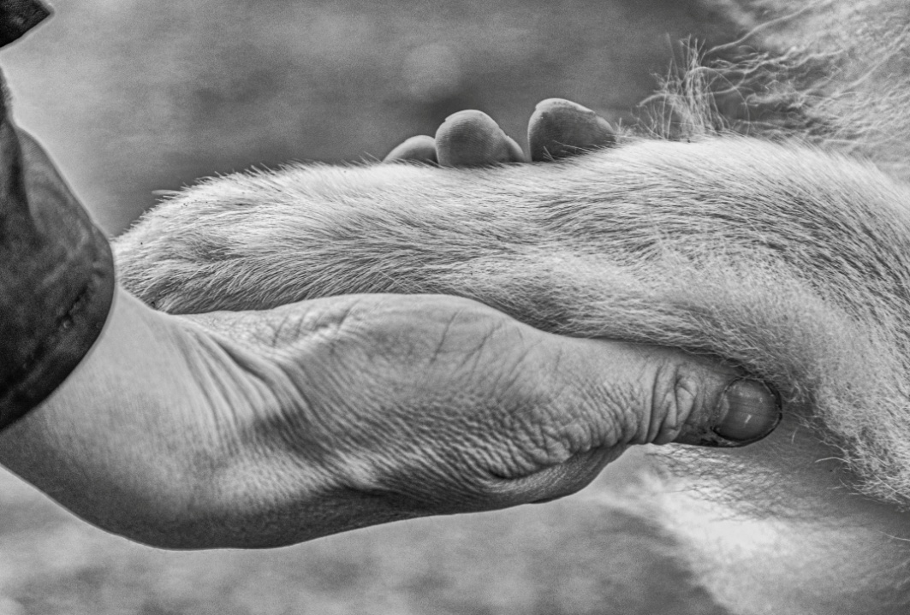
Image 19 (Sian Broderick 2021 A helping hand)

References
Atticus (No date) Depression. Available at:https://minimalistquotes.com/atticus-quote-72391/ (Accessed 2 January 2022)
Barnes S (2017) Expressive Photographers Whose Poignant Images Shed Light on Depression. Available at: https://mymodernmet.com/depression-photography/ (Accessed 2 March 2022)

BBC (2021) How has corona virus affected mental health? Available at: https://www.bbc.co.uk/news/explainers-55957105 (Accessed 2 January 2022)

BBC (2017) The countries where people still eat cats and dogs for dinner. Available at: https://www.bbc.co.uk/news/newsbeat-39577557. (Accessed 2 April 2022)

Billings J (2020) Josh Billings Dog Quotes for You to Enjoy. Available at: https://www.dogquotations.com/josh-billings-dog-quotes.html (Accessed 2 January 2022)

Bryll W M (2020) Louis Wain and His Weird Cats. Available at:https://www.dailyartmagazine.com/louis-wain-cats/ (Accessed December 14 2021)
Burke E (2015). A Philosophical Enquiry into the Sublime and Beautiful. Published Oxford University Press. (Accessed March 24 2022)

Clark J (2021) What Horses Bring to the Therapeutic Process. Available at: https://www.verywellmind.com/equine-therapy-mental-health-treatment-4177932 (Accessed 27 March 2022)

Colossal (2018) Explore Dawid Planeta’s Mystical World of Bright-Eyed Animal Guides Available at:https://www.thisiscolossal.com/2018/05/dawid-planetas-bright-eyed-animal-guides/ (Accessed 3 January 2022)

Evans H (2017) Returning to the Jungle: The Artwork of Dawid Planeta. Available at:https://scene360.com/art/111460/dawid-planeta/ (Accessed 14 December 2021)

Evans R (2020) How a dog can help with depression. Available at: https://powerfulpatients.org/2020/04/29/how-a-dog-can-help-with-depression/ (Accessed 13 December 2021)

Grant M. Britannica (2021) Horace Roman poet. Available at: https://www.britannica.com/biography/Sir-Richard-Fanshawe-1st-Baronet (Accessed 10 December 2021)

Grenley G (2018) How dogs can help with depression.Available at: https://www.nami.org/Blogs/NAMI-Blog/February-2018/How-Dogs-Can-Help-with-Depression (Accessed 4 January 2022)

Kageyama B (2021) The centuries-old history of dog meat. Available at: https://medium.com/lessons-from-history/can-people-eat-dogs-history-says-yes-744246e9b5df. (Accessed 1 April 2022)

Khan (2022) What is Melencolia? Available at: https://www.khanacademy.org/humanities/renaissance-reformation/northern/durer/a/what-is-melencolia. (Accessed 28 March 2022)

Lundgren, Robinson and Segal MA (2021) The Health and Mood-Boosting Benefits of Pets. Available at: https://www.helpguide.org/articles/mental-health/mood-boosting-power-of-dogs.htm (Accessed 2 January 2022)

McVeigh T (2012) Not just horsing around … psychologists put their faith in equine therapies. Available at: https://www.theguardian.com/society/2012/feb/26/horses-therapists-stress-autism-addiction. (Accessed 26 March 2022)

Mull A (2019) How Your Dog Knows When You’re Sick. Available at: https://www.theatlantic.com/health/archive/2019/03/dogs-illness-detection/584614/ (Accessed 7 April 2022)

MFI (2019) What is Mental Illness. Available at: https://mindfreedom.org/kb/voices-for-choices/voices-for-choices-what-is-mental-illness/?gclid=CjwKCAjw9qiTBhBbEiwAp-GE0cd1Jz_2cIaNANSB6uqNXUnc20wK9fHgWZ6_LxS49AKyynl53FTPDBoCUFYQAvD_BwE

MHA (2020) What is the cause of Mental Helath. Availavle at : https://screening.mhanational.org/content/what-causes-mental-illness/. Accessed 20 March 2022)
Minneapolis Institute of Art (2022) What is Melencolia? Available at :https://www.khanacademy.org/humanities/renaissance-reformation/northern/durer/a/what-is-melencolia
McVeigh, T (2011) Mental Health. Available at: https://www.theguardian.com/society/2011/jul/24/mental-health-black-dog-sculpture-campaign. (Accessed 3 January 2022)
NHS (2019) Depression is more than simply feeling unhappy or fed up for a few days. Available at: https://www.nhs.uk/mental-health/conditions/clinical-depression/overview/ (Acccessed 2 April 2022)
Nittle N (2021) The Link Between Depression and Creativity. Available at: https://www.verywellmind.com/the-link-between-depression-and-creativity-5094193#:~:text=While%20studies%20and%20observations%20have,both%20mood%20disorders%20and%20creativity. (Accessed 24 April 2022)
Office for National Statistics (2021) Corona Virus (Covid 19) latest insights: Well-being. Available at:https://www.ons.gov.uk/peoplepopulationandcommunity/healthandsocialcare/conditionsanddiseases/articles/coronaviruscovid19latestinsights/wellbeing (Accessed 5 November 2021)

Pappas S (2012) Canine Comfort: Do Dogs Know When You're Sad? Available at: https://www.livescience.com/20823-canine-comfort-dogs-understand-emotion.html. (Accessed 3 April 2022)

Penguin (2022) The Anatomy of Melancholy.
Available at:https://www.penguin.co.uk/authors/21213/robert-burton.html (Accessed 3 January 2022)

Preston. J, P (2013) - Bly, R (1967) ‘Melancholia, in The Light Around the Body,’ Available at:https://jppreston.com/2013/09/21/the-history-of-the-black-dog-as-metaphor/ (Accessed 2 November 2021)
PTSDUK ( 2022) How dogs can help people with PTSD. Available at: https://www.ptsduk.org/how-dogs-can-help-people-with-ptsd/ (Accessed 2 April 2022)
Samaritans (2021) What do we know about Corona Virus and Suicide Risk? Available at:https://www.samaritans.org/wales/about-samaritans/research-policy/coronavirus-and-suicide/one-year-on-data-on-covid-19/what-do-we-know-about-coronavirus-and-suicide-risk/ (Accessed 31 October 2021)
Schimelpfening N (2020) The History of Depression.Available at: https://www.verywellmind.com/who-discovered-depression-1066770 (Accessed 3 November 2021)

Scoular A (2017) What jobs are working dogs used for? Available at: https://www.telegraph.co.uk/pets/essentials/jobs-for-working-dogs/ (Accessed 22 December 2021)
Smith S J (2018) Dogs for War. Available at: https://www.akc.org/expert-advice/news/dogs-for-war/#:~:text=During%20war%20time%2C%20dogs%20have,ammunition%2C%20food%20and%20medical%20supplies.&text=Numerous%20dog%20books%20state%20that,by%20large%2C%20dangerous%20war%20dogs. (Accessed 3 March 2022)
Sunrise Medical (2018) Assistance dogs for people with disabilities. Available at:https://www.sunrisemedical.co.uk/blog/assistance-dogs (Accessed 27 November 2021)

Vogelsang E (2016) Elke Vogelsang
Available at: https://www.escapeintolife.com/photography/elke-vogelsang/ (Accessed 3 January 2022)

World Health Organisation (2021) I had a black dog his name was depression. Available at: https://www.youtube.com/watch?v=XiCrniLQGYc (Accessed 7 September 2021)
1000 Museums (2020). 6 Famous Artists Who Struggled with Mental Illness. Available at: https://www.1000museums.com/famous-artists-with-depression/ (Accessed 3 March 2022)

