Travel review:

The initial field trip to Paris and Switzerland was cancelled due to safety purposes through the coronavirus pandemic. Further to receiving a confirmation of the cancellation for this trip, we were relatively disappointed, however, we managed to re-arrange a substitute trip to North Wales, Liverpool and Manchester on sure short notice. This trip allowed us to participate in similar travel experiences, such as popular and existing activities, touristic sightseeing and historical places. I certainly liked the idea of domestic travel as I was unable to travel abroad due to difficulties and delays in the process of my visa application. Having the opportunity to be part in this field trip has been nothing but an amazing experience, to have a chance to explore some wonderful activities, places and cities that I never thought I would have.
Day one of our field trip, which was on Monday 2nd March 2020. We managed to stop to North Wales, for our first activity at Zip world, which was an amazing experience for all of us. Half of us did the zip line and all of us did bounce blew. Both activities were great and fun, however, the most important thing was that we had a great time and an unforgettable experience there. For food and beverage service at the zip world café was fantastic, lovely staff and good quality, homemade food which was a bit expensive but tasty.
On Tuesday, 3rd March 2020, we had a chance to visit Anfield stadium in Liverpool. We had the stadium tour and I loved each part of it. Firstly, I assumed that I would be finding it relatively boring as I’m not a big fan of the Liverpool football team, but it was an amazing experience. Our tour guides: David and Dan managed to show us all the interesting places and areas at the stadium. For food and beverage service at Anfield was great, staff were brilliant, and the food was excellent and cheap.
Day three of our field trip to chill factore in Manchester which was on Wednesday 4 March 2020. Chill factore has been one of my favourite activities throughout the trip. This was an amazing and fun experience even though I have managed to fall seven times, but I did enjoy myself. For food and beverage service at Chill factore was great, the staff were always helpful both on the desk and for equipment and the food was outstanding especially they nachos.

Thursdays, 5th March was our last day and the end of our filed trip. Although we managed to stop to cheater to visit Cholmondeley castle gardens. This was also an amazing experience for all of us, as we got a chance to explore the castle and the garden of Cholmondeley. On our way back home, we manged to stop to The Cholmondeley arms to grab somethings to eat. The food and service were great.
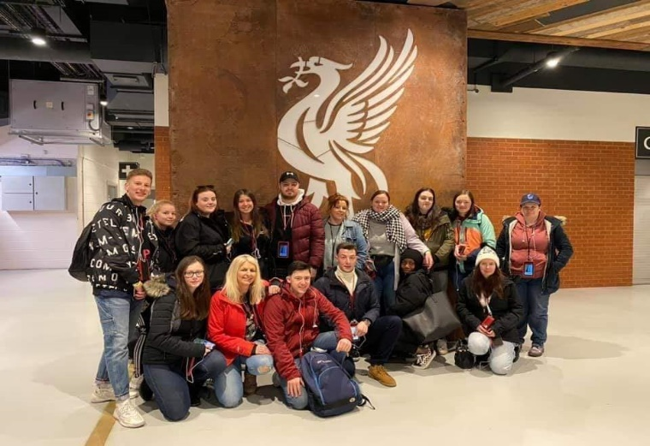
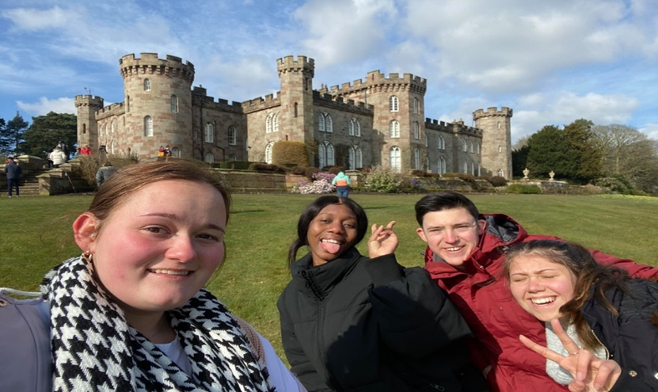
Overall, this trip has been one of the most memorable trips ever. We explored some of the best cities and visited numerous amazing places within the UK and ultimately enjoyed the whole travel experience. Even though not everything went as planned, we wouldn’t change this wonderful experience for the world.

Unforgettable experiences and memories.


