Marketing Management Assignment

NAME:Busthana serin
STUDENT NUMBER:2127472
LECTURER:Tushara balendran
COURSE:Master’s of business administration

Contents
1 Introduction to the chosen organization 2
2 PESTLE analysis 2
2.1 Political Factors 2
2.2 Economic factors 2
2.3 Social factors 3
2.4 Technological factors 3
2.5 Environmental factors 3
2.6 Legal factors 3
3 Porters 5 Forces model 4
3.1 Threats of new entrants- low 4
3.2 Bargaining Power of Buyers-high 4
3.3 Bargaining Power of Suppliers- High 4
3.4 The threat of substitutes- Medium 5
3.5 Rivalry among existing firms- High 5
4 SWOT analysis 6
4.1 Strengths 6
4.2 Weakness 6
4.3 Opportunity 6
4.4 Threats 6
5 STP of Brandix Company 7
5.1 Segmentation 7
5.2 Targeting 7
5.3 Product positioning 8
5.3.1 Positioning map 8
6 Marketing mix strategies 9
6.1 Product Strategy 9
6.2 Price 9
6.3 Place 9
6.4 Promotions 9
7 Conclusion 10
8 Recommendations 10
References 10

List of Figures
Figure 1: Inflation in Sri Lanka over the past months 4
Figure 2: Top apparel exporters in Sri Lanka 5
Figure 3: Internet users in Sri Lanka 7
Figure 4: Income level distribution per province 9
Figure 5: Positioning map 10

Introduction to the chosen organization
In the Fashion and apparel manufacturing industry, Brandix Apparel Limited plays a vital role that was founded by M. H. Omar in 1969. The main products of the Company are Activewear, Casualwear, Sleepwear, Intimate wear, and loungewear (Pathirana & Yarime, 2018). Being one of the leading export Apparel manufacturers in Sri Lanka, countries like India, Bangladesh, and the United State of America are the main export destinations of Brandix. The Company has domestic branches In Batticaloa, Mirigama, Seeduwa, and Pannala with more than 60,000 workforces (Rajapakshe, 2018). In the top 10 best Sri Lankan corporate companies, Brandix Apparel Limited has been ranked.

PESTLE analysis
To examine and understand the external influence on the company, PESTLE analysis is used which consists of six factors as follows.

Political Factors
During the Covid-19 pandemic situation, the whole part of Sri Lanka is under lockdown procedure from time to time that causes to increases export earnings significantly in the Apparel industry (Amadoru, 2021). But for dollar-generated export-led companies, the Sri Lankan government always set favorable policies and procedures. In that scenario, protecting GSP+ to export apparel to EU countries has become a top priority in the practical process. Once Sri Lanka lost GSP+ and regained it during a good governance regime. Recently also, the EU sets a red light for stopping granting such facilities due to high unnecessary Chinese influence, and militarization of bureaucracy (Rajapaksha, 2022).

Economic factors
-1.6% economic growth has been rated in the first quarter, of 2022. According to the National Consumer Price Index, Food inflation increased to 75.8% in June and overall inflation to 66.7% which causes to increase in the prices of equipment, Material cost, maintenance, transport, water, electricity, etc (Risk, 2022). By Fluctuations, Business profitability is affected. Meeting basic needs is not possible with the prevailing situation for low and middle-income earners (Mayandy & Middleditch, 2022).
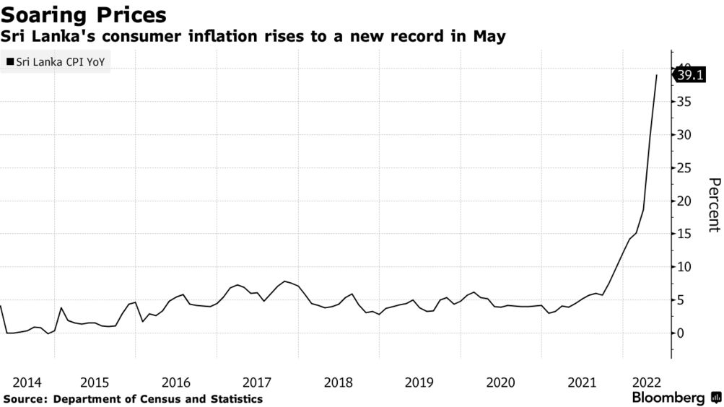
Figure 1: Inflation in Sri Lanka over the past months
(Source: Mayandy, 2022)

Social factors
People are likely to do fashion and purchase new clothes which cause to change in consumer behavior. Among low-income and middle earners, spending on goods and services has been reduced due to economic issues (Kankanamge, 2022). But among high-income earners in urban areas, people do engage in fashion.

Technological factors
On the emerging technological innovation trends, product life cycle length, new product development rate, and innovative features are focused. Due to the advancement of technology and globalization, e-commerce and online purchasing play an important role.

Environmental factors
Green products in relation to sustainability are encouraged by environmental factors in Sri Lanka by following global trends as Brandix is a leading export manufacturer company (Muthukumarana & Karunathilake, 2018). For the use of renewable energy sources, by the government, Attractive subsidies are offered.

Legal factors
To strengthen the employer's brand image, equality, Fair wages, health, equity, inclusion, and safety are ensured. Patents are protected from imitation with strict compliance and intellectual property laws. Through labor laws, employees’ rights are ensured.

Porters 5 Forces model
Porter's Five Forces Framework is considered a method of analysis to understand the environment of competition.

Threats of new entrants- low
Due to the higher entry barrier in the industry, the threats of new entrants are lower. As the unique experience is required by the industry to survive in the market with the brand name, Threats of new entrants are lower (Mendis, 2016). A higher level of Substantial, capital, physical resource, human capital, and investment is required to enter. Although there are 300-350 apparel manufacturers, MAS, Hirdaramani Apparel, Hela Clothing, and Star Garment Group are considered the top manufacturers in Sri Lanka (Welmilla, 2020).
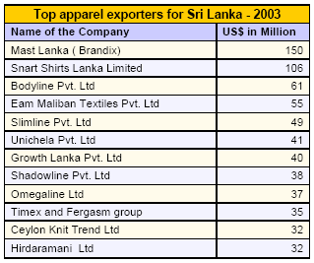
Figure 2: Top apparel exporters in Sri Lanka
(Source: Welmilla, 2020)

Bargaining Power of Buyers-high
High-quality products at affordable prices are expected by the consumers in a more customer base concentration. The power of the Buyer becomes high if there are fewer sellers (Wijesinghe & Mallawarachchi, 2019). With low switching costs, the bargaining power of buyers becomes higher. To push down prices, the buyers have options with other companies like MAS Holdings, Unichela, Hidramani, etc. Several alternative locations are there for buyers when purchasing hence bargaining power of buyers is higher.

Bargaining Power of Suppliers- High
The concentration of suppliers is higher than buyers When the cost to switch from one supplier in the apparel industry. The demands for their offered products become high when suppliers are few (Wijesinghe, 2019). Against Brandix Company, the suppliers' position is strengthening in that particular scenario. By the suppliers, High product differentiation is offered. Although there are several good trustworthy suppliers available internationally and domestically, switching to a new supplier is rather risky with the prevailing situation in Sri Lanka (Weeratunge & Herath).

The threat of substitutes- Medium
As alternative products are used by customers in the industries, a higher substitute threat can be examined. The substitute products’ switching costs are lower. By Substitute products, the same and superior quality is offered by the competition (Alwis & Silva, 2021). To the market, different products are offered in the industrial growing competition. The main products of the Company are Activewear, Casualwear, Sleepwear, Intimate wear, and loungewear. Such products can also be offered by competitors at the medium level (Alwis, 2021).

Rivalry among existing firms- High
There is strong pressure from the rival firms that are more tough competition. Although pricing and targeting strategies are low in such companies, consumer behavior is constantly changing (Weeratunge, 2021). They are more likely to engage in online purchasing through social media that can’t be ignored. By 800 thousand, the number of internet users in Sri Lanka increased between 2020 and 2021 (Silva, Dharmasiri & MPAA, 2022).
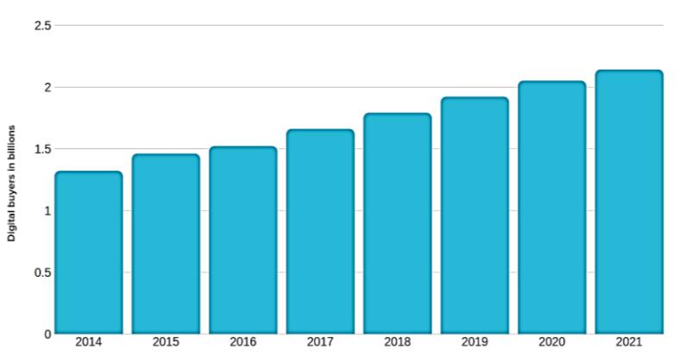
Figure 3: Internet users in Sri Lanka
(Source: Silva, 2022)

SWOT analysis

Strengths
Being one of the leading export Apparel manufacturers in Sri Lanka, countries like India, Bangladesh, and the United State of America are the main export destinations of Brandix (Nethmini & Ismail, 2019). From the government, the company is having strong support. In its Batticaloa branch, Net Zero Carbon status and the world's first LEED platinum certification have been achieved in the world (Lankeshwara, 2016). Being the main contributor to the GDP, it has 53 years of experience in the Apparel and Textile industry. The Company has domestic branches In Batticaloa, Mirigama, Seeduwa, and Pannala with more than 60,000 workforces (Lankeshwara, 2016).

Weakness
Management is too centralized in dominance which causes to having isolation of trade partners. On local buying agencies, the company somehow depends. In terms of its overseas markets, diversification is low (Wickremesinghe, 2012). To support the industry, there are insufficient bilateral trade agreements. Higher material cost causes to bear a higher expense to purchase from the foreign market as well. The main products of the Company are Activewear, Casualwear, Sleepwear, Intimate wear, and loungewear and due to the rivalry competition, the company’s diversification is lower when compared to others. As the company focuses mostly on the international market rather than domestic markets, local markets are out of hand (Wickremesinghe, 2012).

Opportunity
In New York, London, and Hong Kong, Brandix has marketing departments for different forms of activities such as pricing, distributing, advertising, selling, and branding (Silva, 2022). With GSP+, European and EU countries can be more focused. Pioneer Elastic India, Textured jersey Lanka, and ocean Lanka is the main suppliers of Brandix (Silva, 2022). Brandix as a socially responsible apparel manufacturer can be promoted to the world.

Threats
Costs of packaging and material are higher with hyperinflation in Sri Lanka. With the rising of local SMEs, the company might lose the domestic market more and more (Herath, 2015). There is strong pressure from the rival firms that are more tough competition. The bargaining of suppliers and buyers is higher in the Apparel industrial market. Transportation costs, rising labor costs, Cost of raw materials, Consumer Sentiment, and Higher Regulation are the main threats to the company at the current moment.

STP of Brandix Company

Segmentation
Psychographics, Demographics, Geography, and Behavioral segmentation are included in the Segmentation. Age, gender, income, education, ethnicity, marital status, size, occupation, etc are the Demographic factors (DeSarbo & Blanchard, 2017). By facilitating Activewear, Casualwear, Sleep, Intimatewear, and loungewear, both Upper middle-income Young female and male customers are targeted. Lifestyle, hobbies, attitudes, risk aversion, personality, and leadership traits are Psychographic factors (Romppanen, 2021). By going with the trends, Upper middle-income young girls and boys earners have their own fashion. This generation is more into social media and mobile. Geography refers to the region, Country rural location, metropolitan, and population density. Western province is focused as Upper middle-income earners are mostly in there. Brand loyalty, usage level, distribution channels, and benefits are Behavioral factors.
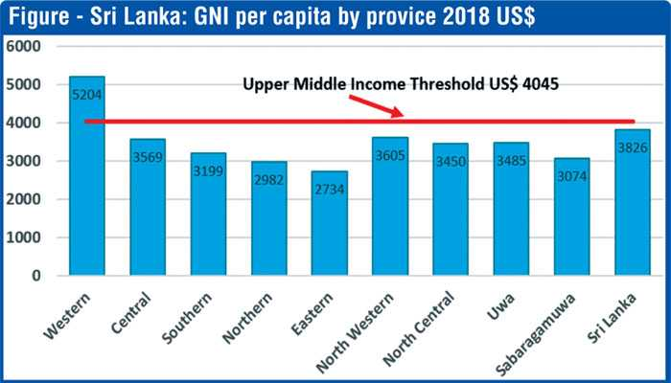
Figure 4: Income level distribution per province
(Source: Jayasinghe, Selvanathan & Selvanathan, 2018)

Targeting
Customer lifetime value is used to predict segment profitability and more opportunities can be expanded Through Digital marketing as the target generation is likely to engage in social media (Lynn, 2012). Changing consumer behavior can be effectively used by reviewing social media posts, shares, likes, reactions, tweets, etc. In Sri Lanka, 83.80% use Facebook, 650% on Pinterest, 6.18% on youtube, 0.73% on Instagram, and 0.25% on Linkedin that emphasizes the targeting of social media should be Facebook (Silva, Dharmasiri & MPAA, 2022).

Product positioning
For the purpose of analyzing company and product position in the market, Symbolic positioning, Functional positioning, and experiential positioning tools can be used by the Company (Rismawati, Wahyuni & Widodo, 2019). Through Symbolic positioning, the Brand image can be improved as the company targets to improve its brand through sales and marketing. Based on the geographical location, prices are changed.

Positioning map
A positioning map is used to understand the market positioning of Brandix Company among the competitors. Hydramani and Hela clothing has set their prices low but high-quality products are the outputs (Embuldeniya, 2015). MAS Holdings and Brandix company has set their prices at a higher level with high-quality products as well. Although JB Apparel has set higher prices its products are low in quality when compared to other company products (Embuldeniya, 2015). Star garments have low-quality products and also low prices have been set.
High Quality

Low price   High price


Low Quality
Figure 5: Positioning map
(Source: Author’s work,2022)

Marketing mix strategies

Product strategy
By launching brand new products and creating new versions of existing products, the product portfolio can be differentiated. To attract Young boys and girls, Activewear, Casualwear, Intimatewear, Sleep, and loungewear are focused on tackling changing consumer behavior (Pathirana & Yarime, 2018).

Price
By offering more discounts to increase revenue and sales of the company, affordable and reasonable are set especially during festival seasons. For wholesale buyers, credit facilities are provided for the purpose of achieving marketing goals (Pathirana, 2018). Through competitive pricing techniques, on payment terms, Flexible opportunities are given to the dealers. MAS Holdings and Brandix company has set their prices at a higher level with high-quality products as well (Rajapakshe, 2018). Geography refers to the region, Country rural location, metropolitan, and population density.

Place
The Company has domestic branches In Batticaloa, Mirigama, Seeduwa, and Pannala with more than 60,000 workforces. Western province is focused as Upper middle-income earners are mostly in there.

Promotions
Sponsorships, public relations, advertisements, and direct marketing are included in Promotions Brandix advertisements are mostly done through roadside banners, TV commercials, radio, paper advertisements, and magazines. Brandix’s t-shirts are sponsored for the Tokyo 2020 Olympics as a Presenting Partner. By Brandix, National Occupational Safety & Health Week was sponsored in 2015 (Muthukumarana, 2018). As the young generation is more likely to engage in social media marketing is used.

Conclusion
In the Fashion and apparel manufacturing industry, Brandix Apparel Limited plays a vital role. 317 Mn. Pieces are annually produced by generating 782 Mn. USD. More sales and revenue is can be generated by improving existing marketing.

Recommendations
As in Sri Lanka, Facebook is a highly used social app, marketing must be conducted through that to have more Facebook followers to get updates on newly launched products. As the targeted young girls and boys are highly into Facebook usage, more updates can be received. A global marketing plan must be developed and socialized through researching local markets, and key relationships. Tracking and adjusting in real-time is much important in the run of a campaign in multiple markets. Marketing messages can be personalized in-market segments. After identifying the possible customers, messages can be personalized effectively and efficiently. Further, local market needs must be understood and a collaborative approach must be developed. With local marketing teams, a close relationship can be established for a global model to work.

References
Amadoru, J., 2021. COVID-19 and Impact on the Economy in Sri Lankan Context. Available at SSRN 3911802.
De Alwis, A.M.L. and De Silva, N., 2022. INDUSTRY 4.0 BASED SUSTAINABLE MANUFACTURING MODEL FOR APPAREL INDUSTRY IN SRI LANKA. In Proceedings The 10th World Construction Symposium| June (p. 572).
DeSarbo, W.S., Blanchard, S.J. and Atalay, A.S., 2017. A new spatial classification methodology for simultaneous segmentation, targeting, and positioning (STP analysis) for marketing research. In Review of marketing research (pp. 75-103). Routledge.
Herath, R.S., 2015. Helpdesk and Incident Management System for Brandix i3 (Doctoral dissertation).
Kankanamge, C.E., 2022. Consumer Behavior in the Use and Disposal of Personal Electronics: a Case Study of University Students in Sri Lanka. Circular Economy and Sustainability, pp.1-18.
Lankeshwara, P., 2016. A study on the impact of workplace environment on employee’s performance: with reference to the Brandix Intimate Apparel-Awissawella. International Journal of Multidisciplinary Studies, 3(1).
Lynn, M., 2012. Segmenting and targeting your market: Strategies and limitations. The Cornell School of Hotel Administration on hospitality: Cutting edge thinking and practice, pp.351-369.
Mendis, M.V.S., 2016. Workplace design and job performance: A study of operational level employees in the apparel industry of Sri Lanka. International Journal of Scientific and Research Publications, 6(12), pp.148-153.
Muthukumarana, T.T., Karunathilake, H.P., Punchihewa, H.K.G., Manthilake, M.M.I.D. and Hewage, K.N., 2018. Life cycle environmental impacts of the apparel industry in Sri Lanka: Analysis of the energy sources. Journal of Cleaner Production, 172, pp.1346-1357.
Nethmini, L.D.P. and Ismail, M.B.M., 2019. Correlation between employee training programmes on employee performance with special reference to Brandix Company. International Journal on Global Business Management & Research, 8(1), pp.13-20.
Pathirana, S. and Yarime, M., 2018. Introducing energy efficient technologies in small-and medium-sized enterprises in the apparel industry: A case study of Sri Lanka. Journal of Cleaner Production, 178, pp.247-257.
Rajapaksha, D., 2022. EU Impact on Foreign Policy Formulation in Sri Lanka in the Post-War Period: With GSP+ trade concession. Available at SSRN 4027815.
Rajapakshe, W., 2018. An analysis of major factors affecting labor turnover in the apparel industry in Sri Lanka: Policy Alternations for Solving the Problem. International Journal of Academic Research in Economics and Management Sciences, 7(3), pp.214-231.
Risk, R., 2022. Inflation and growth. Hindu.
Rismawati, F.F., Wahyuni, S. and Widodo, J., 2019. Strategi Pemasaran STP (Segmenting, Targeting, Positioning) Larissa Aesthetic Center Cabang Jember. Jurnal Pendidikan Ekonomi: Jurnal Ilmiah Ilmu Pendidikan, Ilmu Ekonomi Dan Ilmu Sosial, 13(2), pp.68-72.
Romppanen, J.M., 2021. Segmentation, Targeting & Positioning (STP).
Weeratunge, R.D., Herath, R. and Weligamage, S., 2022. Green Management Orientation in the Supply Chain of the Apparel Industry. Sri Lanka Journal of Marketing, 8.
Wickremesinghe, R.N., 2012. Green Factory as a Competitive Strategy: The Case of Brandix.
Wijesinghe, D. and Mallawarachchi, H., 2019. A systematic approach for maintenance performance measurement: apparel industry in Sri Lanka. Journal of Quality in Maintenance Engineering.

