How does Instagram impact consumer behaviour when buying a product or service from small businesses.

By Samuel Charles Dymock-Brown
Supervised by Dr Hughes
Date: 05/12/2020
Word Count: 7828


DECLARATION
This work has not previously been accepted in substance for any degree and is not being concurrently submitted in candidature for any degree.
Signed: Samuel Charles Dymock-Brown
Date: 04/12/20
STATEMENT 1
This dissertation is being submitted in partial fulfilment of the requirements for the degree of BA.
Signed: Samuel Charles Dymock-Brown
Date: 04/12/20
STATEMENT 2
This dissertation is the result of my own work/investigation, except where otherwise stated. Other sources are acknowledged by footnotes giving explicit references. A bibliography is appended.
Signed: Samuel Charles Dymock-Brown
Date: 04/12/20
STATEMENT 3
I hereby give consent for my dissertation, if accepted, to be available for photocopying and for interlibrary loan, and for the title and summary to be made available to outside organisations.
Signed: Samuel Charles Dymock-Brown
Date: 04/12/20
STATEMENT 4
I hereby give consent for my dissertation, if accepted, to be available on the university’s IT system to those who have consent to use the system.
Signed: Samuel Charles Dymock-Brown
Date: 04/12/20

Acknowledgments

First of all, I would like to express my gratitude to Trinity Saint David University of Wales and the staff who have been part of my journey for the past three years. A big thank you to Dr Gareth Hughes, my supervisor, who has been compassionate, inspiring and incredibly helpful in the writing process of this study. For me to complete my degree, the insights you shared with me as well as the advice and encouragement you gave became the number one aspect.
I would also like to take a moment to thank Jack Steele, Nia James, Jessica Rees, and Cameron Carlson, my colleagues, for always being there for me when I need help. Thank you for bringing a smile to my face when I need it and for smiling at my brilliant jokes while I cheer you all up. You all encouraged me to do my best during the final year of our degree, and I appreciate that very much. Finally, I would like to thank my family and my girlfriend Lauren Rowley, both of whom have been of immense support to me throughout the completion of this degree, whether it be reading through tasks or inspiring me to do my job. I thank each and every one of you, and I will always be thankful for that.

Abstract
This study was carried out in part for a BA Marketing Management undergraduate degree. The researcher used different data that included the examined primary and secondary data. The data collected has included consumer buying behaviour and purchase decisions through using Instagram. A literature review was undertaken by the researcher covering purchase behaviour, marketing as well as social media with Instagram being the main focus. When constructing the primary research for this dissertation, the literature review findings were taken into account. An online questionnaire was distributed to 44 respondents, mainly to users of social media with an interest in the field of study. The results were as follows: 75% of participants used Instagram for most of their time on social media. The study also revealed that 52.3% of participants purchase behaviour has been affected by Instagram influencers. Lastly, the researcher found that 75% of respondents believe that Instagram marketing has the biggest effect on their purchase behaviour when the small business being promoted is from the fashion sector.
Table of Contents
Chapter 1 7
1.0 Introduction 7
1.1 Rational 7
1.2 Aims and Objectives 7
1.3 Research 7
Chapter 2 9
2.0 Chapter Overview 9
2.1 What is marketing? 9
2.2 What is social media? 10
2.3 How Consumer Behaviour Can Be Impacted by Social Media 11
2.4 How Can Consumer Behaviour Be Changed Over Time? 12
2.5 Do Influencers Impact Consumer Behaviour? 14
Chapter 3 15
3.0 Chapter Overview 15
3.1 Research Definition 15
3.2 Research Onion 15
3.2.1 Research Philosophy 16
3.2.2 Research Approach 17
3.2.3 Method Choice 18
3.2.4 Research Strategy 18
3.2.5 Time Horizon 18
3.2.6 Collection Techniques and Procedures 19
3.2.7. Sampling 20
3.2.8 Reliability and Validity 20
3.2.9 Limitations 21
3.2.10 Ethical Issues 21
Chapter 4 22
4.0 Chapter Overview 22
4.1.1 Age 23
4.1.2 Gender 23
4.1.3 Country of Origin 23
4.2.1 Hours Spent on Social Media 24
4.2.2 Which Social Platforms are used 24
4.2.3 Social Media Influencers 25
4.3 Section 3 26
4.3.1 Have Social Media and Influencers Affected Your Buying Behaviour 26
4.3.2 To What Extent Does Instagram’s Influencers Affect Purchasing 27
4.3.3 Which Industry do Influencers have the highest influence 28
4.3.4 When Was Your Last Purchase Made through Instagram 28
Chapter 5 29
5.0 Chapter Overview 29
5.1 Summary of Main Findings 29
5.2 Aims and Objectives 29
5.2.1 Objective 1 30
5.2.2 Objective 2 30
5.2.3 Objective 3 30
5.2.4 Objective 4 30
5.3 Implications of Research 31
5.4 Limitations 31
5.5 Recommendations 31

Chapter 1

Introduction
This thesis aims to analyse the effect Instagram has on consumer buying behaviour when purchasing from a small business. There have been previous studies on this theme, however, mostly with a focus on social media in general with online businesses.

1.1 Rational
The researcher has found a lack of scholarly literature covering a detailed understanding of customer spending habits and purchase choices when purchasing goods through Instagram from small businesses. Studies have also demonstrated how there are several variables that can impact the desire of a customer when buying goods.
There is little research literature about what can manipulate customer purchasing behaviour and whether brand messaging as well as social media channels potentially have a significant impact on buying decisions by consumers. As a consequence, this study would seek to define the core rationale behind my Instagram ads for customer decisions.

1.2 Aims and Objectives
The aim of this thesis is to investigate how Instagram impacts consumer buying behaviour when making purchases from small businesses.
- To review a variety of literature with specific focus on Instagram and how it affects consumer behaviour in the small business sector.
- Develop research methods to enable the collection and analysis of data to support the research aim.
- Synthesise primary and secondary research materials in order to fulfil the aim of the research.
- Draw conclusions which are based on the discussion and offer recommendations for future research on this theme.

1.3 Research
The investigator will perform an online survey using the Google Forms platform. The questionnaire will be circulated mostly to participants from Millennials and Generation Z and others who regularly use social media. As the probability of having a larger number of participants is more possible, the use of a survey approach is seen as the suitable data collection method for this thesis. A questionnaire would help the researcher to gain access to a greater number of respondents who can explain customer motivations and illustrate their luxury fashion item buying decisions.
Previous scholarly literature on the chosen subject for this thesis will be discussed in the following chapter and will further be used to support the study and findings carried out in this thesis.

Chapter 2
Literature Review

2.0 Chapter Overview
Chapter 2 will hold key literature which is linked to how Instagram is used by small businesses and if the social media platform has an effect on their trade. A critical review of academic journals and reports as well as relevant articles will be used to allow a deeper discussion into the impact that Instagram has on consumer behaviour in the small business sector.

With Instagram being the second most popular social media platform (Clement, 2020), this shows that there is an opportunity that cannot be missed by small businesses wishing to attract a new consumer base. All of the behaviours in which Instagram can have an impact on will be covered and ultimately, they will be applied to the research of consumer behaviour within the small business sector.
- To review a variety of literature with specific focus on Instagram and how it affects consumer behaviour in the small business sector.

2.1 What is marketing?
Marketing is arguably the most important sector within a successful business. If a business is selling products or services, the marketing needs to be to an extremely good in order to attract consumers. With many different businesses and services around the world, this proves that there are a number of marketing techniques which suit every sector. This also comes with many different definitions of marketing, due to this, the following definition given by Kotler, will be used as the working definition for this thesis. Kotler states within his marketing model that marketing is,

“the science and art of exploring, creating, and delivering value to satisfy the needs of a target market at a profit. Marketing identifies unfulfilled needs and desires. It defines, measures and quantifies the size of the identified market and the profit potential. It pinpoints which segments the company is capable of serving best and it designs and promotes the appropriate products and services.” (Kotler, 2010)

Kotler clearly states within his definition that marketing is highly dependent on a creative mindset by creating a product or service to offer a demand. Although marketing has one overall definition, there are still so many different types of marketing which work differently for different businesses, examples of this include content marketing and social media marketing.
Content marketing and social media marketing tend to go hand in hand with content being posted through social media to attract new clientele by showing them exactly what the product or service has to offer. The working definition for content marketing is as follows,

“Content marketing is a strategic marketing approach focused on creating and distributing valuable, relevant, and consistent content to attract and retain a clearly defined audience — and, ultimately, to drive profitable customer action.” (Rowley, 2008)

2.2 What is social media?
Social media has become part of everyone’s everyday life over the past few years with new platforms being introduced every year. Social media users are now spending an average of two hours and twenty-four minutes per day networking across eight separate social media platforms (Chaffey, 2020). With social media platforms being free and widely accessible to anyone with an internet access it is the perfect place for small business to enable growth and free marketing. Although Facebook has the highest user figures (2020), Instagram is widely used as the key social media platform to promote a product or service due to the high engagement which the platform allows (Neti, 2011).

In 2020, Instagram has over one billion users visit the social media platform each month with over five hundred million users using the stories function each day. With sixty three percent of users logging onto the platform daily, the average time spent scrolling is twenty-eight minutes with over two hundred million users visiting a business-related page whilst they are online (Instagram, 2020). These statistics show why all businesses need to use Instagram to their advantage as there could be a whole new market that is being missed by not promoting their business through the platform. Instagram also offer a paid advertisement option when posting from a business account, the potential advertising reach depending on the criteria you select is a massive eight hundred and forty-three million users (Hootsuite, 2020). These are astonishing figures which small businesses should not be overlooking as even a new account is able to promote their business through the app to a selected audience enhancing the ability to find a new consumer base.

With Instagram’s main purpose being to share photos and videos, this is perfect for small businesses who are highly skilled at their trade. Content marketing is what is needed by these businesses, so a wider audience has the ability to view the work that is being done at a high level of quality. As well as showing a wide array of work, content marketing will enable the business to establish and maintain a successful brand identity which the audience will connect with (Sherman, 2019).

2.3 How Consumer Behaviour Can Be Impacted by Social Media
Consumer behaviour looks at many facets of how the marketing of a company can affect the behaviour of a consumer to buy a product or service. The working description for this study would be as follows, with customer behaviour spanning various points.

“Consumer behaviour is the study of how people make decisions about what they buy, want, need, or act in regards to a product, service, or company.” (Solomon, 2012)

Determining customer behaviour and how marketers may have a positive effect on a future consumer to suit their product or service is critical. As already mentioned, social media is a big part of the population, with Instagram being the most engaging medium for corporations to use. They will adhere to how their prospective clients operate like many individuals looking for a small company on Instagram by using Instagram companies before they go ahead with an order. (Virtanen, 2017).

Marketing techniques such as advertisement and promotion have been revolutionised by the peculiar features of social media and its immense popularity. Social networking has also affected customer behaviour from the collection of knowledge to post-purchase behaviour, such as declarations of disappointment or attitudes regarding a product or company (Hanna, 2011). Compared to other conventional contact platforms, the far higher degree of social media productivity led market executives to state that businesses would invest in Facebook, Twitter, Myspace, and others in order to thrive in online environments. According to previous research from Internet Retailer, a 2009 report found that a vast number of the top 100 businesses have a presence on Facebook (79 percent), Twitter (69 percent) or both (59 percent). A Deloitte Touche USA report showed that 62 percent of US users read online reviews from customers and 98 percent of them find these reviews credible enough; 80 percent of these reviews are accurate enough (Pookulangaran, 2011). Many consumers made it clear that their shopping decisions were influenced by the reading of these reviews.

Previous studies also found that a small volume of unfavourable evidence from a few blogs may have a huge effect on customer perceptions. Palmer (1996) said that consumers have an inherent desire for an intimate bond for goods they purchase that are high involvement. Complementary and replaceable methods for this bonding are brand creation and partnership development. For the business, the relationship between the brand and the customer is very significant and reinforcing it contributes to loyalty.

2.4 How Can Consumer Behaviour Be Changed Over Time?
Consumer behaviour is an aspect of customers that Companies are constantly seeking to change their goods or services to accommodate them. Consumer behaviour is more than just the goods or service they offer, it is not just through digital, TV ads, advertisements, or other conventional ways that a company affects this. In order to have an impression on consumer emotions, companies need to advertise themselves in the right manner by talking to election campaigns, social causes and everything else that influences consumers to make instinctive, unconscious choices (McKinsey & Company, 2020).

Buyers are incredibly busy in today's world and don't have patience or resources in a supermarket or online to consider the merits of one product against another. They grab a favourite or press it and carry on. Instinctively, an estimated 90 percent of buying decisions are made. Businesses need to create a favourable image that touches the consumer on a subconscious level in order to get customers to prefer your brand. This implies exploring the pictures and storeys in their heads that generate meaningful connections with your brand being the subconscious drivers (Dunwiddie, 2019). The brand needs to think about what ideas, photos, memories and emotions will jump into their consumers heads the moment people look at your brand.

Emotional advantages only work if they are embedded in the experience with the commodity. But it's no wonder that a lot of Super Bowl advertisements don't contribute to the kind of spike you would expect from revenue. The point should be for customers to feel a good interaction with a brand, not for feelings to be expressed by brands. Emotion is the result, the sensation of the experience of a consumer, not really the message itself. And the emotional connexion emerges from tapping into optimistic, common concepts in the memories of customers. A good example of this is a Super Bowl commercial for M&M's that has been rightfully called the" most entertaining ad. M&M's reached into a perfect stored memory of superior chocolate-liquid, rich, enveloping-by producing the impression of Danny Devito blissfully lolling around in a pool of melting chocolate. This raised the image of M&M by customers and related the feeling of joy to the brand itself (Morabito, 2018).

Discovering subconscious challenges and drivers will help you alter the actions of customers regardless of where they fall in every demographic breakdown. Unfortunately, these days, firms spend time and resources over-segmenting their markets on the grounds of the illusion that a more targeted marketing strategy would be more effective. Marketers should question how similar customers are, not how different they are. People are much more alike than we think they are. Virtually all consumers have identical brand associations, no matter their demographics or perceptions. To boost attitudes, they respond favourably to the same remedies. Relevant codes and signals circumvent the aware, cynical brain and, at a subconscious stage, create optimistic brand associations. When people say they have a strong "gut feeling" about something, this is what actually happens.

2.5 Do Influencers Impact Consumer Behaviour?
An influencer can be identified through two different possessions. An influencer is someone who has,
“the power to affect the purchasing decisions of others because of his or her authority, knowledge, position, or relationship with his or her audience.”
Or,
“a following in a distinct niche, with whom he or she actively engages. The size of the following depends on the size of his/her topic of the niche.”

It is important to remember that these people are not just marketing devices, but rather properties of social partnerships in which brands may work together to achieve their marketing goals. (Cobain, 2020)

We are seeing social media continue growing in significance throughout the last decade. 3.484 billion people regularly use social media, which is 45 percent of the world 's population, according to the January 2019, We Are Social survey (2019). These individuals ultimately look to social media influencers to direct them in their decision making.

Social media influencers include individuals who have established on a single subject a reputation for their knowledge and experience. On their favourite social media platforms which tends to be Instagram, they make daily posts about the subject and create wide follow-ups of passionate, interested individuals who pay careful attention to their opinions. Brands love influencers on social media because they can drive trends and inspire their fans to purchase goods that they support.

According to MuseFind (2019), 92 percent of buyers value influencers more than advertisements and celebrity endorsements, looking at the numbers, while according to Variety (2015), teenagers view YouTube stars as 17 times more entertaining and 11 times more outstanding than normal stars.

Chapter 3
Methodology

3.0 Chapter Overview
The most conductive approaches to examine and analyse how Instagram affects customer behaviour when making a transaction from small companies will be found in this chapter of the study.
The target addressed by this chapter is the following:
- Develop research methods to enable the collection and analysis of data to support the research aim.

3.1 Research Definition
Kothari (2004) claims that by applying experimental procedures, the object of science is to reveal answers to questions with the number one goal of discovering the truth that is secret and has not yet been found. It is possible to describe research unique to a market context as:
“any systematic attempt at collecting and interpreting data and evidence in order to inform thinking, decisions and/or actions in relation to an issue of interest to an organisation and/or its stakeholders” (Price, 2009)

3.2 Research Onion
Primary research will be performed within this paper, which will be thoroughly discussed using the Research Onion created by Saunders (2009) to establish the most effective research approach, data collection process, alongside data analysis techniques. For a Research Onion diagram, see figure 1-1 below.
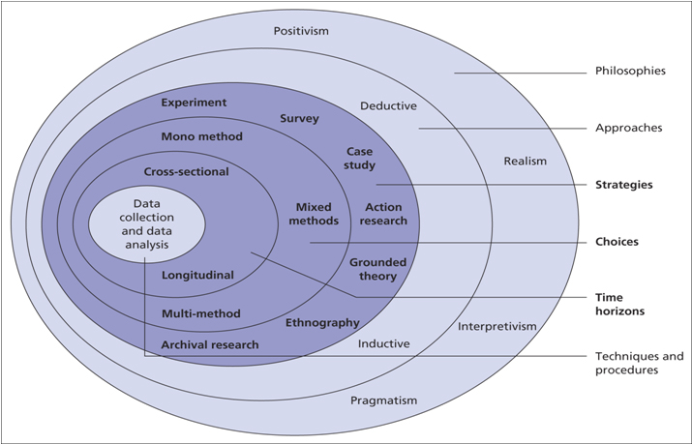
The Research Onion will be used as a guide to enable a coherent chapter, so it is possible to describe the research for this thesis systematically and thoroughly. For a description of the methods that will be included in this analysis of each layer of the research onion, see Table 1-1 below, which will be clarified throughout the rest of Chapter 3.
Figure 1-1: Research Onion Diagram

Layer | Approach Taken
Philosophy | Positivism
Approach | Deductive
Method | Mono-Method
Strategy | Survey
Time Horizon | Cross-sectional
Technique and Procedure | Questionnaire
Table 1-1: Research Onion Approaches Being Taken

3.2.1 Research Philosophy
The philosophy of research deals with the origins, existence and creation of learned knowledge. The philosophy of research is about how data on a given subject can be processed, evaluated and used. The philosophy of research is a huge subject of study, which will take up the majority of this chapter. A quick description of the ontological and epistemological roles will be given due to the limitations of this study to allow a clearer explanation of the positivism paradigm to this research. Ontology can be described as "the science or research of being" in business analysis and it deals with the essence of truth. A fundamental question of whether social entities can be viewed as factual or subjective is correlated with ontology. This thesis would be done by means of a 'objectivist' prism, demonstrating that there is a real target. Epistemology, on the other hand, is used to explain how we perceive the meaning of reality and is specifically concerned with the existence of human knowledge (Crossan, 2003).

The ontological and epistemological role of the theory has now been evolved to discuss the more practical fields of the philosophy of science. The prevailing science paradigms are these two fields, the paradigms of positivism and interpretivism. Positivism focuses on quantifiable results that apply to mathematical analyses. It is to be noted that,

“as a philosophy, positivism is in accordance with the empiricist view that knowledge stems from human experience. It has an atomistic, ontological view of the world as comprising discrete, observable elements and events that interact in an observable, determined and regular manner”

Interpretivism, though, undermines Collins' view of fact through human perceptions alone (Revise Sociology, 2019) Positivism, also referred to as quantitative analysis, means that through observation and experimentation, real understanding can be understood. It also reflects the suggestion that the researcher is autonomous, indicating no communication with the people participating in the sample. The author of this research shall follow the model of positivism for this analysis since it is perceived to be the most fitting approach for the subject selected. A survey that gathers vast volumes of quantitative data, which for this analysis would be the only form of data collection.

3.2.2 Research Approach
The writer of this dissertation has chosen to take a deductive approach.
In quantitative analysis, a deductive research approach is typically used and is structured to validate or nullify a hypothesis or research query. According to Wilson (2010), it is a technique used in the development of a theory-based hypothesis that already exists, accompanied by the development of a testing approach that will evaluate the hypothesis, most usually with a broad sample of interest from the population.
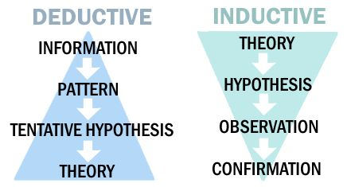
Figure 2-1: Deductive & Inductive Research Approach

As shown in figure 2-1, a deductive analysis approach is typically used for particular experiments where the hypothesis is checked against observations, while inference starts with observations and tries to locate a pattern within them.

3.2.3 Method Choice
Within this analysis, the researcher chose to obtain primary data through using one technique being questionnaires, which is a mono-method. The rationale behind this choice is that research with mixed approaches seem to become very complicated and time-consuming when all facets of the research need proper planning to be explained.

3.2.4 Research Strategy
The following is a concept for a research approach,
“Research approaches are plans and the procedures for research. that span the steps from broad assumptions to detailed methods of data collection, analysis, and interpretation.” (Lincoln, 2011)

One of the most relevant fields is using the best research methods in order to identify issues that need to be explored. If an issue has been established, it is important to consider and refine the study by determining the correct research methodology.
A survey analysis technique is synonymous with deductive research and is typically compiled with questionnaires or interviews. This study will use a survey as the medium of primary research owing to the positivism technique usually using a survey approach, which will be further evaluated and applied for a wider population.

3.2.5 Time Horizon
The time horizon aspect of the research onion is the concluding layer of the study which corresponds to the time needed for the analysis to be carried out. The whole layer of the onion provides two study methods, short-term cross-sectional or long-term longitudinal. Typically, cross-sectional analyses are constrained and reflect evidence over a brief span of time. As this study is constrained in time, the author of this study decided to perform a cross-sectional study because of the approach that has the greatest potential in the given time period to fulfil all of the study's goals.

3.2.6 Collection Techniques and Procedures

3.2.6.1 Data Collection
Depending on the study query, the techniques used during the data collection differ. Because qualitative data is a source of statistical information and is typically gathered in studies regarding positivism, surveys appear to be the most popular form of data collection for such studies. There are many ways where only survey data can be obtained while conducting an analysis of positivism, including questionnaires and interviews. For the intent of this thesis, all data gathered can only be quantitative using a sample if the same questions are posed by all participants to eliminate unintended bias in reaction to the questionnaire structure.

3.2.6.2 Questionnaire Design
There should be a closed-ended approach to positivism when designing questionnaires. When gathering detailed and predictive data, this method is most successful.
Since it is the most suitable approach to collecting the primary data for this analysis, a survey method has been picked.
In order to avoid any confusion or misunderstandings, each question here in this survey will be written in a logical fashion. The questionnaire shall consist of 10 questions outlined in the literature review, spanning from demographics to subjects. For specific replies to be given, the questions asked will be in a sealed format. The author is able to collect data with simplicity through using online surveys, as well as simply build the evidence. The expenses for this research approach are small and using social media platforms to attract a broad audience.

3.2.6.3 Pilot Study
A pilot study corresponds to a limited, experimental version of a study which is a technique used in planning for the penultimate testing to pre-test a particular research instrument. The pilot analysis is used until the study is able to be carried out to discover possible flaws in architecture or to expose any mistake.
In attempt to acquire a critical opinion on the survey and to help with the identification of possible concerns, a pilot questionnaire would be provided to a university lecturer.

3.2.7. Sampling
In statistics, to approximate the features of the total population, sampling is a collection of a sample of individuals from within a statistical community. A population may also be referred to as having all entities or things with the attributes one wants to understand, whereas sampling is the practise about using a single category to be studied in terms of features and values. The number one goal of generating a sample that is represented by a wider population is purposive sampling, which is also known as decision, selective or subjective sampling.
The selection for this analysis would consist of individuals over the age of eighteen attributable to them being familiar regarding answering questionnaires as well as the research subject of Instagram. With the support of social media sites, the questionnaire will be circulated online. The study would strive for a sample size of one hundred people, considering the time constraints for this thesis.

3.2.7.1 Analysis
It will be processed after all data has been obtained, and using the software offered by Google Forms. This would allow the researcher to interpret the details in a clearer way when using the tools, as well as to provide a deeper analysis.

3.2.8 Reliability and Validity
The required ideas have to be provided to ensure high standards of validity and reliability for any study to yield practical results. For both reliability and authenticity, there are several meanings. The foregoing definitions would then be used to protect the functions of reliability and authenticity.
In terms of quantitative analysis, reliability can be argued against since it is a possible issue. Bryman suggests that research within the framework of positivism would not show strong stability standards since, to the point that, it will create difficulties with the calculation process. While study with a high degree of credibility has been produced by a positivist methodology, it should be noted that quantitative research yields lower levels of validity relative to qualitative research.
This is because consistency is associated with objective analysis as well as the potential to replicate the research that would produce reliable findings over time.
This review would guarantee that the questionnaire is well designed and thoroughly piloted to limit any complications as far as possible with respect to the validity of the sample.

3.2.9 Limitations
This study is subject to the constraints of all undergraduate research, since the investigation is controlled by a tight deadline. This requires restricted time.
Inside the analysis, there are still several problems that may occur.
Sample bias-The possible problem of sample bias is related to the dissemination of the questionnaire through social media. This survey could not be a fair reflection of the population at large due to the self-selecting applicants, which may affect the findings.
It should also be remembered that there is very little published in this field of the subject. While this raises the possibility of a new academic contribution to the subject field, it is a concern that there are too few hypotheses and concepts from which science can be created. Because of this, the report was written in more observational words.

3.2.10 Ethical Issues
Ethical issues will be taken into account for this review, as all applicants above the age of 18 will participate in the survey. Participants will still remain anonymous and will keep secret all data gathered. Both the rules and regulations of the university will be complying with, and all data will only be interpreted by the researcher and the university (UWTSD) that facilitates this study. See Appendix B for the acceptance, prior to study, of the ethics form approved by the university.

Chapter 4
Data Analysis

4.0 Chapter Overview
This chapter provides an overview of the primary research data of the researcher that has been obtained by circulating an online questionnaire focused on customer behaviour, specifically Instagram, by using social media. There was a sample of 44 respondents that was sadly below the target but is a number for which it is possible to function and evaluate well. As the timeframe of this study is not limitless, the rationale behind falling short on respondents was due to just pushing the questionnaire via Facebook.
In order to achieve the following goal, the results obtained through the questionnaire will be evaluated and interpreted;
- Synthesise primary and secondary research materials in order to fulfil the aim of the research.
It is important to remember that the primary data displayed will be shown in a percentage to one decimal place format. The questionnaire would be arranged into three parts for the investigator to have identifiable purposes: Section 1, Q1-3 are used to understand the participants' various demographics; Section 2, Q4-9 are to find out how respondents use their social media; Section 3, Q10-16 have been crafted to find how social media can affect the respondents purchase behaviour.

4.1 Section 1

4.1.1 Age
Question one asked the participants in the questionnaire to determine what age group they belong to. The largest sample that was described by 70.5% was the 18-25-year-old participants, followed by 26-35-year olds and the over 46 category, both with 11.4%.
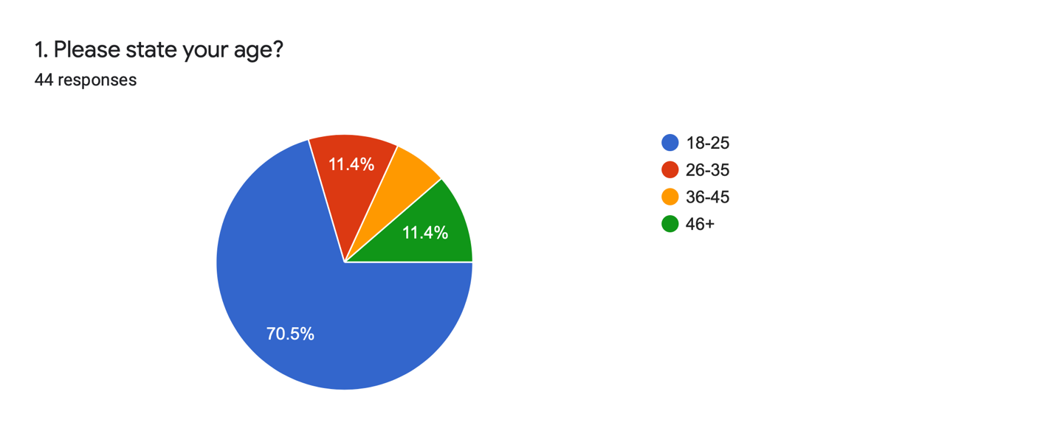
Figure 3-1: Chart Showing Age of Participants

4.1.2 Gender
Question two requested the questionnaire's respondents to define their gender. The findings which have been taken from this revealed that 61.4% of participants identified as female, 36.4% identified as male with 2.3% identifying as “other”.

4.1.3 Country of Origin
Question three was developed to identify which areas of the world the recipients were from and to see if there are any differences in the ways in which different cultures would approach social media. From the primary research conducted, the researcher found that 100% of participants originated from the United Kingdom.

4.2 Section 2

4.2.1 Hours Spent on Social Media
Question 4 had the intention of finding the average time spent on social media throughout all of the participants. A small, 9.1% of participants shared that they spent under 60 minutes logged onto social media throughout their day. The most frequent time period in which participants answered with was 3-6 hours of social media activity throughout the day. This comes with people using social media for 1-3 hours very close behind with 38.6% of participants providing this answer. Shockingly, 6.8% of the respondents admitted to using social media for over 9 hours a day, although their occupation isn’t taken into consideration.
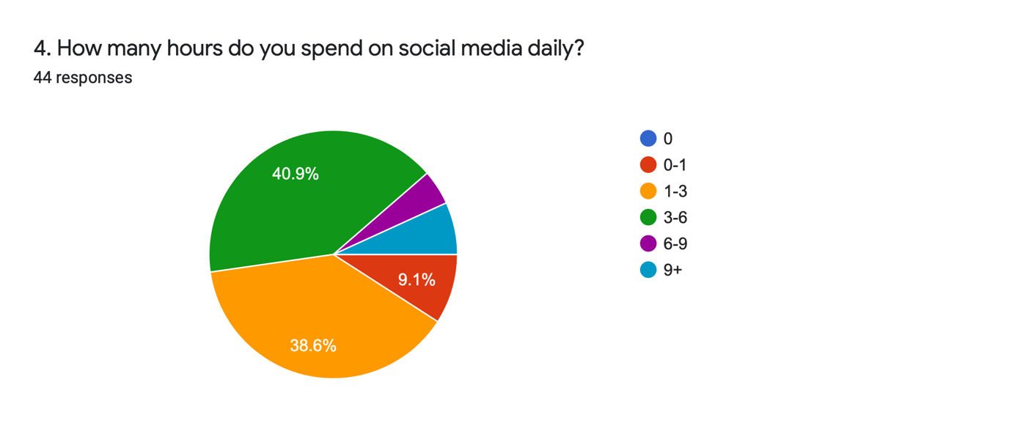
Figure 3-2: Chart of Time Spent on Social Media

4.2.2 Which Social Platforms are used
Question 5 had the intentions of finding out which social platforms the participants used, this was to just get an understanding of how many people used Instagram and how they used their time on social media. The results show that 97.7% of participants use Facebook with a close 93.2% using Instagram, this shows that most participants use these two social media channels. 13.8% of people use TikTok which is the lowest used platform for the participants with twitter and snapchat holding the mid-ground at 63.6% and 68.2%.

Question 6 then goes on to ask which is the most frequently used social platform with Instagram taking the top step with 75% of respondents claiming that it is their most frequently used platform. Instagram being the most used platform was perfect for the researcher due to the overall path being taken throughout this project.
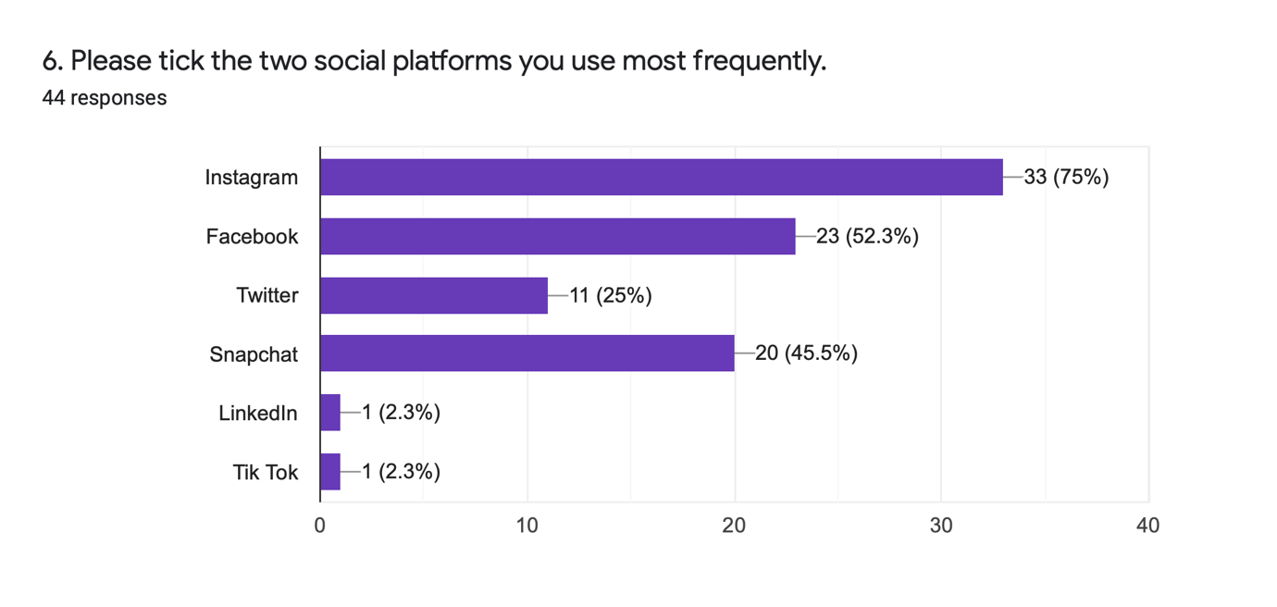
Figure 3-3: Graph Showing Most Frequently Used Social Platforms

4.2.3 Social Media Influencers
From the respondents that answered question 7, 68.2% of them admitted to following an influencer, micro celebrity or and other form of influencer on social media. This shows that the respondents with this answer can be targeted through influencer marketing which is very popular nowadays. Only 25% of participants responded with no, which sits about right with the age of the respondents.

To the respondents who do follow influencers, 45.7% of them disclosing the fact that they follow over 15 influencers. This shows that the respondents do look at how celebrities promote their endorsements and don’t have anything against it. On the other side of the scale, 31.4% of respondents who follow an influencer only follow 1-3 which shows that they have a connection to the low number of influencers they follow.
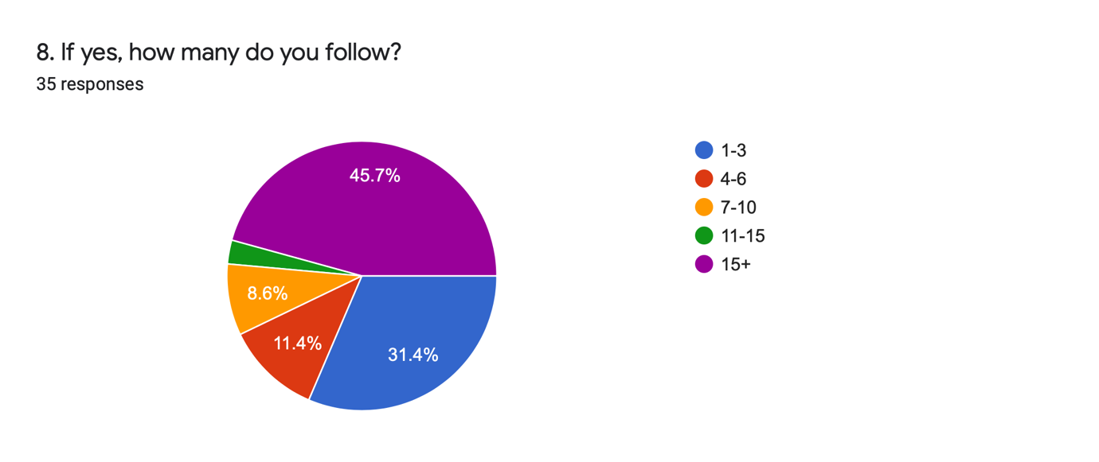
Figure 4-4: Chart of How Many Respondents Follow Influencers
Question 9, came with a response which was 100% one sided with the question being, “Do the influencers you follow endorse any products or services?”. Every respondent answered
Yes, showing that almost every influencer has done some sort of brand deal or endorsement.

4.3 Section 3

4.3.1 Have Social Media and Influencers Affected Your Buying Behaviour
Through question 10-12, the researcher intends to find how the respondents purchasing behaviour has been impacted by social media and influencers throughout Instagram. When the participants were asked if their purchase behaviour had been affected by social media posts of an influencer in the past, 36.4% said yes, that their decisions have been impacted. Whereas 47.7% said that they have never had their decisions impacted by in influencer post. Small businesses will look at the 36.4% who have had their behaviours altered by influencers and they will see a massive opportunity to push their business through influencers on the Instagram platform. The reasons with the most responses for the respondents listening to an influencers opinion on a product is due to the trustworthiness and due to them usually being the trend setters in most industries. Businesses will look at this and see that they have a big influence into any market that they are in.

4.3.2 To What Extent Does Instagram’s Influencers Affect Purchasing
Question 14 asks the respondents to respond with the extent that Instagram influencers affect their purchasing. The majority of participants responded with a little or none at all, with those answers taking up 31.8% and 38.6% of the total responses. Even though the figure is a high percentage, the remaining percentage of people who are impacted by Instagram influencers is also very high as it is roughly 1 in 4 people who do make purchases due to seeing influencers use a product or service.
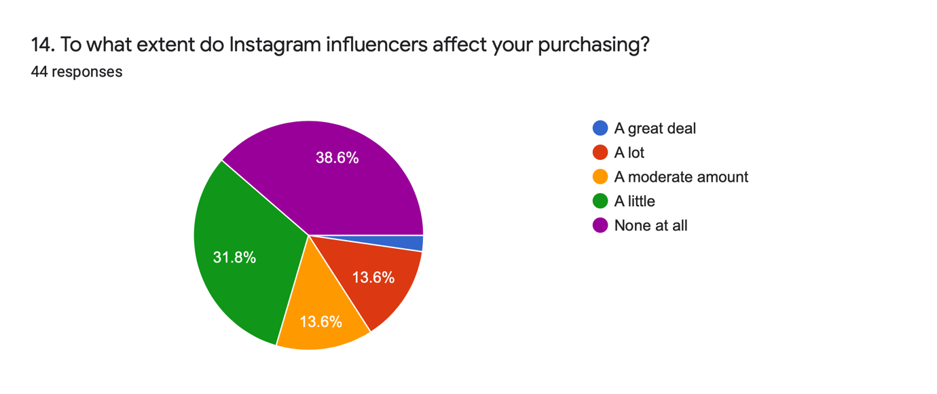
Figure 3-5: Chart Showing the Affect Instagram Influencers Have on Purchasing

4.3.3 Which Industry do Influencers have the highest influence
With the focus on this thesis being small businesses, these small start-ups can see how beneficial influencers can be. Question 15 shows the best industry to use Instagram influencer marketing in. As can be seen in the chart below 75% of respondents believe Instagram influencers have the greatest power within the fashion industry. This figure now shows why most start up clothing brands use an Instagram influencer to promote the business.
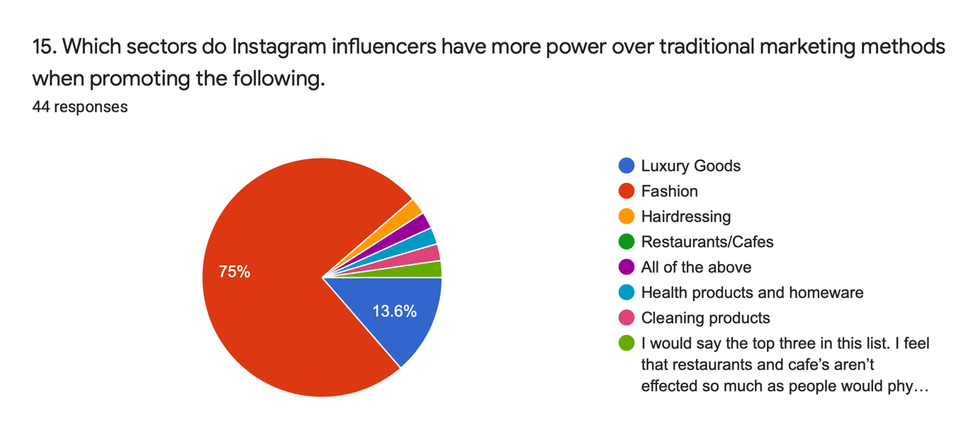
Figure 3-6: Chart Showing Which Sectors Influencers Have the Greatest Influence Within

4.3.4 When Was Your Last Purchase Made through Instagram
From the results gathered from question 16, it shows that 40.9% of respondents have never made a purchase from any sort of Instagram marketing. 18.2% of respondents answered that they had made a purchase within the last week which shows that Instagram marketing does have a strong effect on its users. Overall 59.1% of participants had made a purchase through Instagram throughout the last year which is a great figure to see from a business point of view, especially for small businesses as Instagram is a free form of marketing.

Chapter 5
Conclusion

5.0 Chapter Overview
This final chapter will address and determine whether the dissertation's first three objectives have been accomplished. The shortcomings and consequences of the research will also be considered and potential guidelines for future studies will be discussed.
Finally, the final objective of this study will be reached in chapter five;
- Draw conclusions which are based on the discussion and offer recommendations for future research on this theme.

5.1 Summary of Main Findings
The research question was encouraged by the interest of how Instagram has an impact on consumer buying behaviour when making a purchase from small businesses. The data which was collected using primary research methods was analysed to gain a deeper understanding of the chosen area of study. The interpretation of the quantitative data obtained for this report showed important observations in support of the topics discussed in the literature review.
Primarily, these findings show that social media, especially Instagram is a massive part of people’s lives and the influencers that many follow, have an impact on their purchase decisions. Palmer (1996) said that consumers have an inherent desire for an intimate bond for goods they purchase that are high involvement. From the questionnaire, it can be seen that the participants who purchase goods through Instagram marketing have that same outlook due to the influencers creating that intimate bond to many products.
Secondly, Instagram is shown to be the most used social media platform by all participants backing the point of Instagram being the most used social platform worldwide.
Finally, the primary research helped identify the best industry to use Instagram influencers as their form of marketing. The fashion industry has the highest ability to impact consumer behaviour with many people looking up to influencers as inspiration for their fashion sense.

5.2 Aims and Objectives
The aim of this thesis was to investigate how Instagram impacts consumer buying behaviour when making purchases from small businesses.
The aim was accomplished by completing the following objectives.

5.2.1 Objective 1
- To review a variety of literature with specific focus on Instagram and how it affects consumer behaviour in the small business sector.

In chapter two of the study, objective one was successfully completed, where the writer presented a review of empirical literature on the research's main subject.

5.2.2 Objective 2
- Develop research methods to enable the collection and analysis of data to support the research aim.

Objective two was fulfilled by the distribution of the online questionnaire, collecting 44 responses, purely from social media users.

5.2.3 Objective 3
- Synthesise primary and secondary research materials in order to fulfil the aim of the research.

Via the development of a literature review and the development of a questionnaire, Criterion three was reached. The writer was able to compile a discussion based on the observations from both chapter two and chapter four by the study of both.

5.2.4 Objective 4
- Draw conclusions which are based on the discussion and offer recommendations for future research on this theme.

Objective four has been met within this chapter where the researcher offers recommendations for further research on this theme, based on the main findings discussed in chapter 4.

5.3 Implications of Research
The goal of this research was to understand customer motivation in the small business sector behind purchase decisions through Instagram. The thesis was completed using a questionnaire, gathering 44 answers. The literature review presented hypotheses as well as purchasing judgments on the idea of Instagram marketing. The study was able to compare the hypotheses found to the outcomes of this study in the comprehensive data collection and provide evidence that the observations endorse existing literature.

5.4 Limitations
The above indicates that only quantitative evidence is obtained, creating the key drawback of this analysis, by the researcher preferring to use a mono-method approach. This was a strategy used throughout the analysis to achieve the goals and objectives. While the researcher attempted to create a straightforward questionnaire, however, respondents may have interpreted the issues somewhat differently, which can be acknowledged as a constraint. For this study, the chosen subject is complicated, and the use of a mixed-method technique might probably obtain the ideal data to answer the research question in whole.
The sample size of just 44 is not adequately substantial to be entirely representative of the population, since a larger sample will boost the generalisability of the findings, which is also a disadvantage of the study. Also, due to the lockdowns which have occurred due to COVID-19 the study has had to be completed purely online which has limited the sources in which the information has come from.

5.5 Recommendations
This analysis, as stated earlier, was carried out using a mono-method, collecting only quantitative data. In order to avoid the shortcomings alluded to in section 5.4, it is proposed that analysis, including a qualitative method of gathering data, be repeated with a view to increasing the number of respondents. This will verify data reliability and enable the researcher via Instagram to gain a thorough understanding of consumer behaviours as well as how they affect purchase decisions. It was possible to assess if the results reached in this study are representative of the population as a whole by completing a chi-square test on data obtained from the questionnaire. Lastly, as the research was focused on Instagram, it is recommended to look through all social platforms and attempt to find which has the highest conversion rates.

Bibliography
(2019). Retrieved from Muse Find: https://musefind.com/assets/resources/MuseFind_webinar_cheatsheet.c1fca050cd65cf23.pdf
Ault, S. (2015). Digital Star Popularity Grows Versus Mainstream Celebrities. Retrieved from Variety: https://variety.com/2015/digital/news/youtubers-teen-survey-ksi-pewdiepie-1201544882/
Chaffey, D. (2020, August 3). Global social media research summary August 2020. Retrieved from Smart Insights: https://www.smartinsights.com/social-media-marketing/social-media-strategy/new-global-social-media-research/
Clement, J. (2020, August 21). Global social networks ranked by number of users 2020. Retrieved from Statista: https://www.statista.com/statistics/272014/global-social-networks-ranked-by-number-of-users/
Clement, J. (2020, August 21). Most popular social networks worldwide as of July 2020, ranked by number of active users. Retrieved from Statista: https://www.statista.com/statistics/272014/global-social-networks-ranked-by-number-of-users/
Cobain, D. (2020, June 28). How Influencer Marketing Affects Consumer Buying Behaviour . Retrieved from Miappi: https://miappi.com/how-influencer-marketing-affects-purchasing-behaviour/?cn-reloaded=1
Crossan, F. (2003). Research philosophy: towards an understanding. Nurse Researcher, 46.
Dunwiddie, J. (2019, October 27). How Technology Has Changed Consumer Behavior and the Buying Process . Retrieved from RevLocal: https://www.revlocal.com/resources/library/marketing-downloads/how-technology-has-changed-consumer-behavior-and-the-buying-process-guide
Hanna, R. (2011). We’re all connected: The power of the social media ecosystem. Business Horizons, 265-273.
Hootsuite. (2020, October 12). The state of digital in Q3 2019. Retrieved from Hootsuite: https://hootsuite.com/resources/the-state-of-digital-in-q3-2019
Hu, Y. M. (2014). What we instagram: A first analysis of instagram photo content and user types. Tempe: Arizona State University.
Instagram. (2020, August 11). About Us. Retrieved from About Instagram: https://about.instagram.com/about-us
Kothari, C. (2004). Research Methodology: Methods and Techniques. New Delhi: New Age International Publishers.
Kotler, P. a. (2010). Principles of Marketing. Pearson Eductation.
Lincoln, Y. S. (2011). Paradigmatic controversies, con- tradictions, and emerging confluences revisited. Sage.
M. Saunders, E. A. (2009). Research methods for business students. Pearson Education.
McKinsey & Company. (2020, July 24). Understanding and shaping consumer behavior in the next normal. Retrieved from McKinsey & Company: https://www.mckinsey.com/business-functions/marketing-and-sales/our-insights/understanding-and-shaping-consumer-behavior-in-the-next-normal#
Morabito, G. (2018, February 4). Danny DeVito Is a Human M&M in this Super Bowl Commercial. Retrieved from EATER: https://www.eater.com/2018/2/4/16970490/mms-super-bowl-commercial-danny-devito
Neti, S. (2011). International journal of enterprise computing and business systems. Social media and its role in marketing., 1-5.
Palmer, A. (1996). Integrating Brand Development and Relationship Marketing. Journal of Retailing and Consumer Services, 251-257.
Pookulangaran, S. (2011). Cultural influence on consumers' usage of social networks and its' impact on online purchase intentions. Journal of Retailing and Consumer Services, 348-354.
Price, S. (2009). A Practical Approach In Business Research Methods. London: Chartered Institute or Personnel and Development.
Revise Sociology. (2019). Retrieved from Https://revisesociology.com/2015/05/18/positivism-interpretivism-sociology/
Rowley, J. (2008). Understanding digital content marketing. Journal of marketing management, 517-540 .
Sherman. (2019, August 8). Content Marketing for Small Businesses: How to Create an Effective Strategy. Retrieved from Lyfe Marketing: https://www.lyfemarketing.com/blog/content-marketing-small-businesses/
Solomon, M. R.-B. (2012). Consumer behaviour. Pearson Higher Education AU.
Virtanen, H. B. (2017). Follow for follow: marketing of a start-up company on Instagram. Journal of Small Business and Enterprise Development.
We Are Social. (2019). Digital in 2019. Retrieved from We Are Social: https://wearesocial.com/global-digital-report-2019
Wilson, J. (2010). Essentials of Business Research: A Guide to Doing Your Research Project. Sage Publications .

