NAME: ATINUKE RAMOTA HAMED

STUDENT NUMBER: 1816184

MODULE CODE: BMSW4002

ASSIGNMENT TITLE: EFFECTIVE TEAM
WORKING AND COMMUNICATION

LECTURER NAME: BENEDICT MABU
DATE: AUGUST, 2019
TABLE OF CONTENTS
Communication 3
Importance of Communication 3
Types of Communication 3
Verbal Communication 3–4
Advantages of Verbal Communication 4
Disadvantages of Verbal Communication 5
Written Communication 5–6
Advantages of Written Communication 6
Disadvantages of Written Communication 6
Non-Verbal Communication 6–7
Advantages of Non-Verbal Communication 7–8
Disadvantages of Non-Verbal Communication 8
Visual Communication 8
Advantages of Visual Communication 9
Disadvantages of Visual Communication 9
Summary 10
Reference 11
Appendix 1 12–13
Appendix 2 14
COMMUNICATION
Communication happens between two or more people. It is used to converse, inform and collaborate in any environment from workplaces to communities. It varies from a nod of the head signifying ‘Yes’, translation of languages and sharing of ideas in a large group. It is a desirable skill required by employers for workers to have a good communication skill.

Importance of communication
Communication is very important in so many ways. It is highly necessary in any career especially when you need to delegate responsibilities as a manager to members of staff. Even though it takes some time and regular practice, it improves the interpersonal skills to upskill and refine own self. It’s via communication that an individual is able to convey complex information to perform a job in workplace.

Types of Communication
There are four main types of communication. Verbal, Non-Verbal, Written and Visual.
V
erbal communication is used through speaking and listening by transferring information via languages. It is mostly and commonly the preferable type of communication because it is sometimes easier to explain things in your own spoken words. Spoken communication is one of the stronger communication due to it being mostly direct and can be used either face-to-face, over the phone, audio and dialogue.
It is a way of communicating in conferences, presentations, one-on-one conversations and phone calls. It is highly recommended to use a confidently strong voice, most especially when passing information to a multitude of people. It is also recommended to speak very clearly so that people can understand what you are communicating. Spoken communication do tend to get lost in translation from one conversation to the other.
Another angle of communicating verbally is to be an active listener. Listening is one of the more essential part of a communication. If you do not listen or you do not pay attention to what is being said, you will not know how to respond. It is the key to getting feedback from what has been spoken and by following these, it will most definitely help improve an individual as a successful communicator.
Verbal communication in most cases does not require a massive amount of knowledge, education and reasoning. It is wise to be extra careful to watch the tone of your voice so that you are not misinterpreted by others.

Advantages of Verbal Communication
It is the least expensive form of communication which also saves a lot of time and money. It opens a window for others to give instant feedback on the communication giving the ability to improve going forward. It adds a human touch, warmth and closeness that creates a bond between people. It’s also one of the fastest ways of communicating. Mostly any form of media can be used to communicate verbally. This is also the most widely used mode of communication globally because most people prefer communicating verbally due to its convenience.

Disadvantages of Verbal Communication
People might understand it differently depending on the tone of voice, facial expression and the manner of speaking during the conversation. Multiple languages can be a barrier to verbal communication if the individual being spoken to does not understand or does not know what is being spoken. Long verbal communications can be easily forgotten by the listeners after some time. Irrelevant information can creep in during verbal communication and it can be distracting to the listeners from the main point being passed across whilst also making the individual discussing to lose their train of thought.

W
ritten communication is the ways we write, print or type information to be consumed by others. Symbols can also boost written communication, for instance, an arrow indicating or instructing which direction to go through. It involves making a hand written note on a piece of paper or electronically using a computer. This makes communication easier to understand but requires a certain level of education in order for people reading it to feel the information that was sent has been fully communicated to them.
Writing is mostly used to share memos, postal letters, books, blogs, pamphlets, hand bills, posters, signboard, magazines, catalogue, phonebook, brochure, publications and newspapers. Written communication should always be clear, simple and in the case of memos, brief for people to easily understand and to help others communicate better.
It is very important to watch the tone of the written words so that a joke cannot be misinterpreted as sarcasm while on the other hand, you can mislead readers in the wrong direction if you are not careful of the select words used in the same sentence. Using too many big words can grammatically confuse readers and make them have more questions to ask than answers.
It is highly recommended to find some time to proof read your writing, be it emails or letters. This will allow you to not only find mistakes in it but also correct any error before it is sent to the recipient.

Advantages of Written Communication
Written communications can sometimes be used as a record or evidence and easy to keep safe to be referenced and fully accessible later on in the future. It makes it easy to receive quick response of written documents such as emails saving you lots of time. A written communication can be shared and distributed with a multitude of people easily and effectively.

Disadvantages of Written Communication
Written communications do not describe emotions effectively, for example, discussing bad or good news to anyone are best delivered with a verbal communication. It can take up a lot of time to compose and proof read written documents, if this is a document to be published and there are mistakes in it, after publishing, it will be impossible to correct. Letters via post can also take some to get the recipient. It is essential for readers of a written document to know how to read in order to understand what has been written. It is also essential for the reader to understand the language used to write the document, otherwise, it will be meaningless.

N
on-Verbal communication is mainly categorised in three ways, gestures, body languages and facial expressions. It can be used deliberately and also unintentionally. We might smile spontaneously at someone which will make the other person smile in return. You might also roll your eyes when you see that it is raining heavily because you do not have an umbrella for protection against the rain. When trying to understand others thoughts or feeling, non-verbal can be helpful. For example, you can cover your mouth when you are about to sneeze or cough to inform others around you.
A crossed arm is a closed body language signifying that the individual might not want anyone to approach them or they might be feeling nervous or angry. An individual with their arms on their side and their feet together on the floor is an open body language signifying that they are open and ready to start a conversation. It may also indicate that they are feeling positive.
In non-verbal communication, our emotions do project to others how we are feeling physically. All different emotions, be it facial, gestures or body language can represent any of the following: bored, frustrated, happy, sad or excited. They can all communicate to others how we are really feeling. It is very important to get in the habit of developing self-awareness which means to be mindful of how you come across to others. Emotions most definitely affects your body language and provides you with the ability to positively present yourself.
You can use body language to support verbal communication. For example, when directing someone new to the area, you can communicate to them verbally, stating the street name or building name whilst pointing and waving how the individual can approach the transit. Another example, when telling someone that they did a good job is the ‘thumb up’ gesture which shows the person a further confirmation of what is being said.

Advantages of Non-Verbal Communication
Non-Verbal communication can serve as a quick information or instruction in the form of a sign or a symbol. For example, stop signs on the road or the index finder vertically pointing up close to the lips. It seriously provides necessary assistance to disabled people like the deaf allowing them to understand each other through sign language without a singing word being spoken. It can be used in conjunction with verbal communication to enrich the conversation.

Disadvantages of Non-Verbal Communication
Non-Verbal communication can be unclear and not straight to the point. Since no word is spoken, it can be difficult to understand this type of communication. It can also be confusing because ‘thumb up’ can mean different things, such as, well done, good job and OK. It can sometimes be impossible to stop this kind of communication. You can easily miss a facial expression while focused on hand gestures because both can be happening and expressed at the same time. Any gesture well known in a country can be unacceptable in another country because there are different types of cultures across the globe.

V
isual communication is the way people use graphs, drawings, sketches, art, sign language, photographs and traffic lights to pass information to others. People have various learning styles, there are times when visual communication will be needed to be accompanied with both verbal and written communication. It is essential to use visuals to stimulate and keep the attention of the viewers to ensure that what is being shown is understood.
If you are showing people a graph that includes a content that is not familiar with some, they will lose attention quickly and possibly get confused. In this case, verbal communication is crucial to combine both together.

Advantages of Visual Communication
Complex information, figures, charts and data can be easily presented and understood by viewers due how it expresses and demonstrate the information. Visual communication is mostly very popular because some individuals do not have the time to write or speak for a long period of time but a simple picture can go a long way to persuade and shows confirmation. Visual communication can easily be understood by less educated people in the form of a video, a picture or a sign. It adds to the other three type of communication.

Disadvantages of Visual Communication
Visual communication in most cases are expensive and time consuming to design, draw, collate data for graphs, and edit videos. Sometimes, only big companies can use this form of communication due to the multiple numbers of staff. It can not be sufficient on its own to fully and clearly communicate to people. Most people do not prefer this mode of communication because it can be sometimes less influential and not suitable everywhere. Visual communication can mean different things to different people.
Summary
I
n my summary, it will be inaccurate to say that communication is just an exchange of words, instead, it is a combination of all four types of communication with the added listening to effectively have a satisfactory conversation without barriers.
The tone of voice and written words goes a long way to convince people of the authenticity of communication in addition to a good use of body language, gestures and facial expression in order to send a clear and precise information across to the listeners.
One of the commonly underestimated part of any communication is active listening. Without listening, you can’t understand, without understanding you can’t give feedback and finally, without giving feedback, the individual communicating cannot do better next time.
Communication goes two ways. Speaking (verbal, non-verbal, written and visual) and listening. All the people involved needs to play their role well for effective communication to take place.

References that Inspired This Essay
| https://www.indeed.com/career-advice/career-development/types-of-communication | 2019 |
|Skills for the Workplace Student Yearbook Andrew Maund, Michaela Schriek and Paul K. Tinkler 2017
| https://studymoose.com/advantages-of-verbal-communication-essay | 2019 |
| https://content.wisestep.com/top-advantages-disadvantages-verbal-communications/ | 2016 |
|https://www.essaybox.co.uk/blog/education/pros-cons-of-written-communication/ |08/09/2018 |
|https://thebusinesscommunication.com/advantages-and-disadvantages-of-non-verbal-communication/ | 12/08/2019 |
|https://www.ukessays.com/essays/english-language/a-summary-of-the-communication-process-english-language-essay.php | 12/05/2019 |

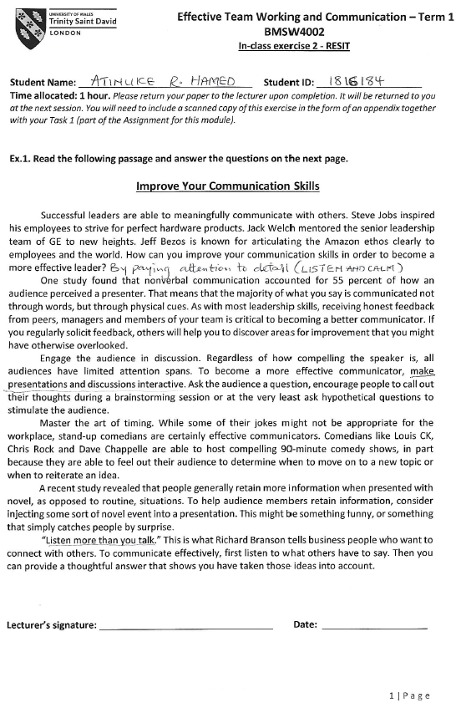
Appendix 1



