SJEQ7003, Ass 3, Alison Wells, 1502112.
The 2010 General Election resulted in a hung parliament and saw the forming of a coalition government between the Conservative Party and the Liberal Democrats. What followed was ‘a programme of austerity in response to the devastating financial crisis of 2008’ (Reforms to the Welfare System begin, 2013). There were unprecedented cuts to public spending in an attempt to reduce the national deficit, no area appeared safe, massive cost cuts to services were announced, as a result no public provider appeared safe. Already stretched services were put under even more strain these included the NHS and Education, to try and achieve the required savings to reduce the deficit. One area that received a great deal of controversy hit by the cuts was the benefits system, cuts to this area resulted in some of society’s most vulnerable people facing further alienation and into economic crisis resulting in large numbers not even being able to even feed themselves, higher numbers of families found themselves needing to access food banks. The Trussell trust is the largest food bank network in the United Kingdom, they report that ‘in 2009/10 they handed out around 41,000 food packs compared with 1.2 million in 2016/17’ (How many people use food banks, 2017).
These cuts had to be defended and resulted in articles being published often sensationalising statistics, to create a narrative to defend the governments social justice strategy. ‘Is Britain a Nation of Lazy Scroungers?’ (Ramish, 2013) was a response to an article written by journalist Tim Shipman for the Daily Mail doing just that, using statistics such as worklessness to defend the benefit cap on household benefits, the article suggested that ‘a million people who are fit to work have been claiming out of work benefits for the last three out of four years’ (Ramish, 2013). What Shipman had achieved is common practice as a method of control he had used his ‘pedagogic authority to create a ‘symbolic violence’ (Bourdieu and Passeron, 1977, p11) and it had captured the reader’s attention. Ramish (2013) ‘accused Duncan Smith of employing a linguistic sleight of hand. He says he is only counting those on working-age benefits who are "judged capable of preparing or looking for work". But almost everyone's capable of preparing for work’. This truth was lost in the communication, ‘the arbitrary power makes imposition possible is never seen in in its full truth’ (Bourdieu and Passeron, 1977, p11).

The figures used in the headlines came from the government’s report on its Social Justice Strategy, to defend the brutal cuts that were affecting peoples life’s Smith portrayed a picture of the government rescuing the vulnerable from a system set in place by the parties predecessors ‘We are making an historic break from a system that, despite many good intentions, failed those most in need – unwittingly fostering dependency rather than encouraging independence; maintaining people in disadvantage rather than transforming lives; spending public money without achieving outcomes or changing lives’ (Iain Duncan Smith, 2013, quoted in The Guardian, 2013). The authenticity of the dialogue did not matter, the thought had been suggested, according to Goldman (2017.p.21) ‘all that can be done is to plant the seed of thought, whether something vital will develop depends largely on the fertility of the human soil’. The public were angry by the cuts, present some negative figures and sew them into a narrative suggesting that the initial suffering will lead to something better, makes the suffering look temporary.
How are the reforms that were discussed in that original article, impacting on our nation today, specifically with regards to youth homelessness? ‘Welfare reforms are contributing to homelessness, among young people aged 16 to 24, by affecting their ability to access and sustain housing’ (Weaver, 2018), commenting on Homeless Link’s Young and Homeless Report, published in April 2018. ‘Young people with experiences of homelessness are one of the most vulnerable groups in society and continue to make up approximately half of the people accessing homelessness services in England.’ (Young and Homeless, 2018).
There are numerous factors contributing to this trend including changes to the welfare system, benefits have in general been cut and in the case of young people it is often creating barriers to safe and secure independent living. ‘Young people have been disproportionally impacted by welfare benefit reforms.’ (Young and Homeless, 2018). In particular with regards to Housing Benefit or Local housing Allowance (LHA) individuals under the age of 35, who have no dependents are restricted to a single room allowance’ (Housing Benefit, 2018). ‘The eligible rent for those aged below 35 has been capped to the shared accommodation rate (SAR) even when not sharing a house, with people being required to cover any shortfall in rent themselves.’ (Young and Homeless, 2018). The rent allowance is generally disproportionate to the actual rents charged. To compound the situation further they are entitled to a reduced rate of benefits. ‘It has been highlighted the very limited availability of accommodation below the SAR rate. 60 80% of the respondents felt that the cap impacted on ability to access and sustain accommodation.’ (Young and Homeless, 2018).
With a limited amount of social housing options available, more people are having to rent from private landlords this is having a ‘Huge impact, as this age group are not landlords preferred choice of tenant group as due to the shared room rate falling below the weekly rent charged they simply will not be able to find accommodation as it won’t be affordable.’ (Local authority respondent, as quoted in Young and Homeless, 2018). Even if they are housed in the private sector, they will face disproportionately higher rents and potentially be subject to rogue landlords, with less stable agreements.

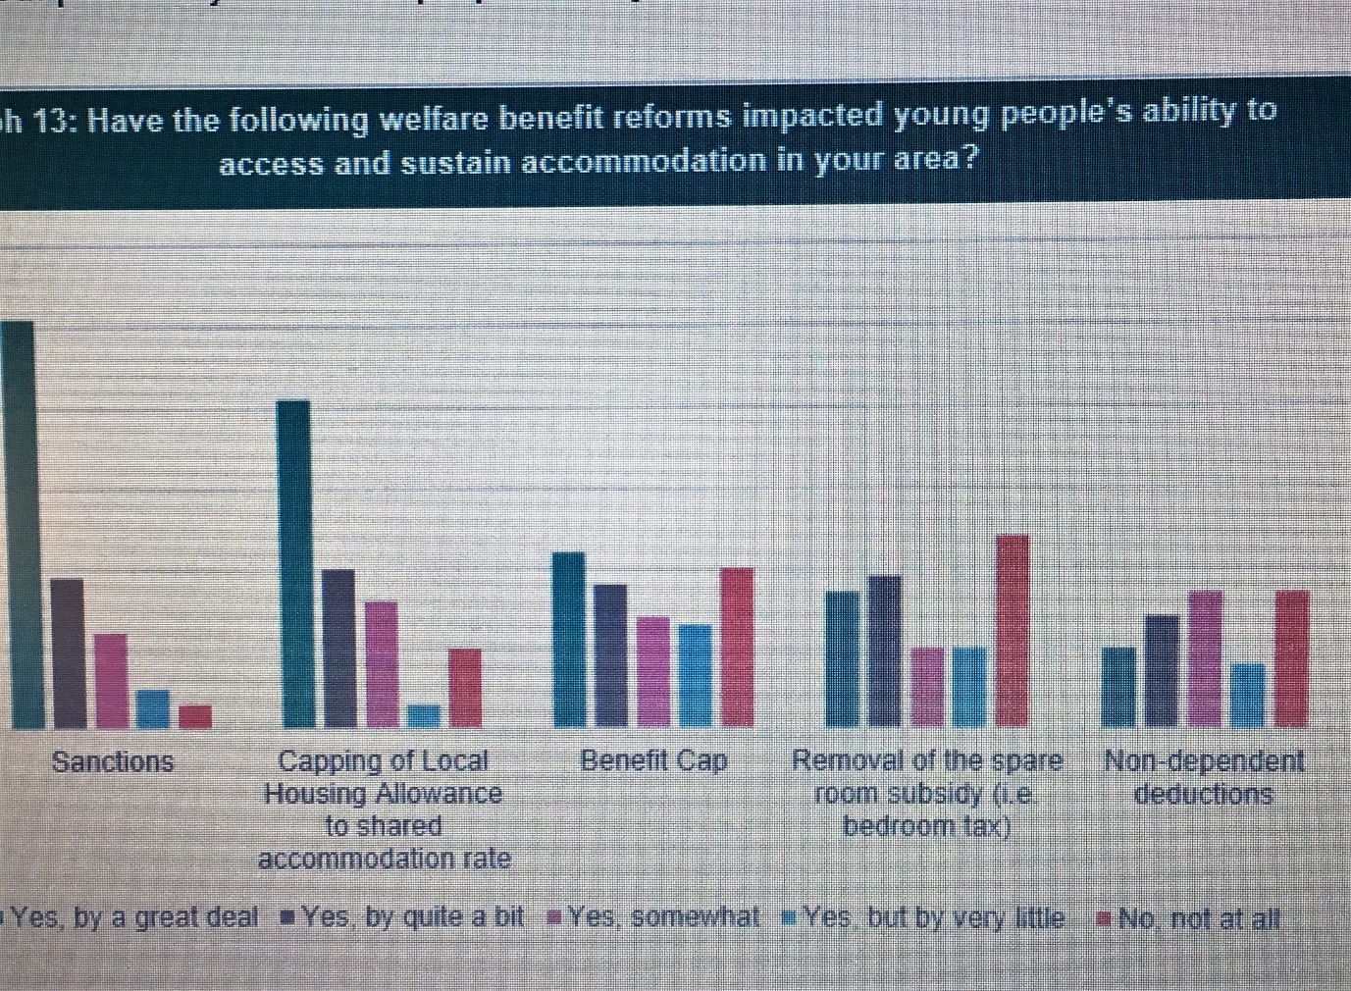 (Young and Homeless, 2018)

‘Eighty percent of respondents reported that capping of Local Housing Allowance’ (Young and Homeless, 2018) had been a barrier in the first instance to secure accommodation, and ‘Ninety percent said benefit sanctions had affected their ability to sustain accommodation.’ (Young and Homeless, 2018). Individuals are already overstretching themselves financially, due to the incongruity between the benefit being received and the actual rent charged, creating a shortfall. Add into the calculation the lower rates of benefit paid to younger claimants and then the withholding of benefit due to capping, in many cases the shortfall can not be made up and so rent arrears can occur, this can lead to eviction.
What is a benefit sanction and why can they be applied? ‘If you don’t meet one or more conditions of your benefit claim, without good reason, your benefit could be stopped or reduced. This is a benefit sanction.’ (Benefits Sanction Statistics, 2018). Looking at the figures with regards to Jobseeker’s Allowance claimants, as this is a likely benefit to be claimed by young people, ‘the average sanction length was twenty-eight days’. (Benefits Sanction Statistics, 2018). There has been much criticism about the sanctions the conclusion to a ‘five-year tracking exercise of hundreds of claimants that the controversial policy of docking benefits as punishment for alleged failures to comply with jobcentre rules has been little short of disastrous.’ (Butler, 2018). He suggests that ‘benefit sanctions are ineffective at getting jobless people into work and are more likely to reduce those affected to poverty, ill-health or even survival crime.’ (Butler, 2018). In the case of housing young people are already experiencing a deficit in the rent allowance and the actual rent charged, by sanctioning their job seekers allowance it is potentially further risking their tenancy as the means to top up the rent deficit has been compromised. The rationale behind them was to promote individuals into work, however ‘Despite claims by ministers in recent years that rigorously enforced conditionality – including mandatory 35-hour job searches – incentivised claimants to move off benefits into work, the study found the positive impact was negligible.’ (Butler, 2018).
When Duncan Smith launched the welfare reforms he declared his commitment to ‘create a welfare system that is fit for the 21st century.’ (Duncan Smith, 2013). The focus was to give incentives to encourage employment, it is debateable whether you could describe a sanction as an incentive. He also declared that ‘We are ensuring there is support for the most vulnerable in our society, and our reforms mean that we will be giving more help - financial and practical - to those people who need it.’ (Duncan Smith, 2013). It is questionable who can be classed as much more vulnerable than a young person who is at serious risk of losing their home. They are already struggling to meet the rent payments by withholding other elements of their income this is not really supporting. Freire (1996) ‘argues that ignorance & lethargy of the poor are the direct result of the whole situation of economic, social and political domination.’ By being kept in a situation that is practically impossible to change, that leaves them with very little income to survive it could be argued they are being kept submerged, the incentive to change is not there, they do not have the energy or the inclination.
It is clear that when a change to policy is implemented this creates a need for change to administrative organisation at different levels, a clear set of procedures need to be introduced, they need to be fully workable and fit for purpose. Individual policy should not be changed in isolation without due consideration given to how one change can determine the working of another. ‘Changes to the welfare safety net can affect the preventative agenda and drivers of homelessness and help or hinder people’s ability to move out of homelessness.’ (Young and Homeless, 2018). Instead of just the here and now being affected, the decision can also impact on the future prospects of whole groups of individuals. To address the long-term issues of homelessness the underlying barriers and issues need to be addressed and a clear preventative plan produced. Different elements of change do not work in isolation to each other, if one area is not right then it can flaw the whole system.
‘At its peak in 2013, under the then secretary of state for work and pensions, Iain Duncan Smith, there were more than a million sanctions.’ (Butler, 2018). The sanctions were imposed for a variety of reasons, in some way they had broken the rules, typical rationale for the punishment for incidences such as ‘failing to turn up for appointments or applying for enough jobs.’ (Butler, 2018). They appear to be extreme and the decision on one element of behaviour could ultimately have significant consequences that may not have been the intended outcome of the individual implementing the sanction, the procedure of punishment working in isolation of overall strategy, a typical example of not operating joined up practice. In reality the threat and implementation of sanctions had the opposite effect of what was intended and produced ‘a culture of counterproductive compliance and futile behaviour among some claimants, who learned “the rules of the game” rather than becoming genuinely engaged with work.’ (Butler, 2018). In all possibility serving to further alienate the individual and creating or building on existing barriers to the world of work.
Narratives are sold to justify a situation, often accompanied by a set of statistics measuring the success of a change. Statistics can be presented in ways to suit the publisher and give justification to the original action. Neither the story or the statistics can be taken in isolation. ‘Neoliberalism is the defining political economic paradigm of our time – it refers to the policies and processes whereby a relative handful of private individuals are permitted to control as much of social life in order to maximise their personal profit’ (Chomsky and McChesney, 1998, p.7). The world of communication is owned and controlled by individuals who fall within the elite controlling group, it is essential to them that they maintain the power dynamic or control will be lost. ‘Neoliberalism operates not only as an economic system, but as a political and cultural system as well.’ (Chomsky and McChesney, 1998, p.9). The decision makers were elected fairly and it was the majority that chose them ‘It works best when there is a formal electrical democracy, but when the population is diverted from the information’ (Chomsky and McChesney, 1998, p.7). The continual misrepresentation of fact, often accompanied by sensational narrative acts nicely as the diversion.

References:
Benefit Sanctions Statistics (2018).
Bourdieu, P. and Passeron, J. (1990) Reproduction in education, society and culture. London: Sage.
Butler, P. (2018) Benefit sanctions found to be ineffective and damaging, the Guardian. Available at: https://www.theguardian.com/society/2018/may/22/benefit-sanctions-found-to-be-ineffective-and-damaging (Accessed: 20 May 2018).
Duncan Smith, I. (2013) Reforms to the welfare system begin, GOV.UK. Available at: https://www.gov.uk/government/news/reforms-to-the-welfare-system-begin (Accessed: 18 May 2018).
Freire, P. and Ramos, M. (1996) Pedagogy of the oppressed. Harmondsworth: Penguin.
Goldman, E. (2017). Anarchism and Other Essays. [S.l.]: Devoted Publishing.
Housing Benefit (2018). Available at: https://www.gov.uk/housing-benefit (Accessed: 19 May 2018).
How many people use food banks? (2017). Available at: https://fullfact.org/economy/how-many-people-use-food-banks/ (Accessed: 18 May 2018).
Chomskey, N. and McChesney, R, (1998) Profit over people. New York: Seven Stories
Ramesh, R. (2018) Is Britain a nation of lazy scroungers?, the Guardian. Available at: https://www.theguardian.com/politics/reality-check/2013/apr/24/benefits (Accessed: 15 May 2018).
Reforms to the welfare system begin (2018). Available at: https://www.gov.uk/government/news/reforms-to-the-welfare-system-begin (Accessed: 20 May 2018).
Shelter Legal England - Main housing duty (2018). Available at: http://england.shelter.org.uk/legal/homelessness_applications/homelessness_duties/accommodation_duties2/main_housing_duty (Accessed: 19 May 2018).
Weaver, L. (2018) Welfare reforms are exacerbating youth homelessness new research reveals, Homeless Link. Available at: https://www.homeless.org.uk/connect/blogs/2018/apr/16/welfare-reforms-are-exacerbating-youth-homelessness-new-research-reveals (Accessed: 20 May 2018).
Young & Homeless 2018 (2018). Homeless Link. Available at: https://www.homeless.org.uk/sites/default/files/site-attachments/Young%20and%20Homeless%202018.pdf (Accessed: 20 May 2018).

