Ragib Miah Student ID: 1912995 Lecturer: Crisford Choguguza
Module: BMSW4005

Certificate I higher education for the workplace
Professional and career development

Reflective Portfolio

Contents
Introduction 3
Self- reflection /competencies 4
Time management 4
Note taking 5
Writing 6
Understanding behaviour 6
Chosen profession/skills needed 6
Learning and development training methods 7
Training methods 8
Reflection on my experience before and after the course 9
References 12
Appendix 13

Introduction

This is reflective writing on how I personally have changed and adapted to higher education learning through lecturers at the university.
The skills that are needed in my chosen profession and how interviews and candidate selections will be performed by using all that I have learned whilst at the university.
At my first year at the university doing higher education I personally have taken in a tremendous amount of skills learned at the lectures, these skills that I have learned but some I had already possessed unknown to me, but have improved on them greatly.
The following reflection will demonstrate on what I have taken in and learned about myself and the skills required for what I want to achieve.

Self-Reflection / Skills and Competencies

During my time at the university I have grown in knowledge, I have learned the meaning about being diligent and what it takes to achieve my goals.
Diligence (noun) Meticulous and tenacious work (Dictionary)
Diligent (Adjective) Having or showing principled and care in one’s tasks.
Diligently (Adverb) In a way that shows principled and care in in one’s duties or tasks.
But being diligent is not enough, possessing other skills and improving on the one’s that I already possess, I know will help to achieve my personal goals.
“Diligence is effort expanded by students to achieve” (Bernard, Thayer, 1993), in order to accomplish any form of tasks designated to a person which make take a large proportion of the persons time diligence is needed.

Time management

I have learned that I have particular skills already, these skill are required in most jobs such as time management and finishing tasks on time, as I am a working person I have never been late to finish tasks or for work as I have always put importance to being on time or ahead of time, that was my perspective on time management, I have learned that it is more than being on time or finishing tasks on time, it is about planning your time for a duration to complete one’s task or work.
Time management is a one of the more important of skills needed in order to be organised, it is good practice to have a personal development plan (PDP), be it for work or education purposes, as it helps to breakdown time to make it more manageable and give a more realistic time frame of how long a certain job or task will take without pressure.
“Time cannot be controlled, but it can be managed” (Morgan, 2017).
A person can deal with the pressures of work or education if the person respects time management and develops a strategy, this will make good stead for future goals (Allen, 2009).
In order to succeed in life, I have come to realise the importance of certain skills that are required and skills that I already possessed but needed to improve on them, In order to succeed on a course, skills have to be learned as students are not born with abilities to study well (Dawson, 2011).
By knowing about personal development plan, I have found it easier to manage my time for work, time for assignments with planned breaks for family.
A PDP is not necessarily to get a promotion but more in reaching your own potential to improve on your performance, “a plan intended to develop skills that are important to the work life” (Morgan, 2017).
Mature students have other responsibilities to the one’s they hitherto complete an assignment, therefore cannot put in 100% into studying (Honea, 2006), so knowing this, a PDP is required to put in more effort into work.

See appendix (1) page (13) for example of personal development plan (PDP).

Note taking

Another skill that I possess is note taking, note taking is an important part of any job or education, it helps to remind a person of their daily tasks and what needs to be done on how to complete a task.
Taking notes is a skill that people need in general, as it helps to fill in forms or reports at a later stage by taking notes that are comprehensible to you for review.
In respect the notes taken should be laid out as uniform as possible, so not to be confused with different sources when looking back at the notes, taking notes must be perceived as a vital process (Becker, 2004).
Many jobs require a person to take notes and fill in statements at a later stage, it has been very helpful and fulfilling to learn about note taking as a skill, a skill that i possess and have improved on due to understanding the process in depth.
Taking notes is the “bread and butter” of student and work life, primary and fundamental venture that people do (Mcmurray, 2011).

Writing

Writing is also a skill that I possess, it may not be perfect but it is a skill that I am improving, this is one of the skills that I have improved a great extent and it is a good skill to have.
Writing skills has to be legible and comprehensible if handwritten or typed for the person writing, legible and comprehensible for the person reading it, in the case of taking notes it must be legible for any person to understand especially if taking a statement for a report.
A person who writes well can convey themselves and is fluently and coherently putting across what they want the reader to understand (Cowley, S. 2011).

Understanding behaviour

The psychology module has taught me different behaviours in children of different ages, it has also taught me different types of aggression in people that I believe to be a skill.
This is a new skill that I have learned while doing level 4 at the university, it is also a skill I require for my chosen profession to understand people, in order to show support and have empathy for the vulnerable.
As humans we own a primary foundational notion, which is the tendency to self-actualisation in structure to fulfil one’s future to attain the elevated level of human beingness (Rogers, 1959).

Chosen profession/skills needed

My chosen profession is to work in social services to help children and the vulnerable, the skills needed for this profession are finding out what type of care and support the person needs, doing assessments to make sure people continue to get the right care, offering information and counselling, intervening when people need support or safeguarding and keeping records and writing reports (Skills for care).
In comparison to the skills I possess and the skills that are needed are very similar, report writing, supporting vulnerable children and the elderly, also having the time to make time to give extra support to those who need it.

Learning and development training methods

By using SWOT analysis to decide on any new strategies, first the task of looking at what was working and what needed more attention.
By doing a SWOT analysis it was found that there was a weakness in the establishment, the workload was too much and progress on helping the vulnerable was lacking, they were not getting the support that was needed fast enough.
See appendix diagram (2) page (13).
As assistant manager a task has been assigned to recruit and teach new employees learn and develop training for the job.
Firstly, the job was advertised for university students wanting to gain experience with hands on training on the subject that the student is studying (health and social care).
Due to a huge response to the job advertisement an interview selection was formed to gain the most diligent applicants.

The candidates were hand selected due to their skills and knowledge of the work that is done in the organisation.
Teams are hand selected accordingly for the knowledge and skills each possess, different types of knowledge is required in a team to reach their aims (Devine, Clayton, Phillips< Dunford, Melner, 1999).
Out of many eligible recruits only four were selected for the position of trainee social worker, the four were selected due to their skills they possess and the qualification they held, also the fact their skills in some areas were stronger than others.
All the candidates have a level 4 in higher education and the position stated at interview further training will be given.
The only skill they do not have is experience, but as stated that training will be given it is not a major issue.
The key skills needed are, communication, writing, notetaking, working well as a team and learning.
Teams are a group of people who have the same goal and communicate with one another to accomplish a given task (Maund, et. al. 2017).
Each applicant is strong in different skills, which at the interview they were selected as candidates for the role.

Training methods

The training methods chosen are, the students are to still complete their university studies level 5 and 6, must attend lectures.
Reading material is given on practices of the establishment on how and what they can and can not do when dealing with people, a code of conduct.
Role play is a good way of learning to deal with people and how they should be supported and who to contact in case of difficulties.
Being the assistant to the senior social worker they have a first-hand view on the work.
Group discussions, this is to see progress and inform each candidate of their tasks and any questions they had to improve on the learning or how tasks can be done better.

Reasons for chosen methods

Continue with studies attending lectures: The candidates will learn many new and updated facts concerning health and social care, the candidates will have an understanding behind the theories of why tasks are performed in certain ways.

Reading: Reading is an excellent way of looking at theories behind facts, also it helps to keep learning and trying to put theories into practice.
Role play: Role play is an excellent way of practicing theories to see how it pans out, it is also an excellent way of learning on how to deal with any work situation or issues.

Hands on experience: Going out with senior staff on call is the best type of experience a candidate can have, it shows what can be expected, the people that you are dealing with, different issues with different people, it helps seeing theories put into practice first hand.

Group discussions: is a unique way of learning from your peers with seniors there to guide you, questions may be asked and answered such as when out on call a person was being aggressive but the senior social worker remained calm and stayed to calm the individual down, theory of aggression can be used to explain that people go through moods due to illness and it was not personal, the attitude that is given back towards the behaviour is crucial, the outcome can be positive if the attitude is positive when dealing with a situation (Ajzen, 1991), it will put issues and theories into perspective.
As each candidate has different learning styles and different skills each one will see, read and talk combined with hands on experience this will give them a experience that they will gain from learning from the chosen methods.
See appendix (3) for learning style diagram page (13).

Reflection on my experience before and after the course

At the start of the course I really did not know what to expect, I did not know how much I had forgotten after returning into education over 27 years after leaving school, going back into higher education at first was quite daunting.
I had a sense that I would not do so well, there were students some same age as me but mostly a lot younger.
I remember having feelings I may get laughed at if I make a mistake, as this was all quite new to me, as an adult I thought I could handle the pressure of being with new people but in many ways it reminded me of first day at secondary school, not knowing anyone and making new friends it was all quite unnerving.
I had to constantly remind myself as to why I was doing this, my reason was I wanted to change the job that I was doing and have a career that I enjoy.
To me a job and a career are two different meanings, a job is work you live off day to day which becomes more a chore and a career is work you enjoy.
After the first week I had gotten to know my peers and they mostly had the same feelings that I did, everyone bonded, and it became more comfortable to talk and ask questions.
The first module of the course was most difficult as it was hard to get into the swing of getting back into education, the time I had to set aside to complete my tasks combined with work and family life it was difficult.
What was hard was the referencing and getting reliable sources, referencing has to be done Harvard style which is a subject I was never taught in school, I slowly learned to adapt and learned the referencing style, yet with difficulties but getting there
It slowly came back to me how much I enjoyed learning, I found out the style of learning I was, which is visual, kinesthetic and auditory with all three combined I was doing very well.
After two weeks of the first module we learnt about personal development plans and time management which put things into perspective, after learning this I had planned my course of when I would do studies, my work and family life would be based around study time so I would have enough time to complete assignments.
After completing the first module assignment waiting for the results was quite intimidating not knowing how I have done if I had failed, I could not pursue my career path which is not an option.
Getting my results and having passed, gave me a boost in my confidence, the next module I found I was more relaxed and comfortable which I also passed.
I really enjoyed the modules, I have learned many new subjects and had a different mindset from theories why things are done the way they are.
Learning new processes, it felt very refreshing that I can still learn and be able to do well.
Then came the pandemic which meant all students had to learn online, I personally found it very hard, it is hard to talk as mic’s had to be switched off and you could not talk if someone else was talking, it was and is very difficult. I personally preferred in class tuition.
I managed to complete and pass two more modules which to me was a relief, as it was hard with online learning, with internet problems or online log in.
The final two modules I had problems, many of my peers may have gone through the same feelings as me.
Being in lockdown, being off work the uncertainty of the pandemic was taking its toll on my peers and me.
It was getting more difficult online learning many times it was hard to understand due to distortion or noises in the background.
In all fairness the lecturers all did well in teaching and supporting the students in a difficult time.
My main goal is to pass the last two modules and continue to level 5 and 6, I realised how much I liked learning and meeting new people.

References

Ajzen, I. (1991). The theory of planned behaviour, organisational and human decision process.
Allen,B. (2009). Study skills for business and management students.
Becker, L. (2004). How to manage your distance and open learning course.
Bernard, H. Thayer, J. D. (1993). Diligence and academic performance
Cowley, S.
Dawson, C. (2011). Basic study skills.
Devine, D. Clayton, L. Phillips, J. Dunford, B. Melner, S. (1999). Teams in organisations; prevalence, characteristic and effectiveness.
Kozlowski,S. W. J. Bell, B. S. (2003). Team learning, development and adaptation.
Maund, a. Schrienk, M. Tnkler, P. K. (2017). Skills for the work place, student year book.
Mcmurray, P. (2001) Study skills essential.
Morgan, P. (2017). The business students guide to study and employability.
Rogers, C. R. (1959). A tentative scale for measurement of process in psychotherapy.
Skills for care, viewed (2020). https://www.skillsforcare.org.uk/.

Appendix

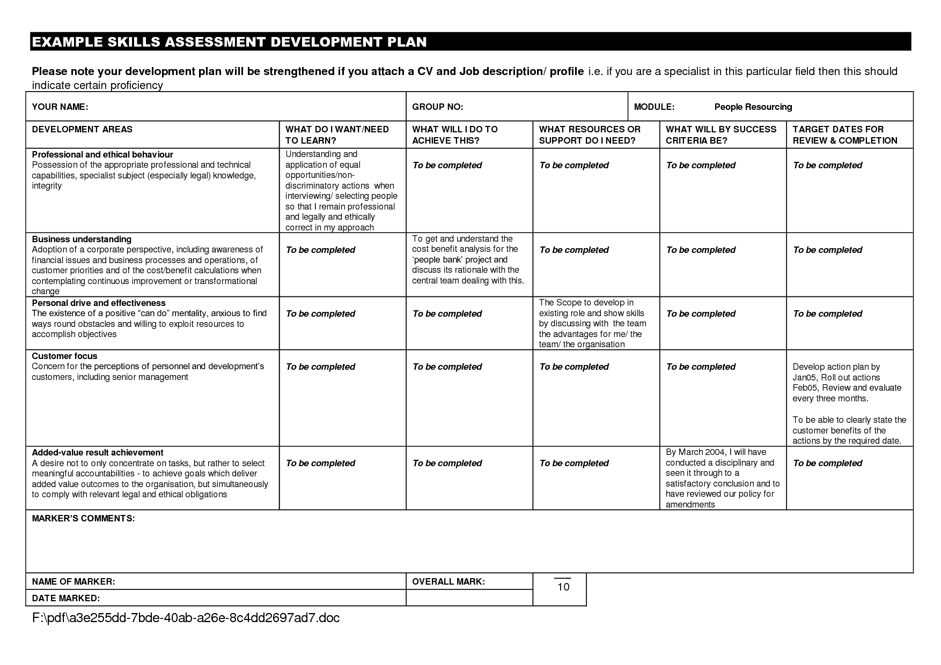Appendix 1

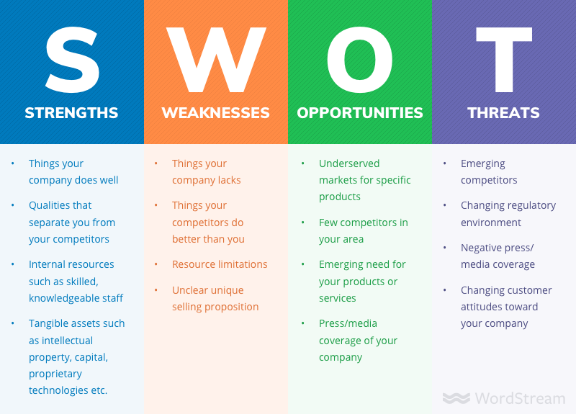 Appendix 2

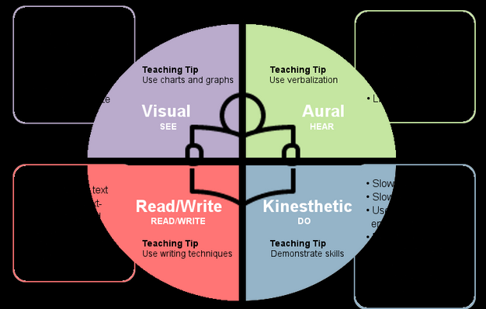 Appendix 3

