Ana Carden-Coyne, David Morris and Tim Wilcox, eds., The Sensory War, 1914–2014(Manchester Art Gallery: Manchester, 2014)
Images from section entitled ‘Embodied Ruins’

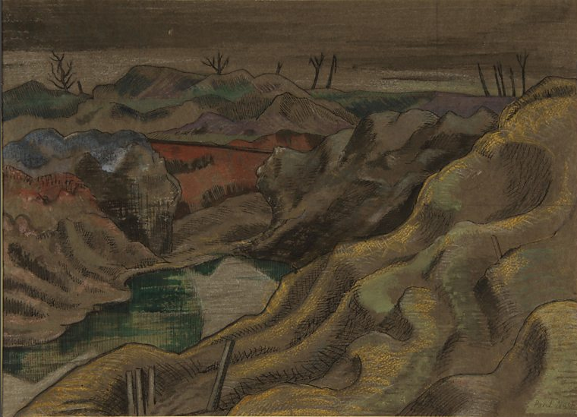
Paul Nash, The Landscape: Hill 60, 1918
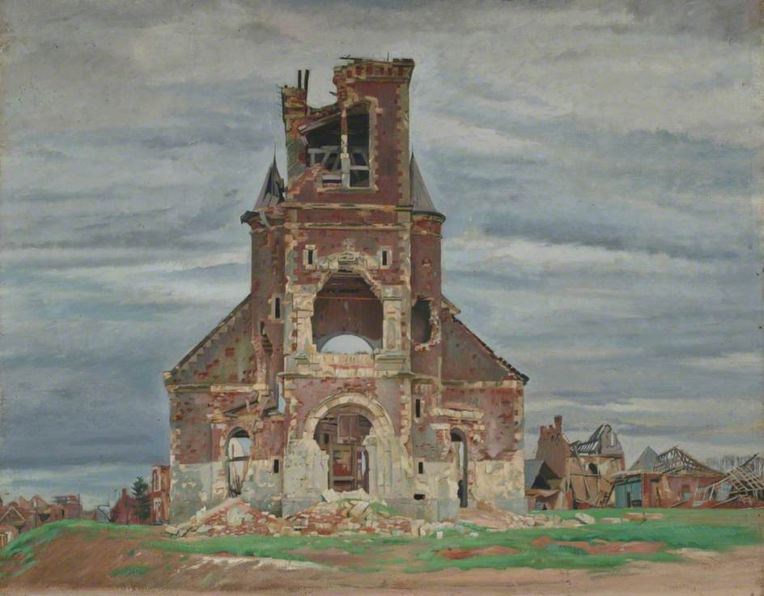
William Rothenstein. The Church at Bourlon, c. 1920

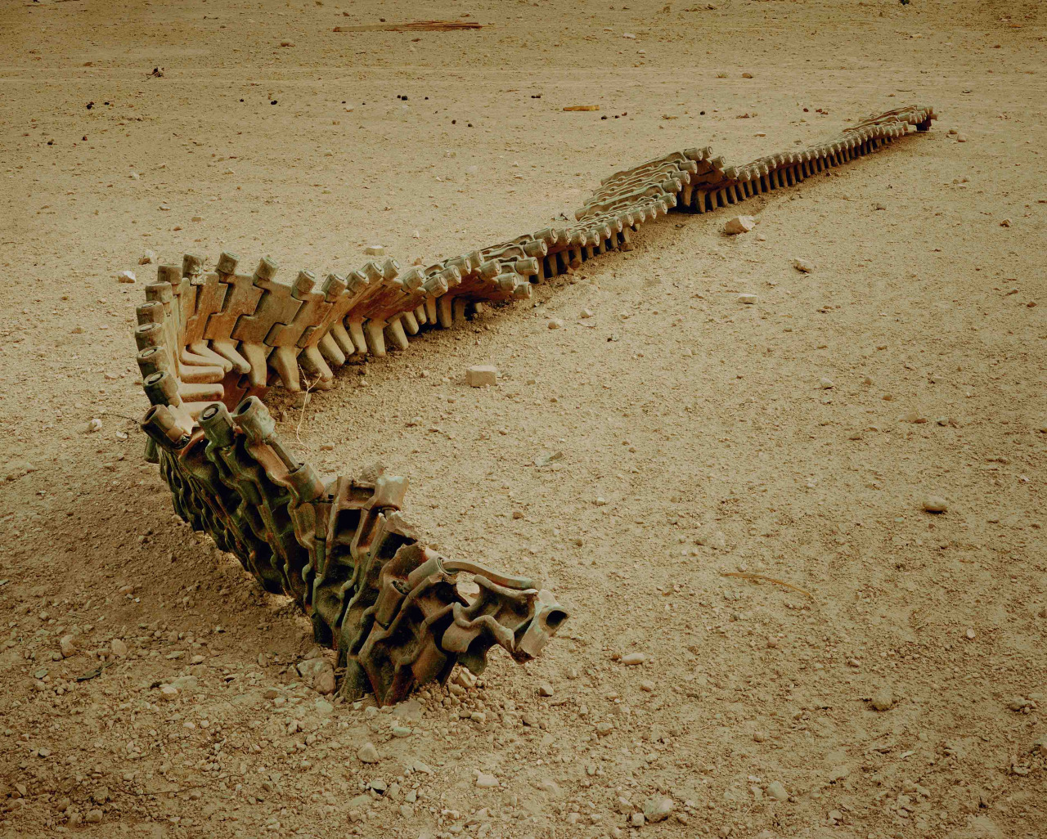
Simon Norfolk, Track of a Destroyed Taliban Tank at Farm Hada Military Base, 2001

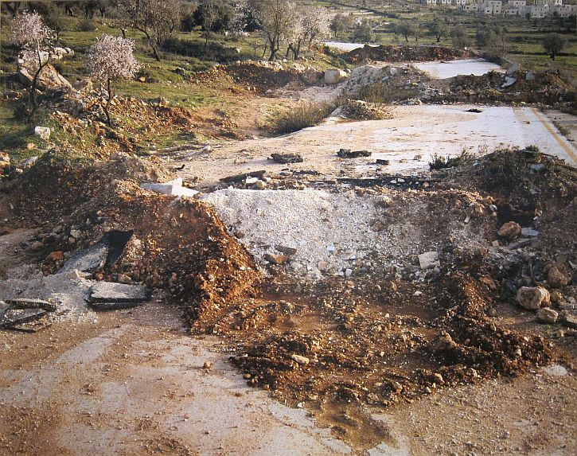
Sophie Ristelhueber,WB#8, 2005
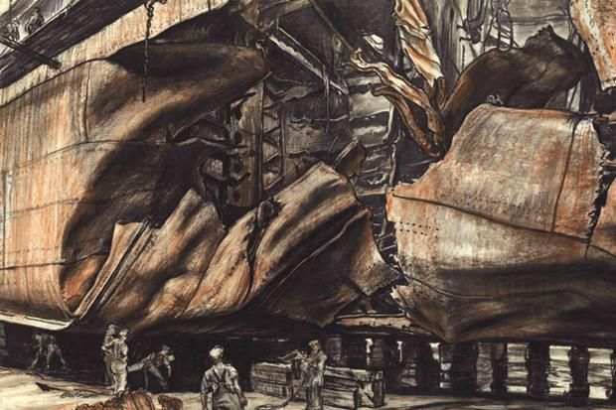 Muirhead Bone. Torpedoed Oil Tanker, 1940

