

Student Name: Podili Deepthi
Student Id: 2432738
Lecturer Name: Malik Mehmood
Module: Artificial Intelligence [ACCA7026]

Abstract
This report discusses how ensemble learning techniques can be applied to network intrusion detection based on NSL-KDD dataset, which is a standard dataset used in cybersecurity studies. RF and GBC are two ensemble classifiers which have been constructed and optimized to perform multi-class intrusion classification. Both models proved to have outstanding predictive potential after thorough preprocessing and balancing with SMOTE. RF model had an accuracy of 99.05% and slightly better than GBC with 99.07%. Once the problem of class imbalance was solved by using SMOTE, RF rose by 99.10% to achieve higher accuracy. Assessment measures such as precision, recall, and F1-score proved that ensemble models are useful in tackling complex forms of intrusion as compared to the conventional individual. It is concluded that ensemble learning, together with a powerful preprocessing and resampling method, provides a solid basis to intelligent Intrusion Detection Systems (IDS) which can detect different types of attacks in a real-world network.

Contents
Abstract 1
1. Introduction 4
2. Related Work 5
3. Methodology 7
3.1 Dataset Description 7
3.2 Proposed Methodology 7
3.2.1 Data Preprocessing 8
3.2.2 Model Development 9
3.2.3 Evaluation Metrics 9
3.2.4 Implementation Environment 9
4. Results and Discussion 10
4.1 Random Forest Performance 10
4.2 Gradient Boosting Performance 12
4.3 SMOTE-Enhanced Random Forest 14
4.4 Comparative Analysis 14
4.5 Feature Importance 15
4.6 Time Comparison 17
4.7 Discussion 18
5. Conclusion 18
References 19

List of Figures
Figure 1: Proposed Methodology 6
Figure 2: Classification report - random forest 8
Figure 3: Confusion matrix - Random Forest 8
Figure 4: Classification report - gradient boosting 9
Figure 5: Confusion Matrix - Gradient Boosting 10
Figure 6: Classification report - SMOTE-Enhanced Random Forest 11
Figure 7: Top 15 features - Random Forest: 12
Figure 8: Top 15 features - Gradient Boosting 13
Figure 9: Time required for both model 13

Table 1: Result Comparison 11

1. Introduction
This has seen cyber threats grow exponentially and in an unprecedented amount and complexity due to the rapid expansion and adoption of networked systems that are interconnected over the past few years by both organizations and individuals [1]. Consequently, intrusion detection systems (also known as IDS) have emerged as absolutely essential elements in the security and protection of the digital infrastructures, networks, and confidential data against malicious and unlawful actions [2]. The classic IDS solutions that are mostly based on signature detection systems are simply constrained because they heavily rely on attack patterns and signatures that are already known [3]. Such traditional approaches find it difficult to identify new or zero-day attacks because they cannot identify systems that have never been seen before, and so they expose systems to new threats on the internet. Considering these issues, machine learning (ML) methods have been gaining prominence and optimism, as a core and prospective strategy, in the design and development of smart intrusion detection systems with the capability of generalization and successful detection of invisible or metamorphic cyberattacks [4].
Ensemble learning is one of the most popular machine learning methods that has shown to be better at generalizing, more stable, and more robust in the fields of cybersecurity and intrusion detection, among other wide variants of machine learning methods available today [5]. This project aims at capitalizing on the two most popular and widely used ensemble learning algorithms which are the Random Forest and Gradient Boosting algorithms. They are used with the NSL-KDD dataset, which is a well-known benchmark dataset commonly utilized in the assessment of intrusion detection models, in the aim of properly detecting and classifying different types of intrusions.
The particular aim of this thorough research are the following:
- To preprocess, clean, and prepare properly the NSL-KDD dataset with the aim of being prepared to become effective and reliable machine learning modeling.
- To develop, train, and optimize the classifiers of Random Forest and Gradient Boosting with the purpose of conducting accurate multi-class classification of the various types of intrusions.
- As a way of performing an in-depth comparison of the model performance based on various measures of evaluation, such as accuracy, precision, recall, and the F1-score, to give a comprehensive picture of the performance of each model.
- To examine the effect of the methods of data balancing, specifically, Synthetic Minority Over-sampling Technique (SMOTE) on the extent of enhancing the performance and reliability of the classifiers.
- To assess the significance of various features in the dataset established by the trained models, and to comment on the implications of such results to practical application of designing more effective and efficient intrusion detection systems in real life.
The rest of this report is structured according to standard academic and technical guidelines: Section 2 is the extensive review of the research and existing methodology related to the area of intelligent intrusion detection systems; Section 3 is the description of the methodology and experimental setup that was used in the current project; Section 4 provides the results of the experiments and in-depth analysis and discussion of the findings; and the conclusion of the report is presented in Section 5.

2. Related Work
The intrusion detection systems based on machine learning have experienced notable development and transformation in the last twenty years due to the presence of more and more complex and varied cyber threats. Simple and easy-to-use shallow classifiers like Naïve Bayes, Decision Trees, and Support Vector Machines (SVMs) were in widespread use in the early days of research because they were relatively easy to understand and on the other hand easy to implement [6]. These initial models showed moderate success but tended to fail in the face of high dimensionality and nonlinearity of network intrusion data [7]. However, in the course of time, ensemble learning techniques have become increasingly popular and are now the choice of researchers and practitioners, and this is mainly explained by their superior generalization properties and their capability to stand the test of time in a variety of cybersecurity environments [4].
The Random Forest algorithm is one of the most commonly known ensemble techniques that was initially introduced by Breiman in 2001 [8]. Random Forest is based on the idea of combining the predictions of the many decision trees that are built with bootstrap aggregation (also called bagging), which is effective in reducing variance and minimizing the chance of overfitting, a pitfall of single-tree models [9]. This combination of many trees enables the Random Forest to make more reliable and consistent predictions [9]. Particularly, empirical studies by Tavallaee et al. in 2009 demonstrated that Random Forest had a classification accuracy of 99.8% in the NSL-KDD dataset with very little parameter tuning [10].
The other effective ensemble method is the Gradient Boosting which is further developed by Friedman in 2001, but it does not follow the same method, it sequentially trains weak learners and then refines the model by reducing residual errors at every training step [11]. This process enables one to correct errors that were made by earlier learners and this leads to a very precise and smooth model.
Intrusion detection datasets, especially those related to the problem of class imbalance, are a long-standing and difficult problem to solve because some types of attacks are much more common than others [12]. Such an unbalance can commonly cause biased models that prefer majority classes at the expense of lowering the detection rates of uncommon yet important classes of attacks. In order to address this, synthetic resampling methods like the Synthetic Minority Over-sampling Technique (SMOTE), proposed by Chawla et al. in 2002 are commonly used to synthesize a population of minority classes and equalize a dataset [13].
The issue of feature importance analysis in intrusion detection systems has also been under the focus of more current studies [14]. Such analysis can not only enhance the interpretability of a given model by determining which aspects of the network contribute the most towards making classification decisions, but also can be used to decrease the computational load of a given model to include only the most influential features.. This report takes the same methodological path and will combine ensemble learning strategies with data balancing as well as interpretability studies and come up with an all-inclusive and efficient IDS model that will address the detection accuracy and computation efficiency and practical feasibility.

3. Methodology

3.1 Dataset Description
The NSL-KDD dataset is the improved version of the original KDD 99 dataset, which was targeted to remove redundancy and bias. It has 41 features and a single target variable that classifies data in different classes. The dataset has both continuous and categorical variables, and it is necessary to preprocess this data to make it be compatible with ensemble learning algorithms. Dataset is accessible via following link:
https://www.kaggle.com/datasets/kiranmahesh/nslkdd

3.2 Proposed Methodology
The proposed methodology followed in this research is shown in figure 1.
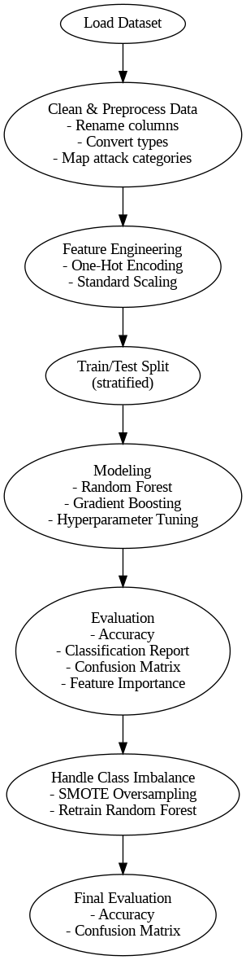
Figure 1: Proposed Methodology
The methodology is explain further as follow:

3.2.1 Data Preprocessing
The preprocessing of data consisted of a number of main activities in order to get the data ready to analyze. To begin with, categorical variables e.g. protocol type, service and flag were coded using one-hot encoding to transform them into a form that could be inputted into machine learning models. Then, numerical characteristics were scaled to have a similar scale of all the attributes, which is useful in enhancing model performance. In order to solve the problem of imbalance between the classes the Synthetic Minority Over-sampling Technique (SMOTE) was utilized, which artificially recreates the samples of the minority attack classes, in such a way that to create a more balanced dataset. The initial dataset was in a 15,780 x 118 shape but upon oversampling, the dataset expanded to 39,355 x 118.

3.2.2 Model Development
The scikit-learn pipeline framework was used to create two ensemble classifiers to improve the performance of models. The first is a Random Forest classifier, which was trained and optimized with the help of the GridSearchCV to identify the optimal hyperparameters. The most suitable settings were 300 estimators, a maximum depth of 40, at least 2 different samples were needed to split an internal node, at least 1 sample needed per a leaf, bootstrapping was turned off. This design was a compromise of performance and computational efficiency. Another model, one of a Gradient Boosting classifier was also optimized using GridSearchCV, which led to the choice of 200 estimators, a maximum depth of 4, and a learning rate of 0.1. These parameters gave an acceptable trade-off between bias and variance, and they contributed to reduction of overfitting.

3.2.3 Evaluation Metrics
Some of the key metrics were used to determine performance evaluation. Measure of accuracy was the general correctness of the predictions, the rate at which the classifier was correct. Precision was used to evaluate the ratio of correct positive predictions to the total positive predictions performed, which indicates how the model is able not to give false alarms. Recall, or sensitivity, assessed the ability of the model to identify true instances of attacks by determining the percentage of false positives that the model would identify compared to all the true positives. F1-score which is the harmonic mean of precision and recall gave a balanced measure that takes into consideration both false positives and false negatives. Also, it was implemented with the help of the confusion matrix as it visualized the distribution of classification results providing more in-depth information on how the model predicted various classes.

3.2.4 Implementation Environment
The experiments were carried out in Python 3.11 with the help of Pandas, scikit-learn, and imbalanced-learn libraries. The model execution was done in the Google colab using a 4-core CPU.

4. Results and Discussion

4.1 Random Forest Performance
The Random Forest model achieve an accuracy of 99.05%. Best parameters are n_estimators=300, max_depth=40, bootstrap=False. Classification report is shown in figure 2 as follow:
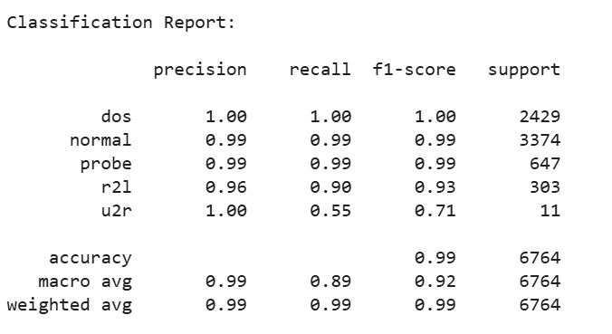
Figure 2: Classification report - random forest

The confusion matrix of Random Forest model is shown in figure 3 as follow:
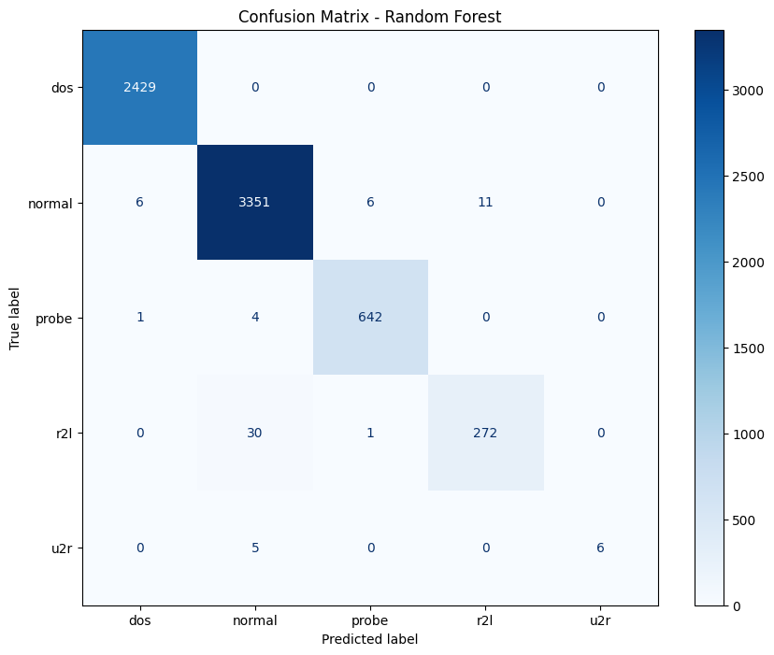
Figure 3: Confusion matrix - Random Forest
Random Forest classifier was trained in one to three minutes, where they did a grid search with 3-fold cross validation on 10 different hyperparameter combinations, which made 30 model fits. After finishing, the optimal choices of the hyperparameters were 300 estimators, a max tree depth of 40, a minimum number of 2 samples to split a node, a minimum number of 1 samples per leaf, and bootstrapping off.
Once tested on the test set, the model was found to be very accurate with 99.05% which is excellent in terms of overall predictive accuracy. The detailed classification report indicates that the classifier had excelled in most of the classes, and that the majority of the classes (DoS, Normal and Probe) have precision, recall, and F1-scores of either near or at 1.00. R2L had a low recall value of 90 that, however, a few detections were missed but the values of precision and F1-score remained high. The U2R class with extremely limited samples possessed a perfect precision but lower 55% recall indicating that although the model correctly predicted positive results of U2R it misses almost half of the true cases of U2R.
Overall, the model performs well in terms of performance and has almost ideal weighted averages of precision, recall and F1-score, although the macro average measures indicate the difficulty of capturing minority classes like U2R. This finding supports the fact that the Random Forest classifier is strong and optimized to the intrusion detection challenge on this dataset.

4.2 Gradient Boosting Performance
The Gradient Boosting model achieved 99.07% accuracy in this research. Best parameters are n_estimators=200, max_depth=4, learning_rate=0.1. The classification report is shown in figure 4 as follow:
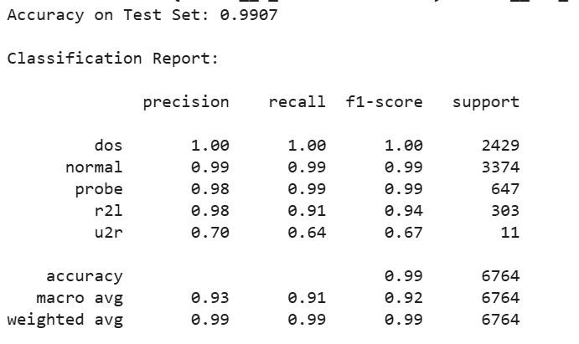
Figure 4: Classification report - gradient boosting

The confusion matrix is shown in figure 5 as follow:
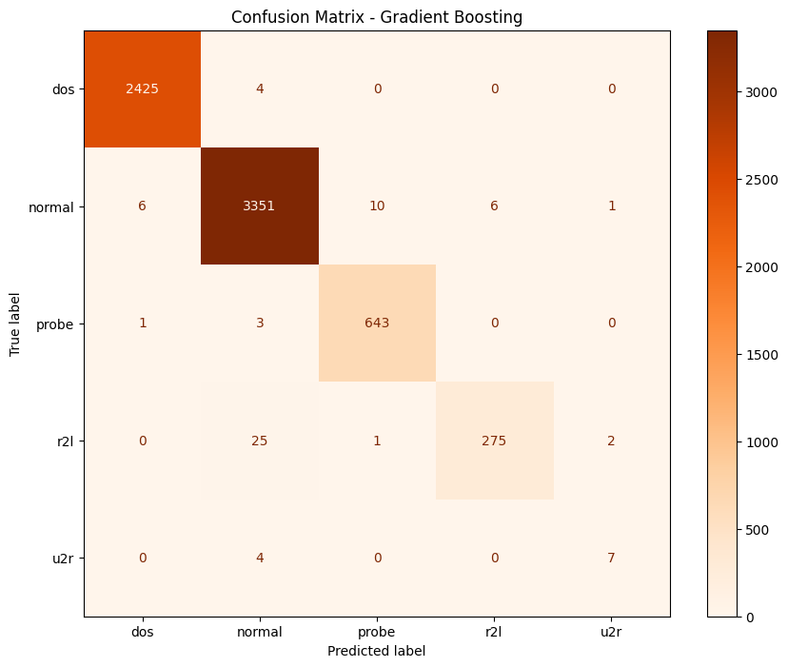
Figure 5: Confusion Matrix – Gradient Boosting
The Gradient Boosting Classifier was trained using a few minutes, where a grid search was performed using 3-fold cross-validation of 5 hyperparameter candidates, yielding 15 model fits. The most optimal values were 200 estimators, maximum tree depth of 4 and a learning rate of 0.1.
The Gradient Boosting model was of an accuracy of 99.07% when tested and performed a little better than the overall correctness of the Random Forest. The classification report indicates that most of the classes have a high performance: DoS and Normal classes have F1-scores that are almost perfect, precision, and recall. Probe class also worked very well, and it has a recall of 99, F1-score of 0.99. In the case of the R2L, the model achieved recall of 91 and F1-score of 0.94, which is good detection with the least false negatives. However, the U2R class is difficult, as well as the Random Forest, with a precision of 70% and a recall of 64%, and an F1-score of 0.67 which is not as high as the other classes because of the few number of samples.
The macro average scores indicate even distribution of performance across all the classes and the minority classes as well, whereas the weighted averages are very high with the value of 0.99 that highlights the robustness of the model in general. It means that the Gradient Boosting Classifier is very efficient at intrusion detection on this dataset, and in particular, it has a high tendency to maintain a high bias-variance tradeoff and reduce overfitting.

4.3 SMOTE-Enhanced Random Forest
A slight improvement in the test accuracy of Random Forest was noticed after using SMOTE and the macro-average F1 of the test improved to 99.10%. The classification report is shown in figure 6 as follow:
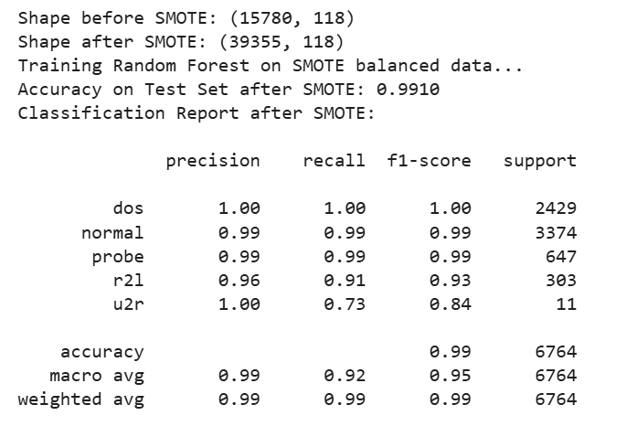
Figure 6: Classification report – SMOTE-Enhanced Random Forest

4.4 Comparative Analysis
The comparison of results is shown in Table 1 as follow:
Metric | Random Forest | Gradient Boosting | RF + SMOTE
Accuracy | 0.9905 | 0.9907 | 0.991
Macro Avg Precision | 0.99 | 0.93 | 0.99
Macro Avg Recall | 0.89 | 0.91 | 0.92
Macro Avg F1 | 0.92 | 0.92 | 0.95
Table 1: Result Comparison

Gradient Boosting performed a bit better on minorities without resampling whereas Random Forest did better with SMOTE. This underscores the benefits of data-level balancing to model-level ensemble strength.

4.5 Feature Importance
The two models were effective in determining some of the major features which had a significant effect in the performance of classification. Some of the most significant ones were src_bytes (number of bytes the sender has sent over the source) and dst_bytes (number of bytes the recipient has received over the destination) that indicate the amount of network traffic. Also, service and flag protocol-related features were extremely important, since they entrap the essence of network communication and connection status. Connection based statistics such as count and srv count which show the number of connections and the number of connections based on service respectively also proved to be significant indicators. These results are in line with other studies and they support the fact that protocol flags and traffic volume are the most important variables to be considered when identifying network intrusion.

Top 15 important features for Random Forest is shown in figure 7 as follow:
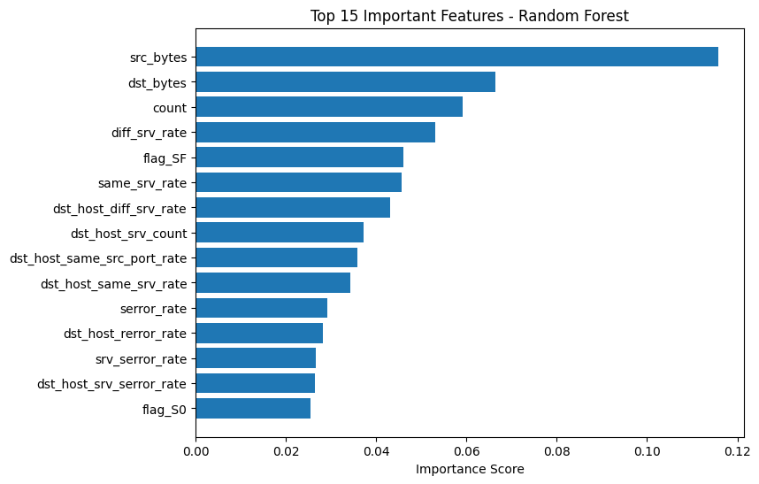
Figure 7: Top 15 features - Random Forest:

Similarly, for Gradient Boosting, top 15 features are shown in figure 8 as follow:
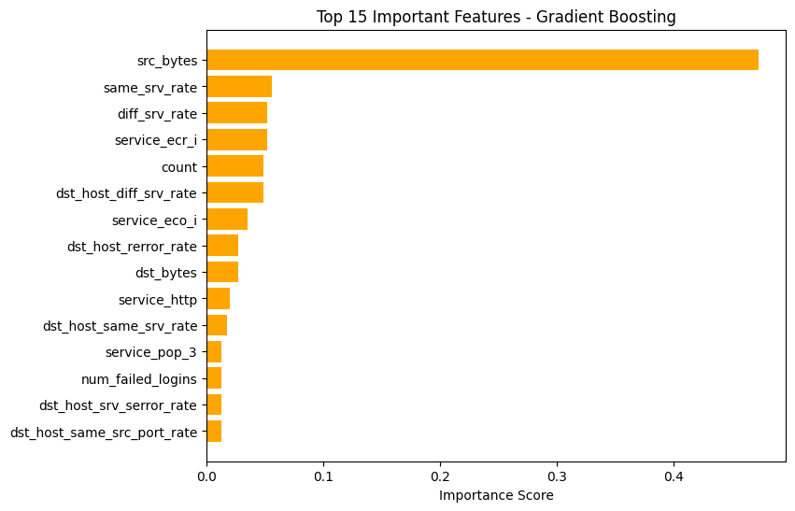
Figure 8: Top 15 features – Gradient Boosting

4.6 Time Comparison
The predictive and training time of the two models point out significant differences in the computational efficiency. The random forest classifier took a training time of about 96 seconds and only 0.30 seconds to make the predictions on the test data. By contrast, the Gradient Boosting classifier was much longer to train, approximately 648 seconds but faster on prediction, only 0.14 seconds. These findings demonstrate that although Gradient Boosting is more time-consuming to train because it follows a sequential learning procedure, it has shorter inference times. In the meantime, Random Forest has a much faster training stage and a little longer time of prediction, because it uses parallel tree-building.

Figure 9 shows time required to run both model as follow:
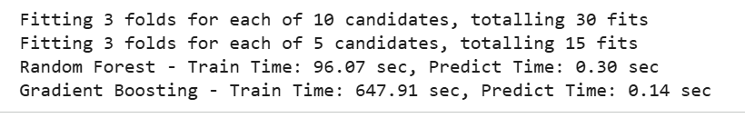
Figure 9: Time required for both model

4.7 Discussion
The results show that ensemble models, especially those used with SMOTE, have good detection against all varieties of attacks. The minor difference in U2R recall points out to the enduring issues with picking out uncommon advanced attacks. However, the high accuracy of both models reduces the occurrence of false positives; which is an important consideration in practice applications of an IDS as false identifications can easily overwhelm the analyst.
Gradient Boosting computational wise took longer to train because of the sequential learning, but showed a bit of improvement in generalization. Random Forest on the other hand was simpler to parallelize and trained more quickly and could therefore be more applicable in real-time systems.

5. Conclusion
This project was able to apply and compare two ensemble learning models of Random Forest and Gradient Boosting as intrusion detectors to the NSL-KDD dataset. Both of them achieved more than 99% accuracy which shows how successful ensemble techniques are to intelligent intrusion detection system (IDS). The results proved that ensemble learning significantly increases the detection accuracy, and the application of SMOTE can be effectively used to overcome the issue of class imbalance, which is beneficial in recalling minority types of attacks. Random Forest was the best model in terms of baseline performance and the most interpretable, and Gradient Boosting performed slightly better on the overall performance, but at the cost of increased computational complexity. Subsequent studies might be on hybrid ensemble-deep learning, including RF-LSTM or XGBoost-CNN, real-time IDS integration with streaming data and feature selection optimization to reduce latency without reducing accuracy. Overall, the present research work can help in the field of AI-based cybersecurity because it shows that ensemble learning with data resampling methods can dramatically increase the accuracy and effectiveness of network intrusion detection systems.

References
- Mallick, M.A.I. and Nath, R., 2024. Navigating the cyber security landscape: A comprehensive review of cyber-attacks, emerging trends, and recent developments. World Scientific News, 190(1), pp.1-69.
- Heidari, A. and Jabraeil Jamali, M.A., 2023. Internet of Things intrusion detection systems: a comprehensive review and future directions. Cluster Computing, 26(6), pp.3753-3780.
- Otoum, Y. and Nayak, A., 2021. As-ids: Anomaly and signature based ids for the internet of things. Journal of Network and Systems Management, 29(3), p.23.
- Sharif, F., 2024. The role of ensemble learning in strengthening intrusion detection systems: A machine learning perspective. Int. J. Comput. Eng. Technol.
- Hossain, M.A. and Islam, M.S., 2023. Ensuring network security with a robust intrusion detection system using ensemble-based machine learning. Array, 19, p.100306.
- Faker, O. and Dogdu, E., 2019, April. Intrusion detection using big data and deep learning techniques. In Proceedings of the 2019 ACM Southeast conference (pp. 86-93).
- Azam, Z., Islam, M.M. and Huda, M.N., 2023. Comparative analysis of intrusion detection systems and machine learning-based model analysis through decision tree. Ieee Access, 11, pp.80348-80391.
- Breiman, L., 2001. Random forests. Machine learning, 45(1), pp.5-32.
- Salman, H.A., Kalakech, A. and Steiti, A., 2024. Random forest algorithm overview. Babylonian Journal of Machine Learning, 2024, pp.69-79.
- Hamidou, S.T. and Mehdi, A., 2025. Enhancing IDS performance through a comparative analysis of Random Forest, XGBoost, and Deep Neural Networks. Machine Learning with Applications, p.100738.
- Svetnik, V., Wang, T., Tong, C., Liaw, A., Sheridan, R.P. and Song, Q., 2005. Boosting: An ensemble learning tool for compound classification and QSAR modeling. Journal of chemical information and modeling, 45(3), pp.786-799.
- Ren, H., Tang, Y., Dong, W., Ren, S. and Jiang, L., 2023. DUEN: Dynamic ensemble handling class imbalance in network intrusion detection. Expert Systems with Applications, 229, p.120420.
- Chawla, N.V., Bowyer, K.W., Hall, L.O. and Kegelmeyer, W.P., 2002. SMOTE: synthetic minority over-sampling technique. Journal of artificial intelligence research, 16, pp.321-357.
- Thakkar, A. and Lohiya, R., 2023. Fusion of statistical importance for feature selection in deep neural network-based intrusion detection system. Information Fusion, 90, pp.353-363.

