Student Name: Nazia Malik
EXPLANATION OF CHOSEN HEALTHCARE SERVICE
I chose antenatal midwifery services as I believe they have a huge impact on a new mother’s life. After having four children of my own, I’ve had several encounters with the midwifery services. The positive impact they’ve had on my life is what inclined me to choose this healthcare service.

Student ID Number: 2424839 COMMUNNITY ANTENATAL MIDWIFERY SERVICES Lecturer: Dr Raheel Sheikh
Module: Introduction to Health and Social Care (LCHS4003)

OVERVIEW OF SERVICE .
- Community antenatal midwifery services, provide care and support for women throughout pregnancy, birth and the postnatal period. The service focuses on continuity of care, building trusting relationships between midwives and expectant mothers, to improve health outcomes and satisfaction. (Bradford et al., 2022)
- Care is mainly delivered in GP surgeries, health clinics and home visits, ensuring accessibility for women in both urban and rural areas. Community midwives also work closely with GPs, obstetricians, health visitors and social workers, to promote integrates, multidisciplinary support for mothers and infants.
- Midwives provide clinical care, emotional support and education on pregnancy, labour and parenthood, adapting care to each women’s individual needs.
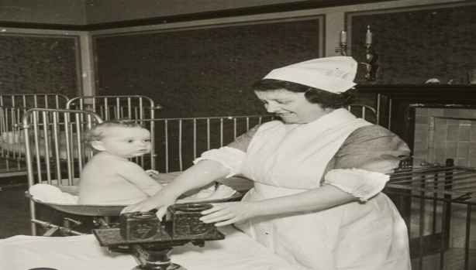
- Services include antenatal classes, birth planning sessions, routine health monitoring and advice on nutrition, breastfeeding and mental wellbeing. This approach aligns with NHS priorities for personalised, preventative and community-based care.
BREIF HISTORY
- Pre-1900s – births attended by traditional “handywoman” or local midwives, with little formal training and wide variations in
standards of care
- 1902 Midwives Act – introduced training, registration and regulation of midwives in the UL, marking the start of professional
midwifery (Keates, 2022)
- 1948 – NHS founded – maternity care became free and universally available, by integrating community midwifery within the
public health system
- 1970-1990s – increased medicalisation of childbirth led to a shift from home births to hospital-based deliveries
- 2016-present – NHS policy (Better Births, NHS Long Term Plan 2019) emphasises personalised, community-based care and
- continuity of carer models. (Lumineau, 2024)
- Ongoing policy initiatives continue to promote integrates maternity systems, digital record keeping and enhanced collaboration
across NHS and community services.
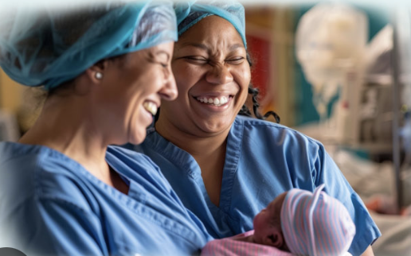
CURRENT FUNCTIONING (MyNursesLife, 2025)
- Operates under NHS Trusts and Health Boards, and services follow NICE Antenatal Care Guidelines, which outline evidence-based
standards for maternal and fetal wellbeing. (National Institute for Health and Care Excellence, 2021)
- The first booking appointment typically occurs around 8-10 weeks of gestation, where the midwife completes a comprehensive health
Assessment, risk evaluation and care plan.
- Services aim to deliver culturally sensitive, inclusive care, acknowledging diverse beliefs and preferences around childbirth.
- Midwives collaborate with GPs, obstetricians, health visitors and social services to ensure continuity.
- Antenatal care includes
- Blood pressure and urine checks (early detection of pre-eclampsia and gestational diabetes)
- Fundal height and fetal heartbeat monitoring (track development and identify potential complications)
- Health education (covers lifestyle, diet, mental health and birth preparation)
- Referrals (obstetric or specialist services, where any potential risks are identified) (NHS, 2020)
CHALLNEGES FACED BY THE SERVICE
- Staffing shortages and workload pressures:
REFERENCES:
Bradford, B.F., Wilson, A.N., Portela, A., McConville, F., Fernandez Turienzo, C. and Homer, C.S.E. (2022). Midwifery Continuity of care: a Scoping Review of where, how, by Whom and for whom? PLOS Global Public Health, [online] 2(10). Available at: https://www.ncbi.nlm.nih.gov/pmc/articles/PMC10021789/.
Burns, C., Foster, L. and Benjamin, A. (2024). Midwife quit over ‘unsafe care’ and staffing. BBC News. [online] 9 Jan. Available at: https://www.bbc.co.uk/news/health-67732916.
Keates, M. (2022). Research rabbit hole ~ 1931 midwives and handywomen – I Walk Alone. [online] iwalkalone.co.uk. Available at: https://iwalkalone.co.uk/research-rabbit-hole-1931-midwives-and-handywomen/.
Lumineau, E. (2024). Midwifery in the 17th Century. [online] The Real Mary King’s Close. Available at: https://www.realmarykingsclose.com/blog/midwifery-in-the-17th-century/.
My Nurses Life. (2025). Homepage. [online] Available at: https://mynurseslife.com.
National Institute for Health and Care Excellence (2021). Overview | antenatal care | guidance | NICE. [online] www.nice.org.uk. Available at: https://www.nice.org.uk/guidance/NG201.
NHS (2020). Antenatal Checks and Tests. [online] nhs.uk. Available at: https://www.nhs.uk/pregnancy/your-pregnancy-care/antenatal-checks-and-tests/.
Vousden, N., Bunch, K., Kenyon, S., Kurinczuk, J.J. and Knight, M. (2024). Impact of maternal risk factors on ethnic disparities in maternal mortality: A national population-based cohort study. The Lancet Regional Health. Europe, 40(40), pp.100893–100893. doi:https://doi.org/10.1016/j.lanepe.2024.100893.

- England has a shortage of approximately 2500+ midwives. Staff shortages can reduce continuity of care, impacting women’s
experiences and outcomes. (Burns, Foster and Benjamin, 2024)
- High workloads, long shifts and emotional strain, contribute to burnout, stress and staff retention challenges. Increased birth
rates, complex pregnancies and expanding service expectations place an additional strain on community midwifes.
- Recruitment and retention issues are compounded by limited funding, rising administrative demands and workforce aging. These
factors can undermine service quality, patient safety and the midwife’s ability to provide personalised, woman-centred care.
- Health inequalities and accessibility:
- Research indicates that women from ethnic minorities and deprives areas face higher risks of adverse maternal outcomes, including
stillbirth and maternal mortality. (Vousden et al., 2024)
- Barriers include language, poverty, transport and cultural differences. Rural and remote region may experience limited access to
midwifery clinics or home visit services due to staff shortages and transport difficulties.
- Service working to provide inclusive and culturally sensitive care, outreach and community engagement.
- Tracking disparities is a key NHS priority to ensure equity, inclusivity and safety for all women.

