
PROJECT PLANNING AND MANAGEMENT IN WORKPLACE
[ALEHA BEGUM 1709652]

December 20, 2019
University of Wales Trinity Saint David

Table of Contents
Executive Summary 1
Introduction 2
Main Findings 4
Conclusion (average of 10% of word count) 5
Bibliography 6
UPDATE TABLE FREQUENTLY – CHECK IT HAS BEEN UPDATED PRIOR TO SUBMISSION

Introduction

Project management is the implementation of methods, processes, skills, experience and knowledge to achieve a set target, providing timescales and boundaries that constrain deliverables. (APM, 2019). It identifies risks and hazards, aiming to plan, control and organise tasks to ensure target is achieved. (Tech Republic, 2019).
The project life cycle is a process that managers implement throughout their project. The framework helps plan and is critical for organisations. (Maven Link, 2019). The cycle consists of five stages; initiation, planning, execution, monitoring and control and execution. (TW Project, 2018).
Cardiff Muslim School is an independent, full time, faith school for both boys and girls. It is a non-profit charity school with no government support. (CMPS, 2018).
The project team members have worked along side Cardiff Muslim School towards completing a set project on fundraising and creating a workshop.

Main Findings

Initiation phase
The initiation stage is the first part of the project life cycle, consisting of defining objectives, purpose, scope, building a team and the deliverables that need to be created. (method 123, 2019).
The project members attended a meeting with school’s deputy head teacher, where aims and objectives were laid out, the purpose of the project and which charities the money will be raised for. To manage the project, a project manager was chosen, as this helps provide direction, vision and manage time effectively. (2020 Project Management, 2019). To layout the project, a quad chart was created using the information provided. It provides a quick review of all aspects that result in effective and quick decision making. (Think Outside the Slide, 2015).
A quad chart consists of four sections; project scope, referring to plans and processes, stakeholders, critical success factors, which is desired outcomes and secondary benefits, and lastly, measures of success. Using this tool helps structure all ideas into a manageable state. (Chegg Study, 2019).
The chart created, highlights the purpose of the project, which is to fundraise and create a leadership workshop, and raise school’s awareness. Some of the identified stakeholders are parents and children. The desired result is to raise £4000. One of the ways the project will prove successful is if the children have been educated on leadership through the workshop.
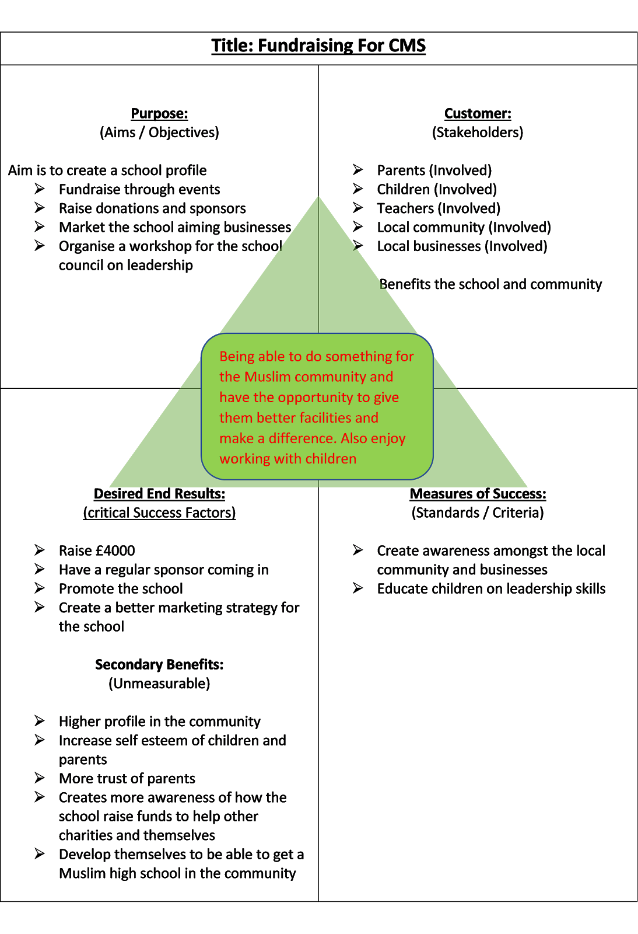
Although the chart provides a lot of advantages for an organisation, it does not prioritise the important factors within it, which could cause misunderstandings. (Quora, 2018).
Planning
This stage commences once the project has been approved. All the larger tasks are broken down into smaller ones, and a schedule is drawn for the activities. Project timeline, budgets and resources are considered and collected. Skills and experience of all group members will be brought forward to assist with task management. (Lucid Charts, 2017). This provides the opportunity to highlight any risks and hazards and identify all stakeholders linked to the project, devising a plan to keep them updated. (Open Text BC, 2019).
To help with the identification of project stakeholders, the project team members completed a stakeholder analysis. This process helps identify who the stakeholders are, grouping them in regard to their participation levels, interests and how they will influence the project. Communication methods will be discussed, looking into motivation factors, other priorities and whether they will have a positive outlook on the project. (Product Plan 2019). Organisations benefit from this tool as it helps shape the project using stakeholder’s opinions and win more resources from their support. (Mind Tools, 2019).

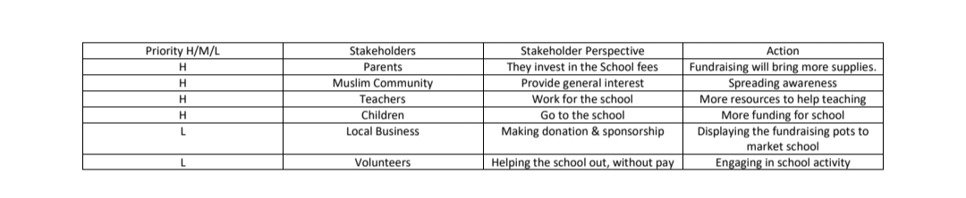
The stakeholder analysis drawn by the project members shows that some of the high priority stakeholders are parents, who invest through school fees, Muslim community who have a general interest and teachers that work in the school, all of whom will bring in more money for resources and to spread awareness.
Criticisms to the theory is that as stakeholders are the sole focus of this management tool, it can become unethical as it can reduce the importance of shareholders and the duty that managers have towards them. (Stakeholder Map, 2019).
A model that can be used to assist the planning process is the McKinsey 7s Model, a tool that analyses an organisation using seven internal elements; strategy, systems, structure, shared values, skills and staff. (Jurevicius, O, 2013). All aspects are interlinked, and a change to one will affect the rest. It also shows how reliant one factor is to the other ones. This can help to clearly understand what the implications will be to any actions. (Kenton, 2019).
Execution
The execution phase is normally the longest stage. (Study.com, 2019). The main task is to implement a variety of processes and conduct deliverables, evaluating processes according to specifications. Project scope must be executed, communicating with stakeholders and team building exercises. (Orange Scrum, 2019).
The project members have used a work-breakdown structure to help define all tasks and targets that need to be achieved, organising them on several levels, portrayed through a diagram. (Cohen, 2018). The two types of structures are called Top-Down and Bottoms-Up, which are methods for analysing securities, helping with budgeting, goal setting and forecasting. (Investopedia, 2019). The Top-Down approach is driven by the upper level executives within a business. The decisions are made by them and delivered to the lower levels. (Eby, 2018).
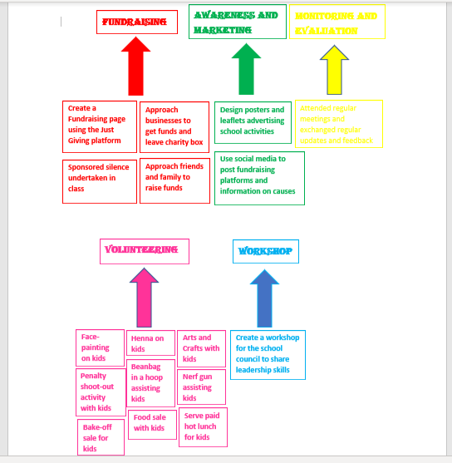

Bottoms-Up approach is the option that the project members opted for. This involves individuals from all departments collaborating and sharing knowledge. The process requires working on smaller tasks towards the deliverables. (Human Business, 2016).
There were five deliverables that were identified. The deliverable that had the most tasks associated with it was volunteering, including face painting, henna, arts and craft session, penalty shoot- out and several others. Considering the SWOT analysis, which is a tool that helps develop business strategies, consists of four aspects, strengths, weaknesses, opportunities and strength. (Parsons, 2018). The strength of these activities is that parents of the school want to have more involvement within the school, so this provided and opportunity for them to do so, by bringing in food for the bake sales and helping with activities.
Monitoring and evaluation
monitoring and control is the fourth aspect to the cycle, but a lot of the monitoring takes place during execution phase. This process ensures the project is running smoothly, on time and according to the set time frame. (Office Timeline, 2017). The progression of tasks will be regularly monitored through meetings with managers, who use the information to compare against their initial plans, all whilst ensuring performance is controlled. (BC Campus, 2019).
The project members completed a risk analysis chart that helps to highlight and review any risks and hazards. The chart aims to measure the factors in terms of how likely it is to occur, the priority of importance and the impact it would have on the project. Strategic plans are considered and actions to overcome them are also identified. (Group Map, 2019).
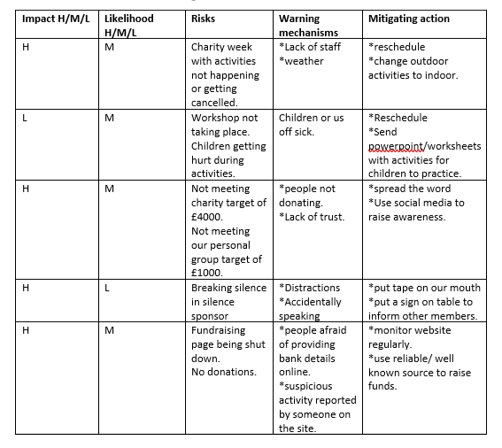
Upon completion of the risk analysis, it was identified that one of the risks that would have a high impact on the project and has a medium likelihood of happening is the cancellation of charity week events, which would be due to lack of staff and poor weather conditions. The mitigating actions decided for this is rescheduling the event or changing outdoor activities to be done inside. The other risks can be seen on the above chart.
To ensure all activities and tasks were being carried out within the set guidelines, certain factors such as religious aspects also had to be considered. Tasks and activities were regularly monitored, and final critical measures were taken by the project manager.
The limitation to the risk analysis is that there is a lack of comprehensive data, and little time to evaluate or training, as it can affect the time scale towards deadline. (Bright Hub PM, 2019).
Another tool the project members implemented is the iron triangle, which is a three-factor framework that are interlinked. These are time, cost and quality. A change in one factor will show an impact on the other two factors, so consideration before changes must always be taken and mitigating actions prepared in case sudden changes are required. (Stakeholder Map, 2019).
An example of a situation that shows the correlation of the iron triangle within the project, is when one of the group members was doing henna for the children at the school as part of volunteering. To help improve the quality of the designs, many templates were printed off which costed for the ink and paper. However, the range of options caused a delay in the children choosing which design they want resulting in long queues.
Implementing PESTEL with the school, an analytical framework to monitor external factors within organisations, an aspect of the model is ‘social’ referring to factors such as population, age distribution, careers and education. Many Muslim schools across Wales and England are not complying with Ofsted, which is a legal requirement. (Guardian, 2008). However, recent reports have shown that the school is teaching in accordance to most of the regulations set by Ofsted, but there is room for improvement, which is needed to meet educational needs. But, this could also be a political or legal factor due to racial discrimination or Ofsted rules. (Estyn, 2018).

Evaluation
Evaluation is the closing stage of the cycle, where everything is reviewed and reflected on. The findings will help towards effective decision-making and planning. Strengths and weaknesses are identified, allowing continuous improvement and learning using lessons learnt from experience and recommendations and inputting them into future projects. (UNDOC, 2019).
The project members used the Gibbs’ reflective cycle to reflect on the experience and how well the project was managed. The cycle consists of five stages, which help to summarise and conclude the project, looking into all the different aspects. (Mind Tools, 2019). As there was a lot of tasks that needed to be completed, as identified through the Bottoms-Up approach, it was important to have a schedule to follow, and to plan effectively, a Gannt chart was created.
A Gannt chart is a tool used to display all activities within a project against the time of when it should start and finish. (Gannt.com, 2019). Advantages of using this tool is that it provides easier task representation, timescales are clearly visible and helps plan and manage time better. (Analysis Tabs, 2019).
As visible on the Gannt chart below, all the identified tasks have been aligned. The tasks ranged from meetings with the schools, helping with charity events, creating workshops, designing leaflets and fundraising. Each aspect had a specific timescale that needed to be adhered to, and as the chart shows, all tasks were completed on time and within the set time frame.

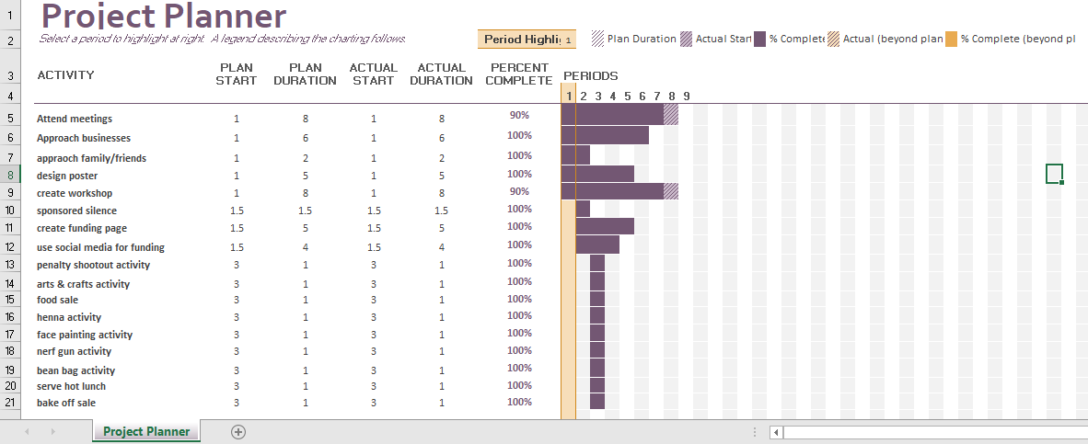

There are however some drawbacks to using this tool. It requires a lot of effort to create and manage, updating is time consuming and all tasks are not completely visible in one screen view. (Analysis Tabs, 2019).
An alternative tool that can be used for this stage is a network diagram, which is a visual presentation of project schedules, helping to track and plan a project from start to finish. There are two types of this diagram. The arrow diagram uses nodes for events, with arrows for activities, and the precedence diagram states the activities as they occur. (Bright Hub, 2019).
All tools have limitations and drawbacks, and the disadvantages to using network diagrams is that it is time consuming to create, costs a lot of money to produce and can become quite complex. (Ask Will Online, 2018).
As a group, reflecting on experience and completing tasks, the team found they worked well, collaborating positively. Communication was also high between the group and the school, using different platforms to stay in touch. Each individual displayed their own skills and knowledge throughout. Some of the issues faced was not being able to attend certain events due to short notice from the school, or because of travel time.

Conclusion

To conclude, the report has shown that the use of quad charts has helped to initialise the project by highlighting all the different aspects of the project and using this as a guide to plan ahead. (Chegg Study, 2019). The use of the stakeholder analysis allowed group members to effectively identify all the stakeholders and configure means of contact to keep them updated. (Product Plan, 2019). Using the Bottoms-Up approach was useful as it worked best for the tasks that were required for completion and helped organise events effectively. (Human Business, 2016). The risk analysis chart allowed the project members to identify and prioritise risks and mitigate actions so that they were fully prepared for any sudden changes. (Group Map, 2019). A Gannt chart was useful as it helped schedule the whole process, allowing time for planning and preparation. It also gave a visual idea of how well the team was doing on time management. (Analysis Tabs, 2019).
To develop themselves for next time, personal issues regarding travelling or personal commitments should be acknowledged with the organisation during the initiation phase to ensure that sufficient notice can be provided regarding special events and activities. also, during the workshop event, one activity was left un-done due to falling behind on time, so more consideration could be taken to ensure everything is done with a strict timetable. This was a weakness identified from SWOT.

Bibliography

2020 Project Management (2019), ’10 Reasons Why Your Project Needs A Project Manager’, [Online] Available: https://2020projectmanagement.com/resources/role-of-project-managers/10-reasons-why-your-project-needs-a-project-manager, [Accessed: 2019,12,10].
Analysis Tabs (2019), ‘Advantages and Disadvantages of Gannt Charts’, [Online] Available: https://analysistabs.com/gantt-chart/advantages-disadvantages/, [Accessed: 2019,12,12].
APM (2019), ‘What is Project Management?’, [Online] Available: https://www.apm.org.uk/resources/what-is-project-management/, [Accessed: 2019,12,10].
Ask Will Online (2018), ‘Pros and Cons of Network Diagrams’, [Online] Available: https://www.askwillonline.com/2012/01/pros-and-cons-of-network-diagrams.html, [Accessed: 2019,12,12].
BC Campus (2019), ‘The Project Life Cycle (Phases), [Online] Available: https://opentextbc.ca/projectmanagement/chapter/chapter-3-the-project-life-cycle-phases-project-management/, [Accessed: 2019,12,11].
Bright Hub (2019), ‘What are Network Diagrams?’, [Online] Available: https://www.brighthubpm.com/project-planning/12712-connecting-a-projects-parts-with-a-network-diagram/, [Accessed: 2019,12,12].
Bright Hub PM (2019), ‘project Risk Management’, [Online] Available: https://www.brighthubpm.com/risk-management/91362-the-limitations-of-risk-assessment-analysis/, [Accessed: 2019,12,11].
Chegg Study (2019), ‘What is a Quad Chart?’, [Online] Available: https://www.chegg.com/homework-help/questions-and-answers/quad-chart-quad-chart-one-page-summary-project-visual-well-descriptive-simple-tool-extreme-q25204961, [Accessed: 2019,12,10].
CMPS Wales (2019), ‘Prospectus’, [Online] Available: https://www.cmpswales.org/docs/Cardiff_Muslim_Primary_School_Prospectus_Website_2017-18.pdf, [Accessed: 2019,12,10].
Cohen, E (2018), ‘A Beginner- Friendly Guide to Work Breakdown Structures (WBS)’, [Online] Available: https://www.workamajig.com/blog/guide-to-work-breakdown-structures-wbs, [Accessed: 2019,12,11].
Eby, K (2018), ‘Which Management Style is best for you: Top-Down or Bottoms-Up Approach?’, [Online] Available: https://www.smartsheet.com/top-down-bottom-up-approach, [Accessed: 2019,12,11].
Estyn (2018), ‘Cardiff Muslim School’, [Online] Available: https://www.estyn.gov.wales/sites/www.estyn.gov.wales/files/documents/Inspection%20report%20Cardiff%20Muslim%20Primary%20School%202014%20%28English%20only%29_0.pdf.pdf.pdf.pdf.pdf.pdf.pdf.pdf.pdf.pdf.pdf.pdf.pdf.pdf.pdf.pdf.pdf.pdf.pdf.pdf.pdf.pdf.pdf.pdf, [Accessed: 2019,11,24].
Gannt.com (2019), ‘What is a Gannt Chart?’, [Online] Available: https://www.gantt.com/, [Accessed: 2019,12,11].
Group Map ‘Risk Assessment’, [Online] Available: https://www.groupmap.com/map-templates/risk-assessment/, [Accessed: 2019,12,11].
Human Business (2016), ‘Bottoms-Up Approach’, [Online] Available: http://www.humanbusiness.eu/bottom-up-approach/, [Accessed: 2019,12,11].
Investopedia (2019), ‘Top-Down vs, Bottoms-Up: What’s the Difference?’, [Online] Available: https://www.investopedia.com/articles/investing/030116/topdown-vs-bottomup.asp, [Accessed: 2019,12,11].
Juervicius, C (2013), ‘McKinsey 7s Model’, [Online] Available: https://strategicmanagementinsight.com/tools/mckinsey-7s-model-framework.html, [Accessed: 2019,12,11].
Kenton, W (2019), ‘McKinsey 7s Model’, [Online] Available: https://www.investopedia.com/terms/m/mckinsey-7s-model.asp, [Accessed: 2019,12,11].
Lucid Chart (2017), ‘The 4 Phases of the Project Management Life Cycle’, [Online] Available: https://www.lucidchart.com/blog/the-4-phases-of-the-project-management-life-cycle, [Accessed: 2019,12,11].
Maven Link (2019) , ‘What is the Project Life Cycle?’, [Online] Available: https://www.mavenlink.com/resources/what-is-the-professional-services-project-life-cycle, [Accessed: 2019,12,10].
Method 123 (2019), ‘Project Initiation Phase’, [Online] Available: https://www.method123.com/project-initiation-phase.php, [Accessed: 2019,12,10].
Mind Tools (2019), ‘Gibbs’ Reflective Cycle’, [Online] Available: https://www.mindtools.com/pages/article/reflective-cycle.htm, [Accessed: 2019,12,11].
Mind Tools (2019), ‘Stakeholder Analysis’, [Online] Available: https://www.mindtools.com/pages/article/newPPM_07.htm, [Accessed: 2019,12,11].
Office Timeline (2017), ‘Conquer the 5 Phases of the PM Life Cycle’, [Online] Available: https://www.officetimeline.com/blog/conquer-the-5-phases-of-the-project-management-life-cycle, [Accessed: 2019,12,11].
Open Text BC (2019), ‘The Project Life Cycle (Phases)’, [Online] Available: https://opentextbc.ca/projectmanagement/chapter/chapter-3-the-project-life-cycle-phases-project-management/, [Accessed: 2019,12,11].
Orange Scrum (2019), ‘Execution in Project Management’, [Online] Available: https://www.orangescrum.com/tutorial/introduction-to-project-management/execution-in-project-management, [Accessed: 2019,12,11].
Parson, N (2018), ‘What is a SWOT Analysis, and how to do it right’, [Online] Available: https://www.liveplan.com/blog/what-is-a-swot-analysis-and-how-to-do-it-right-with-examples/, [Accessed: 2019,12,12].
Product Plan (2019), ‘What is Stakeholder Analysis?’, [Online] Available: https://www.productplan.com/glossary/stakeholder-analysis/, [Accessed: 2019,12,11].
Professional Academy (2019), ‘Marketing Theories- PESTEL Analysis’, [Online] Available: https://www.professionalacademy.com/blogs-and-advice/marketing-theories---pestel-analysis, [Accessed: 2019,12,11].
Quora (2019), ‘What is a Quad Chart?’, [Online] Available: https://www.quora.com/What-is-a-quad-chart, [Accessed: 2019,12,11].
Ray, S (2018), ‘Project Initiation: How to start off your project off right’, [Online] Available: https://www.projectmanager.com/blog/project-initiation, [Accessed: 2019,12,10].
Stakeholder Map (2019), ‘Stakeholder theory’, [Online] Available: https://www.stakeholdermap.com/stakeholder-theory.html, [Accessed: 2019,12,11].
Stakeholdermap.com (2019), ‘Project Management, project planning, templates and advice’, [Online] Available: https://www.stakeholdermap.com/project-management/project-triangle.html, [Accessed: 2019,12,11].
Study.com (2019), ‘The Execution Phase of Project Management’, [Online] Available: https://study.com/academy/lesson/the-execution-phase-of-project-management.html, [Accessed: 2019,12,11].
Tech Republic (2019), ‘The Purpose of Project Management and Setting Objectives’, [Online] Available: https://www.techrepublic.com/resource-library/whitepapers/the-purpose-of-project-management-and-setting-objectives/, [Accessed: 2019,12,10].
The Guardian (2008), ‘Why do too many muslims leave school unqualified?’, [Online] Available: https://www.theguardian.com/education/mortarboard/2008/apr/01/whydotoomanymuslimsleave, [Accessed: 2019,11,25].
Think Outside The Slide (2015), ‘Dealing With Quad Charts:; Issue #348 October 13, 2015’, [Online] Available: https://www.thinkoutsidetheslide.com/issue-348-october-13-2015/, [Accessed: 2019,12,10].
TW Project (2018), ‘Project Life Cycles: Phases and Characteristics’, [Online] Available: https://twproject.com/blog/project-life-cycle-phases-and-characteristics/, [Accessed: 2019,12,10].
UNODC (2019), ‘Evaluation in the project/programme cycle’, [Online] Available: https://www.unodc.org/unodc/en/evaluation/evaluation-and-the-project-programme-cycle.html, [Accessed: 2019,12,11].

Appendix
This section should include any supporting documentation/evidence. Take care not to include documentation that is particularly large. You should also include the source of the information within this section in your reference list.

