Imaginary Friends: How Has CGI Transformed Animated Characters in Film?

Andrew Foxall – 2517335
Animation & VFX – Animation Insights & Perspectives

Table of Contents
Introduction 1
1. Before CGI: Practical Methods For Creating Characters 1
2. The Emergence of CGI Characters: Design Evolution 1
3. Modern CGI: Making The Imaginary Beleivable 1
4. The Future of CGI Characters 1
Conclusion 1
Reference List 2

Introduction
This research journal investigates the way that Computer Generated Imagery has changed the realism and creation of animated characters in film. The focus of this journal is on the evolution of how lifeless and imaginary concepts transformed into real characters on screen.
Filmmakers before CGI had to use practical methods to animate characters such as hand drawings, stop motion, puppetry, claymation, and other techniques. Since computer generation has been introduced these practical processes have been used increasingly less. As software's and computers become more powerful the way characters are designed, interact with environments, and transform keeps improving.
This journal will go through all animation eras, from hand drawings to AI creations. Looking at key milestones in the development of animated characters highlighting the impact that CGI has had and how it has impacted the film industry. This research will also aim to predict what the future holds for character design animation and how CGI will affect it.
Starting by exploring techniques used before CGI by animators such as Winsor McCay, Willis H. O’Brien, and Peter Lord. Then moving onto the emergence of CGI and how it quickly took over the industry single handedly producing full length films like Toy Story and bringing animated characters to life in Planet of the Apes, Avatar, and so many more motion pictures... Finally, investigating what the future of CGI animation could look like with the development of software's like Unreal Engine, Autodesk Products, and Artificial Intelligences.

Before CGI: Practical Methods for Creating Characters
Before there was any CGI, animators had to rely on many different physical methods to design and animate figures. Arguably the first ever animation was ‘Fantasmagorie’ by Emile Cohl in 1908. Cohl was a pioneer in animation being the first person to use the traditional animating technique, sketching out and filming each frame one at a time. This hand drawn animation was of stick figures, them being the first ever animated characters. Though seeming now quite simple, this short under two-minute animation took 700 individual drawings [1].
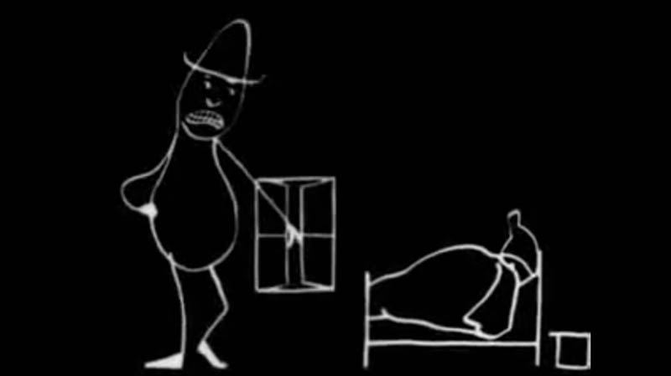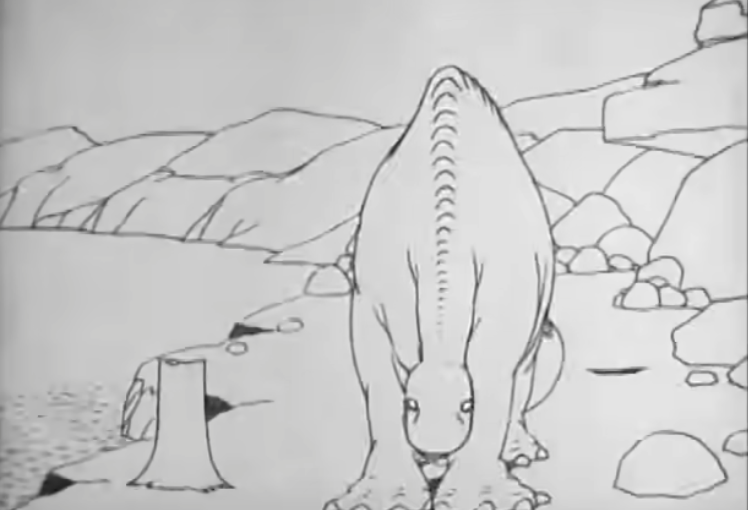
Cohl’s work was inspirational and created a pathway for others to animate such as Winsor McCay. In 1914 McCay created the first distinguishable character, Gertie the Dinosaur, in a short animation. The character style and personality of Gertie is what inspired the iconic characters from Warner Brothers and Disney [2]. In the 1930s Disney popularized animated films starting with ‘Snow White and the Seven Dwarves’, which took over three years to produce, where 250,000 frames were drawn out and pictured [3]. Alongside Disney, Warner Brothers were releasing their own animations in the 1930s with their Looney Tunes series also pushing the animation mainstream [4]. These early animated films and series were able to create characters with personality; however, designs were simple and took lots of time and money to produce. Hand drawn traditional animation has come a long way creating some of the most iconic and creative characters, though the frame-by-frame sketching is time consuming and makes it extremely difficult to revise scenes or amend mistakes.
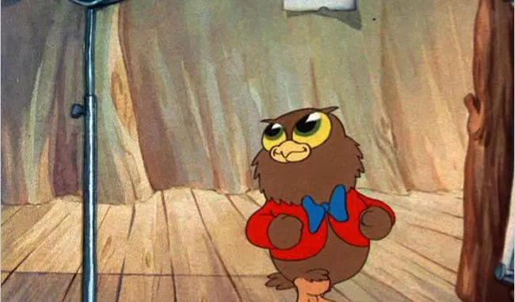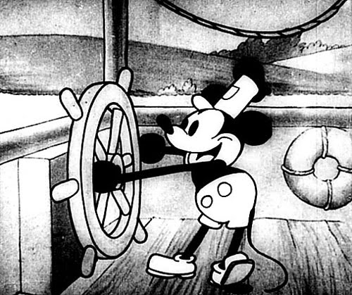
Stop motion animation was the other main alternative method animators used. Stop motion includes moving a physical scene incrementally frame by frame and sequencing it. There are many different types of stop-motion such as puppet, cutout, object, silhouette, and clay animation [5]. Stop motion created more realistic looks for characters when compared traditional animation. Willis O’Brien was one of the most prolific animators in stop motion producing animated models like ‘The Lost World’ and ‘King Kong’ in 1925 and 1933 respectively [6]. O’Brien like Disney with hand drawn animation, made stop motion extremely popular with mainstream films. However, similarly to hand drawn animation, stop motion is very time consuming to produce, ‘King Kong’ took 150 hours to produce [7]. Even more recent productions like ‘Wallace & Gromit: The Curse of the Were-Rabbit’ took Aardman Animations 5 years to produce in 2005 [8].
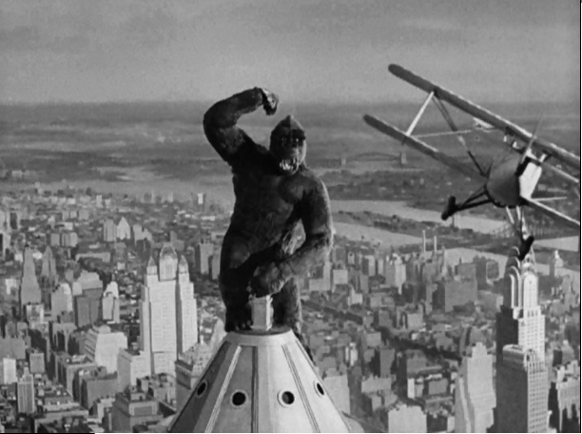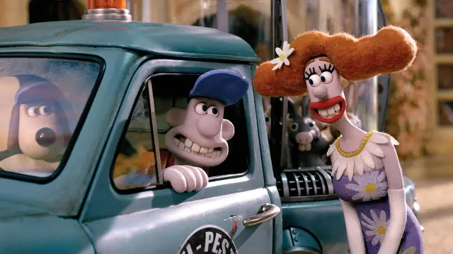
Both types of animation have come a long way, having improved significantly and still being used today. Though the time it takes to create each frame physically isn’t practical, especially when trying to make realistic models. Though visual effects can enhance some stop motion models to seem quite realistic, which they did quite well in Jurassic Park in 1993. However, Jurassic Park integrated both CGI and stop motion into creating the dinosaurs in the film, transitioning in the later films fully to computer generated dinosaurs as it was more realistic and easier to produce [9].
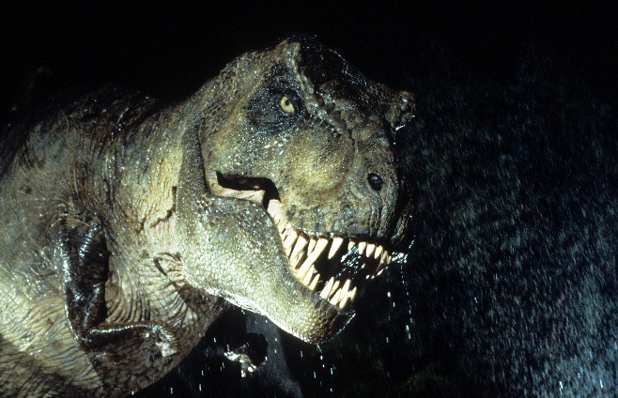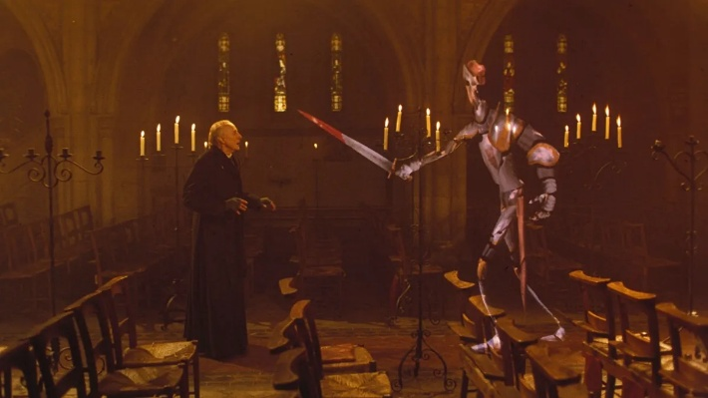

The Emergence of CGI Characters: Design Evolution
Computers in film were initially used for adding effects, enhancing shots, and creating simple digital visuals. In 1985 the first CGI character was introduced in ‘Young Sherlock Holmes’ called the ‘Stained Glass Knight’ coming from Industrial Light & Magic [10]. In 1986, the Computer Division was purchased by Steve Jobs and turned into ‘Pixar’ a new independent company. Pixar went on to produce 3D animations in the like ‘Red’s Dream’ in 1987, ‘Knick Knack’ in 1989, and then ‘Toy Story’ in 1995. Pixar was able to create visually detailed and well rendered characters with clear personality. Pixar were able to show deep emotion and characteristics of each character with subtle and clear movements and acts. This was revolutionary being the first fully CGI film, creating a completely new path for animators. The success of ‘Toy Story’ led to ‘Bugs life’ in 1998, ‘Monsters Inc’ in 2001, ‘Finding Nemo’ in 2003, and so many more films, each progressing in animation quality as time went on [11].
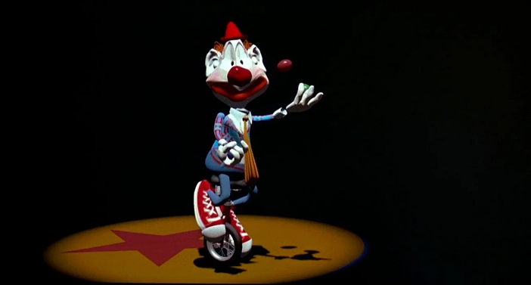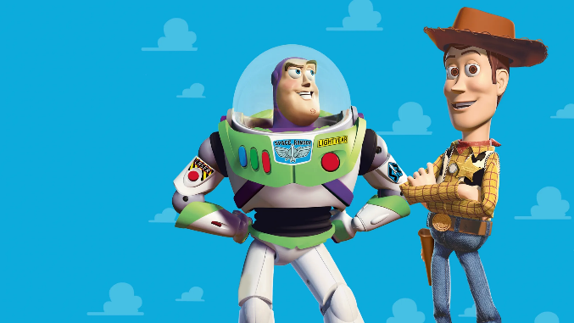
Another huge step in CGI was Jurassic Park, though only used for small portions of the film the CGI dinosaurs they created almost seemed believable. This was one of the first attempts in CGI animation to produce animated character that looks real.
Most companies producing CGI characters in the early stages had their own in-house software’s for animation and rendering, like Pixar who used Renderman as their rendering software starting in 1988 [12]. Around this time Autodesk were developing their own software’s, where they introduced 3D capabilities into ‘AutoCAD’ in the 1990s and then produced a program called ‘Maya’ in 1998 [13].

Modern CGI: Making The Imaginary Believable
CGI in the last 20 years has been remarkable, the aim hasn’t just been about making impressive characters, but making them believable, convincing an audience that they are real. Characters may look realistic in design, but you also need the right texturing, lighting, and animation to fit the scene and character. You need the acting as well as the model.
The perfect example of this is ‘Davy Jones’ in ‘Pirates of the Caribbean’ in 2006. The complexity of the characters face, skin texture, and emotion he displayed made you believe in the character. Using motion capture, ILM were able to clearly give the character human expressions and mannerisms [14].
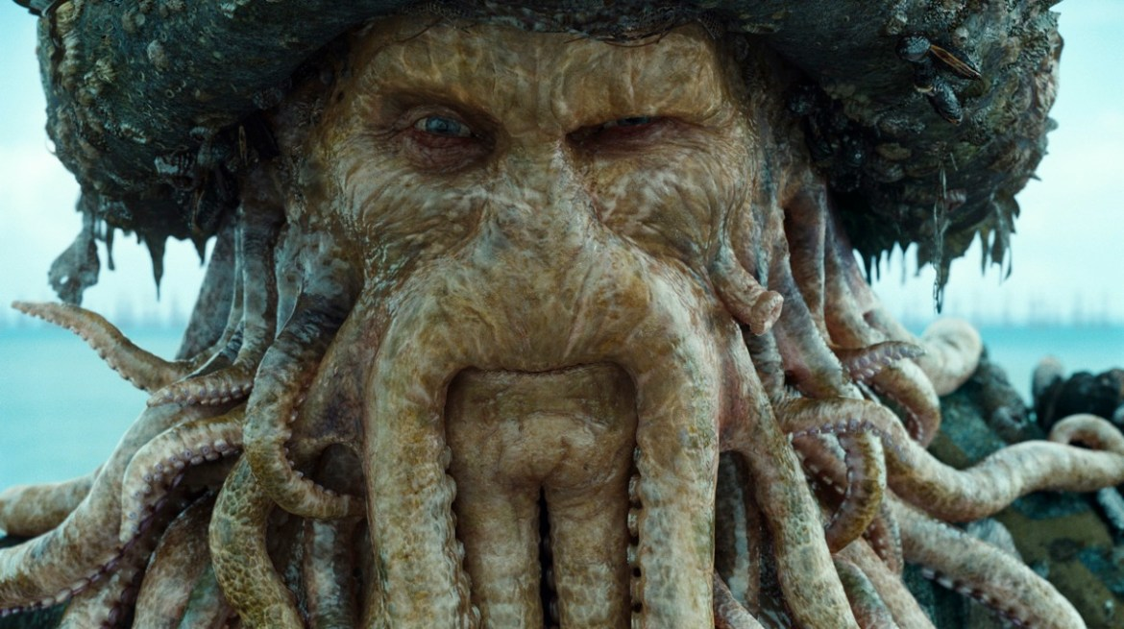
‘Avatar’ then did the same on a larger scale and made it even more convincing. ‘Avatar’ used lots of new motion capture techniques to make characters even more convincing, including facial camera rigs, full body capture, and simulated cameras [15].
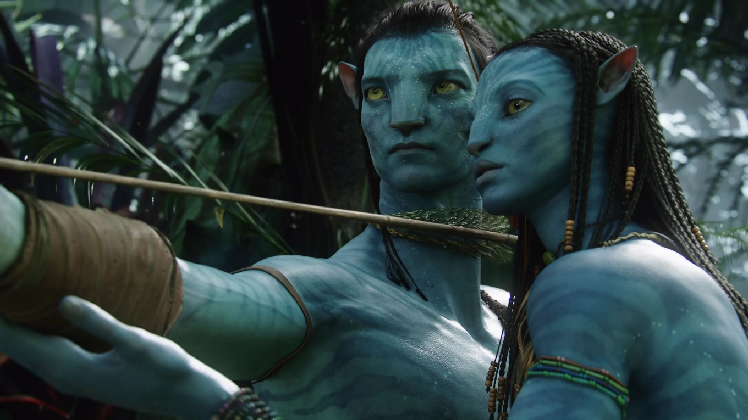
In ‘Planet of the Apes’, the main character ‘Caeser’ is an ape, a non-human character who has lots of emotion. Again, motion capture and CGI work hand in hand on this project to produce an emotional animated character [16].
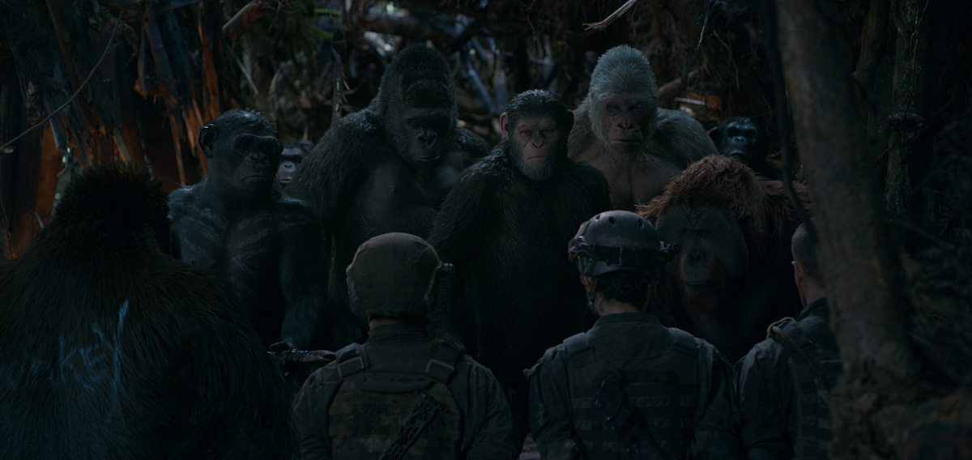
All these films and many others are heavily reliant on the software behind it. As the software and programmes improve the better the detail and rendering in the movements, designs, and environment interaction characters have. Currently programmes like Autodesk Maya, Blender, Cinema 4D, Houdini and many others enable animators to bring these characters to life [17]. Al of these software’s have been around for many years and as they develop in the future so will the characters they are used to produce.
These modern CGI techniques have completely overthrown traditional and stop motion animation due to how convincing they have become. People are now even producing models/puppets using CAD software’s instead of hand modelling and creating stop motion aesthetic animations using CGI, like the ‘LEGO Movie’ and ‘Flushed Away’ to save time and improve graphics [18-19].
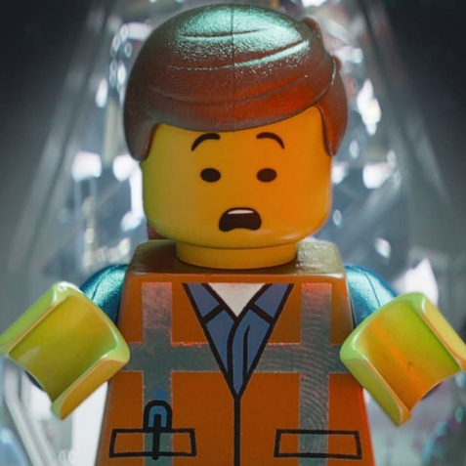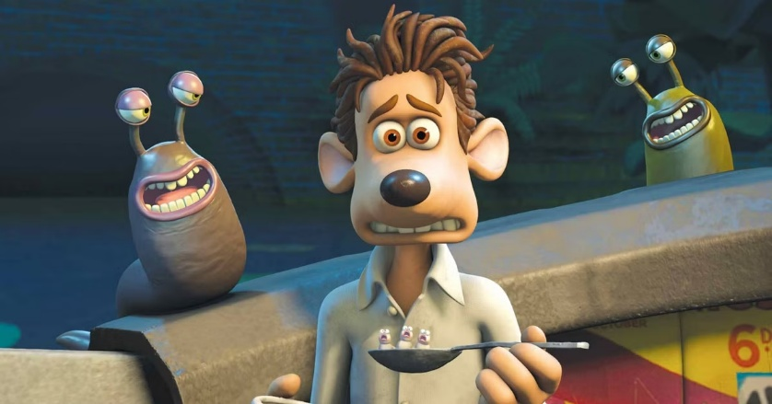

The Future of CGI Characters
As software’s and techniques keep developing, we will start to be able to see no difference between animated characters and real characters. Moving forward AI tools will be utilised more to help with effectiveness in production, in the end AI will start to produce its own modelled characters from prompts and images which are world accurate and convincingly real. Not just will rendering and software’s improve in realism but will make the process much quicker and easier [20].
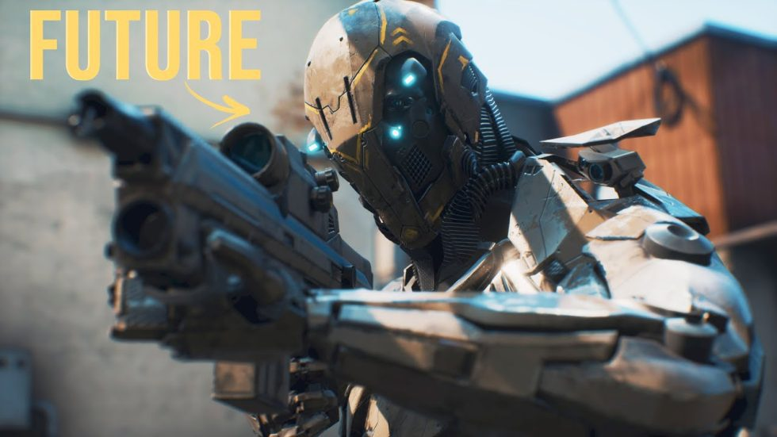
Unreal Engine is at the forefront of CGI, especially with its Metahuman software. This currently allows animators to produce 3D meshes from real human faces [21]. Hopefully with more software’s like Metahuman being developed it will become simple to produce characters with meshes, rigs, skin weighting, and textures by simply picturing or prompting what you want to see. If we develop successful programmes like this, with motion capture we would be able to quickly produce animated characters with that real emotion from the actors.

Looking into another route, AI could simulate emotion and the animation for the character producing realistic motion or movement in a scene by prompting it. AI currently has problems with consistency in scales, scenes, and overall doesn’t look convincing enough. However, as AI develops, we may be able to see it create its own believable animated characters with an original personality and style, though we are not there yet. At the pace Ai is developing hopefully we can keep seeing more AI tools [22].
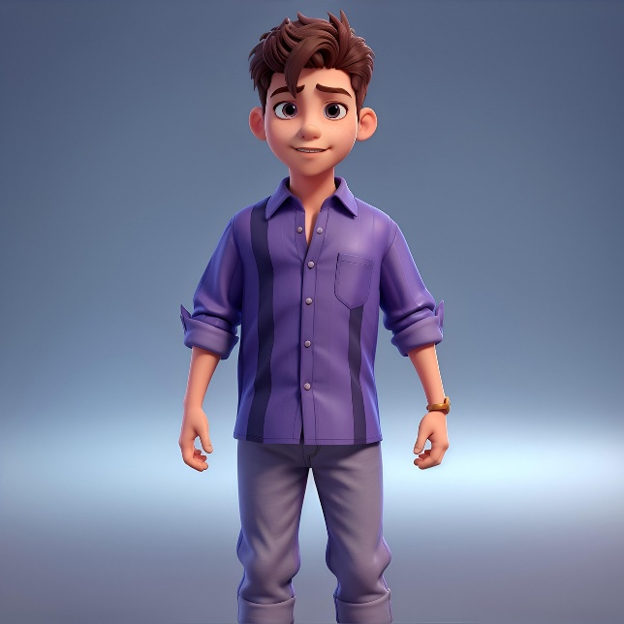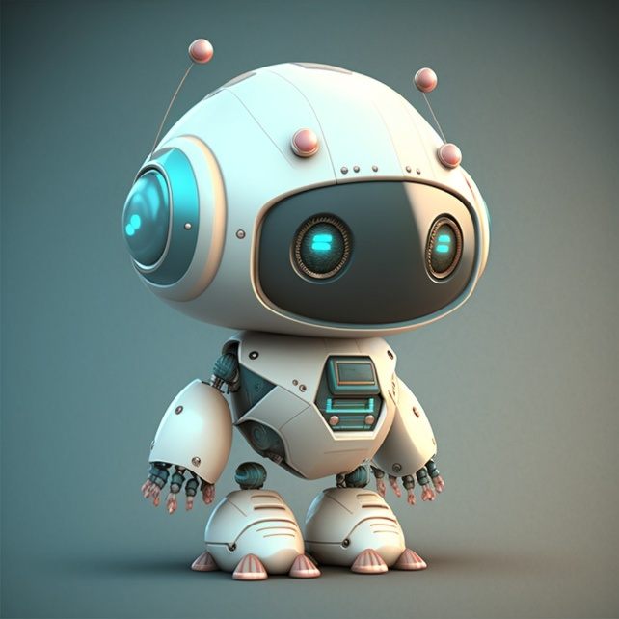
Powerful CAD, animating, and rendering software’s have come a long way, however it still has major limitations. CAD and animating applications struggle with vertices numbers, as well as rendering software’s taking extremely long to produce frames with any detail. As computers develop the rendering times will reduce, and animators will be able to produce more complex and detailed characters.
CGI has completely taken over character animation and will continue to improve with older practical methods now being outdated, the transition will only become clearer.

Conclusion
The creation and look of fictional animated characters have been transformed by CGI in film, allowing audiences to become encapsulated by characters. Character animation and design have come a long way in film and will only improve.
Early animators like Emile Cohl and Winsor McCay proved artificial figures could move, perform, and develop a personality on screen. Inspiring studios Disney and Warner Brothers to produce some of the most iconic characters ever, giving ‘Mickey Mouse’ and ‘Bugs Bunny’ clear personality using timing, emotion, and visual appeal. Stop motion artists like Willis O’Brien and Phil Tippett also showed how 3D animation could be integrated into film.
Early CGI characters then showed what could be possible, with Pixar films showing how you could produce animated style characters and ‘Jurassic Park’ highlighting the possibility of making real looking characters through their dinosaurs. Modern CGI has built on these early examples and produced characters like Davy Jones, Caeser, and the Navi which all persuaded audiences to invest emotion into and made people believe.
The future for CGI characters seems clear, improvements in efficiency to produce as well as detail by developing software’s, hardware’s and AI systems. Where software’s like Unreal Engine, Maya, and Blender will all be at the forefront of.
Overall, CGI hasn’t just caused fictional characters to become more realistic, it has changed the entire process of bringing imaginary characters to life. The best characters don’t need to just look the part they need to act it.

Reference List
[1] Kjell Knudde, ‘Emile Cohl’, Lambiek, 25/10/23. Available: https://www.lambiek.net/artists/c/cohl_emile.htm. [Accessed 10/04/26].
[2] Emma Taggart, ‘What were the first animated films?’, Linearity, 13/04/22. Available: https://www.linearity.io/blog/first-animated-films/. [Accessed 10/04/26].
[3] ‘Cinema Mouse & Man’, Time, 27/12/1937. Available: https://time.com/archive/6758026/cinema-mouse-man/. [Accessed 10/04/26].
[4] Benjamin McVay, ‘The History of Warner Brothers Animation’, Cinema Scholars, 24/05/21. Available: https://cinemascholars.com/the-history-of-warner-brothers-animation-1929-1940/. [Accessed 10/04/26].
[5] ‘Stop motion animation explained’, Adobe. Available: https://www.adobe.com/uk/creativecloud/animation/discover/stop-motion-animation.html. [Accessed 10/04/26].
[6] ‘Willis O’Brien and Stop Motion Animation’, Christina Wehner, 06/08/16. Available: https://christinawehner.wordpress.com/2016/08/06/willis-obrien-and-stop-motion-animation/. [Accessed 10/04/26].
[7] Eliza Berman, ‘5 photos that show how King Kong revolutionized movie special effects’, Time, 09/03/17. Available: https://time.com/4696931/king-kong-franchise-special-effects/. [Accessed 10/04/26].
[8] Anish Vij, ‘People shocked after finding out how long it took to film Wallace and Gromit movie’, Lad Bible, 23/12/24. Available: https://www.ladbible.com/entertainment/film/wallace-gromit-the-curse-of-the-were-rabbit-how-long-film-547067-20241217. [Accessed 10/04/26].
[9] Peter Hodges, ‘Jurassic Park at 30’, USW, 09/05/23. Available: https://www.southwales.ac.uk/news/2023/june/jurassic-park-at-30-how-its-cgi-revolutionised-the-film-industry/. [Accessed 15/04/26].
[10] Ian Failes, ‘Dennis Muren on the origins of the Stained-Glass Man in Young Sherlock Holmes’, Befores and Afters, 02/11/20. Available: https://beforesandafters.com/2020/11/02/dennis-muren-on-the-origins-of-stained-glass-man-in-young-sherlock-holmes/. [Accessed 15/04/26].
[11] ‘Our Story’, Pixar. Available: https://www.pixar.com/our-story. [Accessed 15/04/26].
[12] Joanna Goodrich, ‘The story behind Pixar’s Renderman CGI Software’, IEEE Spectrum, 21/03/24. Available: https://spectrum.ieee.org/story-behind-pixars-cgi-software. [Accessed 15/04/26].
[13] ‘Design Software History: The evolution of Autodesk’, Novedge, 05/09/24. Available: https://novedge.com/blogs/design-news/design-software-history-the-evolution-of-autodesk-from-autocad-to-fusion-360-and-beyond?srsltid=AfmBOorhK9d5HJdQSo41MMWezT__FMDhfQCBxMAjBgnYv1Uk8LFb6OIl. [Accessed 15/04/26].
[14] Ian Failes, ‘Retro Renderman: ILM’s stunning Davy Jones’, Befores and Afters, 19/08/20. Available: https://beforesandafters.com/2020/08/19/retro-renderman-ilms-stunning-davy-jones/. [Accessed 15/04/26].
[15] ‘The Evolution of Animation to CGI and the Impact of James Cameron’s Avatar’, Film Studies. Available: https://filmstudies2270.wordpress.com/animation/the-evolution-of-animation-to-cgi-computer-generated-imagery-and-the-impact-of-james-camerons-avatar/. [Accessed 15/04/26].
[16] Ian Failes, ‘From Performance Capture to Creature: How the Apes were created in ‘War for the Planet of the Apes’’, Cartoon Brew, 18/07/17. Available: https://www.cartoonbrew.com/feature-film/performance-capture-creature-apes-created-war-planet-apes-152357.html. [Accessed 15/04/26].
[17] Michelle Connolly, ‘3D Animation comparison: Top software tools for 2025’, educational Voice, 03/12/24. Available: https://educationalvoice.co.uk/3d-animation-comparison/. [Accessed 15/04/26].
[18] ‘Was the LEGO Movie stop motion?’, LEGO. Available: https://www.lego.com/en-gb/categories/adults-welcome/article/was-the-lego-movie-stop-motion. [Accessed 15/04/26].
[19] ‘Flushed Away’, Aardman. Available: https://www.aardman.com/film-tv-games/flushed-away/. [Accessed 15/04/26].
[20] ‘The future of creating realistic CGI’, Crew in Motion. Available: https://crewinmotion.com/the-future-of-creating-realistic-cgi/. [Accessed 15/04/26].
[21] ‘Metahuman’, Epic Games. Available: https://www.metahuman.com/. [Accessed 15/04/26].
[22] Noha Basiony, ‘How the Creative Limitations of AI Animation Shape Digital Art’, Educational Voice, 19/04/25. Available: https://educationalvoice.co.uk/limitations-of-ai-animation/. [Accessed 15/04/26].

