How do we use digital technology to support veterans with their mental health?
Jourdan Rhian Perry
1906458
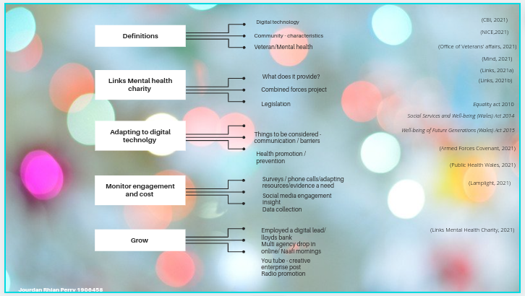

Reference list

Armed Forces Covenant (2021) Home - Armed Forces Covenant. Available at: https://www.armedforcescovenant.gov.uk/ (Accessed: 16 November 2021).

CBI (2021) Driving the adoption of digital technology. Available at: https://www.cbi.org.uk/our-campaigns/driving-the-adoption-of-digital-technology/ (Accessed: 16 November 2021).

Equality Act 2010, c. 15. Available at: https://www.legislation.gov.uk/ukpga/2010/15/contents (Accessed: 18 November 2021).

Links (2021a) LINKS | Llanelli Mental Health Charity, providing support and learning opportunities. Available at: https://www.links.uk.net/#what-we-do (Accessed: 18 November 2021).

Links (2021b) LINKS | Llanelli Mental Health Charity, providing support and learning opportunities. Available at: https://www.links.uk.net/#combined-forces (Accessed: 15 November 2021).

Lamplight (2021) Welcome to Lamplight: please login. Available at: <https://lamplight.online/> (Accessed: 17 November 2021).

Links Mental Health Charity (2021) Meet the team @ Links [video]. Available at https://www.youtube.com/watch?v=kQaJo3MKPm4&t=29s (Accessed: 17 November
2021).

Mind (2021) About Mental Health Problems. Available at: https://www.mind.org.uk/information-support/types-of-mental-health-problems/mental-health-problems-introduction/about-mental-health-problems/ (Accessed: 18 November 2021).

Nice (2021) Quality statement 1: Identifying local priorities | Community engagement: improving health and wellbeing | Quality standards | NICE. Available at: <https://www.nice.org.uk/guidance/qs148/chapter/Quality-statement-1-Identifying-local-priorities#definitions-of-terms-used-in-this-quality-statement> (Accessed: 16 November 2021).

Office of veterans’ affairs (2020) Veterans factsheet 2020. Available at: <https://assets.publishing.service.gov.uk/government/uploads/system/uploads/attachment_data/file/874821/6.6409_CO_Armed-Forces_Veterans-Factsheet_v9_web.pdf> (Accessed: 18 November 2021).

Public Health Wales (2021) Promoting healthy behaviours - Public Health Wales. Available at: https://phw.nhs.wales/about-us/our-priorities/promoting-healthy-behaviours/ (Accessed: 19 November 2021).

Social Services and Well-being (Wales) Act 2014, c. 4. Available at: https://www.legislation.gov.uk/anaw/2014/4/contents (Accessed: 18 November 2021).

Well-being of Future Generations (Wales) Act, 2015, c. 2. Available at: https://www.legislation.gov.uk/anaw/2015/2/contents (Accessed: 18 November 2021).

