

ABBREVIATION
AI | Artificial Intelligence
CIPD | Chartered Institute of Personnel and Development
HIWS | High-Involvement Work Systems
HPWS | High-Performance Work Systems
HR | Human Resources
HRM | Human Resource Management
KPI | Key Performance Indicator
KPIs | Key Performance Indicators
NHSX | NexSpace Health Systems
SDT | Self-Determination Theory
UAE | United Arab Emirates
UK | United Kingdom

TABLE OF CONTENTS
INTRODUCTION 4
TASK A: DESIGNING INNOVATIVE WORKING PRACTICES 4
Traditional Versus Innovative Working Practices 4
High-Performance Work Systems 5
High-Involvement Work Systems 6
Agile and Flexible Working Models 6
Hybrid Working 6
Sociotechnical Systems Theory 7
Recommended Innovative Working Practices for NHSX 8
TASK B: BREEDING AN ENVIRONMENT WHERE TALENT MAY GROW 8
Creating Environments Where Talent Flourishes 9
Comprehensive Talent Growth Strategy for NHSX 11
Learning and Knowledge-Sharing Strategy 13
TASK C: REFLECTIVE REPORT 14
AI as a Strategic Tool 14
Reflective Analysis 15
Personal Action Plan 16
CONCLUSION 16
REFERENCES 16

INTRODUCTION
NexSpace Health Systems (NHSX) has 600 employees across the UK, India and UAE. They are creating new health technologies, but their current employee management practices do not support innovation. NHSX currently limits employee input through centralised decision-making, limited room for trial and error, poor hybrid work practices, and no clear progression path. This report will suggest ways of incorporating high-performance and high-involvement work systems. It will examine how agile, flexible ways of working and technology can support this. It will also address responsible use of AI. NHSX needs to let employees innovate and reduce bottlenecks while keeping patient safety and other factors in mind.

TASK A: DESIGNING INNOVATIVE WORKING PRACTICES
When designing innovative ways of working, consider how work gets done, who holds power, and the relationships and technology involved. NHSX needs quicker decision-making, more empowered employees, and flexible work and technology to support this. All of which need to work together to be effective.

CRITICALLY EVALUATE TRADITIONAL WORK DESIGN VERSUS CONTEMPORARY INNOVATIVE WORKING PRACTICES
Traditional work design uses specialised roles, vertical supervision and standardised procedures. Traditional work design assigns specific roles to specific jobs. This could have provided good job security if NHSX continued this approach. Having many layers of management would slow decision-making. This could lead to little innovation and information silos within NHSX.
Allowing employees more control over their work. They would be more engaged and build stronger professional relationships, which could increase job satisfaction and output (Parker, Morgeson and Johns, 2017). Allowing too much freedom could create confusion about responsibilities. Too much work is being pushed onto employees, and communication is lacking. So NHSX should let employees work innovatively within safe boundaries.
Using High-performance work systems and high-involvement work systems, along with agile ways of working, will help NHSX develop skilled workers who can make decisions. Have a good work-life balance with the help of technology to communicate. Good technology will not help if NHSX continues to measure output by following instructions. NHSX should look at how quickly and how well decisions are made. This includes how NHSX uses information, how innovative employees are, employee wellbeing, and how long employees stay with the company.
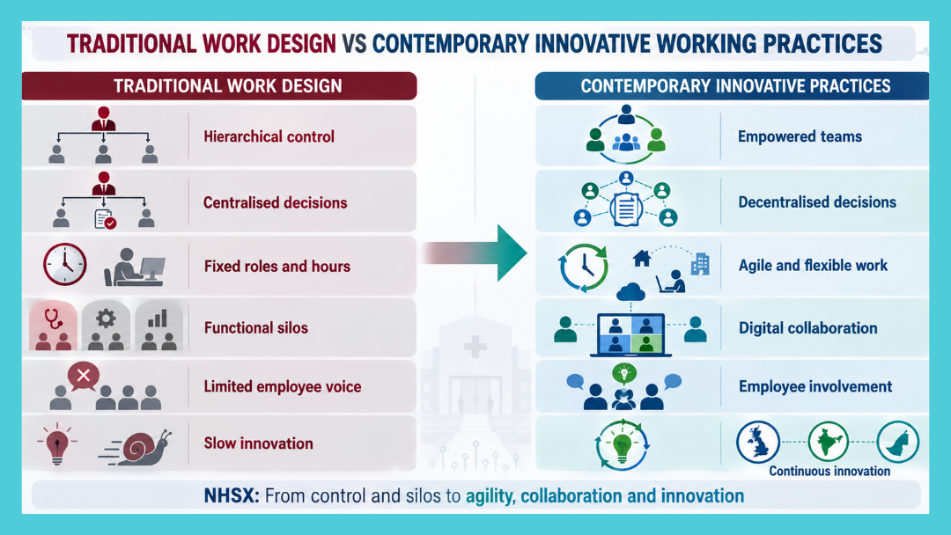
Figure 1: Traditional Work Design Versus Contemporary Innovative Working Practices (https://canva.link/3xwzfvsydi6altq Self-made)

HIGH-PERFORMANCE WORK SYSTEMS (HPWS):
HPWS allows companies to attract and develop workers, giving them more knowledge and skills. By recruiting individuals who can collaborate to solve problems and bring experience in technology and medical fields. This allows them to learn about AI, what it can and can't do in medical fields, and how to use it ethically. Evaluate them on their output and knowledge, and let them try things that may fail. Use team rewards that reward the group rather than individual output.
HPWS can create heavy workloads if implemented poorly. If employees are under constant pressure to meet targets and keep learning new skills, they can burn out. Letting employees set goals and giving them time to learn and rest can prevent this. Monitoring output and ensuring managers can help develop employees can prevent this.

HIGH-INVOLVEMENT WORK SYSTEMS (HIWS):
HIWS can share information and knowledge within a company and give employees a voice in decision-making. NHSX should create teams with members who have knowledge about different medical fields and technology. Let these teams test ideas within a budget and avoid sending them through many management stages. Let employees generate ideas through teams and consider holding competitions.
If NHSX continues to prevent employees from trying things and punishes failure strictly, then high involvement will have no effect. The NHSX board of directors should clarify which decisions employees can make. And give feedback on what they send them. Punish negligence, but allow employees to make mistakes when they follow protocols to innovate.

AGILE AND FLEXIBLE WORKING MODELS:
Agile work practices will allow different disciplines to work together, finish tasks faster, and get feedback sooner. This can enable quicker software testing and ways of working. However, some areas will need to follow protocol and go through stages to complete tasks. NHSX should implement agile ways of working where it benefits them.
Allowing employees to work from home and other locations can help NHSX recruit from around the world. It also lets employees decide when and where they work. Teams can set rules for communication, availability, and collaboration. Remote work can be beneficial if you give employees enough freedom and monitor them effectively (Wang et al., 2021). This includes ensuring they have a good work-life balance and social support.

HYBRID WORKING:
Hybrid working can have many negatives for NHSX. Communication can be lost if there is no overlap in working hours. Not enough time working from home can weaken relationships and prevent the resolution of complex problems. Remote workers may receive less information and have fewer opportunities than in-office workers. If technology is not used properly, it can fragment tasks. This can lead to misunderstandings and reduce productivity. It can harm employee motivation, equity, innovation, and business performance. The objective is equitable coordination, not surveillance (Neeley, 2021).

SOCIOTECHNICAL SYSTEMS THEORY:
Sociotechnical systems theory argues that systems should improve people and their work, and technology can help. NHSX should let employees help choose and test new technologies. Technology should support the day-to-day work and include ways to keep information secure.
Technology can have downsides as well. Having employees on platforms all day means you monitor them and take away their privacy. Technology can also make employees do more work if it is not implemented properly. NHSX should look for ways to protect employees' information and ensure someone oversees it. Make sure output is not measured by time on systems.
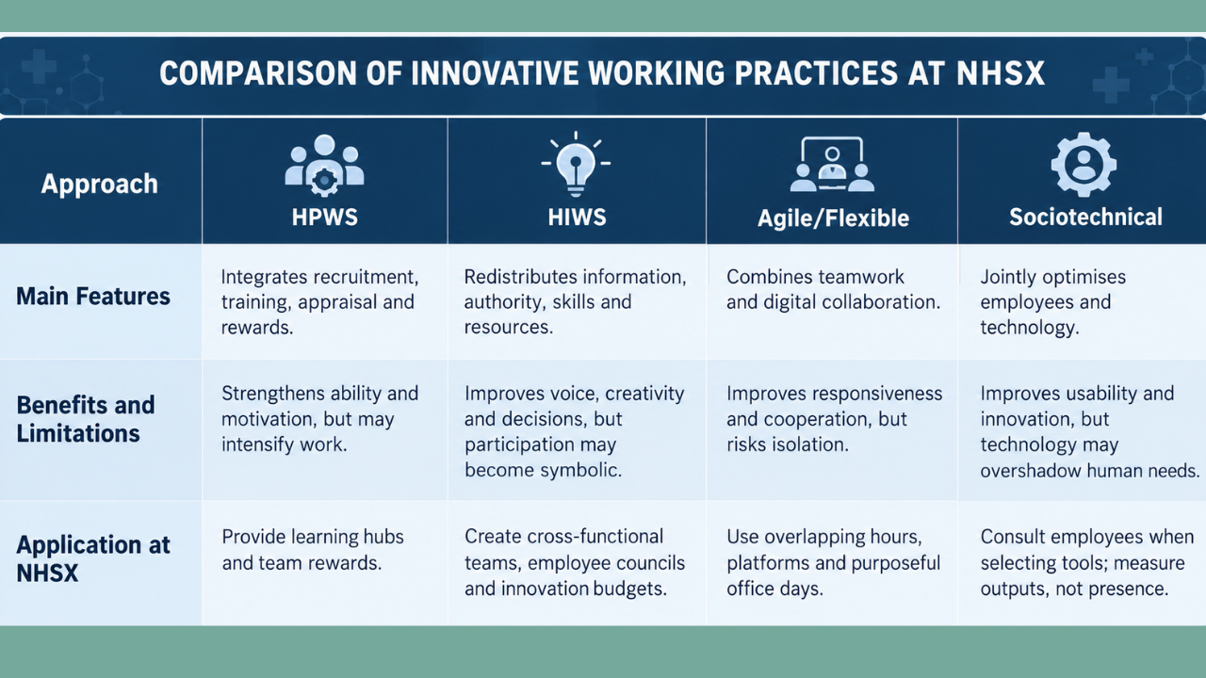
Figure 2: Comparison of Innovative Working Practices
(https://canva.link/1x08dgq2anp6yvi Self-made)
NHSX should pilot the framework in two contrasting units for six months. Measures should include decision time, safe experiments, knowledge reuse, quality, workload, inclusion and regrettable turnover, supported by employee interviews. Clinical, ethical and cybersecurity authorities should retain stop-work powers, while the Board tests whether controls remain proportionate.

RECOMMENDING INNOVATIVE WORKING PRACTICES SUITABLE FOR NEXSPACE HEALTH SYSTEMS
The framework becomes a set of connected practices that complement one another.
- Cross-functional product teams will solve problems for patients or providers, from identifying the problem to learning from the solution. Shared goals and incentives, along with clear authority, will reduce handoffs, enable cross-professional collaboration, and prevent any single voice from overshadowing others (Armstrong and Taylor, 2023).
- Give teams room to innovate by providing innovation budgets and problem-solving opportunities, as long as they don't violate safety or AI ethics. Create a platform where all your projects can live, knowledge is easy to find, and teams can form communities of practice. When you implement technology, your processes must change as well (Westerman, Bonnet and McAfee, 2014).
- Use agile methods to learn more quickly and have teams demonstrate what they have learned. Leaders should remove impediments and avoid forcing sprint metrics to increase employee output (Rigby, Sutherland, and Takeuchi, 2016).
- Quarterly reviews must balance decision speed and rework against workload, wellbeing, inclusion, retention and learning.
These will assess decision speed, rework, employee workload, burnout levels, diversity and inclusion efforts, talent retention, and learning progress.

TASK B: BREEDING AN ENVIRONMENT WHERE TALENT MAY GROW
A talent ecosystem connects organisational capability with employees’ opportunity to learn, contribute and progress. NHSX should integrate workforce planning, development, mobility and leadership accountability across its three countries. The aim is to expand collective capability while making additional investment in genuinely critical roles transparent and fair (Collings and Mellahi, 2009).

CRITICALLY EVALUATE HOW ORGANISATIONS CREATE ENVIRONMENTS WHERE TALENT FLOURISHES
Talent flourishes when learning resources, motivation, relationships and career structures reinforce one another. Training fails when employees lack time to practise, feel unsafe asking questions, or can't use new skills in their roles. NHSX needs opportunity and accountability, not the assumption that individual mindsets can overcome structural barriers.

Senge’s learning organisation links shared vision, team learning and systems thinking (Senge, 2006). NHSX should use communities of practice, retrospectives and a searchable lessons repository to move knowledge across boundaries. Protected time and owners for implementing lessons are essential; otherwise, the repository becomes an archive. Leaders must also examine how targets, workload and approvals produce behaviour instead of attributing every problem to employee capability.

A growth mindset treats capability as developable through effort, strategy and feedback (Dweck, 2006). Managers should provide developmental feedback, stretch work and coaching. However, the concept becomes harmful when it expects persistence to overcome inadequate resources, discrimination, or impossible workloads. NHSX must address these constraints and align rewards with learning.

Psychological safety enables people to ask for help, challenge authority, and report mistakes (Edmondson, 1999). Leaders should invite dissent and respond constructively. In healthcare technology, safety does not remove standards or consequences. NHSX must distinguish good-faith experimentation within approved boundaries from reckless breaches involving patients, security or data. This protects speaking up while maintaining accountability.

Strategic talent management identifies roles that disproportionately affect future advantages and builds pipelines for them (Collings and Mellahi, 2009). At NHSX, these may include clinical AI assurance, cybersecurity and product leadership. Exclusive investment in labelled high potentials may reduce trust and overlook emerging talent. Transparent criteria, regular review and broad foundational learning should therefore accompany targeted succession investment.

Job crafting lets employees reshape tasks, relationships, or perceptions of work, strengthening meaning (Wrzesniewski and Dutton, 2001). NHSX could allocate agreed time to mentoring, improvement projects or communities. Crafting must remain within competence, workload, and regulated responsibilities; otherwise, autonomy creates ambiguity or shifts routine work to colleagues.
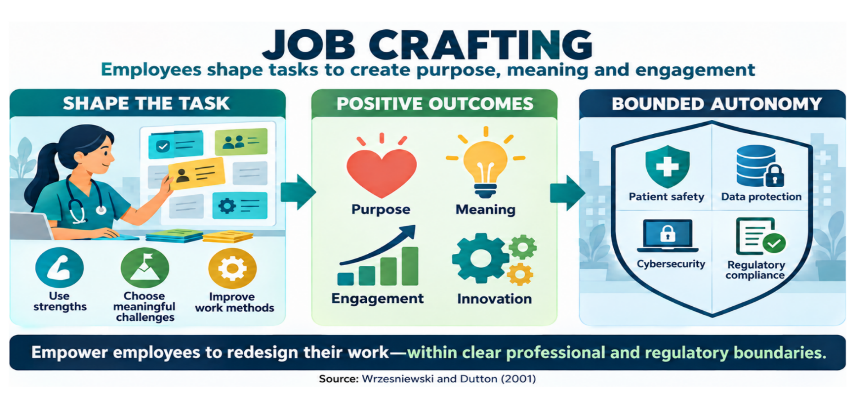
Figure 3: NHSX Job Crafting (https://canva.link/2jcj78697czcxso Self-made)
Self-Determination Theory proposes that autonomy, competence and relatedness support motivation (Deci and Ryan, 2000). Bounded discretion, coaching and cross-location communities can meet these needs. They are interdependent: autonomy without competence increases risk, while training without voice may not retain talent. Roles and development should therefore support all three.

Figure 4: Self-Determination Theory (https://word Self-made)

Employee experience integrates recruitment, onboarding, work, progression and exit. NHSX should map moments that affect belonging and career confidence in each country, disaggregating evidence by location, function and work pattern. Engagement scores alone are insufficient; promotion equity, mobility, learning application, wellbeing and regrettable turnover show whether experience is developmental.

DEVELOP A COMPREHENSIVE TALENT GROWTH STRATEGY FOR NEXSPACE HEALTH SYSTEMS
The Talent Growth System has four stages: diagnose capability, develop through work, enable mobility and hold leaders accountable. First, NHSX should create a consent-based skills inventory that combines employee-validated profiles, project evidence, and future needs. Workforce planning should identify gaps without allowing opaque AI predictions to determine potential. Employees must be able to inspect and correct their data.
Second, an NHSX Academy should offer pathways in AI, clinical practice, regulation, cybersecurity, leadership and cross-cultural collaboration. Mentors should support clear goals, while cross-functional projects provide experience. Access must be equitable across the UK, India and UAE, with protected time and adjusted workloads. Monthly exchanges and a curated hub should record successful methods and intelligent failures. This applies to team learning without adding development to already full workloads (Senge, 2006).
Third, NHSX should publish career families, capability expectations and lateral, specialist and leadership routes. An internal marketplace could match employees to projects and vacancies, while transparent panels reduce sponsorship and location bias. Job crafting may enrich existing roles but should not replace genuine promotion or pay progression.
Fourth, leaders should be trained and assessed as talent coaches. Objectives should include learning, succession, inclusion, wellbeing and mobility alongside output. Judge psychological safety by behaviour and responses to challenge, not a single survey score. Leaders also need guidance to distinguish developmental mistakes from clinical, ethical or cybersecurity breaches.
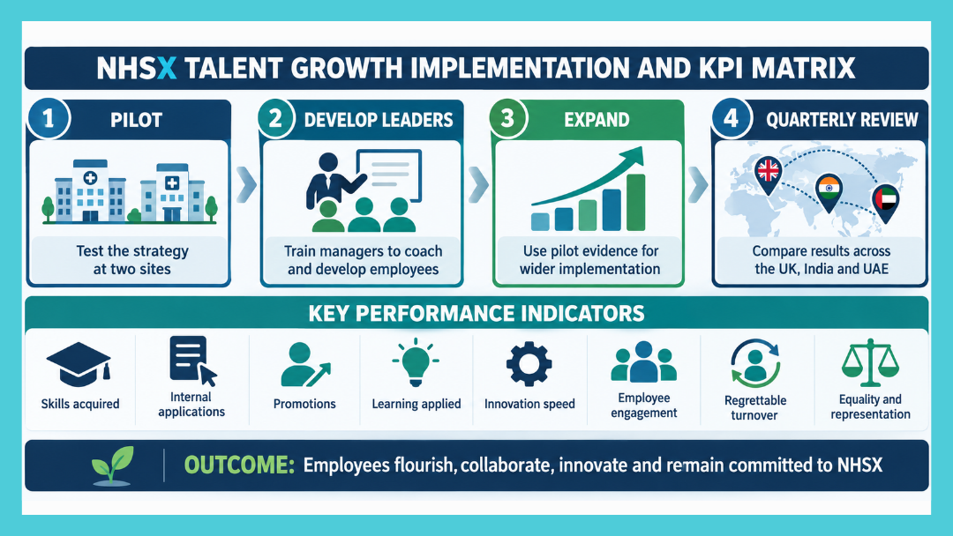
Figure 5: NHSX Talent Growth Implementation and KPI Matrix
(https://canva.link/m8w6zrgbw36xrpp Self-made)
Begin implementation at two contrasting pilot sites, then review quarterly and expand in stages. Governance should include HR, employee, clinical, technology and country representatives. Measures should cover skills applied, internal moves, promotion equity, succession coverage, implemented lessons, innovation time, engagement, wellbeing and regrettable turnover. Country comparisons must account for different labour markets and regulations.
Indicators must be interpreted together. Rising learning with unchanged mobility may mean development lacks opportunity; faster innovation with declining wellbeing may indicate intensification; and retention may reflect weak external options rather than commitment. Interviews, exit evidence and project reviews should complement dashboards. The Board should scale only useful, equitable and sustainable components. The evaluation should examine unintended consequences and employee perceptions, allowing pilot teams to explain barriers before leaders interpret variation as poor performance or copy one country’s approach into another context.
This system should improve capability and retention by connecting learning with meaningful work and progression. Its credibility depends on equitable access, protected time and visible leader accountability.

LEARNING AND KNOWLEDGE-SHARING STRATEGY
Mentoring and experiential learning should form a cycle: agree on goals, learn with a trained mentor, apply knowledge in a cross-functional project, reflect, and publish reusable insights. Communities should validate material, so the hub remains reliable. Mentors need preparation and time, while sponsors must rebalance workloads so stretch assignments don't become unpaid intensification. The cycle builds competence, organisational memory and cross-border relationships around real NHSX problems.
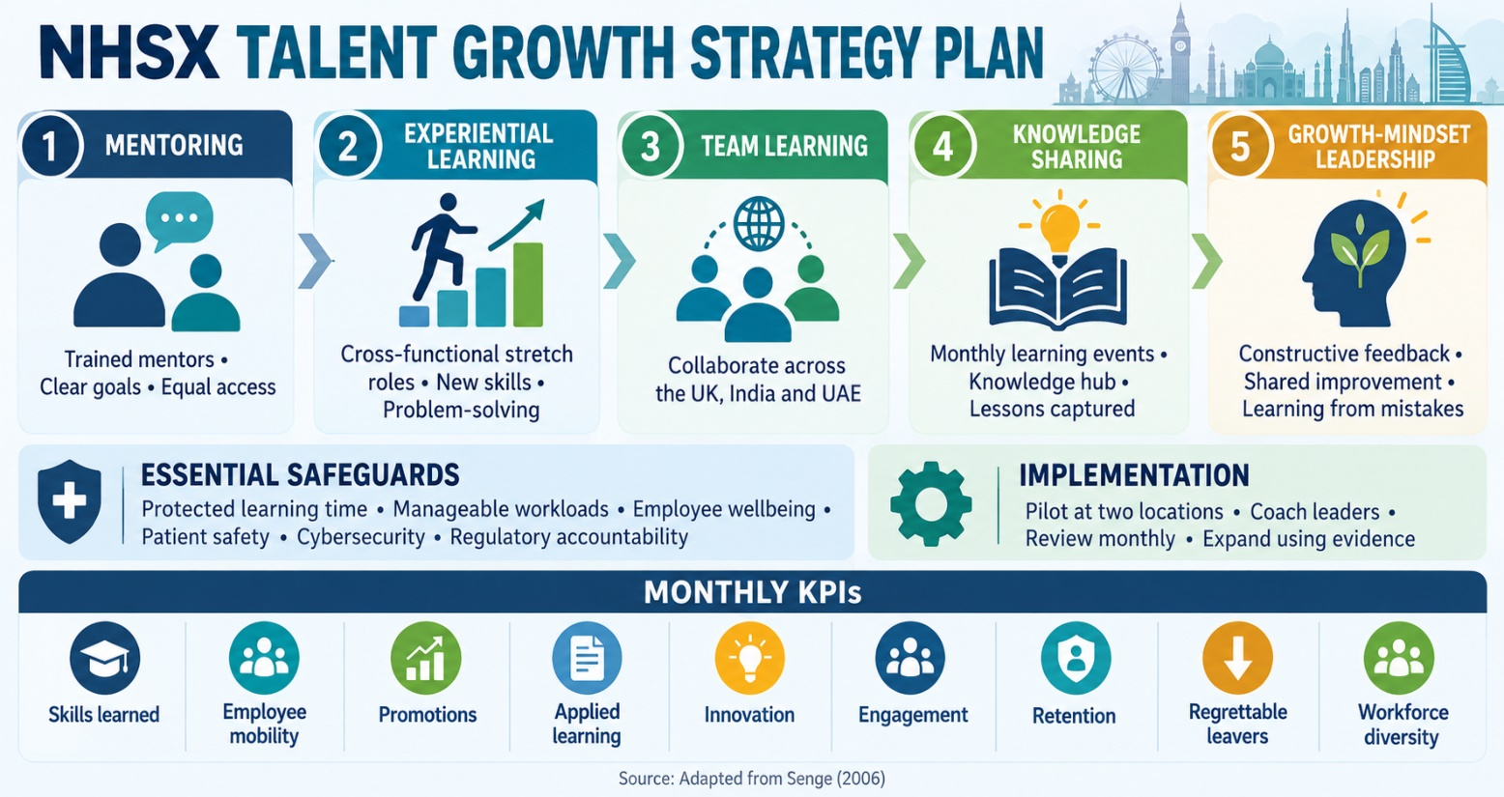
Figure 6: NHSX Talent Growth Strategy Plan
(https://canva.link/yea1933ng9c4g8u Self-made)

TASK C: REFLECTIVE REPORT
This report helped me connect HR theory to an organisational problem rather than present practices as universal solutions. I became more confident evaluating autonomy against control, performance against wellbeing and targeted investment against inclusion. I also identified gaps in HR analytics, employment law, cross-cultural practice, and evaluating AI evidence. These gaps inform my reflection and action plan.

AI AS A STRATEGIC TOOL
AI can identify skills patterns, summarise feedback, model workforce scenarios and flag retention risks. At NHSX, this could guide learning and succession. Yet prediction is not explanation: historic data may reproduce discrimination, and statistical risk must not be treated as intention. AI should augment professional judgement (Daugherty and Wilson, 2018). I would require a defined purpose, proportionate data, group-level validation, explainability, human review, and an appeals process. Consulting affects employees, and considering dignity, context and wellbeing preserves empathy. Responsible HR practice requires challenging plausible outputs, documenting decisions and retaining human accountability.

REFLECTIVE ANALYSIS
Using Jasper’s Experience, Reflection and Action cycle, I examined three uses of AI (Jasper, 2013). Experience: I used AI to proofread the report, suggest creative materials and identify grammatical errors. Reflection: Proofreading exposed repetition, but accepting fluent revisions risked weakening my voice. Visual ideas improved communication yet could oversimplify arguments. Grammar support increased accuracy, but relying on it might keep me from learning why errors occurred. I also recognised that confident output could contain unsupported claims. Action: I will define each use, preserve drafts, verify evidence and decide whether changes improve meaning. I will practise unaided writing before seeking AI feedback, so support develops rather than substitutes for capability.

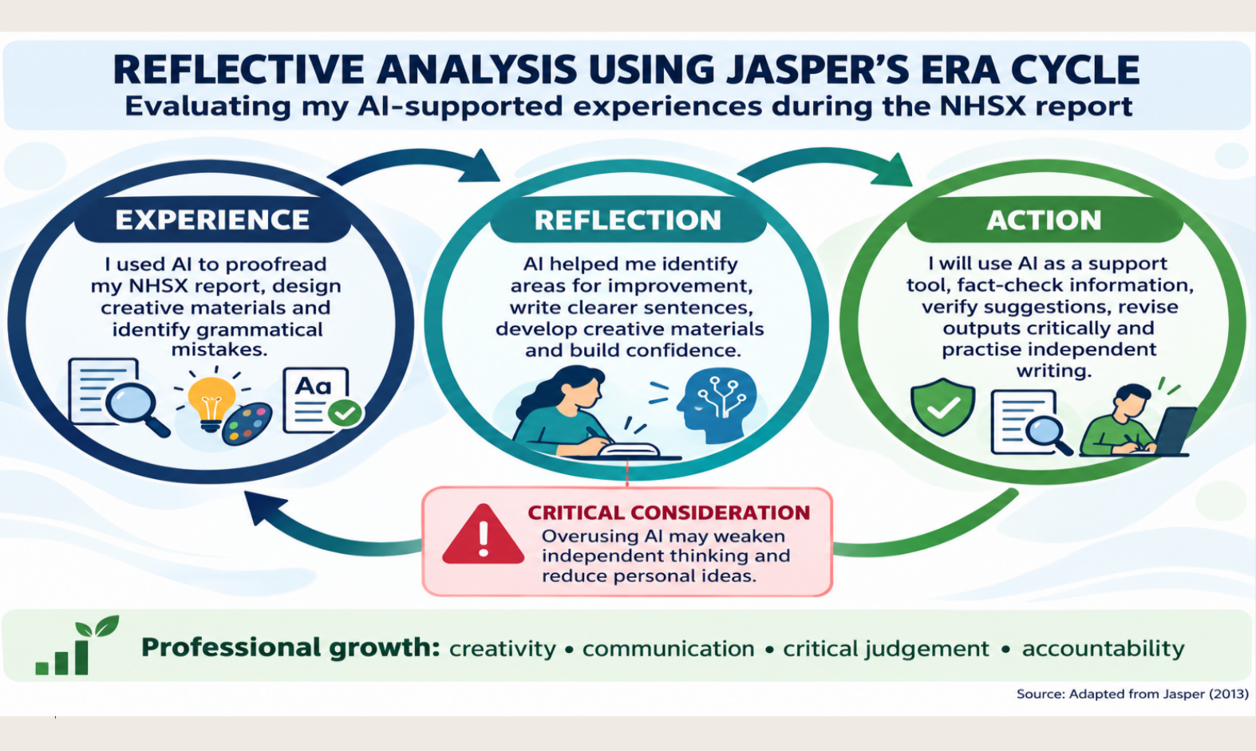
Figure 7: Jasper ERA Reflective Cycle
(https://canva.link/8lwefyw8eyjo3jw Self-made)

PERSONAL ACTION PLAN
Over twelve months, I will follow a measurable plan. Within three months, I will complete an HR analytics project using anonymised data and explain its limitations to a peer. Within six months, I will study responsible AI, data protection, and employment-law fundamentals, and record reflections in a development log. I will seek monthly mentor feedback and practise two coaching conversations each quarter. Joining a diverse project team will develop my cross-cultural communication skills. Quarterly reviews will examine completed learning, analytical quality, feedback, coaching outcomes, and my confidence in explaining ethical decisions. I will revise activities that do not improve practice, ensuring development produces demonstrated capability rather than course attendance alone (Armstrong and Taylor, 2023).

CONCLUSION
NHSX’s advantage depends on aligning work design and talent development with responsible technological growth. The framework combines HPWS, genuine involvement, bounded autonomy, agile delivery, equitable hybrid work and sociotechnical design. The talent ecosystem connects safety, motivation, learning, job crafting and transparent mobility. Neither flexibility nor development is inherently beneficial: each can intensify work or reproduce inequality when resources and accountability are weak. Piloting the system, retaining clinical and ethical guardrails, and evaluating performance alongside wellbeing and inclusion will support evidence-based scaling. Sustainable innovation should mean faster learning and better decisions through capable, connected and responsibly empowered people.

REFERENCES
Amabile, T.M., Conti, R., Coon, H., Lazenby, J. and Herron, M. (1996) ‘Assessing the work environment for creativity’, Academy of Management Journal, 39(5), pp. 1154–1184. doi: 10.2307/256995.

Armstrong, M. and Taylor, S. (2023) Armstrong’s handbook of human resource management practice. 16th edn. London: Kogan Page.

Collings, D.G. and Mellahi, K. (2009) ‘Strategic talent management: A review and research agenda’, Human Resource Management Review, 19(4), pp. 304–313. doi: 10.1016/j.hrmr.2009.04.001

Daugherty, P.R. and Wilson, H.J. (2018) Human + machine: Reimagining work in the age of AI. Boston, MA: Harvard Business Review Press.

Deci, E.L. and Ryan, R.M. (2000) ‘The “what” and “why” of goal pursuits: Human needs and the self-determination of behaviour’, Psychological Inquiry, 11(4), pp. 227–268. doi: 10.1207/S15327965PLI1104_01.

Dweck, C.S. (2006) Mindset: The new psychology of success. New York: Random House.

Edmondson, A. (1999) ‘Psychological safety and learning behaviour in work teams’, Administrative Science Quarterly, 44(2), pp. 350–383. doi: 10.2307/2666999.

Jasper, M. (2013) Beginning reflective practice. 2nd edn. Andover: Cengage Learning.

Jiang, K., Lepak, D.P., Hu, J. and Baer, J.C. (2012) ‘How does human resource management influence organisational outcomes? A meta-analytic investigation of mediating mechanisms’, Academy of Management Journal, 55(6), pp. 1264–1294. doi: 10.5465/amj.2011.0088.

Neeley, T. (2021) Remote work revolution: Succeeding from anywhere. New York: Harper Business.

Parker, S.K., Morgeson, F.P. and Johns, G. (2017) ‘One hundred years of work design research: Looking back and looking forward’, Journal of Applied Psychology, 102(3), pp. 403–420. doi: 10.1037/apl0000106.

Rigby, D.K., Elk, S. and Berez, S. (2020) Doing agile right: Transformation without chaos. Boston, MA: Harvard Business Review Press.

Senge, P.M. (2006) The fifth discipline: The art and practice of the learning organization. Revised edn. New York: Currency Doubleday.

Wang, B., Liu, Y., Qian, J. and Parker, S.K. (2021) ‘Achieving effective remote working during the COVID-19 pandemic: A work design perspective’, Applied Psychology, 70(1), pp. 16–59. doi: 10.1111/apps.12290.

Westerman, G., Bonnet, D. and McAfee, A. (2014) Leading digital: Turning technology into business transformation. Boston, MA: Harvard Business Review Press.

Wrzesniewski, A. and Dutton, J.E. (2001) ‘Crafting a job: Revisioning employees as active crafters of their work’, Academy of Management Review, 26(2), pp. 179–201. doi: 10.5465/AMR.2001.4378011

