Kristian McCallum
2020
Kristian Mccallum (1809532)
University of Wales Trinity Saint David
6/22/2020
Advanced Processes Report

Advanced Materials and Processes M6X00414

1809532
B. Eng. Mechanical Engineering & Manufacturing

Executive Summary

With increased pressure from shareholders to give consistent production rates and a global increased focus on environmental and sustainability issues, the chemical industry is having to consider, more so than ever the material used in both its products and that used in its manufacturing plants.
This report will investigate the use of GRP / Fiberglass product’s as a viable replacement in some traditional steel installations on a chemical site, for this investigation we will be focusing on a drum tipping device that is subjected to high levels of corrosion. The investigation will focus on the GRP/Fiberglass’s corrosion resistance properties and the versatility of the materials. The report will explore the potential cost benefits of using GRP, the maintenance requirements, and consider its green credentials and production limitations.

Table of Contents

Executive Summary 1
Introduction 3
Main Findings 4
Conclusion 7
Recommendations 7
Reference List 8
Appendix 9

Introduction

The subject Chemical plant produces Silanes from fluid bed reactors (see figure 1). For each process run, a catalyst is added into the reactor and it is fluidized as part of the reaction process. In this process some of the catalyst, Cuprous Chloride which is loaded to the reactor via a stainless-steel drum tipper from 45kg drums. Stainless steel is an iron alloy containing a minimum of 10.5% of chromium. It is a common choice in the chemical industry due to its chemical and corrosion resistance.

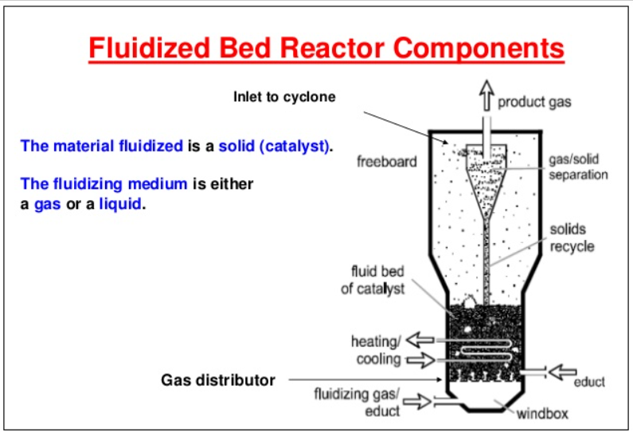
Figure 1
(Anon., n.d.)

The drum tipper is a simple chain-driven enclosed mechanism that tips the drums into a hopper ready for transfer into the reactor. The catalyst loading typically takes place every 2-3days dependant on the rate plan. The tipper is a simply fabricated stainless steel unit (Appendix 1) but due to the chlorides in the cuprous chloride catalyst, the stainless steel tipper has a short, mean time between failures, the main failures being corrosion and fracturing of the mechanisms. When failures occur, this causes delays in loading the reactor bed, and can quickly impact the production plan, the failures are often not possible to repair, as the drum tippers stainless steel body becomes fatigued and is affected by the cuprous to such an extent that weld repairs are not viable. When this happens, temporary repairs have to be made until new material is ordered and a new drum tipper is fabricated or a whole new tipper is procured, this process is both time consuming, labour intensive and costly, The financial impact is quite high as production delays affect sales and repair cost are typically inflated due to time demands. Although stainless steel is a good material to use in this application as it has some corrosion resistance but it does have limitations and there are alternative materials such as GRP that may perform better and may improve reliability and reduce maintenance costs.

Main Findings

When selecting the material of construction for plant equipment many factors must be considered, such as cost of the material, the mechanical strength, chemical resistance of the material, temperature effects on the material and its’s properties (Sinnott & Towler, 2020) and now it is also good practice to consider the materials green credentials and the sustainability of the material (Garcia-Serna, et al., 2007).

The current drum tipper is manufactured from 316 Stainless steel, the steel is the second, most commonly used stainless steel and is predominantly selected for its strength (Appendix 2)and corrosion resistance, however, it's resistance is dependent on its operating environment (Sanni, et al., 2018). In this example, the stainless-steel tipper is on a Cuprous Chloride duty, and the chlorides in the atmosphere cause pitting and cracking in the stainless steel which fail (Duan, et al., 2020) this form of failure occurs regularly and attempting to weld repair the contaminated tipper can cause the stainless to blow through and increase the damage or can cause further crack propagation (Shaikh, et al., 2011). Once the stainless steel has failed it is normally sent for scrap and ultimately the material will be recycled. Theoretically, 100% of the steel is recyclable and it is believed that any new stainless steel item contains in the region of 60% recycled material (Anon., n.d.).

GRP is a composite material and stands for glass reinforced plastic and is manufactured from fibrous reinforced polymers which are made of plastic and reinforced by fine glass fibres. Although glass fibres have been around for hundreds of years its wasn’t until the late 18 hundreds that it was patented (Anon., n.d.)and then in 1936 Games Slater, accidentally discovered how to mass-produce the glass strands by blasting air jets at the molten material (Hamon, 2014), the material was originally used as insulation but was soon being used in multiple applications. By the late 1930s resin was being added to the fiberglass to join it with plastics to create a composite material with great strength and versatility. The material was soon being used to manufacture small boats, sportscar body parts and it even replaced some of the moulded plywood parts in second world war planes (Johnston, 2018). Today the versatility GRP is fully recognised and is used to manufacture many things such as water slides, water pipes, antennas covers, and circuit boards.

GRP is manufactured in several different ways, Filament winding, this is when filaments are tightly wound around mandrels to create to form cylindrical shapes such as pipes and tubes (Ellyin, et al., 1997). Fiberglass hand lay-up operation, this is a 100% manual operation but offers the best overall strength (Jawaid, et al., 2019), Fiberglass spray lay-up operation, this is where a fibrous resin is sprayed from a gun into a mould (Mazumdar, 2001) and Pultrusion operation. Pultrusion is the preferred method of manufacturing industrial quality fiberglass and provides the greatest range of opportunities for use (Liu & Hillier, 1999). In the pultrusion process woven glass fibres are pulled by rollers through a resin impregnation bath or injection chamber where resins such as epoxies, polyester, polyurethane or vinyl ester are added to the woven mass, the combination of resins can set the materials strength, corrosion resistance and it’s UV protection and fire protection. The impregnated fibres are then pulled through a die and heated to make the finished product (see figure 2). These products are often used in the chemical industry as they are chemically resistant and often have enhanced strength.

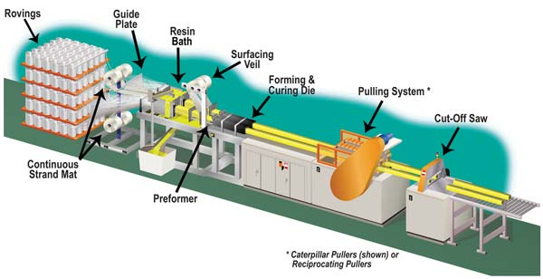
Figure 2.
(Anon., n.d.)

GRP/ fiberglass products are perceived to be and are now marketed as green products. The manufacturer of fiberglass does not generate large plumes of smoke and toxic waste like traditional steel manufacture. During the manufacture of Stainless Steel, it is estimated that between10-40kg/T of air pollution and between 300-400 kg/T of pollutants into wastewater (Anon., 1998) is generated. GRP does not have that type of environmental impact, the processes used in its manufacture do not require the huge levels of heating and cooling that steel processes require. Although GRP does have a relatively low environmental footprint, not unlike other synthetic materials it is however manufactured from petroleum-based products. The petroleum industry is itself responsible for large levels of pollution, especially polluting air, seawater, and soil around the drilling rigs (Misachi, 2017). However, GRP does use petroleum-based products in its manufacture these chemicals are ‘by-products’ and their use could be deemed as environmentally neutral, as it uses products that would otherwise be considered a waste stream.
GRP components are typically very strong and have a long-life span, some manufacturers suggest their products have life cycles of more than 25 years in some cases. When the end of life comes there are currently limited opportunities to reuse & recycle the fiberglass material. Several companies that manufacture GRP composite products are using circular economy and are working with customers to repurpose old GRP products and are making drain covers, building site floors, and plant separators (Capps, 2020). Despite GRP having a long life, when the end of life comes the disposal of GRP products typically has a substantial environmental impact with only 3 options available landfill, incineration, and recycling. With a drive to reduce the mass of waste going to landfill and the incineration of GRP leaving up to 60% of the waste as potentially toxic ash, recycling is the preferred waste path for the material (Larsen, 2009). The wind turbine industry which has grown exponentially in the last decade and is one of the fastest-growing application areas of GRP composite materials is having to consider how to deal with this issue as they deal with a huge number of turbine blades that are reaching the end of life. Early studies are showing that the fibres can be mechanically recovered from the turbines and can be reused to reinforce polypropylene products (Rahimizadeh, et al., 2019)

GRP is also an extremely robust material, depending on its construction-grade it will not deform under impact and is stronger than steel on a kg to kg comparison (Anon., 2020)it is also a nonconductive material, consequently this reduces the earthing concerns when used in a hazardous industry. GRP component manufacturers also suggest that even though the cost of stainless equipment is comparable when originally purchased, the actual cost over the life cycle of the product is considerably lower as GRP products require minimal maintenance in industrial settings once installed. The original installation cost is also lower as the material is lightweight, so it requires less resource to assemble the unit.

Conclusion

Around since the early 1800s stainless steel is without a doubt a very robust, popular material with 52,218,000 metric tonnes produced last year (Anon., n.d.). It is a versatile material and is often a good choice on chemical plants, although this very much depends on its operating environment. GRP is most definitely a strong alternative, it’s chemical and corrosion resistance matched with its durability makes it a suitable replacement for the current material, based on manufactures feedback a GRP tipper could last up to 25 years and it is potentially maintenance-free which on its own would represent a significant financial saving. GRP components can be slightly more expensive, but it is reduced maintenance program would offset any additional purchase costs. Although in principle stainless steel and GRP have a comparable life cycle, in the environment that it is installed this is substantially reduced, only lasting approximately a year despite a regular cleaning and maintenance schedule.
Stainless steel is highly recyclable but does generate a lot of emission during the manufacturing process these emissions can be offset when a product lasts its full life cycle but, in this instance, this would not be the case. Opportunities to recycle GRP are currently limited although alternative opportunities are being identified, its life cycle is potentially long in comparison to stainless steel. With companies feeling the pinch financially and most operating with reduced budgets, the opportunity to reduce maintenance spend would be a welcome one.

Recommendations

A GRP drum tipper will undoubtedly equal the performance of the stainless-steel version and based on the research the GRP version should exceed by a considerable duration possibly more than 20 years. With the financial gain made from the reduction of maintenance of the unit this will offset any risk with altering the materials of construction for this unit. Although this equipment is important, but its usage every 2-3 days does provide some leeway, so it is likely that a change for an alternative could be made in the unlikely event that the tipper is not serviceable. The installation of the GRP drum tipper could also act as a trial and provide valuable data on how serviceable this material would be on the chemical site, in principle there are numerous applications that GRP could be used such as floor gratings, pipe brackets and filtration housings.

Reference List

Anon., 1985. Drum tipper drawing. s.l.:s.n.
Anon., 1998. https://www.environmental-expert.com/articles/iron-and-steel-manufacturing-industry-pollution-prevention-guidelines-1387. [Online]
[Accessed 2020].
Anon., 2020. Relinia. [Online]
Available at: https://www.relinea.com/grp-vs-traditional-materials
[Accessed 5 2020].
Anon., n.d. Environmental aspects of stainless steel. [Online]
Available at: https://www.bssa.org.uk/sectors.php?id=99#:~:text=The amount of recycled stainless,be recycled for 20-30 year
[Accessed 6 20].
Anon., n.d. 316 Stainless Steel Tensile Strength. [Online]
Available at: https://www.jawaysteel.com/316-Stainless-Steel-Tensile-Strength.htm?seo=316-Stainless-Steel-Tensile-Strength
[Accessed 5 2020].
Anon., n.d. http://modulesolutions.no/wp-content/uploads/2015/10/Pultrusion_Process.jpg. [Online].
Anon., n.d. https://image.slidesharecdn.com/fluidizedbedintroduction-131215075950-phpapp02/95/fluidized-bed-introduction-by-mohabat-ali-malikmuetjamshoro-3-638.jpg?cb=1387094430. [Online].
Anon., n.d. International Stainless Steel Forum. [Online]
Available at: https://www.worldstainless.org/
[Accessed 5 20].
Anon., n.d. The History of Fiberglass. [Online]
Available at: https://www.pslc.ws/macrog/mpm/composit/fiber/fibeglas/history.htm
[Accessed 6 2020].
Duan, Z. et al., 2020. Pitting nehaviour of SLM 316L stainless steel exposed to chloride enviroments with different aggressiveness:Pitting mechaniosm induced by gas pores. Corrosion Science, Volume 167.
Ellyin, F., Carroll, M., Kujawski, D. & Chiu, A., 1997. The behavior of multidirectional filament wound fibreglass/epoxy tubulars under biaxial loading. Composites Part A: Applied Science and Manufacturing, Volume 28, pp. 781-790.
Hamon, A., 2014. Did You Know?: R. Games Slayter and Slayter Center. [Online]
Available at: https://www.purdue.edu/newsroom/purduetoday/didyouknow/2014/Q1/did-you-know-r.-games-slayter-and-slayter-center.html
[Accessed 6 2020].
Jawaid, M., Saba, N. & Thariq, M., 2019. Durability and Life Prediction in Biocomposites, Fibre-Reinforced Composites and Hybrid Composites. s.l.:Woodhead Publishers.
Johnston, T., 2018. Uses of Fiberglass. [Online]
Available at: https://www.thoughtco.com/uses-of-fiberglass-820412
[Accessed 6 2020].
Larsen, K., 2009. Recycling Wind Turbine Blades. Renewable Energy Focus, Issue 7, pp. 70-73.
Liu, X. & Hillier, W., 1999. Heat Transfer & Cure Analysis for the pultrusion of a fiberglass-vinylester I beam. Composite Structures, 47(1-4), pp. 581-588.
Mazumdar, S. K., 2001. Composites Manufacturing: Materials, Products, and Process Engineering. s.l.:CRC Press.
Misachi, J., 2017. World Atlas. [Online]
Available at: https://www.worldatlas.com/articles/what-is-the-environmental-impact-of-the-petroleum-industry.html#:~:text=Environmental Impacts Of Petroleum Refinery.,particulate matters, and sulfur dioxide.
[Accessed June 2020].
Rahimizadeh, A., Kalman, J., Fayazbakhsh, K. & Lessard, L., 2019. Recycling of fiberglass wind turbine blades into reinforced filaments for use in additive manufacturing. Composoites Part B: Engineering, Volume 175.
Sanni, O., Poopoola, A. & Fayomi, O., 2018. Enhnced corrosion resistance of stainless steel type 316 in sulphuric acid solution using eco-friendly waste product.. Results in Physics, Volume 9, pp. 225-230.
Shaikh, H. et al., 2011. Stress Corrosion Cracking. s.l.:Woodhead Publishers.

Appendix
Appendix 1.
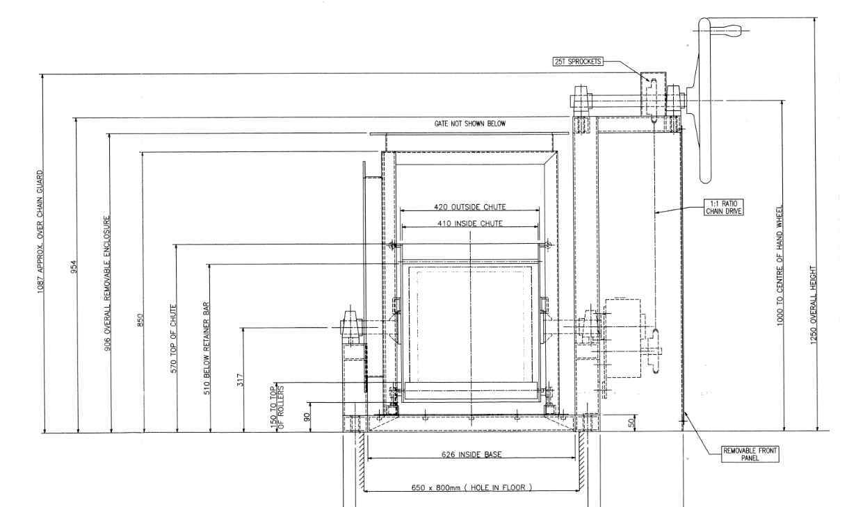
(Anon., 1985)

Appendix 2.
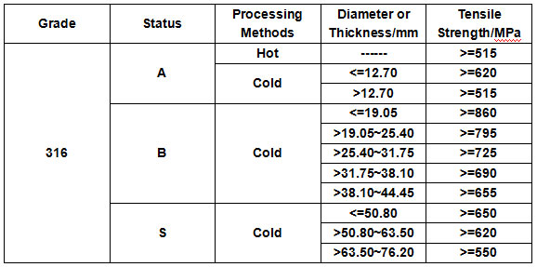
(Anon., n.d.)

