Module title: Complementary Therapies
Module code: BMHP5001
Assessment 1
Module leader: Joanna Walsh
Student Name: Modou Mbacke
Student ID: 1916151

Table of Contents
Introduction 3
Outlining complementary therapy regarding its enhancement of current orthodox treatment 3
Overview of its history, uses, efficacy, and contraindications 3
Evaluating the overall effectiveness of the asana yoga 7
Conclusion 7
Reference list 8

Introduction
The paper is based on the topic of Contemporary therapies. The selected therapy for the study is Asana yoga. There is a concise description of the therapy, and its potential to enhance the recent orthodox treatment. The history, uses, efficacy, and contraindications of the therapy are discussed, along with its overall effectiveness.

Outlining complementary therapy regarding its enhancement of current orthodox treatment
The selected complementary therapy, which has enhanced the structure of orthodox treatment in the UK, is Asana yoga. It has been evident that asana in yoga has been started as a tradition 3,000 years ago (Jayawardena et al., 2020). It is a formation of fitness in mind and body involving the combination of muscular activities, and an awareness of breath and energy. Yoga is such a benefit for every individual, as it has provided several ways for orthodox treatment in the UK. Primarily, yoga helps to improve the mind and generate a sense of well-being. Improvement in flexibility is one of the major benefits of yoga. Increment in blood flow and haemoglobin is occurred due to yoga as well. Yoga can improve the symptoms of arthritis with ease (Thakur et al., 2020). For instance, More than fifty patients in the UK suffering from asthma have been suggested to undergo training with a set of asana yoga. It has included breath exercise, suryanamaskar, along yogasana, which are namely physical postures of pranayama. It has benefitted them in coming out from drug treatment, with greater improvement regarding personal growth, health along well-being. With the help of this, the government follows the Beveridge model, which depicts the encouragement to the national health department to provide health care for people through income tax payments (Wielechowski and Grzęda, 2020). Therefore, the efficacy of asana yoga has enhanced traditional treatment like bronchial asthma, and other critical illness.

Overview of its history, uses, efficacy, and contraindications
History
Asana yoga is a body posture, which is also a common term for a sitting meditation pose. There are 84 types of asana yoga. As per the history of asana yoga, it can be said that it was originated in India around the 2nd to 4th century CE. In the ancient period, the practice of asana was considered the third of the eight limbs in India. It has been found that asana yoga was highly developed within the Indus-Sarasvati civilisation in Northern India over 5,000 years ago. Patanjali is considered the father of yoga (Gupta et al., 2018).
After originating in India, asana yoga started spreading to different parts of the world, along with the high increase of its acceptance. Asana yoga came into the United Kingdom in 1960. At that time, the asana was described as the systems of exercise for women. From that time, the popularity of asana yoga started blooming in the UK. It has been known that different commercial yoga studios started to appear in the city centres during 1990 (Alvarez et al., 2020). The UK sports council also recognised asana yoga as a valid sporting activity. At present, there are around 10,000 yoga teachers in the UK. More than 460,000 citizens take part in asana yoga classes every week. The popularity of yoga has increased rapidly in the last few years in the UK.
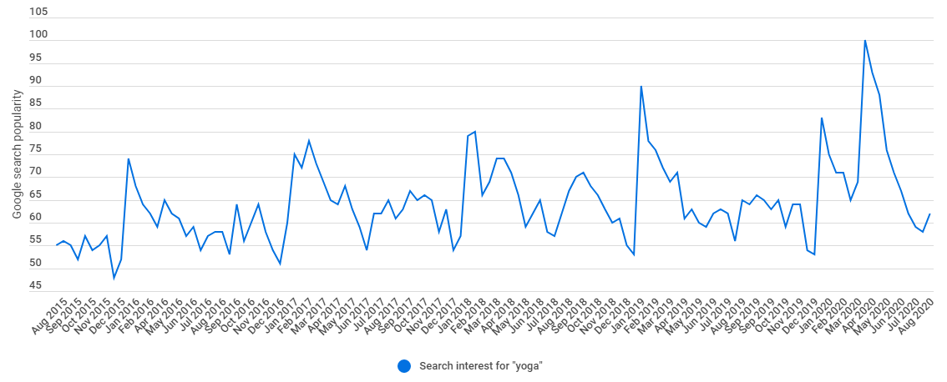
Figure 1: Increased popularity of yoga
(Source: Cadman, 2021)
Uses
The primary reason behind the immense popularity of asana yoga in the UK is its varied uses. It can be said that asana yoga is highly beneficial in the case of offering both physical, as well as spiritual benefits to an individual. One of the most significant uses of asana yoga is that it is responsible for improving the flexibility, strength, and balance of an individual (Timlin and Simpson, 2017). The people of the United Kingdom go through a lot of work stress.
As a result of that, asana yoga has a high significance in this regard as people can eliminate stress while engaging in asana yoga. Asana yoga has various health benefits. It has been seen that an excellent improvement of respiration, energy, and vitality is ensured because of asana yoga. Hence, the practice of asana yoga has been included as a treatment procedure in the NHS. According to the NHS, the practice of asana yoga is highly beneficial for individuals with high blood pressure, heart disease, depression, and anxiety (Nhs, 2021).
Efficacy
In regards to the efficacy of asana yoga, it can be said that the practice is highly beneficial for individuals with different heart diseases. It is obvious that the aspect of heart disease is a concerning issue in the United Kingdom. In this regard, the practice of asana yoga has received high acceptance among the people. While engaging in asana yoga, a person can restore his/her calmness. As a result of that, it can exert potential benefits in the professional life of the person (Gupta et al., 2018). Apart from an extensive usage of asana yoga in the NHS, the therapy is also used in different private practices for dealing with arthritis, and many others. In this regard, there are various yoga centres in the UK. Moreover, the asana yoga is also a component of Macmillan support.
In the present time, the issue of depression is very much common among the youths, and the middle age people of the UK (Timlin and Simpson, 2017). However, asana yoga has high efficacy in the case of dealing with depression. As a result of that, it has been found that 62.8% of the asana yoga practitioners are within the age group of 18-44 years. Moreover, asana yoga has excellent efficacy in dealing with arthritis problems. Due to high efficacy, the fitness industry of the UK has seen rapid growth in recent time.
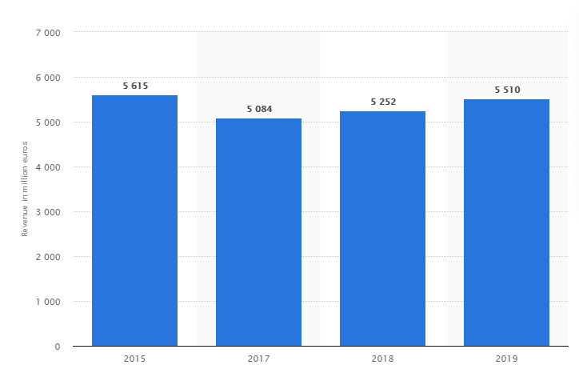
Figure 2: Revenue of the fitness industry of the UK
(Source: Statista, 2021)
Contraindications
It has been found that the practice of asana yoga has been highly beneficial in the case of dealing with various health issues. However, the contraindication lies in the case of epilepsy patients. The practice of asana yoga is not recommended in this regard, and the traditional approach to treat epilepsy is considered useful in this regard. In the United Kingdom, certain asanas are not recommended for heart patients as they can feel pain in the heart (Alvarez et al., 2020). Unsteady blood pressure and sugar level also fall under the contraindication of asana yoga.
This is because several inversion poses can enhance blood pressure, which might result in various serious problems. In this, a patient is always recommended to consult with a specialist doctor. Within the contraindication of asana yoga, it has been found that patients suffering from glaucoma are advised not to opt for any inversion poses (Timlin and Simpson, 2017). However, the treatment of lowering the intraocular pressure is more appropriate for patients with glaucoma. The concerned patients can witness an increase of pressure in their eyes due to the continuation of asana yoga.

Evaluating the overall effectiveness of the asana yoga
In order to discuss the effectiveness of asana yoga, it has been evident that asana in yoga helps individuals in improving their flexibility through stretching muscles. Standing postures help people to work in the lower muscles of the body and arm balance improves the condition of upper part muscles (Jarry, Chang and La Civita, 2017). However, extensive muscle, along with stretch in ligaments can pull people into injuries, which is also evident (Jain et al., 2020). Yoga helps to stand with a straighter posture by strengthening the core muscles of the stomach and back. The cat-cow pose helps to reduce the issues of back pain. Therefore, in order to reduce the issues of neck and back, it is helpful for every individual (Jarry, Chang and La Civita, 2017). Chakrasana, which is one of the postures of yoga, helps to improve the function of the digestive and reproductive system. Therefore, an improvement is observed in the process of digestion among individuals. Apart from that, arthritis can also be treated with the help of yoga, as it removes the discomfort of tender along with puffed joint of the arthritis patients (Thakur et al., 2020).
On the other hand, people are benefitted from their heart health due to yoga. The downward dog pose helps to do it, by reducing stress level and controlling the blood pressure and excess weight as well. Another benefit of yoga reflects upon the betterment of sleep (Jarry, Chang and La Civita, 2017). The legs-up-wall posture of yoga asana helps to have the right mindset and to fall asleep. Therefore, stress among the human body is also controlled due to this. Additionally, mental health, mindfulness, and weight loss are provided by yoga. Therefore, it is beneficial for everyone, as it provides more energy and a brighter mood, which encourages them to perform better, which eventually improves the level of self-care (Jarry, Chang and La Civita, 2017).

Conclusion
From the conduction of the report, it has been found that asana yoga has been highly beneficial in the case of enhancing present orthodox treatment. It has been found that heart patients are highly benefitted from the practice of asana yoga. As a result of that, the therapy has gained immense popularity in the United Kingdom. The effectiveness of the therapy has been analysed.

Reference list
Alvarez, E., Sutton, A., Barton, B. and Vaidya, S., 2020. Evaluating a group-based Yoga of Stress Resilience programme: a pragmatic before–after interventional study protocol. BMJ open, 10(3), p.e035862.
Cadman, J., 2021. Yoga statistics | Finder UK. [online] Finder UK. Available at: <https://www.finder.com/uk/yoga-statistics> [Accessed 8 April 2021].
Gupta, B.M., Ahmed, K.M., Dhawan, S.M. and Gupta, R., 2018. Yoga research a scientometric assessment of global publications output during 2007-16. Pharmacognosy Journal, 10(3). p. 21.
Jain, M., Tripathy, P.R., Manik, R., Tripathy, S., Behera, B. and Barman, A., 2020. Short term effect of yoga asana-an adjunct therapy to conventional treatment in frozen shoulder. Journal of Ayurveda and integrative medicine, 11(2), pp.101-105.
Jarry, J.L., Chang, F.M. and La Civita, L., 2017. Ashtanga yoga for psychological well-being: initial effectiveness study. Mindfulness, 8(5), pp.1269-1279.
Jayawardena, R., Ranasinghe, P., Ranawaka, H., Gamage, N., Dissanayake, D. and Misra, A., 2020. Exploring the therapeutic benefits of Pranayama (yogic breathing): A systematic review. International Journal of Yoga, 13(2), p.99.
Nhs.uk. 2021. A guide to yoga. [online] Available at: <https://www.nhs.uk/live-well/exercise/guide-to-yoga/> [Accessed 8 April 2021].
Statista. 2021. UK: fitness market revenue 2015-19 | Statista. [online] Available at: <https://www.statista.com/statistics/1044273/fitness-market-revenue-uk/> [Accessed 8 April 2021].
Thakur, P., Mohammad, A., Rastogi, Y.R., Saini, R.V. and Saini, A.K., 2020. Yoga as an intervention to manage multiple sclerosis symptoms. Journal of Ayurveda and integrative medicine, 11(2), pp.114-117.
Timlin, D. and Simpson, E.E.A., 2017. A preliminary randomised control trial of the effects of Dru yoga on psychological well-being in Northern Irish first time mothers. Midwifery, 46, pp.29-36.
Wielechowski, M. and Grzęda, Ł., 2020. Health care financing in the European Union countries–structure and changes. Acta Scientiarum Polonorum. Oeconomia, 19(1), pp.71-80.

